Supplementary figure 1
Skin ultrasound examination images of the alopecia area: a few HA remains in the alopecia area with posterior acoustic reinforcement.
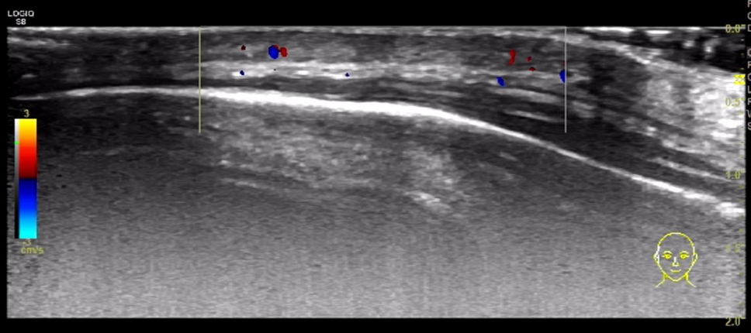

Supplementary figure 2
Therapeutic timeline.

