Supplementary Materials

Supplementary Material 1. SCREENING FORM

- Hospitalization Related Events:
- Hospitalization in the last 12 months (<65 years) or 6 months (≥65 years)
- Rehospitalization within 30 days after discharge
- Emergency room visit within 30 days of discharge
- Frequent emergency room visits (3 times in the past month)
- Transfer to/from another hospital
- Chemotherapy in the last 6 months before hospitalization
- Others:
- Care-Associated Events:
- Accident, falls, or trauma
- Adhesions, seroma, or functional alterations after the intervention
- Damage or complications related to abortion, amniocentesis, labor, or pre-labor: low APGAR score, uterine rupture
- Damage related to IV: extravasation, hematoma, abrasion
- New neurological deficit related to any healthcare assistance
- Dialysis initiated during hospitalization
- Thromboembolic disease (pulmonary embolism and/or deep vein thrombosis) in hospitalized patients
- Stay in intensive care for more than 24 hours
- Eventration or evisceration, suture dehiscence
- Loss or repetition of request
- Unplanned extubation
- Fever
- Hematuria
- Hemorrhage or hematoma related to the intervention
- Myocardial infarction (MI) or cerebrovascular accident (CVA) in hospitalized patients
- Ineffective or incomplete surgical intervention
- Intubation or reintubation in Resuscitation
- Injury to an organ during the procedure
- Death
- Pneumoperitoneum
- Pneumothorax
- Pneumomediastinum
- Chemical or electrical burn
- Cardiac arrest
- Reintubation within 48 hours of extubation
- Second unplanned surgical intervention during this hospitalization
- Suspension of surgery
- Time from consultation to ICU transfer > 6 hours
- Transfer from a general hospitalization unit to another special care unit
- Pressure ulcers
- Others:

- Infection-Related Complications:
- Bacteremia associated with catheter
- Positive culture for C. difficile
- Positive blood culture (S. aureus, fungi, P. aeruginosa)
- Phlebitis
- Fever greater than 38ºC the day before hospital discharge
- Urinary tract infection (UTI)
- New onset pneumonia
- Others:

- Medication-Related Events:
- Alteration of consciousness level (Benzodiazepines, Parenteral Nutrition)
- Cardiac rhythm disturbances (macrolides, quinolones, ATC, anesthetics, donepezil, SSRIs, antiemetics)
- Headache (analgesics)
- Electrolyte imbalance (diuretics)
- Diarrhea (antibiotics)
- Worsening of renal function (aminoglycosides, glycopeptides, ACE inhibitors, ARBs, NSAIDs, Beta blockers)
- Upper gastrointestinal bleeding (gastritis or ulcers from NSAIDs, anticoagulation, antiplatelet therapy)
- Lower gastrointestinal bleeding (anticoagulation)
- Hepatitis (antibiotics, NSAIDs)
- Hyperthermia (inhaled anesthetics, succinylcholine, botulinum toxin)
- Hypotension (diuretics, alpha blockers, beta blockers, ATC, sildenafil, metamizole)
- Infection after immunosuppression (high-dose corticosteroids, cyclosporine, everolimus, tacrolimus, azathioprine, methotrexate, mycophenolate)
- Nausea or vomiting (anesthesia)
- Nephritis (PPIs, antibiotics, NSAIDs)
- Neutropenia (antibiotics, NSAIDs)
- Urinary retention, catheterization (alpha blockers, antihistamines, tricyclic antidepressants, anticholinergics, opioids)
- Rash (allergic reaction to medications, latex, contact dermatitis from sheets)
- Others:

- Treatment-Related Events:
- Adrenaline (anaphylactic shock)
- Andexanet alfa (Ondexxya) (reverse apixaban or rivaroxaban anticoagulation)
- Anti-digoxin antibodies (digitalis intoxication)
- Antidiarrheals (diarrhea associated with antibiotics)
- Antiemetics (Anesthesia)
- Antihistamines (drug allergic reaction)
- Antipsychotic (delirium in hospitalized patient)
- Carboxypeptidase G2 or glucarpidase (Voraxaze) (reverse methotrexate intoxication)
- Sudden discontinuation of medication (severe drug adverse reaction)
- Prothrombin complex concentrate (Prothromplex) (reverse rivaroxaban, apixaban anticoagulation)
- Dantrolene (malignant hyperthermia, neuroleptic syndrome, serotonin syndrome)
- Recombinant Factor VII (Novoseven) (reverse dabigatran anticoagulation)
- Flumazenil (benzodiazepine overdose)
- Glucagon or glucose solution (insulin-induced hypoglycemia)
- Idarucizumab (reverse dabigatran anticoagulation)
- Laxative or enema (constipation due to immobility or opioids)
- Naloxone (opioid overdose)
- N-acetylcysteine (paracetamol overdose)
- Noradrenaline (hypotension, cardiac arrest)
- Prednisone or corticosteroid (drug allergic reaction)
- Protamine (neutralize heparin and LMWH anticoagulation)
- Blood transfusion (bleeding due to invasive procedures, anticoagulation, or antiplatelet therapy)
- Vitamin K (bleeding due to anticoagulation)
- Others:

- Test Results/Observations:
- Glucose < 50 mg/dl > 200 mg/dl
- INR > 6
- PTT > 100 s
- Neutrophils < 0.5 x10³ uL
- Hemoglobin < 6.5 g/dL
- Creatinine x 2 the baseline value
- Sodium < 123 mmol/L > 150 mmol/L
- Potassium > 6.5 mmol/L
- Potassium < 2.5 mmol/L > 6.5 mmol/L
- Positive blood culture
- SARS-CoV-2 positive from the 3rd day of hospitalization
- Doppler ultrasound of lower limbs / Helical CT pulmonary (pulmonary embolism due to immobilization)
- Endoscopic retrograde cholangiopancreatography (ERCP)
- Helical CT pulmonary
- Perioperative troponin > 1.5 ng/ml
- Positive urine culture
- Gastroscopy (Gastritis or ulcer due to NSAIDs, bleeding due to anticoagulants)
- Colonoscopy (Bleeding due to anticoagulants)
- Others:

- Diagnosis-Related Issues:
- Pathological anatomy not related to the diagnosis
- Diagnostic error
- Diagnostic delay
- Others:
Supplementary Material 2. DATA COLLECTION NOTEBOOK
- Date of incident
- Patient's age
- Patient's sex
- Notifier
  - Physician
  - Resident
  - Nurse/Supervisor
  - Nursing Assistant
  - Other
- Where it occurred
In this case, the only option is to select the Nursing Unit.
- Phase
  - Organizational management / Appointments
  - Infrastructure
  - Medical devices / Equipment / Clinical furniture
  - Patient identification
  - Preventive activities
  - Clinical assessment / Diagnosis
  - Clinical documentation / Information / Informed consent
  - Diagnostic test
  - Healthcare-associated infection
  - Medication / Vaccines
  - Blood and blood derivatives
  - Surgical procedures
  - Therapeutic procedures
  - Patient accidents
  - Continuity of care
  - Patient care and follow-up
  - Other
- Type
  - Situation with the potential to cause an incident
  - Incident that did not reach the patient
  - Incident that reached the patient
- Evolution
  - Circumstances or events with the potential to cause error
  - The error occurred but did not reach the patient
  - The error reached the patient but did not cause harm
  - The patient required monitoring and/or intervention, but no harm occurred
  - The patient experienced temporary harm that required medical intervention
  - The patient required or prolonged hospitalization
  - The patient experienced permanent harm
  - Life-sustaining intervention was required for the patient
  - The incident may have been related to the patient's death
  - The error occurred but follow-up was not possible to determine the harm
- Severity
  - Very low
  - Low
  - Moderate
  - Severe
  - Very severe
- Frequency
  - Annual
  - Semi-annual
  - Quarterly
  - Monthly
  - Weekly
- Detectable
  - Always
  - Often
  - Half the time
  - Only on some occasions
  - Impossible to detect
- Feasible solution
  - Not feasible
  - Feasible with difficulties
  - Highly feasible
- Information (multiple options possible):
  - Patient
  - Family members
  - Hospital staff
  - Unknown
- Avoided
  - Yes
  - No
  - Unknown
- How could it have been avoided?

Supplementary table S1. Distribution of Patient Diagnoses According to ICD-10 Categories.
CIE-10 DIAGNOSES | CASES
CERTAIN INFECTIOUS AND PARASITIC DISEASES (A00-B99) | 44
NEOPLASMS (C00-D49) | 83
DISEASES OF THE BLOOD AND BLOOD-FORMING ORGANS AND CERTAIN DISORDERS INVOLVING THE IMMUNE MECHANISM (D50-D89),7 | 7
ENDOCRINE, NUTRITIONAL AND METABOLIC DISEASES (E00-E89) | 9
MENTAL, BEHAVIOURAL AND NEURODEVELOPMENTAL DISORDERS (F01-F99) | 20
DISEASES OF THE NERVOUS SYSTEM (G00-G99) | 27
DISEASES OF THE EYE AND ADNEXA (H00-H59) | 0
DISEASES OF THE EAR AND MASTOID PROCESS (H60-H95) | 1
DISEASES OF THE CIRCULATORY SYSTEM (I00-I99) | 140
DISEASES OF THE RESPIRATORY SYSTEM (J00-J99) | 110
DISEASES OF THE DIGESTIVE SYSTEM (K00-K95) | 83
DISEASES OF THE SKIN AND SUBCUTANEOUS TISSUE (L00-L99) | 9
DISEASES OF THE MUSCULOSKELETAL SYSTEM AND CONNECTIVE TISSUE (M00-M99) | 52
DISEASES OF THE GENITOURINARY SYSTEM (N00-N99),40 | 40
PREGNANCY, CHILDBIRTH AND THE PUERPERIUM (O00-O9A) | 22
CERTAIN CONDITIONS ORIGINATING IN THE PERINATAL PERIOD (P00-P96),37 | 37
CONGENITAL MALFORMATIONS, DEFORMATIONS AND CHROMOSOMAL ABNORMALITIES (Q00-Q99) | 27
SYMPTOMS, SIGNS AND ABNORMAL CLINICAL AND LABORATORY FINDINGS, NOT ELSEWHERE CLASSIFIED (R00-R99),26 | 26
INJURIES, POISONING AND CERTAIN OTHER CONSEQUENCES OF EXTERNAL CAUSES (S00-T88) | 88
EXTERNAL CAUSES OF MORBIDITY (V00-Y99),0 | 0
FACTORS INFLUENCING HEALTH STATUS AND CONTACT WITH HEALTH DEPARTMENTS (Z00-Z99) | 9
CODES FOR SPECIAL PURPOSES (U00-U85) | 20
VACANCIES | 16
TOTAL | 870
Note: Bold text identifies the primary ICD-10 diagnostic categories. Blue numbers represent the absolute count of cases within each category.

Supplementary table S2.Hierarchical Organization of ICD-10 Codes by Range and Condition.

DIAGNOSIS CIE-10 |  | Nº cases
Certain infectious and parasitic diseases(A00-B99) |  | 44
(A00-A09) | Intestinal infectious diseases. | 7
(A15-A19) | Tuberculosis | 5
(A20-A28) | Certain bacterial zoonoses | 0
(A30-A49) | Other bacterial diseases | 23
(A50-A64) | Infections with predominantly sexual transmission | 0
(A65-A69) | Other diseases caused by spirochetes | 0
(A70-A74) | Other diseases caused by chlamydia | 0
(A75-A79) | Rickettsiosis | 1
(A80-A89) | Viral and prion infections of the central nervous system | 0
(A90-A99) | Viral fevers transmitted by arthropods and viral hemorrhagic fevers | 0
(B00-B09) | Viral infections characterized by skin and mucous membrane lesions | 1
(B10) | Other human herpesviruses | 0
(B15-B19) | Viral hepatitis | 0
(B20) | Human immunodeficiency virus (HIV) disease | 2
(B25-B34) | Other viral diseases | 1
(B35-B49) | Mycosis | 3
(B50-B64) | Diseases caused by protozoa | 1
(B65-B83) | Helminthiasis | 0
(B85-B89) | Pediculosis, acariasis, and other infestations | 0
(B90-B94) | Sequelae of infectious and parasitic diseases | 0
(B95-B97) | Bacterial and viral infectious agents | 0
(B99) | Other infectious diseases | 0
Neoplasms (C00-D49) |  | 83
(C00-C96) | Malignant neoplasms | 75
(D00-D09) | In situ neoplasms | 0
(D10-D36) | Benign tumors, except benign neuroendocrine tumors | 5
(D3A) | Benign neuroendocrine tumors | 0
(D37-D48) | Neoplasms of uncertain behavior, polycythemia vera, and myelodysplastic syndromes | 3
(D49) | Neoplasms of unspecified behavior | 0
Diseases of the blood and hematopoietic organs and certain disorders affecting the immune mechanism (D50-D89) |  | 7
(D50-D53) | Deficiency anemias | 3
(D55-D59) | Hemolytic anemias | 0
(D60-D64) | Aplastic anemia and other anemias and bone marrow failure syndromes | 1
(D65-D69) | Coagulation disorders, purpura, and other hemorrhagic conditions | 1
(D70-D77) | Other disorders of the blood and hematopoietic organs | 1
(D78) | Intraoperative and post-procedural complications of the spleen | 0
(D80-D89) | Certain disorders affecting the immune mechanism | 1
Endocrine, nutritional, and metabolic diseases (E00-E89) |  | 9
(E00-E07) | Thyroid gland disorders | 0
(E08-E13) | Diabetes mellitus | 3
(E15-E16) | Other disorders of glucose regulation and pancreatic endocrine secretion | 0
(E20-E35) | Disorders of other endocrine glands | 0
(E36) | Intraoperative complications of the endocrine system | 0
(E40-E46) | Malnutrition | 1
(E50-E64) | Other nutritional deficiencies | 0
(E65-E68) | Overweight, obesity, and other types of hyperalimentation | 0
(E70-E88) | Metabolic disorders | 5
(E89) | Post-procedural complications and endocrine and metabolic disorders, not classified under any other category | 0
Mental, behavioral, and neurological developmental disorders(F01-F99) |  | 20
(F01-F09) | Mental disorders due to known physiological conditions | 4
(F10-F19) | Mental and behavioral disorders due to the consumption of psychoactive substances | 2
(F20-F29) | Schizophrenia, schizotypal disorder, delusional disorder, and other psychotic disorders not related to mood | 4
(F30-F39) | Mood (affective) disorders | 9
(F40-F48) | Anxiety, dissociative, stress-related disorders, and other non-psychotic somatoform mental disorders | 0
(F50-F59) | Behavior syndromes associated with physiological disorders and physical factors | 0
(F60-F69) | Personality and behavior disorders in adults | 0
(F70-F79) | Intellectual disability | 0
(F80-F89) | Generalized and specific developmental disorders | 0
(F90-F98) | Behavioral disorders and emotional disorders typically beginning in childhood and adolescence | 1
(F99) | Unspecified mental disorder | 0
Diseases of the nervous system (G00-G99) |  | 27
(G00-G09) | Inflammatory diseases of the central nervous system | 2
(G10-G14) | Systemic atrophies primarily affecting the central nervous system | 1
(G20-G26) | Extrapyramidal and movement disorders | 0
(G30-G32) | Other degenerative diseases of the nervous system | 6
(G35-G37) | Demyelinating diseases of the central nervous system | 1
(G40-G47) | Episodic and paroxysmal disorders | 10
(G50-G59) | Disorders of the nerves, roots, and nerve plexuses | 0
(G60-G65) | Polyneuropathies and other peripheral nervous system disorders | 2
(G70-G73) | Neuromuscular junction and muscle diseases | 1
(G80-G83) | Cerebral palsy and other paralytic syndromes | 1
(G89-G99) | Other nervous system disorders | 3
Diseases of the eye and its adnexa (H00-H59) (H00-H59) |  | 0
Diseases of the ear and the mastoid process (H60-H95) |  | 1
Diseases of the circulatory system (I00-I99) |  | 140
(I00-I02) | Acute rheumatic fever | 0
(I05-I09) | Chronic rheumatic heart diseases | 3
(I10-I16) | Hypertensive diseases | 15
(I20-I25) | Ischemic heart diseases | 19
(I26-I28) | Pulmonary heart disease and diseases of the pulmonary circulation | 5
(I30-I5A) | Other forms of heart disease | 34
(I60-I69) | Cerebrovascular diseases | 47
(I70-I79) | Diseases of arteries, arterioles, and capillaries | 14
(I80-I89) | Diseases of veins, vessels, and lymph nodes, not classified under any other category | 3
(I95-I99) | Other circulatory system disorders and those unspecified | 0
Diseases of the respiratory system (J00-J99) |  | 110
(J00-J06) | Acute infections of the upper respiratory tract | 3
(J09-J18) | Influenza and pneumonia | 33
(J20-J22) | Other acute infections of the lower respiratory tract | 9
(J30-J39) | Other diseases of the upper respiratory tract | 2
(J40-J47) | Chronic diseases of the lower respiratory tract | 33
(J60-J70) | Pulmonary diseases due to external agents | 7
(J80-J84) | Other respiratory diseases primarily affecting the interstitium | 4
(J85-J86) | Suppurative and necrotic diseases of the lower respiratory tract | 1
(J90-J94) | Other diseases of the pleura | 2
(J95) | Intraoperative and post-procedure complications and disorders of the respiratory system, not classified under any other category | 0
(J96-J99) | Other diseases of the respiratory system | 16
Diseases of the digestive system (K00-K95) |  | 83
(K00-K14) | Diseases of the oral cavity and salivary glands | 2
(K20-K31) | Diseases of the esophagus, stomach, and duodenum | 1
(K35-K38) | Diseases of the appendix | 6
(K40-K46) | Hernia | 9
(K50-K52) | Non-infectious enteritis and colitis | 3
(K55-K64) | Other intestinal diseases | 26
(K65-K68) | Diseases of the peritoneum and retroperitoneum | 0
(K70-K77) | Liver diseases | 8
(K80-K87) | Disorders of the gallbladder, bile ducts, and pancreas | 26
(K90-K95) | Other digestive system diseases | 2
Diseases of the skin and subcutaneous tissue (L00-L99) |  | 9
(L00-L08) | Skin and subcutaneous tissue infections | 2
(L10-L14) | Bullous disorders | 1
(L76) | Intraoperative and post-procedure complications of the skin and subcutaneous | 3
(L80-L99) | Other skin and subcutaneous tissue disorders | 3
Diseases of the musculoskeletal system and connective tissue (M00-M99) |  | 52
(M00-M25) | Arthropathies | 10
(M26-M27) | Dentofacial anomalies [including malocclusion] and other mandibular disorders | 2
(M30-M36) | Systemic connective tissue disorders | 4
(M40-M54) | Dorsopathies | 12
(M60-M79) | Soft tissue disorders | 4
(M80-M94) | Osteopathies and chondropathies | 18
(M95) | Other musculoskeletal system and connective tissue disorders | 0
(M96) | Intraoperative and post-procedure complications and disorders of the musculoskeletal system, not classified under any other category | 2
(M97) | Periprosthetic fracture around internal joint prosthesis | 0
(M99) | Biomechanical injuries, not classified under any other category | 0
Diseases of the genitourinary system (N00-N99) |  | 40
(N00-N08) | Glomerular diseases | 0
(N10-N16) | Tubulointerstitial kidney diseases | 5
(N17-N19) | Acute kidney failure and chronic kidney disease | 6
(N20-N23) | Urinary stones | 1
(N25-N29) | Other kidney and ureter disorders | 1
(N30-N39) | ther urinary system diseases | 14
(N40-N53) | Male genital organ diseases | 6
(N60-N65) | Breast disorders | 1
(N70-N77) | Inflammatory diseases of the female pelvic organs | 1
(N80-N98) | Non-inflammatory disorders of the female genital tract | 4
(N99) | Intraoperative and post-procedure complications and disorders of the genitourinary system, not classified under any other category | 1
Pregnancy, childbirth, and the puerperium (O00-O9A) |  | 22
(O00-O08) | Pregnancy with abortive outcome | 1
(O09) | Supervision of high-risk pregnancy | 0
(O10-O16) | Edema, proteinuria, and hypertensive disorders in pregnancy, labor, and puerperium | 2
(O20-O29) | Other maternal disorders mainly related to pregnancy | 0
(O30-O48) | Maternal care related to the fetus and amniotic cavity and possible problems during delivery | 16
(O60-O77) | Complications of labor and delivery | 2
(O80-O82) | Contact for delivery | 1
(O85-O92) | Complications mainly related to the puerperium | 0
(O94-O9A) | Other obstetric conditions not classified under any other category | 0
Certain conditions originating in the perinatal period (P00-P96) |  | 37
(P00-P04) | Newborn affected by maternal factors and complications of pregnancy, labor, and delivery | 0
(P05-P08) | Newborn disorders related to gestational duration and fetal growth | 16
(P09) | Abnormal findings in neonatal screening | 0
(P10-P15) | Birth trauma | 0
(P19-P29) | Respiratory and cardiovascular disorders specific to the perinatal period | 17
(P35-P39) | Infections specific to the perinatal period | 0
(P50-P61) | Hemorrhagic and hematological disorders of the newborn | 3
(P70-P74) | Transitory endocrine and metabolic disorders specific to the newborn | 0
(P76-P78) | Digestive system disorders of the newborn | 0
(P80-P83) | Disorders affecting the skin and appendages, and temperature regulation of the newborn | 0
(P84) | Other problems of the newborn | 0
(P90-P96) | Other disorders originating in the perinatal period | 1
Congenital malformations, deformities, and chromosomal abnormalities.(Q00-Q99) |  | 27
(Q00-Q07) | Congenital malformations of the nervous system | 4
(Q10-Q18) | Congenital malformations of the eyes, ears, face, and neck | 0
(Q20-Q28) | Congenital malformations of the circulatory system | 12
(Q30-Q34) | Congenital malformations of the respiratory system | 1
(Q35-Q37) | Cleft lip and cleft palate | 0
(Q38-Q45) | Other congenital malformations of the digestive system | 2
(Q50-Q56) | Congenital malformations of the genital organs | 3
(Q60-Q64) | Congenital malformations of the urinary system | 0
(Q65-Q79) | Congenital malformations and deformities of the musculoskeletal system | 4
(Q80-Q89) | Other congenital malformations | 1
(Q90-Q99) | Chromosomal anomalies, not classified under any other category | 0
Symptoms, signs, and abnormal results of complementary tests, not classified under any other category (R00-R99) |  | 26
(R00-R09) | Symptoms and signs affecting the circulatory and respiratory systems | 7
(R10-R19) | Symptoms and signs affecting the digestive system and abdomen | 3
(R20-R23) | Symptoms and signs affecting the skin and subcutaneous tissue | 0
(R25-R29) | Symptoms and signs involving the nervous system and musculoskeletal system | 1
(R30-R39) | Symptoms and signs affecting the genitourinary system | 2
(R40-R46) | Symptoms and signs affecting cognitive functions, perception, emotional state, and behavior | 1
(R47-R49) | Symptoms and signs affecting speech and voice | 1
(R50-R69) | General symptoms and signs | 7
(R70-R79) | Abnormal blood test results, without diagnosis | 3
(R80-R82) | Abnormal urine test results, without diagnosis | 0
(R83-R89) | Abnormal results in analysis of other bodily fluids, substances, and tissues, without diagnosis | 0
(R90-R94) | Abnormal findings in imaging diagnosis and functional studies, without diagnosis | 1
(R97) | Abnormal tumor markers | 0
(R99) | Poorly defined and unknown causes of mortality | 0
Traumatic injuries, poisonings, and other consequences of external causes (S00-T88) |  | 88
(S00-S09) | Head trauma | 15
(S10-S19) | Neck trauma | 1
(S20-S29) | Thoracic trauma | 4
(S30-S39) | Trauma to the abdomen, lower back, lumbar spine, pelvis, and external genitalia | 8
(S40-S49) | Shoulder and arm trauma | 3
(S50-S59) | Elbow and forearm trauma | 2
(S60-S69) | Wrist, hand, and finger trauma | 0
(S70-S79) | Hip and thigh trauma | 2
(S80-S89) | Knee and leg trauma | 6
(S90-S99) | Ankle and foot trauma | 0
(T07-T88) | Traumatic injuries, poisonings, and other consequences of external causes | 47
External causes of morbidity (V00-Y99) |  | 0
Factors influencing health status and contact with healthcare departments (Z00-Z99) |  | 9
(Z40-Z53) | Contacts for other specific health care | 9
Codes for special purposes(U00-U85) |  | 20
 | COVID-19 | 20
Note: Bold text identifies the primary ICD-10 diagnostic categories. Blue numbers represent the absolute count of cases within each category.

Supplementary table S3. Summary of Analysis and Proposed Improvement Actions Across Healthcare Phases

Nº | Phase | NO ESINEA | ESINEA Cases | Total | Proposals | Empty | Type of proposal
1 | Organizational management / Appointments | 10 | 6 | 16 | 0 | 0 | 0
2 | Infraestructure | 0 | 0 | 0 | 0 | 0 | 0
3 | Medical devices | 1 | 3 | 4 | 0 | 0 | 0
4 | Patient identification | 0 | 2 | 2 | 0 | 0 | 0
5 | Preventive activities | 0 | 7 | 7 | 0 | 0 | 0
6 | Clinical assessment / Diagnosis | 12 | 60 | 72 | 35 | 37 | 15
7 | Clinical documentation | 0 | 0 | 0 | 0 | 0 | 0
8 | Diagnostic test | 1 | 17 | 18 | 16 | 2 | 11
9 | Healthcare-associated infection | 1 | 157 | 158 | 155 | 4 | 23
10 | Medication/Vaccines | 2 | 27 | 29 | 3 | 26 | 3
11 | Blood and derivates | 1 | 11 | 12 | 12 | 0 | 1
12 | Surgical procedures | 49 | 78 | 127 | 13 | 114 | 7
13 | Therapeuthic procedures | 8 | 123 | 131 | 17 | 114 | 6
14 | Patient accidents | 0 | 14 | 14 | 6 | 8 | 6
15 | Continuity of care | 1 | 24 | 25 | 22 | 3 | 7
16 | Patient care and follow-up, | 16 | 326 | 342 | 172 | 170 | 9
17 | Others | 1 | 29 | 30 | 0 | 30 | 0
 | TOTAL | 103 | 884 | 987 | 451 | 508 | 88
Note: Bold text is used for table headers and total counts. The "Phase" column lists the stages of care analyzed, and the "Proposals" column indicates the number of specific actions identified for each phase.

Figures S1 to S4
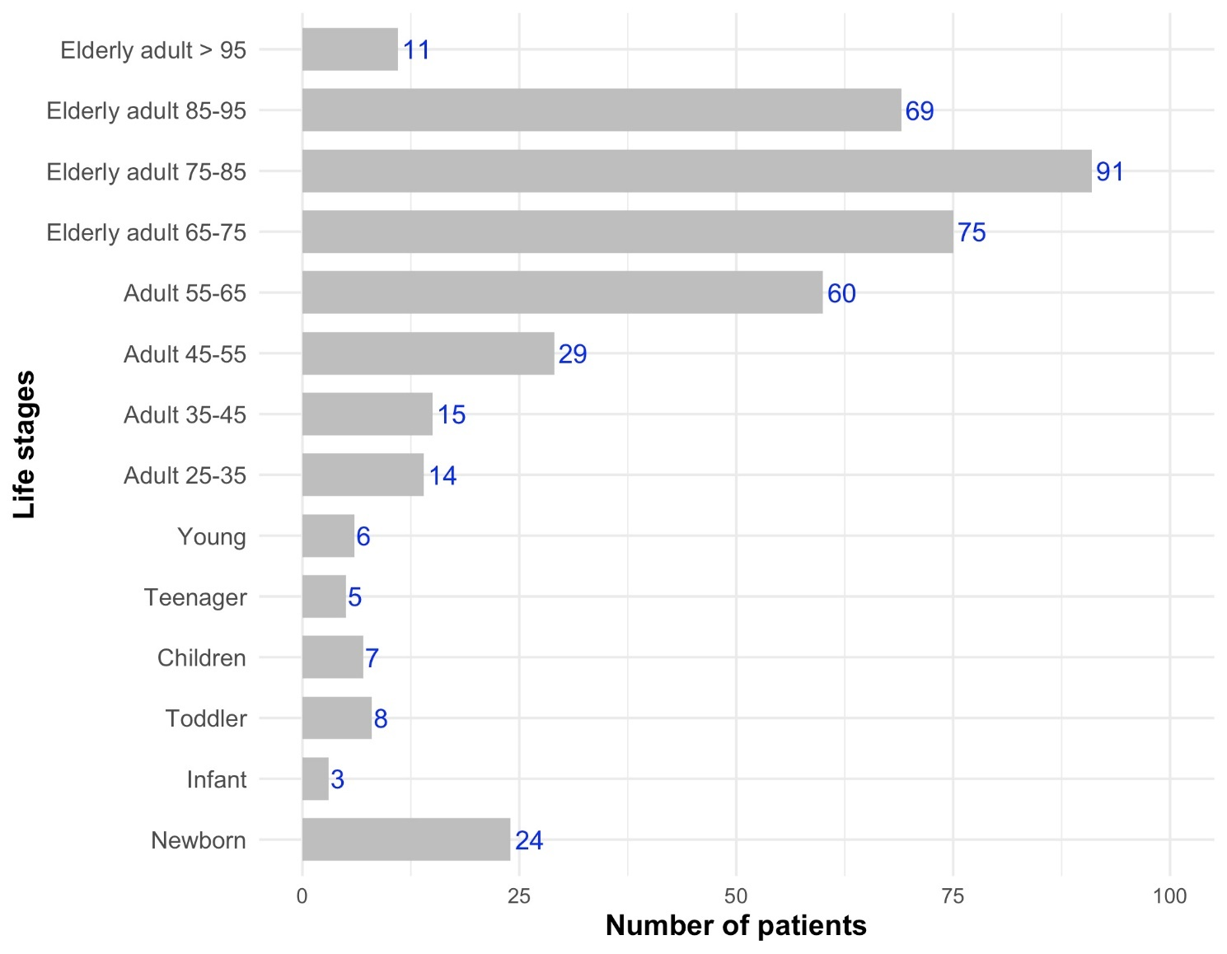
Figure S1. Life Stages. Note: Bold text on the Y-axis identifies the World Health Organization (WHO) Life Stage categories; blue numbers at the end of the bars represent the exact count of patients in each group.

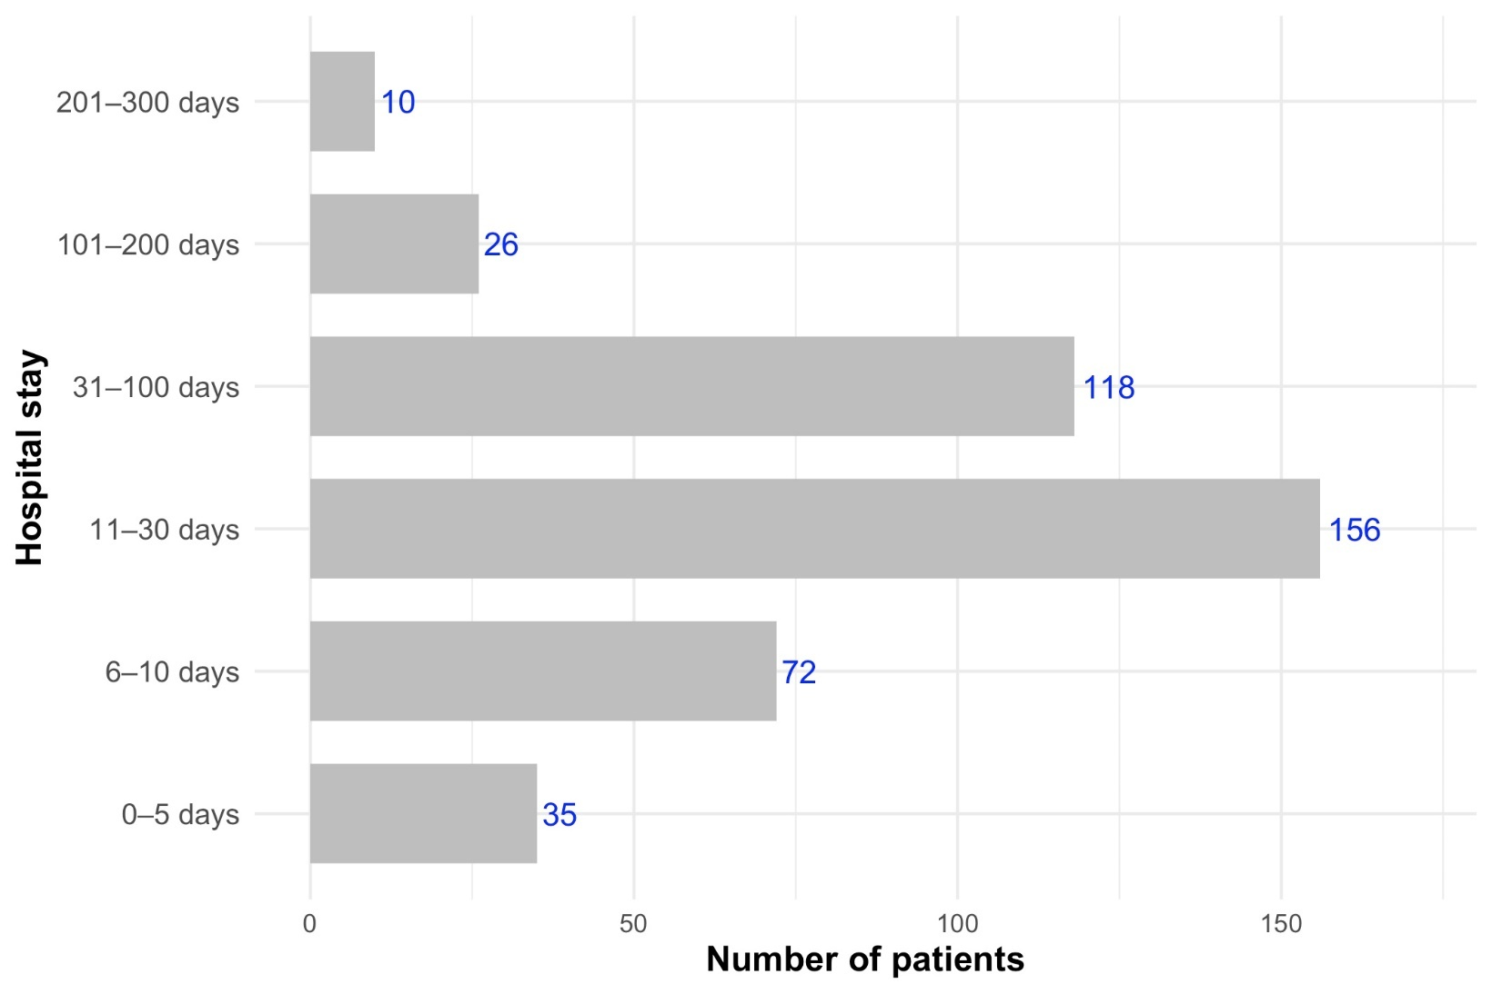
Figure S2. Hospital Stay. Note: Bold text on the Y-axis highlights the specific duration intervals of the hospitalization; blue numbers indicate the total number of patients within each stay category.
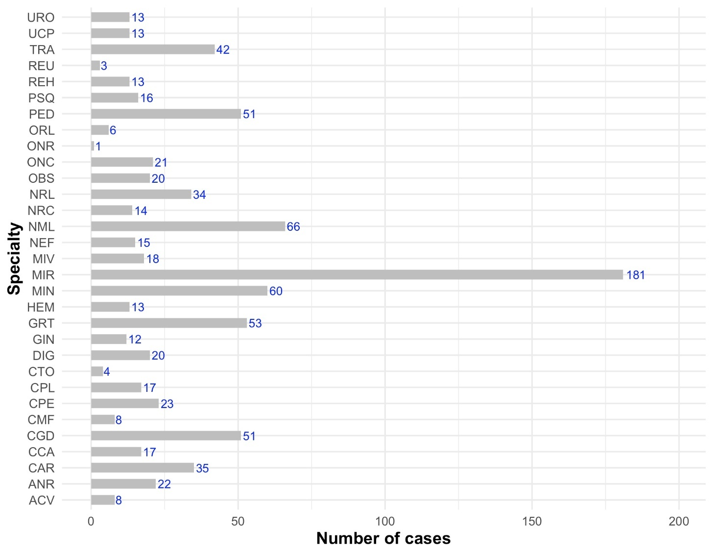
Figure S3. Hospitalization episodes by departments. See glossary. Note: Bold text is used for axis labels ("Phase", "Number of cases", and "Percentage") and the legend heading ("Classification"); blue numbers indicate the exact case counts for each category; and distinct colors in (b) represent the three types of Patient Safety Incidents (PSIs): Near Misses (pink), Incidents (light purple), and Adverse Events (dark purple) to facilitate visual comparison across healthcare phases.

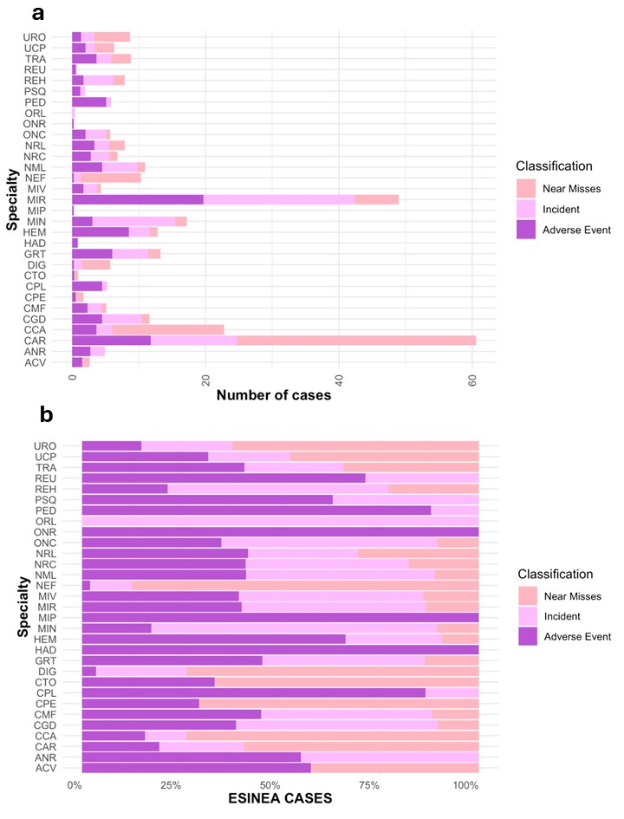
Figure S4. a. Distribution of patient safety incidents (PSIs) by hospital discharge. b. Distribution of patient safety incidents (PSIs) by hospital discharge according to phases. Note: Bold text on the axes identifies the specialties and the measurement scale. The color coding distinguishes the type of PSI: dark purple for Adverse Events, light purple for Incidents, and pink for Near Misses. In chart (a), the bars represent absolute counts; in chart (b), the bars represent the percentage distribution within each specialty

