Supplementary Figure S1
Figure S1. Time Course of Improvement in Individual Components of the Modified Griffith’s Scale over 12 Weeks of Treatment: (A) Overall Photodamage, (B) Fine lines/wrinkles, (C) Coarse lines/wrinkles, (D) Skin tone/evenness, and (E) Tactile Roughness. Data are presented as mean ± standard error. Upper graphs show the changes in parameters over time, while lower bars indicate the statistical difference of corresponding scores between baseline and relevant time points. * p<0.05, *** p<0.001 for placebo-vs-antioxidant group comparisons at each timepoint with Bonferroni correction, and # p<0.05, ### p<0.001 for within-group comparisons versus baseline values.
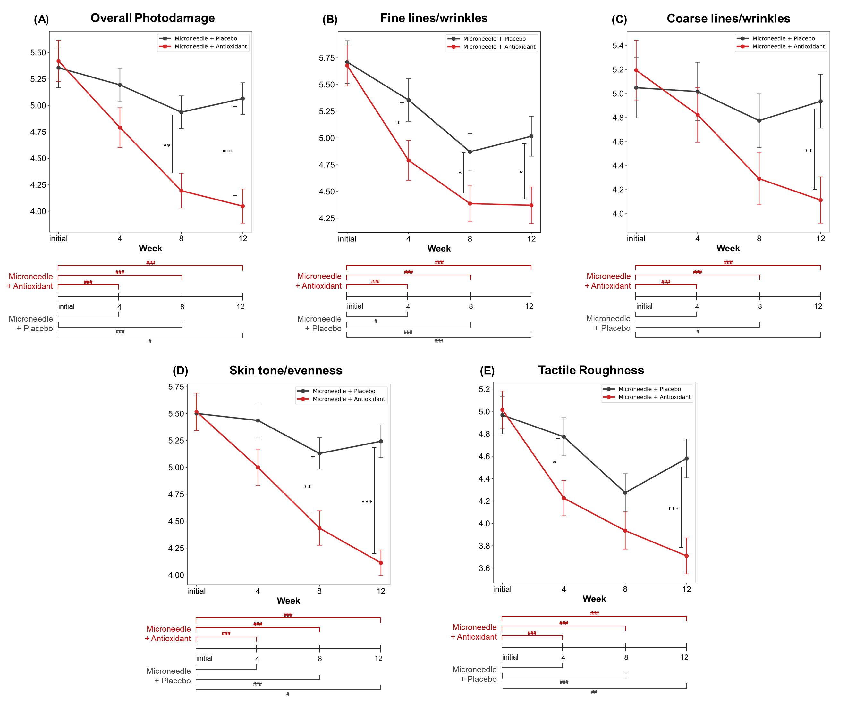
Supplementary Figure S2
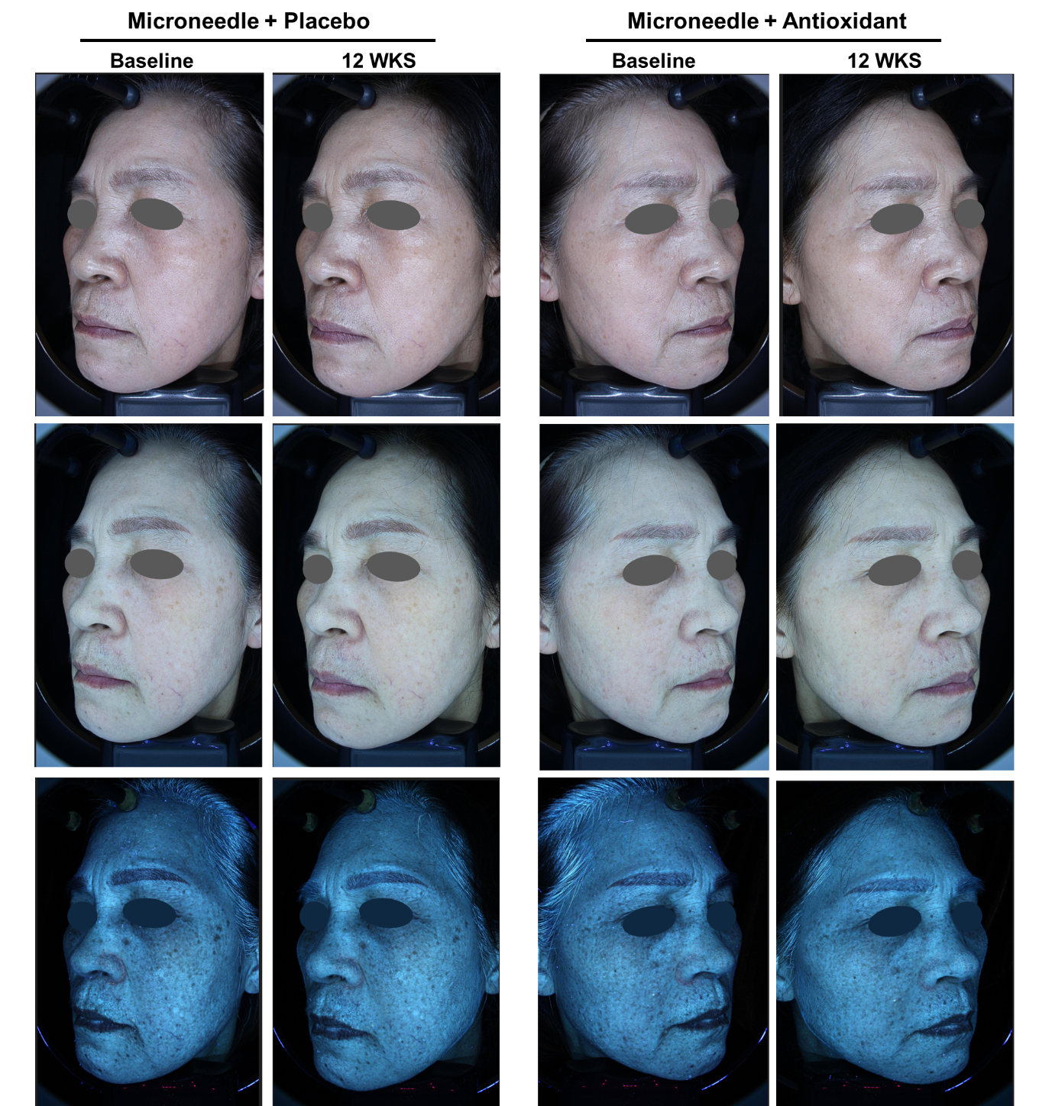
Figure S2. Clinical representative photographs of the Microneedle + Antioxidant and Microneedle + placebo sides at baseline and week 12 in one subject who showed above average clinical response (S06, F/61)

Supplementary Table S1
Table S1. Intraclass Correlation Coefficients (ICC) for Modified Griffith’s Scale and Hemi-MASI Scores

Parameters | ICC (95% CI)
Parameters | Overall | Baseline | Week 4 | Week 8 | Week 12
Modified Griffith’s scale | 0.989 (0.981–0.994) | 0.984 (0.973–0.990) | 0.981 (0.968–0.988) | 0.961 (0.900–0.981) | 0.987 (0.976–0.993)
Hemi-MASI | 0.995 (0.990–0.997) | 0.990 (0.983–0.994) | 0.997 (0.996–0.998) | 0.976 (0.961–0.986) | 0.980 (0.966–0.988)
ICC, Intraclass correlation coefficient
ICC(3,2), mean-rating (k=2), absolute-agreement, two-way mixed-effects model
95% CI, 95% confidence interval

