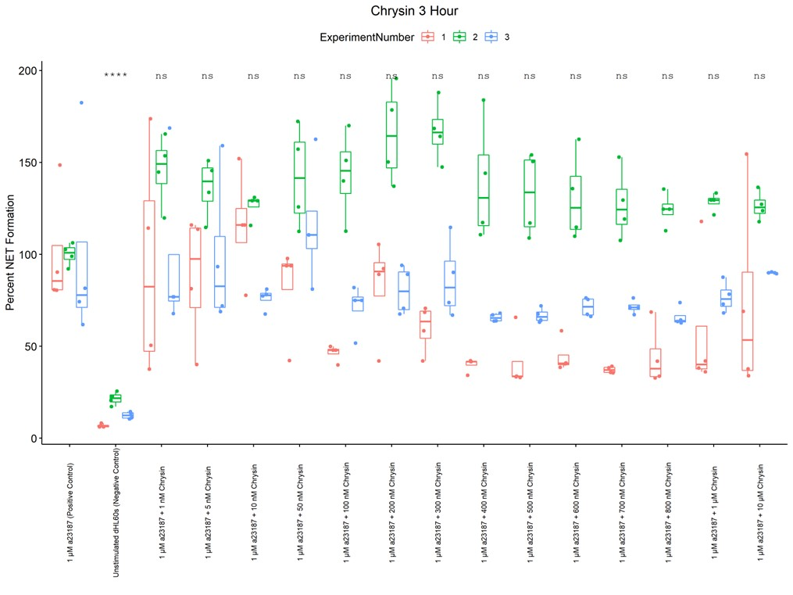
Supplementary Figure 1: Experiment-to-experiment variability potentially indicating an effect from the time of storage of chrysin in aqueous solution

