A
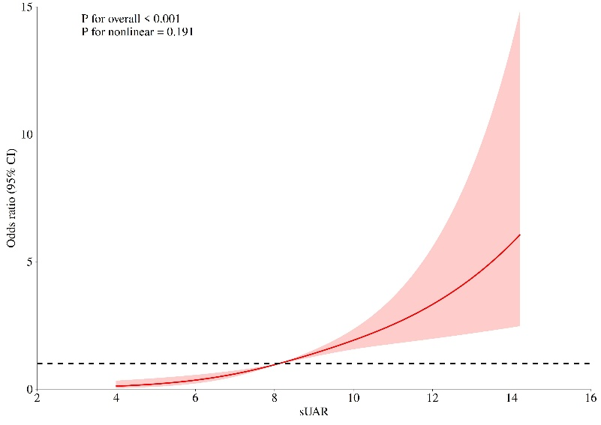
B
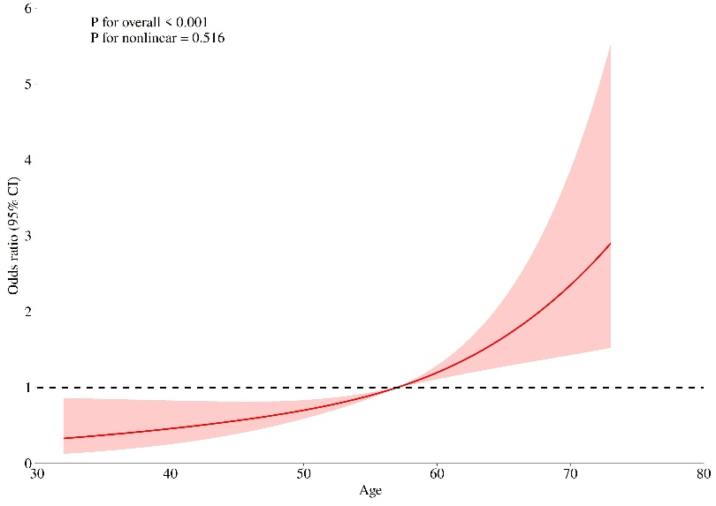
C
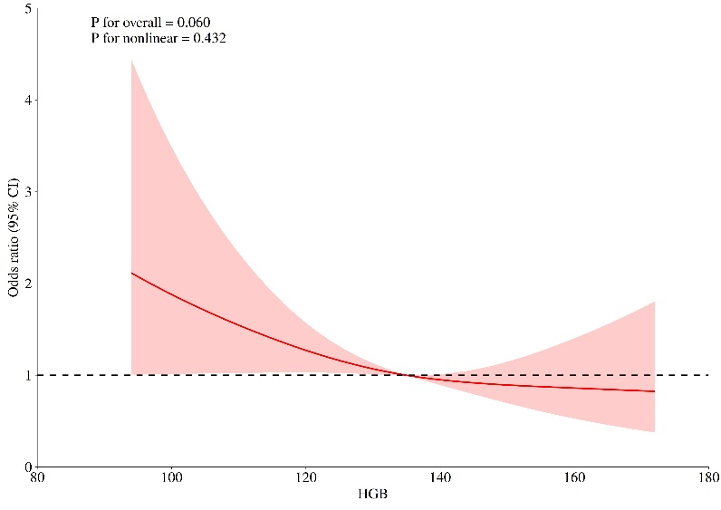
Figure S1 Restricted Cubic Spline (RCS). (A) The relationship between sUAR and AKI risk. (B) The relationship between Age and AKI risk. (C) The relationship between HGB and AKI risk.

Figure S2 The ROC curve of UA, ALB, and sUAR.
Abbreviations: sUAR, serum uric acid-to-albumin ratio.

Notes: Shaded areas represent the 95% CIs (Bootstrop, n=1000)
Figure S3 Calibration plot with loess of the nomogram prediction model for AKI.

Table S1 Collinearity Analysis
Variables | Tolerance | VIF
Age (years) | 0.410 | 2.438
AF | 0.829 | 1.207
lnNT-proBNP (pg/mL) | 0.720 | 1.390
HGB (g/L) | 0.714 | 1.401
Urea (mmol/L) | 0.745 | 1.342
SCr (μmol/L) | 0.283 | 3.535
eGFR [ml·min⁻¹· (1.73m²)⁻¹] | 0.234 | 4.280
UA (μmol/L) | 0.008 | 132.083
Blood glucose (mmol/L) | 0.925 | 1.081
ALB (g/L) | 0.077 | 13.059
sUAR (μmol/g) | 0.007 | 140.520
Notes: Collinearity analysis of the 11 indicators included after univariate logistic regression analysis.
Abbreviations: AF, Atrial fibrillation; NT-proBNP, N-terminal pro-B-type natriuretic peptide; LY, lymphocyte; HGB, hemoglobin; SCr, serum creatinine; eGFR, estimated glomerular filtration rate; UA, uric acid; ALB, albumin; sUAR, serum uric acid-to-albumin ratio; VIF, variance inflation factor.

Table S2 Comparison of UA, ALB, and sUAR
Variables | AUC | 95%CI | P value | Sn | Sp
UA (μmol/L) | 0.687 | 0.636-0.737 | <0.001 | 83.67% | 45.73%
ALB (g/L) | 0.588 | 0.532-0.644 | 0.001 | 45.58% | 69.28%
sUAR (μmol/g) | 0.709 | 0.660-0.759 | <0.001 | 84.35% | 45.73%
Notes: Delong test: sUAR vs. UA (P=0.011); sUAR vs. ALB (P<0.001).
Abbreviations: AUC, area under the ROC curve; UA, uric acid; ALB, albumin; sUAR, serum uric acid-to-albumin ratio; ROC, receiver operating characteristic; Sn, sensitivity; Sp, specificity.

