Supplementary Materials:
Supplemental 1. Literature Search
A thorough literature search was conducted to gather data on PopPK models of VNX. Databases such as PubMed, Web of Science, and Embase were scrutinized, encompassing publications up until October 2024. The search strategy used the following terms: (“venetoclax” OR “Venclexta” OR “RG-7601”OR “RG7601”OR “GDC-0199” OR “4-(4-((2-(4-chlorophenyl)-4,4-dimethylcyclohex-1-en-1-yl)methyl)piperazin-1-yl)-N-((3-nitro-4-((tetrahydro-2H-pyran-4-ylmethyl)amino)phenyl)sulfonyl)-2-(1H-pyrrolo(2,3-b)pyridin-5-yloxy)benzamide”) AND (“population pharmacokinetic” OR “pharmacokinetic modeling” OR “NONMEM” OR “nonlinear mixed effects model” OR “WINNONMIX” ) The reference lists of the identified publications were also screened to identify other potential publications for inclusion.
Inclusion criteria consisted of the following: 1) Study drug: venetoclax, 2) Publication in English, and 3) PopPK studies conducted using nonlinear mixed-effects modeling methods.
Exclusion criteria include: 1) Duplicate articles; 2) Insufficient details for external evaluation; 3) Publications categorized as reviews or methodological articles; and 4) non-parametric model. The following information was extracted from the original studies: structure of the compartmental model, PopPK parameters, covariate model, inter- and intra-individual variability, residual variability, and estimation method.

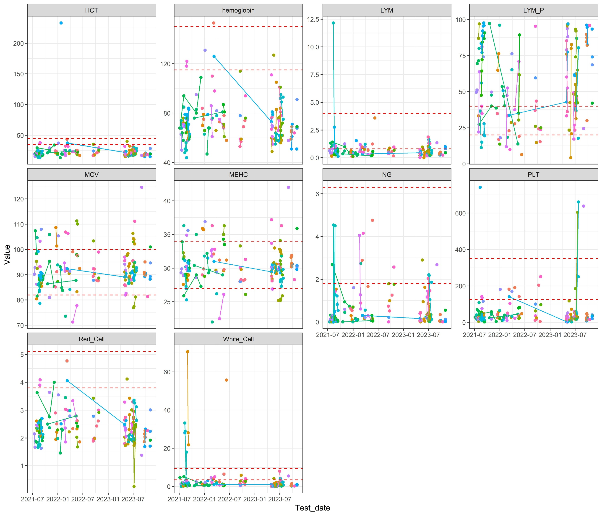
A
Figure S1. The blood routine examination index of the patients included in this study.
Notes: HCT: Hematocrit; hemoglobin: hemoglobin; LYM: Lymphocyte count; LYM_P: Lymphocyte count percentage; MCV: Mean corpuscular volume; MEHC: Mean corpuscular hemoglobin concentration; NG: Neutrophil number; PLT: Platelet count; Red_Cell: Red blood cell count; White_Cell: White blood cell count. The red dashed line represents the normal reference range in healthy population.

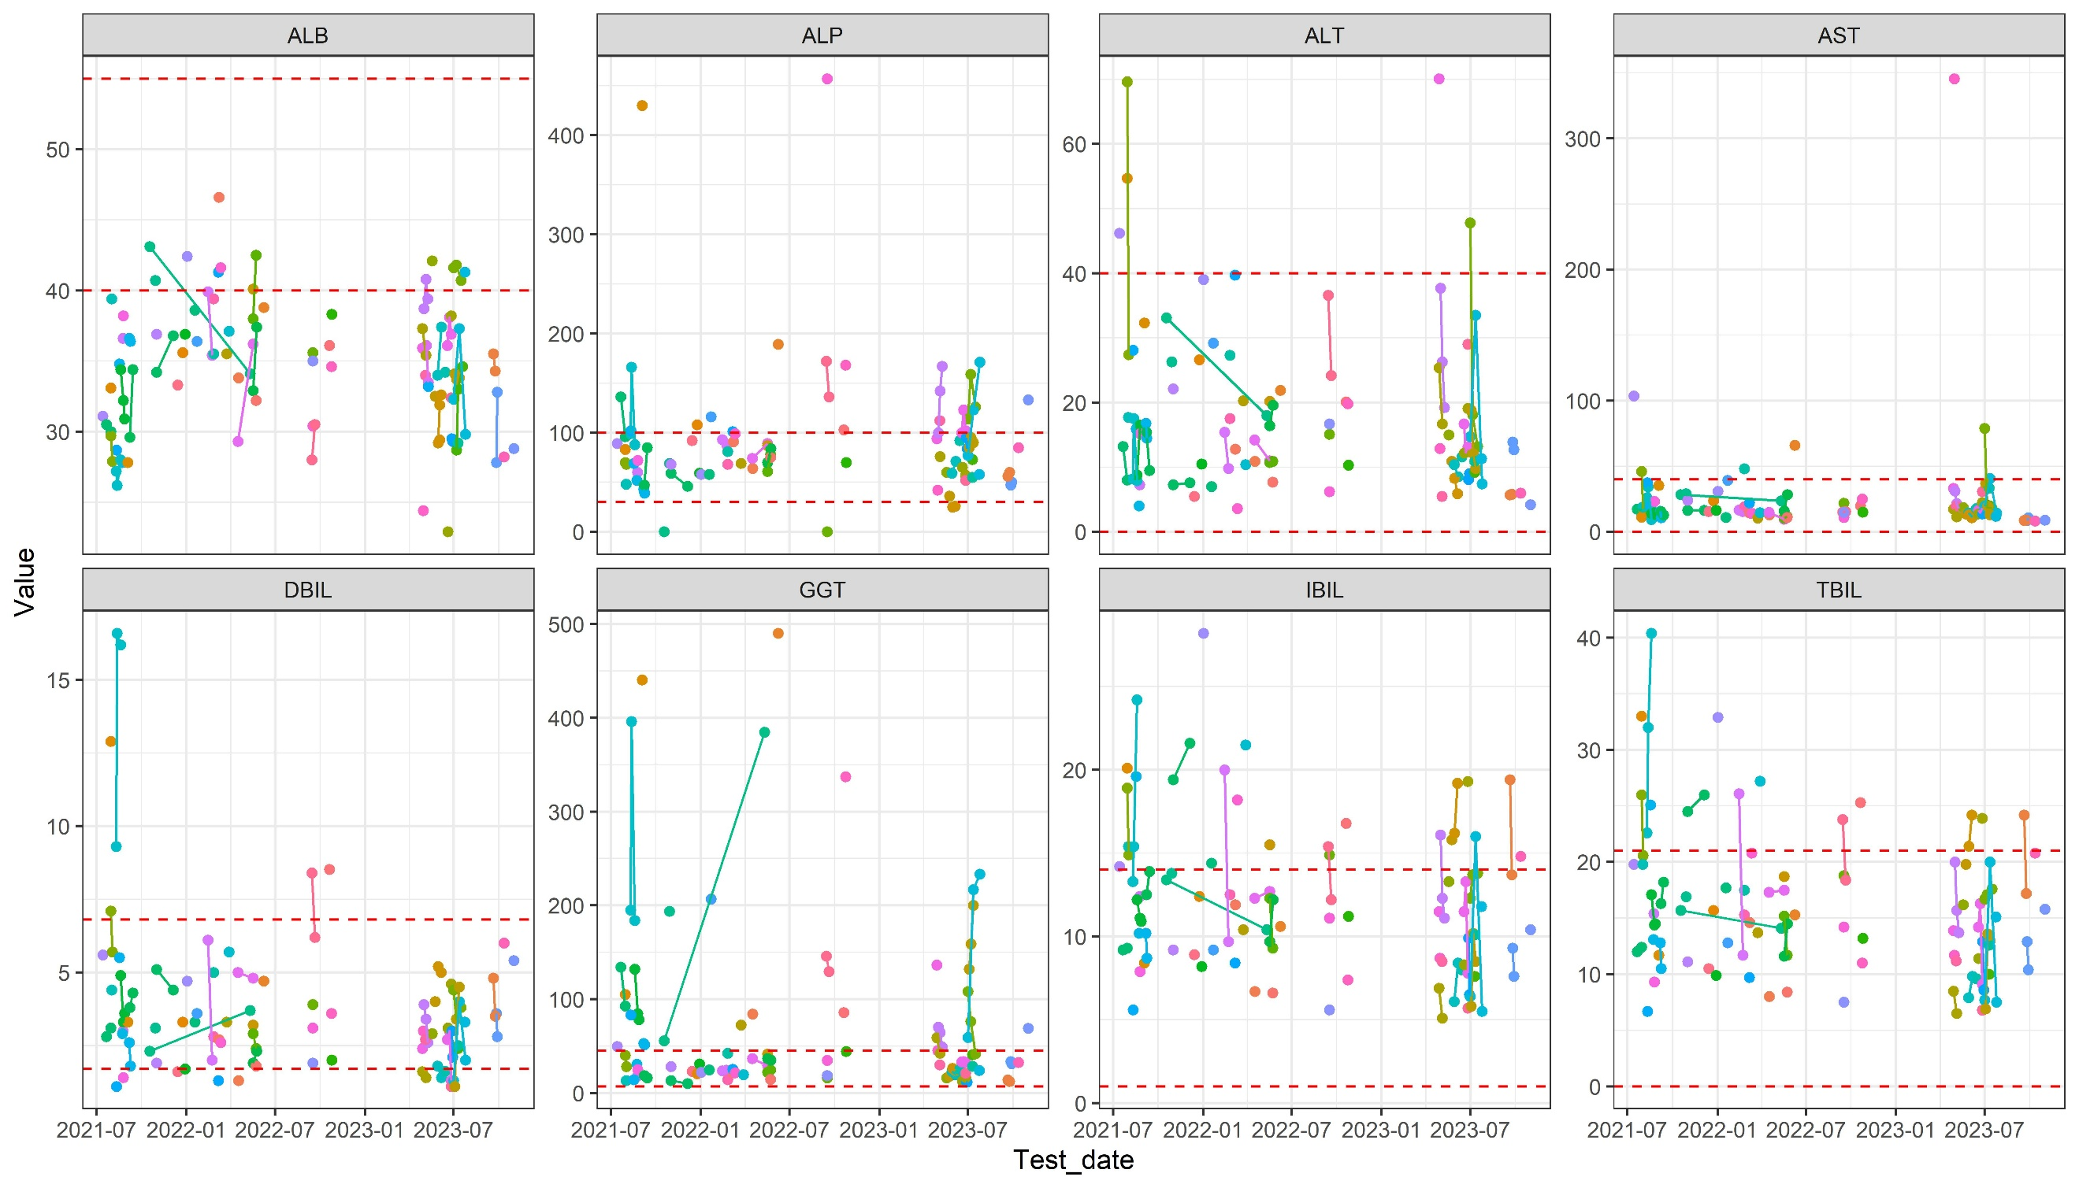Figure S2. The liver function test index of the patients included in this study.
Notes: ALB: Albumin; ALP: Alkaline phosphatase; ALT: Alanine aminotransferase; AST: Aspartate aminotransferase; hemoglobin; DBIL: Direct bilirubin; GGT: Gamma-glutamyl transferase; IBIL: Indirect bilirubin; TBIL: Total bilirubin. The red dashed line represents the normal reference range in healthy population.

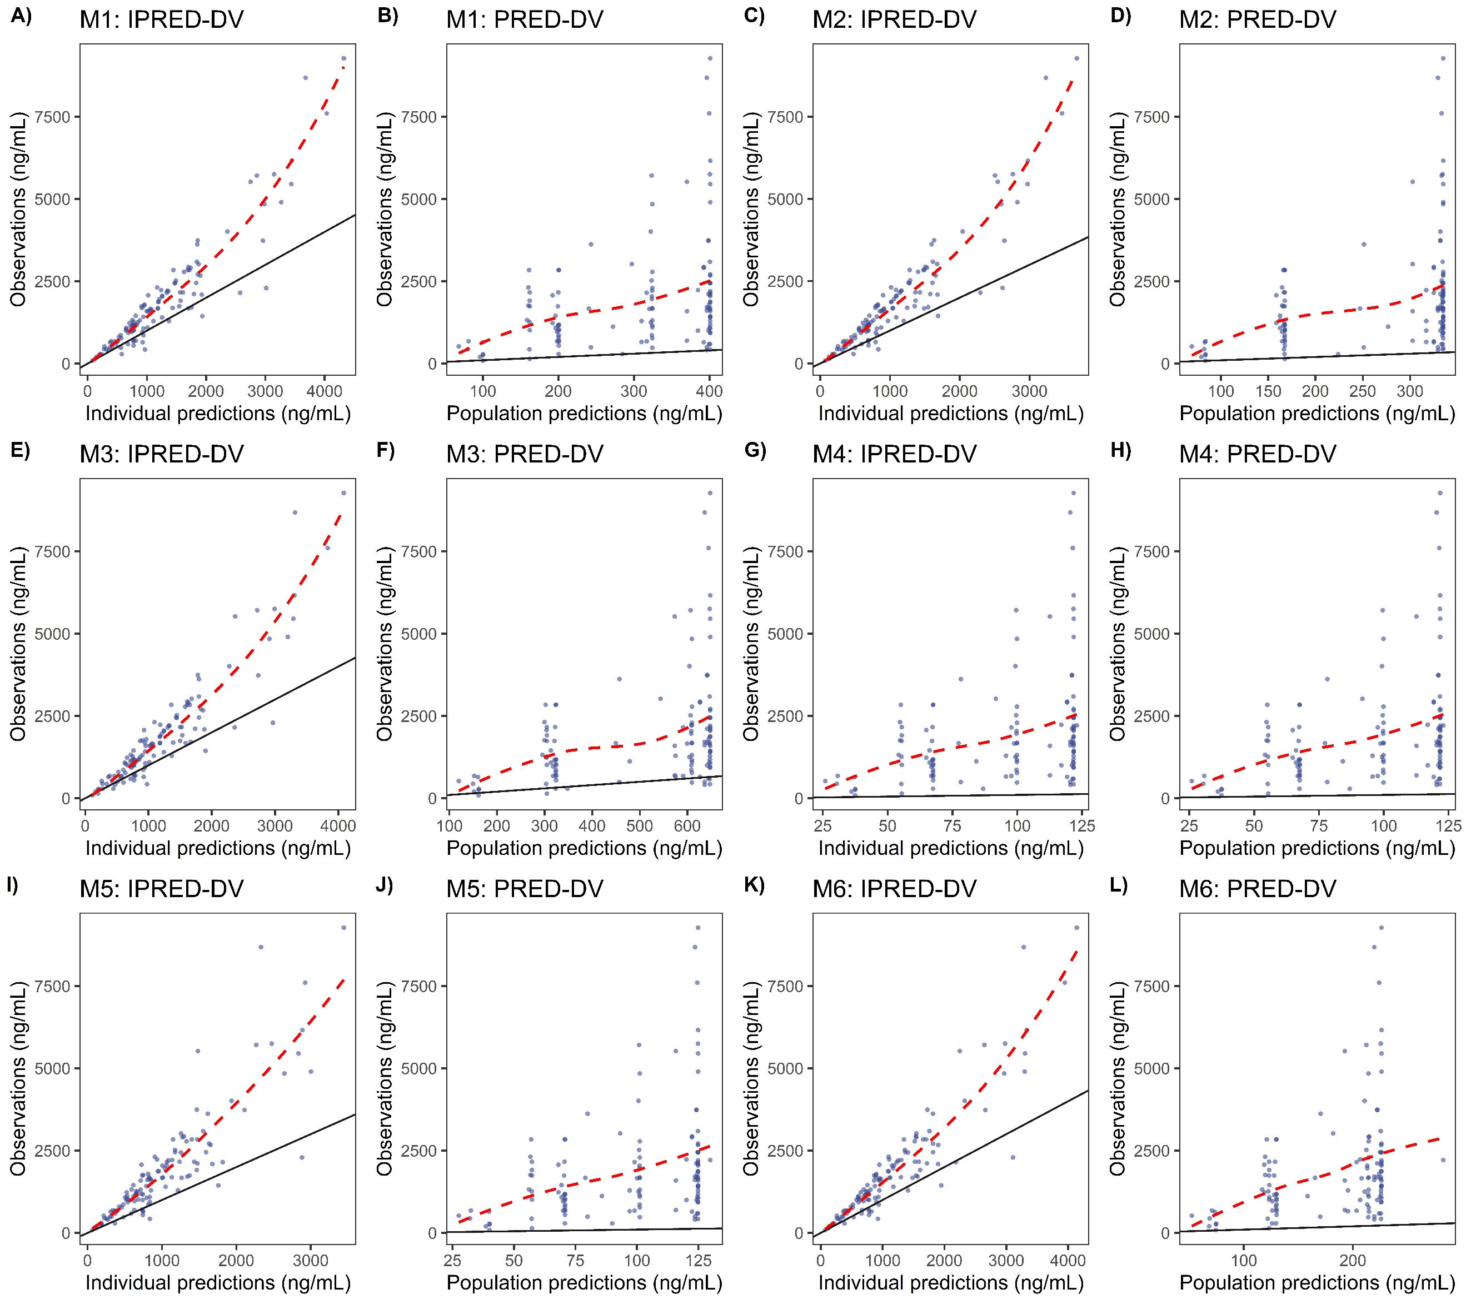
Figure S3. Observed concentrations versus population and individual predictions for the evaluated population pharmacokinetic models of venetoclax.
Notes: Panels A, C, E, G, I, and K show observed concentrations versus individual predictions for models M1-M6, respectively. Panels B, D, F, H, J, and L show observed concentrations versus population predictions for models M1-M6, respectively. The red dashed line indicates the loess regression trendline and the black solid line means the reference line. The blue points represent observed data.
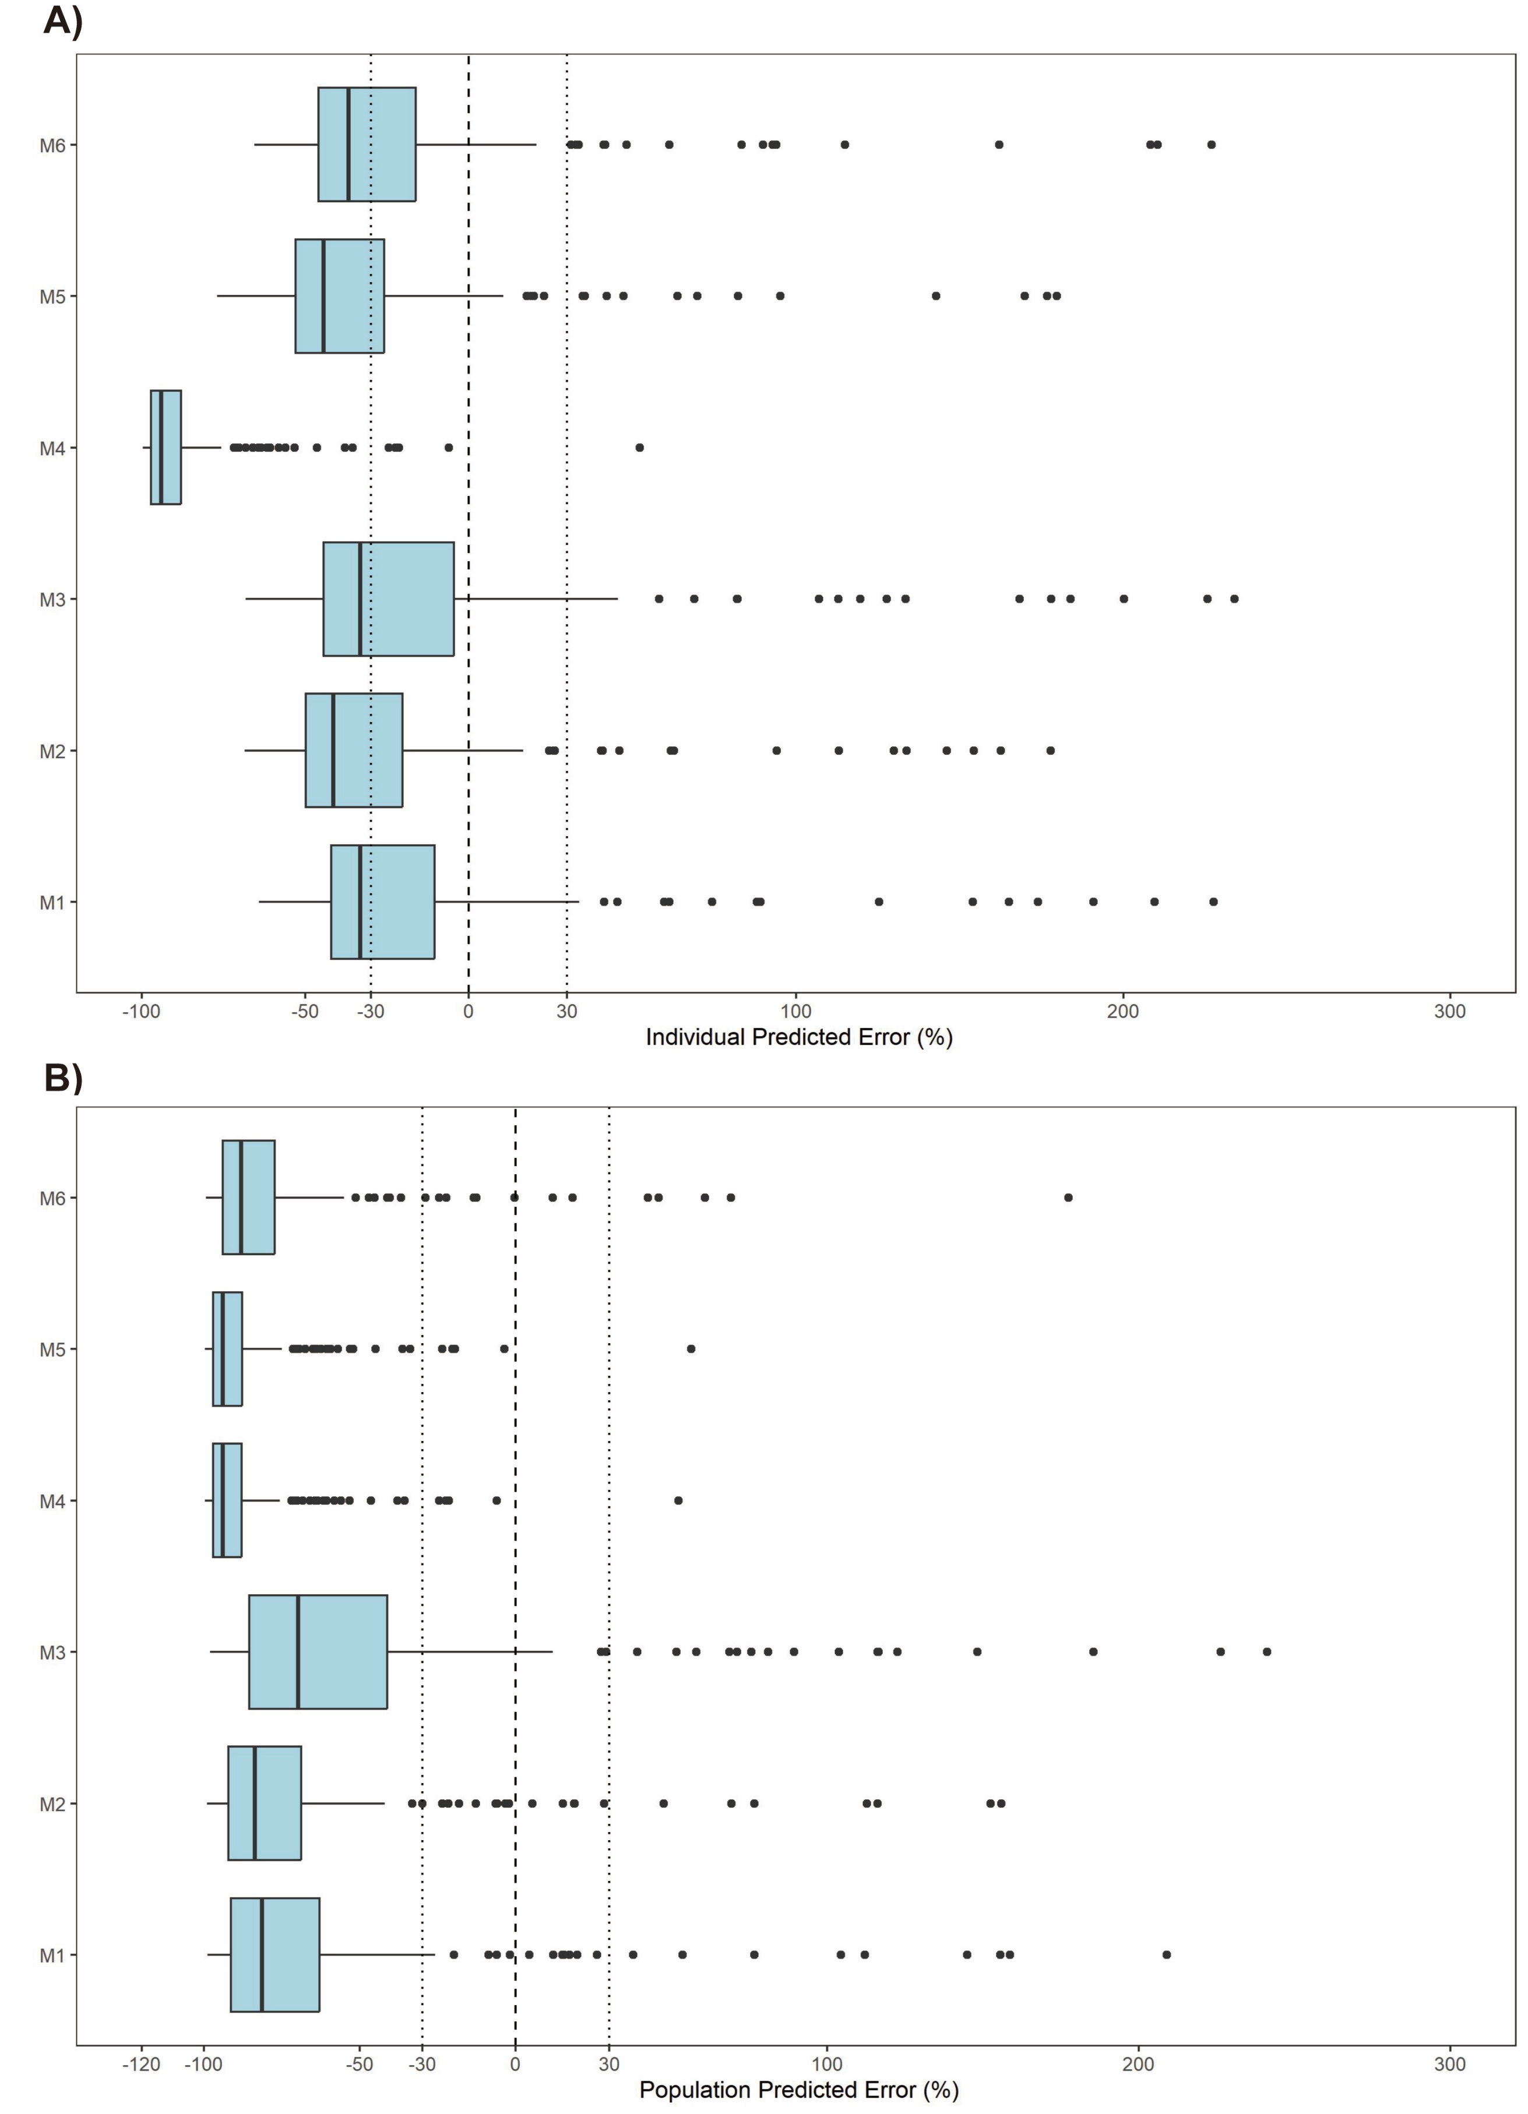
Figure S4. Prediction error (PE) distributions of the individual (A) and population (B) predictions for evaluated population pharmacokinetic models of venetoclax.
Notes: The dotted lines indicate the ±30% boundaries, and the dashed line indicates the 0% reference line. In each boxplot, the box represents the interquartile range (Q1-Q3), the horizontal black line within the box indicates the median (Q2), and the dots represent outliers
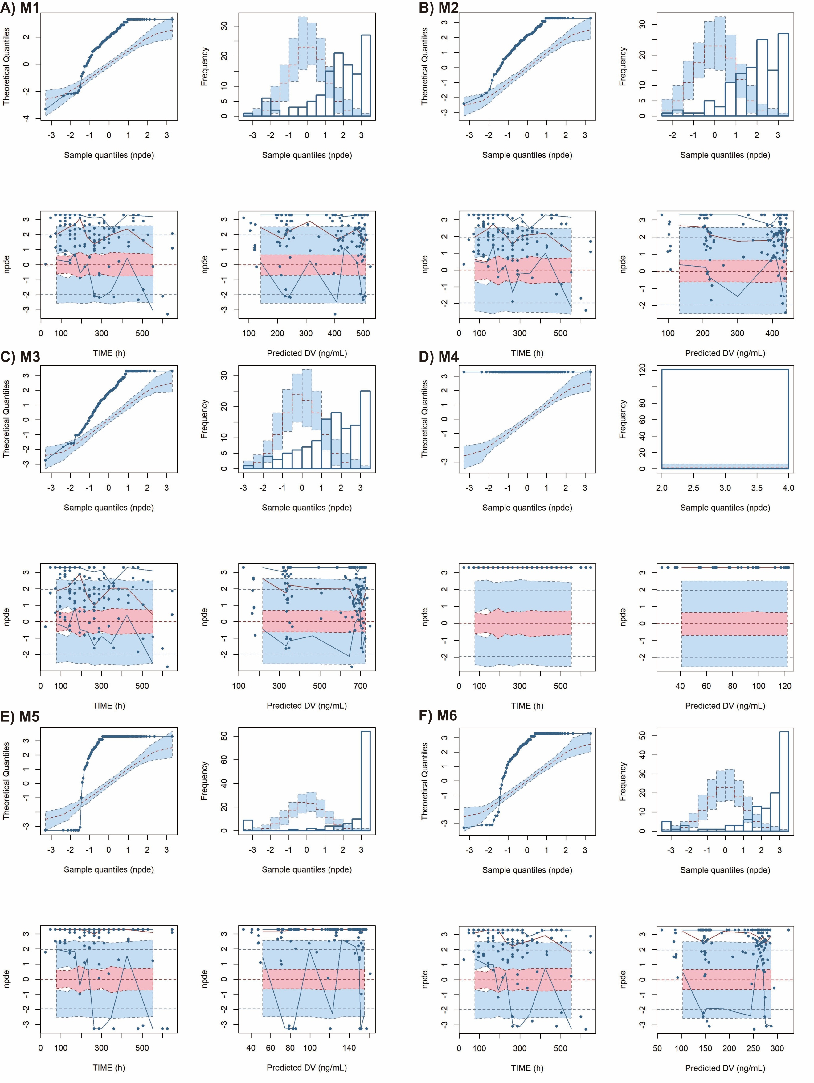
Figure S5. Normalized prediction distribution error (NPDE) plots of evaluated population pharmacokinetic models of venetoclax.
Notes: A-F represents the results from M1 to M6. Quantile-quantile plot of the distribution of the NPDE against theoretical distribution (semitransparent blue fields); Histogram of the distribution of the NPDE against theoretical distribution (semitransparent blue fields); NPDE vs. time after dose (h); NPDE vs. predicted concentrations. The solid black lines represent the actual value of the NPDE at the 5th and 95th percentiles, the red solid line represents the 50th percentiles. The semitransparent red field represents a simulation-based 95% confidence interval for the median at 50th percentile, and semitransparent blue fields represent a simulation-based 95% confidence interval for the corresponding model-predicted 5th and 95th percentiles. The NPDE of the observations are represented by dark blue dots.

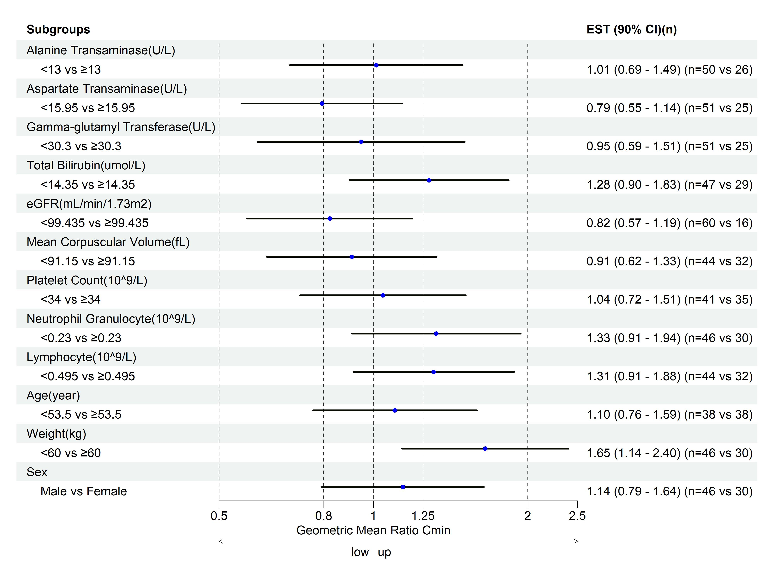Figure S6. The covariates effects on the venetoclax C_{min}.
Notes: ALT: Alanine aminotransferase; AST: Aspartate aminotransferase; eGFR: Estimated glomerular filtration rate; GGT: Gamma-glutamyl transferase; LYM: Lymphocyte count; MCV: Mean corpuscular volume; PLT: Platelet count; TBIL: Total bilirubin.

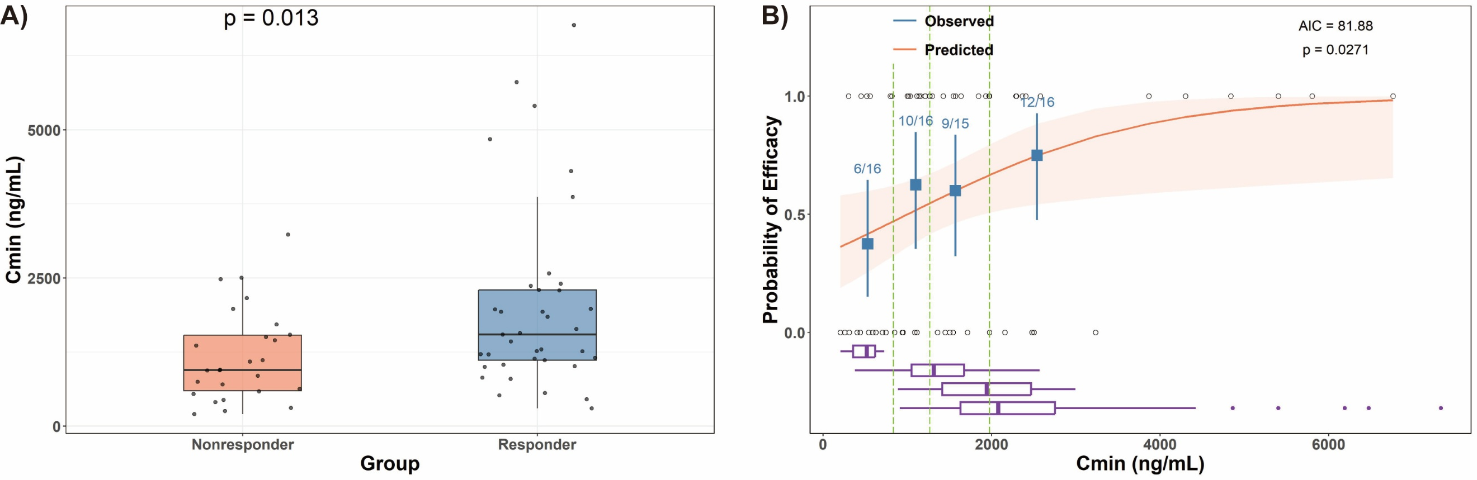
Figure S7. Exposure–response relationship of the overall response in the patients who received the venetoclax versus the predicted C_{min} in the AML only dataset (n=63)
Notes: Left: black dots are the individual exposure metrics predicted based on actual dosing and individual PopPK model parameter estimates. Cmin, the minimum concentration during the steady state. Right: error bars are the 95% CI of ORR in the respective exposure quartile groups. Shaded areas of the logistic regression plots represent the 95% CI of the predicted ORR. Short vertical lines at the lower and upper part of the plotting area represent the exposure metrics in nonresponders and responders, respectively. The boxplots represent the concentration range in each dosage group

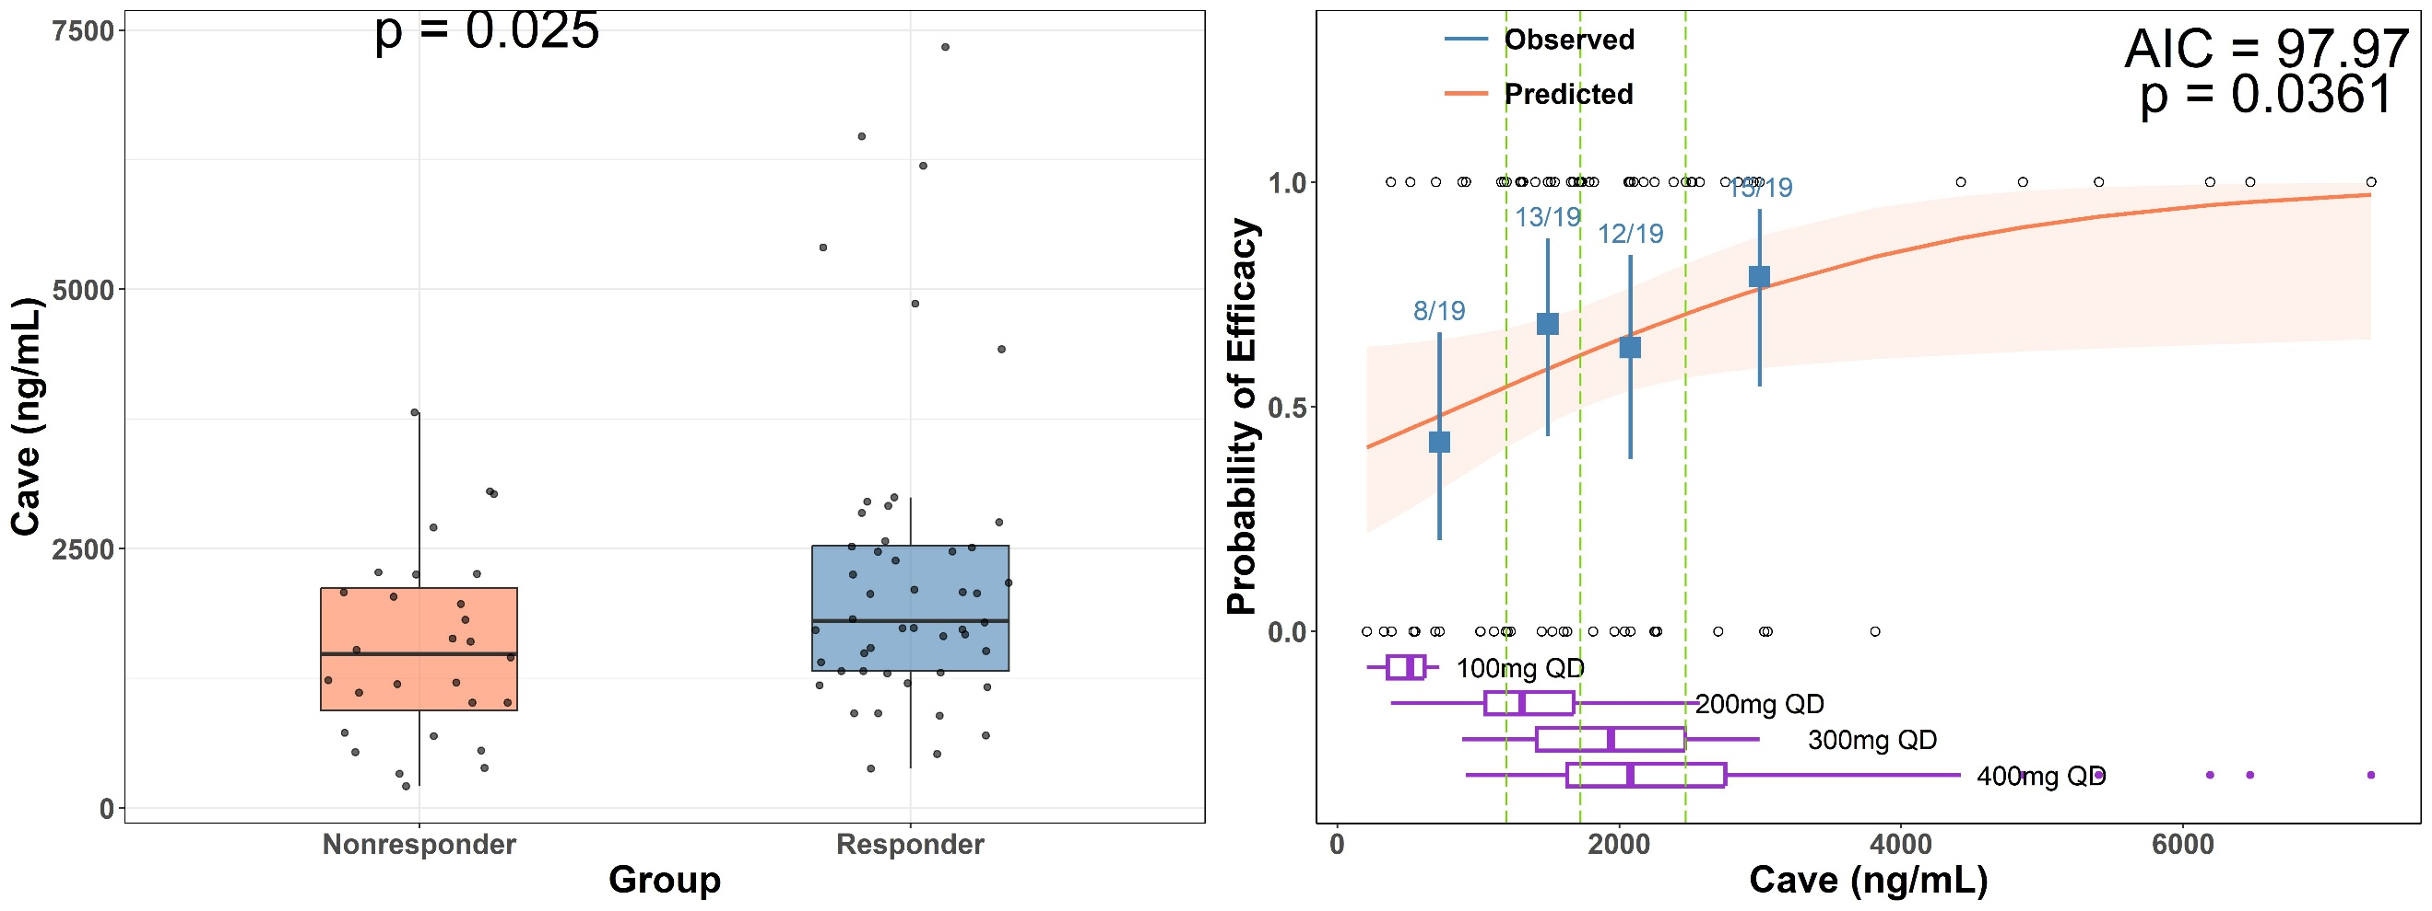
Figure S8. Exposure–response relationship of the overall response in the patients who received the venetoclax versus the predicted C_{ave} in the full dataset (n=76)
Notes: Left: black dots are the individual exposure metrics predicted based on actual dosing and individual PopPK model parameter estimates. Cave, the average concentration during the steady state. Right: error bars are the 95% CI of ORR in the respective exposure quartile groups. Shaded areas of the logistic regression plots represent the 95% CI of the predicted ORR. Short vertical lines at the lower and upper part of the plotting area represent the exposure metrics in nonresponders and responders, respectively. The boxplots represent the concentration range in each dosage group.

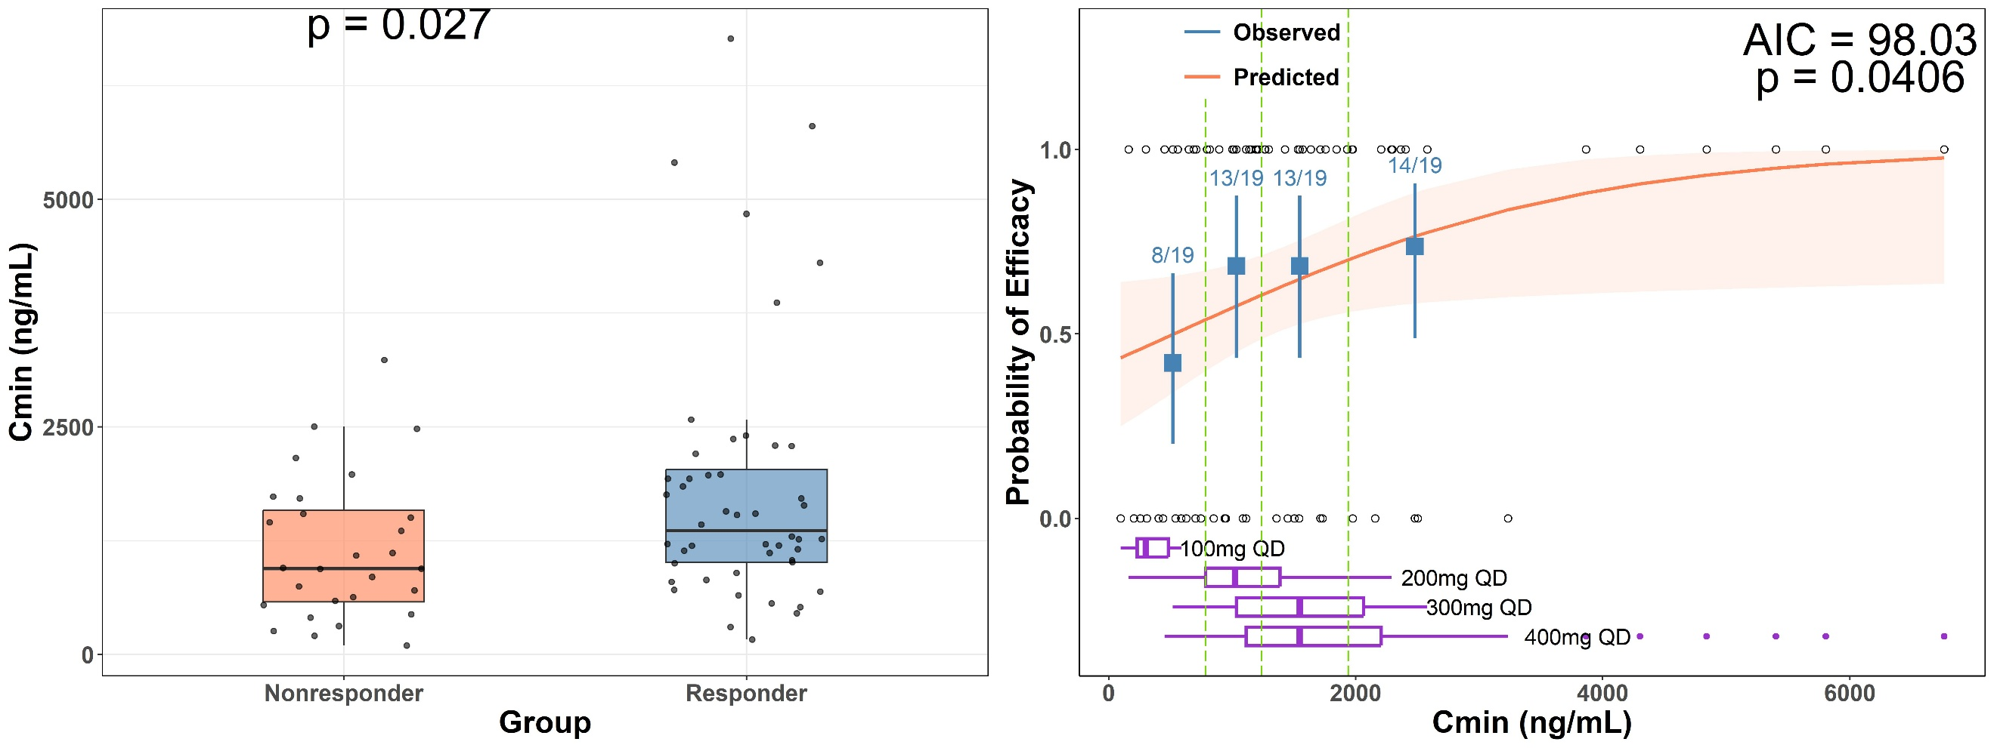
Figure S9. Exposure–response relationship of the overall response in the patients who received the venetoclax versus the predicted C_{min} in the full dataset (n=76)
Notes: Left: black dots are the individual exposure metrics predicted based on actual dosing and individual PopPK model parameter estimates. Cmin, the minimum concentration during the steady state. Right: error bars are the 95% CI of ORR in the respective exposure quartile groups. Shaded areas of the logistic regression plots represent the 95% CI of the predicted ORR. Short vertical lines at the lower and upper part of the plotting area represent the exposure metrics in nonresponders and responders, respectively. The boxplots represent the concentration range in each dosage group.
Table S1. Venetoclax Dose and Concomitant Chemotherapy Regimens in patients diagnosis with acute myeloid leukemia.
Venetoclax Dose (mg) | Concomitant Chemotherapy Regimen | Number of Patients
400 | Azacitidine | 29
400 | Aclarubicin + Cytarabine | 2
400 | Idarubicin + Cytarabine | 3
400 | Homoharringtonine + Azacitidine | 3
400 | Homoharringtonine + Cytarabine | 3
400 | Methotrexate + Vindesine + Thiotepa | 1
300 | Azacitidine | 2
200 | Azacitidine | 6
200 | Homoharringtonine + Cytarabine + Decitabine | 1
200 | Azacitidine + Homoharringtonine | 5
200 | Vincristine + Daunorubicin | 1
100 | Cytarabine | 1
100 | Azacitidine | 4
100 | Azacitidine + Homoharringtonine | 1
100 | Azacitidine + Gilteritinib Fumarate | 1

Table S2. Summary of the included population pharmacokinetics model of venetoclax for external evaluation.
Study  (publication year) | Software/  Algorithm | Fixed effect parameters and covariate models | Between-subject variability | Residual unexplained variability
M1(Jones 2016) ³⁶ | NONMEM /FOCE-I | CL=17.2 L/h  CL=17.2*0.807 (CYP3A moderate Inhibitor)  CL=17.2*0.158 (CYP3A strong Inhibitor)  CL=17.2*1.21 (Rituximab ) | 0.148 | Prop=0.224
M1(Jones 2016) ³⁶ | NONMEM /FOCE-I | Q=3.94 L/h | / | Add=3.05*10⁻⁰⁷
M1(Jones 2016) ³⁶ | NONMEM /FOCE-I | V2=113 L  V2=113*0.683 L (If female)  V2=113*1.79 (If diagnosis as CLL/SLL/NHL) | 0.208
M1(Jones 2016) ³⁶ | NONMEM /FOCE-I | V3=116 L | /
M1(Jones 2016) ³⁶ | NONMEM /FOCE-I | KA=0.16 /h | /
M1(Jones 2016) ³⁶ | NONMEM /FOCE-I | F1=1 FIX  F1=0.334 (Fasting state)  F1=1.24 (Fed state)  F1=1.26 (Moderate fat)  F1=1.42 (High fat) | 0.097
M2(Minocha 2018)³⁷ | NONMEM/FOCE-I | CL=16.3 L/h | 0.1444 | Prop=0.4
M2(Minocha 2018)³⁷ | NONMEM/FOCE-I | V2=37 L (only female) | 0.4624
M2(Minocha 2018)³⁷ | NONMEM/FOCE-I | Q=3.7 L/h | /
M2(Minocha 2018)³⁷ | NONMEM/FOCE-I | V3=122 L | /
M2(Minocha 2018)³⁷ | NONMEM/FOCE-I | KA=0.13/h | 0.0361
M2(Minocha 2018)³⁷ | NONMEM/FOCE-I | Tlag=1.6h | /
Table S2. Summary of the included population pharmacokinetics model of venetoclax for external evaluation. (Continued)
M3(Deng 2019)⁴⁰ | NONMEM /FOCE-I | CL=19.54 L/h  CL=19.54*0.859 (CYP3A moderate Inhibitor)  CL=19.54*0.182 (CYP3A strong Inhibitor)  CL=19.54*1.07 (Rituximab )  CL=19.54*0.853 (OATP1B3 inhibitor)  CL=19.54*0.696 (Central and Eastern Europe/Asia population) | 0.139 | Prop=0.219
M3(Deng 2019)⁴⁰ | NONMEM /FOCE-I | V2=118 L  V2=118*0.7 L (If female)  V2=118*1.7 (If diagnosis as CLL/SLL/NHL) | 0.179 | Add=3.03*10⁻⁰⁷
M3(Deng 2019)⁴⁰ | NONMEM /FOCE-I | Q=4.17 L/h | /
M3(Deng 2019)⁴⁰ | NONMEM /FOCE-I | V3=123 L | /
M3(Deng 2019)⁴⁰ | NONMEM /FOCE-I | KA=0.15 /h  KA=0.15*0.335 (Fasting state)  KA=0.15*1.27 (Fed state)  KA=0.15*1.36 (Moderate fat)  KA=0.15*1.43 (High fat) | /
M3(Deng 2019)⁴⁰ | NONMEM /FOCE-I | F1=1 FIX  F1=0.67 (Fasting state) | 0.101
Table S2. Summary of the included population pharmacokinetics model of venetoclax for external evaluation. (Continued)
M4(Samineni 2022)³⁸ | NONMEM /FOCE-I | CL=18.58 L/h  CL=18.58*0.86 (CYP3A moderate Inhibitor)  CL=18.58*0.18 (CYP3A strong Inhibitor)  CL=18.58*0.86 (OATP1B3 inhibitor)  CL=18.58*1.21 (Rituximab ) | /
M4(Samineni 2022)³⁸ | NONMEM /FOCE-I | V2=116 L  V2=116*0.7 L (If female)  V2=116*1.73 (If diagnosis as CLL/SLL/NHL) | /
M4(Samineni 2022)³⁸ | NONMEM /FOCE-I | Q=4.12 L/h | /
M4(Samineni 2022)³⁸ | NONMEM /FOCE-I | V3=121 L | /
M4(Samineni 2022)³⁸ | NONMEM /FOCE-I | KA=0.16 /h | /
M4(Samineni 2022)³⁸ | NONMEM /FOCE-I | F1=1 FIX  F1=0.34 (Fasting state)  F1=1.3 (Fed state)  F1=1.4 (Moderate fat)  F1=1.4 (High fat)  F1=(DOSE/400)^(-0.15) | /
Table S2. Summary of the included population pharmacokinetics model of venetoclax for external evaluation. (Continued)
M5(Samineni 2022) ³⁹ | NONMEM /FOCE-I | CL=18.63 L/h  CL=18.63*0.84 (CYP3A moderate Inhibitor)  CL=18.63*0.18 (CYP3A strong Inhibitor)  CL=18.63*0.85 (OATP1B3 inhibitor)  CL=18.63*1.63 (If the data was from GO27878 study) | 0.15 | Prop=0.22
M5(Samineni 2022) ³⁹ | NONMEM /FOCE-I | V2=118 L  V2=118*0.7 L (If female)  V2=118*1.73 (If diagnosis as CLL/SLL/NHL)  V2=118*2.33 (If the data was from GO27878 study) | 0.21 | Add=3.07*10⁻⁰⁷
M5(Samineni 2022) ³⁹ | NONMEM /FOCE-I | Q=4.05 L/h | /
M5(Samineni 2022) ³⁹ | NONMEM /FOCE-I | V3=119 L | /
M5(Samineni 2022) ³⁹ | NONMEM /FOCE-I | KA=0.155 /h | /
M5(Samineni 2022) ³⁹ | NONMEM /FOCE-I | F1=1 FIX  F1=0.34 (Fasting state)  F1=1.23 (Fed state)  F1=1.31 (Moderate fat)  F1=1.43 (High fat)  F1=(DOSE/400)^(-0.18) | 0.1
Table S2. Summary of the included population pharmacokinetics model of venetoclax for external evaluation. (Continued)
M6(Gong 2023) ³⁵ | NONMEM /FOCE-I | CL=15 L/h  CL=15*0.783 (CYP3A moderate Inhibitor)  CL=15*0.149 (CYP3A strong Inhibitor)  CL=15*0.834 (OATP1B3 inhibitor)  CL=15*1.35 (If the data was from healthy/non-hemopathy population) | 0.189 | Prop=0.189
M6(Gong 2023) ³⁵ | NONMEM /FOCE-I | V2=107 L  V2=107*0.721 L (If female)  V2=107*0.536 L (If healthy/non-hemopathy population) | 0.283
M6(Gong 2023) ³⁵ | NONMEM /FOCE-I | Q=6.58 L/h | /
M6(Gong 2023) ³⁵ | NONMEM /FOCE-I | V3=217 L | /
M6(Gong 2023) ³⁵ | NONMEM /FOCE-I | KA=0.17 /h | /
M6(Gong 2023) ³⁵ | NONMEM /FOCE-I | KTR=1.35 /h | 0.497
M6(Gong 2023) ³⁵ | NONMEM /FOCE-I | F1=1 FIX  F1=0.34 (Fasting state)  F1=1.42 (Moderate fat)  F1=(DOSE/400)^(-0.201) | 0.17
Notes: CL/F: The apparent plasma clearance; F1: the relative bioavailability; V2: The apparent volume distribution in central compartment; V3: The apparent volume distribution in peripheric compartment; KA: The absorption rate constant; KTR: the transfer rate constant; Q: the inter-compartment clearance; /, represents data not reported; Prop, proportional error; Add, additive error.

