Table S1 ICC for the parameters measured by two radiologists
Variables |  | ICC (95% CI) | F | P
Intratumor parameters | WIS-L | 0.883 (0.823-0.923) | 45.327 | <0.001**
Intratumor parameters | WOS-L | 0.854 (0.792-0.901) | 38.612 | <0.001**
Peritumor parameters | WIS-P | 0.921 (0.884-0.949) | 62.105 | <0.001**
Peritumor parameters | WOS-P | 0.812 (0.762-0.858) | 28.934 | <0.001**
Kinetic parameters | Peak PE | 0.894 (0.843-0.932) | 50.746 | <0.001**
Kinetic parameters | Peak SER | 0.941 (0.903-0.965) | 75.432 | <0.001**
DWI metrics | ADC | 0.833 (0.773-0.882) | 34.215 | <0.001**
Note: **P<0.001. intraclass correlation coefficient ICC. A random subset of 30% of the study cohort (n=47/159) underwent duplicate assessments by two radiologists. All ICC >0.75 demonstrating the reproducibility of included parameters in this study.

Table S2 Final logistic regression coefficients for the IPIO index
Feature | Coefficient(β) | Standard error | Wald χ² | P value | Odds Ratio (95% CI)
Intercept | -2.45 | 0.68 | 12.98 | <0.001 | -
PE | 1.32 | 0.42 | 9.88 | 0.002 | 3.74 (1.64-8.53)
SER | 0.87 | 0.35 | 6.18 | 0.013 | 2.39 (1.20-4.75)
WIS-P | 0.94 | 0.38 | 6.12 | 0.013 | 2.56 (1.22–5.38)
WOS-L | 0.76 | 0.31 | 6.01 | 0.014 | 2.14 (1.17–3.92)
WOS-P | 0.58 | 0.29 | 4.00 | 0.046 | 1.79 (1.01–3.17)
Note: One candidate feature (WIO-I) was excluded from the final model due to collinearity (variance inflation factor > 5), indicating redundancy with other retained parameters.

Figure S1 Ten-fold cross-validation. (left) Training cohort; (right) Independent validation cohort.
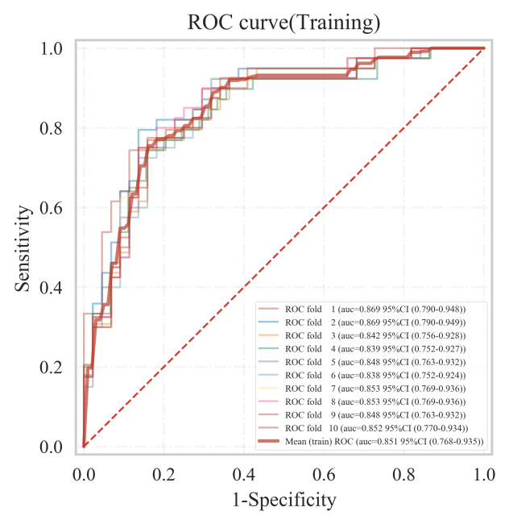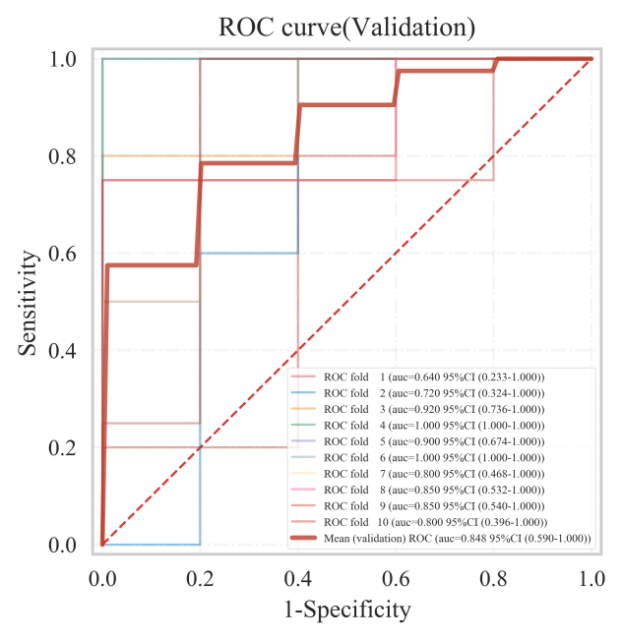
Figure S2 Calibration curves for the IPIO model.
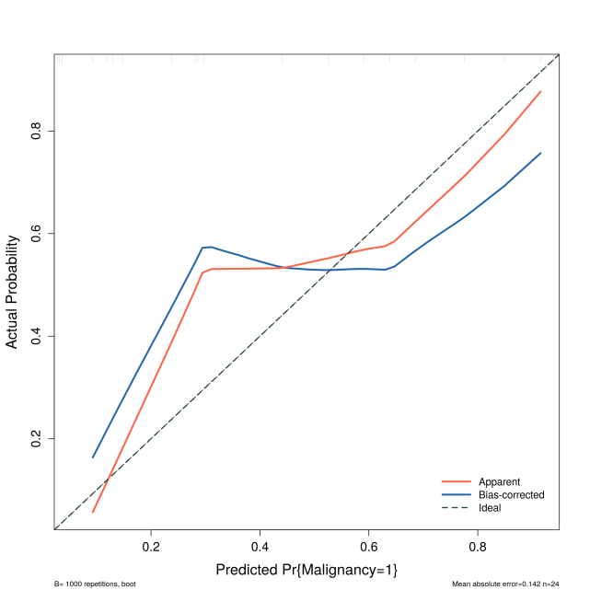
Note: The diagonal dashed line represents perfect calibration

Figure S3 Decision curve analysis for the IPIO model
