Supplementary Figure 1
td Residual Predicted Observed
DependentVariable:mean SCP pVD

 | 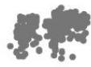 | 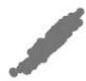
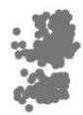 |  | 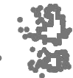
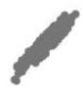 | 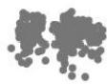
Observed Predicted Std.Residual
Model:Intercept +GROUP+age

Supplementary Figure 2
td Residual Predicted Observed
Dependent Variable: GCL
td Residual Predicted Obseved

 | 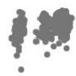 | 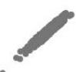
 |  | 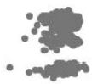
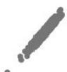 | 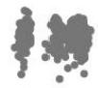
Observed Predicted Std.Residua Model:Intercept +GROUP+age

Supplementary Figure 3
td Residual Predicted Observed
Dependent Variable:mean pRNFL
Std Res idua Predicted Obseved

 | 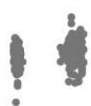 | 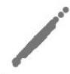
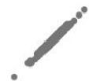 | 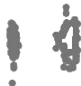
Observed Predicted Std.Residual
Model:Intercept +GROUP+age

Supplementary Figure 4
td Residual Predicted Observed
Dependent Variable:mean pGCL-IPL
td. Residual Predicted
denesbO

 | 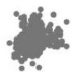 | 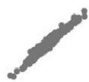
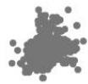 |  | 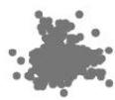
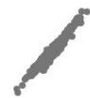 | 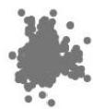
Observed Predicted Std.Residua Model:Intercept +GROUP+age

Supplementary Figure 5
td Residual Predicted Observed
Dependent Variable:mean CW
Std Residual Predicted
denesbO

 | 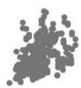 | 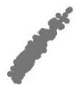
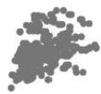 |  | 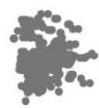
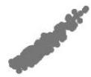 | 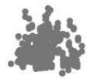
Observed Predicted Std.Residual
Model:Intercept +GROUP+age

Supplementary Figure 6
td Residual Predicted Observed
Dependent Variable:mean CV
Std Residual Predicted
devesbO

 | 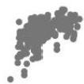 | 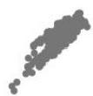
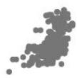 |  | 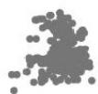
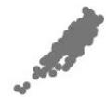 | 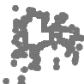
Observed Predicted Std.Residual
Model:Intercept +GROUP+age

Supplementary Figure 7
td Residual Predicted Observed
Dependent Variable:SCP pVD-NS
Std Residual Predicted
denesbO

 | 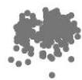 | 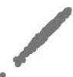
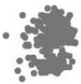 |  | 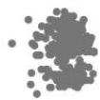
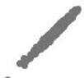 | 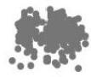
Observed Predicted Std.Residua
Model:Intercept +GROUP+age

Supplementary Figure 8
td Residual Predicted Observed
Dependent Variable:SCP pVD-IN
td. Residual Predicted
denesbO

 | 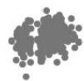 | 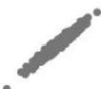
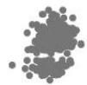 |  | 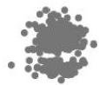
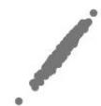 | 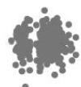
Observed Predicted Std.Residua Model:Intercept +GROUP+age

Supplementary Figure 9
td Residual Predicted Observed
Dependent Variable:SCP pVD-IT
Std Residua Predicted Observed

 | 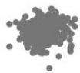 | 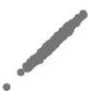
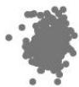 |  | 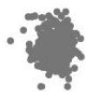
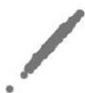 | 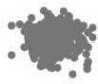
Observed Predicted Std.Residual
Model:Intercept +GROUP+age

Supplementary Figure 10
td Residual Predicted Observed
DependentVariable:SCP pVD-TI
td Residual Predicted Observed

 | 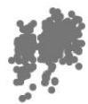 | 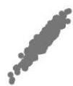
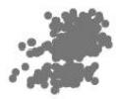 |  | 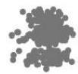
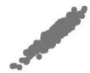 | 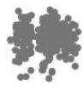
Observed Predicted Std.Residua Model:Intercept +GROUP+age

Supplementary Figure 11
td Residual Predicted Observed
DependentVariable:SCP pVD-TS
Std Res idua Predicted Observed

 | 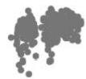 | 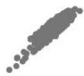
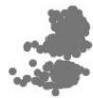 |  | 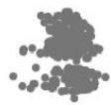
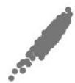 | 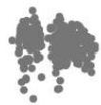
Observed Predicted Std.Residual
Model:Intercept +GROUP+age

Supplementary Figure 12
td Residual Predicted Observed
Dependent Variable:SCP pVD-ST
Std. Residua Predicted
denesbO

 |  | 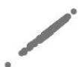
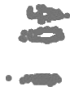 |  | 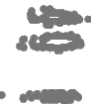
Observed Predicted Std.Residual
Model:Intercept +GROUP+age

Supplementary Figure 13
td Residual Predicted Observed
Dependent Variable:SCP pVD-SN
std. Residua Predicted Observed

 | 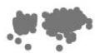 | 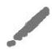
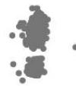 |  | 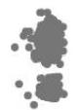
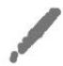 | 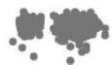
Observed Predicted Std.Residua
Model:Intercept +GROUP+age

Supplementary Figure 14
td Residual Predicted Observed
Dependent Variable:pRNFL-S
td Residual Predicted
devesbO

Observed Predicted Std.Residual
Model:Intercept +GROUP+age

Supplementary Figure 15
td Residual Predicted Observed
Dependent Variable:pRNFL-
std. Residua Predicted Observed

 | 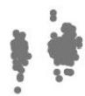 | 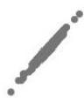
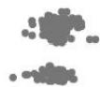 |  | 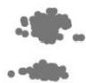
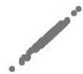 | 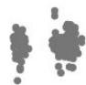
Observed Predicted Std.Residual
Model:Intercept +GROUP+age

Supplementary Figure 16
td Residual Predicted Observed
Dependent Variable:pRNFL-NS
td. Residual Predicted
devesbO

 | 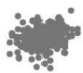 | 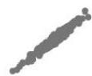
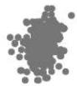 |  | 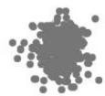
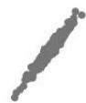 | 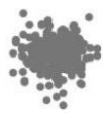
Observed Predicted Std.Residual
Model:Intercept +GROUP+age

Supplementary Figure 17
td Residual Predicted Observed
Dependent Variable:pRNFL-NI
Predicted
Std. Residual
denesbO

 | 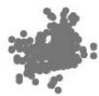 | 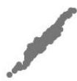
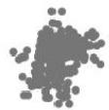 |  | 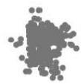
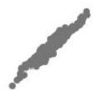 | 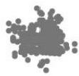
Observed Predicted Std.Residual
Model:Intercept +GROUP+age

Supplementary Figure 18
td Residual Predicted Observed
DependentVariable:pRNFL-IN
td. Residual Predicted
denesbO

 | 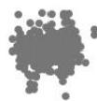 | 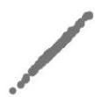
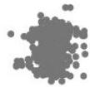 |  | 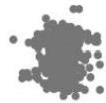
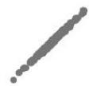 | 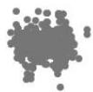
Observed Predicted Std.Residua Model:Intercept +GROUP+age

Supplementary Figure 19
td Residual Predicted Observed
Dependent Variable:pRNFL-IT
Predicted
Std Residual Observed

 | 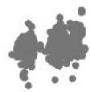 | 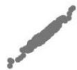
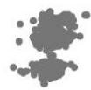 |  | 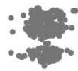
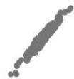 | 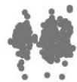
Observed Predicted Std.Residual
Model:Intercept +GROUP+age

Supplementary Figure 20
td Residual Predicted Observed
Dependent Variable:pRNFL-TI
td Residual Predicted Observed

 | 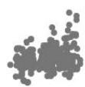 | 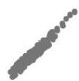
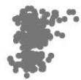 |  | 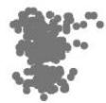
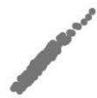 | 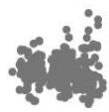
Observed Predicted Std.Residua Model:Intercept +GROUP+age

Supplementary Figure 21
td Residual Predicted Observed
Dependent Variable:pRNFL-TS
Std Residual Predicted Observed

 | 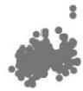 | 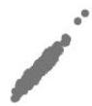
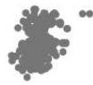 |  | 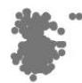
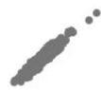 | 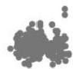
Observed Predicted Std.Residual
Model:Intercept +GROUP+age

Supplementary Figure 22
td Residual Predicted Observed
DependentVariable:pRNFL-ST
td Residual Predicted Observed

 | 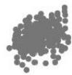 | 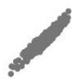
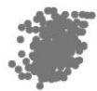 |  | 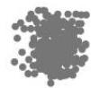
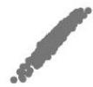 | 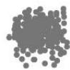
Observed Predicted Std.Residua Model:Intercept +GROUP+age

Supplementary Figure 23
td Residual Predicted Observed
Dependent Variable:SCP pVD-NI
Std Residual Predicted Observed

 |  | 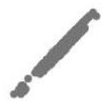
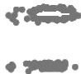 |  | 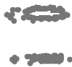
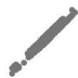 | 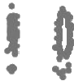
Observed Predicted Std.Residual
Model:Intercept +GROUP+age

Supplementary Figure 24
td Residual Predicted Observed
DependentVariable:pRNFL-SN
std. Residua Predicted
devesbO

 | 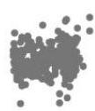 | 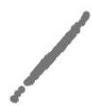
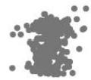 |  | 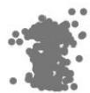
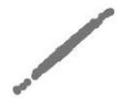 | 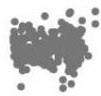
Observed Predicted Std.Residua Model:Intercept +GROUP+age

Supplementary Figure 25
td Residual Predicted Observed
Dependent Variable:pGCL-IPL-S
td Residual Predicted Observed

 | 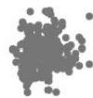 | 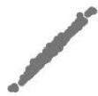
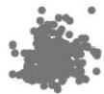 |  | 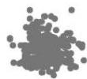
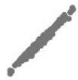 | 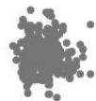
Observed Predicted Std.Residua
Model:Intercept+GROUP+age

Supplementary Figure 26
td Residual Predicted Observed
DependentVariable:pGCL-IPL-
std. Residua Predicted
devesbO

 | 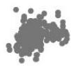 | 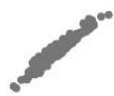
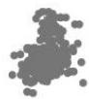 |  | 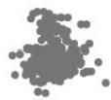
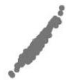 | 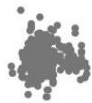
Observed Predicted Std.Residua Model:Intercept +GROUP+age

Supplementary Figure 27
td Residual Predicted Observed
Dependent Variable:pGCL-IPL-NS
td Residual Predicted Observed

 | 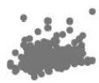 | 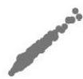
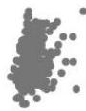 |  | 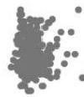
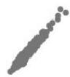 | 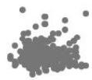
Observed Predicted Std.Residua
Model:Intercept+GROUP+age

Supplementary Figure 28
td Residual Predicted Observed
Dependent Variable:pGCL-IPL-NI
Std Residua Predicted
devesbO

 | 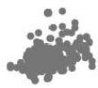 | 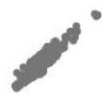
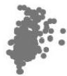 |  | 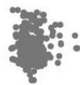
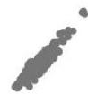 | 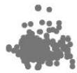
Observed Predicted Std.Residua
Model:Intercept+GROUP+age

Supplementary Figure 29
td Residual Predicted Observed
Dependent Variable:pGCL-IPL-IN
td Residual Predicted Observed

 | 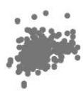 | 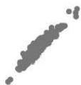
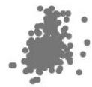 |  | 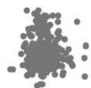
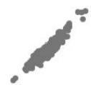 | 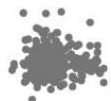
Observed Predicted Std.Residual
Model:Intercept+GROUP+age

Supplementary Figure 30
td Residual Predicted Observed
Dependent Variable:pGCL-IPL-IT
Std Res idua Predicted
devesbO

 | 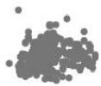 | 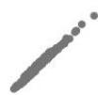
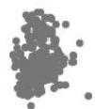 |  | 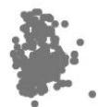
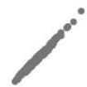 | 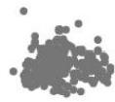
Observed Predicted Std.Residua
Model:Intercept+GROUP+age

Supplementary Figure 31
td Residual Predicted Observed
Dependent Variable:pGCL-IPL-TI
td Residual Predicted Observed

 | 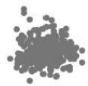 | 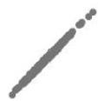
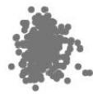 |  | 
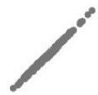 | 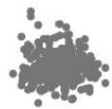
Observed Predicted Std.Residua
Model:Intercept +GROUP+age

Supplementary Figure 32
td Residual Predicted Observed
Dependent Variable:pGCL-IPL-TS
Std Res idua Predicted
devesbO

 | 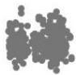 | 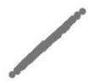
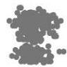 |  | 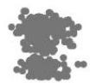
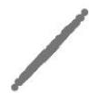 | 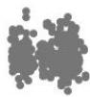
Observed Predicted Std.Residua
Model:Intercept+GROUP+age

Supplementary Figure 33
td Residual Predicted Observed
Dependent Variable:pGCL-IPL-ST
td Residual Predicted Observed

 | 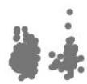 | 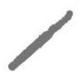
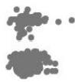 |  | 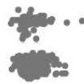
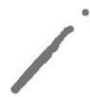 | 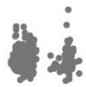
Observed Predicted Std.Residua
Model:Intercept +GROUP+age

Supplementary Figure 34
td Residual Predicted Observed
Dependent Variable:pGCL-IPL-SN
Std Res idua Predicted
devesbO

 | 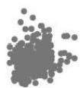 | 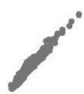
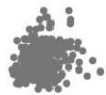 |  | 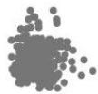
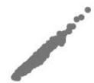 | 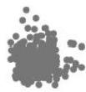
Observed Predicted Std.Residua
Model:Intercept+GROUP+age

Supplementary Figure 35
td Residual Predicted Observed
Dependent Variable:mean CT
td Residual Predicted Observed

 | 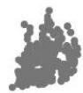 | 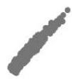
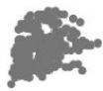 |  | 
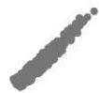 | 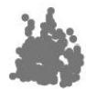
Observed Predicted Std.Residua
Model:Intercept +GROUP+age

Supplementary Figure 36
td Residual Predicted Observed
Dependent Variable:CT-S
std. Residua Predicted
devesbO

 | 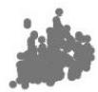 | 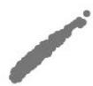
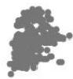 |  | 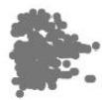
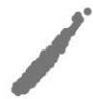 | 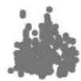
Observed Predicted Std.Residual
Model:Intercept +GROUP+age

Supplementary Figure 37
td Residual Predicted Observed
Dependent Variable:CT-T
td Residual Predicted Observed

 | 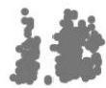 | 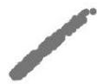
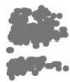 |  | 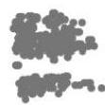
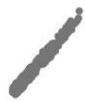 | 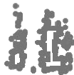
Observed Predicted Std.Residua
Model:Intercept +GROUP+age

Supplementary Figure 38
td Residual Predicted Observed
Dependent Variable:CT-
Std Residua Predicted
devesbO

 | 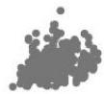 | 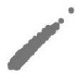
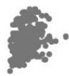 |  | 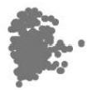
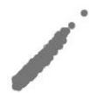 | 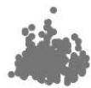
Observed Predicted Std.Residua
Model:Intercept+GROUP+age

Supplementary Figure 39
td Residual Predicted Observed
Dependent Variable:CT-N
td Residual Predicted Observed

 | 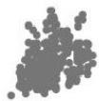 | 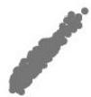
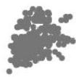 |  | 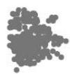
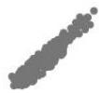 | 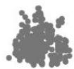
Observed Predicted Std.Residua
Model:Intercept +GROUP+age

Supplementary Figure 40
td Residual Predicted Observed
Dependent Variable:CWV-S
std Res idua Predicted
devesbO

 | 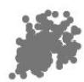 | 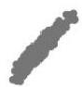
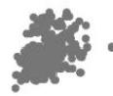 |  | 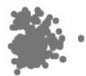
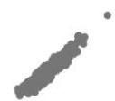 | 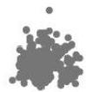
Observed Predicted Std.Residual
Model:Intercept +GROUP+age

Supplementary Figure 41
td Residual Predicted Observed
Dependent Variable:CW-T
td Residual Predicted Observed

 | 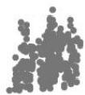 | 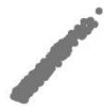
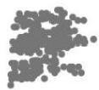 |  | 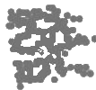
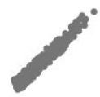 | 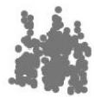
Observed Predicted Std.Residua
Model:Intercept+GROUP+age

Supplementary Figure 42
td Residual Predicted Observed
Dependent Variable:CW-
Std Residual Predicted
devesbO

 | 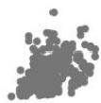 | 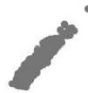
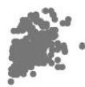 |  | 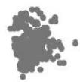
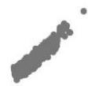 | 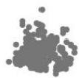
Observed Predicted Std.Residua
Model:Intercept+GROUP+age

Supplementary Figure 43
td Residual Predicted Observed
Dependent Variable:CW-N
std. Residua Predicted
devesbO

 | 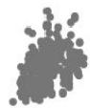 | 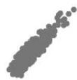
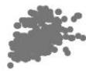 |  | 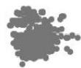
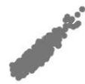 | 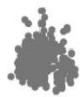
Observed Predicted Std.Residual
Model:Intercept +GROUP+age

Supplementary Figure 44
td Residual Predicted Observed
Dependent Variable:CVI-S
Std Residual Predicted
devesbO

 | 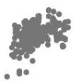 | 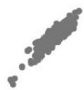
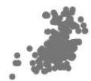 |  | 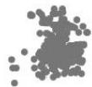
 | 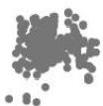
Observed Predicted Std.Residual
Model:Intercept +GROUP+age

Supplementary Figure 45
td Residual Predicted Observed
Dependent Variable:CVI-T
Std Residual Predicted
Observed

 | 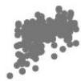 | 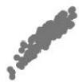
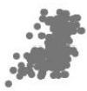 |  | 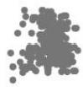
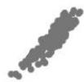 | 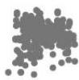
Observed Predicted Std.Residual
Model:Intercept +GROUP+age

Supplementary Figure 46
td Residual Predicted Observed
Dependent Variable:CV-
std. Residua Predicted
devesbO

 | 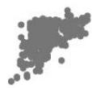 | 
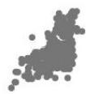 |  | 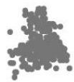
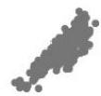 | 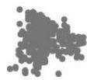
Observed Predicted Std.Residual
Model:Intercept +GROUP+age

Supplementary Figure 47
td Residual Predicted Observed
Dependent Variable:CVI-N
Predicted Observed
Std. Residual

 | 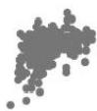 | 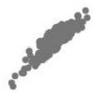
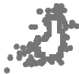 |  | 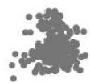
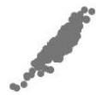 | 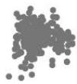
Observed Predicted Std.Residua
Model:Intercept +GROUP+age

Supplementary Figure 48
td Residual Predicted Observed

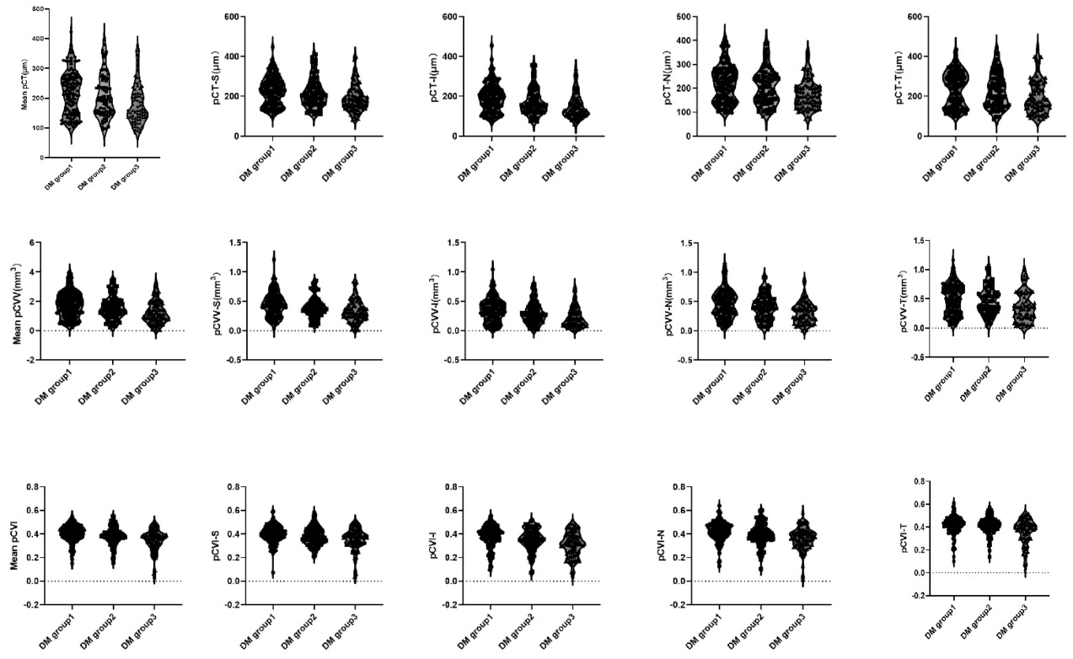

Supplementary Table 1
 |  |  |  |  |  | 1VS2 | 1VS3 | 2VS3
 | DM group1 | DM group2 | DM group3 | Test value | P value* | P value1 | P value2 | P value3
pCT | 217.11±72.8 | 204.05±72.17 | 179.74±65.1 | 2.591 | 0.077 | 0.43 | 0.024 | 0.138
S | 225.33±72.15 | 215.45±73.72 | 190.7±65.58 | 2.257 | 0.107 | 0.611 | 0.038 | 0.12
T | 235.42±86.31 | 225.28±85.74 | 198.2±85.16 | 2.67 | 0.071 | 0.544 | 0.024 | 0.099
I | 190.01±70.19 | 172.44±66.9 | 152.87±60.62 | 2.895 | 0.057 | 0.193 | 0.018 | 0.256
N | 217.86±76.04 | 203.9±74.42 | 177.56±59.81 | 1.865 | 0.157 | 0.548 | 0.056 | 0.189
pCVV | 1.76±0.85 | 1.54±0.74 | 1.25±0.75 | 3.131 | 0.045 | 0.227 | 0.014 | 0.188
S | 0.44±0.21 | 0.39±0.18 | 0.33±0.18 | 2.398 | 0.093 | 0.213 | 0.033 | 0.34
T | 0.5±0.25 | 0.46±0.23 | 0.37±0.25 | 3.051 | 0.049 | 0.467 | 0.015 | 0.089
I | 0.35±0.2 | 0.29±0.17 | 0.23±0.17 | 3.304 | 0.038 | 0.111 | 0.013 | 0.325
N | 0.46±0.24 | 0.4±0.21 | 0.31±0.18 | 2.69 | 0.07 | 0.251 | 0.022 | 0.232
pCVI | 0.4±0.07 | 0.39±0.08 | 0.35±0.09 | 1.418 | 0.244 | 0.715 | 0.101 | 0.209
S | 0.4±0.07 | 0.38±0.08 | 0.35±0.09 | 0.596 | 0.552 | 0.604 | 0.278 | 0.558
T | 0.42±0.08 | 0.41±0.08 | 0.36±0.11 | 2.544 | 0.08 | 0.585 | 0.079 | 0.03
I | 0.38±0.09 | 0.35±0.09 | 0.31±0.1 | 0.552 | 0.557 | 0.751 | 0.297 | 0.469
N | 0.42±0.08 | 0.4±0.09 | 0.36±0.1 | 1.6 | 0.204 | 0.341 | 0.077 | 0.389
P Value1=P value between the DM group1 and DM group2; P Value2= P value between the DM group1 and DM group3; P Value3 = P value between the DM group2 and DM group3; P value*=P value among the three groups

Supplementary Table 2
 |  |  |  |  |  | 1 VS 2 | 1 vs 3 | 2 vs 3
pGCL-IPL | DM group1 | DM group2 | DM group3 | F | P value* | P value1 | P value2 | P value3
Mean | 36.47±3.12 | 36.53±3.82 | 35.91±4.09 | 0.265 | 0.767 | 0.47 | 0.711 | 0.778
Sector
S | 37.69±3.67 | 38.22±4.45 | 37.45±4.39 | 0.817 | 0.443 | 0.202 | 0.615 | 0.52
I | 35.15±3.07 | 34.7±3.62 | 34.24±4.16 | 0.026 | 0.975 | 0.929 | 0.88 | 0.822
NS | 36.94±5.34 | 36.84±5.13 | 36.7±5.53 | 1.002 | 0.368 | 0.526 | 0.158 | 0.424
NI | 35.33±4.83 | 34.39±3.44 | 34.38±5.25 | 1.216 | 0.298 | 0.759 | 0.208 | 0.138
IN | 32.1±3.45 | 31.48±3.19 | 30.94±4.19 | 0.052 | 0.949 | 0.752 | 0.937 | 0.838
IT | 32.49±4.54 | 32.27±4.94 | 31.72±5.27 | 0.116 | 0.890 | 0.952 | 0.646 | 0.697
TI | 41.28±6.1 | 41.42±7.58 | 40.59±8.74 | 0.140 | 0.870 | 0.791 | 0.76 | 0.597
TS | 42.12±6.14 | 42.11±7.45 | 41.28±6.92 | 0.547 | 0.579 | 0.917 | 0.323 | 0.39
ST | 36.92±4.9 | 37.93±6.17 | 36.83±6.3 | 0.980 | 0.377 | 0.255 | 0.791 | 0.208
SN | 34.93±4.41 | 36.49±4.78 | 35.18±5.17 | 3.752 | 0.025 | 0.007 | 0.182 | 0.262
P value*=P value among the three groups

Supplementary Table 3
 |  |  |  |  |  | 1 VS 2 | 1 vs 3 | 2 vs 3
pRNFL | DM group1 | DM group2 | DM group3 | F | P value* | P value1 | P value2 | P value3
Mean | 127.85±15.86 | 127.01±12.54 | 121.53±16.73 | 4.057 | 0.018 | 0.66 | 0.006 | 0.025
Sector
S | 125.4±16.76 | 123.2±13.84 | 118.61±17.47 | 3.477 | 0.032 | 0.354 | 0.009 | 0.088
I | 130.51±17.03 | 131.15±13.86 | 124.71±17.36 | 4.025 | 0.019 | 0.887 | 0.012 | 0.011
NS | 109.18±23.22 | 110.14±19.48 | 107.84±23.5 | 1.949 | 0.144 | 0.701 | 0.056 | 0.133
NI | 89.19±19.41 | 93.59±18.81 | 92.02±19.88 | 1.118 | 0.328 | 0.41 | 0.43 | 0.137
IN | 159.25±30.72 | 162.23±25.91 | 157.45±31.88 | 0.783 | 0.458 | 0.637 | 0.392 | 0.215
IT | 185.28±30.13 | 181.87±29.23 | 167.96±28.63 | 4.659 | 0.010 | 0.657 | 0.004 | 0.016
TI | 95.86±20 | 92.54±17.2 | 84.92±16.76 | 4.000 | 0.019 | 0.417 | 0.005 | 0.049
TS | 95.99±18.61 | 91.83±15.18 | 86.74±17.49 | 1.821 | 0.164 | 0.323 | 0.059 | 0.344
ST | 157.49±27.74 | 147.55±25.44 | 141.24±25.79 | 3.724 | 0.025 | 0.048 | 0.012 | 0.5
SN | 151.31±29.08 | 152.91±29.27 | 147.1±28.48 | 1.084 | 0.340 | 0.808 | 0.224 | 0.166
P value*=P value among the three groups

Supplementary Table 4
 |  |  |  |  |  | 1 VS 2 | 1 vs 3 | 2 vs 3
SCP pVD | DM group1 | DM group2 | DM group3 | F | P value* | P value1 | P value2 | P value3
Mean | 32.34±3.23 | 31.96±3.42 | 29.58±4.11 | 7.95 | 0.00044 | 0.874 | 0.000271 | 0.001
Sector
NS | 29.3±4.97 | 29.34±4.74 | 27.47±5.43 | 1.943 | 0.145 | 0.722 | 0.107 | 0.063
NI | 29.04±5.44 | 28.95±6.01 | 26.05±6.44 | 5.382 | 0.005 | 0.996 | 0.003 | 0.004
IN | 29.43±4.77 | 30.03±4.06 | 27.53±4.85 | 4.256 | 0.015 | 0.229 | 0.057 | 0.004
IT | 32.89±5.86 | 31.71±5.63 | 32.6±6.46 | 0.974 | 0.379 | 0.299 | 0.681 | 0.189
TI | 37.13±5.4 | 35.16±6.75 | 31.41±7.2 | 10.257 | 0.000 | 0.111 | 0.000009 | 0.004
TS | 37.6±5.25 | 36.61±5.83 | 31.8±7.5 | 11.603 | 0.000014 | 0.678 | 0.000008 | 0.000082
ST | 35.7±5.92 | 36.18±5.56 | 34.65±6 | 1.199 | 0.303 | 0.550 | 0.295 | 0.125
SN | 30.78±5.63 | 31.02±6.69 | 28.21±5.11 | 3.521 | 0.031 | 0.56 | 0.036 | 0.011
P value*=P value among the three groups

