Supplementary Materials
Table S1 The clinical presentation and outcomes of 21 patients at the time of first relapse
 | Symptoms | Inflammatory Indicators |  | Imaging |  |  | Time to first relapse (year)
 | Symptoms | ESR | CRP | Mass | Hydronephrosis | Lymph nodes | 5.5
1 | (-) | 30 | WNL | (+) | Bilateral | (-) | 6
2 | (-) | 80 | 44 | (+) | (-) | (-) | 1.5
3 | (-) | WNL | WNL | (+) | Left | (-) | 4.5
4 | Left-sided abdominal pain, lower extremity swelling | 43 | 15 | (-) | (-) | (-) | 5.5
5 | (-) | 25 | WNL | (+) | Bilateral | (-) | 4.5
6 | Back pain, fever | WNL | 9.62 | (+) | Right | (-) | 3.5
7 | Nausea | 27 | WNL | (+) | Bilateral | (-) | 4
8 | Back pain | NA | 12 | (+) | (-) | (-) | 2
9 | Back pain | 45 | 23 | (+) | Bilateral | (+) | 1.25
10 | (-) | 35 | 18 | (+) | (-) | (-) | 1.5
11 | (-) | 24 | 31.25 | (+) | Left | (-) | 1.5
12 | Right back pain, lower extremity swelling, fatigue | 28 | 9.85 | (+) | (-) | (+) | 2
13 | (-) | 30 | WNL | (+) | Bilateral | (-) | 1.5
14 | Abdominal distention | WNL | WNL | (+) | Left | (-) | 2.75
15 | Abdominal distention | WNL | WNL | (+) | (-) | (-) | 7
16 | Abdominal pain | NA | NA | (+) | (-) | (-) | 5
17 | Abdominal pain | 20 | WNL | (+) | (-) | (-) | 6.5
18 | (-) | WNL | 9 | (+) | Bilateral | (+) | 6
19 | (-) | 40 | 15 | (+) | Right | (-) | 1.25
20 | Abdominal and back pain | 102 | WNL | (+) | (-) | (-) | 1.75
21 | Back pain | WNL | 30 | (+) | Bilateral | (-) | 5.5
Patient 2 and Patient 12 each experienced two relapses. For Patient 2, the second relapse occurred 1.25 years after the first and presented with symptoms similar to the initial episode, with additional findings including dull abdominal pain, suprapubic discomfort aggravated during urination, urinary frequency and urgency, and dark tea-colored urine. Patient 12 experienced the second relapse 3.5 years after the first, with clinical manifestations largely consistent with the initial relapse. Patient 3 experienced four relapses; the intervals between the first through fourth relapses were 1.25, 2.25, and 2 years, respectively. Each relapse in Patient 3 demonstrated typical radiologic features, characterized by marked enlargement of the periaortic soft tissue, with or without associated hydronephrosis. CRP, C-reactive protein, mg/L; ESR, erythrocyte sedimentation rate, mm/h; WNL, within normal limits, indicates results falling within the normal reference range. “(-)” indicates that inflammatory markers are within normal limits or that the imaging feature is not present; “(+)” indicates the presence of the imaging feature; NA, not available. “Time to relapse” was calculated from the initial treatment to the first relapse.
Table S2 Comparison of baseline clinical characteristics between patients with and without relapse
 | relapse  (n=21) | non-relapse  (n=75) | p value
Duration of IRF | 3.5 [1.5-5.75] | 2.5 [1.75-3.5] | 0.399
Baseline clinical Characteristics
Male | 16 (76%) | 61 (81%) | 0.76
Age at diagnosis, y | 56 [45-61] | 54 [50-61] | 0.92
Clinical manifestations
Back/abdominal pain | 15 (71%) | 59 (79%) | 0.56
Hematuria | 2 (10%) | 5 (7%) | 0.65
Leg edema | 1 (5%) | 8 (11%) | 0.68
Fever | 2 (10%) | 5 (7%) | 0.65
Fatigue | 3 (14%) | 8 (11%) | 0.70
Weight loss | 0 (0%) | 5 (8%) | 0.33
Asymptomatic | 1 (5%) | 9 (12%) | 0.45
Organ involvement
Arterial involvement
Periaortic and peri-iliac mass | 21 (100%) | 56 (75%) | 0.01
Atypical: dissection, aneurysm | 0 (0%) | 4 (5%) | 0.57
Involvement of urinary system
Hydronephrosis | 17 (81%) | 35 (47%) | 0.006
Unilateral | 9 (43%) | 18 (24%) | 0.09
Bilateral | 8 (38%) | 17 (23%) | 0.15
Retroperitoneal lymph node | 3 (14%) | 6 (8%) | 0.41
Laboratory indices
WBC, ×10⁹/L | 6.87 [6.00-9.39] | 7.67 [6.44-9.74] | 0.30
ESR, mm/h | 34 [14-84] | 32 [20-57] | 0.98
Elevated ESR level | 12 (63%) | 51 (77%) | 0.24
hsCRP, mg/L | 8.96 [1.80-48.54] | 7.95 [1.67-21.83] | 0.29
Elevated hsCRP level | 11 (55%) | 36 (53%) | 1.00
ANA positive | 3 (23%) | 8 (16%) | 0.68
IgG4, mg/L | 406 [288-860] | 555 [224-946] | 0.81
Elevated IgG4 level | 1 (5%) | 6 (9%) | 1.00
Serum creatinine, µmol/L | 153 [96-321] | 109 [81-287] | 0.29
WBC, white blood cell; ESR, erythrocyte sedimentation rate (≥20 mm/h considered elevated; missing data: 2 relapse and 9 non-relapse patients); hsCRP, hypersensitive C-reactive protein (≥8 mg/L considered elevated; missing data: 1 relapse and 7 non-relapse patients); ANA, antinuclear antibody (titers >1:320 considered positive; missing data: 8 relapse and 26 non-relapse patients); serum IgG4 ≥1400 mg/L considered elevated (missing data: 2 relapse and 8 non-relapse patients). Continuous variables are presented as median with interquartile range [IQR], and categorical variables are presented as number (percentage).
Table S3 Comparison of induction remission therapy and maintenance therapy between patients with and without relapse
 | Patients  with relapse  (n=21) | Patients without relapse  (n=75) | p value
Induction remission therapy
GC monotherapy | 4 (19%) | 13 (17%) | 1.00
GC + tamoxifen | 5 (23%) | 8 (11%) | 0.15
GC + IM | 4 (19%) | 28 (37%) | 0.19
GC + CYC | 3 (14%) | 18 (24%) | 0.55
GC + MMF | 1 (5%) | 5 (7%) | 1.00
GC + others | 0 (0%) | 5 (7%) | 0.58
GC + IM + tamoxifen | 7 (33%) | 22 (34%) | 1.00
Tocilizumab | 1 (5%) | 4 (7%) | 1.00
Dose of GC, mg/day | 40 [40-50] | 50 [50-60] | 0.04
Maintenance therapy
GC monotherapy | 1 (5%) | 10 (13%) | 0.45
GC + tamoxifen | 1 (5%) | 6 (8%) | 1.00
GC + IM | 2 (10%) | 35 (47%) | 0.002
GC + IM + tamoxifen | 0 (0%) | 13 (17%) | 0.06
IM monotherapy | 5 (24%) | 3 (4%) | 0.01
Tamoxifen monotherapy | 2 (10%) | 2 (3%) | 0.21
Tofacitinib | 0 (0%) | 4 (5%) | 0.57
None | 10 (48%) | 2 (3%) | <0.001
Dose of GC, mg/day | 0 [0-0] | 5 [2.5-5.00] | <0.001
GC, glucocorticoid therapy; IM, immunosuppressants therapy. “Dose of GC” refers to the daily oral prednisone-equivalent dose used during induction remission or maintenance therapy (mg/day). Continuous variables are presented as median with interquartile range [IQR], and categorical variables are presented as number (percentage).

Table S4 Predictors of relapse in IRF via univariable analysis
 | HR (95%CI) | p value
Male | 0.76 (0.28-2.11) | 0.60
Age at diagnosis, y | 0.99 (0.95-1.03) | 0.59
Involvement
Periaortic and peri-iliac mass | 0.76 (0.28-2.11) | 0.60
Hydronephrosis | 5.35 (1.93-14.83) | 0.001
Retroperitoneal lymph node | 2.25 (0.65-7.80) | 0.20
Artery + urinary system | 1.24 (0.53-2.88) | 0.62
Laboratory indices
WBC, ×10⁹/L | 1.05 (0.89-1.26) | 0.52
ESR, mm/h | 1.00 (0.98-1.02) | 0.88
hsCRP, mg/L | 1.02 (1.00-1.03) | 0.06
ANA positive | 1.49 (0.51-4.33) | 0.47
IgG4, mg/L | 1.00 (1.00-1.00) | 0.77
Elevated IgG4 level | 1.91 (0.23-15.71) | 0.55
Serum creatinine, µmol/L | 1.00 (1.00-1.00) | 0.75
Induction remission therapy
Use of GC | 0.56 (0.07-4.47) | 0.59
Dose of GC, mg/day | 0.98 (0.95-1.01) | 0.14
GC monotherapy | ref
GC + tamoxifen | 1.55 (0.39-6.11) | 0.53
GC + IM | 0.16 (0.02-1.27) | 0.08
GC + IM + tamoxifen | 0.41 (0.15-1.11) | 0.08
Tocilizumab | 2.22 (0.28-17.59) | 0.45
Maintenance therapy
Use of GC | 0.10 (0.03-0.30) | <0.001
Dose of GC, mg/day | 0.70 (0.55-0.89) | 0.004
GC monotherapy | ref
GC + tamoxifen | 2.10 (0.17-26.33) | 0.57
GC + IM | 0.14 (0.01-1.57) | 0.11
GC + IM + tamoxifen | 0.00 (0-Inf) | 1.00
IM monotherapy | 4.36 (0.79-24.11) | 0.09
Tamoxifen monotherapy | 1.16 (0.16-8.63) | 0.88
Tofacitinib | 0.00 (0-Inf) | 0.99
None | 3.41 (1.4-8.31) | 0.007
WBC, white blood cell; ESR, erythrocyte sedimentation rate (≥20 mm/h considered elevated; missing data: 2 relapse and 9 non-relapse patients); hsCRP, hypersensitive C-reactive protein (≥8 mg/L considered elevated; missing data: 1 relapse and 7 non-relapse patients); ANA, antinuclear antibody (titers >1:320 considered positive; missing data: 8 relapse and 26 non-relapse patients); serum IgG4 (≥1400 mg/L considered elevated; missing data: 2 relapse and 8 non-relapse patients); GC, glucocorticoid therapy; IM, immunosuppressant therapy. “Dose of GC” refers to the daily oral prednisone-equivalent dose used during induction remission or maintenance therapy (mg/day).

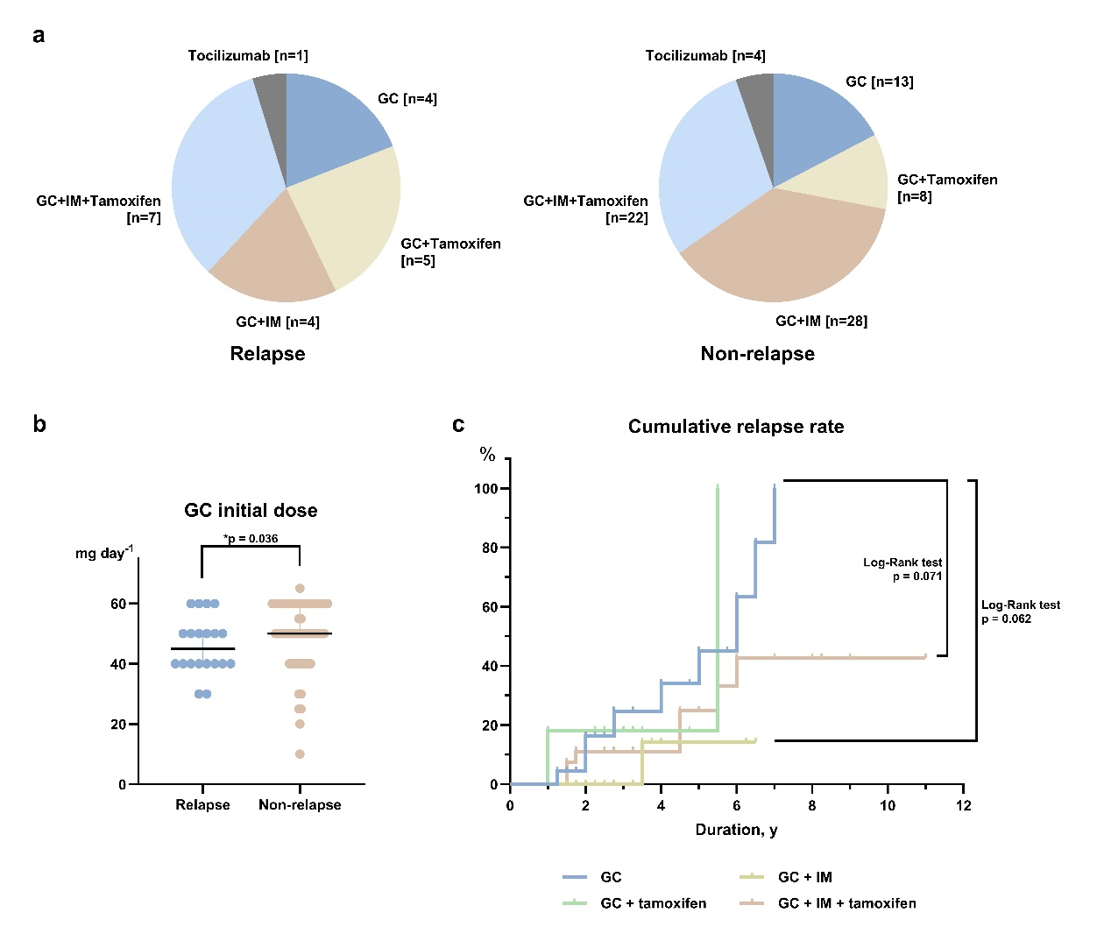
Fig. S1 Comparison of initial therapies between patients with and without relapse
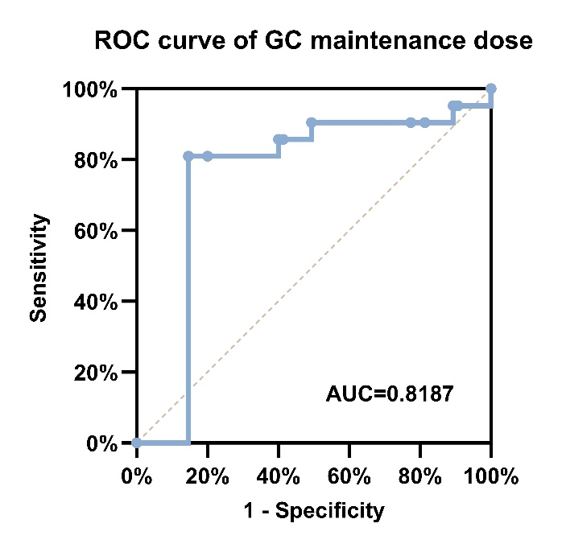
a Distribution of initial therapies in patients with and without relapse. b Comparison of initial GC doses between patients with and without relapse (Wilcoxon rank-sum test). c Comparison of cumulative relapse rates among patients receiving initial GC monotherapy, GC + tamoxifen, GC + immunosuppressants (IM), and GC + tamoxifen + IM (Log-rank test). Symbol: * indicates p < 0.05.
Fig. S2 ROC curve of GC maintenance dose in the relapse of IRF
The ROC curve was generated to identify the optimal GC maintenance dose for predicting relapse among patients receiving GC monotherapy. The area under the curve (AUC) was 0.82 (p < 0.001). The optimal cut-off value, determined using Youden’s index, was 0.625 mg/day, yielding a sensitivity of 81.82% and a specificity of 86.49%.

