Supplementary Table 1. Likelihood Ratio Test Results for Subgroup-Predictor Interaction Effects
Model Type | Residual DF | Residual Deviance | DF Change | Deviance Change | p-value
Main effects only | 349 | 319.706 | - | - | -
With interaction terms | 319 | 293.416 | 30 | 26.29 | 0.66
Note: The models use 3-month postoperative chronic pain (CPSP) as the outcome variable. The main effects model includes main effects of subgroups (Orthopedic, Urinary, General Surgery) and all predictors. The model with interaction terms adds subgroup-predictor interaction terms to the main effects model.

Supplementary Table 2. Bias Correction Results of Core Variables Across Subgroups Using Bayesian Correction
Subgroup | Core Variable | Original OR | Original OR 95% CI (Low) | Original OR 95% CI (High) | Adjusted OR | Adjusted OR 95% CI (Low) | Adjusted OR 95% CI (High) | AUC Original | AUC Adjusted
Abdominal tumor |  |  |  |  |  |  |  | 0.822 | 0.785
 | Age | 1.04 | 0.872 | 1.242 | 1.058 | 0.864 | 1.277
 | Frail state | 51.055 | 6.977 | 373.588 | 132.362 | 16.047 | 1417.481
 | Intraoperative blood loss | 1 | 0.998 | 1.003 | 0.998 | 0.992 | 1.002
 | MME | 1.028 | 0.944 | 1.12 | 1.026 | 0.93 | 1.122
 | Postoperative AST/ALT | 1.07 | 0.713 | 1.606 | 1.004 | 0.648 | 1.534
 | Postoperative monocyte percentage | 0 | 0 | 2653751117 | 0.015 | 0 | 25854.318
 | Postoperative sleep disorder | 0.902 | 0.076 | 10.686 | 0.657 | 0.034 | 7.689
 | Preoperative sleep disorder | 2.94 | 0.3 | 28.813 | 3.649 | 0.275 | 50.699
 | Respiratory tract infection in the past month | 0.135 | 0.009 | 2.113 | 0.074 | 0.003 | 1.366
 | Surgery duration (min) | 0.999 | 0.989 | 1.009 | 0.998 | 0.987 | 1.01
Orthopedic |  |  |  |  |  |  |  | 0.858 | 0.858
 | Age | 0.945 | 0.87 | 1.026 | 0.941 | 0.859 | 1.024
 | Frail state | 8.978 | 3.351 | 24.054 | 10.815 | 4.022 | 31.28
 | Intraoperative blood loss | 1.003 | 1.001 | 1.005 | 1.003 | 1.001 | 1.005
 | MME | 0.992 | 0.939 | 1.049 | 0.993 | 0.939 | 1.053
 | Postoperative AST/ALT | 0.697 | 0.448 | 1.086 | 0.685 | 0.458 | 0.981
 | Postoperative monocyte percentage | 16294.087 | 0 | 8087574544.326 | 360.839 | 0.001 | 51255750.69
 | Postoperative sleep disorder | 4.216 | 1.777 | 10.005 | 4.737 | 1.874 | 12.029
 | Preoperative sleep disorder | 1.954 | 0.838 | 4.556 | 2.043 | 0.848 | 4.936
 | Respiratory tract infection in the past month | 0.68 | 0.206 | 2.241 | 0.673 | 0.195 | 2.32
 | Surgery duration (min) | 1.005 | 0.996 | 1.013 | 1.004 | 0.996 | 1.012
Urinary tract tumor |  |  |  |  |  |  |  | 0.853 | 0.838
 | Age | 1.053 | 0.896 | 1.237 | 1.052 | 0.872 | 1.262
 | Frail state | 141.7 | 12.684 | 1582.968 | 325.68 | 23.839 | 9723.219
 | Intraoperative blood loss | 1 | 0.989 | 1.01 | 0.988 | 0.958 | 1.005
 | MME | 0.999 | 0.966 | 1.032 | 0.951 | 0.828 | 1.011
 | Postoperative AST/ALT | 1.101 | 0.682 | 1.779 | 1.092 | 0.663 | 1.879
 | Postoperative monocyte percentage | 0 | 0 | 305851071.8 | 0.03 | 0 | 147647.502
 | Respiratory tract infection in the past month | 0.877 | 0.021 | 37.349 | 0.491 | 0.005 | 18.27
 | Surgery duration (min) | 0.999 | 0.98 | 1.018 | 1 | 0.977 | 1.023

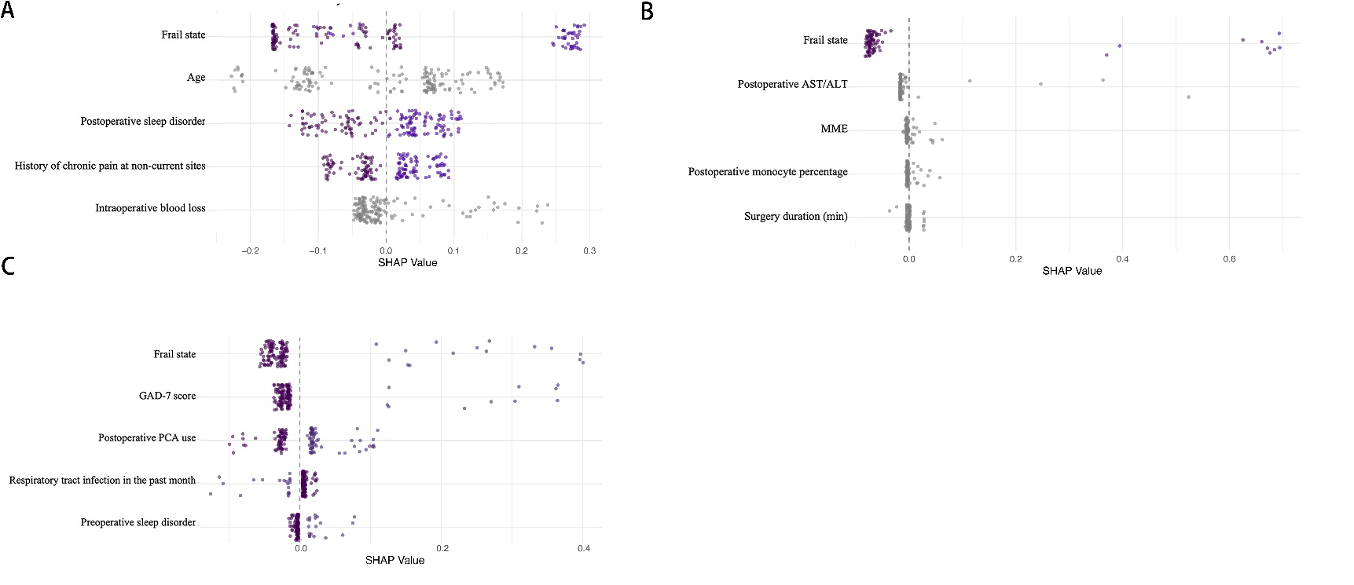

Supplementary Figure 1. SHAP Summary Plots of Random Forest Models for surgery subgroups
Panels A-C are SHAP summary plots of random forest models for orthopedic, urological tumor, and abdominal tumor surgeries, respectively. In each plot, individual scatter points represent the SHAP value of a feature for a single sample. The plots display the distribution of these sample-level SHAP values (X-axis) and the importance ranking of features (Y-axis), globally illustrating the impact degree, direction, and specific influence patterns of each feature on model predictions across all samples. They intuitively compare the differences in feature contributions among the three surgical models.

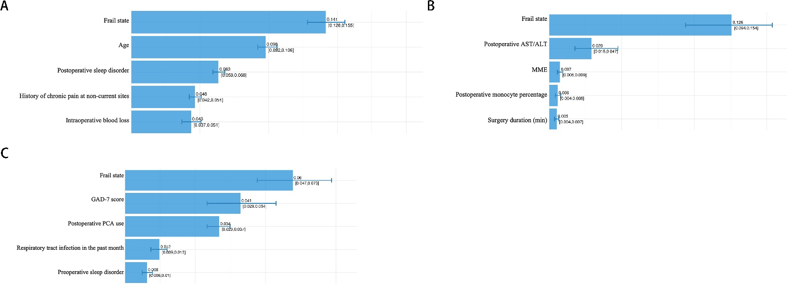

Supplementary Figure 2. SHAP Absolute Values with Confidence Intervals for Feature Importance in Predictive Models of Different Surgery Types
Panels A (Orthopedic surgery), B (Urinary tumor surgery) and C (Abdominal tumor surgery) present the absolute SHAP values with CI.

