Fundamentals

ICD-/OPS-Codes and further Information
Overview of information sources: A more detailed population description inclusion and exclusion criteria, as well as all ICD. OPS and ATC codes used for all influencing variables and all endpoints can be found in the Short Study Protocol in the supplements by Katthagen at al.[1] Coding of the geriatrics-typical characteristic complexes (GtMk) was based on the ‘Abgrenzungskriterien der Geriatrie V1.3’ [2,3]. The following table contains the complete overview of the GtMk codes used. Data collection was based on outpatient and inpatient information in the period of two years before the index event (i.e. the first coded proximal humeral fracture [PHF] diagnosis, ICD S42.2), which was coded as the main or second diagnosis. Deviating or supplementary comments are marked in the table and explained in the footnotes.

Table S1: ICD- and OPS-Codes for the surgical interventions and Geriatric-typical characteristic complexes.
Surgical interventions
Stable-angle plate osteosynthesis for multi-fragmented fracture (LPF) | OPS | 5-794.21, 5-794.k1
Stable-angle plate osteosynthesis for single fragment fracture (sLPF) | OPS | 5-793.k1, 5-793.31
Reverse total shoulder arthroplasty (RTSA) | OPS | 5-824.21
Other fracture fixation | OPS | 5-790.01, 5-790.11, 5-790.21, 5-790.31, 5-790.41, 5-790.51, 5-790.61, 5-790.71, 5-790.81, 5-790.91, 5-790.d1, 5-790.m1, 5-790.n1, 5-790.p1, 5-790.x1, 5-793.11, 5-793.21, 5-793.41, 5-793.51, 5-793.61, 5-793.71, 5-793.81, 5-793.91, 5-793.a1, 5-793.b1, 5-793.c1, 5-793.g1, 5-793.m1, 5-793.n1, 5-793.x1, 5-794.01, 5-794.11,5-794.31, 5-794.41, 5-794.51, 5-794.61, 5-794.71, 5-794.81, 5-794.a1, 5-794.b1, 5-794.c1, 5-794.g1, 5-794.m1, 5-794.n1, 5-794.x1, 5-824.00, 5-824.01, 5-824.0x, 5-824.20
Geriatrics-typical characteristic complexes (GTMM)
Immobility | ICD | M96.8, M62.3, M62.5
Propensity for falls | ICD | H81, H82, R26, R29.81, R42
Cognitive deficits | ICD | F00, F01, F02, F04, F05, F067, F07
Incontinence | ICD | N39.3, N39.4, R15, R32
Decubital ulcers | ICD | I830, I832, L89, L97, L984
Malnutrition and malnourishment | ICD | E41, E43, E44, R64
Fluids and electrolytes disorders | ICD | E86, E87, R60
Depression and anxiety disorders | ICD | F30, F31, F32, F33, F40, F41
Pain | ICD | Acute pain  F45.40, H57.1ª, H92.0ª, K08.88ª, K14.6ª, M25.51ª, M54ª, N23ª, N64.4ª, R07.1ª, R07.2ª, R07.3ª, R07.4ª, R10ª, R51ª, R52.0ª, R52.9ª  Chronic pain  F62.80, R52.1, R52.2
Sensory disorders | ICD | G50-G59, G60-G64, R20
Frailty | ICD | R54
Severe visual and hearing impairment | ICD | H25, H28, H52.4, H53, H54, H90, H91
Medication problems | ICD | X49.9, Y57.9 (in combination with T36-T50)
High risk of complications | ICD | I48, S02, S12^{b}, S22^{b}, S32^{b}, S42^{b}, S52^{b}, S62^{b}, S72^{b}, S72^{b}, S92^{b}, T79-T89, Z43, Z48, Z98,  Z99.2 (dialysis requirement)
High risk of complications | OPS | 8-853, 8-854^{c}, 8-855^{c}, 8-857^{c}
Delayed convalescence | ICD | Z54

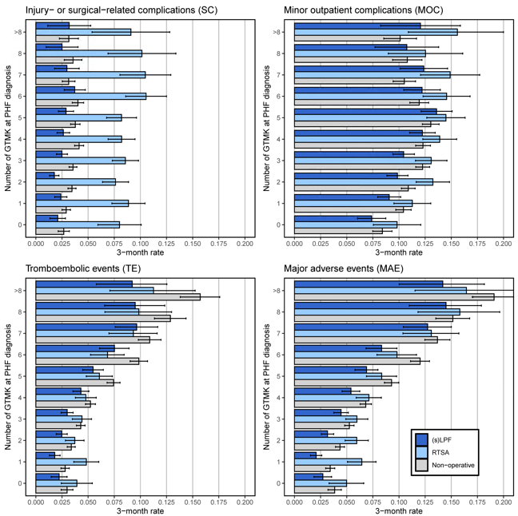
Figure S1: 3-month rates with 95% confidence interval determined using Kaplan-Meier estimates of the primary endpoints (SC, MOC, MAE, TE) depending on the number of GTMK present at the time of PHF diagnosis for the subgroups of sLPF & LPF (dark blue), RTSA (light blue) and non-surgical treatment (light gray). (s)LPF – locked plate fixation for simple and multi-fragment fracture, RTSA –reverse total shoulder arthroplasty

Table S2: 3-month rates with 95% confidence interval (95%-CI) determined using Kaplan-Meier estimates of the primary endpoints (Mortality, SC, MOC, MAE, TE) depending on the number of GTMK present at the time of PHF diagnosis for the subgroups of (s)LPF, RTSA and non-surgical treatment. For a visualisation see Figure 2 or Figure S1. (s)LPF – locked plate fixation for simple and multi-fragment fracture, RTSA –reverse total shoulder arthroplasty
 |  | (s)LPF | RTSA | Non-operative
Mortality
No GTMK | Events | 19 | 16 | 77
No GTMK | Rate (95%-CI) | 1.32% (0.73%, 1.91%) | 2.42% (1.24%, 3.58%) | 2.21% (1.72%, 2.70%)
1 GTMK | Events | 27 | 31 | 130
1 GTMK | Rate (95%-CI) | 1.04% (0.65%, 1.43%) | 2.50% (1.63%, 3.36%) | 1.97% (1.63%, 2.30%)
2 GTMK | Events | 60 | 43 | 231
2 GTMK | Rate (95%-CI) | 1.79% (1.34%, 2.24%) | 2.46% (1.73%, 3.19%) | 2.66% (2.32%, 3.00%)
3 GTMK | Events | 70 | 60 | 305
3 GTMK | Rate (95%-CI) | 2.05% (1.58%, 2.53%) | 3.12% (2.34%, 3.89%) | 3.26% (2.90%, 3.61%)
4 GTMK | Events | 78 | 57 | 338
4 GTMK | Rate (95%-CI) | 2.85% (2.22%, 3.47%) | 3.25% (2.41%, 4.07%) | 4.07% (3.64%, 4.49%)
5 GTMK | Events | 84 | 50 | 425
5 GTMK | Rate (95%-CI) | 4.11% (3.24%, 4.96%) | 3.53% (2.57%, 4.49%) | 6.22% (5.65%, 6.79%)
6 GTMK | Events | 79 | 52 | 391
6 GTMK | Rate (95%-CI) | 5.88% (4.61%, 7.13%) | 5.48% (4.02%, 6.92%) | 7.91% (7.15%, 8.66%)
7 GTMK | Events | 61 | 41 | 293
7 GTMK | Rate (95%-CI) | 7.54% (5.71%, 9.35%) | 6.71% (4.70%, 8.67%) | 9.28% (8.26%, 10.28%)
8 GTMK | Events | 32 | 26 | 197
8 GTMK | Rate (95%-CI) | 8.00% (5.30%, 10.62%) | 7.76% (4.85%, 10.58%) | 10.47% (9.08%, 11.85%)
9 and more | Events | 25 | 22 | 196
9 and more | Rate (95%-CI) | 8.87% (5.49%, 12.12%) | 9.52% (5.66%, 13.23%) | 13.76% (11.95%, 15.53%)
Injury- or surgical-related complications
No GTMK | Events | 30 | 53 | 93
No GTMK | Rate (95%-CI) | 2.09% (1.35%, 2.83%) | 8.01% (5.93%, 10.08%) | 2.67% (2.13%, 3.21%)
1 GTMK | Events | 62 | 110 | 192
1 GTMK | Rate (95%-CI) | 2.38% (1.80%, 2.97%) | 8.86% (7.28%, 10.44%) | 2.91% (2.50%, 3.31%)
2 GTMK | Events | 59 | 133 | 300
2 GTMK | Rate (95%-CI) | 1.76% (1.32%, 2.21%) | 7.62% (6.38%, 8.87%) | 3.46% (3.07%, 3.84%)
3 GTMK | Events | 85 | 165 | 333
3 GTMK | Rate (95%-CI) | 2.49% (1.97%, 3.02%) | 8.57% (7.32%, 9.82%) | 3.55% (3.18%, 3.93%)
4 GTMK | Events | 72 | 144 | 344
4 GTMK | Rate (95%-CI) | 2.63% (2.03%, 3.23%) | 8.20% (6.92%, 9.49%) | 4.14% (3.71%, 4.57%)
5 GTMK | Events | 59 | 116 | 258
5 GTMK | Rate (95%-CI) | 2.89% (2.16%, 3.61%) | 8.20% (6.77%, 9.63%) | 3.78% (3.32%, 4.23%)
6 GTMK | Events | 50 | 100 | 199
6 GTMK | Rate (95%-CI) | 3.72% (2.71%, 4.73%) | 10.54% (8.59%, 12.50%) | 4.03% (3.48%, 4.57%)
7 GTMK | Events | 24 | 64 | 99
7 GTMK | Rate (95%-CI) | 2.97% (1.80%, 4.14%) | 10.47% (8.04%.,12.91%) | 3.13% (2.53%, 3.74%)
8 GTMK | Events | 10 | 34 | 67
8 GTMK | Rate (95%-CI) | 2.50% (0.97%, 4.03%) | 10.15% (6.91%.,13.39%) | 3.56% (2.72%, 4.40%)
9 and more | Events | 9 | 21 | 45
9 and more | Rate (95%-CI) | 3.19% (1.13%, 5.25%) | 9.09% (5.37%, 12.81%) | 3.53% (3.37%, 3.68%)
Minor outpatient complications (MOC)
No GTMK | Events | 106 | 65 | 293
No GTMK | Rate (95%-CI) | 7.38% (6.03%, 8.74%) | 9.82% (7.55%, 12.09%) | 8.41% (7.49%, 9.34%)
1 GTMK | Events | 236 | 140 | 689
1 GTMK | Rate (95%-CI) | 9.06% (7.96%,10.17%) | 11.28% (9.52%, 13.04%) | 10.43% (9.69%, 11.17%)
2 GTMK | Events | 330 | 231 | 945
2 GTMK | Rate (95%-CI) | 9.85% (8.84%, 10.86%) | 13.24% (11.65%, 14.83%) | 10.89% (10.23%, 11.54%)
3 GTMK | Events | 356 | 252 | 1149
3 GTMK | Rate (95%-CI) | 10.45% (9.42%, 11.48%) | 13.08% (11.58%, 14.59%) | 12.26% (11.60%, 12.93%)
4 GTMK | Events | 335 | 244 | 1021
4 GTMK | Rate (95%-CI) | 12.24% (11.01%, 13.47%) | 13.90% (12.28%, 15.52%) | 12.30% (11.59%, 13.01%)
5 GTMK | Events | 278 | 205 | 891
5 GTMK | Rate (95%-CI) | 13.59% (12.11%, 15.08%) | 14.49% (12.65%, 16.33%) | 13.04% (12.24%, 13.84%)
6 GTMK | Events | 164 | 138 | 590
6 GTMK | Rate (95%-CI) | 12.20% (10.45%, 13.95%) | 14.55% (12.30%, 16.80%) | 11.94% (11.03%, 12.84%)
7 GTMK | Events | 100 | 91 | 332
7 GTMK | Rate (95%-CI) | 12.37% (10.10%, 14.64%) | 14.89% (12.06%, 17.72%) | 10.51% (9.44%, 11.58%)
8 GTMK | Events | 43 | 42 | 203
8 GTMK | Rate (95%-CI) | 10.75% (7.71%, 13.79%) | 12.54% (8.98%, 16.09%) | 10.79% (9.39%, 12.20%)
9 and more | Events | 34 | 36 | 144
9 and more | Rate (95%-CI) | 12.06% (8.25%, 15.87%) | 15.58% (10.89%, 20.28%) | 10.11% (8.54%, 11.68%)
Major adverse events (MAE)
No GTMK | Events | 39 | 33 | 134
No GTMK | Rate (95%-CI) | 2.72% (1.87%, 3.55%) | 4.98% (3.31%, 6.63%) | 3.85% (3.21%, 4.48%)
1 GTMK | Events | 54 | 80 | 226
1 GTMK | Rate (95%-CI) | 2.07% (1.53%, 2.62%) | 6.44% (5.07%, 7.80%) | 3.42% (2.98%, 3.86%)
2 GTMK | Events | 106 | 104 | 378
2 GTMK | Rate (95%-CI) | 3.16% (2.57%, 3.76%) | 5.96% (4.84%, 7.06%) | 4.35% (3.92%, 4.78%)
3 GTMK | Events | 152 | 115 | 492
3 GTMK | Rate (95%-CI) | 4.46% (3.76%, 5.15%) | 5.97% (4.91%, 7.02%) | 5.25% (4.80%, 5.70%)
4 GTMK | Events | 148 | 125 | 567
4 GTMK | Rate (95%-CI) | 5.41% (4.56%, 6.25%) | 7.12% (5.91%, 8.31%) | 6.82% (6.28%, 7.36%)
5 GTMK | Events | 141 | 118 | 635
5 GTMK | Rate (95%-CI) | 6.90% (5.79%, 7.99%) | 8.34% (6.89%, 9.77%) | 9.29% (8.60%, 9.98%)
6 GTMK | Events | 112 | 93 | 594
6 GTMK | Rate (95%-CI) | 8.33% (6.84%, 9.80%) | 9.81% (7.89%.,11.68%) | 12.02% (11.11%, 12.92%)
7 GTMK | Events | 103 | 80 | 432
7 GTMK | Rate (95%-CI) | 12.74% (10.41%, 15.01%) | 13.09% (10.37%, 15.72%) | 13.68% (12.47%, 14.87%)
8 GTMK | Events | 58 | 53 | 285
8 GTMK | Rate (95%-CI) | 14.50% (10.98%, 17.88%) | 15.82% (11.82%, 19.64%) | 15.15% (13.52%, 16.76%)
9 and more | Events | 40 | 38 | 272
9 and more | Rate (95%-CI) | 14.18% (10.01%, 18.16%) | 16.45% (11.53%, 21.10%) | 19.09% (17.03%, 21.11%)
Thromboembolic events (TE)
No GTMK | Events | 32 | 26 | 104
No GTMK | Rate (95%-CI) | 2.23% (1.46%, 2.99%) | 3.93% (2.44%, 5.40%) | 2.99% (2.42%, 3.55%)
1 GTMK | Events | 47 | 60 | 185
1 GTMK | Rate (95%-CI) | 1.81% (1.29%, 2.32%) | 4.83% (3.63%, 6.02%) | 2.80% (2.40%, 3.20%)
2 GTMK | Events | 83 | 65 | 294
2 GTMK | Rate (95%-CI) | 2.48% (1.95%, 3.00%) | 3.72% (2.83%, 4.61%) | 3.39% (3.01%, 3.77%)
3 GTMK | Events | 102 | 85 | 402
3 GTMK | Rate (95%-CI) | 2.99% (2.42%, 3.56%) | 4.41% (3.49%, 5.33%) | 4.29% (3.88%, 4.70%)
4 GTMK | Events | 118 | 84 | 434
4 GTMK | Rate (95%-CI) | 4.31% (3.55%, 5.07%) | 4.78% (3.78%, 5.78%) | 5.22% (4.74%, 5.70%)
5 GTMK | Events | 112 | 86 | 508
5 GTMK | Rate (95%-CI) | 5.48% (4.49%, 6.46%) | 6.08% (4.82%, 7.31%) | 7.43% (6.81%, 8.05%)
6 GTMK | Events | 101 | 65 | 487
6 GTMK | Rate (95%-CI) | 7.51% (6.09%, 8.91%) | 6.85% (5.23%, 8.45%) | 9.85% (9.02%, 10.68%)
7 GTMK | Events | 78 | 57 | 344
7 GTMK | Rate (95%-CI) | 9.65% (7.59%, 11.66%) | 9.33% (6.99%, 11.60%) | 10.89% (9.80%, 11.97%)
8 GTMK | Events | 38 | 33 | 242
8 GTMK | Rate (95%-CI) | 9.50% (6.58%, 12.33%) | 9.85% (6.60%, 12.99%) | 12.87% (11.34%, 14.37%)
9 and more | Events | 26 | 26 | 224
9 and more | Rate (95%-CI) | 9.22% (5.78%, 12.53%) | 11.26% (7.08%, 15.24%) | 15.72% (13.81%, 17.59%)

Figure S2: Influence of the number of GTMK present at the time of PHF on the risk of experiencing a primary event within the first 3 months of observation. Adjustment for the patients’ risk profile was done using multivariable Cox regression. The presented hazard ratios (HR) are thus independent from the treatment group.
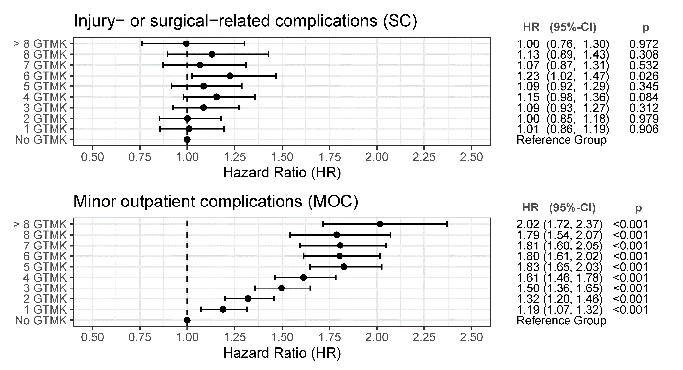

Figure S3: Influence of the individual GTMK on Major Adverse Events with adjustment for the patient risk profile. The influence was assessed for the subgroups of non-surgical (light gray), surgical (dark gray), and for the overall cohort (black diamond). The interaction p-values ($p_{int}$) are calculated using a Cox regression model that includes interaction terms for the individual GTMK and the binary operation variable and quantify the difference in GTMK influence between the non-operative and operative subgroups. Full regression results are presented in Table S7.
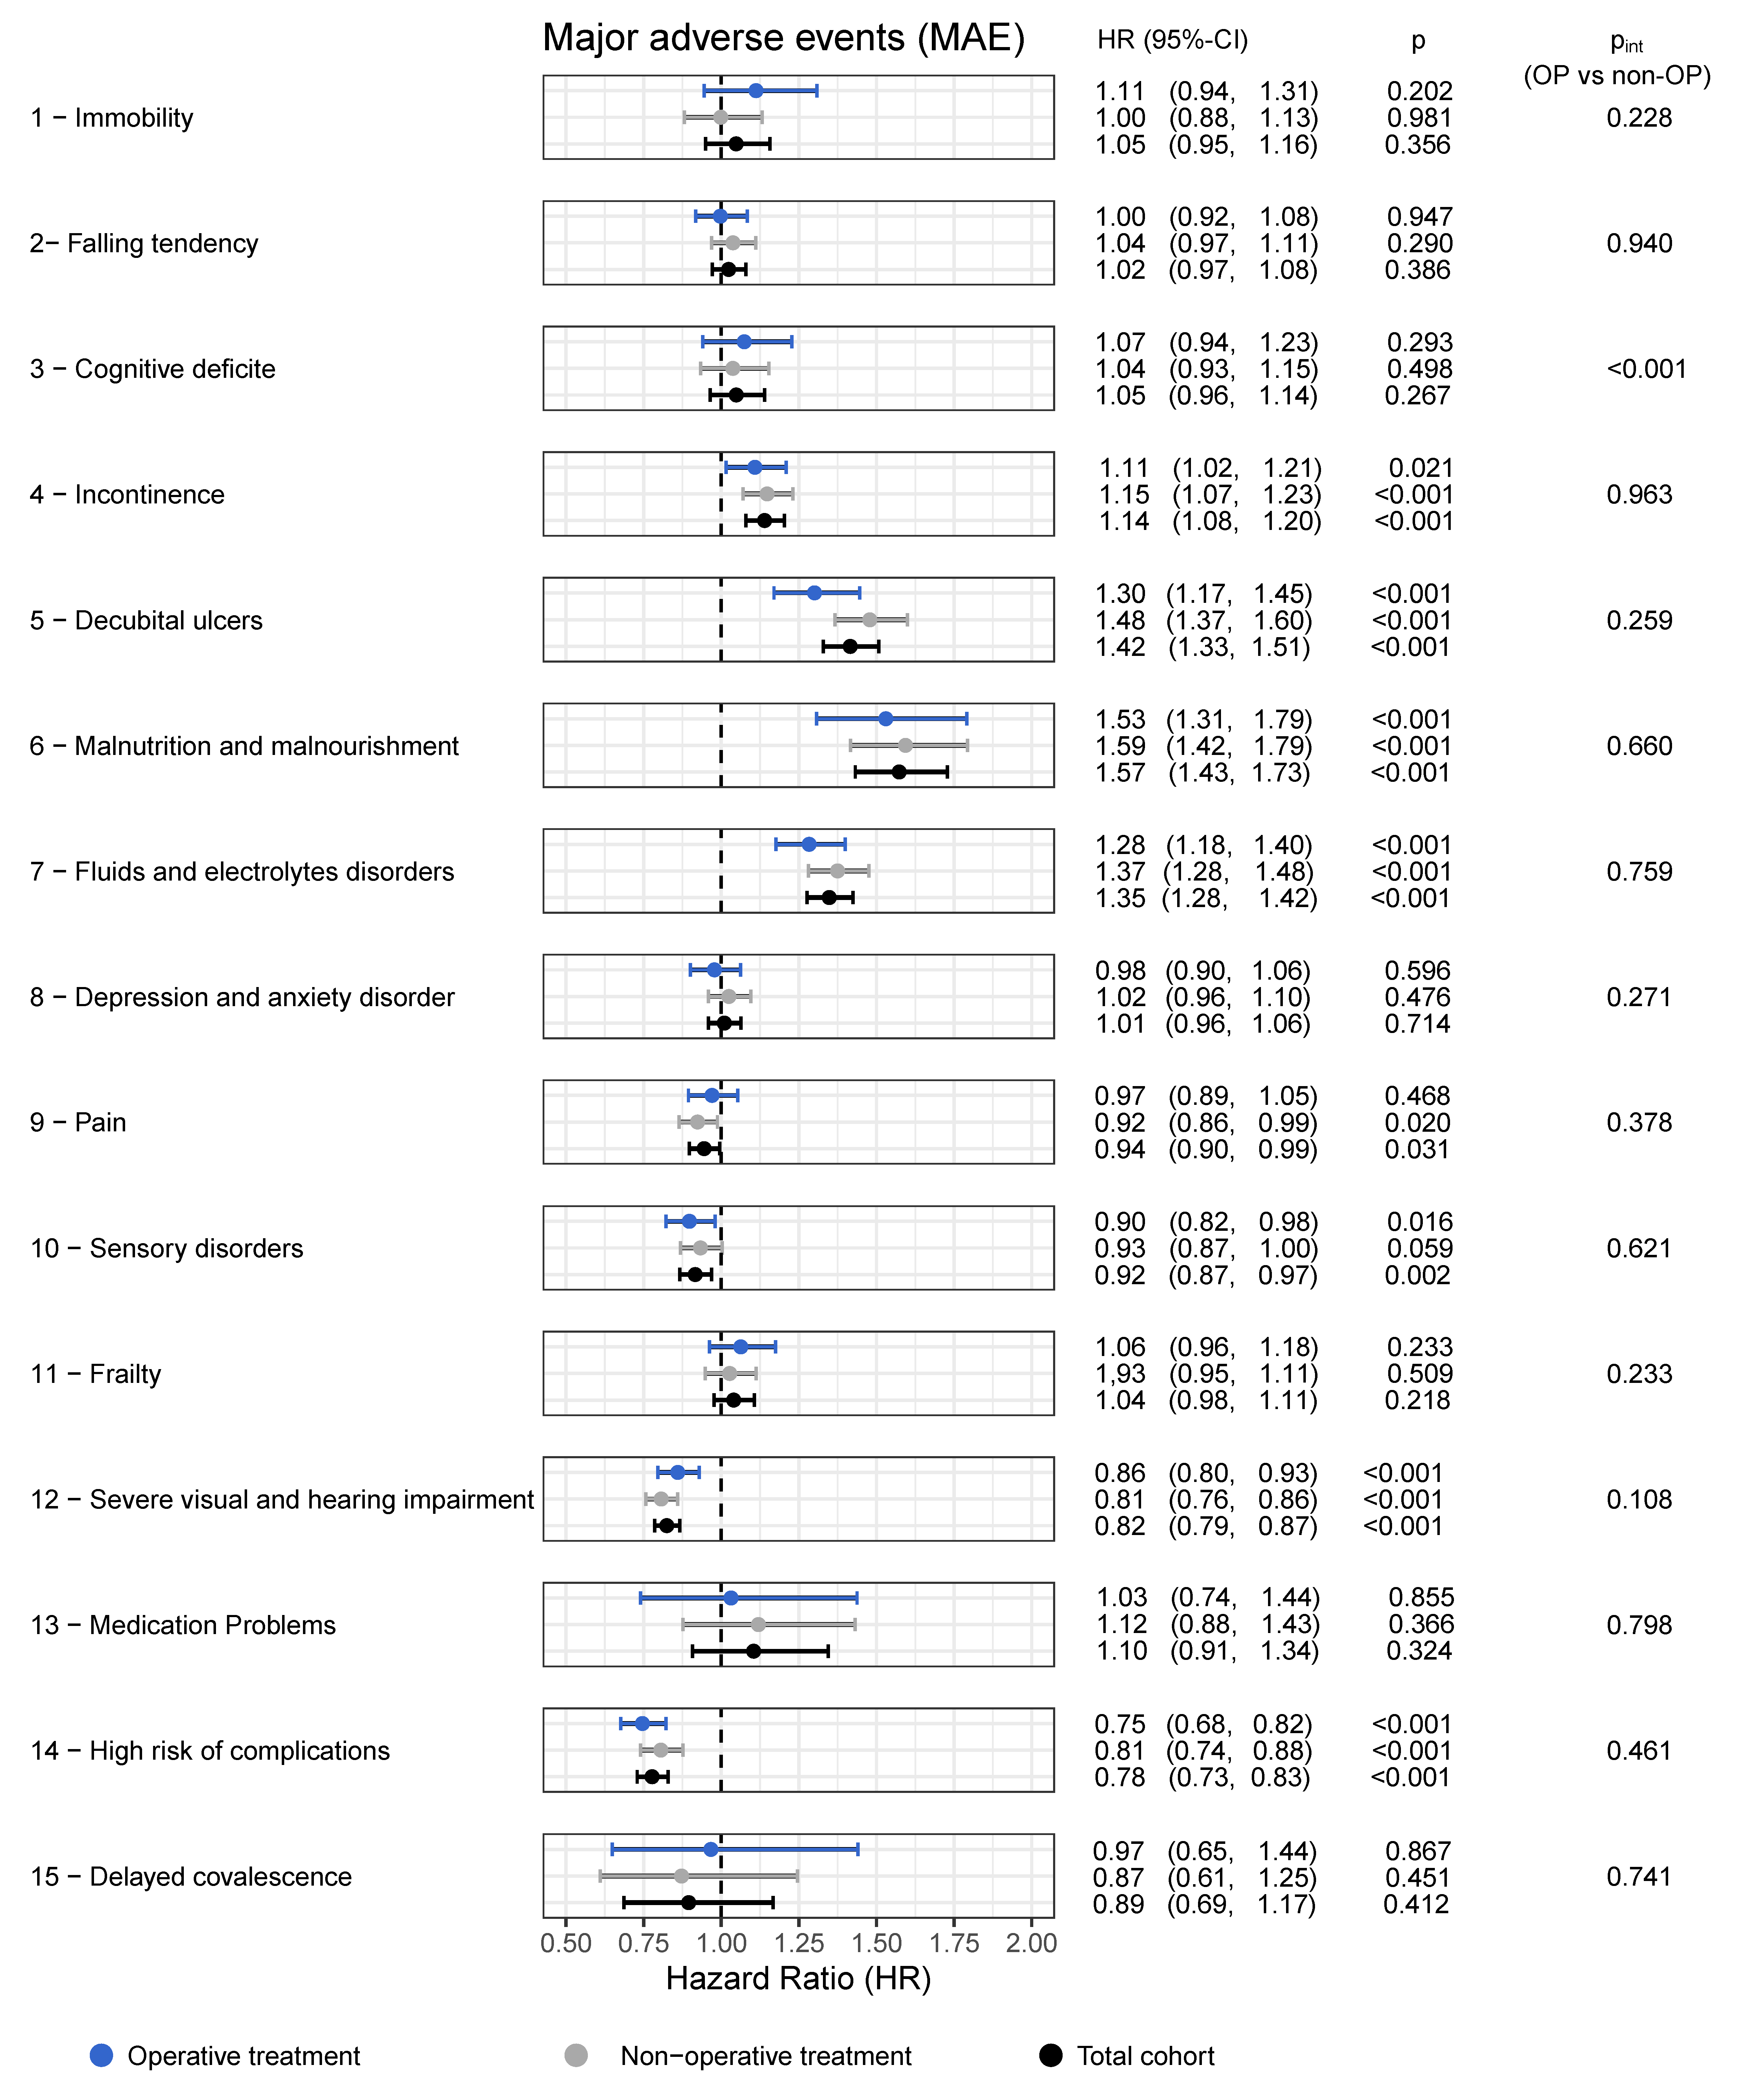

Figure S4: Influence of the individual GTMK on Thromboembolic Events with adjustment for the patient risk profile. The influence was assessed for the subgroups of non-surgical (light gray), Surgical (dark gray), And for the overall cohort (black diamond). The interaction p-values ($p_{int}$) are calculated using a Cox regression model that includes interaction terms for the individual GTMK and the binary operation variable and quantify the difference in GTMK influence between the non-operative and operative subgroups. Full regression results are presented in Table S8
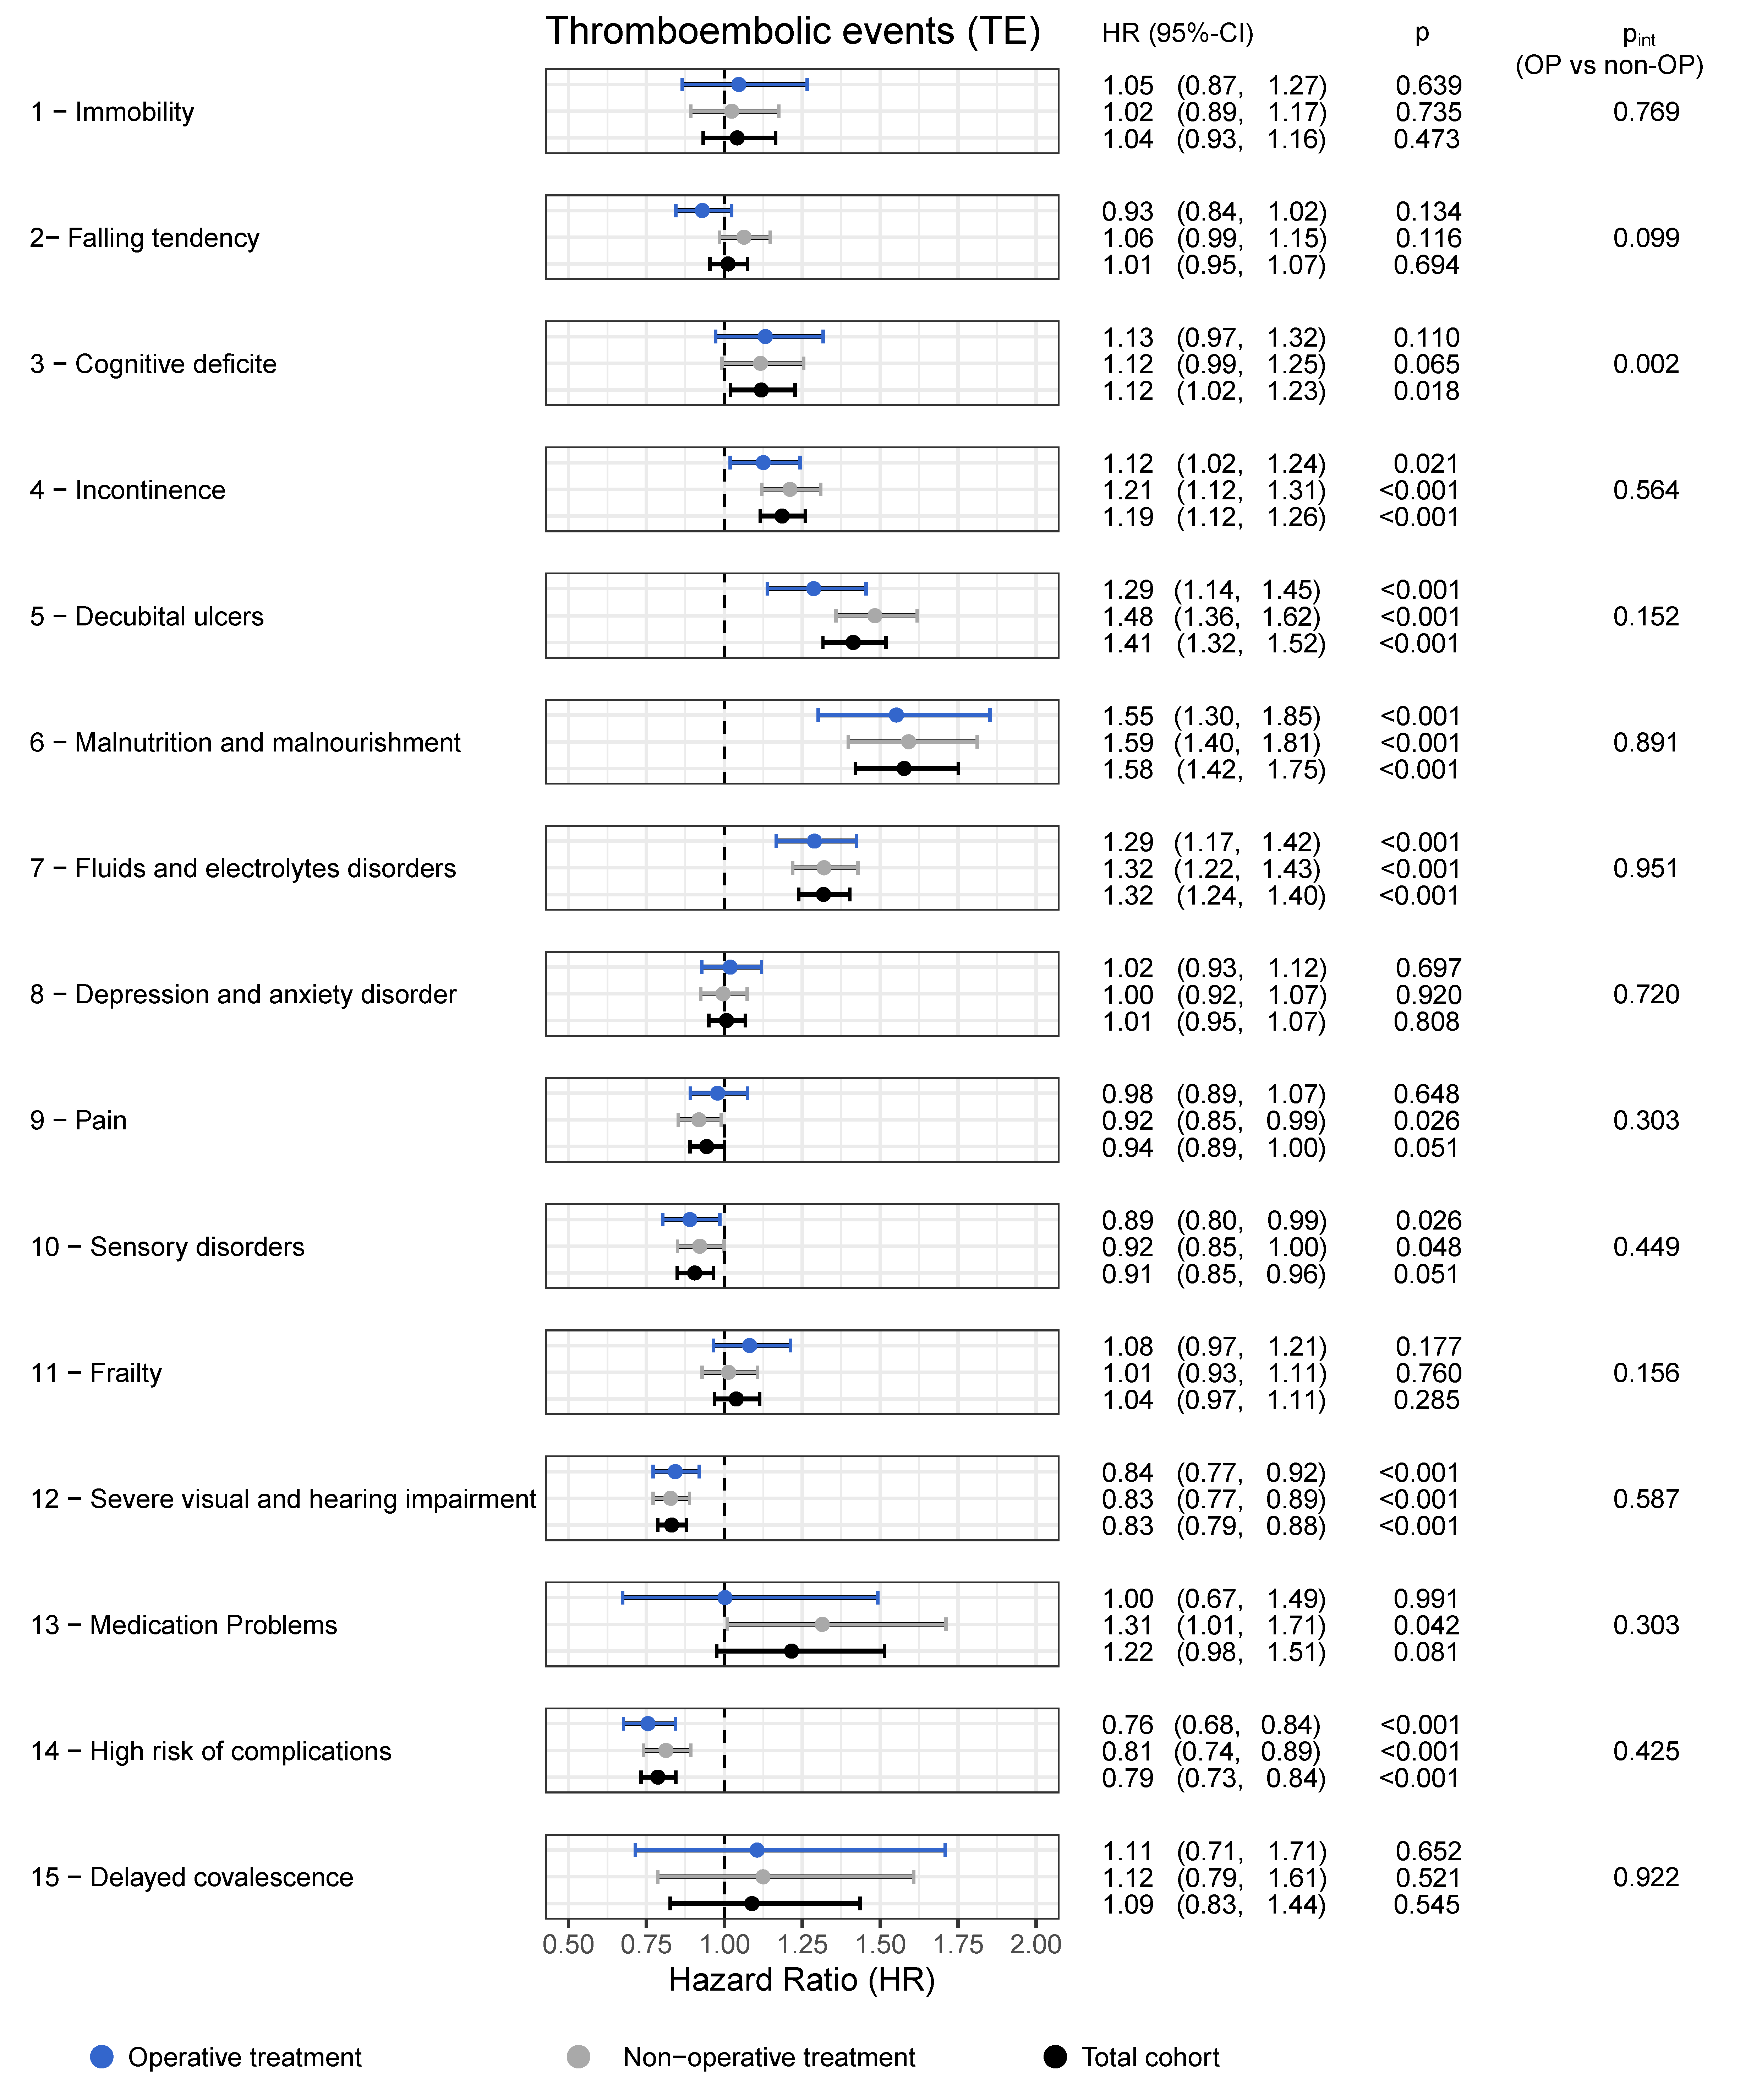

Figure S5: Influence of the individual GTMK on Injury- or Surgical-related complications with adjustment for the patient risk profile. The influence was assessed for the subgroups of non-surgical (light gray), Surgical (dark gray), And for the overall cohort (black diamond). The interaction p-values ($p_{int}$) are calculated using a Cox regression model that includes interaction terms for the individual GTMK and the binary operation variable and quantify the difference in GTMK influence between the non-operative and operative subgroups. Full regression results are presented in Table S9.

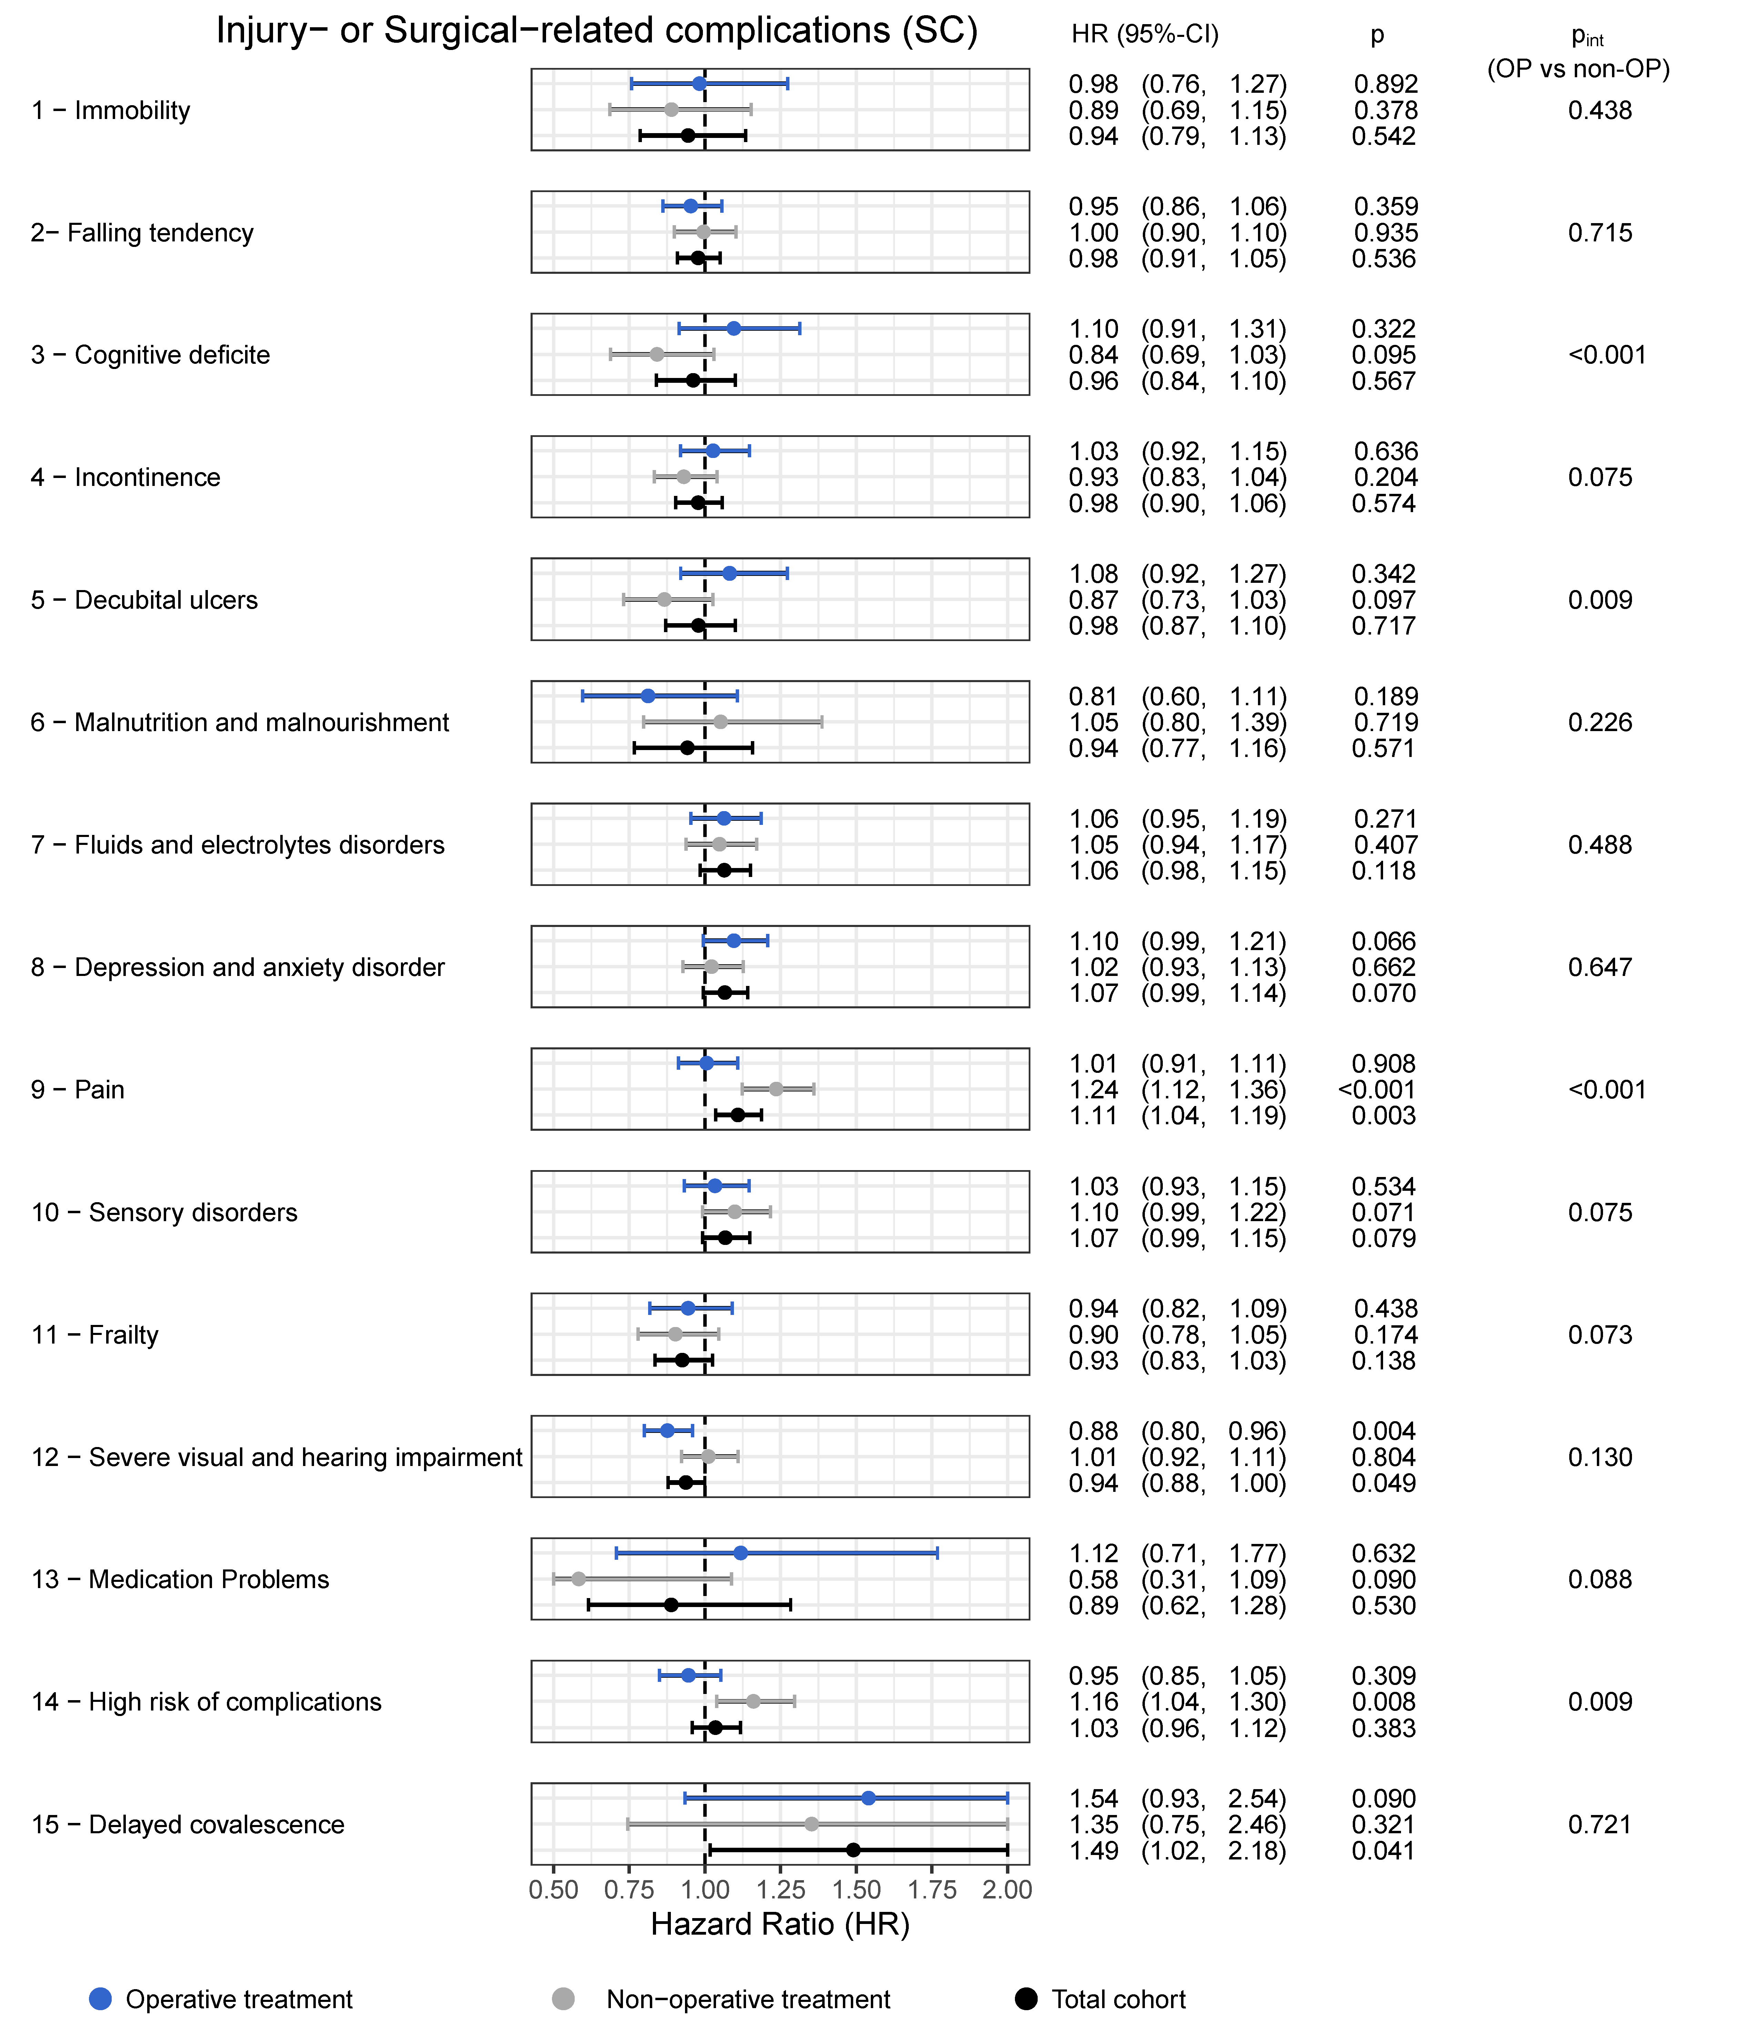

Figure S6: Influence of the individual GTMK on Minor outpatient complications with adjustment for the patient risk profile. The influence was assessed for the subgroups of non-surgical (light gray), Surgical (dark gray), And for the overall cohort (black diamond). The interaction p-values ($p_{int}$) are calculated using a Cox regression model that includes interaction terms for the individual GTMK and the binary operation variable and quantify the difference in GTMK influence between the non-operative and operative subgroups. Full regression results are presented in Table S10.

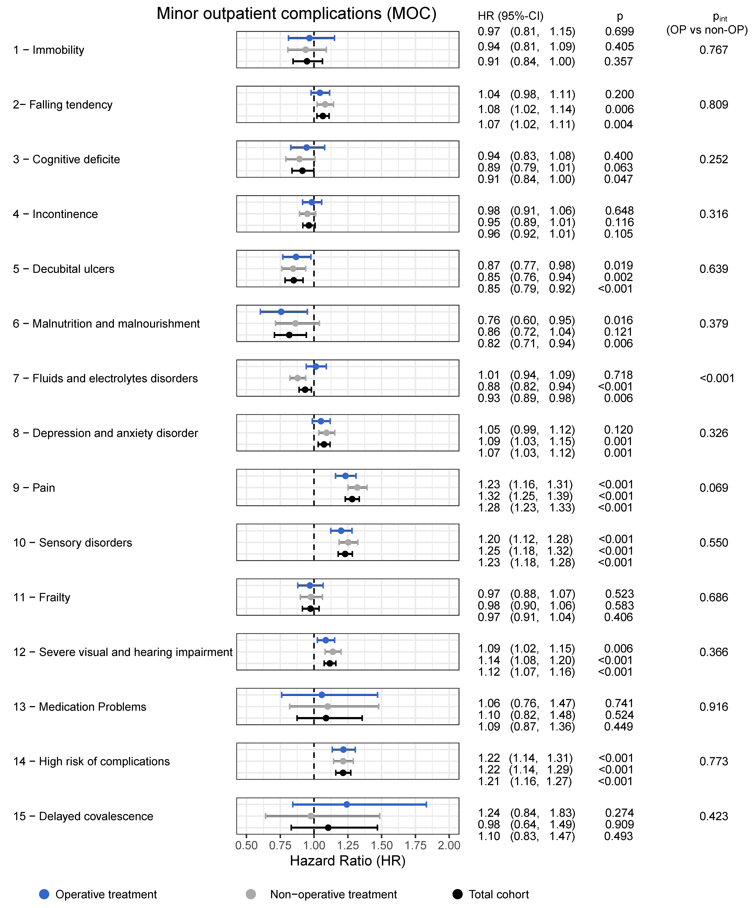

Table S3: Results of the Cox regression with mortality as the endpoint, including the treatment group, number of present GTMK at PHF diagnosis, patient (risk) profile, events occurring within 21 days after PHF diagnosis, and an end of follow-up 3 months after the start ft he observation.
Mortality
Variable |  | HR (95%-CI) | p
Treatment group  (Reference group: non-operative treatment) | sLPF | 0.61 (0.55, 0.68) | < 0.001
Treatment group  (Reference group: non-operative treatment) | LPF | 0.74 (0.61, 0.90) | 0.003
Treatment group  (Reference group: non-operative treatment) | RTSA | 0.68 (0.61, 0.76) | < 0.001
Treatment group  (Reference group: non-operative treatment) | Others | 0.87 (0.79, 0.96) | 0.004
Number of geriatric-typical characteristic complexes (GtMk) present at PHF diagnosis  (Reference group: no GTMK) | 1 GTMK | 0.73 (0.59, 0.90) | 0.004
 | 2 GTMK | 0.82 (0.67, 0.99) | 0.043
 | 3 GTMK | 0.80 (0.66, 0.96) | 0.020
 | 4 GTMK | 0.84 (0.70, 1.02) | 0.080
 | 5 GTMK | 1.00 (0.82, 1.21) | 0.963
 | 6 GTMK | 1.05 (0.86, 1.28) | 0.636
 | 7 GTMK | 1.13 (0.92, 1.38) | 0.242
 | 8 GTMK | 1.09 (0.88, 1.36) | 0.427
 | 9 and more GTMK | 1.18 (0.94, 1.47) | 0.145
Age in years at PHF diagnosis |  | 1,09 (1.08, 1.09) | < 0.001
Female Sex |  | 0,59 (0.54, 0.63) | < 0.001
Comorbidities | Cancer | 1.16 (1.08, 1.24) | < 0.001
Comorbidities | Diabetes | 1.15 (1.08, 1.23) | < 0.001
Comorbidities | Dementia | 1.82 (1.70, 1.96) | < 0.001
Comorbidities | Chronic polyarthritis | 1.02 (0.90, 1.16) | 0.761
Comorbidities | Obesity | 0.81 (0.74, 0.89) | < 0.001
Comorbidities | Nicotine abuse | 1.68 (1.48, 1.89) | < 0.001
Comorbidities | Parkinson | 1.13 (1.00, 1.27) | 0.056
Comorbidities | Rotator cuff rupture | 0.59 (0.44, 0.80) | 0.001
Comorbidities | Alcohol abuse | 1.62 (1.42, 1.85) | < 0.001
Comorbidities | Previous stroke | 1.00 (0.93, 1.07) | 0.938
Comorbidities | Omarthrosis | 0.84 (0.69, 1.02) | 0.081
Comorbidities | Frozen shoulder | 0.81 (0.67, 0.97) | 0.023
Comorbidities | Atrial fibrillation and atrial flutter | 1.39 (1.29, 1.50) | < 0.001
Comorbidities | Congestive heart failure | 1.46 (1.36, 1.56) | < 0.001
Comorbidities | Coronary heart disease | 1.00 (0.94, 1.07) | 0.933
Comorbidities | Hypertonus | 0.89 (0.79, 0.99) | 0.027
Comorbidities | Atherosclerosis | 1.01 (0.93, 1.09) | 0.875
Comorbidities | Chronic kidney disease | 1.31 (1.23, 1.41) | < 0.001
Comorbidities | Any anticoagulant | 1.01 (0.94, 1.09) | 0.703
Comorbidities | Vitamin D or Calcium | 0.93 (0.69, 1.26) | 0.643
Comorbidities | Bisphosphonate | 0.78 (0.59, 1.05) | 0.102
Comorbidities | Osteoporosis | 0.97 (0.90, 1.04) | 0.337
Comorbidities | Any osteoporosis medication | 1.24 (0.89, 1.71) | 0.200
Outpatient sector |  | 0.43 (0.39, 0.47) | < 0.001
Event within 21 days after diagnosis | Treatment change | 0.84 (0.65, 1.08) | 0.178
Event within 21 days after diagnosis | Thromboembolic event | 1.17 (0.50, 2.71) | 0.721
Event within 21 days after diagnosis | Injury-related event | 0.65 (0.50, 0.86) | 0.002
Event within 21 days after diagnosis | Major adverse event | 2.01 (1.21, 3.35) | 0.007
Event within 21 days after diagnosis | Minor outpatient event | 0.69 (0.52, 0.92) | 0.010

Table S4: Results of the Cox regression with major adverse events (MAE) as the endpoint, including the treatment group, number of present GTMK at PHF diagnosis, patient (risk) profile, events occurring within 21 days after PHF diagnosis, and an end of follow-up 3 months after the start of the observation.
Major adverse events (MAE)
Variable |  | HR (95%-CI) | p
Treatment group  (Reference group: non-operative treatment) | sLPF | 0.63 (0.58, 0.68) | < 0.001
Treatment group  (Reference group: non-operative treatment) | LPF | 0.72 (0.61, 0.84) | < 0.001
Treatment group  (Reference group: non-operative treatment) | RTSA | 0.83 (0.76, 0.89) | < 0.001
Treatment group  (Reference group: non-operative treatment) | Others | 0.86 (0.79, 0.92) | < 0.001
Number of geriatric-typical characteristic complexes (GtMk) present at PHF diagnosis  (Reference group: no GTMK) | 1 GTMK | 0.76 (0.65, 0.89) | 0.001
 | 2 GTMK | 0.79 (0.69, 0.92) | 0.002
 | 3 GTMK | 0.80 (0.69, 0.92) | 0.002
 | 4 GTMK | 0.86 (0.74, 0.99) | 0.040
 | 5 GTMK | 0.94 (0.81, 1.08) | 0.384
 | 6 GTMK | 0.98 (0.85, 1.14) | 0.842
 | 7 GTMK | 1.08 (0.92, 1.26) | 0.343
 | 8 GTMK | 1.05 (0.89, 1.24) | 0.589
 | 9 and more GTMK | 1.08 (0.91, 1.29) | 0.354
Age in years at PHF diagnosis |  | 1,06 (1.05, 1.06) | < 0.001
Female Sex |  | 0,64 (0.60, 0.68) | < 0.001
Comorbidities | Cancer | 1.08 (1.03, 1.14) | 0.003
Comorbidities | Diabetes | 1.20 (1.14, 1.27) | < 0.001
Comorbidities | Dementia | 1.53 (1.44, 1.62) | < 0.001
Comorbidities | Chronic polyarthritis | 1.04 (0.94, 1.15) | 0.421
Comorbidities | Obesity | 0.91 (0.85, 0.97) | 0.003
Comorbidities | Nicotine abuse | 1.50 (1.37, 1.65) | < 0.001
Comorbidities | Parkinson | 1.04 (0.94, 1.15) | 0.399
Comorbidities | Rotator cuff rupture | 0.68 (0.55, 0.84) | < 0.001
Comorbidities | Alcohol abuse | 1.61 (1.46, 1.78) | < 0.001
Comorbidities | Previous stroke | 1.08 (1.03, 1.14) | 0.004
Comorbidities | Omarthrosis | 0.87 (0.75, 1.01) | 0.076
Comorbidities | Frozen shoulder | 0.83 (0.72, 0.95) | 0.007
Comorbidities | Atrial fibrillation and atrial flutter | 1.40 (1.32, 1.48) | < 0.001
Comorbidities | Congestive heart failure | 1.40 (1.32, 1.48) | < 0.001
Comorbidities | Coronary heart disease | 1.02 (0.96, 1.07) | 0.537
Comorbidities | Hypertonus | 1.03 (0.94, 1.12) | 0.565
Comorbidities | Atherosclerosis | 1.02 (0.96, 1.08) | 0.566
Comorbidities | Chronic kidney disease | 1.54 (1.46, 1.63) | < 0.001
Comorbidities | Any anticoagulant | 1.05 (0.99, 1.11) | 0.117
Comorbidities | Vitamin D or Calcium | 0.93 (0.73, 1.18) | 0.547
Comorbidities | Bisphosphonate | 0.76 (0.60, 0.95) | 0.016
Comorbidities | Osteoporosis | 0.95 (0.90, 1.00) | 0.051
Comorbidities | Any osteoporosis medication | 1.27 (0.98, 1.63) | 0.067
Outpatient sector |  | 0.39 (0.36, 0.42) | < 0.001
Event within 21 days after diagnosis | Treatment change | 0.97 (0.82, 1.15) | 0.728
Event within 21 days after diagnosis | Thromboembolic event | 1.55 (0.89, 2.69) | 0.119
Event within 21 days after diagnosis | Injury-related event | 0.71 (0.58, 0.86) | < 0.001
Event within 21 days after diagnosis | Major adverse event | 2.73 (1.93, 3.88) | < 0.001
Event within 21 days after diagnosis | Minor outpatient event | 0.68 (0.55, 0.84) | < 0.001

Table S5: Results of the Cox regression with thromboembolic event (TE) as the endpoint, including the treatment group, number of present GTMK at PHF diagnosis, patient (risk) profile, events occurring within 21 days after PHF diagnosis, and an end of follow-up 3 months after the start of the observation.
Thromboembolic events (TE)
Variable |  | HR (95%-CI) | p
Treatment group  (Reference group: non-operative treatment) | sLPF | 0.64 (0.58, 0.7) | < 0.001
Treatment group  (Reference group: non-operative treatment) | LPF | 0.70 (0.59, 0.83) | < 0.001
Treatment group  (Reference group: non-operative treatment) | RTSA | 0.76 (0.69, 0.83) | < 0.001
Treatment group  (Reference group: non-operative treatment) | Others | 0.90 (0.82, 0.97) | 0.010
Number of geriatric-typical characteristic complexes (GtMk) present at PHF diagnosis  (Reference group: no GTMK) | 1 GTMK | 0.80 (0.67, 0.95) | 0.011
 | 2 GTMK | 0.79 (0.67, 0.93) | 0.005
 | 3 GTMK | 0.82 (0.69, 0.96) | 0.014
 | 4 GTMK | 0.88 (0.75, 1.03) | 0.109
 | 5 GTMK | 0.99 (0.84, 1.16) | 0.859
 | 6 GTMK | 1.07 (0.90, 1.26) | 0.450
 | 7 GTMK | 1.12 (0.94, 1.33) | 0.206
 | 8 GTMK | 1.09 (0.91, 1.32) | 0.351
 | 9 and more GTMK | 1.14 (0.94, 1.38) | 0.180
Age in years at PHF diagnosis |  | 1,07 (1.07, 1.07) | < 0.001
Female Sex |  | 0,66 (0.62, 0.71) | < 0.001
Comorbidities | Cancer | 1.10 (1.04, 1.17) | 0.001
Comorbidities | Diabetes | 1.15 (1.08, 1.22) | < 0.001
Comorbidities | Dementia | 1.69 (1.58, 1.80) | < 0.001
Comorbidities | Chronic polyarthritis | 1.01 (0.90, 1.13) | 0.831
Comorbidities | Obesity | 0.86 (0.79, 0.92) | < 0.001
Comorbidities | Nicotine abuse | 1.55 (1.39, 1.72) | < 0.001
Comorbidities | Parkinson | 1.08 (0.97, 1.21) | 0.167
Comorbidities | Rotator cuff rupture | 0.58 (0.45, 0.76) | < 0.001
Comorbidities | Alcohol abuse | 1.50 (1.33, 1.68) | < 0.001
Comorbidities | Previous stroke | 1.10 (1.04, 1.17) | 0.002
Comorbidities | Omarthrosis | 0.88 (0.74, 1.04) | 0.135
Comorbidities | Frozen shoulder | 0.80 (0.68, 0.94) | 0.006
Comorbidities | Atrial fibrillation and atrial flutter | 1.32 (1.23, 1.41) | < 0.001
Comorbidities | Congestive heart failure | 1.32 (1.24, 1.41) | < 0.001
Comorbidities | Coronary heart disease | 1.00 (0.94, 1.07) | 0.928
Comorbidities | Hypertonus | 0.95 (0.87, 1.05) | 0.326
Comorbidities | Atherosclerosis | 1.02 (0.96, 1.09) | 0.522
Comorbidities | Chronic kidney disease | 1.26 (1.18, 1.34) | < 0.001
Comorbidities | Any anticoagulant | 1.05 (0.98, 1.12) | 0.175
Comorbidities | Vitamin D or Calcium | 0.95 (0.73, 1.23) | 0.697
Comorbidities | Bisphosphonate | 0.81 (0.63, 1.04) | 0.102
Comorbidities | Osteoporosis | 0.97 (0.91, 1.03) | 0.288
Comorbidities | Any osteoporosis medication | 1.19 (0.90, 1.57) | 0.227
Outpatient sector |  | 0.42 (0.38, 0.45) | < 0.001
Event within 21 days after diagnosis | Treatment change | 0.84 (0.68, 1.04) | 0.112
Event within 21 days after diagnosis | Thromboembolic event | 2.96 (1.58, 5.56) | 0.001
Event within 21 days after diagnosis | Injury-related event | 0.68 (0.54, 0.86) | 0.001
Event within 21 days after diagnosis | Major adverse event | 1.87 (1.17, 3.00) | 0.009
Event within 21 days after diagnosis | Minor outpatient event | 0.77 (0.61, 0.97) | 0.025

Table S6: Results of the Cox regression with injury- or surgical related complications (SC) as the endpoint and death as competing event, including the treatment group, number of present GTMK at PHF diagnosis, patient (risk) profile, events occurring within 21 days after PHF diagnosis, and an end of follow-up 3 months after the start of the observation.
Injury- or surgical related complications (SC)
Variable |  | HR (95%-CI) | p
Treatment group  (Reference group: non-operative treatment) | sLPF | 0.66 (0.59, 0.75) | < 0.001
Treatment group  (Reference group: non-operative treatment) | LPF | 0.58 (0.45, 0.75) | < 0.001
Treatment group  (Reference group: non-operative treatment) | RTSA | 0.69 (0.61, 0.78) | < 0.001
Treatment group  (Reference group: non-operative treatment) | Others | 0.78 (0.69, 0.87) | < 0.001
Number of geriatric-typical characteristic complexes (GtMk) present at PHF diagnosis  (Reference group: no GTMK) | 1 GTMK | 1.01 (0.86, 1.19) | 0.906
 | 2 GTMK | 1.00 (0.85, 1.18) | 0.979
 | 3 GTMK | 1.09 (0.93, 1.27) | 0.312
 | 4 GTMK | 1.15 (0.98, 1.36) | 0.084
 | 5 GTMK | 1.09 (0.92, 1.29) | 0.345
 | 6 GTMK | 1.23 (1.02, 1.47) | 0.026
 | 7 GTMK | 1.07 (0.87, 1.31) | 0.532
 | 8 GTMK | 1.13 (0.89, 1.43) | 0.308
 | 9 and more GTMK | 1.00 (0.76, 1.30) | 0.972
Age in years at PHF diagnosis |  | 0,99 (0,99, 1.00) | 0.012
Female Sex |  | 0,80 (0,74, 0,87) | < 0.001
Comorbidities | Cancer | 1.04 (0.97, 1.12) | 0.228
Comorbidities | Diabetes | 1.01 (0.94, 1.08) | 0.792
Comorbidities | Dementia | 0.97 (0.88, 1.08) | 0.627
Comorbidities | Chronic polyarthritis | 0.98 (0.86, 1.11) | 0.745
Comorbidities | Obesity | 1.18 (1.09, 1.27) | < 0.001
Comorbidities | Nicotine abuse | 1.13 (1.01, 1.27) | 0.039
Comorbidities | Parkinson | 1.31 (1.14, 1.51) | < 0.001
Comorbidities | Rotator cuff rupture | 1.53 (1.30, 1.80) | < 0.001
Comorbidities | Alcohol abuse | 1.49 (1.33, 1.68) | < 0.001
Comorbidities | Previous stroke | 0.91 (0.84, 0.98) | 0.013
Comorbidities | Omarthrosis | 1.01 (0.85, 1.22) | 0.876
Comorbidities | Frozen shoulder | 1.07 (0.92, 1.24) | 0.396
Comorbidities | Atrial fibrillation and atrial flutter | 1.07 (0.98, 1.17) | 0.143
Comorbidities | Congestive heart failure | 1.11 (1.02, 1.20) | 0.015
Comorbidities | Coronary heart disease | 0.98 (0.91, 1.06) | 0.671
Comorbidities | Hypertonus | 1.11 (1.01, 1.22) | 0.036
Comorbidities | Atherosclerosis | 0.98 (0.90, 1.07) | 0.692
Comorbidities | Chronic kidney disease | 1.09 (1.00, 1.17) | 0.039
Comorbidities | Any anticoagulant | 1.02 (0.94, 1.11) | 0.632
Comorbidities | Vitamin D or Calcium | 1.00 (0.76, 1.32) | 0.994
Comorbidities | Bisphosphonate | 1.11 (0.84, 1.46) | 0.463
Comorbidities | Osteoporosis | 1.09 (1.01, 1.18) | 0.021
Comorbidities | Any osteoporosis medication | 0.95 (0.70, 1.29) | 0.745
Outpatient sector |  | 0.86 (0.78, 0.94) | 0.002
Event within 21 days after diagnosis | Treatment change | 18.85 (16.89, 21.04) | < 0.001
Event within 21 days after diagnosis | Thromboembolic event | 0.89 (0.23, 3.36) | 0.861
Event within 21 days after diagnosis | Injury-related event | 1.25 (1.03, 1.52) | 0.025
Event within 21 days after diagnosis | Major adverse event | 2.38 (1.15, 4.95) | 0.020
Event within 21 days after diagnosis | Minor outpatient event | 1.30 (1.11, 1.52) | 0.001

Table S7: Results of the Cox regression with minor outpatient complications (SC) as the endpoint and death as competing event, including the treatment group, number of present GTMK at PHF diagnosis, patient (risk) profile, events occurring within 21 days after PHF diagnosis, and an end of follow-up 3 months after the start of the observation
Minor outpatient complications (MOC)
Variable |  | HR (95%-CI) | p
Treatment group  (Reference group: non-operative treatment) | sLPF | 1.05 (0.99, 1.12) | 0.100
Treatment group  (Reference group: non-operative treatment) | LPF | 1.01 (0.89, 1.14) | 0.879
Treatment group  (Reference group: non-operative treatment) | RTSA | 1.21 (1.13, 1.30) | < 0.001
Treatment group  (Reference group: non-operative treatment) | Others | 1.13 (1.05, 1.21) | 0.001
Number of geriatric-typical characteristic complexes (GtMk) present at PHF diagnosis  (Reference group: no GTMK) | 1 GTMK | 1.19 (1.07, 1.32) | 0.001
 | 2 GTMK | 1.32 (1.20, 1.46) | < 0.001
 | 3 GTMK | 1.50 (1.36, 1.65) | < 0.001
 | 4 GTMK | 1.61 (1.46, 1.78) | < 0.001
 | 5 GTMK | 1.83 (1.65, 2.03) | < 0.001
 | 6 GTMK | 1.80 (1.61, 2.02) | < 0.001
 | 7 GTMK | 1.81 (1.60, 2.05) | < 0.001
 | 8 GTMK | 1.79 (1.54, 2.07) | < 0.001
 | 9 and more GTMK | 2.02 (1.72, 2.37) | < 0.001
Age in years at PHF diagnosis |  | 0.97 (0.97, 0.98) | < 0.001
Female Sex |  | 0.93 (0.89, 0.98) | 0.011
Comorbidities | Cancer | 1.04 (1.00, 1.08) | 0.076
Comorbidities | Diabetes | 0.96 (0.92, 1.00) | 0.052
Comorbidities | Dementia | 0.69 (0.64, 0.74) | < 0.001
Comorbidities | Chronic polyarthritis | 1.07 (1.00, 1.15) | 0.060
Comorbidities | Obesity | 1.12 (1.07, 1.18) | < 0.001
Comorbidities | Nicotine abuse | 0.92 (0.86, 1.00) | 0.038
Comorbidities | Parkinson | 0.87 (0.78, 0.97) | 0.010
Comorbidities | Rotator cuff rupture | 1.92 (1.78, 2.08) | < 0.001
Comorbidities | Alcohol abuse | 0.89 (0.82, 0.98) | 0.014
Comorbidities | Previous stroke | 1.07 (1.03, 1.12) | 0.002
Comorbidities | Omarthrosis | 1.80 (1.67, 1.94) | < 0.001
Comorbidities | Frozen shoulder | 3.37 (3.18, 3.56) | < 0.001
Comorbidities | Atrial fibrillation and atrial flutter | 0.90 (0.85, 0.96) | 0.001
Comorbidities | Congestive heart failure | 0.97 (0.92, 1.02) | 0.185
Comorbidities | Coronary heart disease | 1.04 (0.99, 1.09) | 0.100
Comorbidities | Hypertonus | 1.05 (0.99, 1.10) | 0.108
Comorbidities | Atherosclerosis | 1.00 (0.95, 1.06) | 0.903
Comorbidities | Chronic kidney disease | 1.00 (0.95, 1.05) | 0.952
Comorbidities | Any anticoagulant | 0.94 (0.90, 0.99) | 0.018
Comorbidities | Vitamin D or Calcium | 1.05 (0.90, 1.23) | 0.530
Comorbidities | Bisphosphonate | 1.05 (0.90, 1.23) | 0.528
Comorbidities | Osteoporosis | 1.12 (1.07, 1.17) | < 0.001
Comorbidities | Any osteoporosis medication | 0.97 (0.82, 1.16) | 0.779
Outpatient sector |  | 1.02 (0.96, 1.07) | 0.578
Event within 21 days after diagnosis | Treatment change | 1.49 (1.34, 1.67) | < 0.001
Event within 21 days after diagnosis | Thromboembolic event | 3.04 (0.98, 9.46) | 0.055
Event within 21 days after diagnosis | Injury-related event | 3.26 (3.01, 3.54) | < 0.001
Event within 21 days after diagnosis | Major adverse event | 0.45 (0.18, 1.10) | 0.079
Event within 21 days after diagnosis | Minor outpatient event | 3.00 (2.82, 3.21) | < 0.001

Table S8: Results of the Cox regression models with mortality as an outcome for the overall cohort, the subgroup of those who underwent surgery within 21 days of PHF diagnosis, and those who did not. Included variables are current GTMK at the time of PHF diagnosis, patient (risk) profile, and events that occurred within 21 days of PHF diagnosis, with an end of follow-up 3 months after the start of observation. The difference between operative and non-operative treatment within individual GTMK is quantified with the interaction p value $p_{int}$. This comes from a Cox regression which, in addition to the influencing factors listed here, also includes the interaction between operation and the individual GTMK.
Mortality
 | Total cohort |  | Subgroup:  Operative Treatment |  | Subgroup:  Non-Operative Treatment |  | OP vs no OP
Variable | HR (95%-CI) | p | HR (95%-CI) | P | HR (95%-CI) | p | P_{int}
Immobility | 1.05 (0.93, 1.18) | 0.478 | 1.15 (0.93, 1.41) | 0.198 | 0.98 (0.84, 1.14) | 0.809 | 0.194
Falling tendency | 0.98 (0.92, 1.05) | 0.656 | 0.91 (0.82, 1.02) | 0.114 | 1.02 (0.94, 1.11) | 0.633 | 0.311
Cognitive deficits | 1.14 (1.03, 1.26) | 0.014 | 1.16 (0.97, 1.38) | 0.097 | 1.13 (1.00, 1.29) | 0.059 | 0.002
Incontinence | 1.22 (1.13, 1.30) | < 0.001 | 1.16 (1.03, 1.30) | 0.013 | 1.23 (1.13, 1.35) | < 0.001 | 0.771
Decubital ulcers | 1.51 (1.40, 1.63) | < 0.001 | 1.35 (1.17, 1.54) | < 0.001 | 1.59 (1.45, 1.75) | < 0.001 | 0.148
Malnutrition and malnourishment | 1.68 (1.51, 1.88) | < 0.001 | 1.66 (1.37, 2.01) | < 0.001 | 1.70 (1.48, 1.95) | < 0.001 | 0.872
Fluids and electrolytes disorders | 1.40 (1.30, 1.50) | < 0.001 | 1.33 (1.18, 1.49) | < 0.001 | 1.42 (1.30, 1.55) | < 0.001 | 0.698
Depression and anxiety disorders | 1.01 (0.95, 1.08) | 0.692 | 1.03 (0.92, 1.15) | 0.620 | 1.00 (0.92, 1.09) | 0.998 | 0.789
Pain | 0.93 (0.87, 1.00) | 0.036 | 0.98 (0.88, 1.10) | 0.744 | 0.90 (0.83, 0.98) | 0.015 | 0.219
Sensory disorders | 0.89 (0.82, 0.95) | 0.001 | 0.88 (0.78, 0.99) | 0.036 | 0.90 (0.82, 0.98) | 0.020 | 0.607
Frailty | 1.03 (0.95, 1.11) | 0.433 | 1.07 (0.94, 1.22) | 0.297 | 1.01 (0.92, 1.11) | 0.838 | 0.170
Severe visual and hearing impairment | 0.79 (0.74, 0.84) | < 0.001 | 0.80 (0.72, 0.88) | < 0.001 | 0.79 (0.73, 0.85) | < 0.001 | 0.647
Medication problems | 1.23 (0.97, 1.57) | 0.090 | 1.13 (0.73, 1.75) | 0.582 | 1.26 (0.94, 1.7) | 0.117 | 0.709
High risk of complications | 0.75 (0.69, 0.81) | < 0.001 | 0.71 (0.62, 0.81) | < 0.001 | 0.78 (0.7, 0.86) | < 0.001 | 0.452
Delayed convalescence | 0.98 (0.71, 1.34) | 0.878 | 1.16 (0.72, 1.85) | 0.547 | 0.90 (0.58, 1.39) | 0.632 | 0.456
Age in years at PHF diagnosis | 1.09 (1.08, 1.10) | < 0.001 | 1.10 (1.09, 1.11) | < 0.001 | 1.08 (1.07, 1.08) | < 0.001
Female Sex | 0.57 (0.53, 0.61) | < 0.001 | 0.57 (0.50, 0.65) | < 0.001 | 0.58 (0.53, 0.64) | < 0.001
Cancer | 1.19 (1.11, 1.27) | < 0.001 | 1.15 (1.03, 1.28) | 0.013 | 1.22 (1.12, 1.32) | < 0.001
Diabetes | 1.18 (1.10, 1.26) | < 0.001 | 1.19 (1.07, 1.33) | 0.002 | 1.16 (1.07, 1.27) | < 0.001
Dementia | 1.59 (1.44, 1.76) | < 0.001 | 1.81 (1.53, 2.15) | < 0.001 | 1.45 (1.28, 1.65) | < 0.001
Chronic polyarthritis | 1.05 (0.92, 1.19) | 0.501 | 1.00 (0.80, 1.25) | 0.997 | 1.05 (0.9, 1.24) | 0.533
Obesity | 0.84 (0.77, 0.92) | < 0.001 | 0.87 (0.75, 1.01) | 0.068 | 0.83 (0.74, 0.93) | 0.002
Nicotine abuse | 1.62 (1.43, 1.83) | < 0.001 | 1.63 (1.34, 1.99) | < 0.001 | 1.60 (1.37, 1.87) | < 0.001
Parkinson | 1.11 (0.98, 1.25) | 0.099 | 1.21 (0.99, 1.47) | 0.060 | 1.03 (0.89, 1.21) | 0.668
Rotator cuff rupture | 0.55 (0.41, 0.74) | < 0.001 | 0.67 (0.47, 0.95) | 0.023 | 0.41 (0.22, 0.77) | 0.006
Alcohol abuse | 1.53 (1.34, 1.75) | < 0.001 | 1.73 (1.41, 2.12) | < 0.001 | 1.41 (1.18, 1.68) | < 0.001
Previous stroke | 1.03 (0.96, 1.10) | 0.402 | 1.05 (0.94, 1.17) | 0.408 | 1.01 (0.93, 1.10) | 0.848
Omarthrosis | 0.9 (0.74, 1.10) | 0.305 | 0.84 (0.59, 1.20) | 0.348 | 0.93 (0.74, 1.18) | 0.548
Frozen shoulder | 0.85 (0.71, 1.02) | 0.082 | 0.88 (0.65, 1.19) | 0.396 | 0.83 (0.66, 1.05) | 0.120
Atrial fibrillation and atrial flutter | 1.46 (1.35, 1.58) | < 0.001 | 1.49 (1.31, 1.69) | < 0.001 | 1.42 (1.29, 1.57) | < 0.001
Congestive heart failure | 1.37 (1.28, 1.47) | < 0.001 | 1.39 (1.23, 1.56) | < 0.001 | 1.35 (1.24, 1.48) | < 0.001
Coronary heart disease | 1.03 (0.96, 1.11) | 0.366 | 1.09 (0.97, 1.22) | 0.147 | 1.00 (0.92, 1.09) | 0.980
Hypertonus | 0.9 (0.81, 1.01) | 0.068 | 0.89 (0.75, 1.06) | 0.192 | 0.92 (0.80, 1.05) | 0.202
Atherosclerosis | 1.02 (0.94, 1.10) | 0.678 | 1.06 (0.93, 1.20) | 0.381 | 0.99 (0.90, 1.09) | 0.866
Chronic kidney disease | 1.28 (1.19, 1.37) | < 0.001 | 1.24 (1.11, 1.39) | < 0.001 | 1.29 (1.19, 1.41) | < 0.001
Any anticoagulant | 1.01 (0.94, 1.09) | 0.793 | 0.98 (0.86, 1.10) | 0.696 | 1.02 (0.93, 1.11) | 0.749
Vitamin D or Calcium | 0.92 (0.68, 1.25) | 0.588 | 0.74 (0.44, 1.26) | 0.268 | 1.03 (0.71, 1.5) | 0.881
Bisphosphonate | 0.79 (0.59, 1.06) | 0.118 | 0.62 (0.37, 1.02) | 0.062 | 0.92 (0.65, 1.32) | 0.659
Osteoporosis | 0.99 (0.92, 1.06) | 0.693 | 1.00 (0.89, 1.12) | 0.986 | 0.98 (0.89, 1.07) | 0.603
Any osteoporosis medication | 1.25 (0.90, 1.73) | 0.179 | 1.72 (0.99, 3.00) | 0.056 | 1.04 (0.70. 1.56) | 0.830
Outpatient sector | 0.50 (0.46, 0.55) | < 0.001 | 0.79 (0.26, 2.47) | 0.692 | 0.42 (0.38, 0.46) | < 0.001
Treatment change within 21 days after diagnosis | 0.73 (0.57, 0.94) | 0.014 | 0.86 (0.67, 1.12) | 0.264
Thromboembolic event within 21 days after diagnosis | 1.32 (0.57, 3.05) | 0.521 | 0.34 (0.04, 2.95) | 0.325 | 1.83 (0.72. 4.63) | 0.202
Injury-related event within 21 days after diagnosis | 0.72 (0.55, 0.94) | 0.015 | 0.91 (0.56, 1.47) | 0.694 | 0.59 (0.43. 0.82) | 0.002
Major adverse event within 21 days after diagnosis | 2.05 (1.23, 3.41) | 0.006 | 3.53 (1.33, 9.37) | 0.011 | 1.59 (0.88. 2.90) | 0.126
Minor outpatient event within 21 days after diagnosis | 0.72 (0.54, 0.95) | 0.019 | 0.55 (0.26, 1.15) | 0.112 | 0.76 (0.56. 1.03) | 0.075

Table S9: Results of the Cox regression models with major adverse event as an outcome for the overall cohort, the subgroup of those who underwent surgery within 21 days of PHF diagnosis, and those who did not. Included variables are current GTMK at the time of PHF diagnosis, patient (risk) profile, and events that occurred within 21 days of PHF diagnosis, with an end of follow-up 3 months after the start of observation. The difference between operative and non-operative treatment within individual GTMK is quantified with the interaction p value $p_{int}$. This comes from a Cox regression which, in addition to the influencing factors listed here, also includes the interaction between operation and the individual GTMK.
Major adverse event (MAE)
 | Total cohort |  | Subgroup:  Operative Treatment |  | Subgroup:  Non-Operative Treatment |  | OP vs no OP
Variable | HR (95%-CI) | p | HR (95%-CI) | p | HR (95%-CI) | p | P_{int}
Immobility | 1.05 (0.95, 1.16) | 0.356 | 1.11 (0.94, 1.31) | 0.202 | 1.00 (0.88, 1.13) | 0.981 | 0.228
Falling tendency | 1.02 (0.97, 1.08) | 0.386 | 1.00 (0.92, 1.08) | 0.947 | 1.04 (0.97, 1.11) | 0.290 | 0.940
Cognitive deficits | 1.05 (0.96, 1.14) | 0.267 | 1.07 (0.94, 1.23) | 0.293 | 1.04 (0.93, 1.15) | 0.498 | <0.001
Incontinence | 1.14 (1.08, 1.20) | < 0.001 | 1.11 (1.02, 1.21) | 0.021 | 1.15 (1.07, 1.23) | < 0.001 | 0.963
Decubital ulcers | 1.42 (1.33, 1.51) | < 0.001 | 1.30 (1.17, 1.45) | < 0.001 | 1.48 (1.37, 1.60) | < 0.001 | 0.259
Malnutrition and malnourishment | 1.57 (1.43, 1.73) | < 0.001 | 1.53 (1.31, 1.79) | < 0.001 | 1.59 (1.42, 1.79) | < 0.001 | 0.660
Fluids and electrolytes disorders | 1.35 (1.28, 1.42) | < 0.001 | 1.28 (1.18, 1.40) | < 0.001 | 1.37 (1.28, 1.48) | < 0.001 | 0.759
Depression and anxiety disorders | 1.01 (0.96, 1.06) | 0.714 | 0.98 (0.90, 1.06) | 0.596 | 1.02 (0.96, 1.10) | 0.476 | 0.271
Pain | 0.94 (0.90, 0.99) | 0.031 | 0.97 (0.89, 1.05) | 0.468 | 0.92 (0.86, 0.99) | 0.020 | 0.378
Sensory disorders | 0.92 (0.87, 0.97) | 0.002 | 0.90 (0.82, 0.98) | 0.016 | 0.93 (0.87, 1.00) | 0.059 | 0.621
Frailty | 1.04 (0.98, 1.11) | 0.218 | 1.06 (0.96, 1.18) | 0.233 | 1.03 (0.95, 1.11) | 0.509 | 0.233
Severe visual and hearing impairment | 0.82 (0.79, 0.87) | < 0.001 | 0.86 (0.80, 0.93) | < 0.001 | 0.81 (0.76, 0.86) | < 0.001 | 0.108
Medication problems | 1.10 (0.91, 1.34) | 0.324 | 1.03 (0.74, 1.44) | 0.855 | 1.12 (0.88, 1.43) | 0.366 | 0.798
High risk of complications | 0.78 (0.73, 0.83) | < 0.001 | 0.75 (0.68, 0.82) | < 0.001 | 0.81 (0.74, 0.88) | < 0.001 | 0.461
Delayed convalescence | 0.89 (0.69, 1.17) | 0.412 | 0.97 (0.65, 1.44) | 0.867 | 0.87 (0.61, 1.25) | 0.451 | 0.741
Age in years at PHF diagnosis | 1.06 (1.05, 1.06) | < 0.001 | 1.06 (1.06, 1.07) | < 0.001 | 1.05 (1.04, 1.05) | < 0.001
Female Sex | 0.63 (0.59, 0.66) | < 0.001 | 0.61 (0.55, 0.67) | < 0.001 | 0.65 (0.60, 0.70) | < 0.001
Cancer | 1.10 (1.05, 1.16) | < 0.001 | 1.05 (0.96, 1.14) | 0.277 | 1.14 (1.07, 1.22) | < 0.001
Diabetes | 1.23 (1.16, 1.29) | < 0.001 | 1.28 (1.18, 1.39) | < 0.001 | 1.19 (1.11, 1.28) | < 0.001
Dementia | 1.42 (1.31, 1.55) | < 0.001 | 1.57 (1.38, 1.79) | < 0.001 | 1.31 (1.18, 1.46) | < 0.001
Chronic polyarthritis | 1.06 (0.96, 1.17) | 0.223 | 1.05 (0.90, 1.23) | 0.531 | 1.06 (0.93, 1.20) | 0.379
Obesity | 0.94 (0.88, 1.00) | 0.052 | 0.94 (0.85, 1.04) | 0.247 | 0.94 (0.86, 1.02) | 0.162
Nicotine abuse | 1.46 (1.33, 1.60) | < 0.001 | 1.46 (1.26, 1.68) | < 0.001 | 1.46 (1.30, 1.65) | < 0.001
Parkinson | 1.03 (0.93, 1.14) | 0.555 | 1.20 (1.03, 1.40) | 0.017 | 0.91 (0.8, 1.04) | 0.173
Rotator cuff rupture | 0.65 (0.53, 0.80) | < 0.001 | 0.72 (0.56, 0.92) | 0.009 | 0.62 (0.42, 0.93) | 0.019
Alcohol abuse | 1.54 (1.39, 1.69) | < 0.001 | 1.63 (1.41, 1.88) | < 0.001 | 1.47 (1.29, 1.68) | < 0.001
Previous stroke | 1.11 (1.05, 1.17) | < 0.001 | 1.10 (1.01, 1.20) | 0.024 | 1.10 (1.03, 1.18) | 0.005
Omarthrosis | 0.93 (0.80, 1.07) | 0.306 | 0.82 (0.63, 1.07) | 0.140 | 0.99 (0.82, 1.18) | 0.880
Frozen shoulder | 0.86 (0.75, 0.99) | 0.035 | 0.89 (0.71, 1.10) | 0.284 | 0.85 (0.72, 1.02) | 0.076
Atrial fibrillation and atrial flutter | 1.46 (1.37, 1.55) | < 0.001 | 1.47 (1.34, 1.62) | < 0.001 | 1.43 (1.33, 1.55) | < 0.001
Congestive heart failure | 1.33 (1.26, 1.40) | < 0.001 | 1.37 (1.25, 1.49) | < 0.001 | 1.29 (1.20, 1.39) | < 0.001
Coronary heart disease | 1.04 (0.99, 1.10) | 0.126 | 1.09 (1.00, 1.18) | 0.058 | 1.01 (0.94, 1.09) | 0.721
Hypertonus | 1.04 (0.95, 1.14) | 0.377 | 1.00 (0.88, 1.15) | 0.969 | 1.07 (0.95, 1.20) | 0.246
Atherosclerosis | 1.02 (0.96, 1.09) | 0.459 | 1.06 (0.96, 1.16) | 0.250 | 1.00 (0.93, 1.08) | 0.958
Chronic kidney disease | 1.50 (1.43, 1.59) | < 0.001 | 1.55 (1.43, 1.69) | < 0.001 | 1.47 (1.37, 1.57) | < 0.001
Any anticoagulant | 1.05 (0.99, 1.11) | 0.124 | 1.03 (0.94, 1.13) | 0.479 | 1.04 (0.97, 1.12) | 0.289
Vitamin D or Calcium | 0.93 (0.73, 1.17) | 0.525 | 0.83 (0.57, 1.21) | 0.345 | 1.00 (0.74, 1.36) | 0.999
Bisphosphonate | 0.77 (0.61, 0.96) | 0.022 | 0.69 (0.48, 0.99) | 0.047 | 0.84 (0.63, 1.12) | 0.225
Osteoporosis | 0.96 (0.91, 1.02) | 0.198 | 0.97 (0.89, 1.06) | 0.499 | 0.96 (0.89, 1.03) | 0.259
Any osteoporosis medication | 1.26 (0.98, 1.63) | 0.068 | 1.52 (1.02, 2.27) | 0.040 | 1.11 (0.80, 1.53) | 0.547
Outpatient sector | 0.46 (0.43, 0.49) | < 0.001 | 1.19 (0.59, 2.38) | 0.626 | 0.38 (0.36, 0.41) | < 0.001
Treatment change within 21 days after diagnosis | 0.95 (0.81, 1.12) | 0.544 | 1.08 (0.92, 1.28) | 0.340
Thromboembolic event within 21 days after diagnosis | 1.66 (0.96, 2.87) | 0.070 | 1.04 (0.28, 3.94) | 0.950 | 1.77 (0.96, 3.25) | 0.066
Injury-related event within 21 days after diagnosis | 0.77 (0.63, 0.94) | 0.009 | 0.96 (0.69, 1.34) | 0.811 | 0.63 (0.50, 0.80) | < 0.001
Major adverse event within 21 days after diagnosis | 2.87 (2.02, 4.06) | < 0.001 | 2.77 (1.28, 5.98) | 0.010 | 2.66 (1.80, 3.95) | < 0.001
Minor outpatient event within 21 days after diagnosis | 0.70 (0.56, 0.86) | 0.001 | 0.68 (0.43, 1.08) | 0.105 | 0.69 (0.55, 0.88) | 0.003

Table S10: Results of the Cox regression models with thromboembolic event as an outcome for the overall cohort, the subgroup of those who underwent surgery within 21 days of PHF diagnosis, and those who did not. Included variables are current GTMK at the time of PHF diagnosis, patient (risk) profile, and events that occurred within 21 days of PHF diagnosis, with an end of follow-up 3 months after the start of observation. The difference between operative and non-operative treatment within individual GTMK is quantified with the interaction p value $p_{int}$. This comes from a Cox regression which, in addition to the influencing factors listed here, also includes the interaction between operation and the individual GTMK.
Thromboembolic event (TE)
 | Total cohort |  | Subgroup:  Operative Treatment |  | Subgroup:  Non-Operative Treatment |  | OP vs no OP
Variable | HR (95%-CI) | p | HR (95%-CI) | p | HR (95%-CI) | p | P_{int}
Immobility | 1.04 (0.93, 1.16) | 0.473 | 1.05 (0.87, 1.27) | 0.639 | 1.02 (0.89, 1.17) | 0.735 | 0.769
Falling tendency | 1.01 (0.95, 1.07) | 0.694 | 0.93 (0.84, 1.02) | 0.134 | 1.06 (0.99, 1.15) | 0.116 | 0.099
Cognitive deficits | 1.12 (1.02, 1.23) | 0.018 | 1.13 (0.97, 1.32) | 0.110 | 1.12 (0.99, 1.25) | 0.065 | 0.002
Incontinence | 1.19 (1.12, 1.26) | < 0.001 | 1.12 (1.02, 1.24) | 0.021 | 1.21 (1.12, 1.31) | < 0.001 | 0.564
Decubital ulcers | 1.41 (1.32, 1.52) | < 0.001 | 1.29 (1.14, 1.45) | < 0.001 | 1.48 (1.36, 1.62) | < 0.001 | 0.152
Malnutrition and malnourishment | 1.58 (1.42, 1.75) | < 0.001 | 1.55 (1.30, 1.85) | < 0.001 | 1.59 (1.40, 1.81) | < 0.001 | 0.891
Fluids and electrolytes disorders | 1.32 (1.24, 1.40) | < 0.001 | 1.29 (1.17, 1.42) | < 0.001 | 1.32 (1.22, 1.43) | < 0.001 | 0.951
Depression and anxiety disorders | 1.01 (0.95, 1.07) | 0.808 | 1.02 (0.93, 1.12) | 0.697 | 1.00 (0.92, 1.07) | 0.920 | 0.720
Pain | 0.94 (0.89, 1.00) | 0.051 | 0.98 (0.89, 1.07) | 0.648 | 0.92 (0.85, 0.99) | 0.026 | 0.303
Sensory disorders | 0.91 (0.85, 0.96) | 0.002 | 0.89 (0.80, 0.99) | 0.026 | 0.92 (0.85, 1.00) | 0.048 | 0.449
Frailty | 1.04 (0.97, 1.11) | 0.285 | 1.08 (0.97, 1.21) | 0.177 | 1.01 (0.93, 1.11) | 0.760 | 0.156
Severe visual and hearing impairment | 0.83 (0.79, 0.88) | < 0.001 | 0.84 (0.77, 0.92) | < 0.001 | 0.83 (0.77, 0.89) | < 0.001 | 0.587
Medication problems | 1.22 (0.98, 1.51) | 0.081 | 1.00 (0.67, 1.49) | 0.991 | 1.31 (1.01, 1.71) | 0.042 | 0.303
High risk of complications | 0.79 (0.73, 0.84) | < 0.001 | 0.76 (0.68, 0.84) | < 0.001 | 0.81 (0.74, 0.89) | < 0.001 | 0.425
Delayed convalescence | 1.09 (0.83, 1.44) | 0.545 | 1.11 (0.71, 1.71) | 0.652 | 1.12 (0.79, 1.61) | 0.521 | 0.922
Age in years at PHF diagnosis | 1.07 (1.07, 1.08) | < 0.001 | 1.08 (1.07, 1.09) | < 0.001 | 1.06 (1.06, 1.07) | < 0.001
Female Sex | 0.65 (0.61, 0.7) | < 0.001 | 0.68 (0.61, 0.76) | < 0.001 | 0.65 (0.60, 0.71) | < 0.001
Cancer | 1.12 (1.06, 1.19) | < 0.001 | 1.09 (0.99, 1.19) | 0.089 | 1.15 (1.07, 1.24) | < 0.001
Diabetes | 1.17 (1.10, 1.24) | < 0.001 | 1.19 (1.08, 1.31) | < 0.001 | 1.16 (1.07, 1.25) | < 0.001
Dementia | 1.50 (1.37, 1.65) | < 0.001 | 1.69 (1.45, 1.96) | < 0.001 | 1.37 (1.22, 1.54) | < 0.001
Chronic polyarthritis | 1.04 (0.92, 1.16) | 0.543 | 1.02 (0.85, 1.23) | 0.833 | 1.03 (0.90, 1.19) | 0.640
Obesity | 0.89 (0.82, 0.96) | 0.002 | 0.90 (0.80, 1.02) | 0.096 | 0.88 (0.80, 0.97) | 0.014
Nicotine abuse | 1.50 (1.35, 1.67) | < 0.001 | 1.49 (1.26, 1.77) | < 0.001 | 1.50 (1.31, 1.73) | < 0.001
Parkinson | 1.06 (0.95, 1.19) | 0.269 | 1.18 (0.99, 1.40) | 0.066 | 0.98 (0.85, 1.13) | 0.819
Rotator cuff rupture | 0.56 (0.43, 0.72) | < 0.001 | 0.66 (0.49, 0.89) | 0.006 | 0.44 (0.26, 0.75) | 0.002
Alcohol abuse | 1.43 (1.27, 1.61) | < 0.001 | 1.58 (1.33, 1.88) | < 0.001 | 1.33 (1.13, 1.55) | < 0.001
Previous stroke | 1.13 (1.06, 1.20) | < 0.001 | 1.15 (1.04, 1.27) | 0.004 | 1.10 (1.02, 1.19) | 0.012
Omarthrosis | 0.93 (0.78, 1.10) | 0.398 | 0.80 (0.58, 1.09) | 0.15 | 1.00 (0.82, 1.23) | 0.983
Frozen shoulder | 0.84 (0.71, 0.98) | 0.027 | 0.86 (0.67, 1.12) | 0.263 | 0.82 (0.67, 1.00) | 0.052
Atrial fibrillation and atrial flutter | 1.37 (1.28, 1.47) | < 0.001 | 1.41 (1.26, 1.57) | < 0.001 | 1.34 (1.23, 1.46) | < 0.001
Congestive heart failure | 1.26 (1.18, 1.34) | < 0.001 | 1.26 (1.14, 1.4) | < 0.001 | 1.24 (1.15, 1.35) | < 0.001
Coronary heart disease | 1.03 (0.97, 1.09) | 0.376 | 1.10 (1.00, 1.22) | 0.055 | 0.98 (0.91, 1.06) | 0.631
Hypertonus | 0.97 (0.88, 1.06) | 0.518 | 0.92 (0.8, 1.07) | 0.269 | 1.01 (0.89, 1.14) | 0.906
Atherosclerosis | 1.03 (0.96, 1.11) | 0.361 | 1.05 (0.94, 1.17) | 0.378 | 1.02 (0.94, 1.11) | 0.634
Chronic kidney disease | 1.23 (1.15, 1.3) | < 0.001 | 1.18 (1.07, 1.30) | 0.001 | 1.26 (1.16, 1.36) | < 0.001
Any anticoagulant | 1.04 (0.97, 1.11) | 0.231 | 1.01 (0.91, 1.12) | 0.871 | 1.05 (0.96, 1.14) | 0.282
Vitamin D or Calcium | 0.94 (0.72, 1.22) | 0.624 | 0.82 (0.54, 1.27) | 0.377 | 1.01 (0.73, 1.41) | 0.947
Bisphosphonate | 0.82 (0.64, 1.05) | 0.113 | 0.67 (0.44, 1.01) | 0.055 | 0.94 (0.69, 1.29) | 0.708
Osteoporosis | 0.98 (0.93, 1.05) | 0.628 | 1.00 (0.91, 1.11) | 0.987 | 0.97 (0.90, 1.06) | 0.521
Any osteoporosis medication | 1.2 (0.91, 1.59) | 0.199 | 1.54 (0.98, 2.44) | 0.064 | 1.03 (0.72, 1.47) | 0.888
Outpatient sector | 0.48 (0.45, 0.52) | < 0.001 | 1.12 (0.5, 2.51) | 0.774 | 0.41 (0.38, 0.45) | < 0.001
Treatment change within 21 days after diagnosis | 0.79 (0.64, 0.97) | 0.024 | 0.91 (0.73, 1.12) | 0.363
Thromboembolic event within 21 days after diagnosis | 3.22 (1.73, 6.01) | < 0.001 | 1.7 (0.42, 6.86) | 0.455 | 3.85 (1.88, 7.86) | < 0.001
Injury-related event within 21 days after diagnosis | 0.74 (0.59, 0.93) | 0.010 | 0.77 (0.5, 1.18) | 0.23 | 0.67 (0.51, 0.88) | 0.003
Major adverse event within 21 days after diagnosis | 1.92 (1.2, 3.06) | 0.006 | 2.75 (1.1, 6.86) | 0.03 | 1.54 (0.89, 2.68) | 0.121
Minor outpatient event within 21 days after diagnosis | 0.79 (0.63, 0.99) | 0.040 | 0.86 (0.53, 1.39) | 0.547 | 0.77 (0.6, 1) | 0.052

Table S11: Results of the Cox regression models with ijury- or surgical related complication as an outcome and death as competing event for the overall cohort, the subgroup of those who underwent surgery within 21 days of PHF diagnosis, and those who did not. Included variables are current GTMK at the time of PHF diagnosis, patient (risk) profile, and events that occurred within 21 days of PHF diagnosis, with an end of follow-up 3 months after the start of observation. The difference between operative and non-operative treatment within individual GTMK is quantified with the interaction p value $p_{int}$. This comes from a Cox regression which, in addition to the influencing factors listed here, also includes the interaction between operation and the individual GTMK.
Injury- or surgical related complication (SC)
 | Total cohort |  | Subgroup:  Operative Treatment |  | Subgroup:  Non-Operative Treatment |  | OP vs no OP
Variable | HR (95%-CI) | p | HR (95%-CI) | p | HR (95%-CI) | p | P_{int}
Immobility | 0.94 (0.79, 1.13) | 0.542 | 0.98 (0.76, 1.27) | 0.892 | 0.89 (0.69, 1.15) | 0.378 | 0.438
Falling tendency | 0.98 (0.91, 1.05) | 0.536 | 0.95 (0.86, 1.06) | 0.359 | 1.00 (0.90, 1.10) | 0.935 | 0.715
Cognitive deficits | 0.96 (0.84, 1.10) | 0.567 | 1.10 (0.91, 1.31) | 0.322 | 0.84 (0.69, 1.03) | 0.095 | < 0.001
Incontinence | 0.98 (0.9, 1.06) | 0.574 | 1.03 (0.92, 1.15) | 0.636 | 0.93 (0.83, 1.04) | 0.204 | 0.075
Decubital ulcers | 0.98 (0.87, 1.10) | 0.717 | 1.08 (0.92, 1.27) | 0.342 | 0.87 (0.73, 1.03) | 0.097 | 0.009
Malnutrition and malnourishment | 0.94 (0.77, 1.16) | 0.571 | 0.81 (0.60, 1.11) | 0.189 | 1.05 (0.80, 1.39) | 0.719 | 0.226
Fluids and electrolytes disorders | 1.06 (0.98, 1.15) | 0.118 | 1.06 (0.95, 1.19) | 0.271 | 1.05 (0.94, 1.17) | 0.407 | 0.488
Depression and anxiety disorders | 1.07 (0.99, 1.14) | 0.070 | 1.1 (0.99, 1.21) | 0.066 | 1.02 (0.93, 1.13) | 0.662 | 0.647
Pain | 1.11 (1.04, 1.19) | 0.003 | 1.01 (0.91, 1.11) | 0.908 | 1.24 (1.12, 1.36) | < 0.001 | < 0.001
Sensory disorders | 1.07 (0.99, 1.15) | 0.079 | 1.03 (0.93, 1.15) | 0.534 | 1.10 (0.99, 1.22) | 0.071 | 0.075
Frailty | 0.93 (0.83, 1.03) | 0.138 | 0.94 (0.82, 1.09) | 0.438 | 0.90 (0.78, 1.05) | 0.174 | 0.073
Severe visual and hearing impairment | 0.94 (0.88, 1.00) | 0.049 | 0.88 (0.80, 0.96) | 0.004 | 1.01 (0.92, 1.11) | 0.804 | 0.130
Medication problems | 0.89 (0.62, 1.28) | 0.530 | 1.12 (0.71, 1.77) | 0.632 | 0.58 (0.31, 1.09) | 0.090 | 0.088
High risk of complications | 1.03 (0.96, 1.12) | 0.383 | 0.95 (0.85, 1.05) | 0.309 | 1.16 (1.04, 1.30) | 0.008 | 0.009
Delayed convalescence | 1.49 (1.02, 2.18) | 0.041 | 1.54 (0.93, 2.54) | 0.090 | 1.35 (0.75, 2.46) | 0.321 | 0.721
Age in years at PHF diagnosis | 1.00 (0.99, 1.00) | 0.467 | 1.01 (1.01, 1.02) | < 0.001 | 0.98 (0.98, 0.99) | < 0.001
Female Sex | 0.78 (0.72, 0.85) | < 0.001 | 0.60 (0.54, 0.68) | < 0.001 | 1.06 (0.94, 1.20) | 0.359
Cancer | 1.04 (0.97, 1.12) | 0.246 | 1.02 (0.92, 1.12) | 0.765 | 1.06 (0.96, 1.17) | 0.262
Diabetes | 1.01 (0.94, 1.08) | 0.817 | 1.01 (0.91, 1.12) | 0.84 | 1.01 (0.91, 1.12) | 0.901
Dementia | 1.03 (0.90, 1.18) | 0.689 | 1.08 (0.90, 1.30) | 0.413 | 0.96 (0.78, 1.19) | 0.719
Chronic polyarthritis | 0.98 (0.86, 1.11) | 0.732 | 0.89 (0.74, 1.08) | 0.257 | 1.06 (0.89, 1.26) | 0.499
Obesity | 1.17 (1.08, 1.26) | < 0.001 | 1.09 (0.97, 1.21) | 0.139 | 1.28 (1.15, 1.43) | < 0.001
Nicotine abuse | 1.12 (1.00, 1.26) | 0.046 | 1.04 (0.89, 1.23) | 0.6 | 1.22 (1.04, 1.44) | 0.017
Parkinson | 1.31 (1.14, 1.52) | < 0.001 | 1.25 (1.03, 1.52) | 0.027 | 1.34 (1.08, 1.65) | 0.007
Rotator cuff rupture | 1.49 (1.27, 1.75) | < 0.001 | 1.27 (1.01, 1.60) | 0.04 | 1.78 (1.4, 2.27) | < 0.001
Alcohol abuse | 1.50 (1.34, 1.69) | < 0.001 | 1.32 (1.13, 1.55) | 0.001 | 1.81 (1.52, 2.15) | < 0.001
Previous stroke | 0.92 (0.85, 0.99) | 0.027 | 0.94 (0.84, 1.05) | 0.266 | 0.89 (0.80, 1.00) | 0.041
Omarthrosis | 1.00 (0.83, 1.20) | 0.978 | 0.84 (0.62, 1.16) | 0.29 | 1.08 (0.87, 1.36) | 0.484
Frozen shoulder | 1.06 (0.91, 1.22) | 0.463 | 0.95 (0.75, 1.20) | 0.659 | 1.15 (0.95, 1.39) | 0.155
Atrial fibrillation and atrial flutter | 1.08 (0.98, 1.18) | 0.126 | 1.07 (0.93, 1.22) | 0.346 | 1.07 (0.94, 1.22) | 0.315
Congestive heart failure | 1.10 (1.02, 1.20) | 0.017 | 1.15 (1.02, 1.28) | 0.017 | 1.04 (0.93, 1.17) | 0.499
Coronary heart disease | 0.98 (0.91, 1.06) | 0.655 | 0.95 (0.85, 1.06) | 0.331 | 1.01 (0.91, 1.13) | 0.825
Hypertonus | 1.11 (1.01, 1.22) | 0.036 | 1.08 (0.94, 1.24) | 0.274 | 1.14 (1.00, 1.30) | 0.054
Atherosclerosis | 0.98 (0.90, 1.07) | 0.669 | 1.01 (0.89, 1.14) | 0.936 | 0.96 (0.85, 1.09) | 0.534
Chronic kidney disease | 1.09 (1.00, 1.17) | 0.042 | 1.12 (1.01, 1.25) | 0.035 | 1.02 (0.91, 1.15) | 0.702
Any anticoagulant | 1.03 (0.95, 1.12) | 0.512 | 1.00 (0.89, 1.13) | 0.969 | 1.05 (0.93, 1.18) | 0.415
Vitamin D or Calcium | 0.99 (0.76, 1.31) | 0.964 | 0.95 (0.65, 1.40) | 0.81 | 1.11 (0.75, 1.65) | 0.591
Bisphosphonate | 1.10 (0.84, 1.45) | 0.483 | 1.15 (0.78, 1.69) | 0.495 | 1.11 (0.76, 1.64) | 0.582
Osteoporosis | 1.08 (1.00, 1.17) | 0.038 | 1.03 (0.93, 1.14) | 0.591 | 1.14 (1.02, 1.26) | 0.018
Any osteoporosis medication | 0.95 (0.7, 1.3) | 0.767 | 1 (0.65, 1.54) | 0.994 | 0.84 (0.55, 1.30) | 0.445
Outpatient sector | 1.06 (0.98, 1.15) | 0.129 | 1.2 (0.45, 3.21) | 0.713 | 0.79 (0.72, 0.87) | < 0.001
Treatment change within 21 days after diagnosis | 16.52 (15.26, 17.89) | < 0.001 | 21.02 (19.2, 23.02) | < 0.001
Thromboembolic event within 21 days after diagnosis | 0.93 (0.25, 3.54) | 0.921 | 6.41 (0.39, 105.41) | 0.194 | 0.60 (0.13, 2.84) | 0.517
Injury-related event within 21 days after diagnosis | 1.37 (1.13, 1.66) | 0.001 | 1.24 (0.9, 1.7) | 0.182 | 1.19 (0.93, 1.53) | 0.163
Major adverse event within 21 days after diagnosis | 2.67 (1.28, 5.55) | 0.008 | 0.56 (0.03, 9.21) | 0.686 | 2.95 (1.41, 6.19) | 0.004
Minor outpatient event within 21 days after diagnosis | 1.31 (1.12, 1.53) | 0.001 | 0.64 (0.41, 1) | 0.052 | 1.40 (1.16, 1.68) | < 0.001

Table S12: Results of the Cox regression models with minor outpatient complication as an outcome and death as competing event for the overall cohort, the subgroup of those who underwent surgery within 21 days of PHF diagnosis, and those who did not. Included variables are current GTMK at the time of PHF diagnosis, patient (risk) profile, and events that occurred within 21 days of PHF diagnosis, with an end of follow-up 3 months after the start of observation. The difference between operative and non-operative treatment within individual GTMK is quantified with the interaction p value $p_{int}$. This comes from a Cox regression which, in addition to the influencing factors listed here, also includes the interaction between operation and the individual GTMK.
Minor outpatient complication (MOC)
 | Total cohort |  | Subgroup:  Operative Treatment |  | Subgroup:  Non-Operative Treatment |  | OP vs no OP
Variable | HR (95%-CI) | p | HR (95%-CI) | p | HR (95%-CI) | p | P_{int}
Immobility | 0.95 (0.84, 1.06) | 0.357 | 0.97 (0.81, 1.15) | 0.699 | 0.94 (0.81, 1.09) | 0.405 | 0.767
Falling tendency | 1.07 (1.02, 1.11) | 0.004 | 1.04 (0.98, 1.11) | 0.200 | 1.08 (1.02, 1.14) | 0.006 | 0.809
Cognitive deficits | 0.91 (0.84, 1.00) | 0.047 | 0.94 (0.83, 1.08) | 0.400 | 0.89 (0.79, 1.01) | 0.063 | 0.252
Incontinence | 0.96 (0.92, 1.01) | 0.105 | 0.98 (0.91, 1.06) | 0.648 | 0.95 (0.89, 1.01) | 0.116 | 0.316
Decubital ulcers | 0.85 (0.79, 0.92) | < 0.001 | 0.87 (0.77, 0.98) | 0.019 | 0.85 (0.76, 0.94) | 0.002 | 0.639
Malnutrition and malnourishment | 0.82 (0.71, 0.94) | 0.006 | 0.76 (0.60, 0.95) | 0.016 | 0.86 (0.72, 1.04) | 0.121 | 0.379
Fluids and electrolytes disorders | 0.93 (0.89, 0.98) | 0.006 | 1.01 (0.94, 1.09) | 0.718 | 0.88 (0.82, 0.94) | < 0.001 | < 0.001
Depression and anxiety disorders | 1.07 (1.03, 1.12) | 0.001 | 1.05 (0.99, 1.12) | 0.120 | 1.09 (1.03, 1.15) | 0.001 | 0.326
Pain | 1.28 (1.23, 1.33) | < 0.001 | 1.23 (1.16, 1.31) | < 0.001 | 1.32 (1.25, 1.39) | < 0.001 | 0.069
Sensory disorders | 1.23 (1.18, 1.28) | < 0.001 | 1.20 (1.12, 1.28) | < 0.001 | 1.25 (1.18, 1.32) | < 0.001 | 0.550
Frailty | 0.97 (0.91, 1.04) | 0.406 | 0.97 (0.88, 1.07) | 0.523 | 0.98 (0.90, 1.06) | 0.582 | 0.686
Severe visual and hearing impairment | 1.12 (1.07, 1.16) | < 0.001 | 1.09 (1.02, 1.15) | 0.006 | 1.14 (1.08, 1.20) | < 0.001 | 0.366
Medication problems | 1.09 (0.87, 1.36) | 0.449 | 1.06 (0.76, 1.47) | 0.741 | 1.1 (0.82, 1.48) | 0.524 | 0.916
High risk of complications | 1.21 (1.16, 1.27) | < 0.001 | 1.22 (1.14, 1.31) | < 0.001 | 1.22 (1.14, 1.29) | < 0.001 | 0.773
Delayed convalescence | 1.1 (0.83, 1.47) | 0.493 | 1.24 (0.84, 1.83) | 0.274 | 0.98 (0.64, 1.49) | 0.909 | 0.423
Age in years at PHF diagnosis | 0.98 (0.98, 0.98) | < 0.001 | 0.98 (0.98, 0.99) | < 0.001 | 0.97 (0.97, 0.98) | < 0.001
Female Sex | 0.93 (0.89, 0.99) | 0.013 | 0.94 (0.86, 1.02) | 0.123 | 0.93 (0.86, 0.99) | 0.026
Cancer | 1.04 (0.99, 1.08) | 0.094 | 1.04 (0.98, 1.11) | 0.19 | 1.03 (0.97, 1.09) | 0.292
Diabetes | 0.95 (0.9, 0.99) | 0.013 | 0.99 (0.92, 1.05) | 0.699 | 0.91 (0.86, 0.97) | 0.003
Dementia | 0.82 (0.75, 0.90) | < 0.001 | 0.83 (0.72, 0.96) | 0.011 | 0.83 (0.73, 0.94) | 0.003
Chronic polyarthritis | 1.05 (0.98, 1.12) | 0.199 | 1.02 (0.91, 1.14) | 0.72 | 1.07 (0.97, 1.17) | 0.162
Obesity | 1.11 (1.06, 1.17) | < 0.001 | 1.15 (1.08, 1.24) | < 0.001 | 1.08 (1.01, 1.15) | 0.017
Nicotine abuse | 0.94 (0.87, 1.01) | 0.101 | 1.01 (0.91, 1.13) | 0.797 | 0.89 (0.80, 0.98) | 0.023
Parkinson | 0.89 (0.80, 0.99) | 0.038 | 0.84 (0.71, 0.99) | 0.039 | 0.95 (0.82, 1.09) | 0.428
Rotator cuff rupture | 1.92 (1.78, 2.08) | < 0.001 | 2.23 (2.00, 2.50) | < 0.001 | 1.69 (1.53, 1.87) | < 0.001
Alcohol abuse | 0.93 (0.85, 1.02) | 0.135 | 0.98 (0.87, 1.11) | 0.757 | 0.88 (0.77, 1.00) | 0.045
Previous stroke | 1.07 (1.02, 1.12) | 0.003 | 1.13 (1.05, 1.21) | 0.001 | 1.04 (0.98, 1.10) | 0.240
Omarthrosis | 1.74 (1.61, 1.88) | < 0.001 | 1.72 (1.51, 1.96) | < 0.001 | 1.77 (1.61, 1.95) | < 0.001
Frozen shoulder | 3.24 (3.07, 3.43) | < 0.001 | 3.43 (3.13, 3.74) | < 0.001 | 3.14 (2.92, 3.37) | < 0.001
Atrial fibrillation and atrial flutter | 0.90 (0.84, 0.95) | < 0.001 | 0.9 (0.82, 0.99) | 0.027 | 0.89 (0.83, 0.97) | 0.006
Congestive heart failure | 1.00 (0.95, 1.05) | 0.856 | 1.03 (0.96, 1.12) | 0.395 | 0.97 (0.90, 1.04) | 0.335
Coronary heart disease | 1.02 (0.97, 1.07) | 0.389 | 1.02 (0.94, 1.09) | 0.686 | 1.03 (0.96, 1.1) | 0.391
Hypertonus | 1.05 (0.99, 1.1) | 0.093 | 1.03 (0.94, 1.12) | 0.549 | 1.06 (0.99, 1.14) | 0.095
Atherosclerosis | 1.00 (0.95, 1.05) | 0.886 | 0.96 (0.89, 1.04) | 0.341 | 1.02 (0.95, 1.09) | 0.524
Chronic kidney disease | 1.02 (0.97, 1.07) | 0.441 | 0.96 (0.89, 1.04) | 0.334 | 1.07 (1.00, 1.14) | 0.06
Any anticoagulant | 0.95 (0.91, 1.00) | 0.061 | 0.96 (0.89, 1.04) | 0.298 | 0.95 (0.89, 1.02) | 0.146
Vitamin D or Calcium | 1.06 (0.9, 1.24) | 0.487 | 1.06 (0.82, 1.35) | 0.669 | 1.05 (0.86, 1.29) | 0.625
Bisphosphonate | 1.04 (0.89, 1.22) | 0.606 | 0.93 (0.73, 1.19) | 0.567 | 1.13 (0.92, 1.38) | 0.252
Osteoporosis | 1.10 (1.06, 1.15) | < 0.001 | 1.08 (1.01, 1.15) | 0.024 | 1.12 (1.06, 1.19) | < 0.001
Any osteoporosis medication | 0.97 (0.82, 1.16) | 0.763 | 1 (0.76, 1.32) | 0.994 | 0.96 (0.76, 1.21) | 0.75
Outpatient sector | 0.94 (0.9, 0.98) | 0.006 | 1.19 (0.75, 1.9) | 0.458 | 0.99 (0.94, 1.05) | 0.841
Treatment change within 21 days after diagnosis | 1.64 (1.48, 1.81) | < 0.001 | 1.6 (1.44, 1.77) | < 0.001
Thromboembolic event within 21 days after diagnosis | 3.04 (0.97, 9.52) | 0.056 | 5.94 (0.57, 61.47) | 0.135 | 2.6 (0.72, 9.42) | 0.146
Injury-related event within 21 days after diagnosis | 3.2 (2.96, 3.47) | < 0.001 | 2.53 (2.19, 2.93) | < 0.001 | 3.72 (3.37, 4.11) | < 0.001
Major adverse event within 21 days after diagnosis | 0.45 (0.18, 1.1) | 0.081 | 0.21 (0.02, 2.21) | 0.196 | 0.56 (0.21, 1.48) | 0.239
Minor outpatient event within 21 days after diagnosis | 2.99 (2.8, 3.19) | < 0.001 | 2.88 (2.49, 3.32) | < 0.001 | 3.13 (2.91, 3.38) | < 0.001

References:
1. Katthagen JC, Raschke MJ, Fischhuber K, Iking J, Marschall U, Sussiek J, et al. Conservative Versus Operative Treatment of Proximal Humerus Fractures in Older Individuals—an Analysis of Insurance Data. Dtsch Arzteblatt Int. 2024 Jun 28;(Forthcoming):arztebl.m2024.0059.
2. Koeppe J, Stolberg-Stolberg J, Rischen R, Freistuehler M, Faldum A, Raschke MJ, et al. Increased complication rates of salvage reverse total shoulder arthroplasty (RTSA) after failed locked plate fixation compared with primary RTSA in the treatment of proximal humeral fractures in elderly patients. J Shoulder Elbow Surg. 2023 Aug;32(8):1574–83.
3. Abgrenzungskriterien der Geriatrie - Version V1.3.

These codes were only collected if they were coded within 3 months prior to the index event.
Fractures (codes of the form S-2.-[-]) were only recorded if they were coded within 26 weeks prior to the index event.
Dialysis requirement is assumed if at least 12 dialyses were coded within 2 years prior to the index event.

