This file includes:
Table S1-S4
Figure S1
Box S1

Table S1. List of Study Sites.
Number | Institutions | Site Location (City)
1 | Beijing Anding Hospital Capital Medical University | Beijing
2 | Chaohu Hospital of Anhui Medical University | Wuhu
3 | Peking University Sixth Hospital | Beijing
4 | Beijing Huilongguan Hospital | Beijing
5 | The Fourth People's Hospital of Chengdu | Chengdu
6 | Chongqing Eleventh People's Hospital | Chongqing
7 | Dalian Seventh People's Hospital | Dalian
8 | The Third Hospital of Daqing City | Daqing
9 | The Affiliated Brain Hospital of Guangzhou Medical University | Guangzhou
10 | Hangzhou Seventh People's Hospital | Hangzhou
11 | Anhui Mental Health Center | Anhui
12 | Hebei Mental Health Center | Baoding
13 | The First Hospital of Hebei Medical University | Shijiazhuang
14 | The Second Affiliated Hospital of Xinxiang Medical University | Xinxiang
15 | The Second People's Hospital of Hunan Province/Brain Hospital of Hunan Province | Changsha
16 | HuZhou Third Municipal Hospital | Huzhou
17 | Jiangxi Provincial Psychiatric Hospital | Nanchang
18 | Nanjing Brain Hospital | Nanjing
19 | The Affiliated Kangning Hospital of Ningbo University | Ningbo
20 | Shandong Daizhuang Hospital | Jining
21 | Shandong Mental Healt Center | Jinan
22 | Tianjin Mental Health Center | Tianjin
23 | Urumqi Fourth People's Hospital | Urumqi
24 | Wuxi Mental Health Center | Wuxi
25 | Xi'an Mental Health Center | Xi'an
26 | Zhenjiang Mental Health Center (Zhenjiang NO.5 People's Hospital) | Zhenjiang

Table S2. The change in the PANSS-EC score from baseline to 2 hours after the first IM treatment in Other Analysis Populations
 | Change, mean ± SD | Adjusted change, mean (95% CI)* | Difference of the adjusted change (IM olanzapine vs. IM haloperidol), mean (95% CI)*
Supplemental analysis 1&
IM olanzapine (N=158) | -9.4 ± 4.8 | -9.37 (-10.01, -8.73) | -0.00 (-0.92, 0.92)
IM haloperidol (N=154) | -9.5 ± 5.3 | -9.37 (-10.04, -8.70) | -0.00 (-0.92, 0.92)
Supplemental analysis 2#
IM olanzapine (N=142) | -9.4 ± 4.8 | -9.43 (-10.11, -8.75) | 0.04 (-0.93, 1.00)
IM haloperidol (N=140) | -9.5 ± 5.2 | -9.47 (-10.16, -8.78) | 0.04 (-0.93, 1.00)
*The adjusted mean are the least squares estimated values after the pooled analysis of the covariance analysis model using the Rubin method. The covariance analysis model takes the change value of the PANSS-EC score at 2 h post the first IM injection as the dependent variable, the treatment groups and stratification factors (schizophrenia vs bipolar I disorder) as fixed effects, and the baseline PANSS-EC score as the covariate. The missing PANSS-EC scores were imputed using the Markov Chain Monte Carlo (MCMC) multiple imputation method, under the assumption that missing data adhered to the missing-at-random mechanism.
&Supplemental analysis 1 was based on the data from per-protocol set (PPS). #Supplemental analysis 2 included participants from the full analysis set (FAS), excluding 35 subjects who were asleep at 2 h post the first IM injection. Abbreviations: CI, Confidence Interval; IM, intramuscular; PANSS-EC: Positive and Negative Syndrome Scale-Excited Component; SD: standard deviation. Missing values on the PANSS-EC score were imputed with the use of the Markov Chain Monte Carlo (MCMC) method.

Table S3. Mean change from baseline in CGI-I scores and CGI-S scores after the first injection (full analysis set)
 | Adjusted change, mean (95% CI)* | Difference of the adjusted change (IM olanzapine vs.IM haloperidol), mean (95% CI) *
CGI-I scores
2 h
IM olanzapine (N=158) | 1.79 (1.66, 1.92) | -0.11 (-0.29, 0.07)
IM haloperidol (N=155) | 1.90 (1.77, 2.03) | -0.11 (-0.29, 0.07)
24 h
IM olanzapine (N=159) | 2.15 (2.01, 2.28) | 0.08 (-0.11, 0.27)
IM haloperidol (N=157) | 2.07 (1.93, 2.20) | 0.08 (-0.11, 0.27)
CGI-S scores
24 h
IM Olanzapine (N=159) | -1.80 (-1.97, -1.63) | 0.04 (-0.21, 0.28)
IM Haloperidol (N=157) | -1.83 (-2.01, -1.66) | 0.04 (-0.21, 0.28)
*The adjusted mean are the least squares estimated values which were estimated based on the covariance analysis (ANCOVA) model. For the change from baseline in CGI-I scores, separate models were fitted for the 2-hour and 24-hour time points after the first intramuscular injection, with treatment group and stratification factor (schizophrenia vs. bipolar I disorder) as fixed effects. The 2-hour analysis used observed cases only; for the 24-hour analysis, missing data were imputed using the Last Observation Carried Forward (LOCF) method prior to modeling. For the change from baseline in the Clinical Global Impression-Severity (CGI-S) score at 24 hours, the ANCOVA model included the baseline CGI-S score as a covariate, in addition to the fixed effects of treatment group and stratification factor, and was also applied after LOCF imputation.
Abbreviations: CGI-I: Clinical Global Impression-Global Improvement; CGI-S: Clinical Global Impression-Severity; CI, Confidence Interval; IM: intramuscular; SD: standard deviation.

Table S4. Proportion of participant injection frequency within the 24-hour treatment period
Number of injections received | Proportion of participants, % (n; 95% CI) | Percentage difference, % (95% CI)*
One injection
IM olanzapine (N=159) | 91.2 (145; 85.67, 95.10) | -3.72 (-9.25, 1.81)
IM haloperidol (N=158) | 94.9 (150; 90.27, 97.79) | -3.72 (-9.25, 1.81)
Two injections
IM olanzapine (N=159) | 8.8 (14; 4.90, 14.33) | 3.72 (-1.81, 9.25)
IM haloperidol (N=158) | 5.1 (8; 2.21, 9.73) | 3.72 (-1.81, 9.25)
Three injections
IM olanzapine (N=159) | 0 (0; 0.00, 2.29) | 0.00 (-2.38, 2.37)
IM haloperidol (N=158) | 0 (0; 0.00, 2.31) | 0.00 (-2.38, 2.37)
*Results were calculated using the CMH chi-square test considering the random stratification factors was used: schizophrenia vs bipolar I disorder. Abbreviations: CI, confidence interval; CMH, Cochran-Mantel-Haenszel; IM, intramuscular.

Supplementary Figure

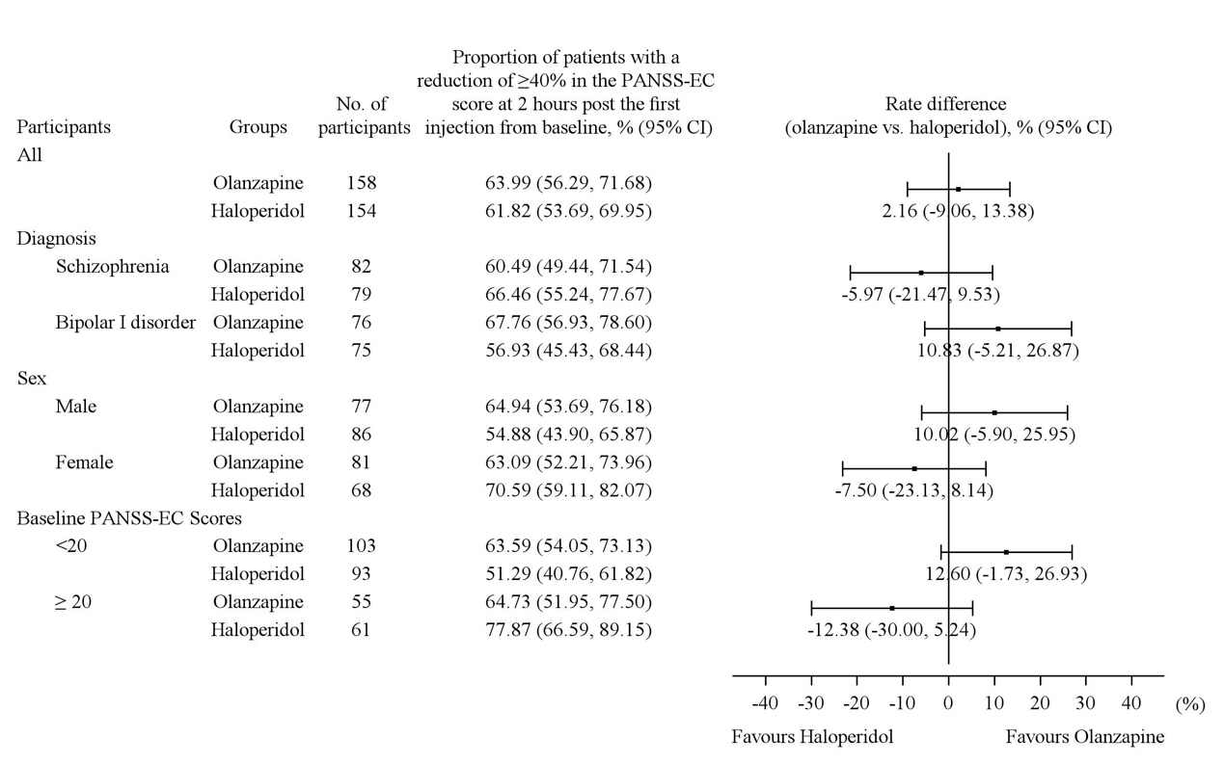
Figure S1. Forest plots of the proportion of patients with a reduction from baseline in the PANSS-EC score at 2 hours (per-protocol analysis set). Abbreviations: CI, confidence interval; PANSS-EC, Positive and Negative Syndrome Scale-Excited Component.

Box S1. Patient eligibility criteria
Inclusion criteria
1. Male or female aged ≥18 to ≤65 years old;
2. Patients diagnosed with schizophrenia or bipolar I disorder who met the criteria of the Diagnostic and Statistical Manual of Mental Disorders, Fifth Edition (DSM-5);
3. Patients were clinically agitated with a Positive and Negative Syndrome Scale-Excited Component (PANSS-EC) score of ≥14, and a value ≥4 on at least one of its five items before randomization;
4. Patients and/or guardians provide a signed informed consent form before screening.
Exclusive criteria
1. Agitation caused by delirium, seizures, developmental delay, intoxication, etc., or withdrawal from drug abuse (e.g., amphetamine, cocaine);
2. Patients who were currently at serious suicide risk, as judged by the investigator;
3. Patients with glaucoma or known risk of angle-closure glaucoma;
4. Patients who have brain diseases such as intracranial infection, brain trauma, cerebrovascular disease, basal ganglia disease, intracranial space-occupying lesion, hypoxic encephalopathy, Parkinson's disease, dementia, etc.;
5. Known prolonged QT interval (QTc ≥ 450ms in men or ≥ 470ms in women at screening/baseline), congenital long QT syndrome, decompensated heart failure, or history of ventricular arrhythmia, or torsade de pointes;
6. Electrolyte disturbances (e.g., hypokalemia) at screening have not been corrected;
7. Treatment with benzodiazepines, other hypnotic agents, or short-acting oral or intramuscular antipsychotic agent within 4 hours before randomization;
8. Administration of any psychostimulants, or reserpine within 1 week before randomization;
9. Patients who received long-acting injections of typical or atypical antipsychotics within 2 weeks before randomization or between one dosing interval (whichever is longer);
10. Patients who received electroconvulsive therapy (ECT)/modified electroconvulsive therapy (MECT) within 4 weeks before screening, or are expected to require ECT/MECT during the study treatment;
11. Treatment with clozapine within 4 weeks before screening;
12. Patients who had received olanzapine or haloperidol, and were considered to have had a poor response, or discontinuation interval of less than 5 half-lives (known) before randomization;
13. Allergic constitution, or known relevant allergic reaction or intolerance to olanzapine, haloperidol, and/or any of its excipients, or similar ingredients;
14. Patients with serious or unstable medical illnesses in the past or currently, which as determined by the investigator, will affect their participation in the trial;
15. Patients with known seizures, or a history of epilepsy;
16. Alanine transaminase (ALT) and aspartate aminotransferase (AST)＞2×upper limit of normal (ULN) (refer to the normal range of laboratory examination in the site), or absolute neutrophil count < 1000/mm³ (1.0×10⁹/L) at screening;
17. Females currently pregnant or lactating, or the serum/urine pregnancy test of females of childbearing age was positive;
18. Abnormal and clinically significant laboratory examinations or electrocardiograms that were judged by the investigator to be ineligible;
19. Patients who had participated in another clinical trial within 3 months before randomization;
20. Patients with other unreasonable factors, as judged by the investigator.

