Supporting Information
Figure S1. Alterations in the zeta potential of BiNPs observed pre- and post-digoxin loading.

Figure S2. Comparison of the redifferentiation effects between Selumetinib and Bi@Digoxin. Data are shown as mean ± SD. (n = 3), ns (not significant), **p < 0.01.

Figure S3. Blood biochemical assays in different groups of mice.
Figure S4. Blood routine indexes in different groups of mice.

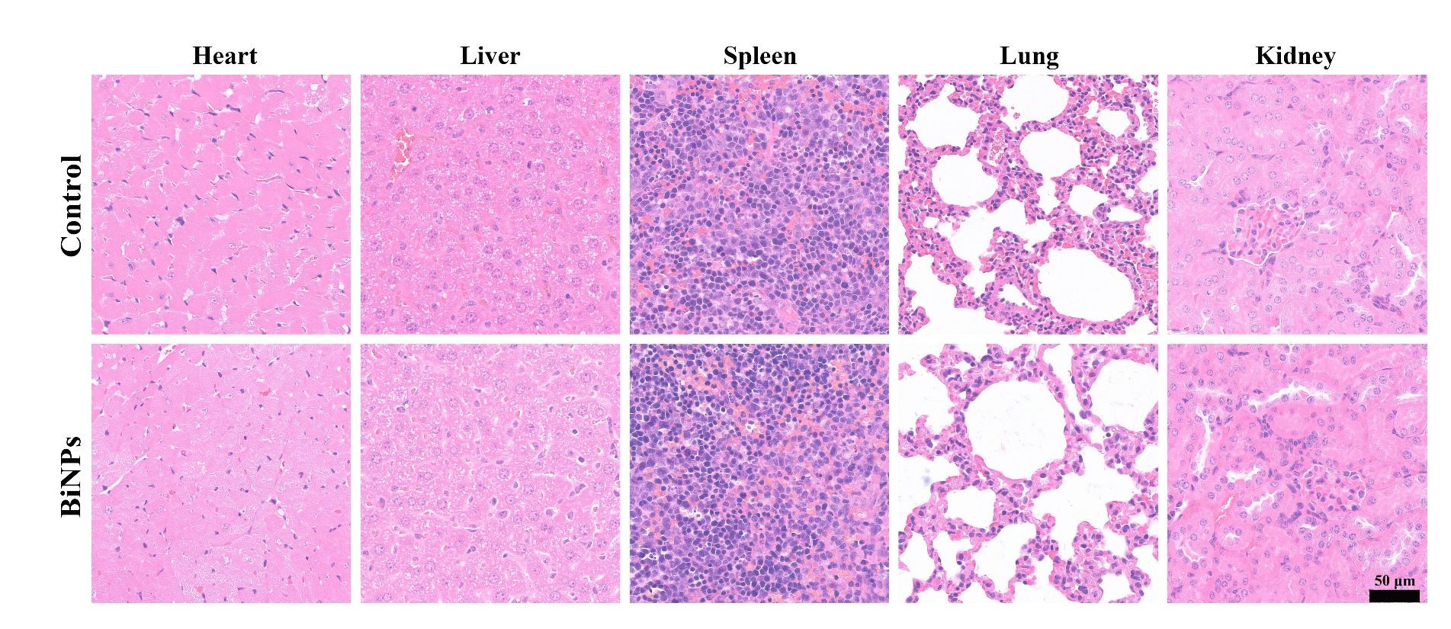
Figure S5. H&E staining of various organs obtained from mice.

Figure S6. Hemolysis rate analysis of BiNPs with different concentrations.
Figure S7. Circulation curve and distribution histogram of BiNPs in mice.

