Multivalent atezolizumab-liposome conjugates as active immunotherapeutic platforms for enhanced PD-L1 blockade in melanoma (Supplementary material)
Ziyun Cheng^{1,2}, Mohamadreza Amin¹, Mandy van Brakel², Andrea Sacchetti³, Robbert Q. Kim⁴, Ann L. B. Seynhaeve¹, Reno Debets², Timo L. M. ten Hagen¹
¹ Precision Medicine in Oncology (PrMiO) and Nanomedicine Innovation Center Erasmus (NICE), Department of Pathology, Erasmus MC Cancer Institute, Erasmus MC, Rotterdam, the Netherlands
² Laboratory of Tumor Immunology, Department of Medical Oncology, Erasmus MC Cancer Institute, Erasmus MC, Rotterdam, the Netherlands
³ Department of Pathology, Erasmus MC, University Medical Center Rotterdam, the Netherlands
⁴ Department of Cell and Chemical Biology, Leiden University Medical Center, Leiden, the Netherlands
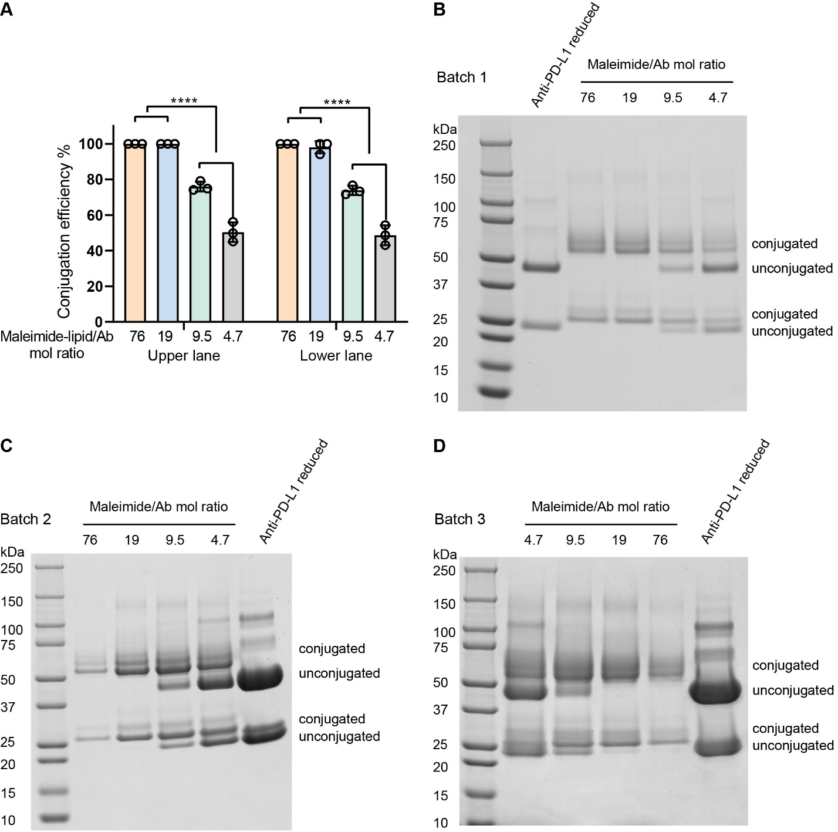
Supplementary Figure 1 Antibody-lipid conjugation efficiency and SDS-PAGE confirmation of anti-PD-L1 conjugates. A Quantification of antibody-lipid conjugation efficiency for three batches. Conjugation efficiency=Amount of conjugated protein/Total protein (Protein amount was measured using Image J analysis). B-D Presentation of atezolizumab (anti-PD-L1) before and after conjugation with DSPE-PEG(2000)-Maleimide was shown in SDS-PAGE. Lane 1: protein marker; Lane 2-6: anti-PD-L1-lipid conjugates (four different Maleimide/Ab molar ratios); anti-PD-L1 reduced by TCEP. Abbreviation: TCEP, Tris-(2-Carboxyethyl) phosphine. p-value < 0.05 was considered statistically significant (****p < 0.0001).
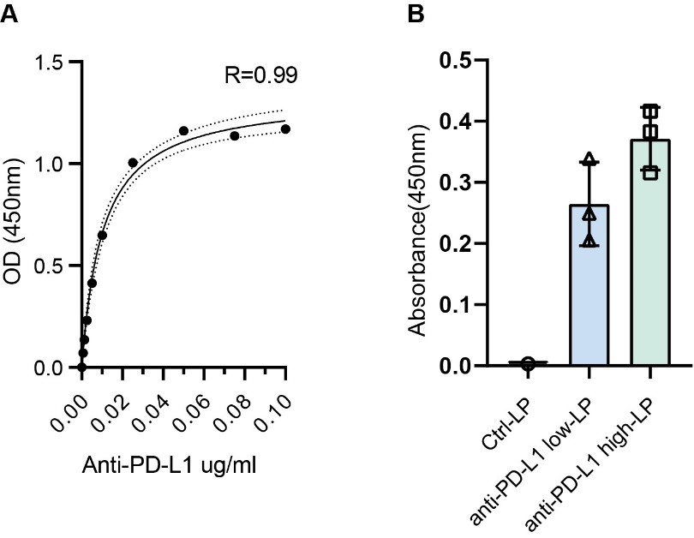
Supplementary Figure 2 Quantitation of anti-PD-L1 coupling to LPs using a functional ELISA. A Parental antibodies (atezolizumab) were used to generate a standard curve. B Antibody signals were quantified by measuring absorbance at 450 nm using a plate reader.
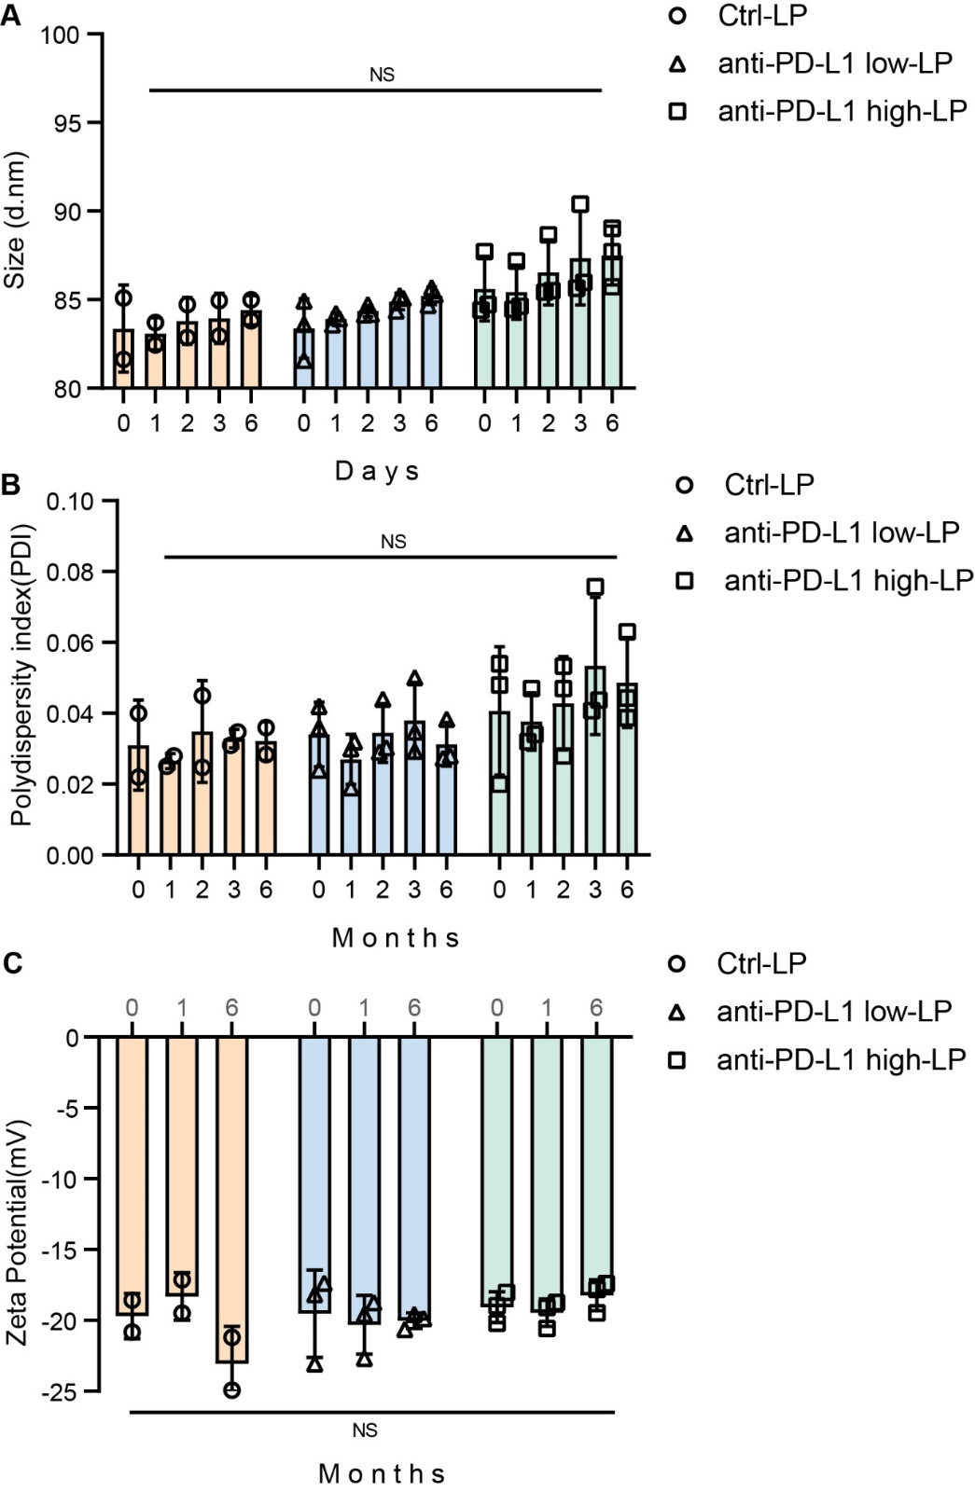
Supplementary Figure 3 Physicochemical Characterization and Stability of Anti-PD-L1 Liposomes. A-C The size, polydispersity index (PDI), and zeta potential (charge) of each batch were measured using dynamic light scattering (DLS). The same samples were analyzed at months 0, 1, 2, 3, and 6 to monitor stability over time. NS = not significant.
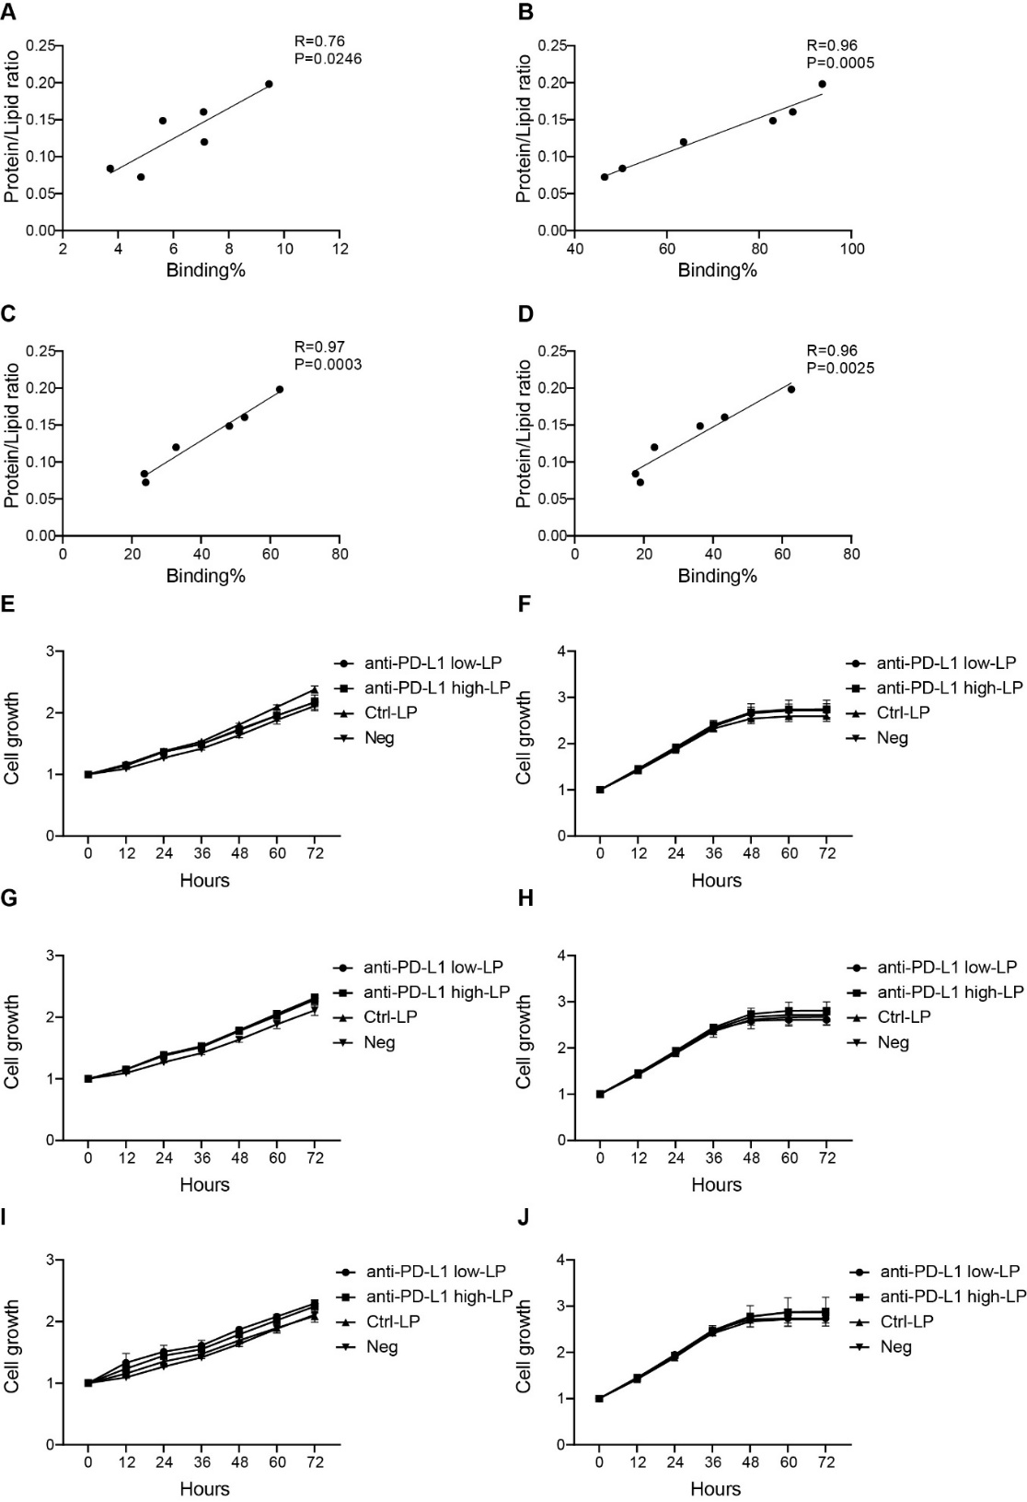
Supplementary Figure 4 Correlation of antibody density with binding efficiency and cytotoxicity of liposomes in melanoma cells. A-D The correlation between protein/lipid levels and binding capacity was assessed using the Pearson Correlation Coefficient (r) in GraphPad Prism (A MZ2Mel43; B MZ2Mel43 with IFN-γ stimulation; C BLM; D BLM with IFN-γ). E-J The toxicities of liposomes (at phosphorus concentrations of 1 µM, 10 µM, and 100 µM) were evaluated in MZ2Mel43 and BLM cells over 72 h. Cell growth was monitored using Incucyte (E MZ2Mel43, lipid concentration: 100uM; F BLM, lipid concentration: 100uM; G MZ2Mel43, lipid concentration: 10uM; H BLM, lipid concentration: 10uM; I MZ2Mel43, lipid concentration: 1uM; J BLM, lipid concentration: 1uM).

Supplementary Table 1: Antibody and lipid concentrations
Batches | Formulation | ug/mL protein | uM/mL lipid
Batch 1 | Anti-PD-L1 low-LP | 0.38 | 5.19
Batch 1 | Anti-PD-L1 high-LP | 0.94 | 4.72
Batch 2 | Anti-PD-L1 low-LP | 0.70 | 5.87
Batch 2 | Anti-PD-L1 high-LP | 0.83 | 5.16
Batch 3 | Anti-PD-L1 low-LP | 0.47 | 5.64
Batch 3 | Anti-PD-L1 high-LP | 0.64 | 4.30

Supplementary Table 2: PD-L1 expression
Cell lines | Parameters | Without IFN-γ | With IFN-γ
MZ2Mel43 | Percentage | 65.7% | 100%
MZ2Mel43 | MFI | 634 | 13345
BLM | Percentage | 100% | 100%
BLM | MFI | 34843 | 39325
MFI, Mean Fluorescence Intensity.

