Table S1 Locations of non-acupoints for Specific Acupoint Group (Right Knee Example)
Program | Division | Meridians | Acupoint Selection
Program | Division | Meridians | No Needle Retention | Needle Retention (15-20 minutes)
A | Mid | Yangming Meridian、  Taiyin Meridians | ST25 (Right）  ST31 (Right)  ST36 (Right)  SP6 (Left)  BL23 (Left)  BL54 (Left)  SI11 (Left)  Yaoshu  DU14 | HT3 (Left)  PC3 (Left)  LU5 (Left)  LI10 (Right)  ST43(Left)  SP3 (Right)
B | Lower-internal | Taiyang Meridian、the Three Yin Meridians | ST25 (Right)  SP10 (Left)  BL62 (Right)  GB30 (Right)  BL23 (Left)  SI11 (Right)  Yaoshu  DU4  DU14 | LU5 (Left)  HT3 (Left)  PC3 (Left)  SI3 (Right)  KI2 (Right)  KI4 (Right)  KI7 (Right)  BL65 (Left)
C | Upper-internal | Taiyang Meridian、the Three Yin Meridians | ST25 (Left)  KI27 (Left)  KI6 (Right)  Adductor Tubercle (Right)  GB30 (Left)  BL23 (Right)  BL54 (Right)  SI11 (Left),  Yaoshu  DU14 | LU5 (Left)  HT3 (Left)  PC3 (Left)  SI3 (Right)  KI2 (Left)  KI4 (Left)  KI7 (Left)  SP6 (Left)  BL65 (Right)  BL60 (Right)
D | Upper-external | Shaoyang Meridian、 Jueyin Meridian | ST25 (Right)  SP13 (Left)  GB40 (Right)  GB30 (Right)  BL18 (Right)  BL23 (Left)  BL54 (Left)  SI11 (Right)  Yaoshu  GV9  DU14 | LU5 (Left)  HT3 (Left)  PC3 (Left)  SJ5 (Right)  GB39 (Left)  GB41 (Left)  LR3 (Right)  LR5 (Right)
E | Lower-external | Shaoyang Meridian、 Jueyin Meridian | ST25 (Left)  SP13 (Right)  GB30 (Left)  BL23 (Right)  BL54 (Right)  BL18 (Left)  SI11 (Right)  Yaoshu  GV9  DU14 | LU5 (Left)  HT3 (Left)  PC3 (Left)  GB39 (Left)  GB41 (Left)  SP6 (Right)  LR3 (Right)  SJ5 (Right)
Note: We have developed a series of acupuncture prescriptions for knee osteoarthritis (KOA) under different sensitization conditions, based on the main acupoints and meridians associated with various sensitization areas of the knee: mid, upper-internal, lower-internal, upper-external, and lower-external regions. These prescriptions are derived from both clinical experience and literature and include both retained and non-retained needle protocols.
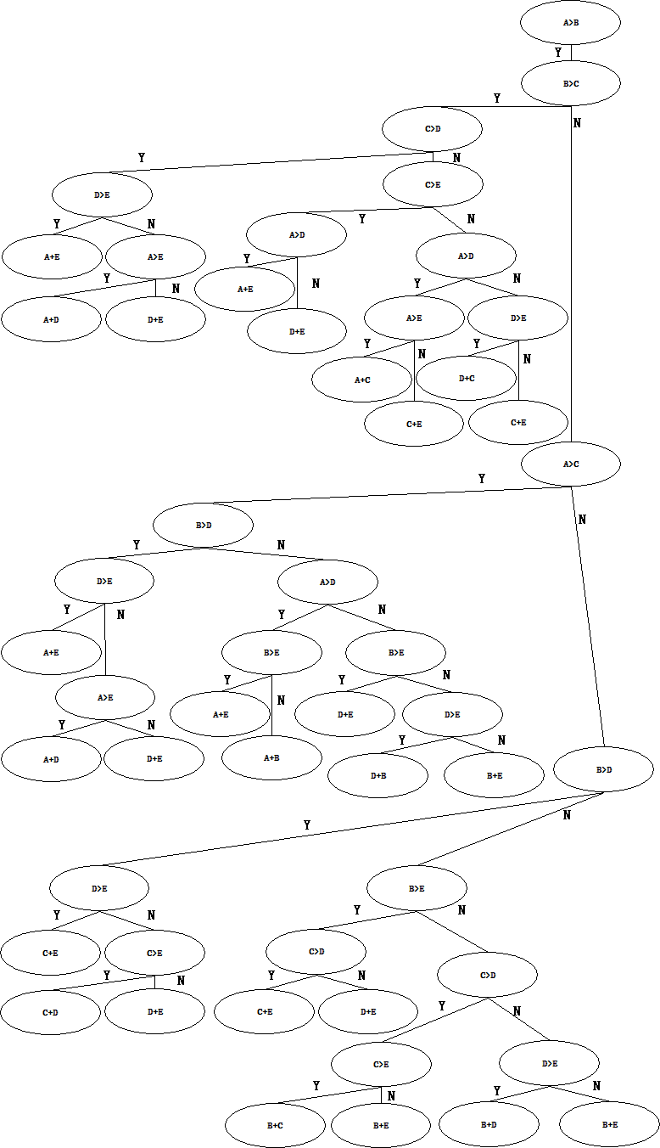
Fig S1 Diagnostic decision tree model
Note: The system extracts temperature data from infrared thermal images of the knee, calculating the average temperature of each region based on pixel values. The highest and lowest temperature points within each region are identified to determine the most sensitized area. This process is unaffected by external temperature fluctuations, ensuring the relative positioning of sensitized areas remains consistent, even when absolute temperatures change. Acupoint combinations are then determined by integrating relevant traditional Chinese medicine meridians and commonly used acupuncture points for treating knee OA. These combinations are generated by an AI program using a decision tree model, which applies nested if-else logic to classify and generate acupuncture prescriptions.

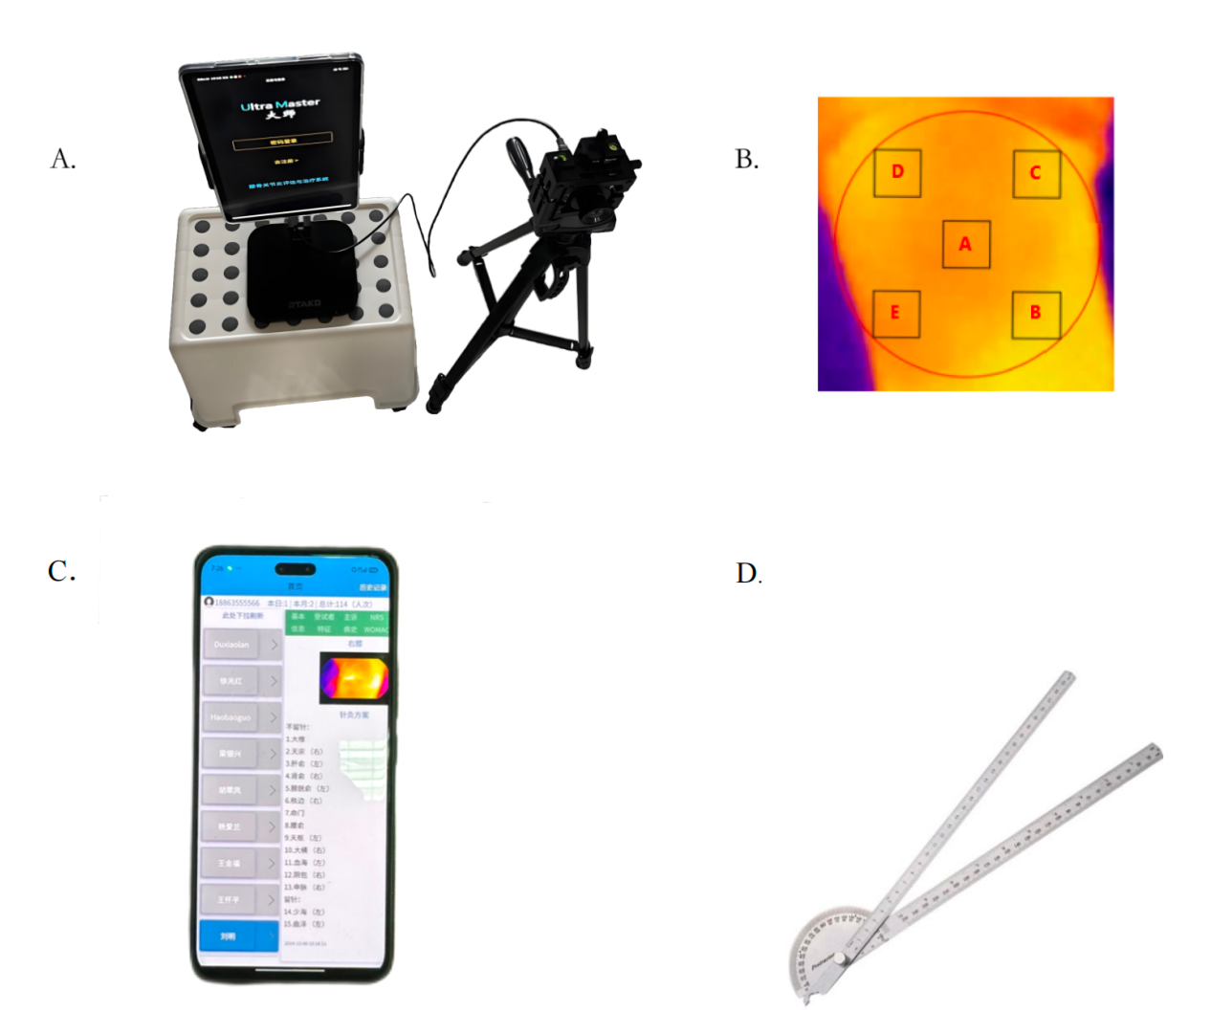
Fig S2. (A) AI machine with the personalized knee joint infrared imaging acupuncture system. (B) Diagram of knee joint region division. (C)Acupuncture point program displayed on the phone. (D) Multi-functional movable angle ruler

