Supplemental Materials

Figure S1: Staged photo of basic scenario non- hemorrhagic pumping system.

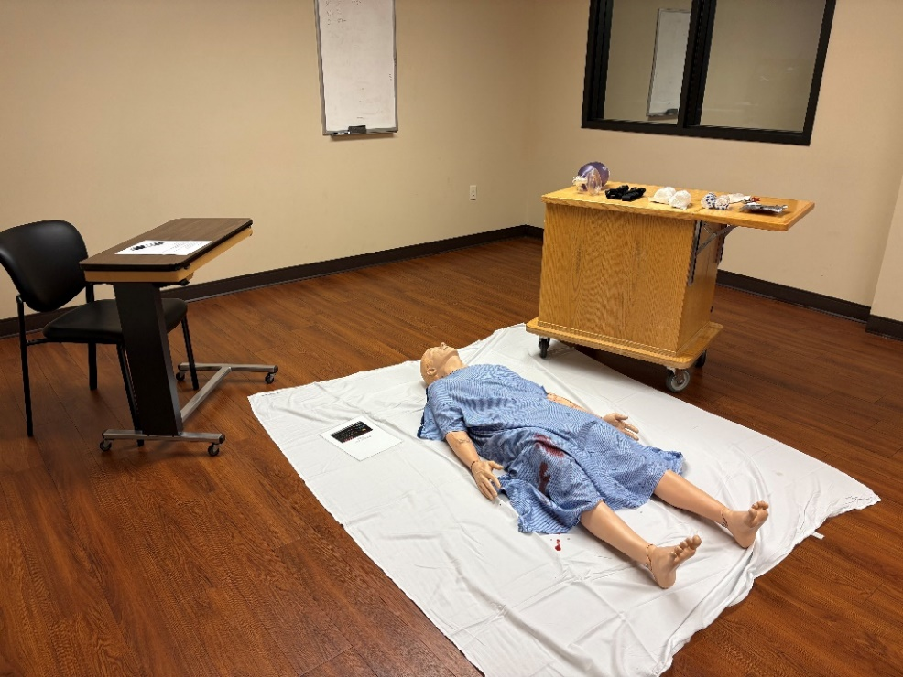

Figure S2: Staged photo of scenario including hemorrhagic pumping system
Black arrows indicate simulated bleeding source.
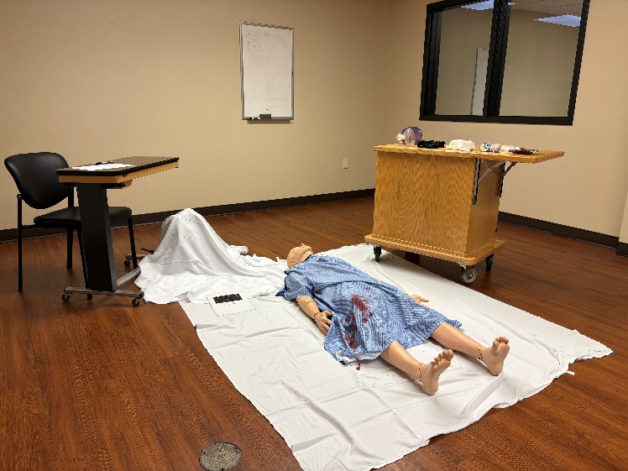 | 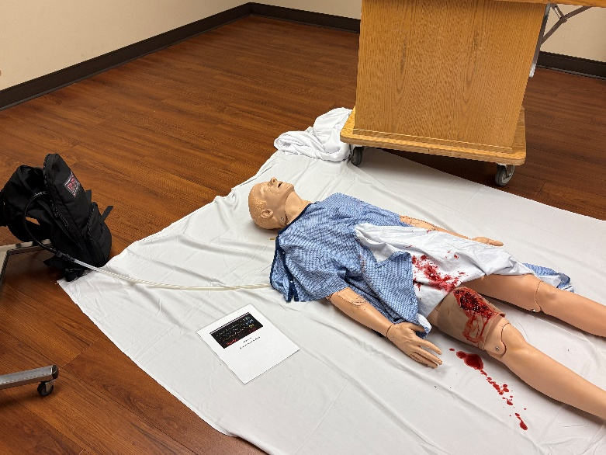

Figure S3. Standardized Vital Signs Card

Box S1 Standardized Scenario Prompt

Moulage Scenario
(Please return to Trauma Research upon completion of the scenario)

Expected duration of scenario: 5 minutes

PLOT (do not read to participant): 25-year-old male involved in an industrial accident presents with a large tissue wound to the right midthigh.

Prior to beginning the simulation, participants should be informed that they will be evaluated individually, receive no feedback from the facilitator, and that the simulation would end after 5 minutes, or when they have verbalized the patient is stabilized.

PARTICIPANT BRIEFING:
(To be read aloud to participant outside room before entering the simulation)

“You have been called to care for a 25-year-old male following a traumatic accident. A bystander is on scene but has limited information. You will have 5 minutes to assess and appropriately treat the patient. Everything you need for treatment is at the patient’s side. Once you feel that you’ve tended to the subject appropriately you may end the scenario. There is a 5-minute time limit.”

FACILITATOR HANDOVER TO PARTICIPANT:
(To be read aloud to participant inside room to initiate simulation.)

“This is John, he was cleaning a commercial ice cream maker when the machine lurched and pulled him inside of the machinery.”

IF the participant asks for more information, you may respond with:

“I’m sorry, I don’t have any more information for you.”

Box S2. Participant Recruitment Email.

We are recruiting people to participate in a training evaluation project at the Simulation Lab.

Dear First Responders,

We are emailing to invite you to be part of our training evaluation project about optimizing patient care in trauma settings by determining the most effective training method for care providers.

The purpose of this training evaluation is to compare trauma simulation methods. This study compares two training methods. There is an equal chance of being assigned to either one of the two study groups. It will take approximately 10-15 minutes to participate in the training evaluation.

As with other simulations, there is the potential risk of injury, slip, trip or fall while working in the simulation. Further, you will be doing a voluntary simulation and thus lose some of your free time. There may be no direct benefit to you for taking part in this study. However, your participation will contribute to the results of this study. Information acquired from this study may help guide educators and regulators to make decisions that could impact the future of simulation education, training, and testing.

Although participation is completely voluntary, we hope you will choose to be part of this project.

For more information, or to sign up:

Principal Investigators Contact Details

Thank you,

The Study team

