Table S1. Group, time, and group × time effects across all indicators
Dependent variable | Group |  |  | Time |  |  | Group × time interaction
Dependent variable | F | p | partial η² | F | p | partial η² | F | p | partial η² | Cohen’s d
Exercise time | 0.422 | 0.516 | 0.001 | 89.723 | < 0.001 | 0.180 | 0.140 | 0.709 | < 0.001 | 0.611
Maximum load | 0.001 | 0.970 | < 0.001 | 196.636 | < 0.001 | 0.324 | 0.001 | 0.980 | < 0.001 | 0.935
RER | 1.086 | 0.298 | 0.003 | 11.636 | < 0.001 | 0.028 | 0.105 | 0.746 | < 0.001 | 0.193
Peak VO₂ | 0.054 | 0.816 | < 0.001 | 197.347 | < 0.001 | 0.325 | 0.303 | 0.582 | < 0.001 | 0.930
AT VO₂ | 0.862 | 0.354 | 0.002 | 92.025 | < 0.001 | 0.183 | 3.498 | 0.062 | 0.008 | 0.672
Resting HR | 2.601 | 0.108 | 0.006 | 40.592 | < 0.001 | 0.090 | 1.741 | 0.188 | 0.004 | -0.480
Peaking HR | 2.775 | 0.097 | 0.007 | 1.806 | 0.180 | 0.004 | 0.697 | 0.404 | 0.002 | 0.033
HRR | 0.247 | 0.620 | < 0.001 | 23.867 | < 0.001 | 0.055 | 0.011 | 0.915 | < 0.001 | 0.343
Resting SBP | 0.002 | 0.965 | < 0.001 | 18.919 | < 0.001 | 0.044 | 0.331 | 0.566 | 0.001 | -0.292
Resting DBP | 0.134 | 0.715 | < 0.001 | 24.419 | < 0.001 | 0.056 | 0.039 | 0.844 | < 0.001 | -0.318
Peaking SBP | 0.091 | 0.764 | < 0.001 | 0.901 | 0.343 | 0.002 | 0.160 | 0.690 | < 0.001 | 0.053
Peaking DBP | 0.394 | 0.530 | 0.001 | 1.695 | 0.194 | 0.004 | 1.652 | 0.199 | 0.004 | -0.108
O₂ pulse | 0.014 | 0.906 | < 0.001 | 126.231 | < 0.001 | 0.235 | 0.038 | 0.845 | < 0.001 | 0.746
VO₂/WR | 0.032 | 0.857 | < 0.001 | 5.533 | 0.019 | 0.013 | 0.006 | 0.941 | < 0.001 | 0.163
VE/VCO₂@AT | 0.009 | 0.926 | < 0.001 | 20.646 | < 0.001 | 0.048 | 2.257 | 0.134 | 0.005 | -0.307
VE/VCO₂ slope | 1.208 | 0.272 | 0.003 | 3.483 | 0.063 | 0.008 | 0.006 | 0.936 | < 0.001 | -0.087
PETCO₂ | 1.323 | 0.251 | 0.0033 | 2.364 | 0.125 | 0.006 | 0.057 | 0.811 | < 0.001 | -0.142
GAD-7 | 0.12 | 0.729 | < 0.001 | 65.614 | < 0.001 | 0.138 | 0.049 | 0.826 | < 0.001 | -0.529
PHQ-9 | 0.008 | 0.929 | < 0.001 | 63.962 | < 0.001 | 0.135 | 0.037 | 0.847 | < 0.001 | -0.531
Waist circumference | 0.008 | 0.929 | < 0.001 | 25.190 | < 0.001 | 0.058 | 0.162 | 0.688 | < 0.001 | -0.338
Hip circumference | 0.008 | 0.927 | < 0.001 | 0.146 | 0.702 | ＜0.001 | 0.256 | 0.613 | < 0.001 | -0.022
Left thigh circumference | 2.866 | 0.091 | 0.007 | 0.852 | 0.357 | 0.002 | 3.120 | 0.078 | 0.008 | 0.005
Right thigh circumference | 4.351 | 0.038 | 0.010 | 0.388 | 0.533 | 0.001 | 5.505 | 0.019 | 0.013 | -0.028
Left calf circumference | 1.645 | 0.200 | 0.004 | 3.669 | 0.056 | 0.009 | 1.208 | 0.272 | 0.003 | -0.085
Right calf circumference | 1.280 | 0.259 | 0.003 | 2.768 | 0.097 | 0.007 | 0.893 | 0.345 | 0.002 | -0.073
Left upper arm | 0.704 | 0.402 | 0.002 | 9.456 | ＜0.001 | 0.023 | 1.703 | 0.193 | 0.004 | -0.234

Table S2. Cohen's d (pre vs post within each group and between-group differences in change)
 |  | HIIT（n=82） |  |  |  |  | MIIT（n=127） |  |  |  | HIIT vs MIIT
Indicator |  | Baseline |  | Change | p | Cohen’s d | Baseline | Change | p | Cohen’s d | p | Cohen’s d
Cardio-pulmonary fitness
HRR (bpm) |  | 17.1±8.9 |  | 3.1±8.7 | 0.002 | 0.356 | 18.2±9.2 | 3.0±10.0 | 0.001 | 0.300 | 0.816 | 0.011
Resting HR (bpm) |  | 82.6±15.2 |  | -7.0±12.9 | < 0.001 | -0.543 | 80.9±14.7 | -4.6±13.8 | < 0.001 | -0.333 | 0.249 | -0.178
Peaking HR (bpm) |  | 136.0±20.4 |  | 0.6±16.7 | 0.752 | 0.036 | 131.4±20.5 | 2.5±17.1 | 0.102 | 0.146 | 0.850 | -0.112
Peak VO₂ (ml/min/kg) |  | 19.4±3.7 |  | 3.3±2.8 | < 0.001 | 1.179 | 18.4±4.9 | 3.0±3.6 | < 0.001 | 0.833 | 0.122 | 0.091
AT VO₂ (ml/min/kg) |  | 12.3±2.4 |  | 1.9±2.3 | < 0.001 | 0.826 | 12.1±2.7 | 1.3±2.5 | < 0.001 | 0.520 | 0.010 | 0.248
Exercise time (s) |  | 473.6±115.1 |  | 67.8±120.8 | < 0.001 | 0.561 | 458.6±120.4 | 73.3±106.9 | < 0.001 | 0.686 | 0.898 | -0.049
Maximum load (w) |  | 94.8±33.8 |  | 17.2±13.5 | < 0.001 | 1.274 | 93.1±37.9 | 17.2±20.6 | < 0.001 | 0.835 | 0.375 | < 0.001
RER |  | 1.2±0.1 |  | 0.02±0.1 | 0.039 | 0.200 | 1.2±0.1 | 0.03±0.1 | 0.009 | 0.300 | 0.198 | -0.100
Resting SBP (mmHg) |  | 124.4±21.2 |  | -4.7±19.2 | 0.029 | -0.245 | 122.4±18.4 | -6.1±17.9 | < 0.001 | -0.341 | 0.349 | 0.076
Resting DBP (mmHg) |  | 75.3±11.5 |  | -4.2±13.3 | 0.006 | -0.316 | 76.3±12.4 | -4.5±13.4 | < 0.001 | -0.336 | 0.965 | 0.022
Peaking SBP (mmHg) |  | 170.7±31.1 |  | 2.7±30.6 | 0.420 | 0.088 | 166.2±31.6 | 1.1±29.4 | 0.669 | 0.037 | 0.198 | 0.054
Peaking DBP (mmHg) |  | 86.2±13.8 |  | -2.5±15.3 | 0.142 | -0.163 | 85.9±12.5 | -0.02±15 | 0.991 | 0.001 | 0.261 | -0.164
O₂ pulse (mL/beat) |  | 9.3±2.7 |  | 1.2±1.5 | < 0.001 | 0.800 | 9.2±2.8 | 1.3±1.8 | < 0.001 | 0.722 | 0.550 | -0.059
VO₂/WR (mL/min/w) |  | 10.3±1.6 |  | 0.3±1.8 | 0.137 | 0.167 | 10.3±1.8 | 0.3±2.1 | 0.096 | 0.143 | 0.907 | < 0.001
VE/VCO₂@AT |  | 28.5±3.5 |  | -1.2±2.7 | < 0.001 | -0.444 | 29.2±4.2 | -0.6±3.0 | 0.028 | -0.200 | 0.013 | -0.208
VE/VCO₂ slope |  | 27.4±4.0 |  | -0.5±3.9 | 0.234 | -0.128 | 28.9±5.8 | -0.5±3.9 | 0.176 | -0.128 | 0.223 | < 0.001
PETCO₂ (mmHg) |  | 34.1±3.4 |  | -0.3±3.0 | 0.374 | -0.100 | 33.1±3.7 | -0.4±3.7 | 0.215 | -0.108 | 0.125 | 0.029
Psychological scale (score)
GAD-7 |  | 4.5±4.6 |  | -2.5±3.7 | < 0.001 | -0.676 | 5.2±5.9 | -2.6±4.9 | < 0.001 | -0.531 | 0.679 | 0.022
PHQ-9 |  | 4.1±3.8 |  | -2.0±3.1 | < 0.001 | -0.645 | 5.1±5.3 | -1.9±3.7 | < 0.001 | -0.514 | 0.176 | 0.029
Body circumference (cm)
Waist circumference |  | 83.5±10.8 |  | -1.7±5.4 | 0.005 | -0.315 | 84.8±10.3 | -1.5±4.2 | < 0.001 | -0.357 | 0.493 | -0.042
Hip circumference |  | 94.3±7.1 |  | -0.3±5.4 | 0.616 | -0.056 | 95.5±6.8 | 0.04±3.4 | 0.908 | 0.012 | 0.266 | -0.079
Left thigh circumference |  | 50.0±5.0 |  | -0.2±4.2 | 0.575 | -0.048 | 49.8±5.8 | 0.7±4.2 | 0.049 | 0.167 | 0.083 | -0.214
Right thigh circumference |  | 50.4±5.1 |  | -0.5±4.0 | 0.257 | -0.125 | 50.0±5.8 | 0.8±4.3 | 0.032 | 0.186 | 0.025 | -0.311
Left calf circumference |  | 34.4±4.2 |  | -0.1±3.2 | < 0.001 | -0.031 | 35.4±3.6 | -0.5±1.9 | < 0.001 | -0.263 | 0.901 | 0.152
Right calf circumference |  | 34.5±4.2 |  | -0.1±3.2 | 0.740 | -0.031 | 35.4±3.5 | -0.4±1.9 | 0.008 | -0.211 | 0.923 | 0.114
Left upper arm |  | 28.1±2.9 |  | -0.6±2.0 | 0.004 | -0.300 | 28.2±3.2 | -0.3±2.4 | 0.233 | -0.125 | 0.170 | -0.136
Right upper arm |  | 28.5±3.0 |  | -0.8±2.3 | 0.004 | 0.348 | 28.5±3.1 | -0.3±2.2 | 0.157 | -0.136 | 0.085 | -0.223

Table S3. Predictors of change variables and group × predictor interaction effects
Change variable | HIIT× Predictor（n=82） |  |  |  |  | MIIT× Predictor（n=127） |  |  |  |  | Pooled model (n = 209, Group × Predictor interaction)
Change variable | β | 95%CI | p | R² | AdjustedR² | β | 95%CI | p | R² | Adjusted R² | β | 95%CI | p | R² | Adjusted R²
Resting HR | -0.178 | (-0.329, -0.027) | 0.0216 | 0.099 | 0.052 | -0.237 | (-0.365, -0.108) | < 0.001 | 0.132 | 0.104 | -0.207 | (-0.304, -0.110) | < 0.001 | 0.092 | 0.074
Peaking HR | 0.113 | (-0.002, 0.229) | 0.0541 | 0.080 | 0.032 | 0.051 | (-0.053, 0.155) | 0.335 | 0.045 | 0.014 | 0.077 | (0.000, 0.155) | 0.050 | 0.031 | 0.012
GAD-7 | -0.346 | (-0.879, 0.186) | 0.199 | 0.055 | 0.006 | -0.165 | (-0.536, 0.207) | 0.382 | 0.044 | 0.012 | -0.236 | (-0.535, 0.063) | 0.121 | 0.024 | 0.005
PHQ-9 | -0.281 | (-0.919, 0.356) | 0.382 | 0.044 | -0.006 | -0.067 | (-0.555, 0.420) | 0.785 | 0.038 | 0.007 | -0.122 | (-0.506, 0.262) | 0.532 | 0.014 | -0.005
Exercise time | 0.012 | (-0.005, 0.028) | 0.159 | 0.059 | 0.010 | 0.012 | (-0.005, 0.028) | 0.173 | 0.052 | 0.021 | 0.011 | (-0.001, 0.023) | 0.071 | 0.028 | 0.009
Maximum load | 0.086 | (-0.065, 0.236) | 0.262 | 0.050 | 0.001 | 0.049 | (-0.041, 0.140) | 0.280 | 0.047 | 0.016 | 0.052 | (-0.024, 0.127) | 0.179 | 0.021 | 0.002
Peak VO₂ | 0.033 | (-0.233, 0.299) | 0.806 | 0.035 | -0.015 | -0.189 | (-0.689, 0.312) | 0.457 | 0.042 | 0.011 | 0.008 | (-0.233, 0.249) | 0.945 | 0.012 | -0.007
AT VO₂ | 0.303 | (-0.548, 1.154) | 0.481 | 0.040 | -0.009 | 0.139 | (-0.595, 0.873) | 0.709 | 0.039 | 0.007 | 0.123 | (-0.423, 0.669) | 0.657 | 0.013 | -0.006

Table S4. Normality test results for dependent variables
Dependent variable | group | statistics | df
Exercise time | MIIT | .968 | 127 | .007
Exercise time | HIIT | .982 | 82 | .356
Maximum load | MIIT | .964 | 127 | .003
Maximum load | HIIT | .960 | 82 | .014
RER | MIIT | .967 | 127 | .006
RER | HIIT | .988 | 82 | .650
Peak VO₂ | MIIT | .956 | 127 | .001
Peak VO₂ | HIIT | .953 | 82 | .006
AT VO₂ | MIIT | .984 | 127 | .175
AT VO₂ | HIIT | .961 | 82 | .017
Resting HR | MIIT | .987 | 127 | .343
Resting HR | HIIT | .962 | 82 | .021
Peaking HR | MIIT | .994 | 127 | .891
Peaking HR | HIIT | .990 | 82 | .816
HRR | MIIT | .958 | 127 | .001
HRR | HIIT | .956 | 82 | .009
Resting SBP | MIIT | .978 | 127 | .052
Resting SBP | HIIT | .974 | 82 | .114
Resting DBP | MIIT | .983 | 127 | .155
Resting DBP | HIIT | .988 | 82 | .692
Peaking SBP | MIIT | .982 | 127 | .122
Peaking SBP | HIIT | .986 | 82 | .571
Peaking DBP | MIIT | .988 | 127 | .401
Peaking DBP | HIIT | .982 | 82 | .349
O₂pulse | MIIT | .957 | 127 | .001
O₂pulse | HIIT | .965 | 82 | .032
VO₂/WR | MIIT | .985 | 127 | .238
VO₂/WR | HIIT | .971 | 82 | .069
VE/VCO₂@AT | MIIT | .972 | 127 | .017
VE/VCO₂@AT | HIIT | .974 | 82 | .109
VE/VCO₂ slope | MIIT | .981 | 127 | .091
VE/VCO₂ slope | HIIT | .985 | 82 | .499
PETCO₂ | MIIT | .979 | 127 | .065
PETCO₂ | HIIT | .989 | 82 | .776
GAD-7 | MIIT | .759 | 127 | .000
GAD-7 | HIIT | .756 | 82 | .000
PHQ-9 | MIIT | .804 | 127 | .000
PHQ-9 | HIIT | .771 | 82 | .000
Waist circumference | MIIT | .964 | 127 | .003
Waist circumference | HIIT | .976 | 82 | .141
Hip circumference | MIIT | .925 | 127 | .000
Hip circumference | HIIT | .974 | 82 | .108
Left thigh circumference | MIIT | .930 | 127 | .000
Left thigh circumference | HIIT | .980 | 82 | .256
Right thigh circumference | MIIT | .942 | 127 | .000
Right thigh circumference | HIIT | .977 | 82 | .167
Left calf circumference | MIIT | .948 | 127 | .000
Left calf circumference | HIIT | .975 | 82 | .123
Right calf circumference | MIIT | .949 | 127 | .000
Right calf circumference | HIIT | .976 | 82 | .144
Left upper arm | MIIT | .944 | 127 | .000
Left upper arm | HIIT | .981 | 82 | .297
Right upper arm | MIIT | .940 | 127 | .000
Right upper arm | HIIT | .987 | 82 | .606

Table S5. Residual normality test results for dependent variables
Dependent variable | group | statistics | df | p
Exercise time | MIIT | .993 | 127 | .825
Exercise time | HIIT | .988 | 82 | .659
Maximum load | MIIT | .980 | 127 | .073
Maximum load | HIIT | .981 | 82 | .293
RER | MIIT | .986 | 127 | .274
RER | HIIT | .991 | 82 | .873
Peak VO₂ | MIIT | .982 | 127 | .117
Peak VO₂ | HIIT | .990 | 82 | .823
AT VO₂ | MIIT | .993 | 127 | .807
AT VO₂ | HIIT | .976 | 82 | .152
Resting HR | MIIT | .991 | 127 | .667
Resting HR | HIIT | .974 | 82 | .117
Peaking HR | MIIT | .991 | 127 | .695
Peaking HR | HIIT | .992 | 82 | .931
HRR | MIIT | .984 | 127 | .166
HRR | HIIT | .983 | 82 | .365
Resting SBP | MIIT | .991 | 127 | .606
Resting SBP | HIIT | .985 | 82 | .476
Resting DBP | MIIT | .987 | 127 | .350
Resting DBP | HIIT | .980 | 82 | .245
Peaking SBP | MIIT | .983 | 127 | .159
Peaking SBP | HIIT | .979 | 82 | .241
Peaking DBP | MIIT | .979 | 127 | .068
Peaking DBP | HIIT | .991 | 82 | .850
O₂pulse | MIIT | .987 | 127 | .352
O₂pulse | HIIT | .986 | 82 | .531
VO₂/WR | MIIT | .992 | 127 | .730
VO₂/WR | HIIT | .982 | 82 | .358
VE/VCO₂@AT | MIIT | .983 | 127 | .162
VE/VCO₂@AT | HIIT | .983 | 82 | .395
VE/VCO₂ slope | MIIT | .989 | 127 | .490
VE/VCO₂ slope | HIIT | .979 | 82 | .229
PETCO₂ | MIIT | .991 | 127 | .635
PETCO₂ | HIIT | .983 | 82 | .406
GAD-7 | MIIT | .989 | 127 | .452
GAD-7 | HIIT | .988 | 82 | .680
PHQ-9 | MIIT | .990 | 127 | .538
PHQ-9 | HIIT | .959 | 82 | .013
Waist circumference | MIIT | .978 | 127 | .052
Waist circumference | HIIT | .979 | 82 | .219
Hip circumference | MIIT | .981 | 127 | .096
Hip circumference | HIIT | .975 | 82 | .121
Left thigh circumference | MIIT | .993 | 127 | .818
Left thigh circumference | HIIT | .984 | 82 | .435
Right thigh circumference | MIIT | .988 | 127 | .404
Right thigh circumference | HIIT | .984 | 82 | .434
Left calf circumference | MIIT | .989 | 127 | .498
Left calf circumference | HIIT | .989 | 82 | .730
Right calf circumference | MIIT | .995 | 127 | .955
Right calf circumference | HIIT | .977 | 82 | .168
Left upper arm | MIIT | .983 | 127 | .149
Left upper arm | HIIT | .970 | 82 | .064
Right upper arm | MIIT | .985 | 127 | .227
Right upper arm | HIIT | .981 | 82 | .284

Table S6. Influence diagnostics (Cook’s Distance and Leverage Values) for physical ability and aerobic metabolism in HIIT, MIIT, and combined groups
Group |  | Exercise time |  | Maximum load |  | Peak VO₂ |  | AT VO₂ |  | O₂pulse |  | VO₂/WR
Group |  | Cook’s D | Leverage | Cook’s D | Leverage | Cook’s D | Leverage | Cook’s D | Leverage | Cook’s D | Leverage | Cook’s D | Leverage
HIIT | Median | .0014 | .0240 | .0013 | .0251 | .0019 | .0014 | .0250 | .0014 | .0017 | .0251 | .0017 | .0247
HIIT | Mean | .0050 | .0287 | .0074 | .0288 | .0045 | .0051 | .0288 | .0051 | .0063 | .0286 | .0054 | .0284
MIIT | Median | .0022 | .0268 | .0013 | .0258 | .0014 | .0012 | .0266 | .0012 | .0017 | .0278 | .0009 | .0262
MIIT | Mean | .0069 | .0296 | .0034 | .0292 | .0040 | .0039 | .0289 | .0039 | .0047 | .0293 | .0035 | .0293
ALL | Median | .0017 | .0249 | .0013 | .0256 | .0018 | .0013 | .0259 | .0013 | .0017 | .0263 | .0013 | .0255
ALL | Mean | .0058 | .0290 | .0058 | .0290 | .0043 | .0046 | .0288 | .0046 | .0057 | .0289 | .0047 | .0288

Table S7. Influence diagnostics (Cook’s Distance and Leverage Values) for heart rate and blood pressure responses in HIIT, MIIT, and combined groups
Group |  | Resting HR |  | Peaking HR |  | HRR |  | Resting SBP |  | Resting DBP |  | Peaking SBP |  | Peaking DBP
Group |  | Cook’s D | Leverage | Cook’s D | Leverage | Cook’s D | Leverage | Cook’s D | Leverage | Cook’s D | Leverage | Cook’s D | Leverage | Cook’s D | Leverage
HIIT | Median | .0018 | .0246 | .0017 | .0251 | .0016 | .0238 | .0012 | .0016 | .0238 | .0012 | .0018 | .0246 | .0017 | .0251
HIIT | Mean | .0061 | .0286 | .0063 | .0286 | .0047 | .0287 | .0040 | .0047 | .0287 | .0040 | .0061 | .0286 | .0063 | .0286
MIIT | Median | .0016 | .0280 | .0017 | .0278 | .0017 | .0278 | .0024 | .0017 | .0278 | .0024 | .0016 | .0280 | .0017 | .0278
MIIT | Mean | .0046 | .0293 | .0047 | .0293 | .0048 | .0298 | .0046 | .0048 | .0298 | .0046 | .0046 | .0293 | .0047 | .0293
ALL | Median | .0017 | .0264 | .0017 | .0263 | .0017 | .0261 | .0013 | .0017 | .0261 | .0013 | .0017 | .0264 | .0017 | .0263
ALL | Mean | .0055 | .0289 | .0057 | .0289 | .0048 | .0291 | .0043 | .0048 | .0291 | .0043 | .0055 | .0289 | .0057 | .0289

Table S8. Influence diagnostics (Cook’s Distance and Leverage Values) for ventilation and gas exchange in HIIT, MIIT, and combined groups
Group |  | RER |  | VO₂/WR |  | VE/VCO₂@AT |  | VE/VCO₂ slope |  | PETCO₂
Group |  | Cook’s D | Leverage | Cook’s D | Leverage | Cook’s D | Leverage | Cook’s D | Leverage | Cook’s D | Leverage
HIIT | Median | .0018 | .0230 | .0018 | .0239 | .0015 | .0244 | .0012 | .0237 | .0018 | .0249
HIIT | Mean | .0063 | .0291 | .0050 | .0287 | .0049 | .0289 | .0046 | .0279 | .0045 | .0287
MIIT | Median | .0018 | .0253 | .0011 | .0266 | .0020 | .0271 | .0014 | .0268 | .0015 | .0260
MIIT | Mean | .0052 | .0289 | .0034 | .0294 | .0046 | .0287 | .0051 | .0285 | .0041 | .0294
ALL | Median | .0018 | .0244 | .0014 | .0257 | .0016 | .0259 | .0012 | .0248 | .0017 | .0257
ALL | Mean | .0059 | .0290 | .0044 | .0290 | .0048 | .0288 | .0048 | .0281 | .0044 | .0290

Table S9. Influence diagnostics (Cook’s Distance and Leverage Values) for psychological scales and body measurements in HIIT, MIIT, and combined groups
Group |  | PHQ-9 |  | GAD -7 |  | Waist |  | Hip
Group |  | Cook’s D | Leverage | Cook’s D | Leverage | Cook’s D | Leverage | Cook’s D | Leverage
HIIT | Median | .0010 | .0248 | .0005 | .0244 | .0007 | .0211 | .0009 | .0223
HIIT | Mean | .0055 | .0281 | .0023 | .0273 | .0049 | .0271 | .0042 | .0266
MIIT | Median | .0008 | .0254 | .0006 | .0269 | .0014 | .0281 | .0015 | .0260
MIIT | Mean | .0028 | .0279 | .0022 | .0286 | .0049 | .0306 | .0047 | .0287
ALL | Median | .0009 | .0252 | .0006 | .0256 | .0010 | .0242 | .0011 | .0235
ALL | Mean | .0044 | .0280 | .0022 | .0279 | .0049 | .0285 | .0044 | .0274

Table S10. Influence diagnostics (Cook’s Distance and Leverage Values) for body circumference in HIIT, MIIT, and combined groups
Group |  | Left thigh |  | Right thigh |  | Left calf |  | Right calf |  | Left upper arm |  | Right upper arm
Group |  | Cook’s D | Leverage | Cook’s D | Leverage | Cook’s D | Leverage | Cook’s D | Leverage | Cook’s D | Leverage | Cook’s D | Leverage
HIIT | Median | .0012 | .0240 | .0012 | .0235 | .0008 | .0216 | .0011 | .0222 | .0008 | .0227 | .0011 | .0224
HIIT | Mean | .0054 | .0273 | .0057 | .0277 | .0040 | .0260 | .0045 | .0262 | .0045 | .0278 | .0058 | .0275
MIIT | Median | .0026 | .0269 | .0022 | .0273 | .0017 | .0265 | .0015 | .0265 | .0012 | .0268 | .0024 | .0277
MIIT | Mean | .0066 | .0297 | .0064 | .0292 | .0055 | .0294 | .0058 | .0293 | .0033 | .0292 | .0055 | .0299
ALL | Median | .0019 | .0257 | .0015 | .0259 | .0010 | .0245 | .0012 | .0251 | .0009 | .0241 | .0017 | .0250
ALL | Mean | .0059 | .0283 | .0060 | .0283 | .0046 | .0274 | .0051 | .0274 | .0040 | .0283 | .0057 | .0285

Table S11. Collinearity diagnostics (VIF and Tolerance) for dependent variables
Dependent variable | VIF range | Tolerance range
Exercise time | 1.016-1.123 | 0.891-0.984
Maximum load | 1.019-1.847 | 0.541-0.981
RER | 1.027-1.096 | 0.912-0.974
Peak VO₂ | 1.029-1.212 | 0.825-0.971
AT VO₂ | 1.013-1.093 | 0.915-0.987
Resting HR | 1.020-1.132 | 0.883-0.980
Peaking HR | 1.038-1.197 | 0.835-0.963
HRR | 1.015-1.082 | 0.924-0.985
Resting SBP | 1.014-1.096 | 0.912-0.987
Resting DBP | 1.013-1.090 | 0.917-0.987
Peaking SBP | 1.017-1.117 | 0.895-0.984
Peaking DBP | 1.012-1.098 | 0.910-0.988
O₂ pulse | 1.015-1.843 | 0.543-0.986
VO₂/WR | 1.012-1.087 | 0.920-0.988
VE/VCO₂@AT | 1.034-1.299 | 0.770-0.967
VE/VCO₂ slope | 1.048-1.213 | 0.824-0.954
PETCO₂ | 1.038-1.109 | 0.902-0.963
GAD-7 | 1.014-1.136 | 0.880-0.986
PHQ-9 | 1.020-1.124 | 0.890-0.980
Waist circumference | 1.014-3.584 | 0.279-0.986
Hip circumference | 1.014-2.436 | 0.411-0.986
Left thigh circumference | 1.027-2.122 | 0.471-0.974
Right thigh circumference | 1.031-2.052 | 0.487-0.970
Left calf circumference | 1.023-2.091 | 0.478-0.977
Right calf circumference | 1.021-2.067 | 0.484-0.979
Left upper arm | 1.014-2.320 | 0.431-0.987
Right upper arm | 1.015-2.472 | 0.405-0.985

Table S12. Durbin-watson statistics and collinearity diagnostics for change variables
Change variable | Durbin-Watson | VIF range | Tolerance range
ALL (n=209)
Exercise time | 2.220 | 1.019-1.098 | 0.911-0.981
Maximum load | 2.208 | 1.068-1.108 | 0.902-0.936
Peak VO₂ | 2.243 | 1.064-1.083 | 0.923-0.940
AT VO₂ | 2.211 | 1.033-1.078 | 0.927-0.968
Resting HR | 2.180 | 1.038-1.115 | 0.897-0.963
Peaking HR | 2.243 | 1.016-1.094 | 0.914-0.984
GAD-7 | 2.223 | 1.015-1.125 | 0.889-0.985
PHQ-9 | 2.220 | 1.015-1.102 | 0.908-0.985
HIIT (n=82)
Exercise time | 2.300 | 1.024-1.195 | 0.837-0.977
Maximum load | 2.268 | 1.106-1.185 | 0.844-0.905
Peak VO₂ | 2.320 | 1.050-1.171 | 0.854-0.953
AT VO₂ | 2.295 | 1.013-1.180 | 0.848-0.987
Resting HR | 2.337 | 1.028-1.211 | 0.826-0.972
Peaking HR | 2.267 | 1.022-1.185 | 0.844-0.979
GAD-7 | 2.311 | 1.028-1.193 | 0.839-0.973
PHQ-9 | 2.297 | 1.022-1.194 | 0.837-0.979
MIIT (n=127)
Exercise time | 2.161 | 1.043-1.095 | 0.913-0.959
Maximum load | 2.144 | 1.048-1.169 | 0.856-0.955
Peak VO₂ | 2.190 | 1.041-1.164 | 0.859-0.961
AT VO₂ | 2.139 | 1.076-1.110 | 0.901-0.929
Resting HR | 2.042 | 1.070-1.149 | 0.870-0.935
Peaking HR | 2.186 | 1.030-1.115 | 0.897-0.971
GAD-7 | 2.150 | 1.072-1.123 | 0.890-0.933
PHQ-9 | 2.147 | 1.028-1.118 | 0.895-0.972

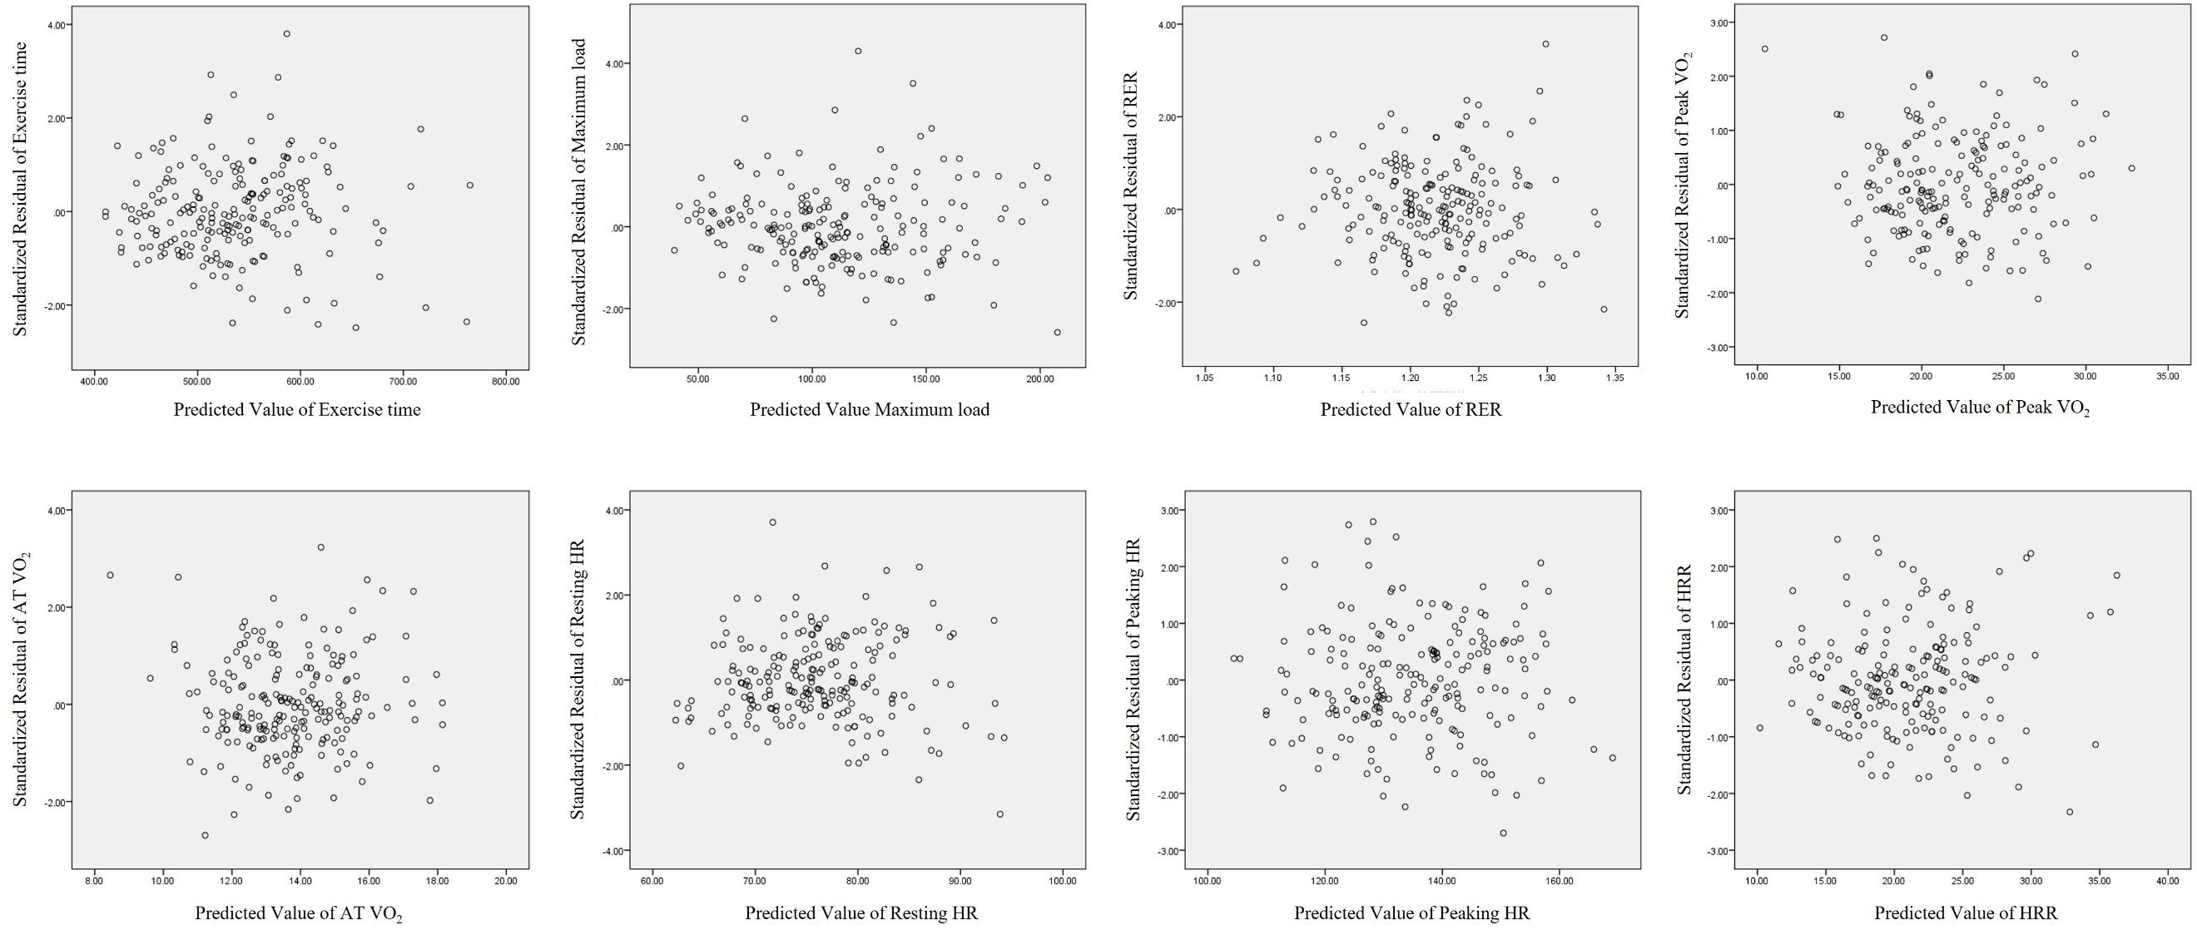
Figure S1. Homoscedasticity assessment for physical performance and heart rate variables
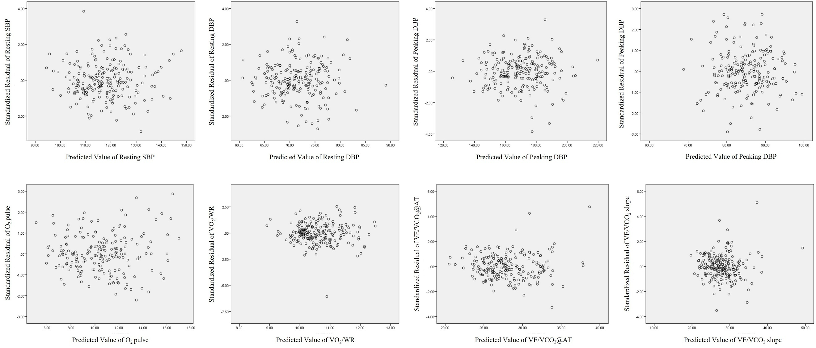Figure S2. Homoscedasticity assessment for aerobic metabolism, blood pressure and ventilation variables
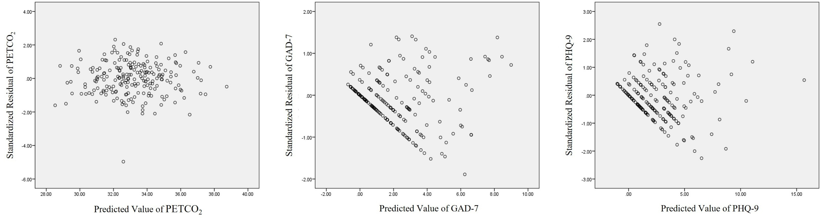 Figure S3. Homoscedasticity assessment for psychological scale and ventilation variables
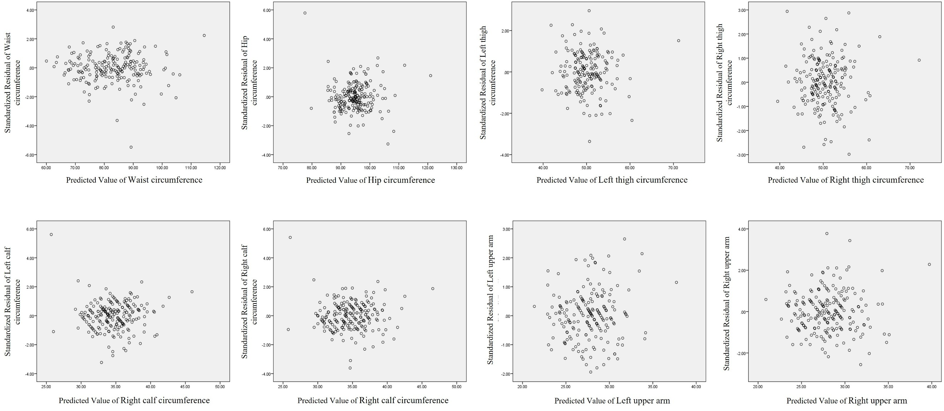
Figure S4. Homoscedasticity assessment for body circumference variables

