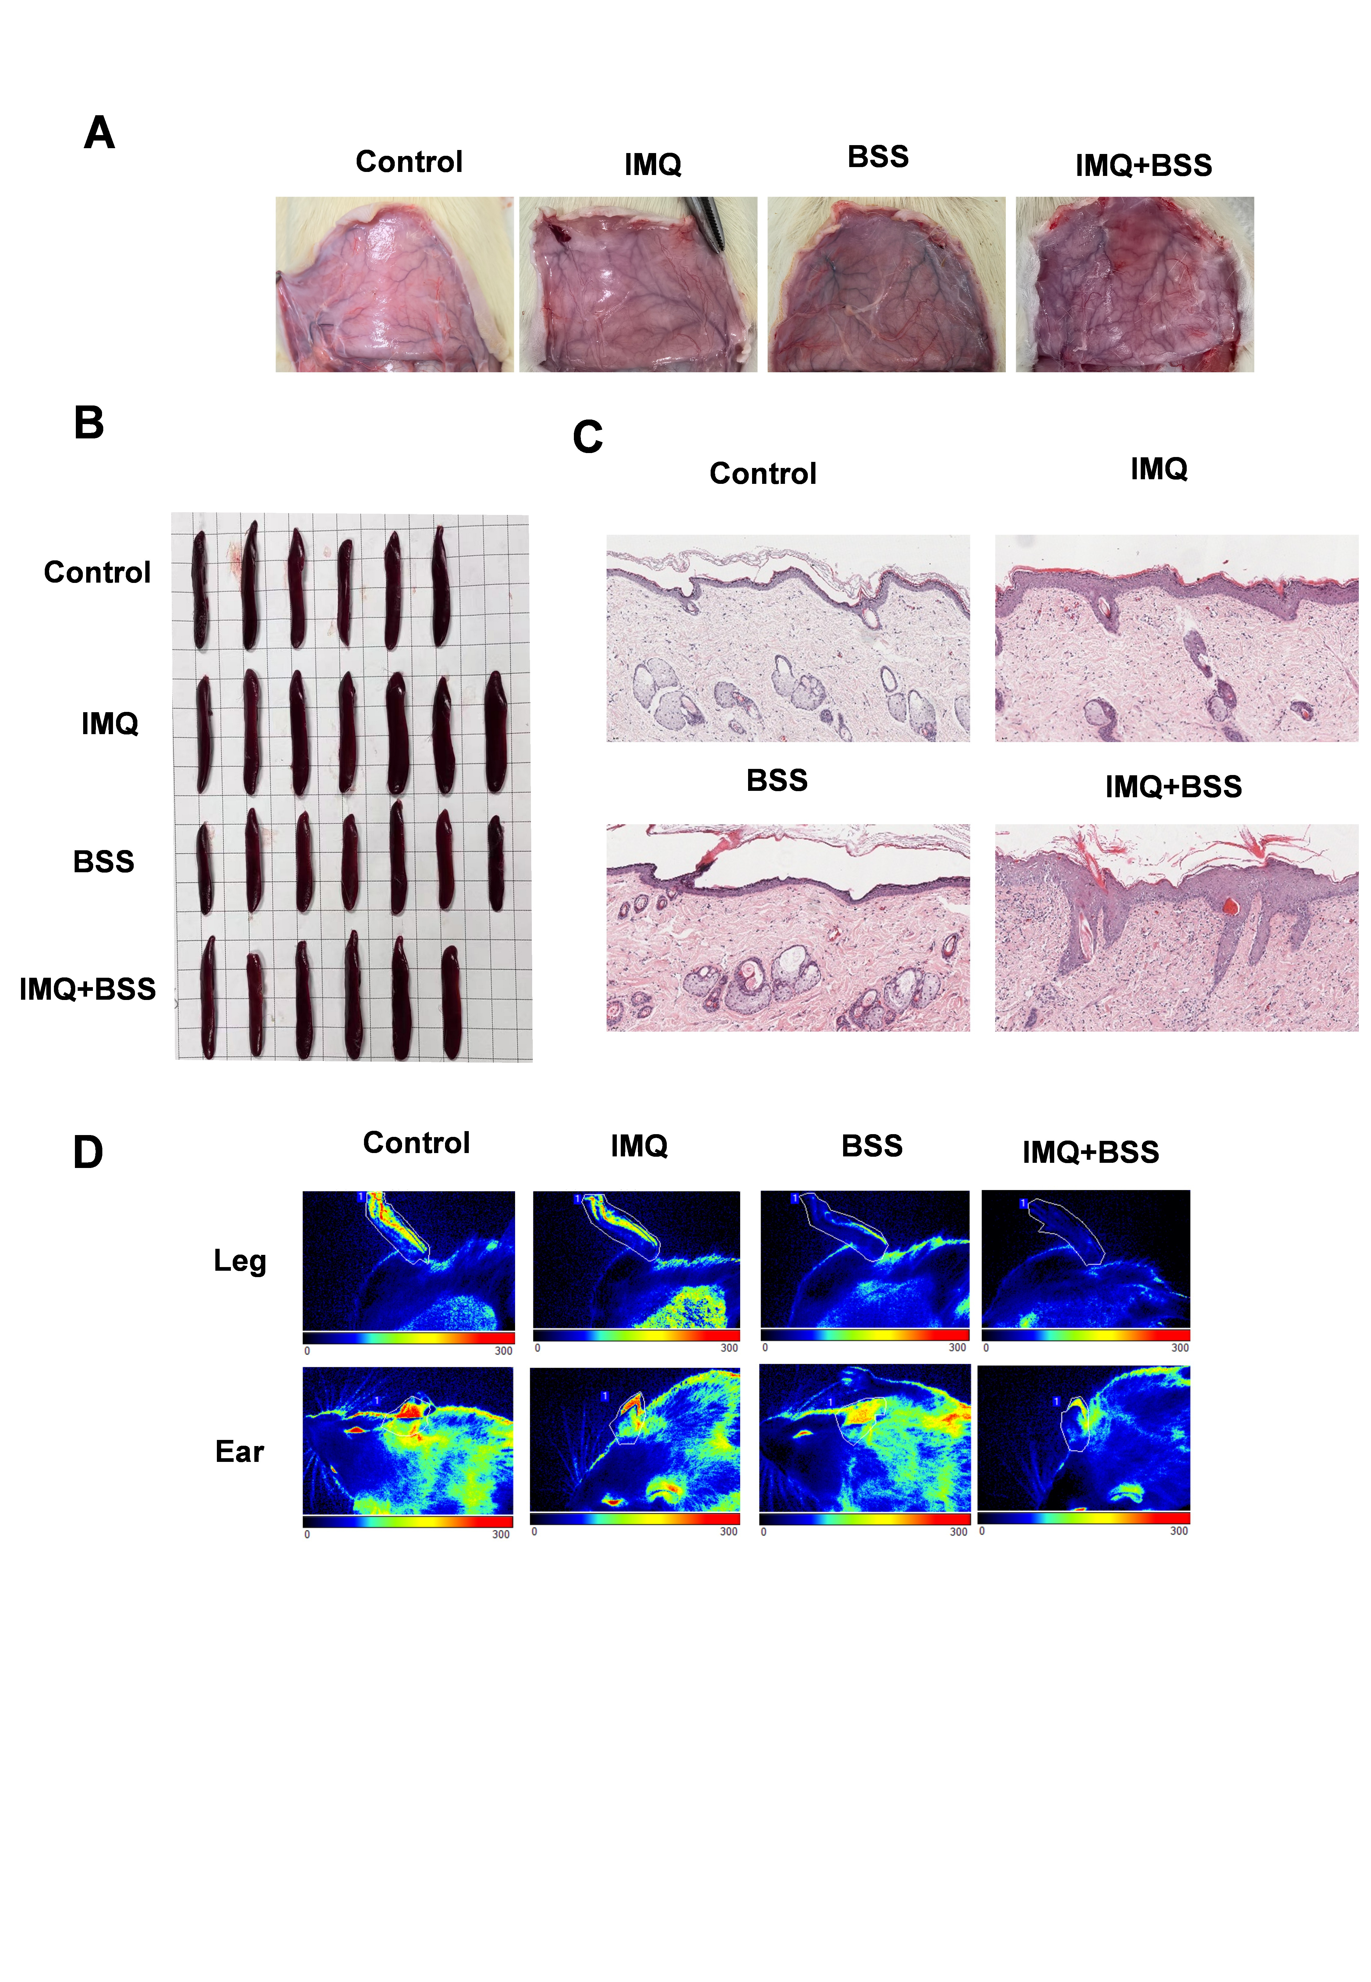
Supplementary Figure 1: A. Subcutaneous blood vessel morphology in rats. B. Spleen appearance. C. HE staining. D. Blood perfusion volume assessment in legs and ear.

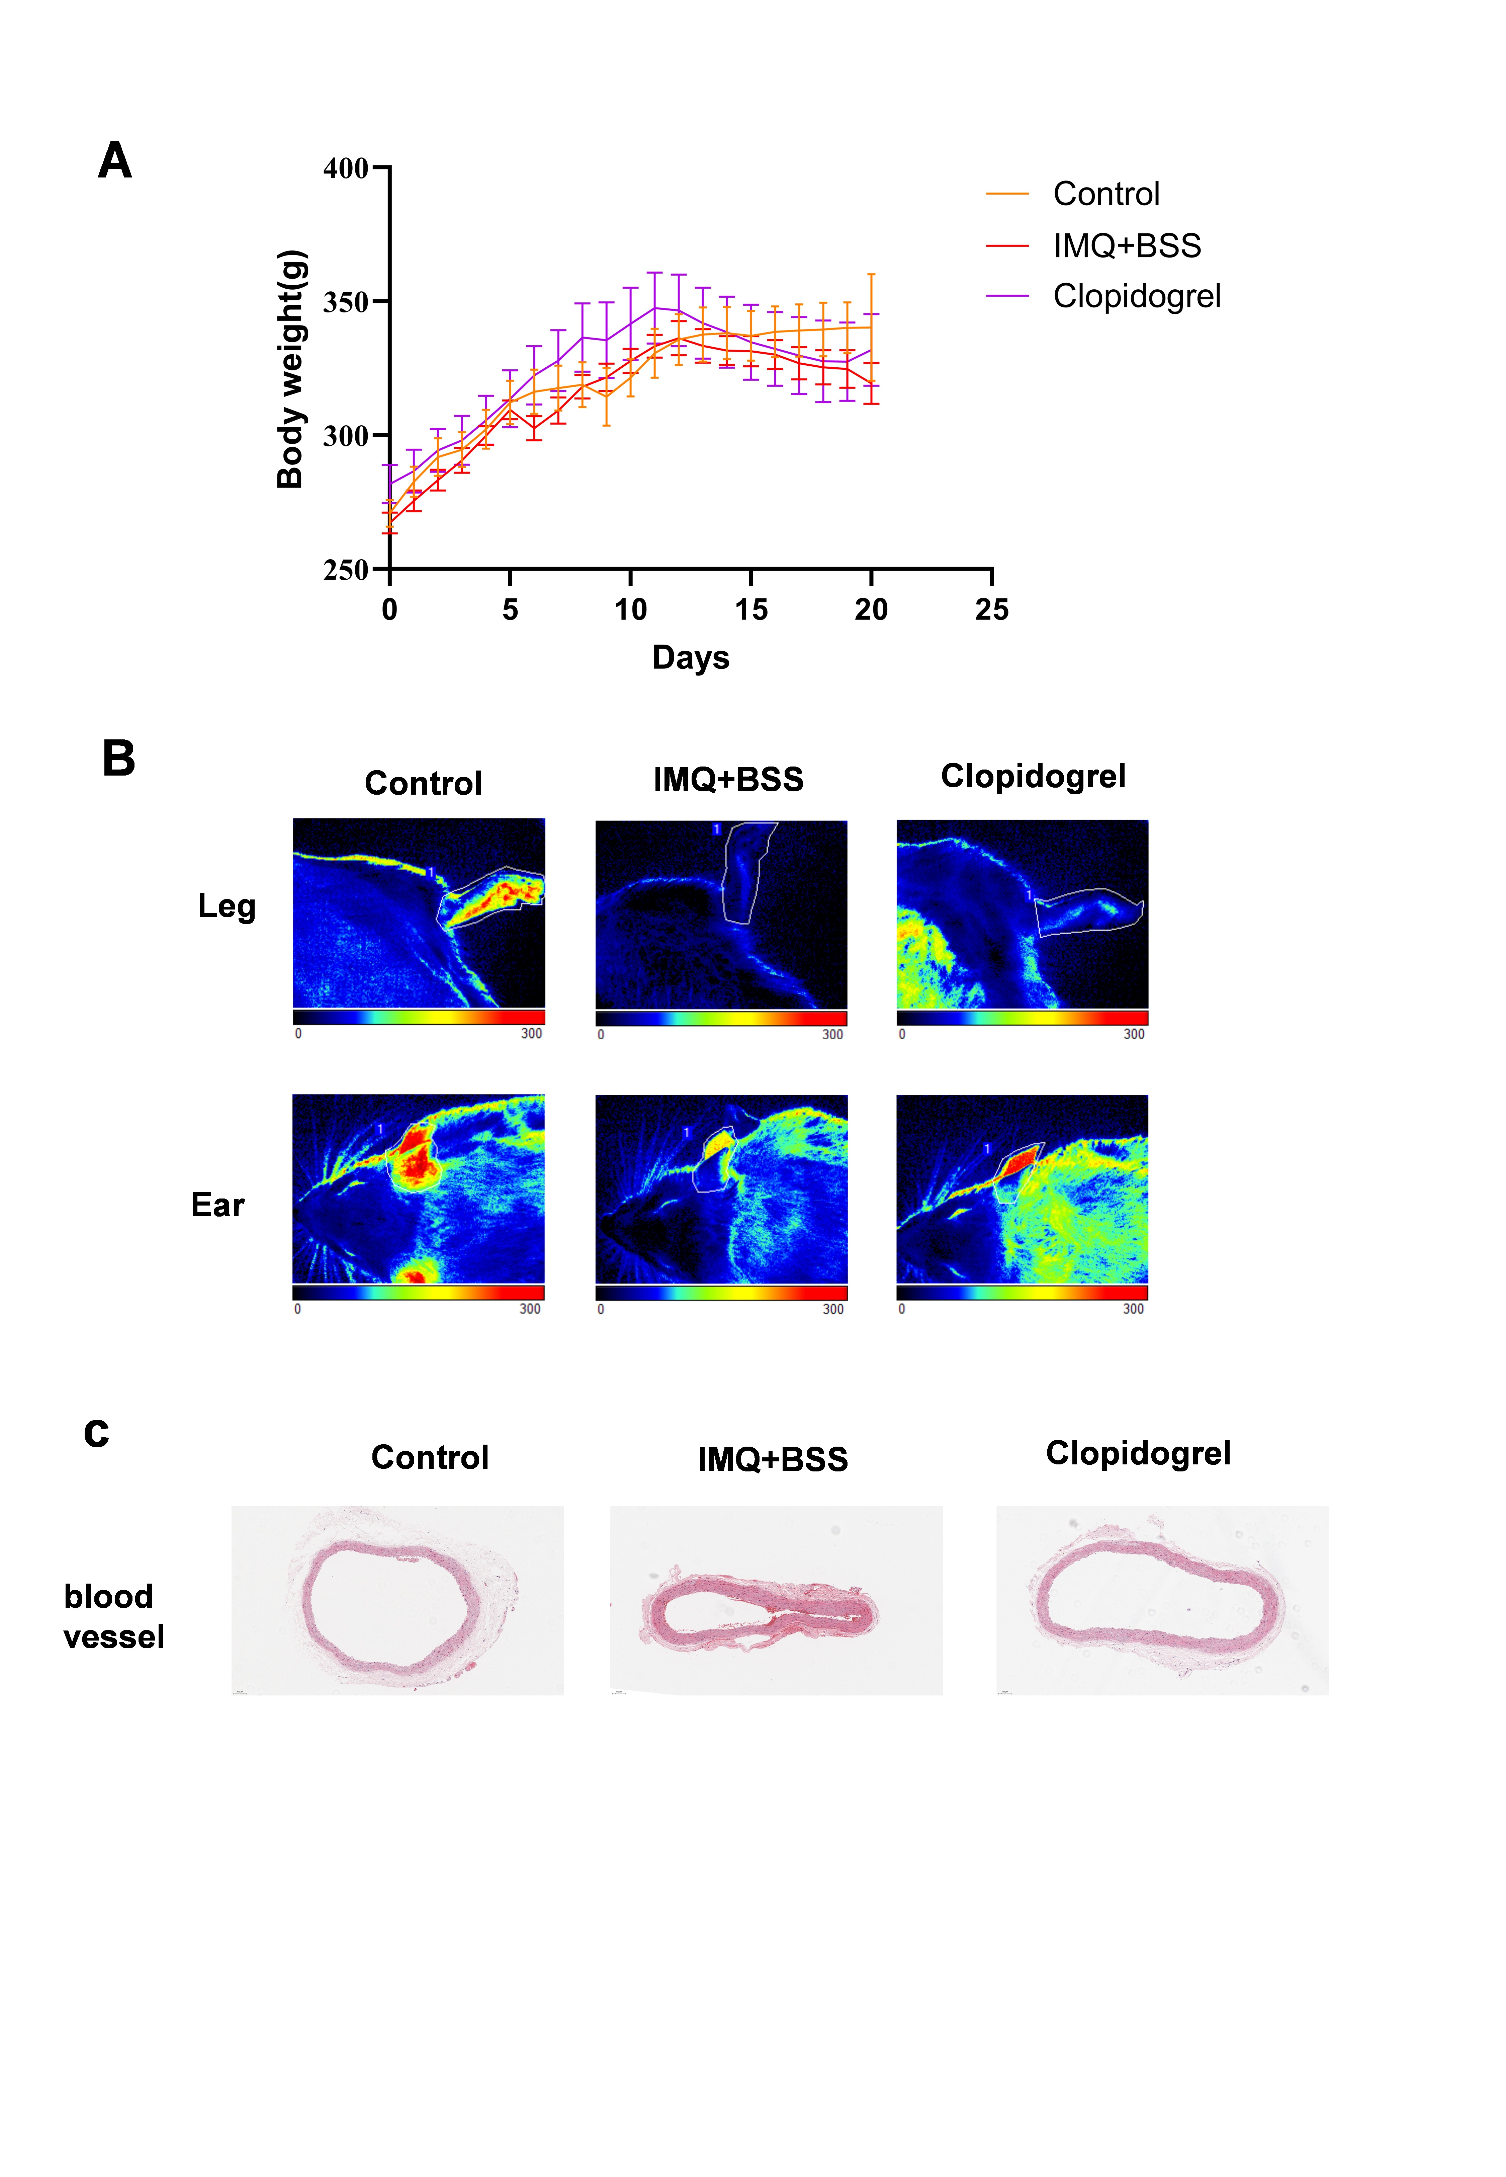
Supplementary Figure 2: A. Body weight changes over time. B. Blood perfusion volume assessment in legs and ear. C. Blood vessel HE staining

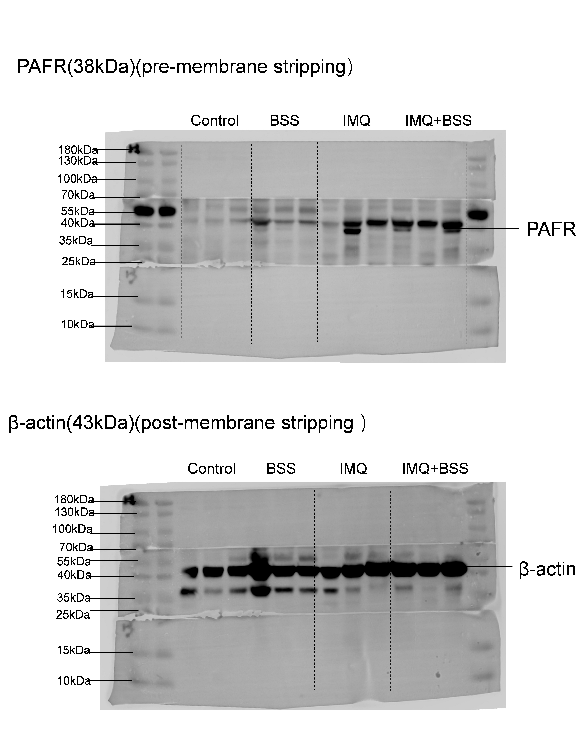
Supplementary Figure 3: Western blot strips for the original image of Figure 3D (protein PAFR), which has been cropped and shown in Figure 3D of the manuscript.

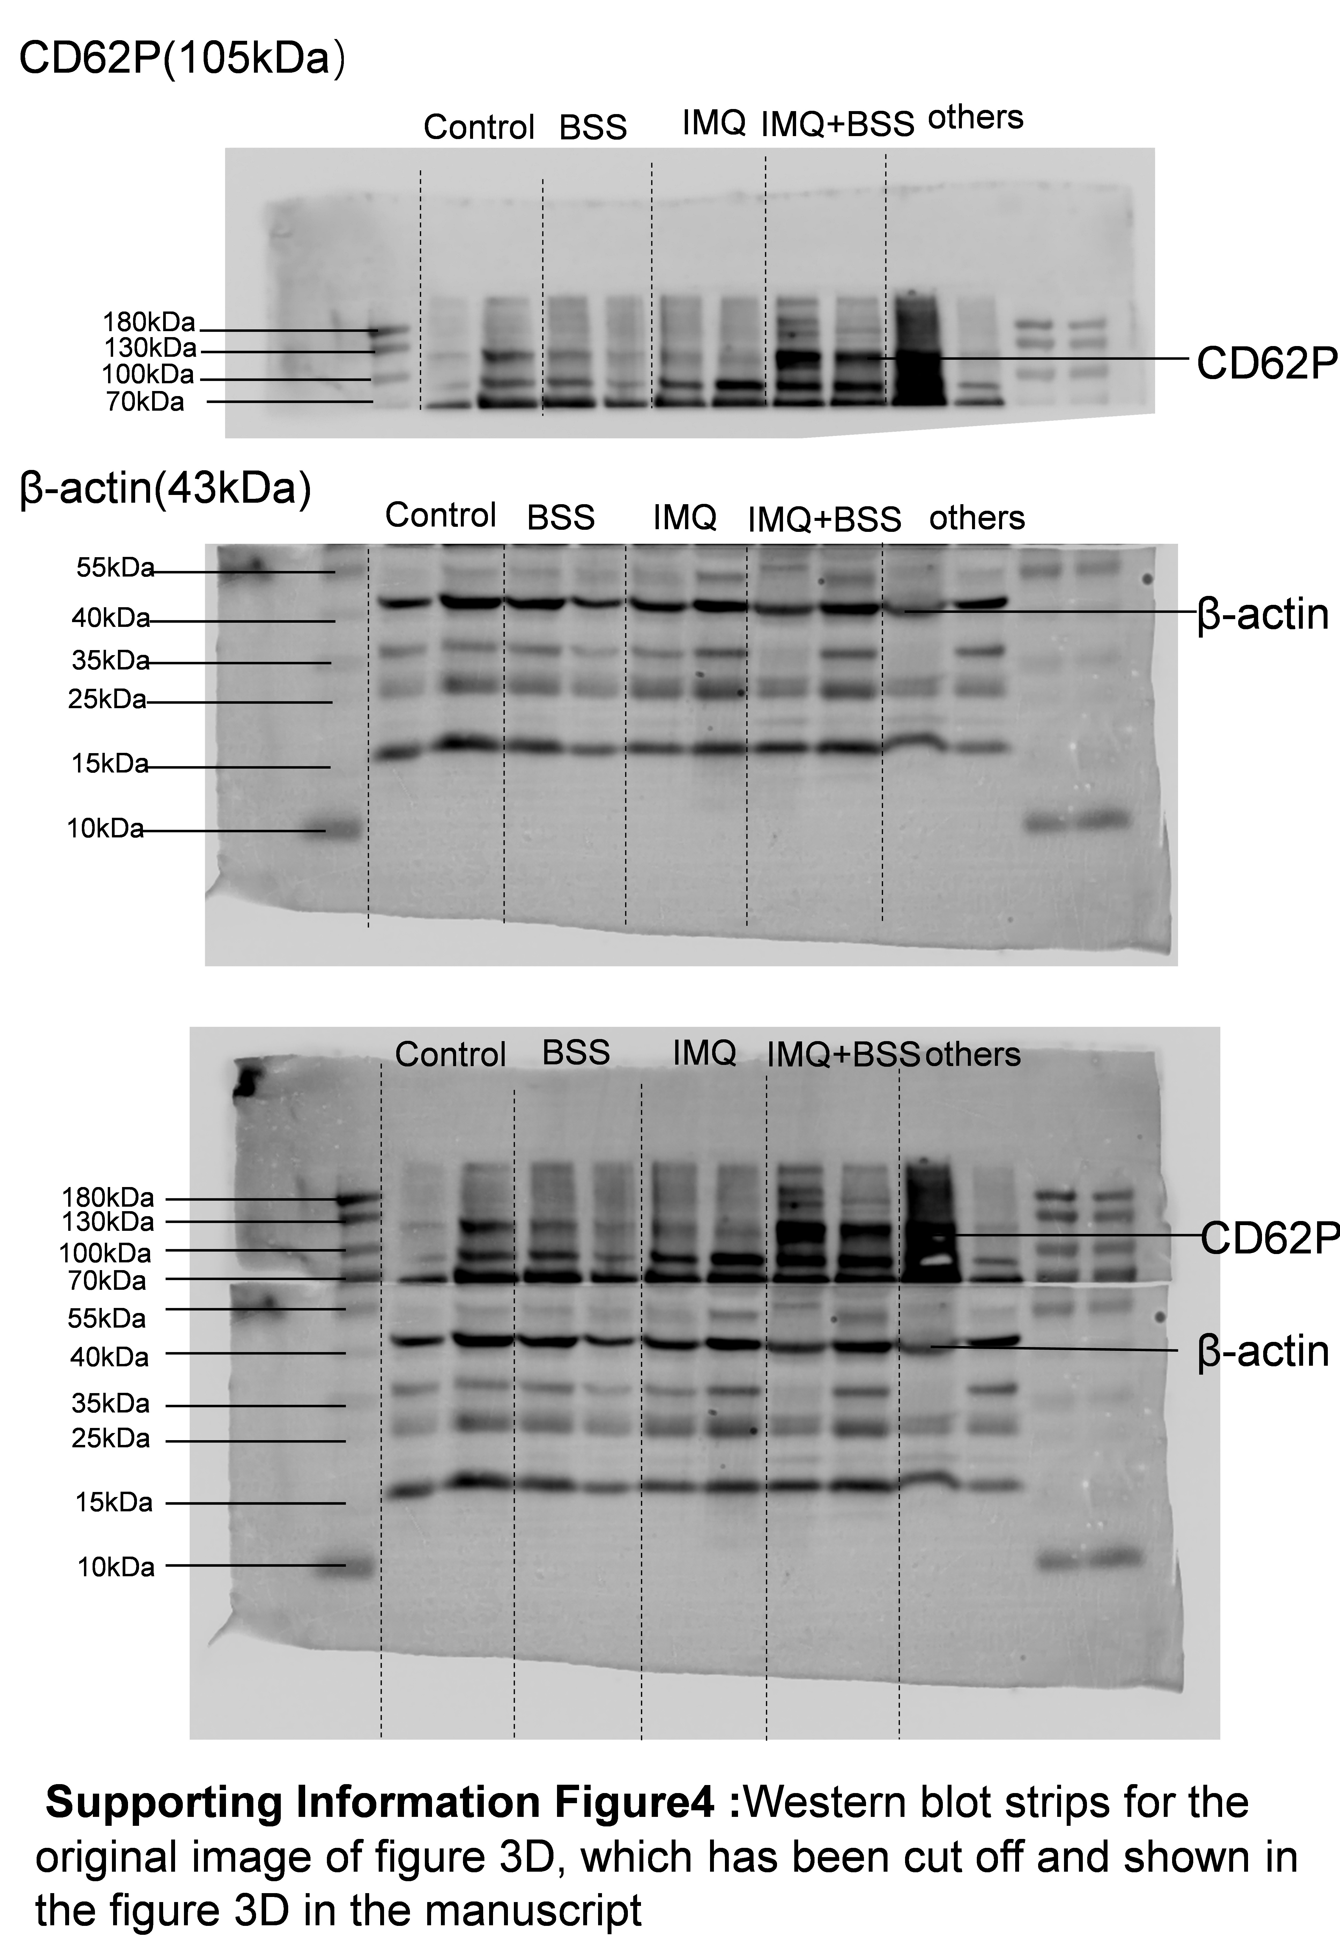
Supplementary Figure 4: Western blot strips for the original image of Figure 3D (protein CD62P, from the first experiment), which has been cropped and shown in Figure 3D of the manuscript

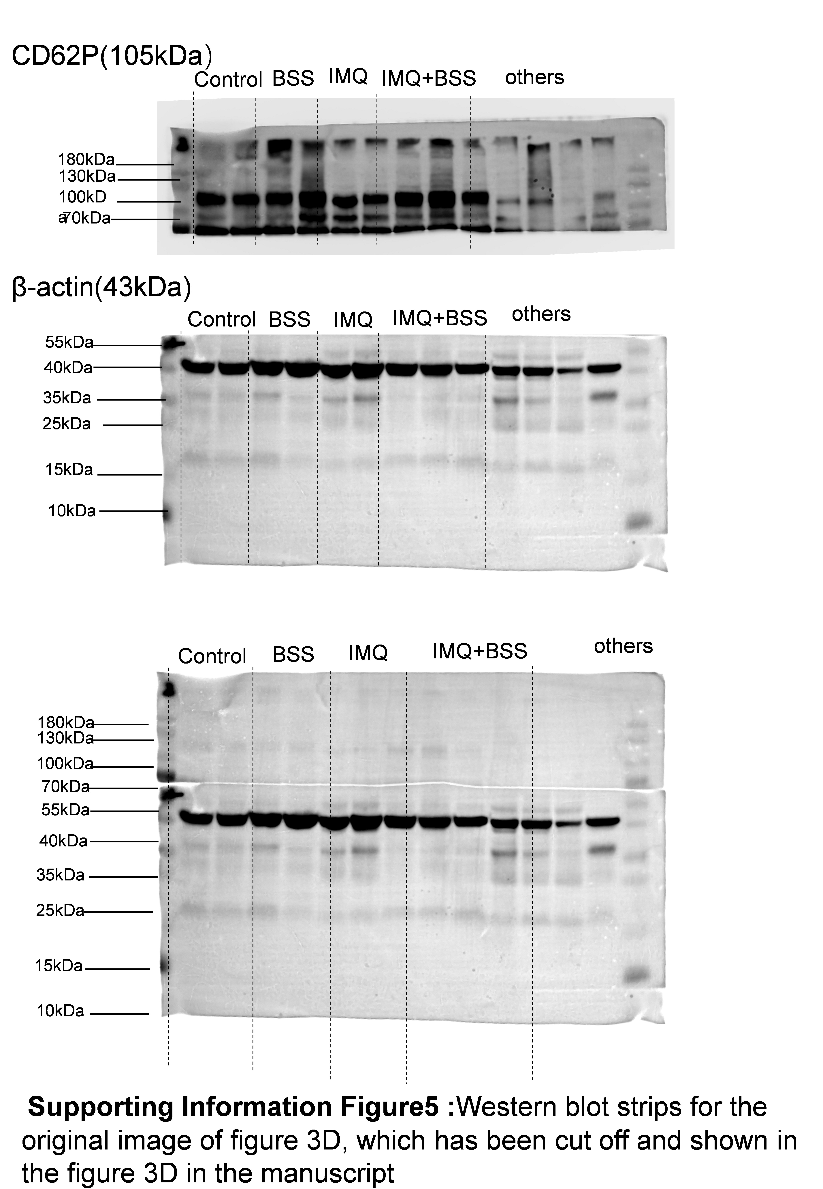
Supplementary Figure 5: Western blot strips for the original image of Figure 3D (protein CD62P, from the second experiment), which has been cropped and shown in Figure 3D of the manuscript

Supplementary methods
Network Pharmacology Analysis
Acquisition of Clopidogrel Targets
The structural file and SMILES number of clopidogrel, along with its known targets, were obtained from PubChem. The structure was uploaded to SwissTarget Prediction and PharmMapper for target prediction. The prediction results with probabilities ≥ and Z scores ≥ 0.5 were screened. Known targets from PubChem and predicted targets from the two platforms were combined to construct the clopidogrel target dataset.
Acquisition of Psoriasis and PAF Targets
Using “Psoriasis” and “PAF (platelet-activating factor)” as keywords, targets with a relevance score ≥ 1 were screened in the GeneCards, OMIM, and DisGeNET databases. Targets from the three databases were integrated to construct the psoriasis target dataset and the PAF target dataset.
Identification of potential targets and network construction
The clopidogrel target dataset was intersected with the psoriasis and PAF target datasets to obtain the potential targets of clopidogrel that act on both. The potential targets were imported into Cytoscape 3 to construct networks: nodes represented clopidogrel-, psoriasis-, and PAF-related targets, and edges represented interactions and their strengths. The NetworkAnalyzer plugin was used to perform topological analysis, calculating parameters such as degree, centrality, and closeness.
PPI Network Construction and Analysis
The intersection genes of clopidogrel-psoriasis and clopidogrel-PAF were imported into the STRING database (v11.5), with a confidence threshold set to >0.7, to construct PPI networks. The PPI networks were imported into Cytoscape 3.9.1, and topological analysis was performed using the CytoNCA plugin. Six metrics—betweenness, closeness, degree, eigenvector, LAC, and network—were calculated. Protein nodes where all metrics were higher than the median were cyclically screened as key nodes (receptors for molecular docking).
GO and KEGG pathway enrichment analysis
Gene ID conversion (Symbol → Entrez) was performed using org.Hs.eg.db (v3.17.0) in R (v4.4.2). GO analysis (BP, MF, CC) and KEGG pathway analysis were performed using clusterProfiler (v4.6.0). P values were corrected using the Benjamini‒Hochberg (BH) method, with a significance threshold of *q*<0.05. The enrichment results were visualized using ggplot2 (v3.4.2).
Molecular docking
The crystal structures of key proteins were obtained from the RCSB PDB. The protein structures were processed using AutoDockTools 1.5.7: water molecules were removed, hydrogen atoms were added, charges were calculated, and atom types were assigned. The coordinates of the protein active sites and the docking box parameters (grid spacing of 1 Å) were defined. The 3D structure of the active ingredient was acquired from PubChem and energy-minimized using OpenBabel 3.1.1 (MMFF94s force field). Semiflexible docking was performed using AutoDock Vina (exhaustiveness=8; rotation of nonring bonds in ligands was allowed). The top 7 conformations were selected on the basis of the absolute value of the binding energy (ΔG). Ligand‒receptor interactions (hydrogen bonds, π‒π stacking, hydrophobic interactions, etc.) and key amino acid residues were analyzed using PyMOL.

