Supplemental contents to:
Transcatheter arterial chemoembolization may be selectively indicated as postoperative adjuvant therapy for hepatocellular carcinoma patients with microvascular invasion

Table of Contents

Supplementary Table 1. Univariate and multivariate Cox-regression analyses predicting RFS in the after PSM cohort 2
Supplementary Table 2. Univariate and multivariate Cox-regression analyses predicting OS in the after PSM cohort 3
Supplementary Table 3. Comparisons of long-term outcomes between HCC patients with MVI with and without PA-TACE before and after PSM 4
Supplementary Figure 1. Patient selection flow. 5
Supplementary Figure 2. The proportion of data in this study 6
Supplementary Figure 3. Subgroups analyses of RFS among low risk factors in HCC patients with MVI.. 7
Supplementary Figure 4. Subgroups analyses of OS among low risk factors in HCC patients with MVI.. 8

Supplementary Table 1 Univariate and multivariate Cox-regression analyses predicting RFS in the after PSM cohort
 | Univariable |  |  | Multivariable
Variables | HR (95% CI) | P |  | HR (95% CI) | P
Sex (male) | 0.818 (0.526, 1.274) | 0.374
Age (year) | 1.002 (0.987, 1.017) | 0.827
HBV infection | 1.660 (0.958, 2.875) | 0.071
AFP ≥ 400 ng/ml | 1.425 (1.048, 1.939) | 0.024 |  | 1.260 (0.990, 1.764) | 0.179
Total bilirubin (μmol/L) | 1.035 (1.011, 1.058) | 0.003 |  | 1.029 (1.005, 1.055) | 0.019
Platelet count (10⁹ /L) | 0.998 (0.996, 1.000) | 0.079
Prothrombin time (s) | 1.099 (0.979, 1.233) | 0.108
Albumin (g/L) | 0.967 (0.935, 1.000) | 0.051
ALT (U/L) | 1.002 (0.997, 1.008) | 0.392
AST (U/L) | 1.005 (1.002,1.008) | 0.002 |  | 1.003 (1.000, 1.007) | 0.077
Tumor size ≥ 5 cm | 1.517 (1.090, 2.112) | 0.013 |  | 1.311 (0.992, 1.864) | 0.131
Mutiple tumors | 0.914 (0.644,1.298) | 0.615
Cirrhosis | 1.110 (0.812, 1.517) | 0.513
Ascites | 0.861 (0.454, 1.634) | 0.648
Major resection | 1.538 (1.102, 2.146) | 0.011 |  | 1.333 (0.920, 1.931) | 0.128
ES grade III/IV | 1.533 (1.120, 2.100) | 0.008 |  | 1.364 (0.975, 1.907) | 0.070
MVI grade M2 | 1.416 (1.011, 1.984) | 0.043 |  | 1.236 (0.873, 1.752) | 0.233
PA-TACE | 0.713 (0.525, 0.968) | 0.030 |  | 0.627 (0.459, 0.857) | 0.003
Abbreviations: AFP, alpha-fetoprotein; ALT, alanine aminotransferase; AST, aspartate aminotransferase; BCLC, Barcelona Clinical Liver Cancer; Edmondson-Steiner, ES; HBV, hepatitis B virus; HCC, hepatocellular carcinoma; MVI, microvascular invasion; PA-TACE, postoperative adjuvant TACE; PSM, propensity score matching; TACE, transcatheter arterial chemoembolization; RFS, recurrence free survival.

Supplementary Table 2 Univariate and multivariate Cox-regression analyses predicting OS in the after PSM cohort
 | Univariable |  |  | Multivariable
 | HR (95% CI) | P |  | HR (95% CI) | P
Sex (male) | 0.807 (0.488, 1.334) | 0.403
Age (year) | 0.997 (0.980, 1.014) | 0.747
HBV infection | 1.338 (0.718, 2.491) | 0.359
AFP ≥ 400 ng/ml | 1.530 (1.058, 2.213) | 0.024 |  | 1.298 (0.872, 1.934) | 0.199
Total bilirubin (μmol/L) | 1.024 (1.000, 1.049) | 0.050
Platelet count (10⁹ /L) | 0.996 (0.993, 0.999) | 0.013 |  | 0.995 (0.992, 0.998) | 0.002
Prothrombin time (s) | 1.119 (0.972, 1.289) | 0.117
Albumin (g/L) | 0.972 (0.935, 1.011) | 0.159
ALT (U/L) | 1.004 (0.998,1.011) | 0.173
AST (U/L) | 1.008 (1.003, 1.013) | 0.002 |  | 1.004 (0.998, 1.011) | 0.148
Tumor size ≥ 5 cm | 1.845 (1.211, 2.811) | 0.004 |  | 1.722 (1.092, 2.716) | 0.019
Mutiple tumors | 1.062 (0.696, 1.621) | 0.779
Cirrhosis | 1.052 (0.725, 1.528) | 0.789
Ascites | 1.063 (0.538, 2.099) | 0.861
Major resection | 1.922 (1.314, 2.810) | 0.001 |  | 1.562 (1.020, 2.392) | 0.040
ES grade III/IV | 1.366 (0.937, 1.990) | 0.105
MVI grade M2 | 1.546 (1.039, 2.300) | 0.032 |  | 1.447 (0.965, 2.170) | 0.074
PA-TACE | 0.687 (0.474, 0.995) | 0.047 |  | 0.668 (0.459, 0.972) | 0.035
Abbreviations: AFP, alpha-fetoprotein; ALT, alanine aminotransferase; AST, aspartate aminotransferase; BCLC, Barcelona Clinical Liver Cancer; Edmondson-Steiner, ES; HBV, hepatitis B virus; HCC, hepatocellular carcinoma; MVI, microvascular invasion; PA-TACE, postoperative adjuvant transcatheter arterial chemoembolization; PSM, propensity score matching; TACE, transcatheter arterial chemoembolization; OS, overall survival.

Supplementary Table 3 Comparisons of long-term outcomes between HCC patients with MVI with and without PA-TACE before and after PSM
 | Before PSM (n = 440) |  |  |  | After PSM (n = 292)
 | Non-TACE  (n = 288) | PA-TACE  (n = 152) | P |  | Non-TACE  (n = 146) | PA-TACE  (n = 146) | P
Recurrence during the follow-up | 170 (59.0) | 79 (52.0) | 0.156 |  | 89 (61.0) | 76 (52.1) | 0.125
Death during the follow-up | 126 (43.8) | 50 (32.9) | 0.027 |  | 67 (45.9) | 48 (32.9) | 0.023
Median RFS, 95% CI, months | 9.0 (13.8–17.6) | 13.0 (16.2–21.7) | 0.029 |  | 9.0 (12.7, 17.9) | 13.0 (16.2, 21.8) | 0.026
1-year RFS rate, % | 48.8 | 57.3 |  |  | 46.2 | 57.4
3-year RFS rate, % | 27.2 | 30.5 |  |  | 23.4 | 30.6
5-year RFS rate, % | 13.2 | 21.9 |  |  | 12.3 | 21.9
Median OS, 95% CI, months | 38.0 (31.7–36.8) | 42.0 (34.0–40.7) | 0.026 |  | 41.0 (31.9, 39.0) | 42.0 (33.7, 40.6) | 0.044
1-year OS rate, % | 72.5 | 84.1 |  |  | 71.2 | 83.4
3-year OS rate, % | 55.1 | 63 |  |  | 54 | 63.2
5-year OS rate, % | 45 | 61.4 |  |  | 41.1 | 51.2
Abbreviations: HCC, hepatocellular carcinoma; MVI, microvascular invasion; PA-TACE, postoperative adjuvant TACE; TACE, transcatheter arterial chemoembolization; PSM, propensity score matching; RFS, recurrence free survival; OS, overall survival.

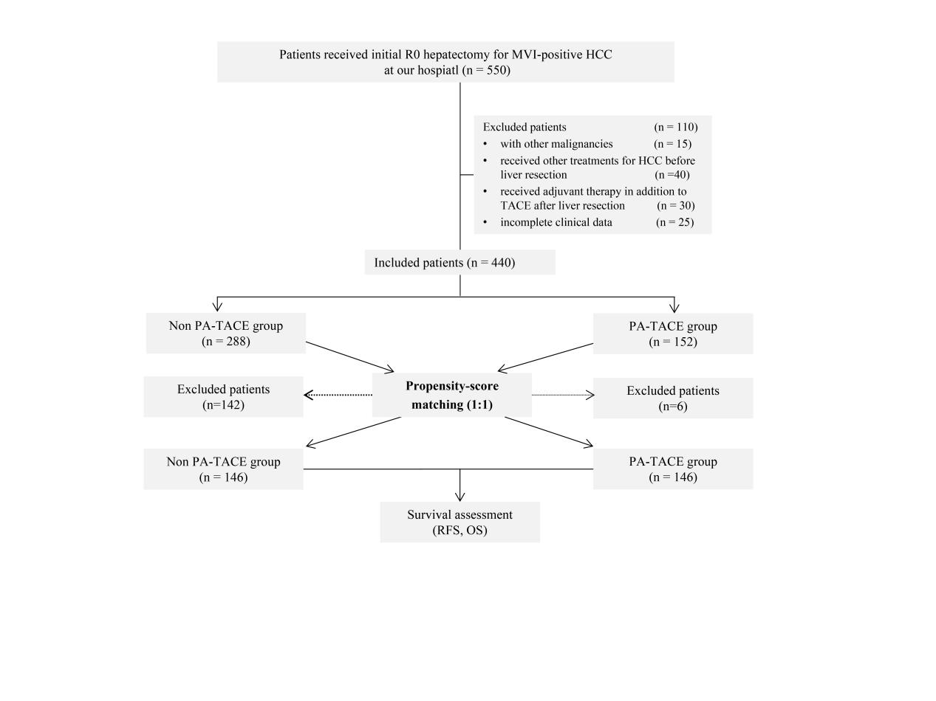
Supplementary Figure 1. Patient selection flow.
Abbreviations: HCC: Hepatocellular carcinoma; PA-TACE, postoperative adjuvant transcatheter arterial chemoembolization; RFS, recurrence free survival; OS, overall survival.

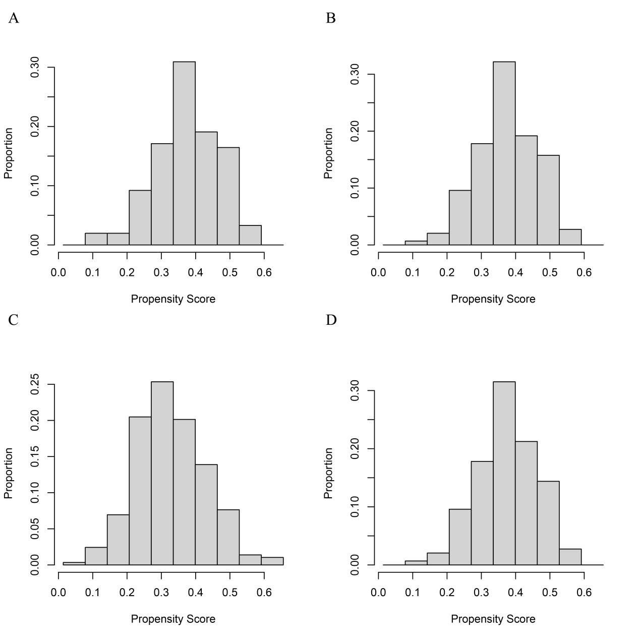
Supplementary Figure 2. The proportion of data utilized in this study. The comparison between pre-PSM (A and C) and post-PSM (B and D) data for both the Non PA-TACE and PA-TACE groups demonstrates the effect of PSM in creating balanced cohorts for analysis.
Abbreviations: PA-TACE, postoperative adjuvant transcatheter arterial chemoembolization; TACE, transcatheter arterial chemoembolization; PSM, propensity score matching.

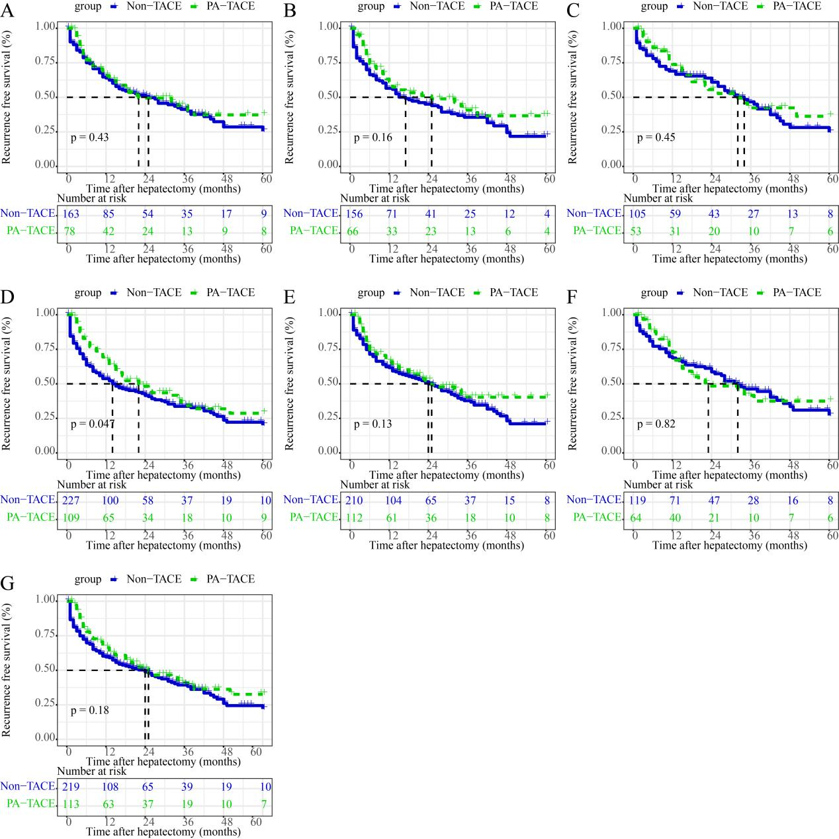
Supplementary Figure 3. Subgroups analyses of RFS among low risk factors in HCC patients with MVI. (A) AFP < 400 ng/ml; (B) absence of cirrhosis; (C) tumor size < 5cm; (D) single tumor number; (E) minor resection; (F) ES grade I/II; (G) M1-type MVI.
Abbreviations: AFP, alpha-fetoprotein; MVI, microvascular invasion; ES, Edmondson- Steiner; HCC, hepatocellular carcinoma; PA-TACE, postoperative adjuvant transcatheter arterial chemoembolization; TACE, transcatheter arterial chemoembolization; RFS, recurrence free survival.

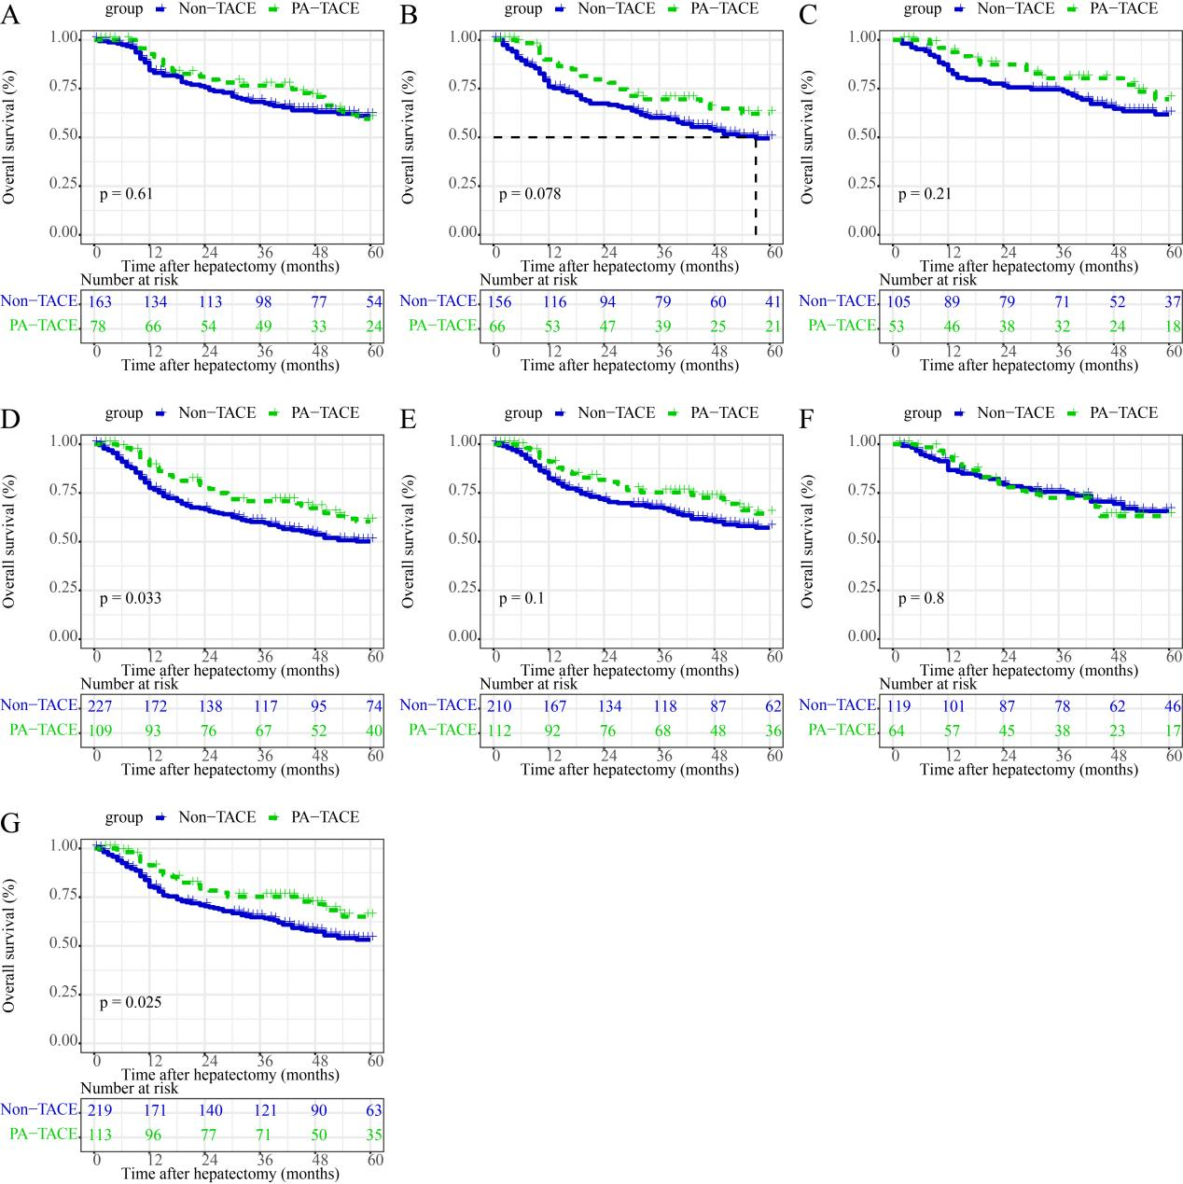
Supplementary Figure 4. Subgroups analyses of OS among low risk factors in HCC patients with MVI. (A) AFP < 400 ng/ml; (B) absence of cirrhosis; (C) tumor size < 5cm; (D) single tumor number; (E) minor resection; (F) ES grade I/II; (G) M1-type MVI.
Abbreviations: AFP, alpha-fetoprotein; MVI, microvascular invasion; ES, Edmondson-Steiner; HCC, hepatocellular carcinoma; PA-TACE, postoperative adjuvant transcatheter arterial chemoembolization; TACE, transcatheter arterial chemoembolization; OS, overall survival.

