Supplementary Figure 1.
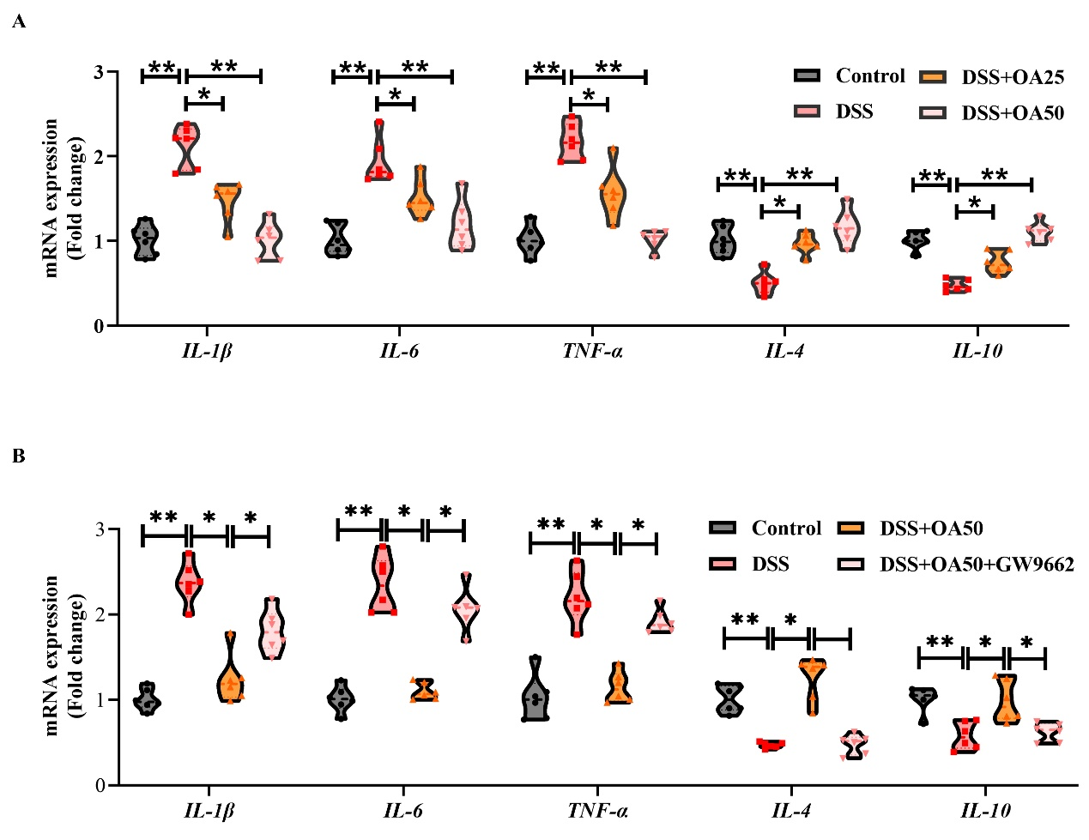
Supplementary Figure 1. (A) The relative mRNA expression levels of IL-1β, IL-6, TNF-α, IL-4 and IL-10 in colonic tissues were determined via qRT-PCR analysis. (B) The relative mRNA expression levels of IL-1β, IL-6, TNF-α, IL-4 and IL-10 in colonic tissues were determined via qRT-PCR analysis. All data were presented as mean ± SD, n =6 per group. *P < 0.05, **P < 0.01 vs. corresponding control.

Supplementary Table 1. Primer sequence for quantitative real-time PCR.
Gene | Forward | Reverse
β-actin | GGCTGTATTCCCCTCCATCG | CCAGTTGGTAACAATGCCATGT
IL-1β | GAAATGCCACCTTTTGACAGTG | TGGATGCTCTCATCAGGACAG
IL-6 | CTCTGGGAAATCGTGGAAAT | CCAGTTTGGTAGCATCCATC
TNF-α | CCCTCACACTCAGATCATCTTC | GTTGGTTGTCTTTGAGATCCAT
IL-8 | CAAGGCTGGTCCATGCTCC | TGCTATCACTTCCTTTCTGTTGC
IL-4 | GGTCTCAACCCCCAGCTAGT | GCCGATGATCTCTCTCAAGTGAT
IL-10 | GCTCTTACTGACTGGCATGAG | CGCAGCTCTAGGAGCATGTG
ZO-1 | GCCGCTAAGAGCACAGCAA | TCCCCACTCTGAAAATGAGGA
Occludin | TTGAAAGTCCACCTCCTTACAGA | CCGGATAAAAAGAGTACGCTGG
Claudin-1 | GGGGACAACATCGTGACCG | AGGAGTCGAAGACTTTGCACT

Supplementary Table 2. The antibodies list.
Antibody | Origin | Vendor | Catalog No.
ZO-1 | Rabbit | HUABIO | HA722797
Occludin | Rabbit | HUABIO | ET1701-76
Claudin | Rabbit | HUABIO | HA721999
iNOS | Rabbit | Proteintech | 22226-1-AP
p- P65 | Rabbit | Proteintech | 82335-1-RR
P65 | Rabbit | Proteintech | 80979-1-RR
PPARγ | Mouse | Proteintech | 66936-1-lg
β-actin | Rabbit | ABclonal | AC026
IkBα | Rabbit | Boster | BM3932
IKKα/β | Rabbit | Boster | BM4499
p-IKKα/β | Rabbit | Cell Signaling Technology | 2697S

Supplementary Table 3. The Secondary antibody list.
Antibody | Vendor | Catalog No. | Application
HRP Conjugated AffiniPure Goat Anti-rabbit IgG (H+L) | Boster | BA1054 | WB
HRP Conjugated AffiniPure Goat Anti-mouse IgG (H+L) | Boster | BA1050 | WB
Goat anti-rabbit IgG H&L (HRP) | Abcam | AB205718 | IHC

