Supplementary Figure 1. The phenotype and valves of bile acid metabolism in CHB, LC and HCC patients.
- Box plots of BAs levels in patients with decompensated cirrhosis compared to compensated stage. (B-I) The ROC analysis of bile acids for the power to predict the risk of disease progression. Significance levels are denoted as follows: ns, not significant; * P < 0.05; ** P < 0.01; *** P < 0.001.

Supplementary Figure 2. Correlation analysis of cholesterol (TC) and total bile acids (TBA).
This study employed Pearson correlation analysis and Spearman's rank correlation analysis to examine the relationship between cholesterol (TC) and total bile acids (TBA) in a total of 82 samples. The results showed a Pearson linear correlation coefficient of r = -0.064 (p = 0.565) between TC and TBA, indicating no statistically significant linear correlation (p > 0.05). Further analysis using the more outlier-resistant Spearman's rank correlation yielded a monotonic correlation coefficient of ρ = -0.093, which similarly demonstrated no significant monotonic trend between the two variables.

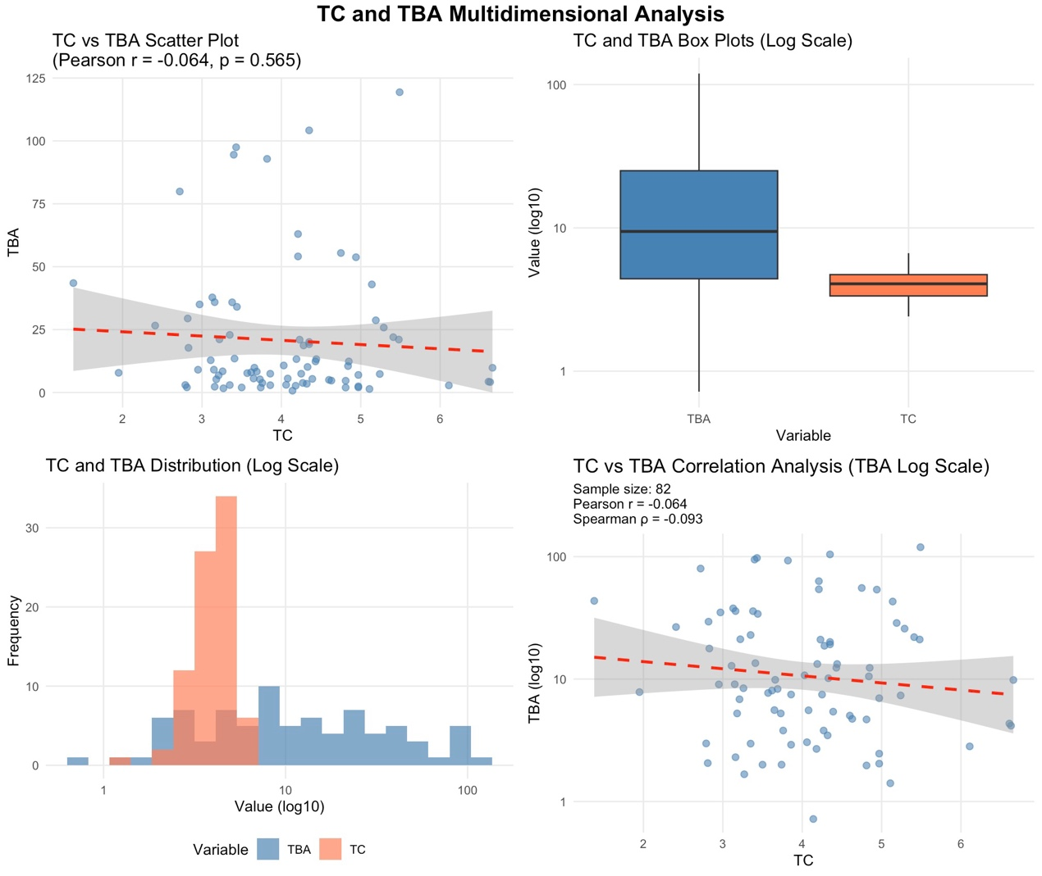

Supplementary Figure 3. Differences in the proportion of hydrophobic and hydrophilic bile acids in the chronic hepatitis B(CHB), liver cirrhosis, and HCC groups.
Significant differences were observed in the ratio of hydrophobic to hydrophilic bile acids among the three patient groups: CHB, post-hepatitis B liver cirrhosis, and HCC. Particularly notable differences were identified between the CHB group and the liver cirrhosis group, as well as between theCHB group and the HCC group.
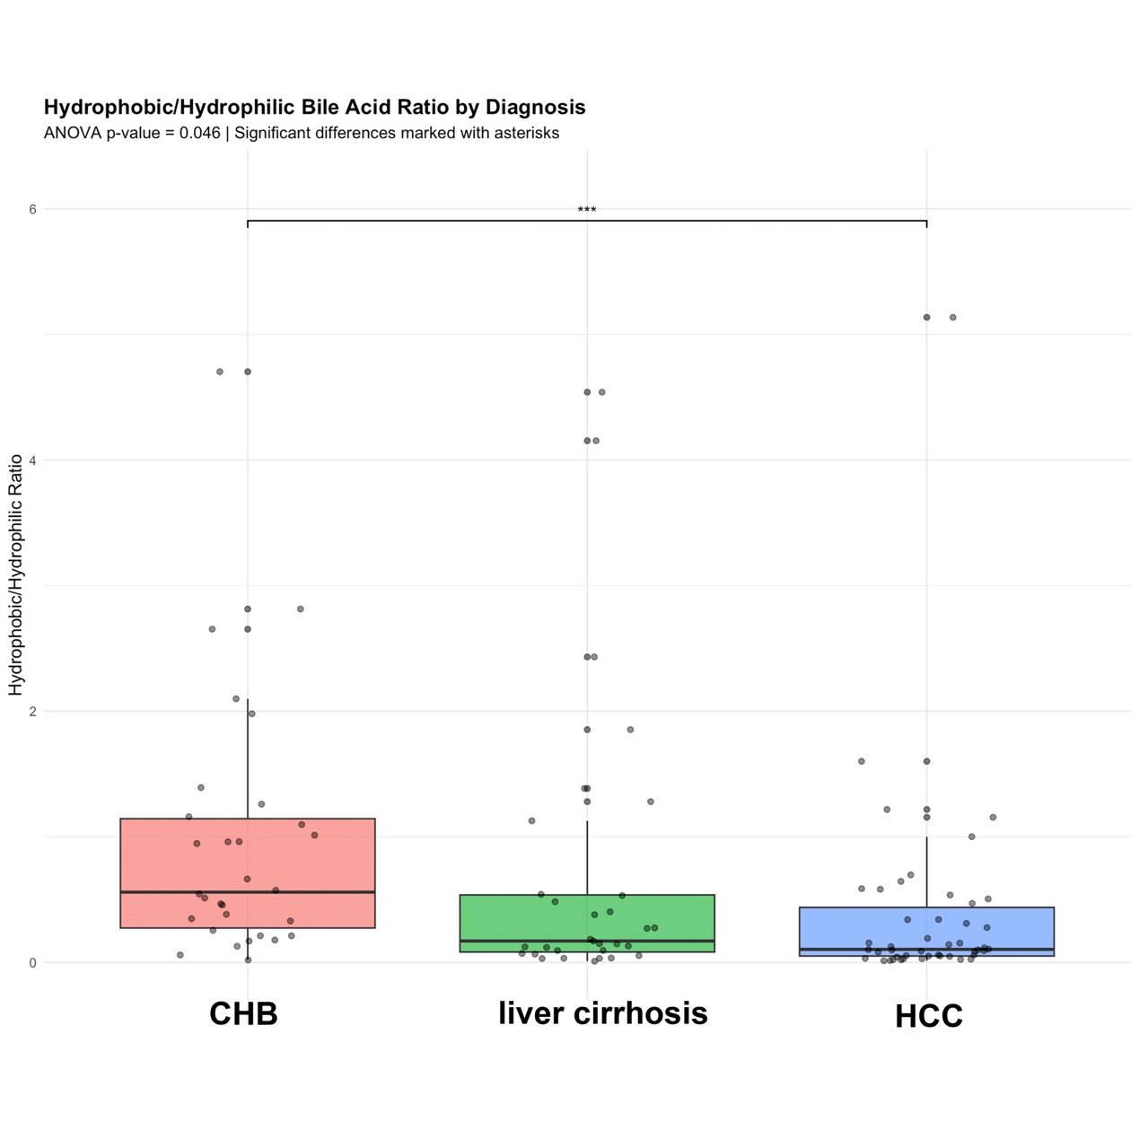

Supplementary Table 1. Baseline characteristics of the training and validation cohorts.

Variable | Total  (n = 608) | Group |  | P
Variable | Total  (n = 608) | Training set  (n = 425) | Validation set  (n = 183) | P
Sex, n (%) |  |  |  | 0.602
Male | 433(71.22) | 300(70.59) | 133(72.68) | 0.602
Female | 175(28.78) | 125(29.41) | 50(27.32) | 0.602
HBsAg, n (%) |  |  |  | 0.506
≤250 (IU/mL) | 191(31.41) | 137(32.24) | 54(29.51) | 0.506
>250 (IU/mL) | 417(68.59) | 288(67.76) | 129(70.49) | 0.506
Age  (years) | 50.00  (40.00, 60.00) | 50.00  (39.00, 60.00) | 50.00  (41.00, 60.50) | 0.727
HBeAg  (IU/mL) | 0.39  (0.29, 0.60) | 0.40  (0.30, 0.60) | 0.38  (0.00, 0.55) | 0.225
HBcAb  (S/CO) | 8.87  (7.80, 10.25) | 8.91  (7.79, 10.28) | 8.79  (7.81, 10.03) | 0.589
AFP  (ng/mL) | 3.05  (2.19, 5.41) | 3.25  (2.21, 5.88) | 2.94  (2.15, 4.47) | 0.055
PLR | 67.98  (44.36, 100.00) | 67.47  (43.82, 96.73) | 69.51  (45.27, 105.01) | 0.490
NLR | 1.81  (1.25, 2.51) | 1.77  (1.24, 2.51) | 1.90  (1.32, 2.50) | 0.405
INR | 1.01  (0.93, 1.13) | 1.01  (0.93, 1.13) | 1.01  (0.93, 1.15) | 0.316
TBIL  (umol/L) | 15.10  (11.57, 22.45) | 14.90  (11.45, 22.50) | 15.30  (11.70, 22.40) | 0.478
ALB  (umol/L) | 41.00  (36.00, 43.80) | 41.05  (35.90, 43.90) | 41.00  (36.30, 43.60) | 0.618
ALT  (U/L) | 31.00  (20.00, 47.00) | 32.00  (21.00, 47.50) | 31.00  (19.00, 47.00) | 0.246

Supplementary Table 2. The content of serum BAs among CHB, HBV-related LC and HCC.
 | CHB  （N=260） | HBV-related LC  （N=101） | HBV-related HCC  （N=70） | P value
TBA (umol/L) * | 5.27(2.88-11.14) | 18.66(7.72-54.0575) | 13.3(7.535-34.79) | <0.001
CA (nmol/L) * | 104(50.75-256) | 411(190.5-951.5) | 323(99.35-930.5) | <0.001
GCA (nmol/L) * | 510(245-1140) | 4605(1140-20850) | 3490(1105-10850) | <0.001
TCA (nmol/L) * | 37.1(18.05-80.4) | 746.5(68.35-3955) | 345(96.75-1735) | <0.001
CDCA (nmol/L) * | 490(239-1085) | 910.5(454.5-1797.5) | 1060(362.5-2200) | <0.001
GCDCA (nmol/L) * | 1160(585.5-2765) | 4795(1890-13550) | 4160(1985-11550) | <0.001
TCDCA (nmol/L) * | 143(66.55-358.5) | 1540(199-6765) | 721(293-3235) | <0.001
DCA (nmol/L) * | 251(90.15-507.5) | 71.55(12.975-305.75) | 61.9(21.4-339) | <0.001
GDCA (nmol/L) | 160(54.75-417) | 123.5(7.3075-585.5) | 123(14-544) | 0.732
TDCA (nmol/L) | 21.6(6.705-52.85) | 23.55(3.46-150.5) | 27.2(8.59-125) | 0.219
UDCA (nmol/L) | 199(86.25-823.5) | 227.5(79.875-1765) | 276(82.55-876.5) | 0.909
GUDCA (nmol/L) * | 380(111.5-2610) | 835(186.5-7787.5) | 868(274.5-3260) | 0.007
TUDCA (nmol/L) * | 14.3(3.0726-139) | 51.25(11.875-749) | 55.8(16.8-304) | <0.001
LCA (nmol/L) * | 14.7(6.1512-27.45) | 8.93(2.755-18.05) | 7.35(3.315-23.8) | 0.009
GLCA (nmol/L) | 6.38(2.3656-18.85) | 4.235(2.0425-13.95) | 4.26(1.9-11.75) | 0.291
TLCA (nmol/L) | 2.27(0.8015-8.205) | 1.59(0.551-6.75) | 1.3(0.583-3.82) | 0.357
Data were expressed as median with interquartile range. *：Compared with CHB, P<0.05.
Abbreviations: NC: normal controls; CHB, chronic hepatasis B; CA; Cholic acid; DCA, Deoxycholic acid; CDCA, Chenodeoxycholic acid; UDCA, ursodeoxycholic acid; LCA, lithocholic acid; GCA, glycocholic acid; GLCA, Lithocholylglycine; GDCA, glycodeoxycholic acid; GCDCA, Glycochenodeoxycholic acid; TCA, Taurocholic acid; TLCA, Taurolithocholic acid; TDCA, Taurodeoxycholic acid; TCDCA, Taurochenodeoxycholic acid; TUDCA, Tauroursodeoxycholic acid.

Supplementary Table 3. The cut-off, AUC, sensitivity and specificity of Nomogram, APRI, FIB-4 and AFP.

Model | Cut-off | AUC | Sensitivity | Specificity
Nomogram | 2.152 | 0.915(0.888,0.942) | 0.663 | 0.84
APRI | 1.774 | 0.610(0.541,0.678) | 0.394 | 0.851
FIB-4 | 3.445 | 0.764(0.708,0.819) | 0.702 | 0.73
AFP | 0.145 | 0.798(0.739,0.857) | 0.854 | 0.472

Supplementary Table 4. The content of serum BAs among normal controls, CHB, HBV-related LC and HCC.
 | NC  (n=32) | CHB  (n=70) | LC  (n=50) | HCC  (n=40)
TBA  (umol/L) | 4.93  (3.04, 8.30) | 5.24  (2.97, 9.75) | 25.81  (12.13, 57.47) | 19.70  (9.07, 55.00)
CA  (nmol/L) | 51.8  (31.4,123.0) | 173.0  (90.3,366.0) | 815.0  (284.0,1740.0) | 336.0  (137.0,861.0)
GCA  (nmol/L) | 182.0  (137.0,419.0) | 709.0  (284.0,1940.0) | 8250.0  (1290.0,22000.0) | 5320.0  (2520.0,13000.0)
TCA  (nmol/L) | 15.1  (9.05,28.7) | 53.6  (30.9,135.0) | 155.0(47.9,761.5) | 460.0  (141.0,1110.0)
CDCA  (nmol/L) | 459.0  (327.0,648.0) | 846.0  (436.0,1900.0) | 939.0  (522.0,3290.0) | 637.0  (294.0,1540.0)
GCDCA (nmol/L) | 662.0  (487.0,1160) | 2730.0  (960.0,5570.0) | 11198.0  (3350.0,37000.0) | 9440.0  (5600.0,32500.0)
TCDCA (nmol/L) | 85.2  (49.8,112.0) | 199.0  (122.0,375.0) | 194.0  (146.0,891.0) | 1300.0  (224.0,2180.0)
DCA  (nmol/L) | 176.0  (29.1,408.0) | 292.0  (94.7,526.0) | 393.0  (140.0,822.0) | 109.0  (32.7,373.0)
GDCA  (nmol/L) | 83.2  (40.5,198.0) | 135.0  (52.7,379.0) | 746.0  (201.0,2350.0) | 520.0  (261.0,2220.0)
TDCA  (nmol/L) | 12.5  (9.42,20.6) | 26.3  (13.3,61.1) | 73.3  (42.3,264.0) | 84.6  (56.6,182.0)
UDCA  (nmol/L) | 232.0  (120.0,366.0) | 349.0  (142.0,686.0) | 5490.0  (253.0,6210.0) | 1650.0  (165.0,4240.0)
GUDCA (nmol/L) | 387.0  (212.0,831.0) | 421.0  (182.0,871.0) | 51200.0  (1500.,60900.0) | 25100.0  (2020.0,98200.0)
TUDCA (nmol/L) | 11.3  (5.11,30.5) | 16.7  (8.05,36.1) | 309.0  (31.0,1080.0) | 123.0  (37.8,784.0)
LCA  (nmol/L) | 7.64  (3.82,16.60) | 10.70  (6.51,29.50) | 19.50  (7.18,44.00) | 12.70  (6.29,35.30)
GLCA  (nmol/L) | 7.31  (3.35,14.50) | 7.47  (3.40,24.40) | 16.10  (4.49,58.60) | 18.10  (5.33,63.00)
TLCA  (nmol/L) | 0.77  (0.01,2.25) | 1.62  (0.83,4.93) | 4.23  (1.71,17.10) | 6.29  (3.18,13.10)
Data were expressed as median with interquartile range.
Abbreviations: NC: normal controls; CHB, chronic hepatasis B; CA; Cholic acid; DCA, Deoxycholic acid; CDCA, Chenodeoxycholic acid; UDCA, ursodeoxycholic acid; LCA, lithocholic acid; GCA, glycocholic acid; GLCA, Lithocholylglycine; GDCA, glycodeoxycholic acid; GCDCA, Glycochenodeoxycholic acid; TCA, Taurocholic acid; TLCA, Taurolithocholic acid; TDCA, Taurodeoxycholic acid; TCDCA, Taurochenodeoxycholic acid; TUDCA, Tauroursodeoxycholic acid.

Supplementary Table 5. Multivariate logistic regression analysis was conducted to analyze predictors of HBV-related liver disease, with alpha-fetoprotein (AFP) additionally included as a covariate
Variable | Beta | SE | OR | 95%CI | P
age | 0.062 | 0.011 | 1.064 | 1.041-1.087 | <0.001
ALB | -0.105 | 0.023 | 0.900 | 0.860-0.942 | <0.001
TCA | 0.038 | 0.009 | 1.039 | 1.021-1.057 | <0.001
AFP | 0.002 | 0.001 | 1.002 | 0.999-1.005 | 0.123
Abbreviations: ALB, albumin; TCA, taurocholic acid, AFP, alpha-fetoprotein.

Supplementary Table 6. Multivariate logistic regression analysis was performed to identify predictors of HBV-related liver disease, with total bilirubin (TBIL) included as a variable.
Variable | Beta | SE | OR | 95% CI | P
Age | 0.063 | 0.011 | 1.065 | 1.042-1.088 | <0.001
ALB | -0.107 | 0.023 | 0.898 | 0.858-0.940 | <0.001
TCA | 0.039 | 0.009 | 1.040 | 1.022-1.058 | <0.001
TBIL | 0.017 | 0.010 | 1.017 | 0.997-1.038 | 0.082
Abbreviations: ALB, albumin; TCA, taurocholic acid, TBIL, total bilirubin.

