Figure S1. Evolution of bilateral ptosis following immunotherapy. (A) Presentation at 7 days post-immunotherapy. (B) Significant improvement 7.2 months after initiating corticosteroid treatment. (C) Ocular MRI showed no abnormal muscle signals.

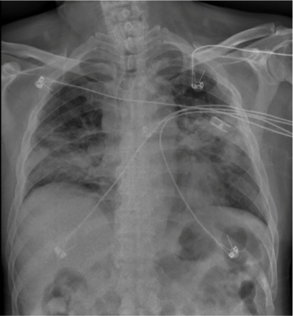
Figure S2. Chest X-ray pneumonia image day 2 after radiotherapy.

