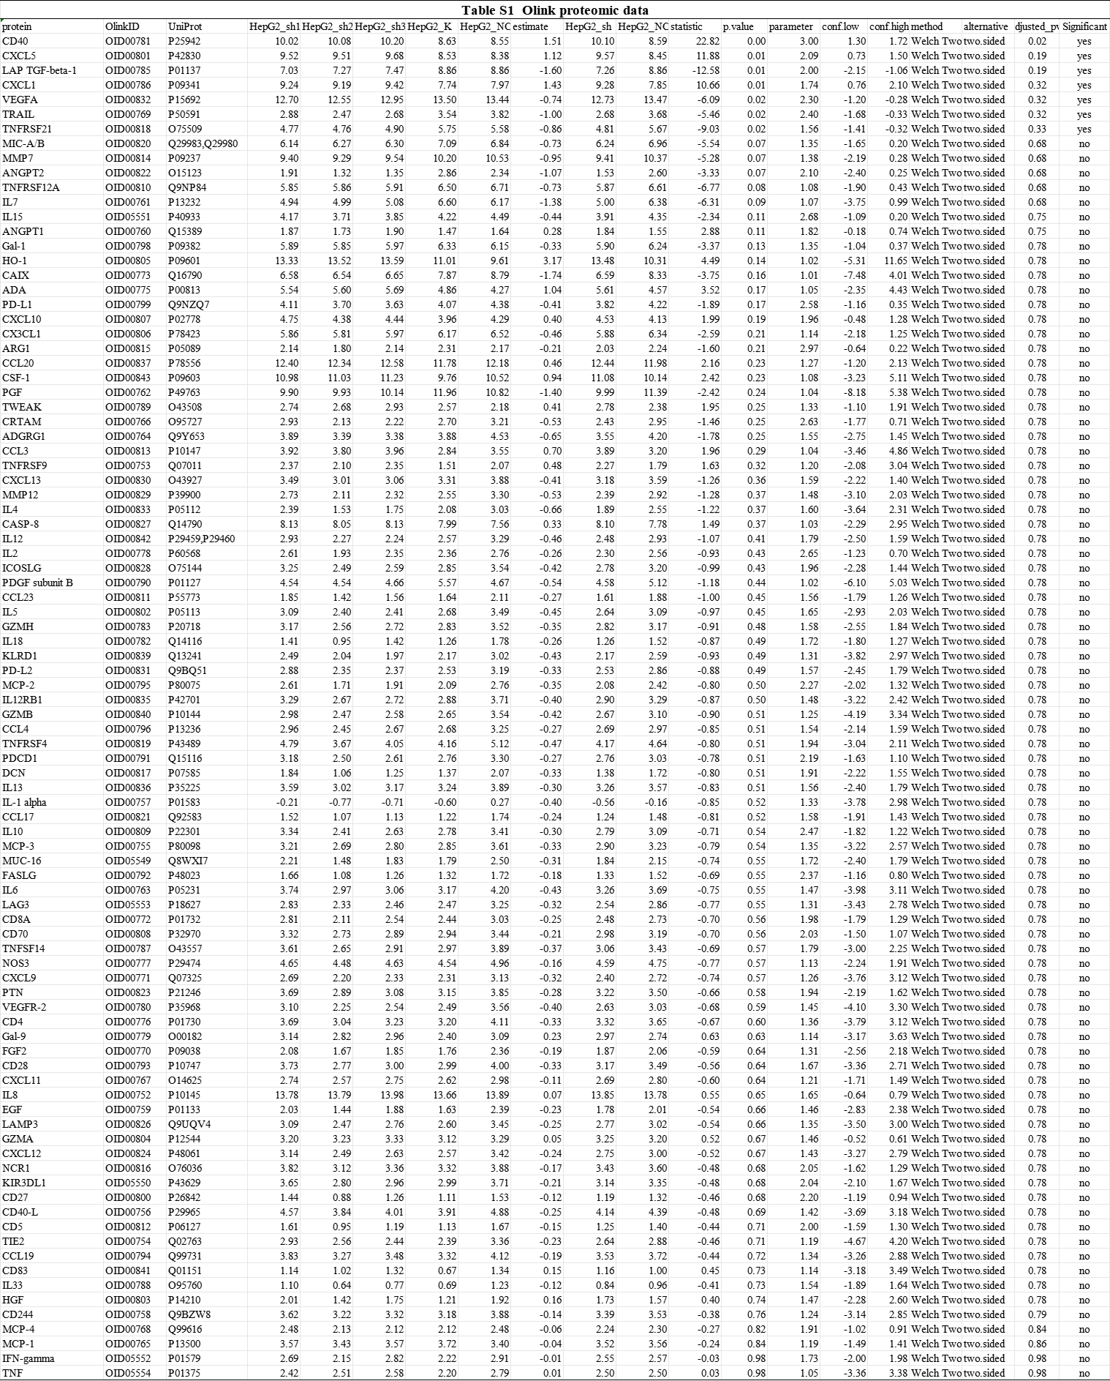

Figure S1: IL-1β is elevated following CDCA3 knockdown.
Note: ***p < 0.001.

