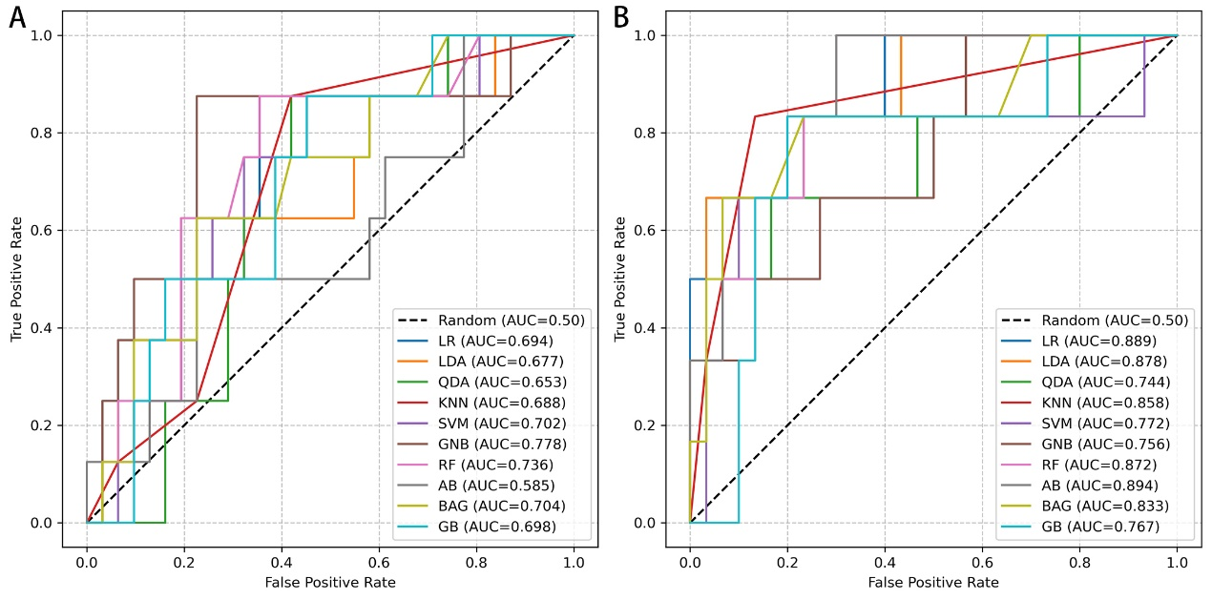
Supplementary Figure 1: ROC curve after age was incorporated.
Notes: Panel A: ROC curves of each model in the internal validation set after age was incorporated; PanelB: ROC curves of each model in the external validation set after age was incorporated. Abbreviation: LR, Logistic Regression; AB, AdaBoost; BAG, Bagging; GB, XGBoost; GNB, GaussianNB; KNN, k-Nearest Neighbors; LDA, Latent Dirichlet Allocation; QDA, quadratic discriminant analysis; RF, Random Forest; SVM, support vector machine

Supplementary Table 1 Time Interval Difference Between the Examinations and May 1, 2025
Group | Ruptured Group (n =37) | Unruptured Group (n = 155) | P
Interval Times (days) | 1477.58 ± 864.59 | 1763.43 ± 1207.77 | 0.10
Notes: Data are presented as mean ± standard deviation.

