Manuscript ID number: 559296
Title of paper: Risk factors associated with virological failure in HIV patients with low level viremia: a retrospective study

Tables
sTable 1. Categorical variable transformation based on ROC analysis
Variables, n(%) | Total (n = 773)
ART delay
≥1.6 months | 331 (42.82)
<1.6 months | 442 (57.18)
triglyceride
≥1.96 mmol/L | 268 (34.67)
<1.96 mmol/L | 505 (65.33)
Notes: ART, Antiretroviral Therapy

Figures
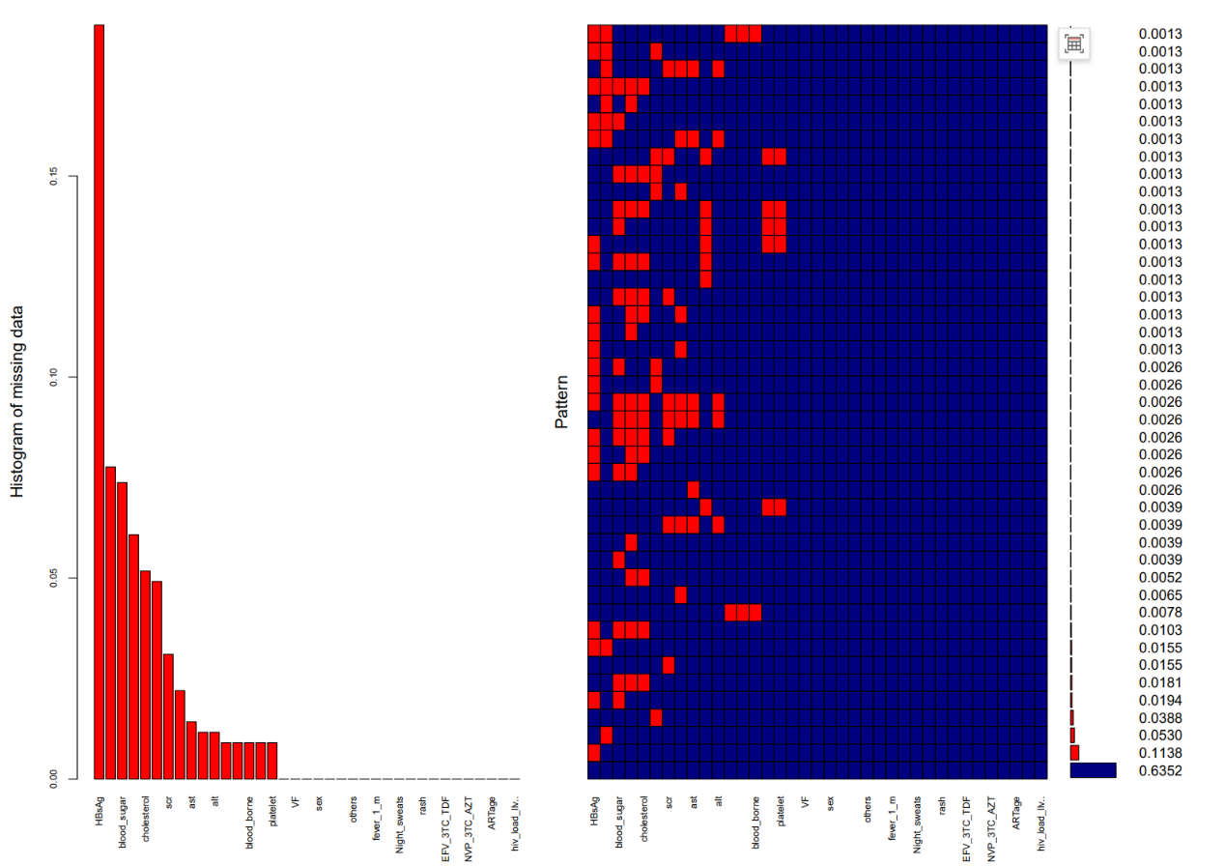
sFig. 1 Missing Value Imputation.
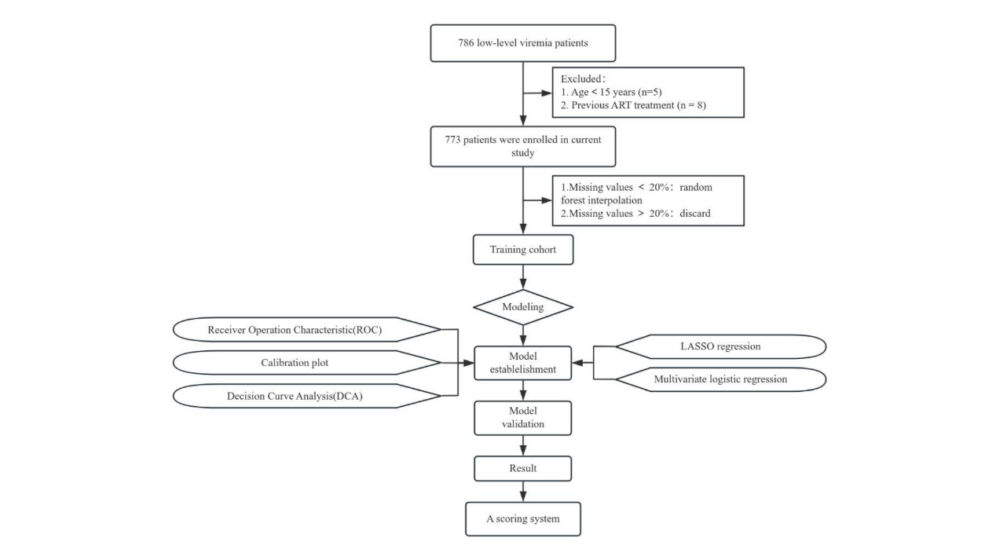
sFig. 2 Patient selection and model development pipeline for predicting virological failure in low-level viremia patients.

