Supplementary Materials

- Example of nomogram use:

A 56-year-old male laborer with a long history of alcohol consumption was admitted for “swelling and pain of the left lower limb for 1 day.” Physical examination: T 38.9℃, BP 121/103 mmHg, P 94 bpm, R 25 bpm. The patient was fully conscious. Breath sounds were clear in both lungs without rales. Cardiac rhythm was irregular with a ventricular rate of 156 bpm, without murmurs. The abdomen was soft with no tenderness or rebound pain. The left lower limb showed erythema and blisters.
Laboratory results on admission: WBC 20.87×10⁹/L, PLT 44×10⁹/L, lactate 6.4 mmol/L, PCT 32.5 ng/mL, CRP 221.6 mg/L, creatinine 112 μmol/L. The SOFA score was 10. The finger test revealed purulent discharge. The patient received antimicrobial therapy after admission.
Based on the patient’s data, the points corresponding to each variable were identified on the nomogram, yielding a total score of (21+35+38+56=) 150, corresponding to an estimated probability of NSTIs of approximately 0.86 (Fig. S1).
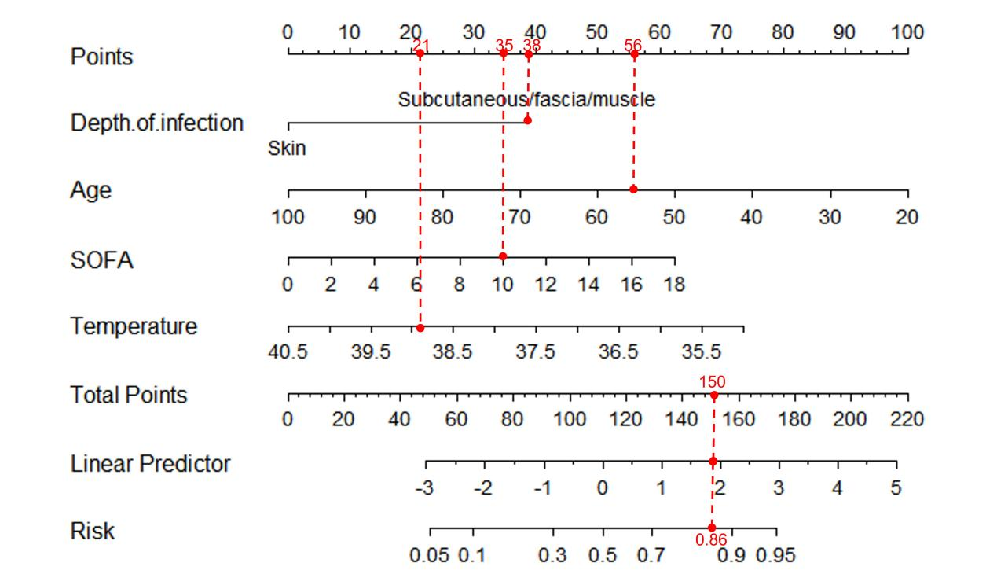
Figure S1. Example of nomogram use

According to the predicted probability from the nomogram, this patient had a high risk of NSTIs. Surgical intervention with incision and decompression was performed, followed by multiple debridements and skin grafting after infection control. Intraoperative findings confirmed extensive liquefactive necrosis of the subcutaneous tissue and fascia.

- Decision threshold heatmap

Figure S2. Decision threshold heatmap of the nomogram

- Sensitivity analysis

Table S1. Results of the adjusted models for sensitivity analysis
Variables | B | Wald | OR | 95% CI | p-value
Original model
Depth of infection | 1.849 | 13.553 | 6.354 | 2.374-17.005 | <0.001
Age | -0.060 | 13.272 | 0.942 | 0.912-0.973 | <0.001
SOFA | 0.166 | 8.413 | 1.181 | 1.055-1.321 | 0.004
Temperature | -0.640 | 5.456 | 0.527 | 0.308-0.902 | 0.020
Adjusted model Iª
Depth of infection | 1.912 | 13.569 | 6.769 | 2.447-18.726 | <0.001
Age | -0.062 | 13.243 | 0.940 | 0.910-0.972 | <0.001
SOFA | 0.171 | 8.302 | 1.187 | 1.056-1.333 | 0.004
Temperature | -0.666 | 5.260 | 0.514 | 0.291-0.908 | 0.022
Adjusted model II^{b}
Depth of infection | 1.839 | 11.709 | 6.290 | 2.194-18.036 | <0.001
Age | -0.058 | 9.997 | 0.944 | 0.910-0.978 | 0.002
SOFA | 0.171 | 7.234 | 1.187 | 1.048-1.345 | 0.007
Temperature | -0.664 | 4.846 | 0.515 | 0.285-0.930 | 0.028
Abbreviations: SOFA, Sequential Organ Failure Assessment.
ª The model was adjusted for demographic factors (sex, smoking and drinking).
^{b} The model was adjusted for demographic factors (sex, smoking and drinking) and comorbidities (diabetes mellitus, hypertension, gastrointestinal disease, heart disease, chronic liver disease, and chronic kidney disease).

