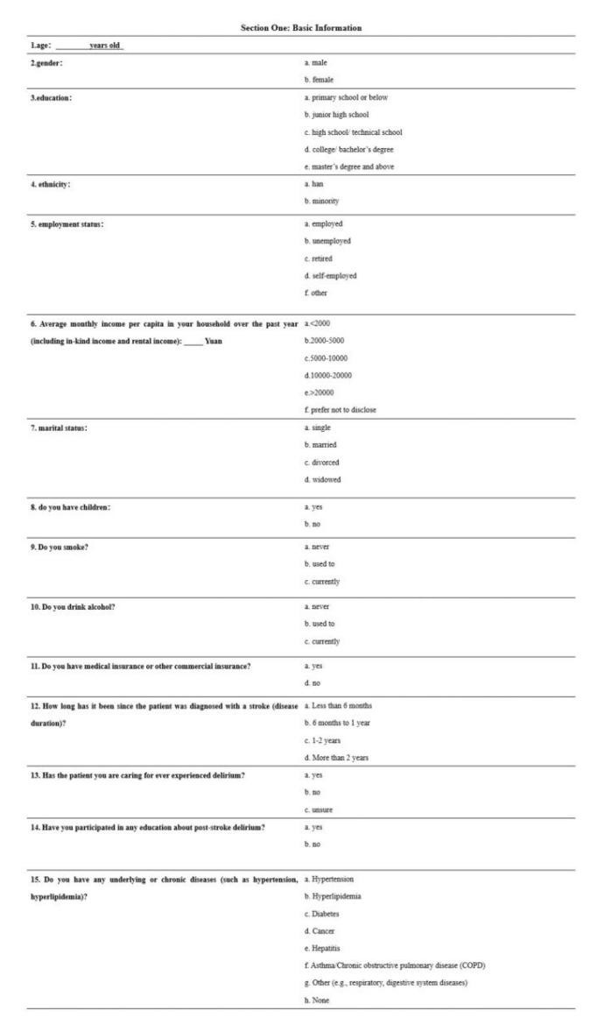
Figure S1 Basic information section of the caregiver questionnaire
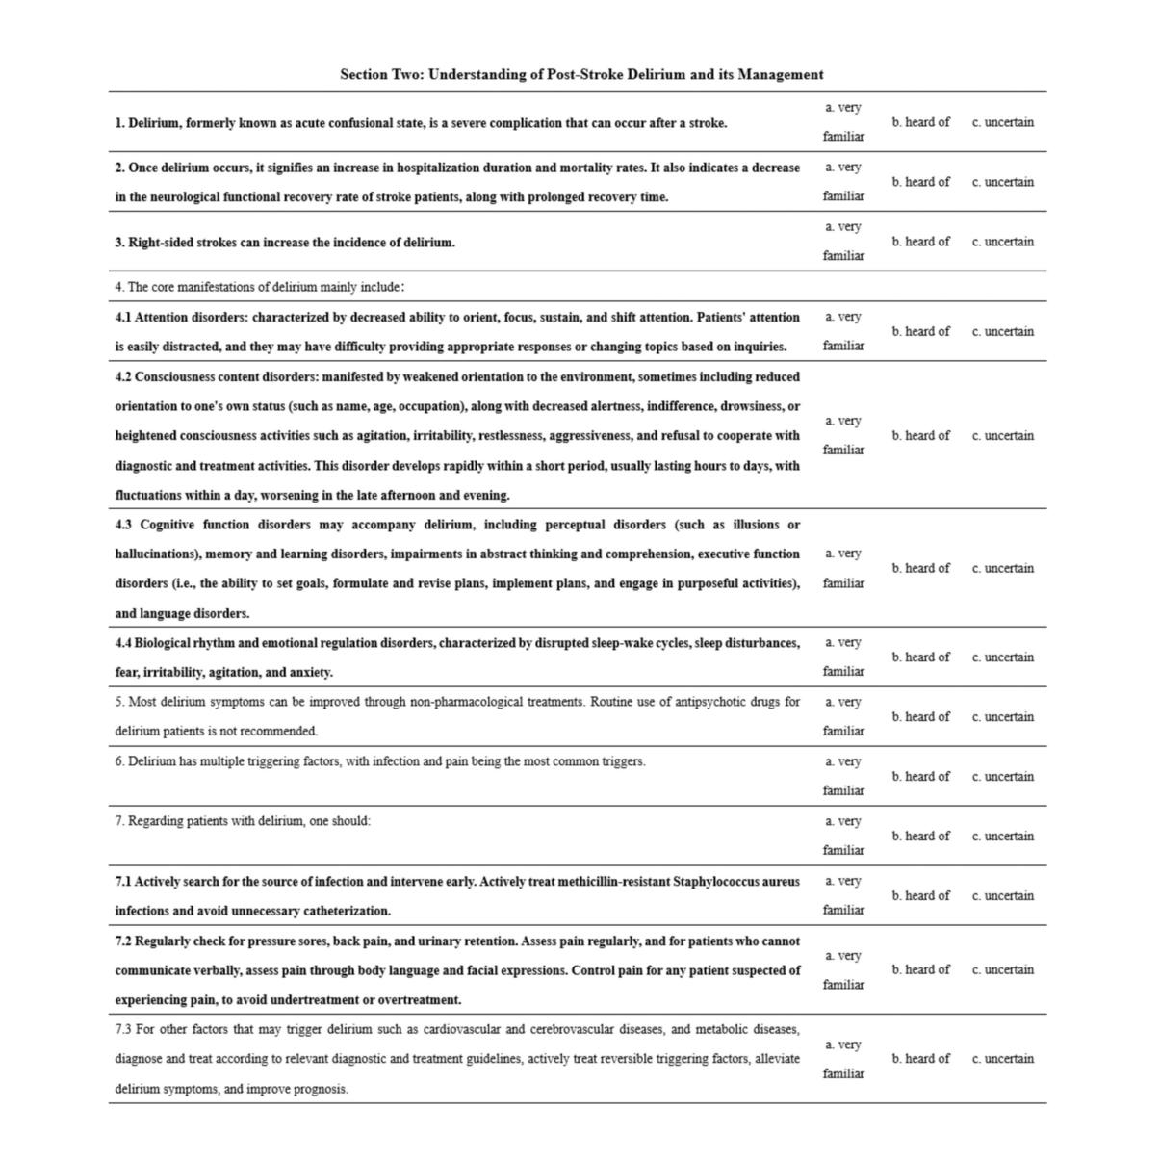
Figure S2 Knowledge section of the caregiver questionnaire
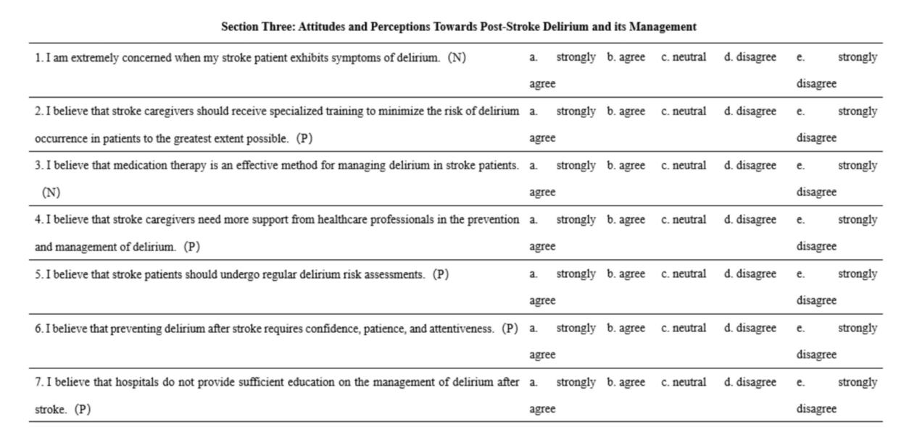
Figure S3 Attitude section of the caregiver questionnaire

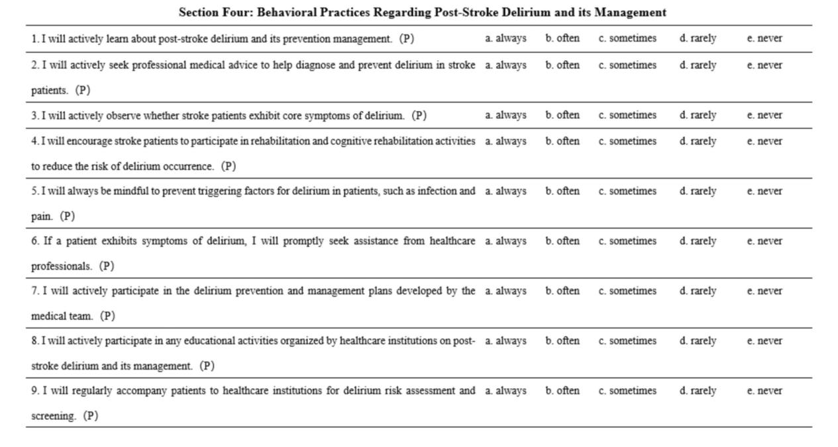
Figure S4 Practice section of the caregiver questionnaire

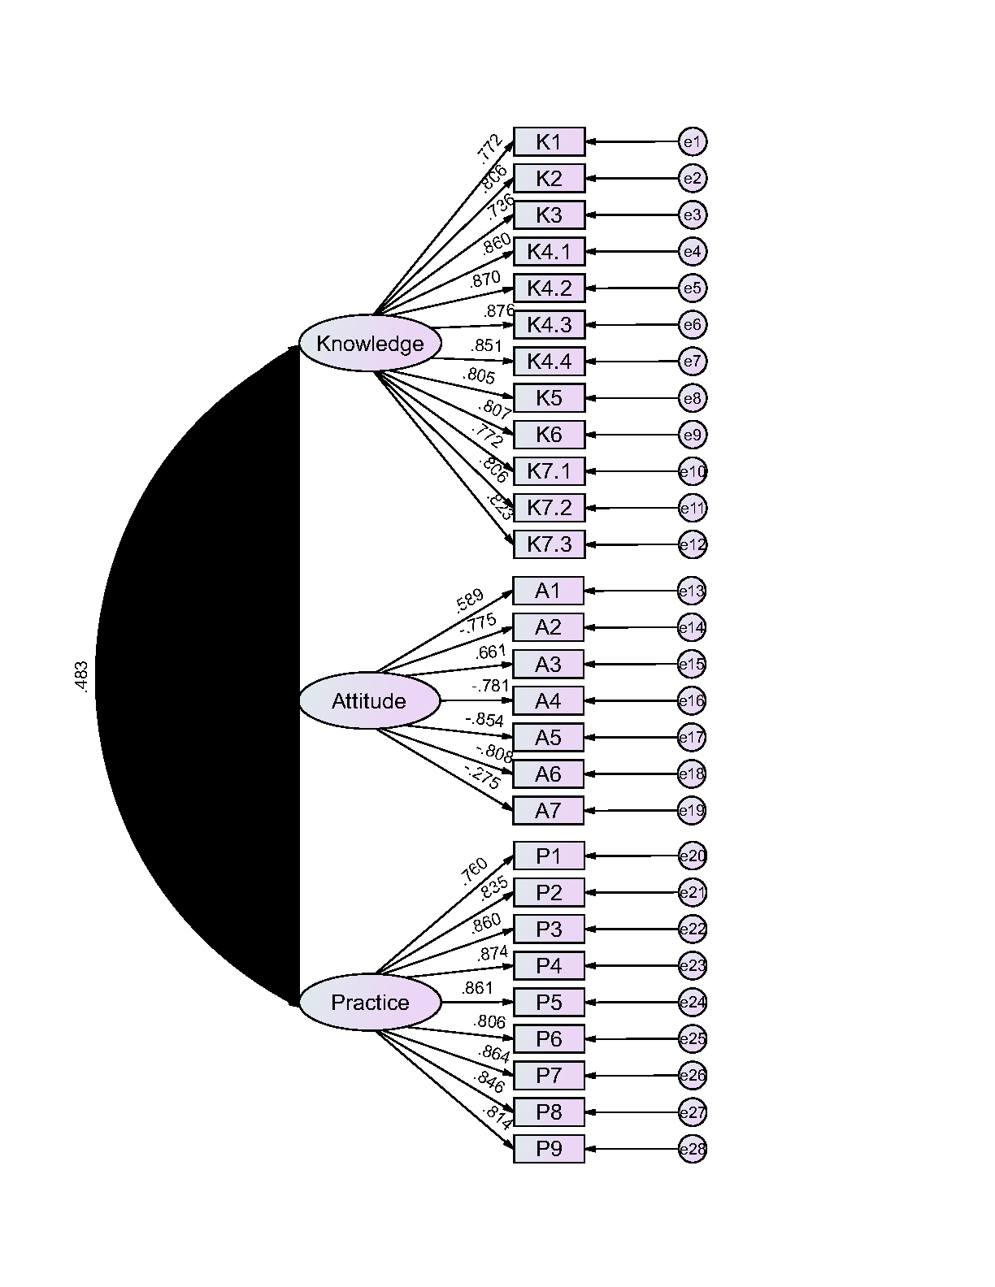
Figure S5 Confirmatory Factor Analysis
Table S1 Distribution of knowledge dimension responses
Knowledge | N(%)
Knowledge | Very familiar | Heard of | Uncertain
1. Delirium, formerly known as acute confessional state, is a severe complication that can occur after a stroke. | 58(11.98) | 264(54.55) | 162(33.47)
2. Once delirium occurs, it signifies an increase in hospitalization duration and mortality rates. It also indicates a decrease in the neurological functional recovery rate of stroke patients, along with prolonged recovery time. | 54(11.16) | 264(54.55) | 166(34.3)
3. Right-sided strokes can increase the incidence of delirium. | 30(6.2) | 180(37.19) | 274(56.61)
4.1 Attention disorders: characterized by decreased ability to orient, focus, sustain, and shift attention. Patients' attention is easily distracted, and they may have difficulty providing appropriate responses or changing topics based on inquiries. | 66(13.64) | 237(48.97) | 181(37.4)
4.2 Consciousness content disorders: manifested by weakened orientation to the environment, sometimes including reduced orientation to one's own status (such as name, age, occupation), along with decreased alertness, indifference, drowsiness, or heightened consciousness activities such as agitation, irritability, restlessness, aggressiveness, and refusal to cooperate with diagnostic and treatment activities. This disorder develops rapidly within a short period, usually lasting hours to days, with fluctuations within a day, worsening in the late afternoon and evening. | 61(12.6) | 241(49.79) | 182(37.6)
4.3 Cognitive function disorders may accompany delirium, including perceptual disorders (such as illusions or hallucinations), memory and learning disorders, impairments in abstract thinking and comprehension, executive function disorders (i.e., the ability to set goals, formulate and revise plans, implement plans, and engage in purposeful activities), and language disorders. | 72(14.88) | 244(50.41) | 168(34.71)
4.4 Biological rhythm and emotional regulation disorders, characterized by disrupted sleep-wake cycles, sleep disturbances, fear, irritability, agitation, and anxiety. | 97(20.04) | 229(47.31) | 158(32.64)
5. Most delirium symptoms can be improved through non-pharmacological treatments. Routine use of antipsychotic drugs for delirium patients is not recommended. | 50(10.33) | 213(44.01) | 221(45.66)
6. Delirium has multiple triggering factors, with infection and pain being the most common triggers. | 59(12.19) | 217(44.83) | 208(42.98)
7.1 Actively search for the source of infection and intervene early. Actively treat methicillin-resistant Staphylococcus aureus infections and avoid unnecessary catheterization. | 48(9.92) | 202(41.74) | 234(48.35)
7.2 Regularly check for pressure sores, back pain, and urinary retention. Assess pain regularly, and for patients who cannot communicate verbally, assess pain through body language and facial expressions. Control pain for any patient suspected of experiencing pain, to avoid undertreatment or overtreatment. | 65(13.43) | 232(47.93) | 187(38.64)
7.3 For other factors that may trigger delirium such as cardiovascular and cerebrovascular diseases, and metabolic diseases, diagnose and treat according to relevant diagnostic and treatment guidelines, actively treat reversible triggering factors, alleviate delirium symptoms, and improve prognosis. | 67(13.84) | 234(48.35) | 183(37.81)

Table S2 Distribution of attitude dimension responses
Attitude | Strongly agree | Agree | Neutral | Disagree | Strongly disagree
1. I am extremely concerned when my stroke patient exhibits symptoms of delirium. | 156(32.23) | 205(42.36) | 86(17.77) | 15(3.1) | 22(4.55)
2. I believe that stroke caregivers should receive specialized training to minimize the risk of delirium occurrence in patients to the greatest extent possible. | 157(32.44) | 234(48.35) | 67(13.84) | 13(2.69) | 13(2.69)
3. I believe that medication therapy is an effective method for managing delirium in stroke patients. | 94(19.42) | 231(47.73) | 129(26.65) | 23(4.75) | 7(1.45)
4. I believe that stroke caregivers need more support from healthcare professionals in the prevention and management of delirium. | 169(34.92) | 241(49.79) | 63(13.02) | 6(1.24) | 5(1.03)
5. I believe that stroke patients should undergo regular delirium risk assessments. | 135(27.89) | 254(52.48) | 71(14.67) | 16(3.31) | 8(1.65)
6. I believe that preventing delirium after stroke requires confidence, patience, and attentiveness. | 207(42.77) | 224(46.28) | 47(9.71) | 3(0.62) | 3(0.62)
7. I believe that hospitals do not provide sufficient education on the management of delirium after stroke. | 89(18.39) | 171(35.33) | 161(33.26) | 54(11.16) | 9(1.86)

Table S3 Distribution of practice dimension responses
Practice | Always | Often | Sometimes | Rarely | Never
1. I will actively learn about post-stroke delirium and its prevention management. | 70(14.46) | 150(30.99) | 159(32.85) | 78(16.12) | 27(5.58)
2. I will actively seek professional medical advice to help diagnose and prevent delirium in stroke patients. | 76(15.7) | 174(35.95) | 132(27.27) | 71(14.67) | 31(6.4)
3. I will actively observe whether stroke patients exhibit core symptoms of delirium. | 77(15.91) | 184(38.02) | 118(24.38) | 74(15.29) | 31(6.4)
4. I will encourage stroke patients to participate in rehabilitation and cognitive rehabilitation activities to reduce the risk of delirium occurrence. | 97(20.04) | 200(41.32) | 100(20.66) | 57(11.78) | 30(6.2)
5. I will always be mindful to prevent triggering factors for delirium in patients, such as infection and pain. | 85(17.56) | 202(41.74) | 108(22.31) | 57(11.78) | 32(6.61)
6. If a patient exhibits symptoms of delirium, I will promptly seek assistance from healthcare professionals. | 145(29.96) | 202(41.74) | 71(14.67) | 43(8.88) | 23(4.75)
7. I will actively participate in the delirium prevention and management plans developed by the medical team. | 95(19.63) | 176(36.36) | 117(24.17) | 56(11.57) | 40(8.26)
8. I will actively participate in any educational activities organized by healthcare institutions on post-stroke delirium and its management. | 88(18.18) | 186(38.43) | 116(23.97) | 70(14.46) | 44(9.09)
9. I will regularly accompany patients to healthcare institutions for delirium risk assessment and screening. | 82(16.94) | 152(31.4) | 121(25) | 81(16.74) | 48(9.92)

Table S4. SEM model fit
Indicators | Reference | Results
RMSEA | <0.08 Good | 0.056
SRMR | <0.08 Good | 0.043
TLI | >0.8 Good | 0.955
CFI | >0.8 Good | 0.950

