Supplementary Figure
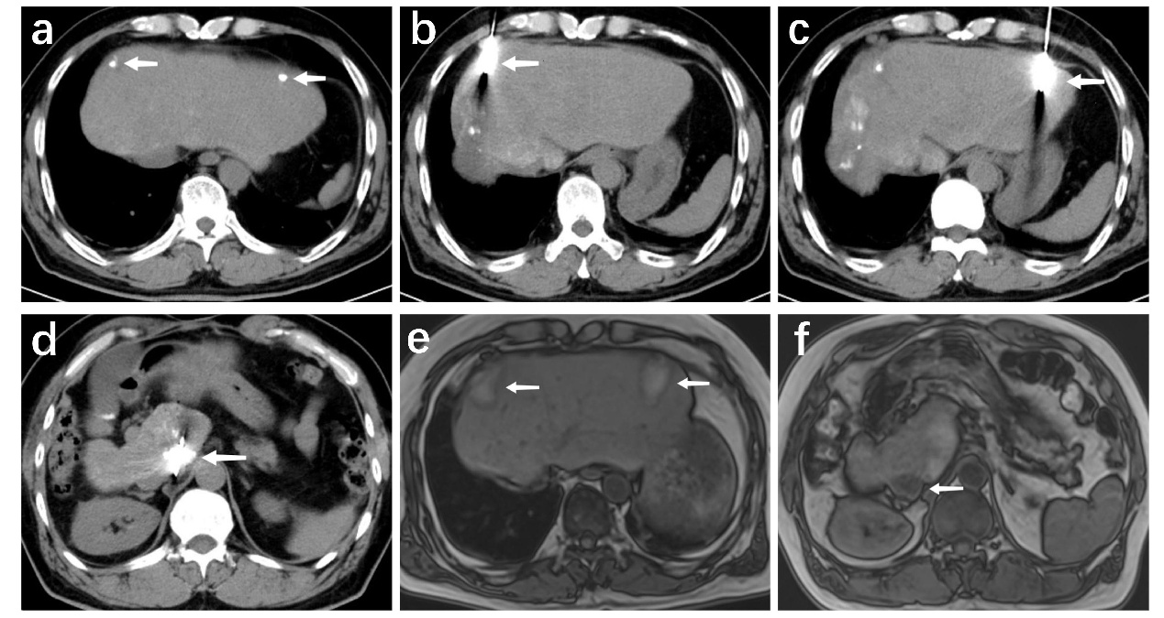Supplementary Figure: Serial imaging findings of 3 recurrent lesions in Case 1 following treatment with TACE combined with MWA.(a) Lesions 1 and 2 showed dense lipiodol deposition within the lesions after TACE; (b-d) Intraoperative CT scans of Lesions 1-3 during MWA, showing accurate puncture of the ablation needle to the center of the lesions; (e-f) Follow-up examination 1 month after surgery showed no enhancement in the original lesion area, indicating complete tumor necrosis and complete coverage of the original lesions by the ablation range.The arrow indicates the location of the lesion.

