Engineered Cancer Cell Membrane-Functionalized Metal-organic Frameworks for Irinotecan/Curcumin Codelivery in Colorectal Cancer: Enhanced Efficacy and Mitigated Toxicity

Shuiling Jin^{1†}, Aifang Zhou^{2†}, Qi Zhang^{1†}, Di Zhao², Xintong Dong², Hong-Min Meng², Zhengquan Yu¹, Zhaohui Li¹
¹ The First Affiliated Hospital of Zhengzhou University, Zhengzhou, Henan Province, China.
² College of Chemistry, Zhengzhou University, Zhengzhou, Henan Province, China.
†Authors contributed equally to this work
Corresponding authors: hmmeng2017@zzu.edu.cn (H-M. Meng), zhaohui.li@zzu.edu.cn (Z. Li).

Supplementary figures
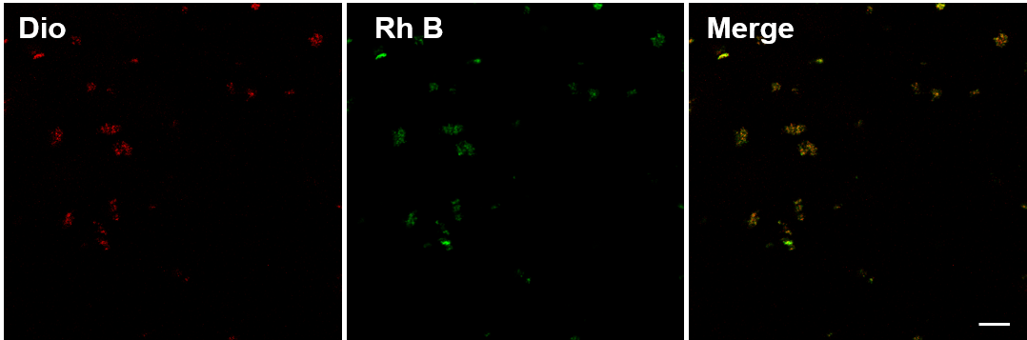
Figure S1. The preparation of MCM was assessed by confocal laser scanning microscopy. Scale bar: 25 μm.
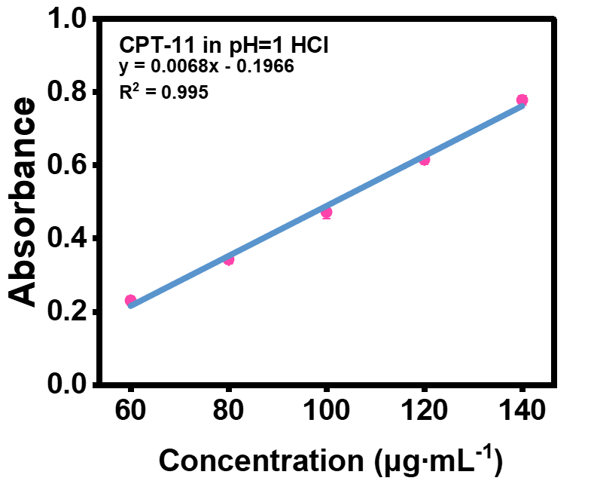
Figure S2. The relationship of the absorbance value at 370 nm with different concentrations of CPT-11 in pH=1 solution.
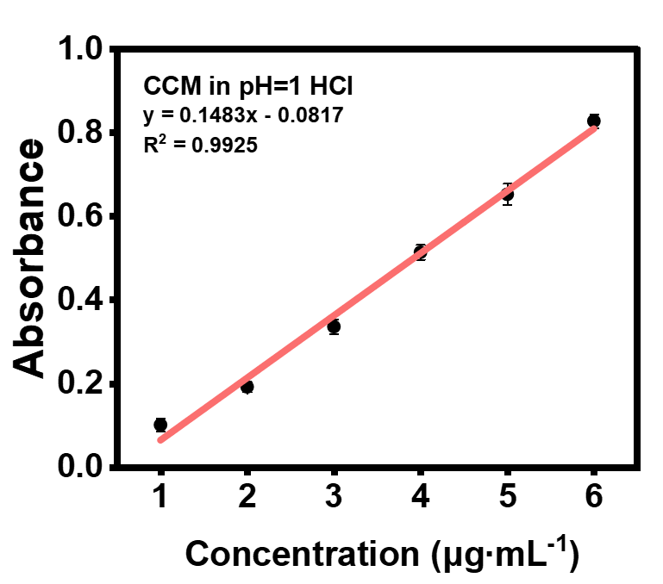
Figure S3. The relationship of the absorbance value at 420 nm with different concentrations of CCM in pH=1 solution.
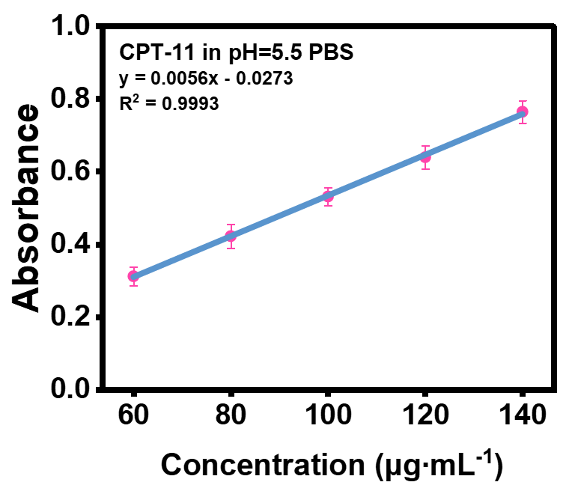
Figure S4. The relationship of the absorbance value at 370 nm with different concentrations of CPT-11 in pH=5.5 solution.
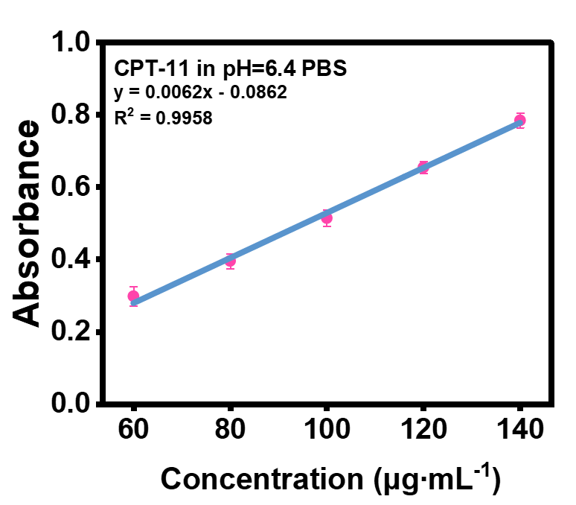
Figure S5. The relationship of the absorbance value at 370 nm with different concentrations of CPT-11 in pH=6.4 solution.

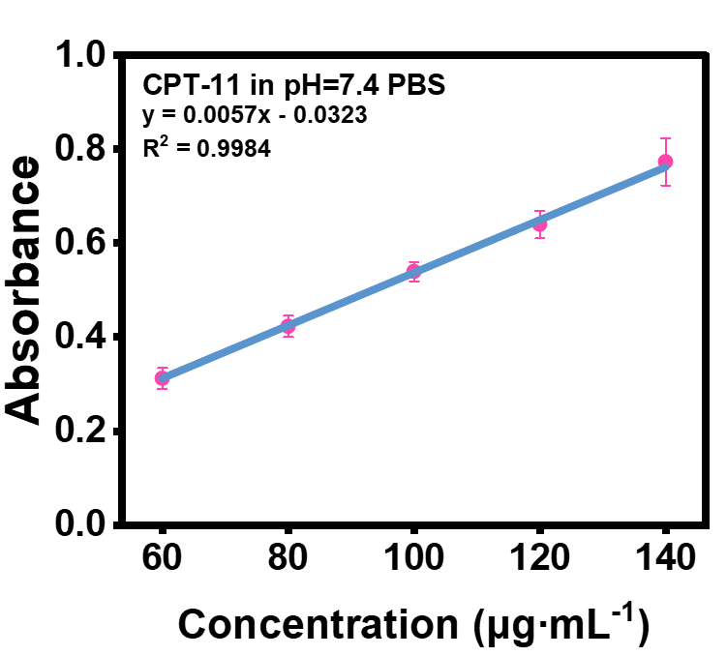
Figure S6. The relationship of the absorbance value at 370 nm with different concentrations of CPT-11 in pH=7.4 solution.
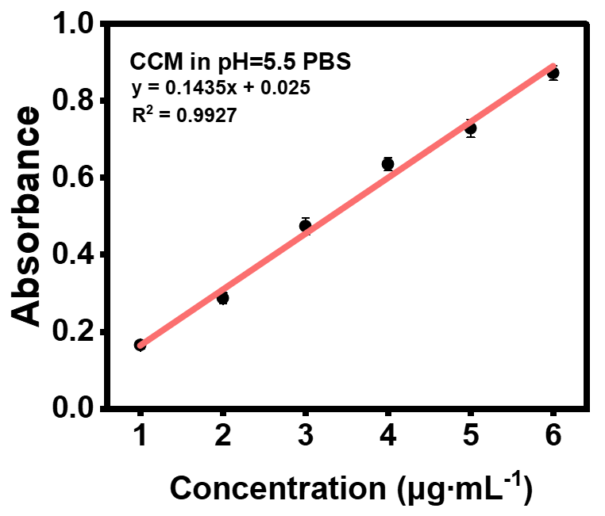
Figure S7. The relationship of the absorbance value at 420 nm with different concentrations of CCM in pH=5.5 solution.
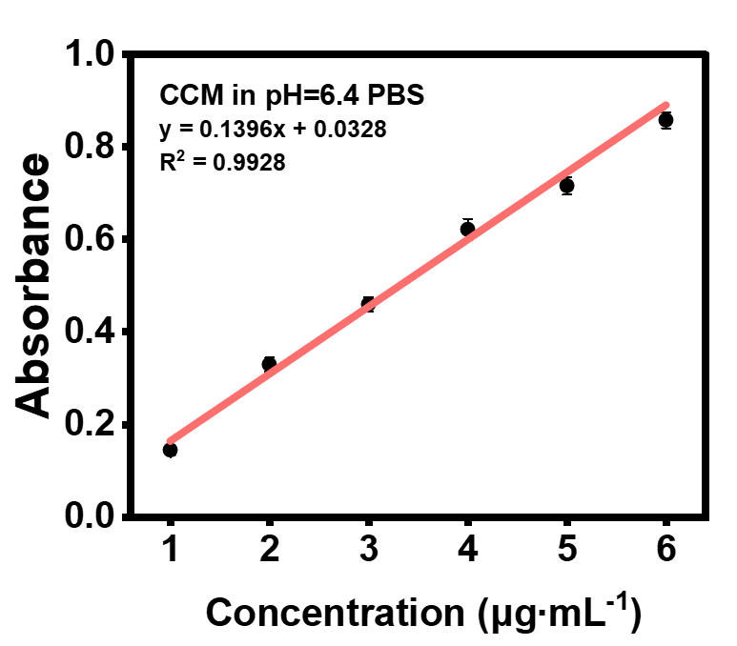
Figure S8. The relationship of the absorbance value at 420 nm with different concentrations of CCM in pH=6.4 solution.
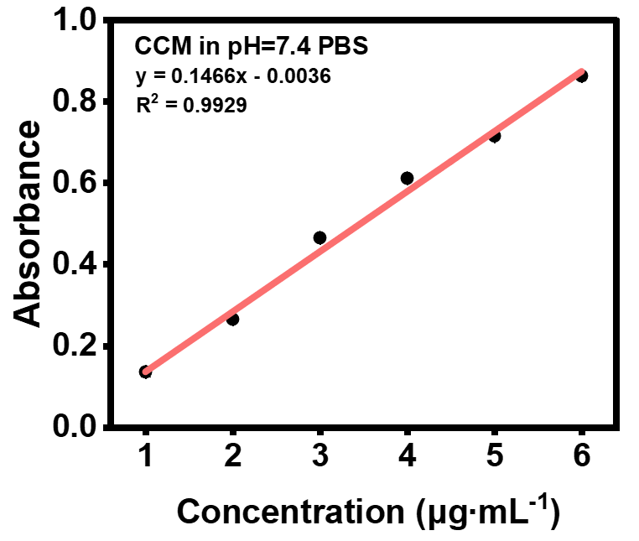
Figure S9. The relationship of the absorbance value at 420 nm with different concentrations of CCM in pH=7.4 solution.
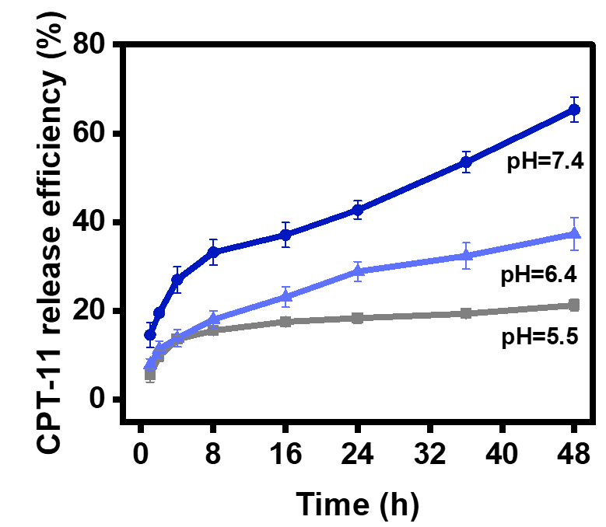
Figure S10. Release kinetics of CPT-11 from MZCC in PBS with different pH values (5.5, 6.4, and 7.4).
Figure 11. Release kinetics of CCM from MZCC in PBS with different pH values (5.5, 6.4, and 7.4).

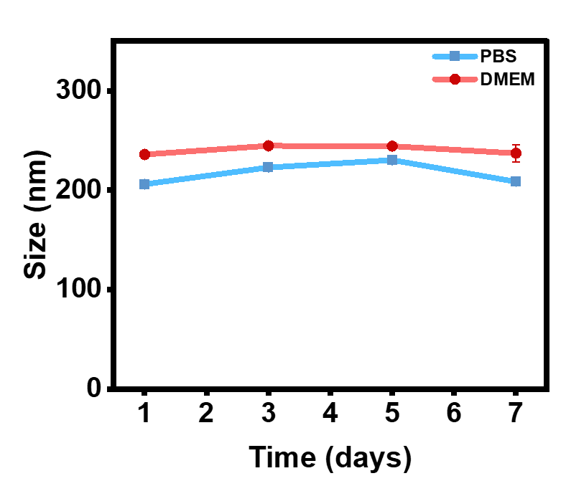
Figure 12. The size change of MZCC in PBS and DMEM medium.

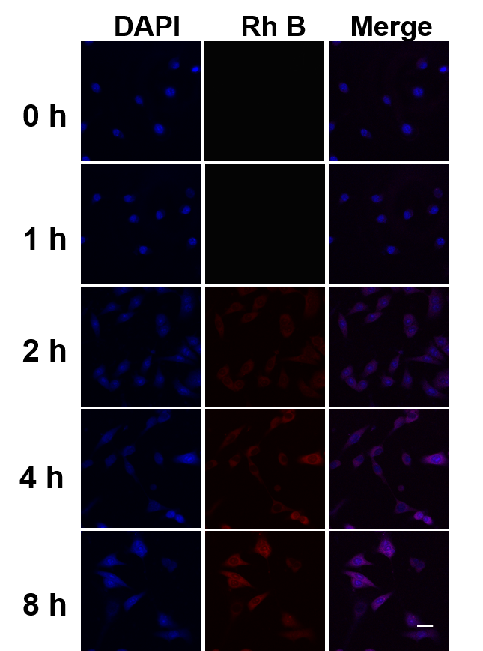
Figure S13. Cellular uptake behavior of MZCC was assessed by confocal laser scanning microscopy. Scale bar: 25 μm.

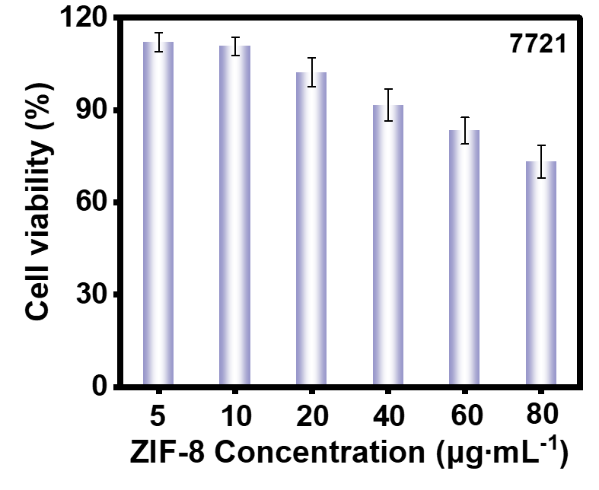
Figure S14. Cell viability of 7721 cells after treated with different concentrations of ZIF-8 for 24 h.
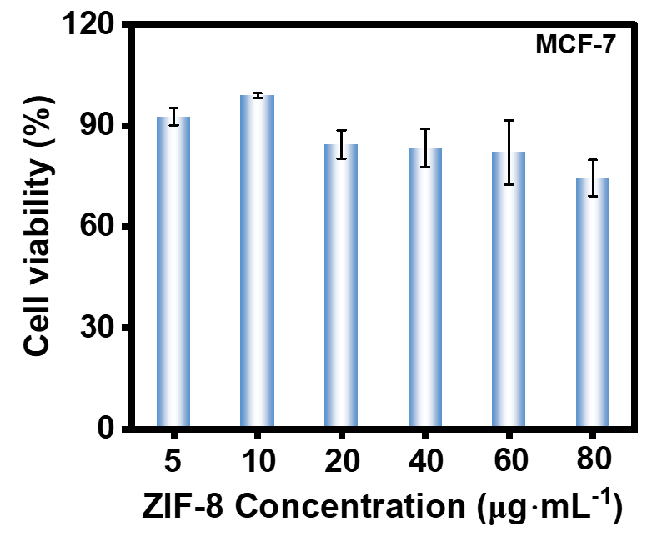
Figure S15. Cell viability of MCF-7 cells after treated with different concentrations of ZIF-8 for 24 h.
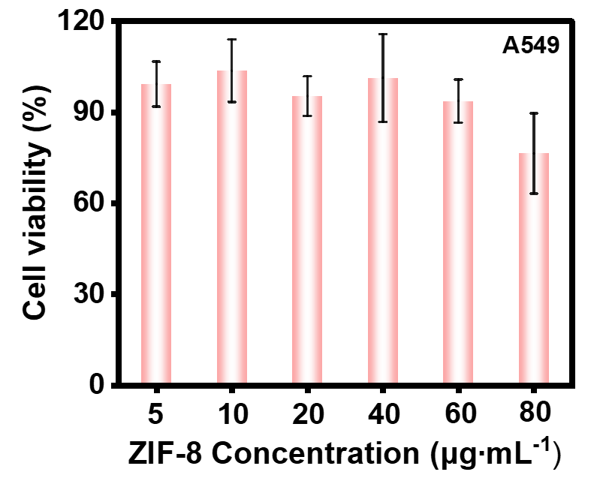
Figure S16. Cell viability of A549 cells after treated with different concentrations of ZIF-8 for 24 h.
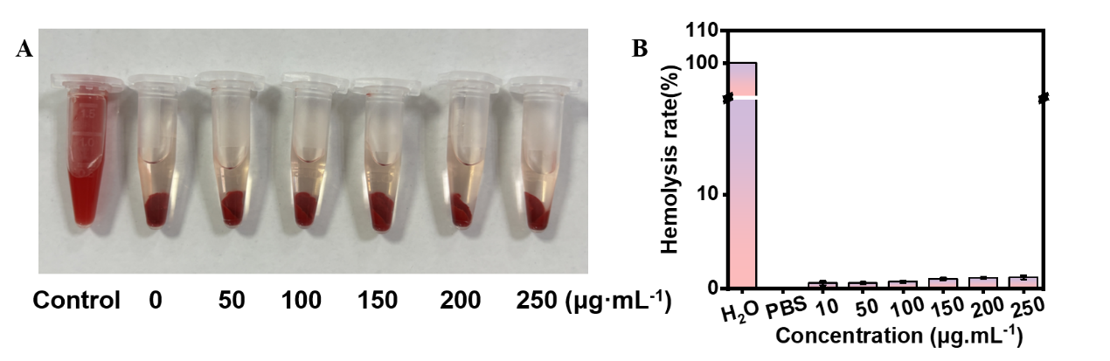
Figure S17. Hemolysis test of ZIF-8.
Figure S18. Blood biochemistry and hematology analysis of control and MZCC treated group.

