Supplementary information
Methods
DNA extraction
DNA was extracted from 250 μg aliquots of the saliva samples using the NucleoSpin 96 Soil kit (Macherey-Nagel). Bead beating was done horizontally on a Vortex-Genie 2 at 2700 rpm for 5 minutes. A minimum of one negative control was included per batch of samples from the DNA extraction and throughout the laboratory process (including sequencing). A ZymoBIOMICS Microbial Community Standard (Zymo Research) was also included in the analysis as a positive (mock) control.
DNA sequencing
Before library preparation, the DNA was quantified by an Infinite F Nano+ plate reader (Tecan) using the Quant-iT dsDNA Assay Kit (Thermo Fisher). The genomic DNA was normalized to 10 ng/μl. The enzymatic fragmentation of DNA and library construction was conducted by DreamPrep NGS (Tecan) using Celero EZ DNA-seq Core Module Kit (Tecan). The fragmented DNA was amplified using PCR. Short and large DNA fragments were removed using double sided magnetic bead size selection (AMPure XP, Beckman Coulter). Adapter sequences from Celero 96-Plex Adaptor Plate (Tecan) were added to each sample during library construction. The final concentration for each library was quantified by Infinite F Nano+ Plate Reader (Tecan) using NuQuant NGS Library Quantification Module and Qubit 2.0 (Thermo Fisher).
Qubit and TapeStation were used to determine the concentration of the final library before sequencing. The library was sequenced on a NovaSeq system (Illumina) with 2 x 150 bp read lengths.
Gene catalogue and species definitions
The Clinical Microbiomics Human Microbiome Reference HMR05 gene catalogue is derived primarily from high-quality (HQ) prokaryotic MAGs (metagenome-assembled genomes) identified from 30,382 human microbiome samples collected from nine distinct human body sites: gut (n = 19,296), oral (n = 4994), skin (n = 4306), urine (n = 934), small intestine (n = 780), nasopharyngeal (n = 422), vaginal (n = 367), airway (n = 108), and milk (n = 100). This includes MAGs available from UHGG ¹ and from ELGG ². 11% (n = 3317) of the samples were not publicly available. In addition, genome assemblies from NCBI and PATRIC were added to capture otherwise missing species of interest (human-associated pathogens, probiotics, food ingredients, and species relevant for benchmarking). Human-relevant eukaryotic species were manually identified from various sources, including an analysis of gut fungal species ³, publicly available lists of pathogens, the eukaryotes profiled by MetaPhlAn 4 ⁴, and various species relevant for benchmarking, resulting in 2740 genomes representing 244 species.
For MAGs not obtained from publicly available MAG collections, reads were host-filtered, trimmed, and assembled into contigs with Megahit ⁵ or metaSPAdes ⁶, and then binned using VAMB ⁷. MAGs were considered high-quality if they had > 90% completeness and < 5% contamination based on CheckM2 (v. 2022-07-19) and passed the GUNC chimerism test ⁸. All MAGs were taxonomically annotated using GTDB-Tk ⁹ with GTDB database version r214, ¹⁰. To combine MAGs from multiple VAMB batches and MAG collections, MAGs annotated to the same species were merged into species clusters. MAGs without GTDB-Tk species-level annotations were merged with each other or with existing species clusters at 95% ANI ¹¹; FastANI ¹²). This resulted in 6567 prokaryotic species clusters, 10% of which were unannotated at species level.
To derive a pan-genome catalogue for each species, we used a three-step clustering approach. First, genes were clustered with MMseqs2 ¹³ with 98% identity and 90% bi-directional coverage. Second, the representatives from the first iteration were clustered with MMseqs2 with 95% identity and 90% bi-directional coverage. Representatives of the second iteration were chosen as the ones with highest cardinality from the first iteration. Third, the second iteration representatives were clustered with cd-hit (cd-hit-est, ¹⁴ with 95% identity and 90% coverage of the shorter sequence. Genes shorter than 100 bp or with species prevalence < 1% were discarded.
For prokaryotes and eukaryotes separately, the entire set of pangenomes were then clustered with MMseqs2 with 97% identity and 90% bi-directional coverage to obtain between-species clusters. The pan-genomes from prokaryotic (n = 6567) and eukaryotic (n = 244) species were merged into a final gene catalogue of 25,761,278 genes.
To enable quantification of each species in the database, up to 250 signature genes were selected for each species based on core genes (≥ 60% prevalence in species MAGs) with a length ≥ 200 bp and ≤ 20 kbp. Furthermore, signature genes were required to be species-unique, with no alignments of 100 bp with > 97% sequence-identity to other genes in the catalogue; however, if fewer than 20 genes meeting these criteria were available for a species, then genes with segments > 200 bp without alignments to other genes were used, and non-unique segments of these genes were masked.
Sequencing data preprocessing
Raw FASTQ files were filtered to remove human genomic contamination by discarding read pairs in which either read mapped to the human reference genome GRCh38.p14 with Bowtie2 ¹⁵) in local alignment mode. Reads were then trimmed to remove adapters and bases with a Phred score below 30 using AdapterRemoval ¹⁶. Host-filtered read pairs with both lengths ≥ 100 bp, defined as high-quality non-host (HQNH) reads, were retained.
Mapping reads to the gene catalogue
High-quality non-host (HQNH) reads were mapped to the gene catalogue using BWA mem ¹⁷). An individual read was considered uniquely mapped to a gene if the mapping quality (MAPQ) was ≥ 20 and the read aligned with ≥ 95 % identity over ≥ 100 bp. However, if > 10 bases of the read did not align to the gene or extend beyond the gene, the read was considered unmapped. Reads meeting the alignment length and identity criteria but not the MAPQ threshold were considered multi-mapped.
Each read pair was counted as either 1) uniquely mapped to a specific gene, if one or both individual reads were uniquely mapped to a gene, or 2) multi-mapped, if neither read was uniquely mapped, and at least one was multi-mapped, or 3) unmapped, if both individual reads were unmapped. If the two reads were each uniquely mapped to a different gene, the gene mapped by read 1 was counted but not the gene mapped by read 2. A gene count table was created with the number of uniquely mapped read pairs for each gene.
Species relative abundance calculation
The expected read counts for signature genes in each species in each sample were modelled with a negative binomial distribution as follows. First, if >=50 of the signature genes for a species had non-zero read counts and >=99% of genes were expected to have non-zero read counts given the total read count for that species (1-(((n_genes-1)/n_genes)^n_reads)>=0.99), then signature genes with zero reads were ignored in that sample. Second, the expected 99% quantile (between 0.5% and 99.5%) of read counts were calculated for each gene based on a negative binomial distribution with a mean proportional to the effective gene length (accounting for read length and mapping alignment criteria) and dispersion defined as log2(effective gene length). The abundance of each species was then calculated as the mean read count normalised by effective gene length based on reads mapping to signature genes with observed read counts within the expected 99% quantile. Species abundances were set to zero if less than 5 genes with non-zero read counts were within the 99% quantile. Furthermore, species with <66% of genes with non-zero read count within the 99% quantile were set to zero, unless the median abundance of signature genes was non-zero, in which case the median gene-length- corrected abundance of non-zero genes was used. Abundances were then normalized sample-wise such that the total abundance of all species sums to 100 %.
Rarefied species abundance profiles were calculated by random sampling, without replacement, of a fixed number of signature gene counts per sample, and then following the procedure described above. In this study, 9074 signature gene counts were sampled.
The relative abundances of microbial taxa were recomputed while excluding the signal from the set of species identified as background.
Background signal removal
Species signals that likely originate from amplification of reagent contaminants or other background signals were identified using two different approaches. The first approach was data driven, where the abundance profiles of the different species indicate that they are likely background species de Goffau et al. 2018 ¹⁸. Here, species with high negative correlation with sequencing depth (Spearman correlation coefficient < -0.80) were considered background species. Furthermore, clusters of species that were pairwise correlated (Spearman correlation coefficient > 0.90 in at least four samples) with uniform abundance ratios were also considered background signal. The relative abundances of microbial taxa were recomputed while excluding the signal from the set of species identified as background.
Functional annotation and profiling
EggNOG-mapper ¹⁹ was used to map prokaryotic genes in the gene catalogue to the EggNOG orthologous groups database ²⁰ and Kyoto Encyclopedia of Genes and Genomes (KEGG) Orthology (KO) database. Eukaryotic genes were annotated using KofamScan ²¹. Functional potential profiles based on KOs were calculated as the proportion of the total gene abundance that mapped to a given KO. CAZyme annotations were inferred for each gene using run_dbcan ²², retaining annotations that were identified by both HMMER (E < 1e-15, coverage > 0.5) and DIAMOND (E < 1e-100).
Kyoto Encyclopedia of Genes and Genomes (KEGG) modules ²³ are defined as a set of Kyoto Encyclopedia of Genes and Genomes orthologys (KOs) that enable a specific function or pathway. Functional potential profiles based on KEGG modules were generated from the species profiles. For this, we identified the set of species associated to each of the KEGG modules by following three criteria: 1) a species was associated to a KEGG module if it included at least 2/3 of the genes encoding the proteins/enzymes needed to complete the functionality of the module, 2) if a module had alternative reaction paths, only one of these was required to be 2/3 complete, 3) for modules with three or fewer steps, all steps were required to be comprised in the given species. KEGG module profiles based on counts, relative abundances, rarefied counts and rarefied relative abundances were then calculated by adding, respectively, the number of counts, relative abundances, rarefied counts and rarefied relative abundances from each species associated to a given KEGG module.
Diversity estimates
Alpha and beta diversity estimates were calculated from rarefied abundance matrices, created by random sampling of reads without replacement. All samples were represented by the same number of informative sequencing reads: rarefaction of species abundance was performed by sampling only from reads mapping to species signature genes (with rarefaction target of 9074 reads).
Alpha diversity was calculated as richness (number of species observed in a sample) and as Shannon diversity index, which in addition accounts for the abundance evenness of the species. Both measures were calculated from rarefied species abundance estimates.
Changes in overall microbiome community composition were evaluated using Bray-Curtis dissimilarity, which accounts for differences in relative abundances of species among samples. Bray-Curtis dissimilarity can range between 0-1, where 0 means that two samples have identical compositions - they share all species at same relative abundance. A value of 1 means that the two samples are completely different - they do not share any species. For visual interpretation, the samples are projected onto the first two dimensions of a principal coordinates analysis (PCoA) of the Bray-Curtis dissimilarities.
Statistics
Permutational multivariate analysis of variance (PERMANOVA) tests were performed using the adonis2 function from the vegan R package with 1000 permutations and by = “margin”, thus assessing the marginal effects of the terms (i.e., each marginal term analysed in a model with all other variables). With 1000 permutations, the lowest possible P value is 1/1001 = 0.000999.
Differences between taxa abundances and KEGG module abundances were tested in two ways: using Mann-Whitney U -test (to match the previous study gehpso), as well as with a linear regression model, adjusting for variables smoking and diet. Mann-Whitney U -test was also used to determine statistical significance when associating taxa and KEGG module abundances to PASI scores.
When performing statistical testing on multiple hypotheses, we use the Benjamini–Hochberg (BH) method to control the false discovery rate (FDR) at a level of 10 %. In case both groups compared to each other have very low median relative abundance, the FDR-corrected p-value cannot be calculated.
Differential abundance analysis with LinDA framework
Testing for differences in microbiome taxon abundances was performed with a linear regression framework with a compositional bias correction based on LinDA ²⁴. For each sample individually, the zero-omitted relative taxon abundances were transformed with a centred log-ratio transformation (CLR) to account for the compositional structure of the data ²⁵. To be robust against outliers in the data, winsorization was performed, capping the CLR-transformed abundances at their 3rd and 97th percentile. For each taxon present in at least 5 of the samples in each group, a linear regression model was fitted with the taxon as the outcome. Any bias in the coefficients arising from the compositional structure of the data was identified and adjusted for based on the assumption that the modal regression coefficient across all tested taxa should be zero ²⁴. The reported effect sizes are the bias-corrected coefficients from the linear models. Due to the log transformation of the data, the coefficients can be interpreted as log2 fold changes.
For abundance analysis, pairwise comparisons between study groups were performed by contrasting the estimated marginal means for each study group with the R package “emmeans” ²⁶. Standard deviations were estimated by the Huber-White sandwich formula to account for heteroscedastic errors via the “sandwich” R package ²⁷. Test statistics were defined as T-values, i.e., bias-corrected coefficients divided by their standard deviation, and P-values were derived from the t-distribution for abundance testing and from the normal distribution for prevalence testing. The following model was applied: ∼ 𝐺𝑅𝑂𝑈𝑃 + 𝑠𝑚𝑜𝑘𝑖𝑛𝑔 + 𝑑𝑖𝑒𝑡, allowing for adjustment of variables smoking and diet. The abundance tests were performed at species, genus, family, class, order and phylum levels. Multiple testing correction was performed separately for each taxonomy level. A taxon prevalence filter of >=5 in each group was applied. To control the false discovery rate due to multiple testing, the P-values were adjusted using the Benjamini and Hochberg procedure ²⁸. Test results were considered significant at the level of 0.1.
Results
In total 123 samples were extracted and sequenced. Of the 123 samples, 118 were successfully sequenced (Table S1).
Sequencing quality
We obtained good sequencing data meeting the contract specification (6 Gbp ~ 20 M read pairs) for all samples with an average of 16.7 M read pairs per sample and a minimum of 8.2 M read pairs. (Figure S1). Most of the reads (on average 99.4%) were of high quality.
The samples contained high proportions of host (human) DNA (on average 14.3M read pairs, 85.4%) which decreases the proportion of microbial DNA available for microbiome analysis. However, for most samples (115/123, 93.5%), we obtained high numbers of read pairs mapping to the gene catalogue despite the high amount of host DNA, see Table S2.
Taxonomic overview
Taxonomical profiling of the microbiome composition was performed using the Clinical Microbiomics Human Microbiome Profiler that identifies and quantifies Metagenomic Species (MGSs)^{7,29}.
We found 965 out of 6809 MGS with relative abundance higher than zero across all samples. The 5844 MGS that were not found were removed from any downstream analysis.
Taxonomic profiles aggregated at species level are shown in Figure S5.
Taxonomic profiles aggregated at genus level are shown in Figure S6.

Tables
Table S1: Number of samples received and successfully sequenced for each sample type.
 | PSO | CONTROL | FAMILY | Total
All | 52 | 50 | 21 | 123
Successfully sequenced | 49 | 48 | 21 | 118

Table S2: Average, minimum and maximum values of quality control and read mapping statistics.
 | Min | Average | Max
Read pairs | 8.2 M | 16.7 M | 27.2 M
High quality reads | 8.2 M | 16.6 M | 26.6 M
High quality non-host reads | 0.0 M | 2.3 M | 11.4 M

Table S3: Permutational multivariate analysis of variance (PERMANOVA) test of differences in β-diversity without adjustment for diet, smoking and physical activity.
 | Sum of squares | R² | P value
Group | 0.510 | 2.1% | 0.196
Residual | 24.144 | 97.9% | NA
Total | 24.654 | 100% | NA

Table S4: Permutational multivariate analysis of variance (PERMANOVA) test of differences in β-diversity based on smoking status.
 | Sum of squares | R² | P value
Smoking | 0.754 | 3.1% | 0.001
Residual | 23.900 | 96.9% | NA
Total | 24.654 | 100% | NA

 | Sum of squares | R² | P value
Diet | 0.375 | 1.5% | 0.037
Residual | 24.279 | 98.5% | NA
Total | 24.654 | 100% | NA
Table S5: Permutational multivariate analysis of variance (PERMANOVA) test of differences in β-diversity based on diet.
Table S6: Top 10 species that are affected by variable GROUP in Mann-Whitney U test. The median relative abundance (in percent) of each taxon in each group is shown. Table is sorted by increasing nominal P-values. RBC: rank biserial correlation, is a measure of the effect size. FDR: the FDR-adjusted P-value
Taxonomy | Comparison | Mann-Whitney U
Taxonomy | Comparison | RBC | P | FDR | Median (%)
 |  |  |  |  | CONTROL | FAMILY | PSO
Leptotrichia sp018128225 | CONTROL vs PSO | -0.401 | 0.000 | 0.079 | 0.028 | 0.018 | 0.000
Butyrivibrio sp015258065 | CONTROL vs PSO | -0.409 | 0.000 | 0.117 | 0.136 | 0.086 | 0.055
Leptotrichia sp018128225 | FAMILY vs PSO | -0.452 | 0.001 | 0.380 | 0.028 | 0.018 | 0.000
F0428 sp003043955 | CONTROL vs PSO | -0.364 | 0.002 | 0.290 | 0.279 | 0.283 | 0.057
Peptidiphaga gingivicola | FAMILY vs PSO | -0.190 | 0.002 |  | 0.000 | 0.000 | 0.000
Saccharimonas sp018127705 | CONTROL vs FAMILY | 0.380 | 0.003 | 0.998 | 0.000 | 0.009 | 0.000
Streptococcus pseudopneumoniae M | FAMILY vs PSO | -0.415 | 0.005 | 0.733 | 0.027 | 0.097 | 0.022
Streptococcus parasanguinis | FAMILY vs PSO | -0.415 | 0.006 | 0.733 | 0.196 | 0.371 | 0.180

Table S7: Top 10 families that are affected by variable GROUP in Mann-Whitney U test. The median relative abundance (in percent) of each taxon in each group is shown. Table is sorted by increasing nominal P-values. RBC: rank biserial correlation, is a measure of the effect size. FDR: the FDR-adjusted P-value.
Taxonomy | Comparison | Mann-Whitney U
Taxonomy | Comparison | RBC | P | FDR | Median (%)
 |  |  |  |  | CONTROL | FAMILY | PSO
Leptotrichiaceae | CONTROL vs PSO | -0.385 | 0.001 | 0.059 | 1.091 | 0.928 | 0.503
Lachnospiraceae | FAMILY vs PSO | -0.465 | 0.002 | 0.135 | 2.196 | 2.132 | 1.250
Lachnospiraceae | CONTROL vs PSO | -0.331 | 0.004 | 0.139 | 2.196 | 2.132 | 1.250
Nanosyncoccaceae | FAMILY vs PSO | -0.408 | 0.007 | 0.161 | 0.563 | 0.769 | 0.366
Leptotrichiaceae | FAMILY vs PSO | -0.404 | 0.008 | 0.161 | 1.091 | 0.928 | 0.503
UBA660 | FAMILY vs PSO | -0.341 | 0.013 | 0.205 | 0.000 | 0.015 | 0.000
Trichinellidae | CONTROL vs FAMILY | 0.215 | 0.016 | 0.932 | 0.000 | 0.000 | 0.000
Campylobacteraceae | FAMILY vs PSO | -0.354 | 0.019 | 0.244 | 1.198 | 1.466 | 0.976
Selenomonadaceae | CONTROL vs PSO | -0.248 | 0.033 | 0.551 | 1.499 | 1.240 | 0.932
Burkholderiaceae A | CONTROL vs PSO | -0.236 | 0.043 | 0.551 | 0.526 | 0.609 | 0.291

Table S8: Top 10 KEGG modules that are affected by variable GROUP in Mann-Whitney U test. The median relative abundance (in percent) of each KEGG module in each group is shown. Table is sorted by increasing nominal P-values. RBC: rank biserial correlation, is a measure of the effect size. FDR: the FDR-adjusted P-value.
Taxonomy | Comparison | Mann-Whitney U
Taxonomy | Comparison | RBC | P | FDR | Median (%)
 |  |  |  |  | CONTROL | FAMILY | PSO
M00278 – PTS sustem, sorbose-specific II component | CONTROL vs PSO | -0.392 | 0.001 | 0.301 | 0.086 | 0.058 | 0.019
M00002 – Glycolysis, core module involving three-carbon compounds | FAMILY vs PSO | 0.489 | 0.001 | 0.303 | 77.009 | 73.149 | 78.853
M00506 – CheA-CheYBV (chemotaxis) two-component regulatory system | CONTROL vs PSO | -0.371 | 0.002 | 0.301 | 2.801 | 2.542 | 1.912
M00496 – ComD-ComE (competence) two-component regulatory system | FAMILY vs PSO | -0.463 | 0.002 | 0.303 | 0.880 | 1.270 | 0.799
M00096 – C5 isoprenoid biosynthesis, non-mevalonate pathway | FAMILY vs PSO | 0.453 | 0.003 | 0.303 | 67.531 | 65.038 | 69.167
M00002 – Glycolysis, core module involving three-carbon compounds | CONTROL vs FAMILY | -0.427 | 0.005 | 0.857 | 77.009 | 73.149 | 78.853
M00212 – Ribose transport system | CONTROL vs PSO | -0.323 | 0.007 | 0.706 | 9.278 | 7.077 | 6.885
M00153 – Cytochrome d ubiquinol oxidase | FAMILY vs PSO | 0.402 | 0.008 | 0.520 | 59.175 | 56.271 | 60.349
M00362 – Nucleotide sugar biosynthesis, prokaryotes | CONTROL vs FAMILY | -0.392 | 0.009 | 0.857 | 22.864 | 20.047 | 20.141
M00632 – Galactose degradation, Leloir pathway, galactose => alpha-D-glucose-1P | CONTROL vs FAMILY | -0.392 | 0.009 | 0.857 | 60.884 | 56.482 | 59.100

Table S9: Overall counts of all the eucaryotes present in at least one sample. Count is number of samples.
Species | Count | Superkingdom
Saccharomyces cerevisiae | 4 | Eukaryota
Candida parapsilosis | 1 | Eukaryota
Candida tropicalis | 1 | Eukaryota
Candida dubliniensis | 3 | Eukaryota
Nakaseomyces glabratus | 1 | Eukaryota
Trichnella patagoniensis | 27 | Eukaryota

Figures
Figure S1: Bar plots summarizing read quality and read mapping for all samples grouped by variable GROUP.
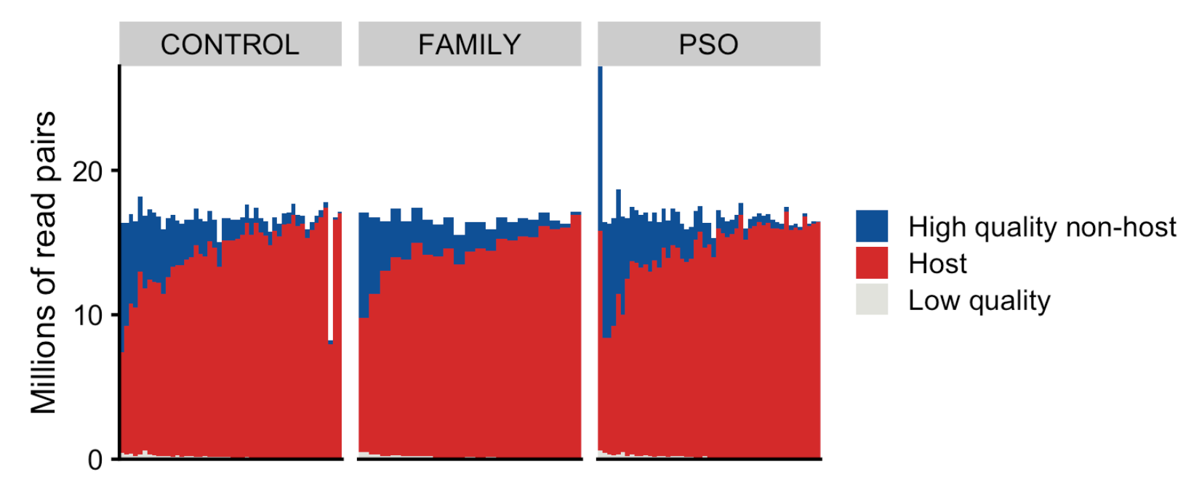

Figure S2: Proportion of read pairs. Bar plots summarizing read quality and read mapping. Categories of different read types are given in percentages. 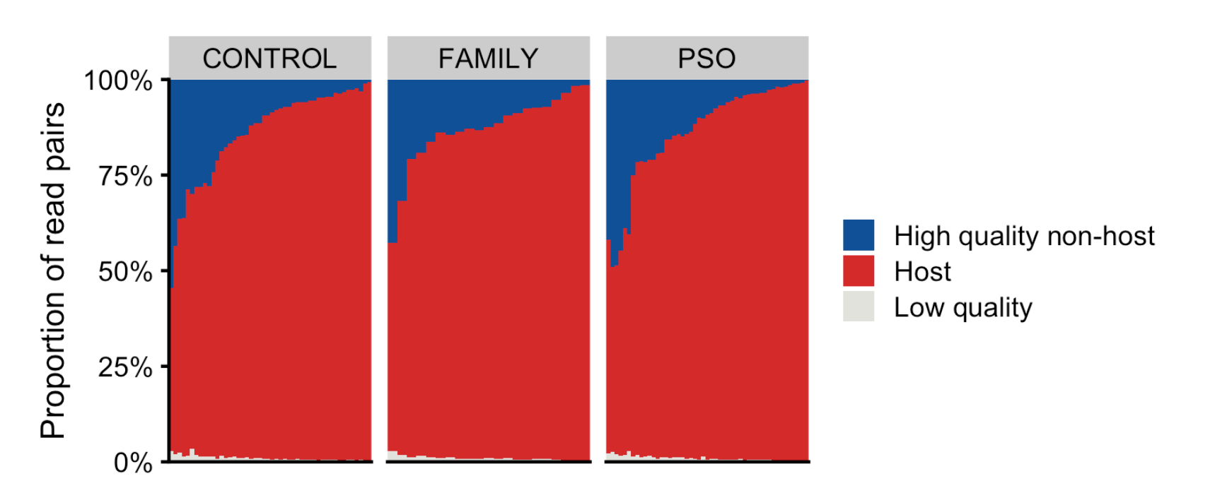

Figure S3: Sample-specific profiling sensitivity of relative species abundance. Bars indicate the relative species abundance where there is 95% chance of detecting a given species based on the number of reads mapping to the signature genes. Samples are ordered by decreasing sensitivity.
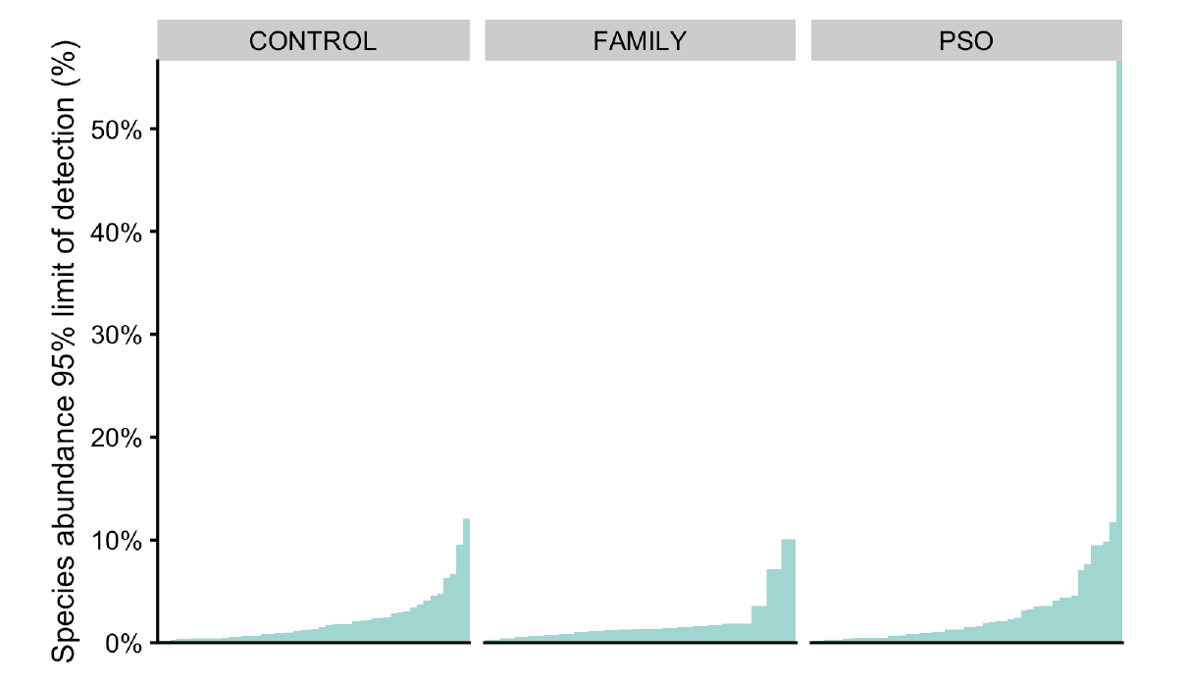

Figure S4: Sample-specific profiling sensitivity of relative species abundance. Bars indicate the relative species abundance where there is 95% chance of detecting a given species based on the number of reads mapping to the signature genes. Samples are ordered by decreasing sensitivity.
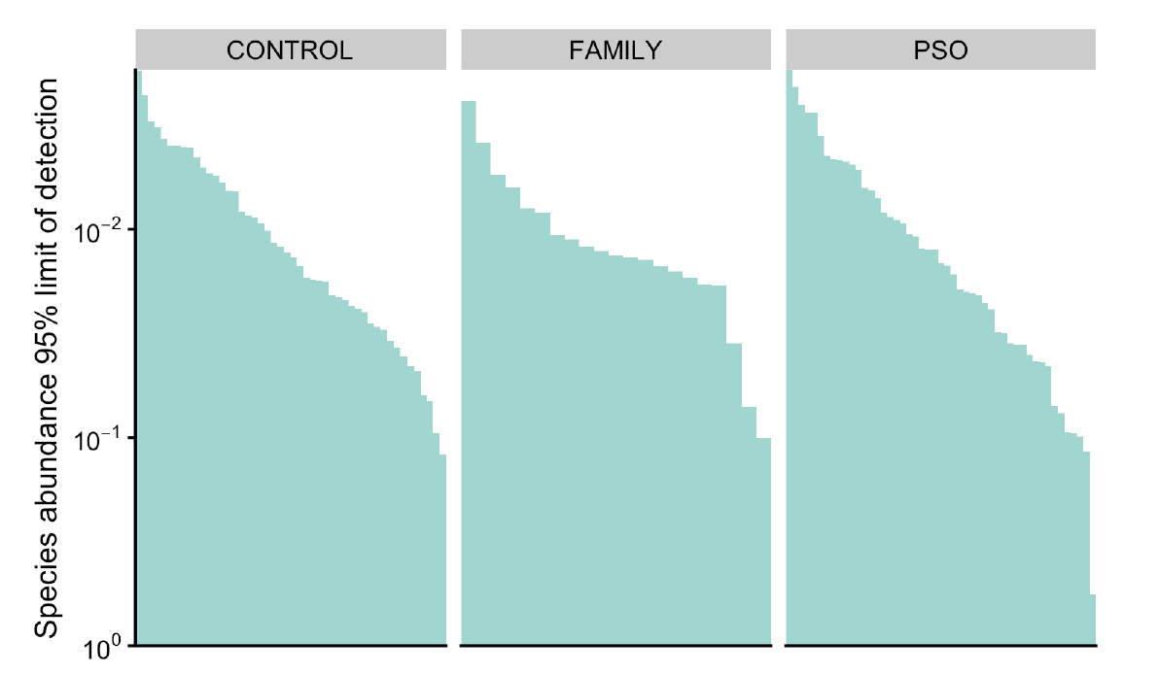
Figure S5: Taxonomic overview at species level per sample. Bar plots display the relative abundance of the ten taxa with highest average abundance across all samples. Light grey (Other) indicates the total relative abundance of species that are not among the ten most abundant taxa. The x-axis is sorted by the most abundant taxa.
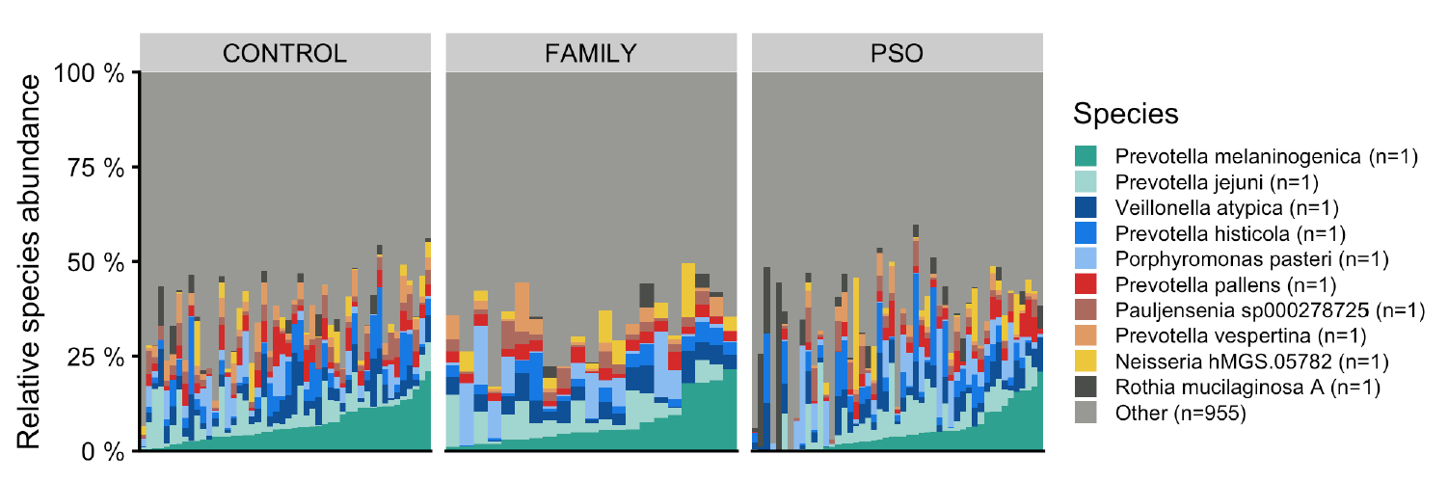

Figure S6: Taxonomic overview at genus level per sample. Bar plots display the relative abundance of the ten taxa with highest average abundance across all samples. Light grey (Other) indicates the total relative abundance of species that are not among the ten most abundant taxa. The x-axis is sorted by the most abundant taxa.
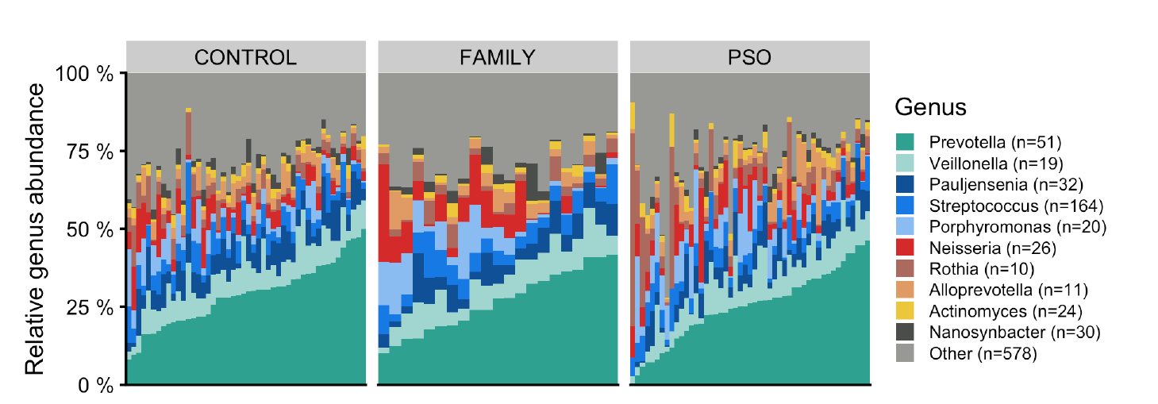

Figure S7: (A) Principal coordinates analysis based on Bray-Curtis dissimilarities among samples, calculated based on the species abundances. Samples are colour coded by group status. The x- and y-axis indicate the microbial variance explained by the first two principal coordinates. (B) Permutational multivariate analysis of variance (PERMANOVA) test of differences in β-diversity without adjustment for diet, smoking and physical activity.

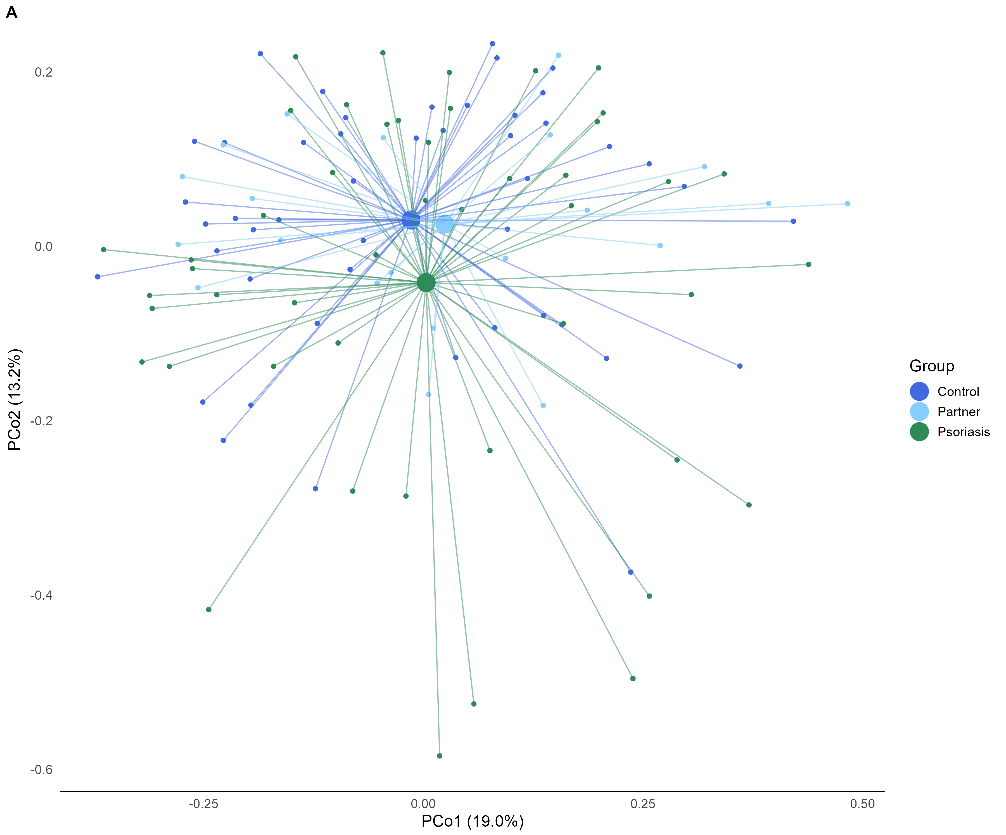

Figure S8: (A) Principal coordinates analysis based on Bray-Curtis dissimilarities among samples, calculated based on the species abundances. Samples are colour coded by smoking status. The x- and y-axis indicate the microbial variance explained by the first two principal coordinates.
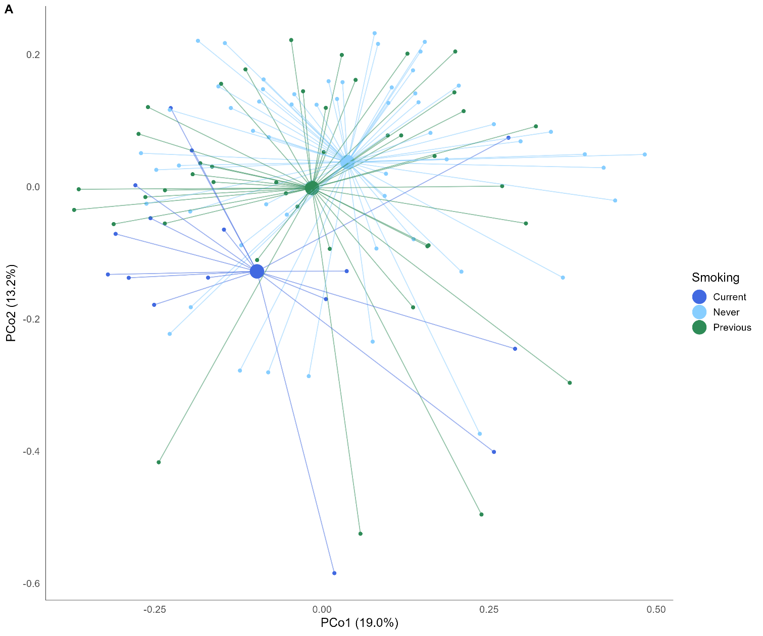

Figure S9: (A) Principal coordinates analysis based on Bray-Curtis dissimilarities among samples, calculated based on the species abundances. Samples are colour coded by diet (DQS). The x- and y-axis indicate the microbial variance explained by the first two principal coordinates
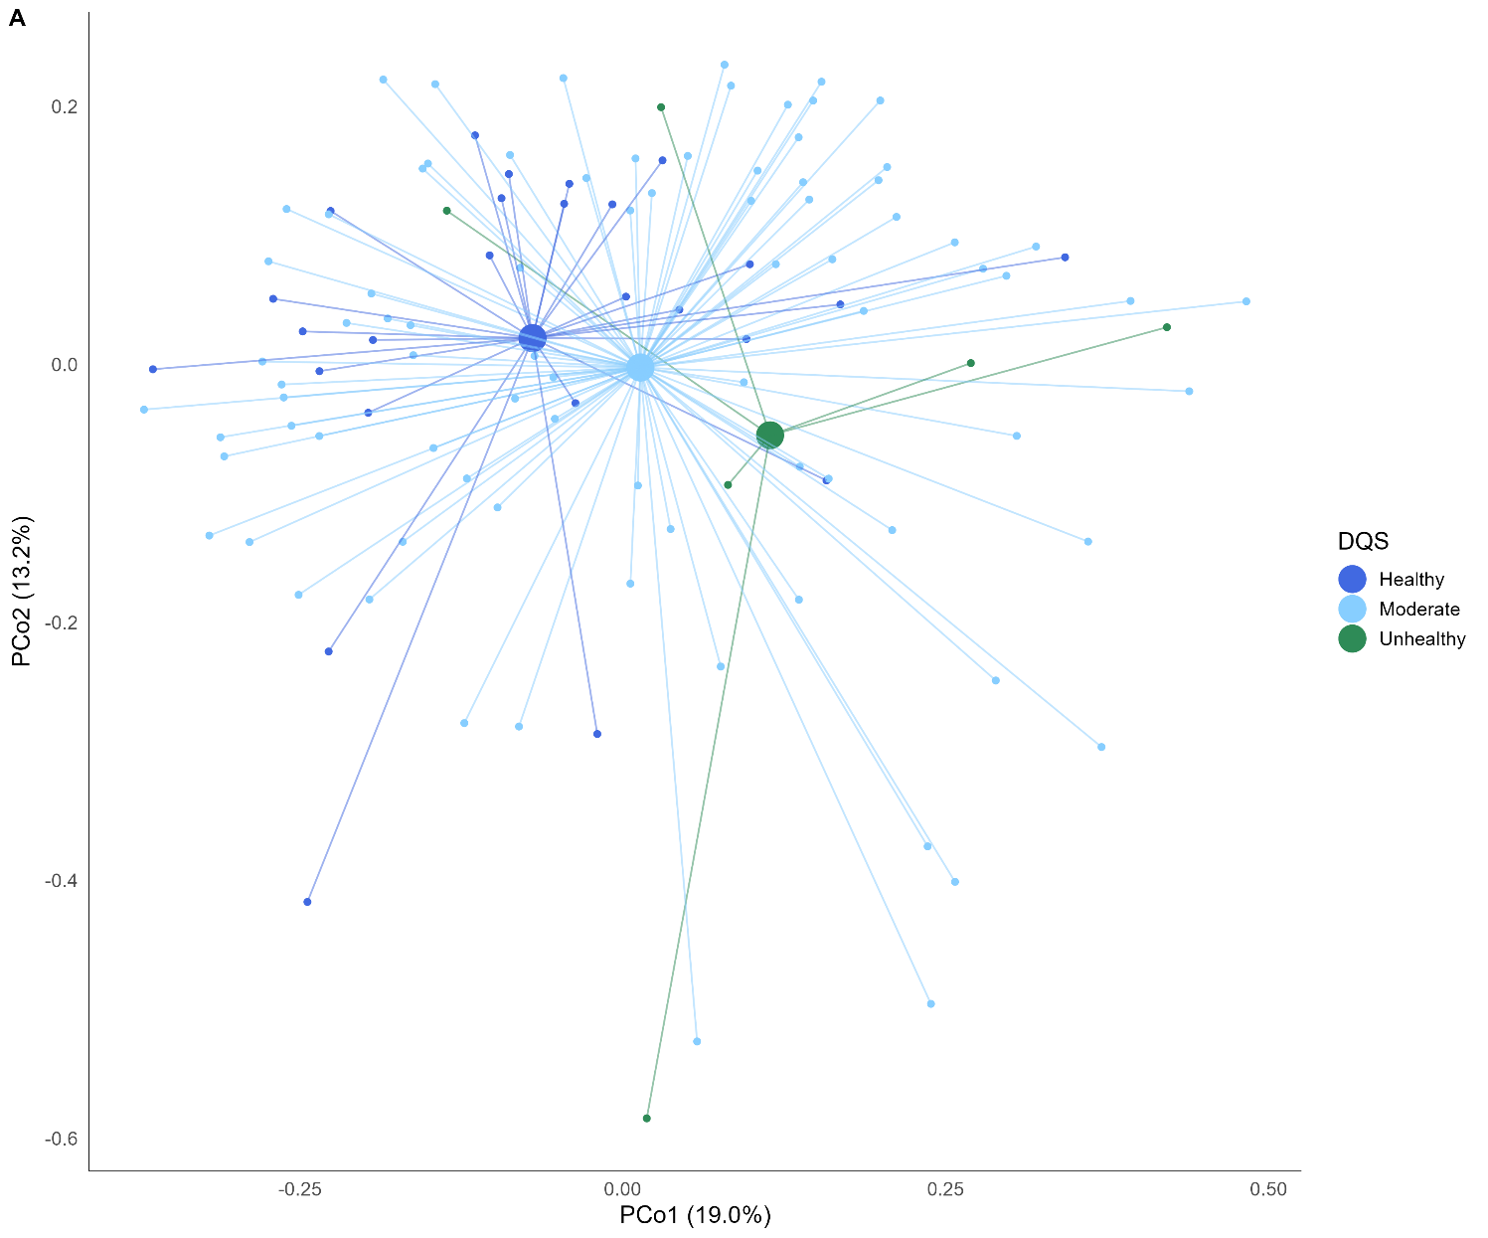

References
1. Almeida A, Nayfach S, Boland M, et al. A unified catalog of 204,938 reference genomes from the human gut microbiome. Nat Biotechnol 2021;39.
2. Zeng S, Patangia D, Almeida A, et al. A compendium of 32,277 metagenome-assembled genomes and over 80 million genes from the early-life human gut microbiome. Nat Commun 2022;13.
3. Nash AK, Auchtung TA, Wong MC, et al. The gut mycobiome of the Human Microbiome Project healthy cohort. Microbiome 2017;5.
4. Blanco-Míguez A, Beghini F, Cumbo F, et al. Extending and improving metagenomic taxonomic profiling with uncharacterized species using MetaPhlAn 4. Nat Biotechnol 2023;41.
5. Li D, Liu CM, Luo R, Sadakane K, Lam TW. MEGAHIT: An ultra-fast single-node solution for large and complex metagenomics assembly via succinct de Bruijn graph. Bioinformatics 2015;31.
6. Nurk S, Meleshko D, Korobeynikov A, Pevzner PA. MetaSPAdes: A new versatile metagenomic assembler. Genome Res 2017;27.
7. Nissen JN, Johansen J, Allesøe RL, et al. Improved metagenome binning and assembly using deep variational autoencoders. Nat Biotechnol 2021;39.
8. Orakov A, Fullam A, Coelho LP, et al. GUNC: detection of chimerism and contamination in prokaryotic genomes. Genome Biol 2021;22.
9. Chaumeil PA, Mussig AJ, Hugenholtz P, Parks DH. GTDB-Tk v2: memory friendly classification with the genome taxonomy database. Bioinformatics 2022;38.
10. Parks DH, Chuvochina M, Rinke C, Mussig AJ, Chaumeil PA, Hugenholtz P. GTDB: An ongoing census of bacterial and archaeal diversity through a phylogenetically consistent, rank normalized and complete genome-based taxonomy. Nucleic Acids Res 2022;50.
11. Olm MR, Brown CT, Brooks B, Banfield JF. DRep: A tool for fast and accurate genomic comparisons that enables improved genome recovery from metagenomes through de-replication. ISME Journal 2017;11.
12. Jain C, Rodriguez-R LM, Phillippy AM, Konstantinidis KT, Aluru S. High throughput ANI analysis of 90K prokaryotic genomes reveals clear species boundaries. Nat Commun 2018;9.
13. Steinegger M, Söding J. Clustering huge protein sequence sets in linear time. Nat Commun 2018;9.
14. Fu L, Niu B, Zhu Z, Wu S, Li W. CD-HIT: Accelerated for clustering the next-generation sequencing data. Bioinformatics 2012;28.
15. Langmead B, Salzberg SL. Fast gapped-read alignment with Bowtie 2. Nat Methods 2012;9.
16. Schubert M, Lindgreen S, Orlando L. AdapterRemoval v2: Rapid adapter trimming, identification, and read merging. BMC Res Notes 2016;9.
17. Li H, Durbin R. Fast and accurate short read alignment with Burrows-Wheeler transform. Bioinformatics 2009;25.
18. de Goffau MC, Lager S, Salter SJ, et al. Recognizing the reagent microbiome. Nature Microbiology 2018;3.
19. Cantalapiedra CP, Hern̗andez-Plaza A, Letunic I, Bork P, Huerta-Cepas J. eggNOG-mapper v2: Functional Annotation, Orthology Assignments, and Domain Prediction at the Metagenomic Scale. Mol Biol Evol 2021;38.
20. Huerta-Cepas J, Szklarczyk D, Heller D, et al. EggNOG 5.0: A hierarchical, functionally and phylogenetically annotated orthology resource based on 5090 organisms and 2502 viruses. Nucleic Acids Res 2019;47.
21. Aramaki T, Blanc-Mathieu R, Endo H, et al. KofamKOALA: KEGG Ortholog assignment based on profile HMM and adaptive score threshold. Bioinformatics 2020;36.
22. Zhang H, Yohe T, Huang L, et al. DbCAN2: A meta server for automated carbohydrate-active enzyme annotation. Nucleic Acids Res 2018;46.
23. Kanehisa M, Goto S. KEGG: Kyoto Encyclopedia of Genes and Genomes. Nucleic Acids Research 2000;28.
24. Zhou H, He K, Chen J, Zhang X. LinDA: linear models for differential abundance analysis of microbiome compositional data. Genome Biol 2022;23.
25. Aitchison J. The Statistical Analysis of Compositional Data. J R Stat Soc Series B Stat Methodol 1982;44.
26. Searle SR, Speed FM, Milliken GA. Population marginal means in the linear model: An alternative to least squares means. American Statistician 1980;34.
27. White H. A Heteroskedasticity-Consistent Covariance Matrix Estimator and a Direct Test for Heteroskedasticity. Econometrica 1980;48.
28. Benjamini Y, Hochberg Y. Controlling the False Discovery Rate: A Practical and Powerful Approach to Multiple Testing. J R Stat Soc Series B Stat Methodol 1995;57.
29. Nielsen HB, Almeida M, Juncker AS, et al. Identification and assembly of genomes and genetic elements in complex metagenomic samples without using reference genomes. Nat Biotechnol 2014;32.

Figure S10 - Diet Quality Score – Questionnaire

How often do you eat bread with the following types of fat?
 | More than twice a day | 1–2 times a day | 4–6 times a week | 1–3 times a week | Seldom/never
Butter, or similar | ☐ | ☐ | ☐ | ☐ | ☐
Margarine or plant-based margarine | ☐ | ☐ | ☐ | ☐ | ☐
Animal fat | ☐ | ☐ | ☐ | ☐ | ☐
Eat bread without any spread | ☐ | ☐ | ☐ | ☐ | ☐
How often do you eat the following types of cold cuts or toppings?
 | More than twice a day | 1–2 times a day | 4–6 times a week | 1–3 times a week | Seldom/never
Cold cuts, meat | ☐ | ☐ | ☐ | ☐ | ☐
Fish toppings | ☐ | ☐ | ☐ | ☐ | ☐
Eggs | ☐ | ☐ | ☐ | ☐ | ☐
Salad spreads or mayonnaise-based salads | ☐ | ☐ | ☐ | ☐ | ☐
How often do you eat the following types of hot meals?
 | More than once a day | 5–7 times a week | 3–4 times a week | 1–2 times a week | Seldom/never
Meat (beef, veal, pork, lamb) | ☐ | ☐ | ☐ | ☐ | ☐
Poultry (chicken, turkey, duck) | ☐ | ☐ | ☐ | ☐ | ☐
Fish | ☐ | ☐ | ☐ | ☐ | ☐
Vegetable or vegetarian dishes | ☐ | ☐ | ☐ | ☐ | ☐
How often do you eat the following types of vegetables?
 | More than once a day | 5–7 times a week | 3–4 times a week | 1–2 times a week | Seldom/never
Mixed salad, raw vegetable mixes | ☐ | ☐ | ☐ | ☐ | ☐
Other raw vegetables | ☐ | ☐ | ☐ | ☐ | ☐
Cooked vegetables (boiled, baked, fried, stewed, or stir-fried dishes) | ☐ | ☐ | ☐ | ☐ | ☐

How often do you or others in your household use the following types of fat in cooking?
 | More than once a day | 5–7 times a week | 3–4 times a week | 1–2 times a week | Seldom/never
Cooking margarine | ☐ | ☐ | ☐ | ☐ | ☐
Plant margarine | ☐ | ☐ | ☐ | ☐ | ☐
Butter or similar | ☐ | ☐ | ☐ | ☐ | ☐
Animal fat/lard (e.g., Palmin) | ☐ | ☐ | ☐ | ☐ | ☐
Olive oil | ☐ | ☐ | ☐ | ☐ | ☐
Corn, sunflower, or grape seed oil | ☐ | ☐ | ☐ | ☐ | ☐
Rapeseed, canola, or salad oil | ☐ | ☐ | ☐ | ☐ | ☐
Cook without using fat | ☐ | ☐ | ☐ | ☐ | ☐
How often do you eat or drink the following?
 | More than once a day | 5–7 times a week | 3–4 times a week | 1–2 times a week | Seldom/never
Food from pizzerias, burger bars, shawarma bars, etc. | ☐ | ☐ | ☐ | ☐ | ☐
Cakes, chocolate, ice cream, and candy | ☐ | ☐ | ☐ | ☐ | ☐
Soft drinks, cola, juice, and similar with sugar | ☐ | ☐ | ☐ | ☐ | ☐
Soft drinks, cola, juice, and similar without sugar | ☐ | ☐ | ☐ | ☐ | ☐
Energy drinks (e.g., Red Bull, Cult, etc.) | ☐ | ☐ | ☐ | ☐ | ☐
How many portions of fruit do you usually eat? (1 portion = 1 piece or 1 dl – include fruit compote or fruit purée)
>6 times/day ☐
5–6/day ☐
3–4/day ☐
1–2/day ☐
5–6/week ☐
None ☐
Would you like to eat more healthily?
☐ Yes ☐ No
If you want to eat more healthily, would you like support or help to achieve this?
☐ Yes ☐ No
Do you have support for eating more healthily from your social circle (e.g., family, friends, colleagues, acquaintances)?
☐ Yes ☐ No
How would you rate your overall dietary habits?
☐ Very healthy ☐ Healthy ☐ Fairly healthy ☐ Unhealthy ☐ Very unhealthy

Construction of the DQS
Food | Frequency | Score
Vegetables (cooked or raw) and/or vegetarian dishes | ≥ 5-7 servings/week | 3 points
 | The answers in between | 2 points
 | ≤ 2 servings/week | 1 point
Fruit | ≥ 3 pieces/day | 3 points
 | ≥ 3 pieces/week and ≤ pieces/day | 2 points
 | ≤ 2 pieces/week | 1 point
Fish | ≥ 200 g/week | 3 points
 | Answers in between | 2 points
 | No intake | 1 point
Fat
Fat, bread | None | (3 points)
 | Minarine, vegetable margarine | (2 points)
 | Butter, blended spread, lard | (1 point)
Fat, cooking | None/olive oil | (3 points)
 | Vegetable margarine, oil | (2 points)
 | Margarine, butter, blended spread, lard | (1 point)
Fat, summarized | 6 points, summarized | 3 points
 | 3-5 points, summarized | 2 point
 | 2 points, summarized | 1 point

