Supplementary Materials

Contents
Table S1 Lipid Compositions of plasma membranes of mammals (PMm) 1
Table S2 Lipid Compositions of Gram-negative (G⁻) bacteria outer membrane 2
Table S3 Lipid Compositions of Gram-negative (G⁺) bacteria cell membrane 3
Table S4 Clog P Values of Compounds 5a-t 5
Table S5 The MIC values of selected antibiotics against S. aureus ATCC 29213 and E. coli ATCC 25922 in the presence or absence of 32 μg/mL PG 6
Spectral Data for Compounds 5a-t 7
NMR and HRMS Spectra of Compounds 5a-t 20
References 49

Table S1 Lipid Compositions of plasma membranes of mammals (PMm) ^{1,2}
Lipid Name | Lipid Head/Tail | #Lipids in Leaflets |  | Charge(e)
Lipid Name | Lipid Head/Tail | Outer | Inner
POPCª | PC^{b} (16:0/18:1(9Z)) | 16 | 7 | 0
PLPC^{c} | PC (16:0/18:2(9Z,12Z)) | 22 | 11 | 0
PAPE^{d} | PE^{e} (16:0/20:4(5Z,8Z,11Z,14Z)) | 3 | 12 | 0
POPE^{f} | PE (16:0/18:1(9Z)) | 3 | 14 | 0
POPI^{g} | PI^{h} (16:0/18:1(9Z)) | 0 | 5 | -1
PAPS^{i} | PS^{j} (16:0/20:4(5Z,8Z,11Z,14Z)) | 0 | 11 | -1
POPA^{k} | PA^{l} (16:0/18:1(9Z)) | 0 | 1 | -1
SSM^{m} | SM^{n} (d18:1/18:0) | 11 | 5 | 0
NSMº | SM (d18:1/24:1) | 11 | 5 | 0
CMH^{p} | GlcCer^{q} (d18:1/16:0) | 4 | 0 | 0
CHOL^{r} | Cholesterol | 37 | 29 | 0
TOTAL |  | 107 | 100
System parameters:
Size (Å3): 75.26 x 75.26 x 122.17
# water / Na⁺ / Cl⁻ : 13544 / 54 / 37
Temperature (K): 313
Notes: ª POPC, 1-palmitoyl-2-oleoyl-sn-phosphatidylcholine; ^{b} PC, Phosphatidylcholine; ^{c} PLPC, 1-palmitoyl-2-linoleoyl-sn-glycero-3-phosphocholine; ^{d} PAPE, 1-palmitoyl-2-arachidonoyl-sn-glycero-3-phosphoethanolamine; ^{e} PE, Phosphatidylethanolamine; ^{f} POPE, 1-palmitoyl-2-oleoyl-sn-phosphatidylethanolamine; ^{g} POPI, 1-palmitoyl-2-oleoyl-sn-phosphatidylinositol; ^{h} PI, Phosphatidylinositol; ^{i} PAPS, 1-palmitoyl-2-arachidonyl-phosphatidylserine; ^{j} PS, Phosphatidylserine; ^{k} POPA, 1-palmitoyl-2-oleoyl-sn-glycero-3-phosphate; ^{l} PA, Phosphatidic acid; ^{m} SSM, Stearoyl-sphingomyelin; ^{n} SM, Spingomyelin; º NSM, N-Stearoyl-D-Sphingomyelin; ^{p} CMH, Ceramide Monohexoside; ^{q} GlcCer, Glucocerebroside; ^{r} CHOL, Cholesterol.

Table S2 Lipid Compositions of Gram-negative (G⁻) bacteria outer membrane ^{3,4}
Lipid Name | Lipid Head/Tail | #Lipids in Leaflets |  | Charge(e)
Lipid Name | Lipid Head/Tail | Outer | Inner
ECLIPA | E.coli R1 core-Lipid A* | 35 | 0 | -10
PPPEª | PE^{b} (16:0/16:1 (9Z)) | 0 | 75 | 0
PVPG^{c} | PG^{d} (16:0/18:1(11Z)) | 0 | 20 | -1
PVCL2e | CL^{f} (1'-[16:0/18:1(11Z)],3'-[16:0/18:1(11Z)]) | 0 | 5 | -2
TOTAL |  | 35 | 100
System parameters:
Size (Å3): 81.44 x 81.44 x 129.69
# water / Na⁺ / Cl⁻ / Ca²⁺: 14934 / 70 / 40 / 175
Temperature (K): 313
Notes: ª PPPE, 1-palmitoyl-2-palmitoleoyl-sn-phosphatidylethanolamine ; ^{b} PE, Phosphatidylethanolamine; ^{c} PVPG, 1-palmitoyl-2-vacenoyl-sn-phosphatidylglycerol; ^{d} PG, Phosphatidylglycerol; ^{e} PVCL2: 1,1′-palmitoyl-2,2′-vacenoyl cardiolipin; ^{f} CL, Cardiolipin.

Table S3 Lipid Compositions of Gram-negative (G⁺) bacteria cell membrane ^{2,5,6}
Lipid Name | Lipid Head/Tail | #Lipids in Leaflets | Charge(e)
Lipid Name | Lipid Head/Tail | Outer or Inner | Charge(e)
MAIPGª | PG^{b} (14:0 /a15:0) | 22 | -1
AIPG^{c} | PG (a15:0 /i15:0) | 27 | -1
PAIPG^{d} | PG (16:0 /a15:0) | 9 | -1
DPPG^{e} | PG (16:0 /16:0) | 7 | -1
MAIPE^{f} | PE^{g} (14:0 /a15:0) | 9 | 0
AIPE^{h} | PE (a15:0 /i15:0) | 11 | 0
PAIPE^{i} | PE (16:0 /a15:0) | 4 | 0
DPPE^{j} | PE (16:0 /16:0) | 3 | 0
PAICL2 | CL^{k} (1'-[16:0 / a15:0],3'-[16:0 / a15:0]) | 8 | -2
TOTAL |  | 100
System parameters:
Size (Å3): 81.74 x 81.74 x 100
# water / Na⁺ / Cl⁻ : 12413 / 195 / 33
Temperature (K): 313
Notes: ª MAIPG, 12-methyl tetradecanoic acid and myristic acid with PG headgroup; ^{b} PG, Phosphatidylglycerol; ^{c} AIPG, 3-methyl tetradecanoic acid and 12-methyl tetradecanoic acid with PG headgroup; ^{d} PAIPG, 12-methyl tetradecanoic acid and palmitic acid with PG headgroup; ^{e} DPPG, 1,2-dipalmitoyl-sn-glycero-3-phosphoglycerol; ^{f} MAIPE, 12-methyl tetradecanoic acid and myristic acid with PE headgroup; ^{g} PE, Phosphatidylethanolamine; ^{h} AIPE, 13-methyl tetradecanoic acid and 12-methyl tetradecanoic acid with PE headgroup; ^{I} PAIPE, 12-methyl tetradecanoic acid and palmitic acid with with PE headgroup; ^{j} DPPE, Dipalmitoylphosphatidylethanolamine; ^{k} CL, Cardiolipin.

Table S4 Clog P Values of Compounds 5a-t
Compd. | clog Pª | Compd. | clog P | Compd. | clog P | Compd. | clog P
1 | 7.35 | 5f | 2.21 | 5l | 1.12 | 5r | 3.24
5a | 2.11 | 5g | 3.27 | 5m | 3.24 | 5s | 4.30
5b | 3.17 | 5h | 5.38 | 5n | 4.3 | 5t | 6.41
5c | 5.29 | 5i | 6.44 | 5o | 5.35
5d | 6.35 | 5j | 7.50 | 5p | 1.12
5e | 7.40 | 5k | 0.06 | 5q | 2.18
Note: ª clog P values were calculated by ChemDraw Ultra 2014 software.

Table S5 The MIC values of selected antibiotics against S. aureus ATCC 29213 and E. coli ATCC 25922 in the presence or absence of 32 μg/mL PG
Antibiotics | MICª (μg/mL)
Antibiotics | S. aureus ATCC 29213 |  | E. coli ATCC 25922
Antibiotics | single | + PG^{b} | single | + PG
Daptomycin | 2 | 32 | ND^{c} | ND
Colistin | ND | ND | 1 | 16
Ceftazidime | 16 | 16 | 4 | 4
Gentamicin | 1 | 1 | 8 | 8
Levofloxacin | 0.5 | 0.5 | 0.25 | 0.25
Tigecycline | 4 | 4 | 2 | 2
Notes: ª MIC, minimum inhibitory concentration; ^{b} PG, phosphatidylglycerol; ^{c} ND, not determined.

Spectral Data for Compounds 5a-t
Supplementary Data 1: (E)-N,N'-(((2-(3,7-dimethylocta-2,6-dien-1-yl)-5-pentyl-1,3-phenylene)bis(oxy))bis(ethane-2,1-diyl))bis(2-(ethylamino)-N,N-dimethyl-2-oxoethan-1-aminium) bromide (5a) : Yield: 70.9%, white solid, ¹H NMR (600 MHz, CDCl₃) δ: 8.78 (t, J = 5.4 Hz, 2H), 6.48 (s, 2H), 5.03 – 4.98 (m, 1H), 4.91 (t, J = 5.2 Hz, 1H), 4.78 (s, 4H), 4.47 (s, 4H), 4.26 (s, 4H), 3.53 (s, 12H), 3.35 – 3.31 (m, 4H), 3.25 (d, J = 5.0 Hz, 2H), 2.61 – 2.54 (m, 2H), 2.03 – 1.94 (m, 2H), 1.94 – 1.88 (m, 2H), 1.69 (s, 3H), 1.64 (s, 3H), 1.63 – 1.57 (m, 3H), 1.39 – 1.31 (m, 4H), 1.21 (t, J = 7.3 Hz, 6H), 0.91 (t, J = 6.9 Hz, 3H); ¹³C NMR (151 MHz, CDCl₃) δ: 162.4, 155.7, 143.7, 136.5, 131.8, 123.7, 122.5, 115.7, 106.2, 65.0, 64.5, 62.4, 53.0, 39.5, 36.5, 34.8, 31.6, 31.3, 26.8, 25.8, 22.5, 22.4, 17.8, 16.8, 14.2, 14.1; HRMS (ESI) C₃₇H₆₆Br₂N₄O₄ [M − 2Br]/2⁺ calcd = 315.2537; found = 315.2520.
Supplementary Data 2: (E)-N,N'-(((2-(3,7-dimethylocta-2,6-dien-1-yl)-5-pentyl-1,3-phenylene)bis(oxy))bis(ethane-2,1-diyl))bis(N,N-dimethyl-2-oxo-2-(propylamino)ethan-1-aminium) bromide (5b): Yield: 36.5%, white solid, ¹H NMR (600 MHz, CDCl₃) δ: 8.70 (t, J = 5.6 Hz, 2H), 6.40 (s, 2H), 4.96 – 4.91 (m, 1H), 4.84 (dd, J = 5.8, 4.8 Hz, 1H), 4.71 (s, 4H), 4.43 – 4.35 (m, 4H), 4.22 – 4.14 (m, 4H), 3.45 (s, 12H), 3.17 (dd, J = 13.4, 6.7 Hz, 6H), 2.53 – 2.48 (m, 2H), 1.90 (dd, J = 14.8, 6.9 Hz, 2H), 1.87 – 1.83 (m, 4H), 1.61 (s, 3H), 1.57 (s, 3H), 1.56 – 1.51 (m, 6H), 1.32 – 1.23 (m, 5H), 0.88 (t, J = 7.4 Hz, 6H), 0.84 (t, J = 7.0 Hz, 3H); ¹³C NMR (151 MHz, CDCl₃) δ: 161.5, 154.6, 142.7, 135.5, 130.8, 122.7, 121.5, 114.6, 105.2, 64.0, 63.5, 61.4, 52.0, 40.6, 38.5, 35.4, 30.6, 30.2, 28.7, 25.8, 24.7, 21.5, 21.3, 21.3, 16.8, 15.8, 13.1, 10.6; HRMS (ESI) C₃₉H₇₀Br₂N₄O₄ [M − 2Br]/2⁺ calcd = 329.2693; found = 329.2689.
Supplementary Data 3: (E)-N,N'-(((2-(3,7-dimethylocta-2,6-dien-1-yl)-5-pentyl-1,3-phenylene)bis(oxy))bis(ethane-2,1-diyl))bis(N,N-dimethyl-2-oxo-2-(pentylamino)ethan-1-aminium) bromide (5c): Yield: 20.3%, white solid, ¹H NMR (600 MHz, CDCl₃) δ: 8.77 (t, J = 5.6 Hz, 2H), 6.47 (s, 2H), 5.03 – 4.98 (m, 1H), 4.90 (dd, J = 5.8, 4.8 Hz, 1H), 4.79 (s, 4H), 4.49 – 4.44 (m, 4H), 4.28 – 4.23 (m, 4H), 3.52 (s, 12H), 3.29 – 3.22 (m, 6H), 2.58 (t, 2H), 2.00 – 1.95 (m, 4H), 1.93 – 1.88 (m, 2H), 1.68 (s, 3H), 1.64 (s, 3H), 1.63 – 1.57 (m, 6H), 1.38 – 1.28 (m, 13H), 0.93 – 0.87 (m, 9H); ¹³C NMR (151 MHz, CDCl₃) δ: 162.5, 155.7, 143.7, 136.5, 131.8, 123.7, 122.5, 115.7, 106.2, 65.1, 64.6, 62.4, 53.0, 40.0, 39.5, 36.5, 31.6, 31.3, 29.2, 28.6, 26.8, 25.8, 22.5, 22.3, 22.2, 17.8, 16.8, 14.1, 14.0; HRMS (ESI) C₄₃H₇₈Br₂N₄O₄ [M − 2Br]/2⁺ calcd = 357.3006; found = 357.3002.
Supplementary Data 4: (E)-N,N'-(((2-(3,7-dimethylocta-2,6-dien-1-yl)-5-pentyl-1,3-phenylene)bis(oxy))bis(ethane-2,1-diyl))bis(2-(hexylamino)-N,N-dimethyl-2-oxoethan-1-aminium) bromide (5d): Yield: 40.0%, white solid, ¹H NMR (600 MHz, CDCl₃) δ: 8.78 (t, J = 5.6 Hz, 2H), 6.47 (s, 2H), 5.03 – 4.98 (m, 1H), 4.90 (dd, J = 5.8, 4.8 Hz, 1H), 4.79 (s, 4H), 4.49 – 4.43 (m, 4H), 4.27 – 4.22 (m, 4H), 3.52 (s, 12H), 3.29 – 3.22 (m, 6H), 2.60 – 2.55 (m, 2H), 1.97 (dd, J = 14.7, 6.9 Hz, 2H), 1.92 – 1.89 (m, 4H), 1.68 (s, 3H), 1.64 (s, 3H), 1.63 – 1.57 (m, 6H), 1.40 – 1.31 (m, 9H), 1.31 – 1.24 (m, 8H), 0.91 (t, J = 7.0 Hz, 3H), 0.87 (t, J = 6.9 Hz, 6H); ¹³C NMR (151 MHz, CDCl₃) δ: 162.5, 155.6, 143.7, 136.6, 131.8, 123.7, 122.5, 115.6, 106.2, 65.1, 64.5, 62.4, 53.0, 40.0, 39.5, 36.5, 31.6, 31.4, 31.3, 28.9, 26.8, 26.7, 25.8, 22.5, 22.3, 17.8, 16.8, 14.1, 14.0; HRMS (ESI) C₄₅H₈₂Br₂N₄O₄ [M − 2Br]/2⁺ calcd = 371.3163; found = 371.3154.
Supplementary Data 5: (E)-N,N'-(((2-(3,7-dimethylocta-2,6-dien-1-yl)-5-pentyl-1,3-phenylene)bis(oxy))bis(ethane-2,1-diyl))bis(2-(heptylamino)-N,N-dimethyl-2-oxoethan-1-aminium) bromide (5e): Yield: 40.9%, white solid, ¹H NMR (600 MHz, CDCl₃) δ: 8.78 (t, J = 5.6 Hz, 2H), 6.47 (s, 2H), 5.03 – 4.98 (m, 1H), 4.90 (dd, J = 5.7, 4.8 Hz, 1H), 4.79 (s, 4H), 4.49 – 4.43 (m, 4H), 4.27 – 4.21 (m, 4H), 3.52 (s, 12H), 3.29 – 3.22 (m, 6H), 2.60 – 2.55 (m, 1H), 1.98 (dd, J = 14.7, 6.9 Hz, 2H), 1.93 – 1.88 (m, 4H), 1.68 (s, 3H), 1.64 (s, 3H), 1.63 – 1.57 (m, 6H), 1.39 – 1.21 (m, 21H), 0.91 (t, J = 7.0 Hz, 3H), 0.87 (t, J = 7.0 Hz, 6H); ¹³C NMR (151 MHz, CDCl₃) δ: 162.5, 155.7, 143.7, 136.6, 131.8, 123.7, 122.5, 115.6, 106.2, 65.1, 64.6, 62.4, 53.0, 40.0, 39.5, 36.5, 31.7, 31.6, 31.3, 29.0, 28.9, 27.0, 26.8, 25.8, 22.6, 22.6, 22.4, 17.8, 16.8, 14.1, 14.1; HRMS (ESI) C₄₇H₈₆Br₂N₄O₄ [M − 2Br]/2⁺ calcd = 385.3319; found = 385.3319.
Supplementary Data 6: (E)-3,3'-((2-(3,7-dimethylocta-2,6-dien-1-yl)-5-pentyl-1,3-phenylene)bis(oxy))bis(N-(2-(ethylamino)-2-oxoethyl)-N,N-dimethylpropan-1-aminium) bromide (5f): Yield: 60.4%, pale yellow gel, ¹H NMR (600 MHz, CDCl₃) δ: 8.87 (t, J = 5.2 Hz, 2H), 6.34 (s, 2H), 5.10 (dd, J = 6.7, 5.7 Hz, 1H), 5.05 – 5.00 (m, 1H), 4.68 (s, 4H), 4.11 (dd, J = 9.0, 3.4 Hz, 4H), 3.89 – 3.84 (m, 4H), 3.43 (s, 12H), 3.33 – 3.30 (m, 4H), 3.28 (d, J = 6.6 Hz, 2H), 2.56 – 2.51 (m, 2H), 2.39 – 2.33 (m, 4H), 2.04 – 2.00 (m, 3H), 1.96 – 1.91 (m, 2H), 1.74 (s, 3H), 1.63 (s, 3H), 1.61 – 1.56 (m, 2H), 1.35 – 1.29 (m, 4H), 1.26 (t, J = 7.1 Hz, 2H), 1.21 (t, J = 7.3 Hz, 6H), 0.90 (t, J = 7.0 Hz, 3H); ¹³C NMR (151 MHz, CDCl₃) δ: 162.6, 156.8, 142.5, 134.3, 131.5, 124.0, 123.3, 115.7, 105.5, 67.0, 65.9, 63.3, 52.0, 41.6, 39.9, 36.5, 31.7, 31.3, 26.8, 26.3, 25.7, 22.6, 22.5, 22.3, 20.1, 17.8, 16.4, 14.1, 11.6; HRMS (ESI) C₃₉H₇₀Br₂N₄O₄ [M − 2Br]/2⁺ calcd = 329.2693; found = 329.2683.
Supplementary Data 7: (E)-3,3'-((2-(3,7-dimethylocta-2,6-dien-1-yl)-5-pentyl-1,3-phenylene)bis(oxy))bis(N,N-dimethyl-N-(2-oxo-2-(propylamino)ethyl)propan-1-aminium) bromide (5g): Yield: 45.3%, pale yellow gel, ¹H NMR (600 MHz, CDCl₃) δ: 8.86 (t, J = 5.6 Hz, 2H), 6.34 (s, 2H), 5.10 (dd, J = 6.7, 5.6 Hz, 1H), 5.05 – 5.00 (m, 1H), 4.69 (s, 4H), 4.10 (t, J = 5.5 Hz, 4H), 3.89 – 3.84 (m, 4H), 3.42 (s, 12H), 3.27 (d, J = 6.6 Hz, 2H), 3.24 (dd, J = 13.4, 6.8 Hz, 4H), 2.55 – 2.51 (m, 2H), 2.40 – 2.33 (m, 4H), 2.02 (dd, J = 14.9, 7.1 Hz, 2H), 1.97 – 1.91 (m, 3H), 1.74 (s, 3H), 1.63 (s, 3H), 1.63 – 1.56 (m, 8H), 1.35 – 1.29 (m, 4H), 0.95 (t, J = 7.4 Hz, 6H), 0.90 (t, J = 7.0 Hz, 3H); ¹³C NMR (151 MHz, CDCl₃) δ: 162.5, 156.2, 142.7, 134.5, 131.7, 123.9, 123.4, 115.7, 105.7, 64.4, 64.2, 63.1, 52.3, 41.6, 39.8, 36.4, 31.6, 31.2, 26.9, 25.7, 23.6, 22.6, 22.4, 22.3, 17.8, 16.6, 14.1, 11.6; HRMS (ESI) C₄₁H₇₄Br₂N₄O₄ [M − 2Br]/2⁺ calcd = 343.2850; found = 343.2841.
Supplementary Data 8: (E)-3,3'-((2-(3,7-dimethylocta-2,6-dien-1-yl)-5-pentyl-1,3-phenylene)bis(oxy))bis(N,N-dimethyl-N-(2-oxo-2-(pentylamino)ethyl)propan-1-aminium) bromide (5h): Yield: 62.0%, white gel, ¹H NMR (600 MHz, CDCl₃) δ: 8.86 (t, J = 5.6 Hz, 2H), 6.35 (s, 2H), 5.13 (dd, J = 7.0, 5.9 Hz, 1H), 5.04 – 5.00 (m, 1H), 4.65 (s, 4H), 4.03 (t, J = 5.8 Hz, 4H), 3.76 – 3.71 (m, 4H), 3.39 (s, 12H), 3.29 (d, J = 6.8 Hz, 2H), 3.22 (dd, J = 13.3, 6.8 Hz, 4H), 2.55 – 2.51 (m, 2H), 2.07 – 2.00 (m, 6H), 1.93 – 1.82 (m, 8H), 1.73 (s, 3H), 1.63 (s, 3H), 1.62 – 1.57 (m, 7H), 1.36 – 1.31 (m, 4H), 0.95 (t, J = 7.4 Hz, 6H), 0.90 (t, J = 6.9 Hz, 3H); ¹³C NMR (151 MHz, CDCl₃) δ: 162.4, 156.2, 142.8, 134.5, 131.7, 123.8, 123.4, 115.7, 105.7, 64.4, 64.3, 63.1, 52.3, 39.9, 39.8, 36.4, 31.6, 31.3, 29.2, 28.6, 26.9, 25.7, 23.6, 22.6, 22.4, 22.3, 17.8, 16.6, 14.1, 14.0; HRMS (ESI) C₄₅H₈₂Br₂N₄O₄ [M − 2Br]/2⁺ calcd = 371.3163; found = 371.3155.
Supplementary Data 9: (E)-3,3'-((2-(3,7-dimethylocta-2,6-dien-1-yl)-5-pentyl-1,3-phenylene)bis(oxy))bis(N-(2-(hexylamino)-2-oxoethyl)-N,N-dimethylpropan-1-aminium) bromide (5i): Yield: 50.0%, pale yellow gel, ¹H NMR (600 MHz, CDCl₃) δ: 8.81 (t, J = 5.5 Hz, 2H), 6.27 (s, 2H), 5.03 (t, J = 6.4 Hz, 1H), 4.96 (t, J = 6.9 Hz, 1H), 4.62 (s, 4H), 4.03 (t, J = 5.4 Hz, 4H), 3.82 – 3.76 (m, 4H), 3.35 (s, 12H), 3.21 – 3.16 (m, 3H), 2.48 – 2.44 (m, 2H), 2.32 – 2.25 (m, 4H), 1.98 – 1.92 (m, 2H), 1.89 – 1.85 (m, 2H), 1.67 (s, 3H), 1.56 (s, 3H), 1.53 – 1.49 (m, 5H), 1.30 – 1.18 (m, 20H), 0.83 (t, J = 7.0 Hz, 3H), 0.80 (t, J = 6.8 Hz, 6H); ¹³C NMR (151 MHz, CDCl₃) δ: 161.4, 155.2, 141.8, 133.5, 130.7, 122.8, 122.3, 114.6, 104.7, 63.4, 63.3, 62.1, 51.3, 38.9, 38.8, 35.4, 30.6, 30.3, 30.2, 27.9, 25.9, 25.7, 24.7, 22.6, 21.5, 21.5, 16.8, 15.6, 13.1, 13.0; HRMS (ESI) C₄₇H₈₆Br₂N₄O₄ [M − 2Br]/2⁺ calcd = 385.3319; found = 385.3309.
Supplementary Data 10: (E)-3,3'-((2-(3,7-dimethylocta-2,6-dien-1-yl)-5-pentyl-1,3-phenylene)bis(oxy))bis(N-(2-(heptylamino)-2-oxoethyl)-N,N-dimethylpropan-1-aminium) bromide (5j): Yield: 50.0%, pale yellow gel, ¹H NMR (600 MHz, CDCl₃) δ: 8.79 (t, J = 5.6 Hz, 2H), 6.27 (s, 2H), 5.03 (dd, J = 6.7, 5.8 Hz, 1H), 4.97 – 4.94 (m, 1H), 4.61 (s, 4H), 4.03 (t, J = 5.4 Hz, 4H), 3.83 – 3.75 (m, 4H), 3.34 (s, 12H), 3.23 – 3.14 (m, 6H), 2.51 – 2.43 (m, 2H), 2.34 – 2.23 (m, 4H), 2.00 – 1.93 (m, 2H), 1.89 – 1.84 (m, 2H), 1.67 (s, 3H), 1.56 (s, 3H), 1.54 – 1.49 (m, 5H), 1.29 – 1.16 (m, 24H), 0.83 (t, J = 7.0 Hz, 3H), 0.80 (t, J = 7.0 Hz, 6H); ¹³C NMR (151 MHz, CDCl₃) δ: 161.4, 155.2, 141.8, 133.5, 130.7, 122.8, 122.3, 114.7, 104.7, 63.4, 63.3, 62.1, 51.3, 39.0, 38.8, 35.4, 30.7, 30.6, 30.2, 27.9, 27.9, 26.0, 25.9, 24.7, 22.6, 21.6, 21.5, 16.8, 15.6, 13.1; HRMS (ESI) C₄₉H₉₀Br₂N₄O₄ [M − 2Br]/2⁺ calcd = 399.3476; found = 399.3472.
Supplementary Data 11: (E)-4,4'-((2-(3,7-dimethylocta-2,6-dien-1-yl)-5-pentyl-1,3-phenylene)bis(oxy))bis(N-(2-(ethylamino)-2-oxoethyl)-N,N-dimethylbutan-1-aminium) bromide (5k): Yield: 40.8%, white gel, ¹H NMR (600 MHz, CDCl₃) δ: 8.81 (t, J = 5.4 Hz, 2H), 6.28 (s, 2H), 5.06 (dd, J = 7.0, 6.0 Hz, 1H), 5.00 – 4.91 (m, 1H), 4.55 (s, 4H), 3.96 (t, J = 5.7 Hz, 4H), 3.70 – 3.65 (m, 4H), 3.32 (s, 12H), 3.27 – 3.19 (m, 6H), 2.50 – 2.42 (m, 2H), 2.01 – 1.92 (m, 6H), 1.87 – 1.80 (m, 4H), 1.66 (s, 3H), 1.56 (s, 3H), 1.54 – 1.50 (m, 3H), 1.31 – 1.23 (m, 6H), 1.13 (t, J = 7.3 Hz, 6H), 0.83 (t, J = 6.9 Hz, 3H); ¹³C NMR (151 MHz, CDCl₃) δ: 161.4, 155.7, 141.4, 133.3, 130.5, 123.0, 122.2, 114.6, 104.5, 66.0, 64.8, 62.2, 51.0, 38.9, 35.5, 33.7, 30.6, 30.3, 25.8, 25.2, 24.7, 21.5, 21.5, 19.1, 16.8, 15.4, 13.1, 13.1; HRMS (ESI) C₄₁H₇₄Br₂N₄O₄ [M − 2Br]/2⁺ calcd = 343.2850; found = 343.2839.
Supplementary Data 12: (E)-4,4'-((2-(3,7-dimethylocta-2,6-dien-1-yl)-5-pentyl-1,3-phenylene)bis(oxy))bis(N,N-dimethyl-N-(2-oxo-2-(propylamino)ethyl)butan-1-aminium) bromide (5l): Yield: 71.2%, white gel, ¹H NMR (600 MHz, CDCl₃) δ: 8.86 (t, J = 5.6 Hz, 2H), 6.35 (s, 2H), 5.13 (dd, J = 7.0, 5.9 Hz, 1H), 5.04 – 5.00 (m, 1H), 4.65 (s, 4H), 4.03 (t, J = 5.8 Hz, 4H), 3.76 – 3.71 (m, 4H), 3.39 (s, 12H), 3.29 (d, J = 6.8 Hz, 2H), 3.22 (dd, J = 13.3, 6.8 Hz, 4H), 2.55 – 2.51 (m, 2H), 2.07 – 2.00 (m, 6H), 1.93 – 1.82 (m, 8H), 1.73 (s, 3H), 1.63 (s, 3H), 1.62 – 1.57 (m, 7H), 1.36 – 1.31 (m, 4H), 0.95 (t, J = 7.4 Hz, 6H), 0.90 (t, J = 6.9 Hz, 3H); ¹³C NMR (151 MHz, CDCl₃) δ: 162.5, 156.2, 142.7, 134.5, 131.7, 123.9, 123.4, 115.7, 105.7, 64.4, 64.2, 63.1, 52.3, 41.6, 39.8, 36.4, 31.6, 31.2, 26.9, 25.7, 23.6, 22.6, 22.4, 22.3, 17.8, 16.6, 14.1, 11.6; HRMS (ESI) C₄₃H₇₈Br₂N₄O₄ [M − 2Br]/2⁺ calcd = 357.3006; found = 357.2994.
Supplementary Data 13: (E)-4,4'-((2-(3,7-dimethylocta-2,6-dien-1-yl)-5-pentyl-1,3-phenylene)bis(oxy))bis(N,N-dimethyl-N-(2-oxo-2-(pentylamino)ethyl)butan-1-aminium) bromide (5m): Yield: 62.9%, white gel, ¹H NMR (600 MHz, CDCl₃) δ: ¹H NMR (600 MHz, CDCl₃) δ 8.88 (t, J = 5.6 Hz, 2H), 6.35 (s, 2H), 5.13 (dd, J = 7.0, 6.1 Hz, 1H), 5.05 – 4.99 (m, 1H), 4.63 (s, 4H), 4.02 (t, J = 5.7 Hz, 4H), 3.76 – 3.72 (m, 4H), 3.38 (s, 12H), 3.28 (d, J = 6.9 Hz, 2H), 3.25 (dd, J = 14.3, 6.2 Hz, 4H), 2.55 – 2.52 (m, 2H), 2.07 – 2.00 (m, 6H), 1.96 – 1.86 (m, 8H), 1.73 (s, 3H), 1.63 (s, 3H), 1.61 – 1.57 (m, 7H), 1.33 – 1.30 (m, 12H), 0.91 – 0.88 (m, 9H); ¹³C NMR (151 MHz, CDCl₃) δ: 162.5, 156.8, 142.5, 134.3, 131.5, 124.0, 123.3, 115.6, 105.5, 67.0, 65.9, 63.3, 51.9, 39.9, 36.5, 31.7, 31.3, 29.2, 28.6, 26.8, 26.3, 25.7, 22.6, 22.3, 20.1, 17.8, 16.4, 14.1, 14.0; HRMS (ESI) C₄₇H₈₆Br₂N₄O₄ [M − 2Br]/2⁺ calcd = 385.3319; found = 385.3314.
Supplementary Data 14: (E)-4,4'-((2-(3,7-dimethylocta-2,6-dien-1-yl)-5-pentyl-1,3-phenylene)bis(oxy))bis(N-(2-(hexylamino)-2-oxoethyl)-N,N-dimethylbutan-1-aminium) bromide (5n): Yield: 61.2%, pale yellow gel, ¹H NMR (600 MHz, CDCl₃) δ: 8.88 (t, J = 5.4 Hz, 2H), 6.35 (s, 2H), 5.13 (t, J = 6.5 Hz, 1H), 5.05 – 5.00 (m, 1H), 4.63 (s, 4H), 4.02 (t, J = 5.7 Hz, 4H), 3.77 – 3.71 (m, 4H), 3.38 (s, 12H), 3.28 (d, J = 6.9 Hz, 2H), 3.25 (dd, J = 13.4, 7.1 Hz, 4H), 2.55 – 2.51 (m, 2H), 2.09 – 1.98 (m, 6H), 1.94 – 1.86 (m, 6H), 1.73 (s, 3H), 1.63 (s, 3H), 1.61 – 1.56 (m, 5H), 1.37 – 1.23 (m, 20H), 0.90 (t, J = 6.9 Hz, 3H), 0.87 (t, J = 6.9 Hz, 6H); ¹³C NMR (151 MHz, CDCl₃) δ: 162.5, 156.8, 142.5, 134.3, 131.5, 124.0, 123.3, 115.6, 105.5, 67.0, 65.9, 63.3, 51.9, 40.0, 39.9, 36.5, 31.7, 31.4, 31.3, 28.9, 26.8, 26.7, 26.3, 25.7, 22.6, 22.5, 20.1, 17.8, 16.4, 14.1, 14.1; HRMS (ESI) C₄₉H₉₀Br₂N₄O₄ [M − 2Br]/2⁺ calcd = 399.3476; found = 399.3466.
Supplementary Data 15: (E)-4,4'-((2-(3,7-dimethylocta-2,6-dien-1-yl)-5-pentyl-1,3-phenylene)bis(oxy))bis(N-(2-(heptylamino)-2-oxoethyl)-N,N-dimethylbutan-1-aminium) bromide (5o): Yield: 69.1%, white gel, ¹H NMR (600 MHz, CDCl₃) δ: 8.86 (t, J = 5.3 Hz, 2H), 6.35 (s, 2H), 5.13 (t, J = 6.5 Hz, 1H), 5.04 – 5.01 (m, 1H), 4.64 (s, 4H), 4.02 (t, J = 5.7 Hz, 4H), 3.77 – 3.71 (m, 4H), 3.38 (s, 12H), 3.28 (d, J = 6.8 Hz, 2H), 3.24 (dd, J = 13.8, 6.7 Hz, 4H), 2.55 – 2.51 (m, 2H), 2.09 – 1.97 (m, 6H), 1.96 – 1.88 (m, 6H), 1.73 (s, 3H), 1.63 (s, 3H), 1.62 – 1.56 (m, 7H), 1.36 – 1.24 (m, 22H), 0.90 (t, J = 6.9 Hz, 3H), 0.87 (t, J = 7.0 Hz, 6H); ¹³C NMR (151 MHz, CDCl₃) δ: 162.5, 156.8, 142.5, 134.3, 131.5, 124.0, 123.3, 115.6, 105.5, 67.0, 65.9, 63.3, 52.0, 40.0, 39.9, 36.5, 31.7, 31.7, 31.3, 29.0, 28.9, 27.0, 26.8, 26.3, 25.7, 22.6, 22.6, 20.1, 17.8, 16.4, 14.1; HRMS (ESI) C₅₁H₉₄Br₂N₄O₄ [M − 2Br]/2⁺ calcd = 413.3632; found = 413.3630.
Supplementary Data 16: (E)-5,5'-((2-(3,7-dimethylocta-2,6-dien-1-yl)-5-pentyl-1,3-phenylene)bis(oxy))bis(N-(2-(ethylamino)-2-oxoethyl)-N,N-dimethylpentan-1-aminium) bromide (5p): Yield: 37.0%, pale yellow gel, ¹H NMR (600 MHz, DMSO-d₆) δ: 8.60 (t, J = 5.2 Hz, 2H), 6.41 (s, 2H), 5.11 (dd, J = 7.3, 6.3 Hz, 1H), 5.04 – 5.01 (m, 1H), 4.05 (s, 4H), 3.94 (t, J = 6.3 Hz, 4H), 3.52 – 3.38 (m, 4H), 3.19 (s, 12H), 3.17 – 3.12 (m, 6H), 1.99 (dd, J = 14.7, 7.2 Hz, 2H), 1.91 – 1.88 (m, 2H), 1.80 – 1.73 (m, 10H), 1.70 (s, 3H), 1.59 (s, 3H), 1.57 – 1.53 (m, 3H), 1.52 (s, 2H), 1.49 – 1.41 (m, 4H), 1.36 – 1.24 (m, 4H), 1.05 (t, J = 7.2 Hz, 6H), 0.87 (t, J = 7.0 Hz, 3H); ¹³C NMR (151 MHz, DMSO-d₆) δ: 162.2, 156.1, 140.8, 132.5, 130.0, 123.5, 122.5, 113.7, 104.2, 66.6, 63.6, 61.1, 54.3, 52.6, 50.7, 35.2, 33.0, 30.4, 30.2, 27.9, 25.6, 24.9, 21.8, 21.4, 21.1, 16.9, 15.3, 13.6, 13.4; HRMS (ESI) C₄₃H₇₈Br₂N₄O₄ [M − 2Br]/2⁺ calcd = 357.3006; found = 357.2997.
Supplementary Data 17: (E)-5,5'-((2-(3,7-dimethylocta-2,6-dien-1-yl)-5-pentyl-1,3-phenylene)bis(oxy))bis(N,N-dimethyl-N-(2-oxo-2-(propylamino)ethyl)pentan-1-aminium) bromide (5q): Yield: 38.8%, white gel, ¹H NMR (600 MHz, CDCl₃) δ: 8.87 (t, J = 5.5 Hz, 2H), 6.34 (s, 2H), 5.17 (dd, J = 7.2, 6.1 Hz, 1H), 5.07 – 5.04 (m, 1H), 4.61 (s, 4H), 3.99 (t, J = 5.8 Hz, 4H), 3.68 – 3.63 (m, 4H), 3.37 (s, 12H), 3.28 (d, J = 7.1 Hz, 2H), 3.24 (dd, J = 13.5, 6.6 Hz, 4H), 2.55 – 2.51 (m, 2H), 2.03 (dd, J = 14.9, 7.1 Hz, 2H), 1.95 – 1.83 (m, 12H), 1.74 (s, 3H), 1.63 (s, 3H), 1.62 – 1.58 (m, 11H), 1.36 – 1.31 (m, 4H), 0.95 (t, J = 7.4 Hz, 6H), 0.90 (t, J = 6.8 Hz, 3H); ¹³C NMR (151 MHz, CDCl₃) δ: 162.6, 157.0, 142.2, 134.1, 131.4, 124.3, 123.2, 115.5, 105.0, 67.5, 66.2, 63.3, 51.9, 41.6, 39.9, 36.5, 31.7, 31.3, 28.7, 26.8, 25.7, 23.2, 22.7, 22.6, 22.3, 17.8, 16.3, 14.1, 11.6; HRMS (ESI) C₄₅H₈₂Br₂N₄O₄ [M − 2Br]/2⁺ calcd = 371.3163; found = 371.3154.
Supplementary Data 18: (E)-5,5'-((2-(3,7-dimethylocta-2,6-dien-1-yl)-5-pentyl-1,3-phenylene)bis(oxy))bis(N,N-dimethyl-N-(2-oxo-2-(pentylamino)ethyl)pentan-1-aminium) bromide (5r): Yield: 36.0%, pale yellow gel, ¹H NMR (600 MHz, DMSO-d₆) δ: 8.59 (s, 2H), 6.41 (s, 2H), 5.11 (t, J = 6.8 Hz, 1H), 5.03 (t, J = 6.7 Hz, 1H), 4.07 (s, 4H), 3.93 (t, J = 6.0 Hz, 4H), 3.50 – 3.46 (m, 4H), 3.19 (s, 12H), 3.10 (d, J = 5.7 Hz, 6H), 1.99 (dd, J = 13.6, 7.5 Hz, 2H), 1.93 – 1.85 (m, 2H), 1.76 (d, J = 5.9 Hz, 10H), 1.70 (s, 3H), 1.59 (s, 3H), 1.57 – 1.54 (m, 2H), 1.52 (s, 3H), 1.43 (d, J = 5.7 Hz, 10H), 1.31 – 1.26 (m, 10H), 0.86 (t, J = 6.7 Hz, 9H); ¹³C NMR (151 MHz, DMSO-d₆) δ: 162.3, 156.1, 140.8, 132.5, 130.0, 123.5, 122.5, 113.7, 104.2, 66.6, 63.5, 61.1, 50.7, 37.9, 35.2, 30.5, 30.2, 27.9, 27.7, 25.6, 24.9, 21.8, 21.4, 21.1, 21.1, 16.9, 15.3, 13.4, 13.3; HRMS (ESI) C₄₉H₉₀Br₂N₄O₄ [M − 2Br]/2⁺ calcd = 399.3476; found = 399.3468.
Supplementary Data 19: (E)-5,5'-((2-(3,7-dimethylocta-2,6-dien-1-yl)-5-pentyl-1,3-phenylene)bis(oxy))bis(N-(2-(hexylamino)-2-oxoethyl)-N,N-dimethylpentan-1-aminium) bromide (5s): Yield: 46.9%, pale yellow gel, ¹H NMR (600 MHz, CDCl₃) δ: 8.87 (t, J = 5.6 Hz, 2H), 6.34 (s, 2H), 5.17 (dd, J = 7.2, 6.0 Hz, 1H), 5.11 – 4.99 (m, 1H), 4.61 (s, 4H), 4.00 (t, J = 5.8 Hz, 4H), 3.67 – 3.62 (m, 4H), 3.35 (s, 12H), 3.32 – 3.22 (m, 6H), 2.60 – 2.48 (m, 2H), 2.07 – 2.00 (m, 2H), 1.98 – 1.84 (m, 10H), 1.73 (s, 3H), 1.64 (s, 3H), 1.62 – 1.57 (m, 9H), 1.35 – 1.31 (m, 8H), 1.31 – 1.25 (m, 12H), 0.90 (t, J = 7.0 Hz, 3H), 0.87 (t, J = 6.9 Hz, 6H); ¹³C NMR (151 MHz, CDCl₃) δ: 161.5, 155.9, 141.2, 133.1, 130.4, 123.3, 122.1, 114.5, 104.0, 66.4, 65.3, 62.3, 50.9, 38.9, 38.9, 35.5, 30.7, 30.3, 30.3, 27.9, 27.7, 25.8, 25.7, 24.7, 22.2, 21. 7, 21.5, 16.7, 15.3, 13.1, 13.0; HRMS (ESI) C₅₁H₉₄Br₂N₄O₄ [M − 2Br]/2⁺ calcd = 413.3632; found = 413.3613.
Supplementary Data 20: (E)-5,5'-((2-(3,7-dimethylocta-2,6-dien-1-yl)-5-pentyl-1,3-phenylene)bis(oxy))bis(N-(2-(heptylamino)-2-oxoethyl)-N,N-dimethylpentan-1-aminium) bromide (5t): Yield: 85.8%, white gel, ¹H NMR (600 MHz, CDCl₃) δ: 8.85 (t, J = 4.9 Hz, 2H), 6.34 (s, 2H), 5.17 (t, J = 6.7 Hz, 1H), 5.07 – 5.04 (m, 1H), 4.62 (s, 4H), 3.99 (t, J = 5.8 Hz, 4H), 3.68 – 3.62 (m, 4H), 3.37 (s, 12H), 3.30 – 3.23 (m, 6H), 2.55 – 2.51 (m, 2H), 2.03 (dd, J = 15.1, 7.3 Hz, 2H), 1.96 – 1.85 (m, 12H), 1.74 (s, 3H), 1.63 (s, 3H), 1.62 – 1.58 (m, 9H), 1.36 – 1.22 (m, 22H), 0.90 (t, J = 6.9 Hz, 3H), 0.87 (t, J = 7.0 Hz, 6H); ¹³C NMR (151 MHz, CDCl₃) δ: 162.5, 157.0, 142.2, 134.1, 131.4, 124.3, 123.2, 115.5, 105.0, 67.5, 66.2, 63.3, 51.9, 40.0, 39.9, 36.5, 31.7, 31.7, 31.3, 29.0, 28.9, 28.8, 27.0, 26.8, 25.7, 23.2, 22.7, 22.6, 22.6, 17.8, 16.3, 14.1, 14.1; HRMS (ESI) C₅₃H₉₈Br₂N₄O₄ [M − 2Br]/2⁺ calcd = 427.3789; found = 427.3780.

NMR and HRMS Spectra of Compounds 5a-t
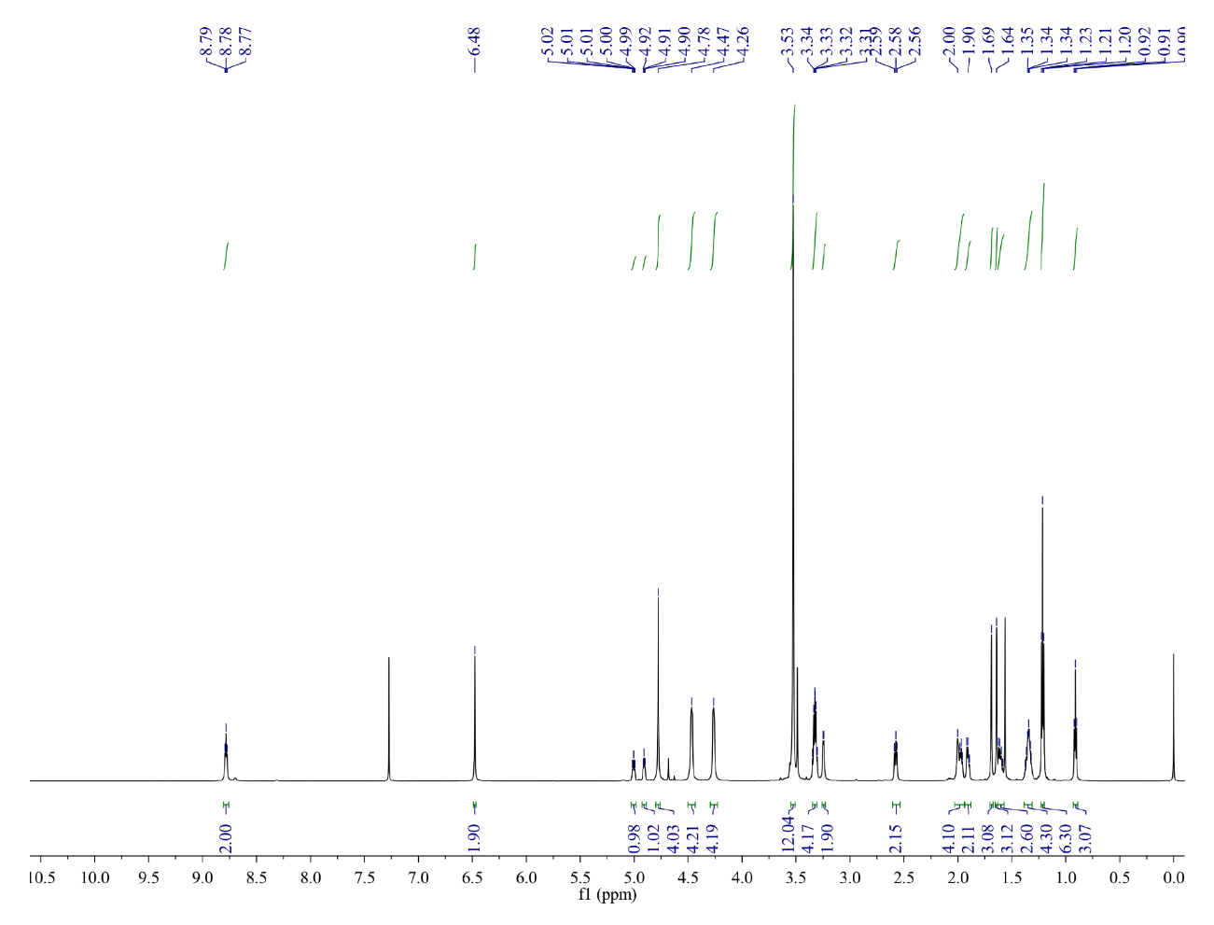
Fig S1. ¹H NMR spectrum of 5a
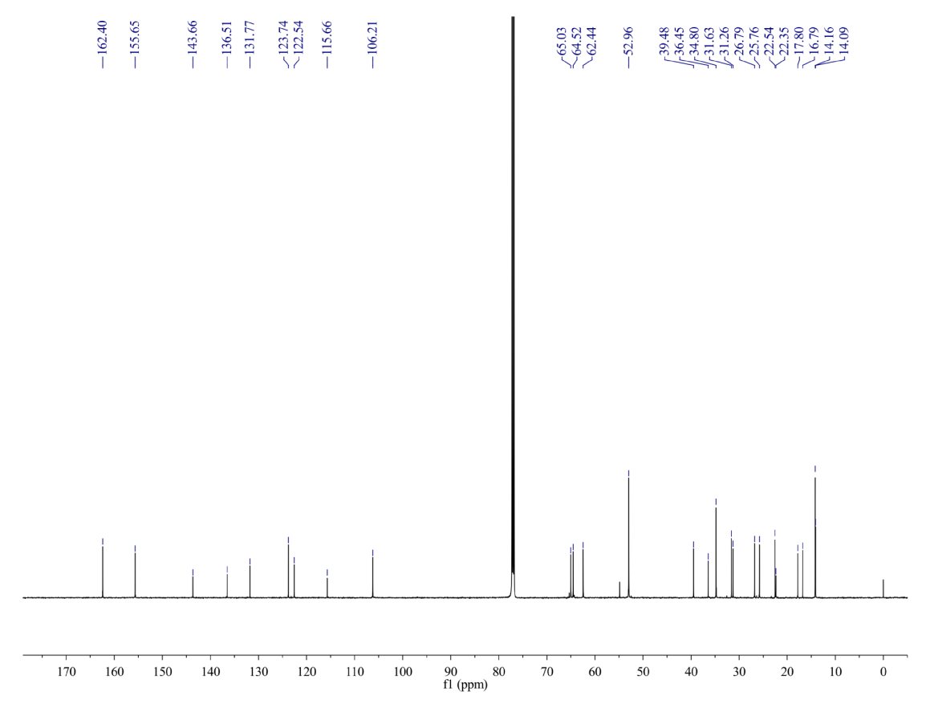
Fig S2. ¹³C NMR spectrum of 5a
Fig S3. HRMS spectrum of 5a
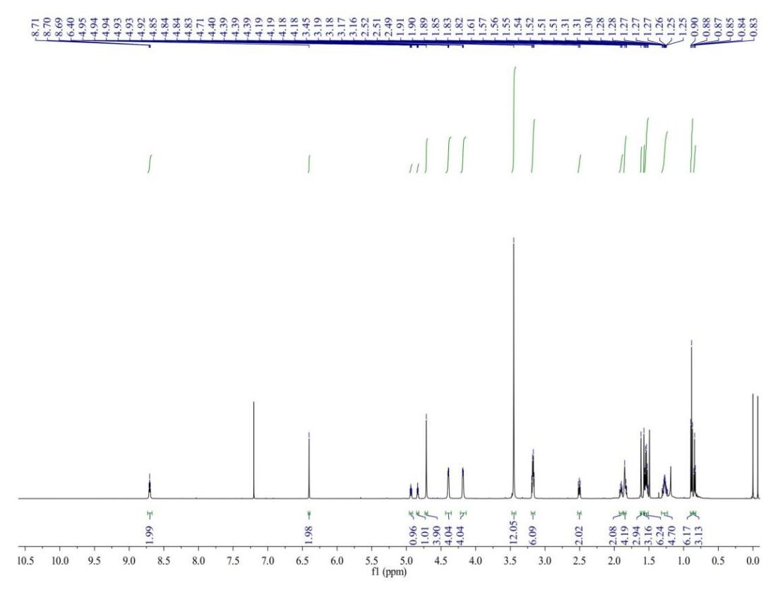
Fig S4. ¹H NMR spectrum of 5b

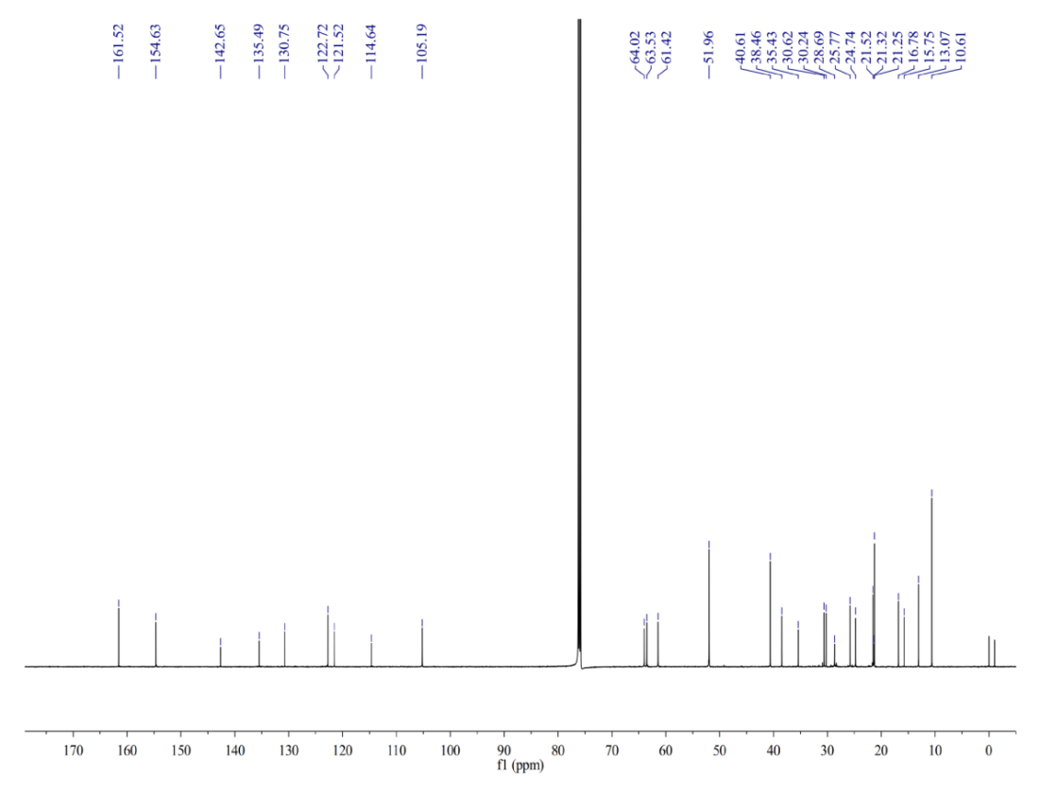
Fig S5. ¹³C NMR spectrum of 5b
Fig S6. HRMS spectrum of 5b

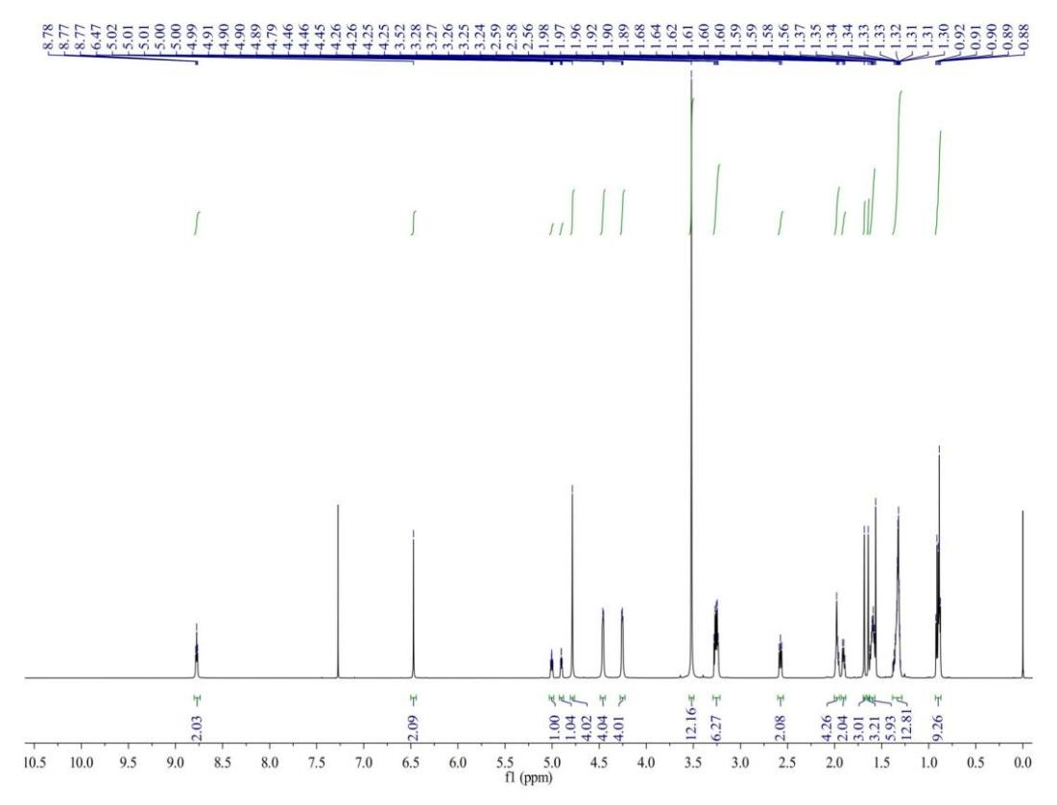
Fig S7. ¹H NMR spectrum of 5c
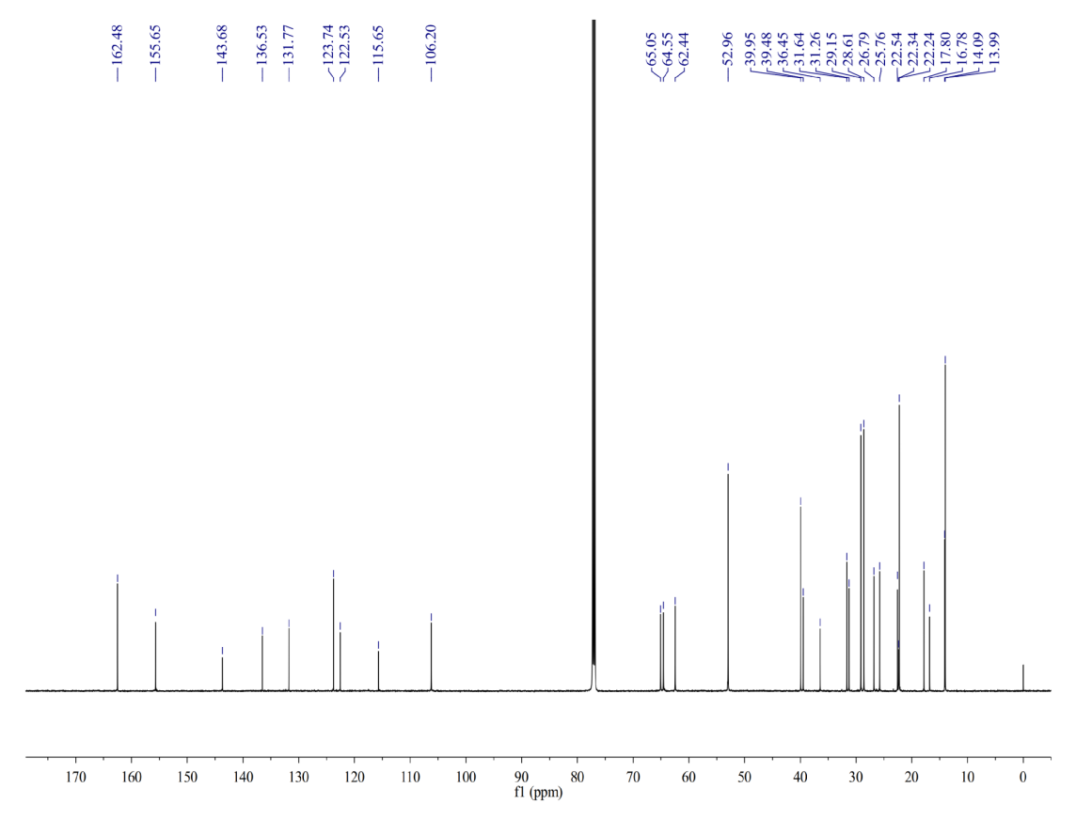
Fig S8. ¹³C NMR spectrum of 5c

Fig S9. HRMS spectrum of 5c
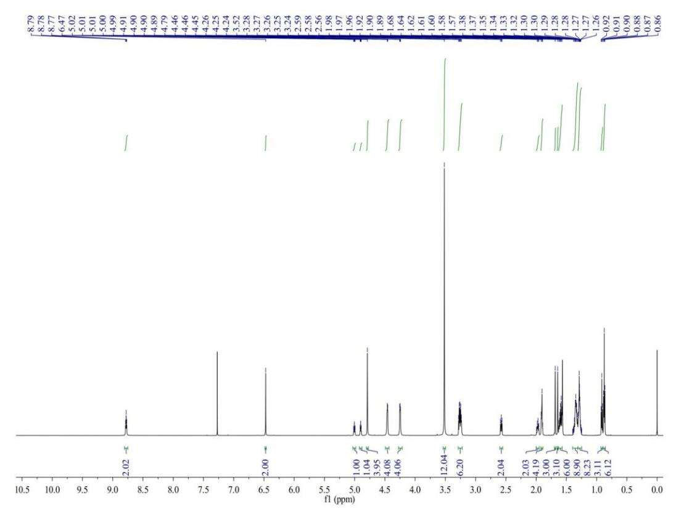
Fig S10. ¹H NMR spectrum of 5d

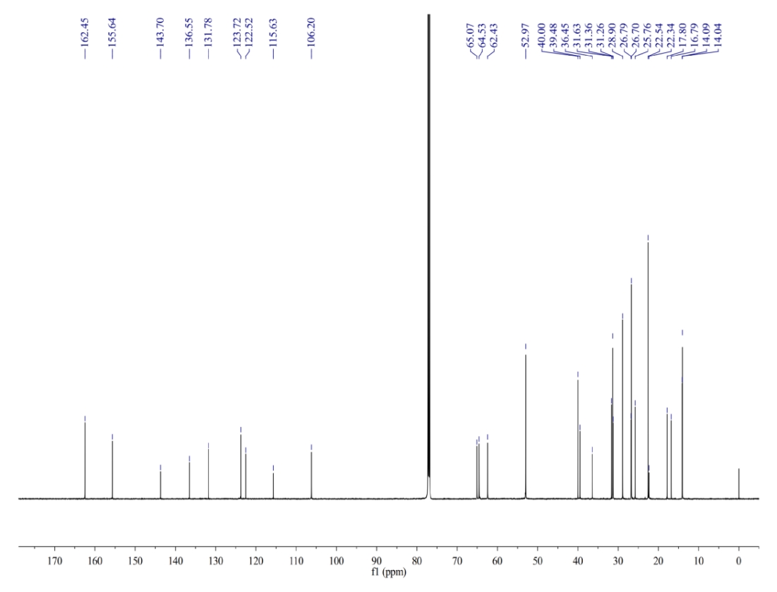
Fig S11. ¹³C NMR spectrum of 5d
Fig S12. HRMS spectrum of 5d

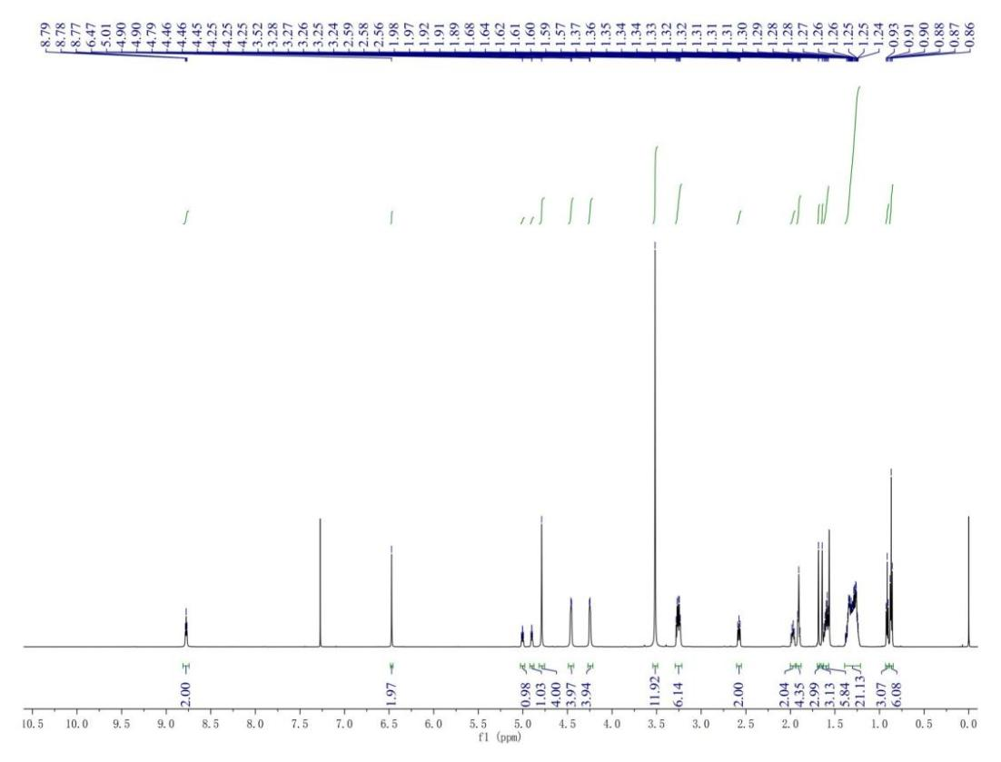
Fig S13. ¹H NMR spectrum of 5e
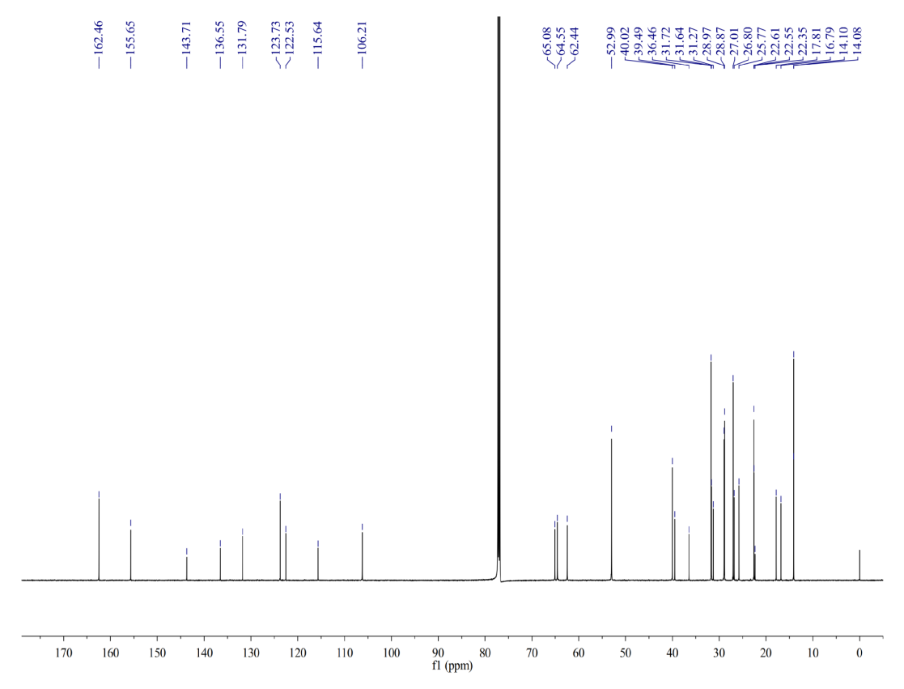
Fig S14. ¹³C NMR spectrum of 5e

Fig S15. HRMS spectrum of 5e
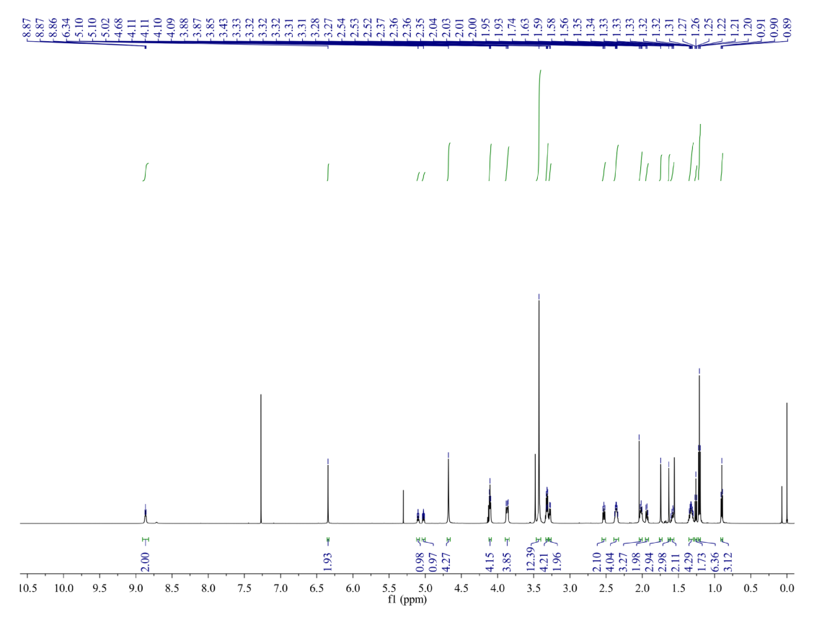
Fig S16. ¹H NMR spectrum of 5f

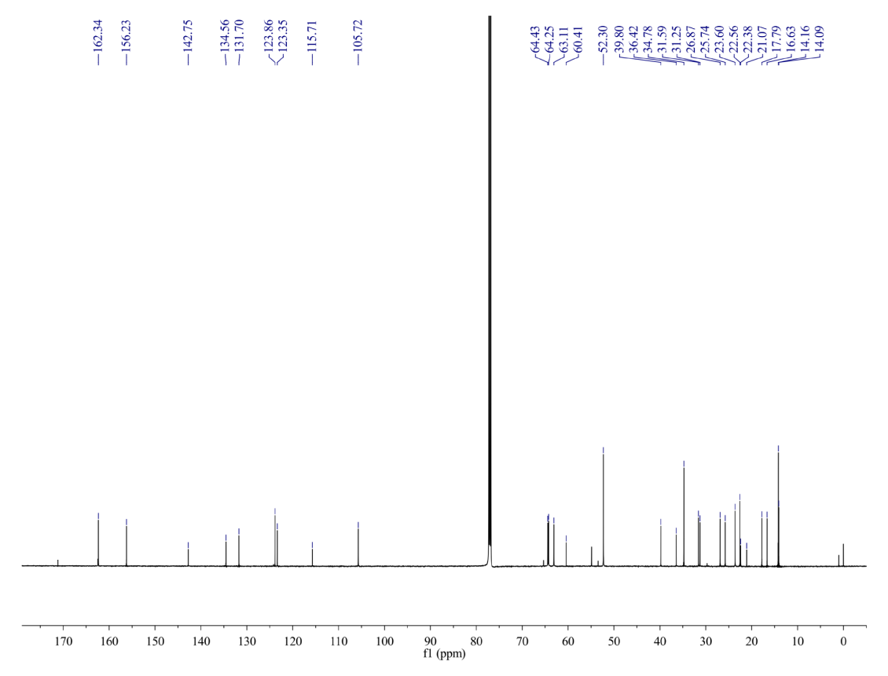
Fig S17. ¹³C NMR spectrum of 5f
Fig S18. HRMS spectrum of 5f

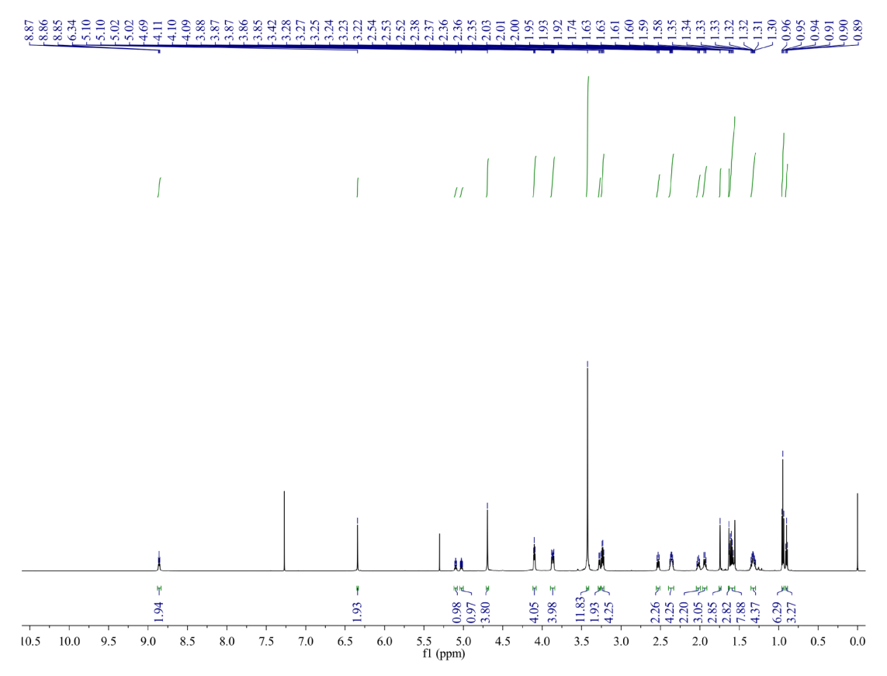
Fig S19. ¹H NMR spectrum of 5g
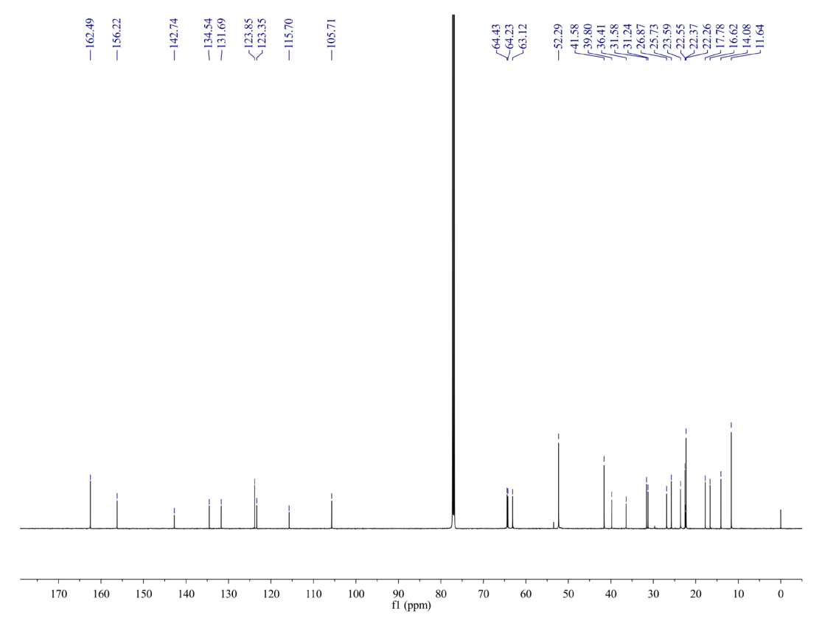
Fig S20. ¹³C NMR spectrum of 5g

Fig S21. HRMS spectrum of 5g
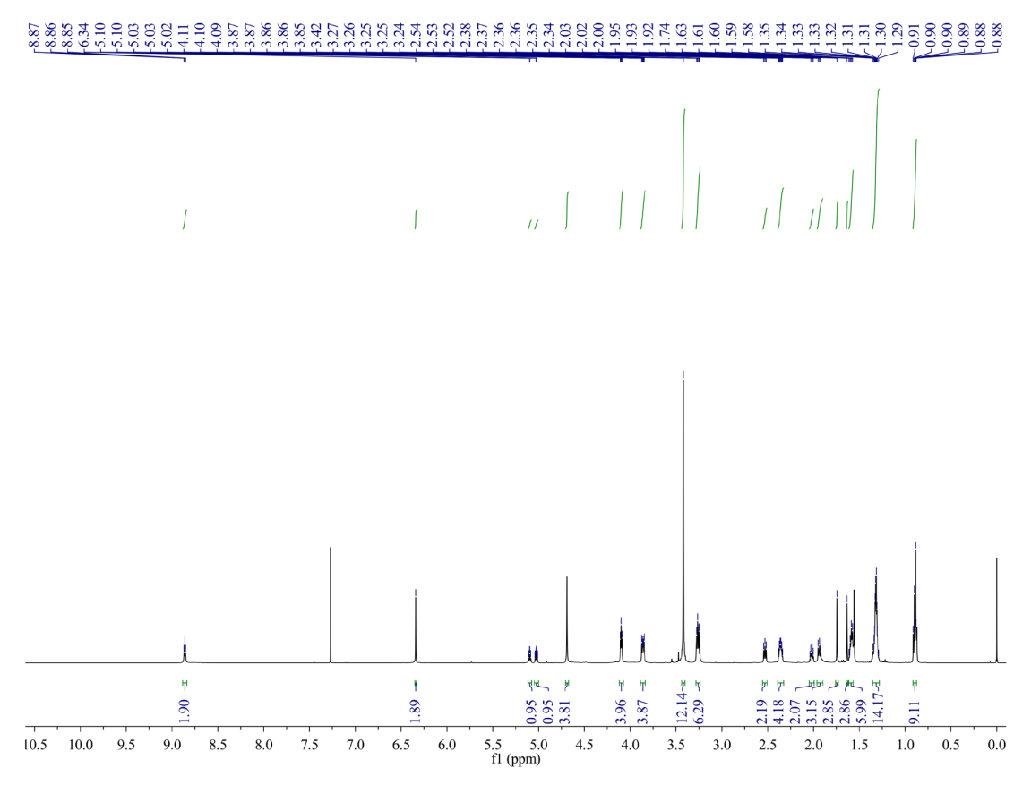
Fig S22. ¹H NMR spectrum of 5h

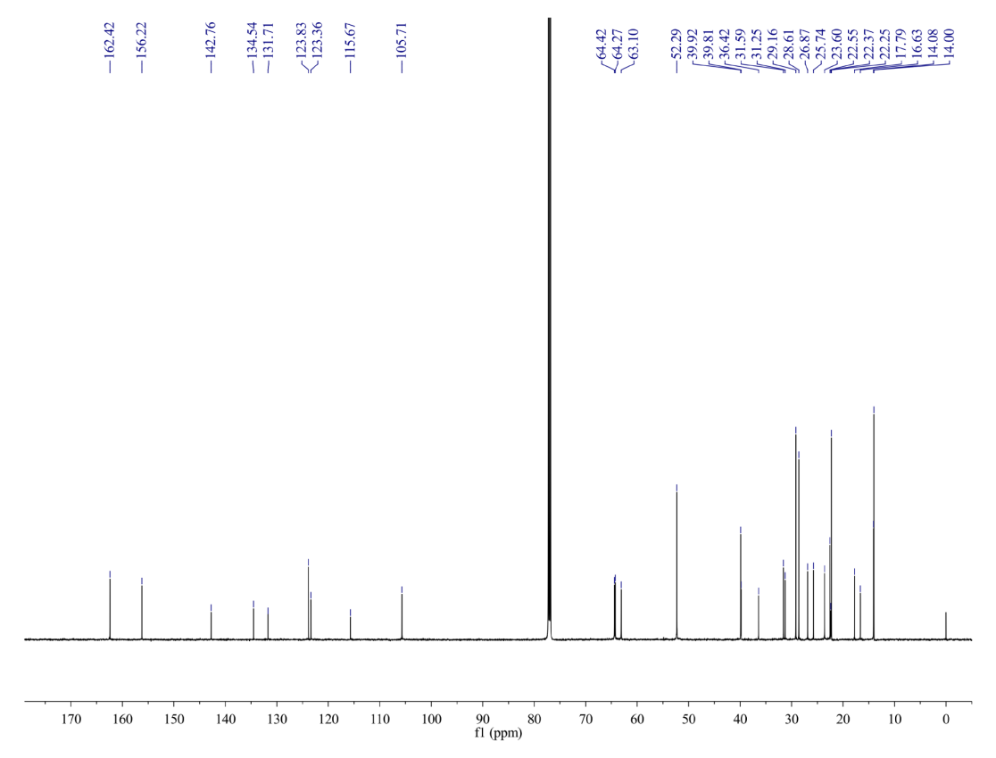
Fig S23. ¹³C NMR spectrum of 5h
Fig S24. HRMS spectrum of 5h

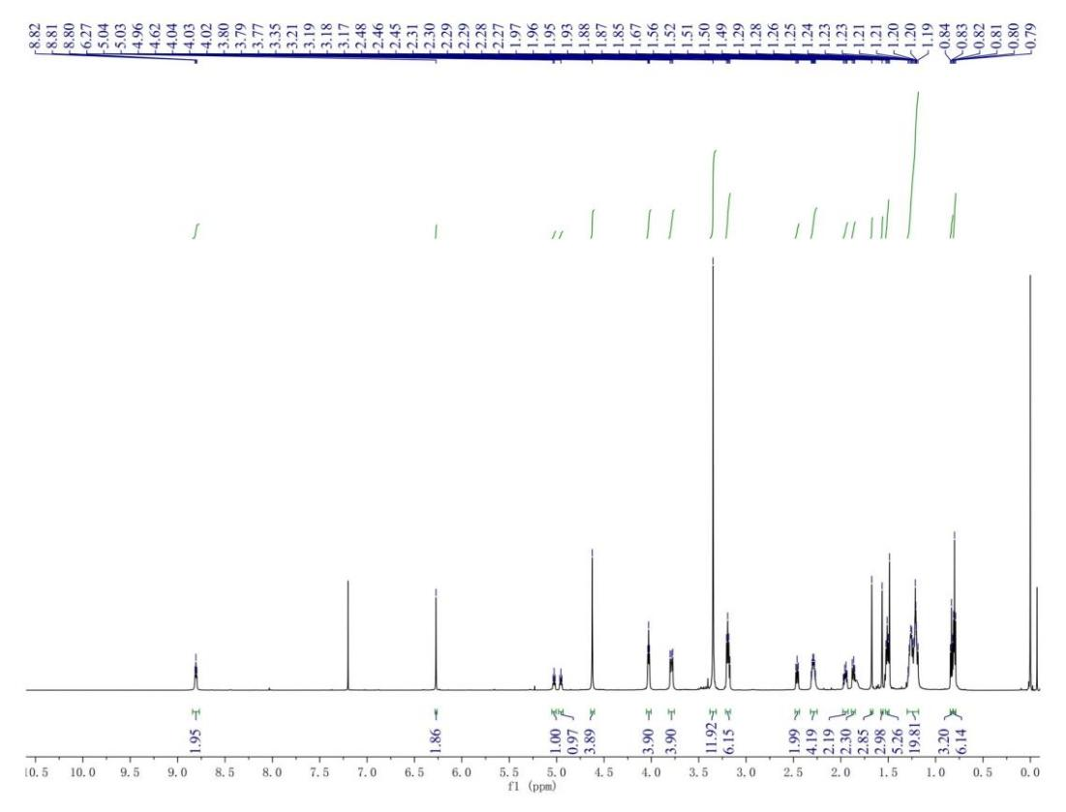
Fig S25. ¹H NMR spectrum of 5i
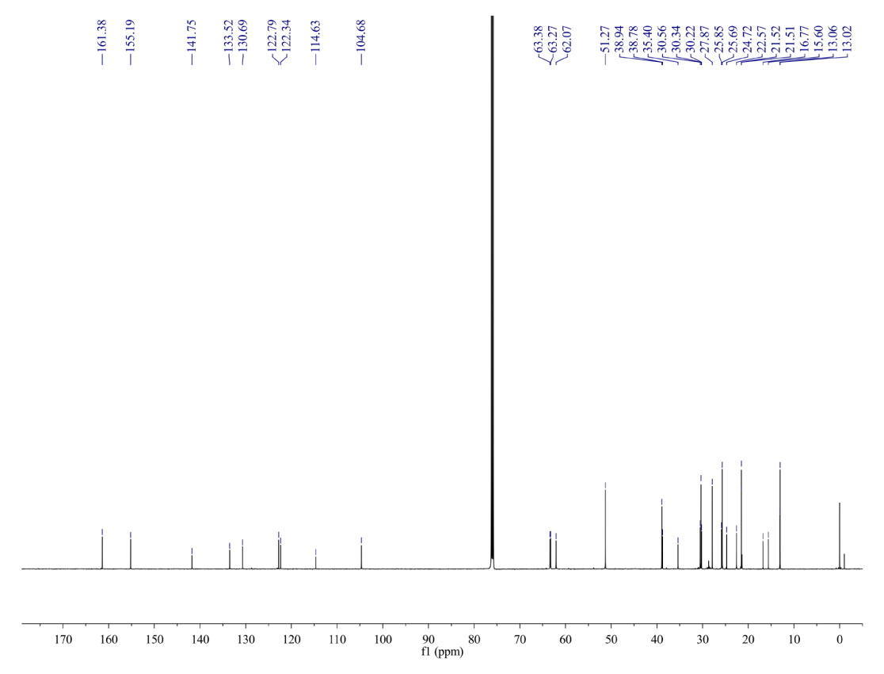
Fig S26. ¹³C NMR spectrum of 5i

Fig S27. HRMS spectrum of 5i
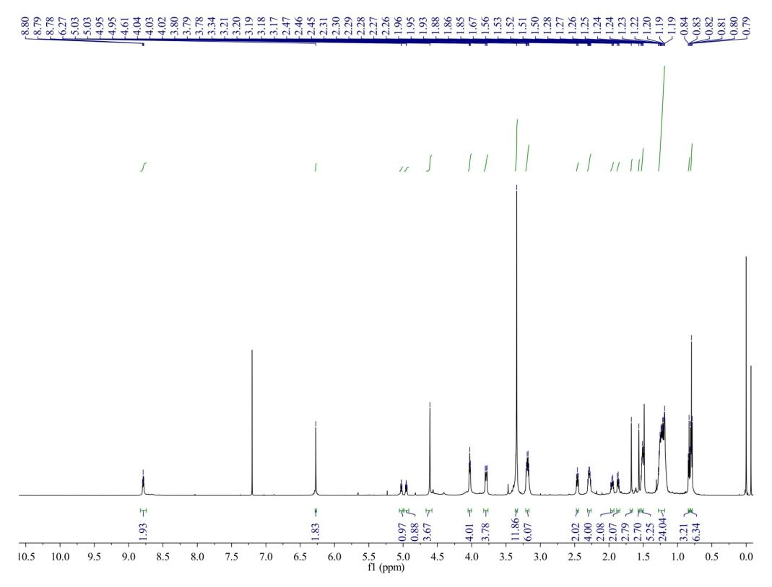
Fig S28. ¹H NMR spectrum of 5j

Fig S29. ¹³C NMR spectrum of 5j
Fig S30. HRMS spectrum of 5j

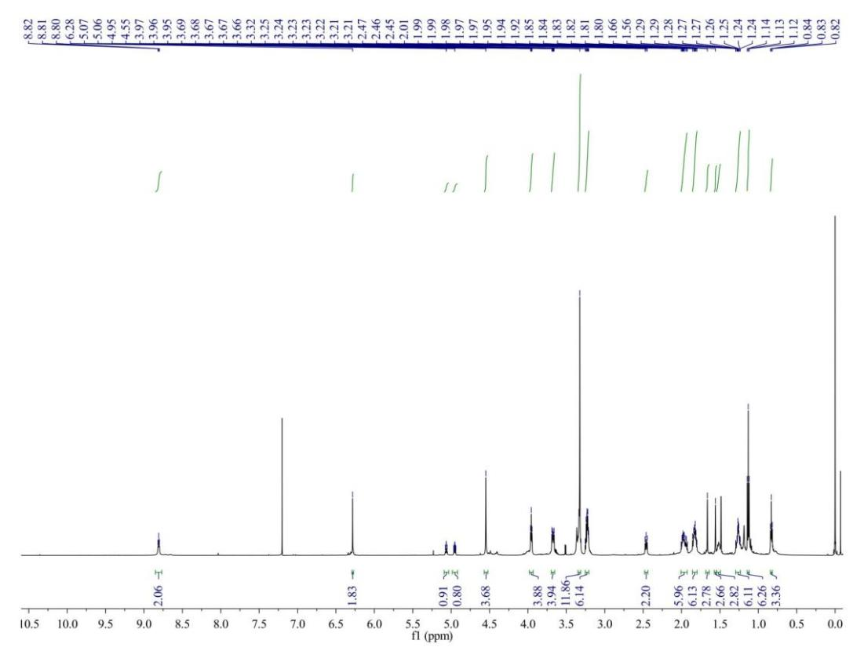
Fig S31. ¹H NMR spectrum of 5k
Fig S32. ¹³C NMR spectrum of 5k
Fig S33. HRMS spectrum of 5k
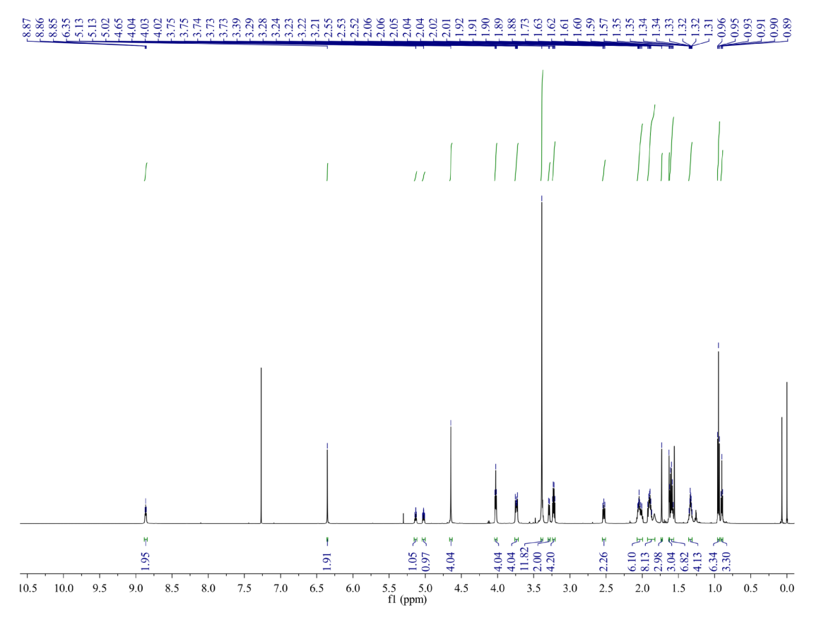
Fig S34. ¹H NMR spectrum of 5l
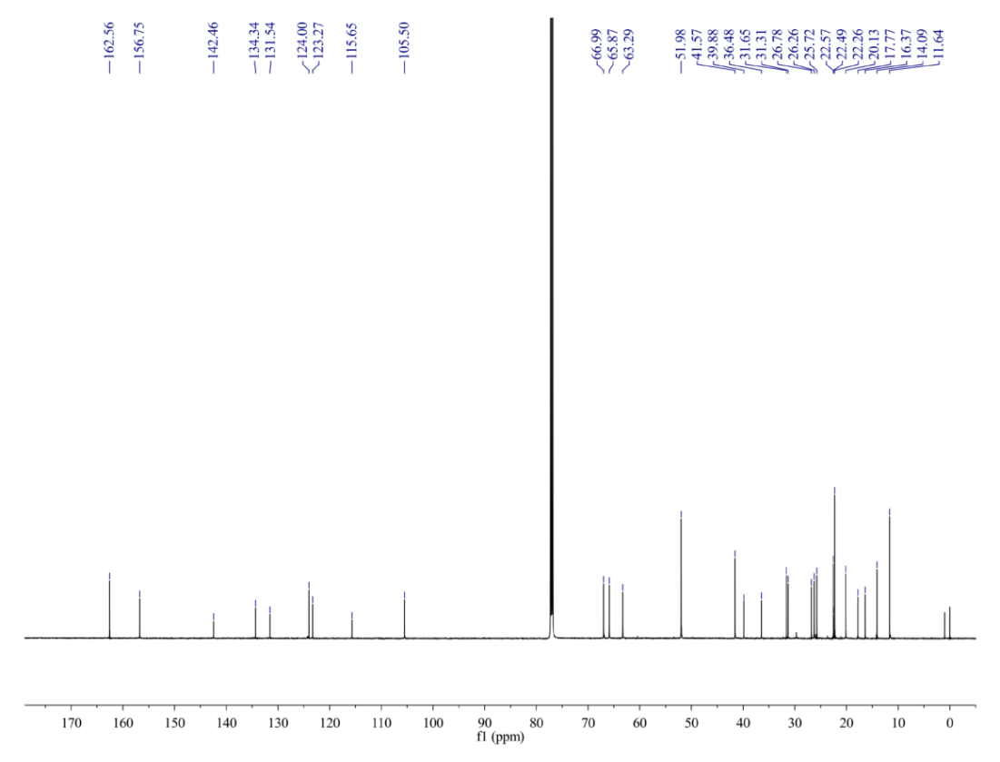
Fig S35. ¹³C NMR spectrum of 5l
Fig S36. HRMS spectrum of 5l

Fig S37. ¹H NMR spectrum of 5m
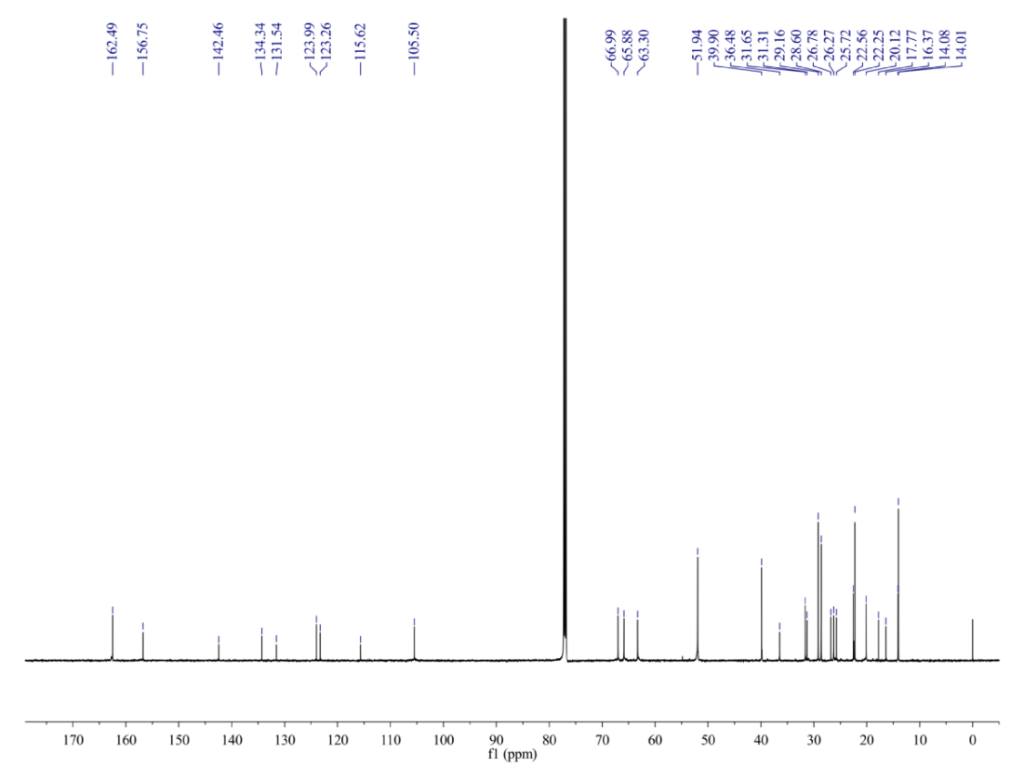
Fig S38. ¹³C NMR spectrum of 5m

Fig S39. HRMS spectrum of 5m
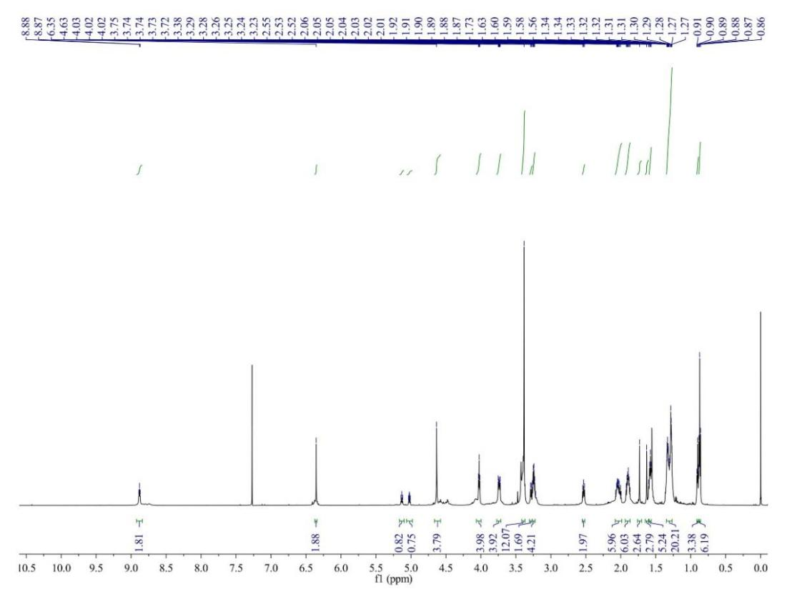
Fig S40. ¹H NMR spectrum of 5n

Fig S41. ¹³C NMR spectrum of 5n
Fig S42. HRMS spectrum of 5n

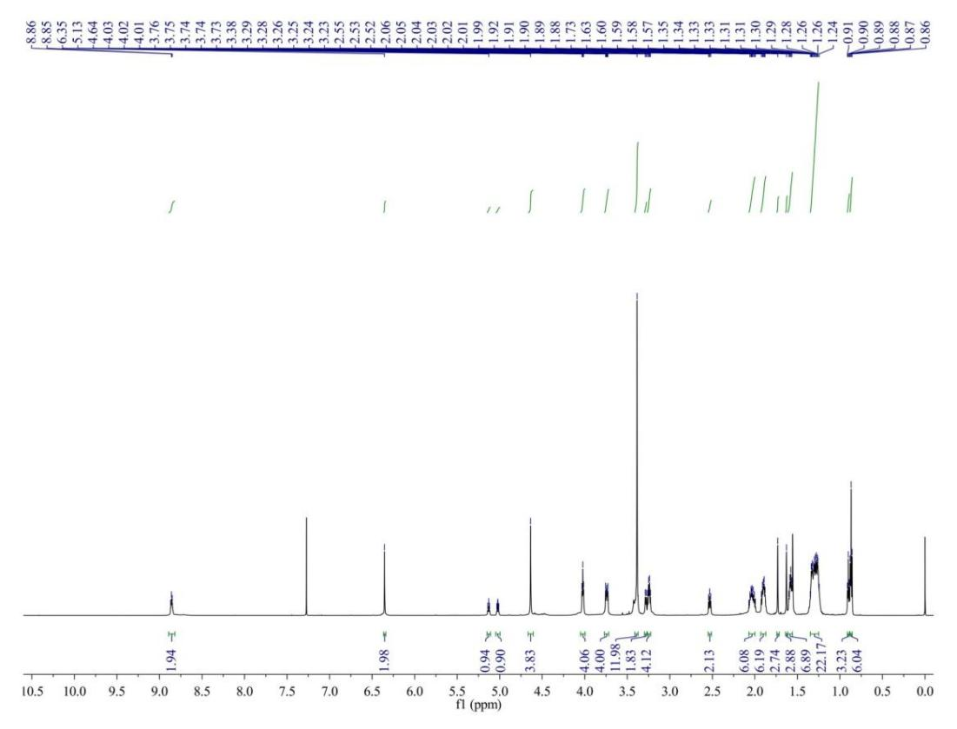
Fig S43. ¹H NMR spectrum of 5o
Fig S44. ¹³C NMR spectrum of 5o
Fig S45. HRMS spectrum of 5o
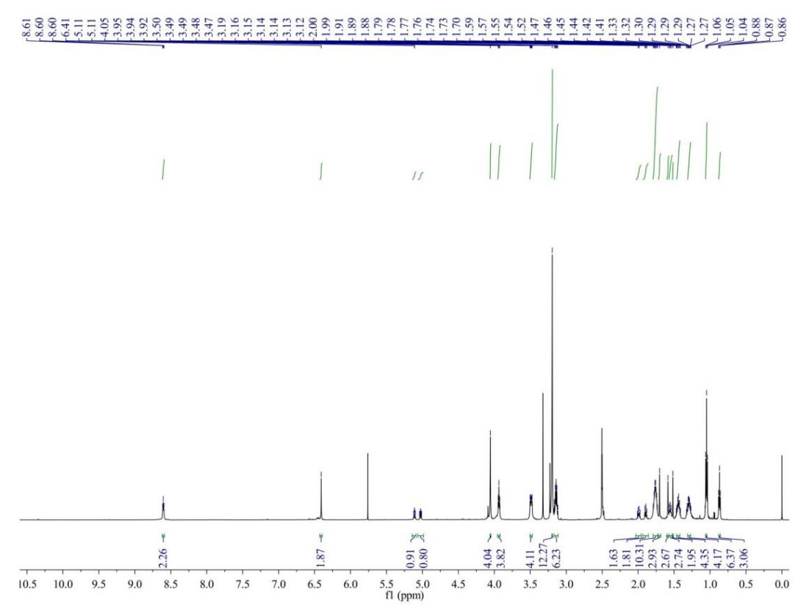
Fig S46. ¹H NMR spectrum of 5p
Fig S47. ¹³C NMR spectrum of 5p
Fig S48. HRMS spectrum of 5p

Fig S49. ¹H NMR spectrum of 5q
Fig S50. ¹³C NMR spectrum of 5q
Fig S51. HRMS spectrum of 5q
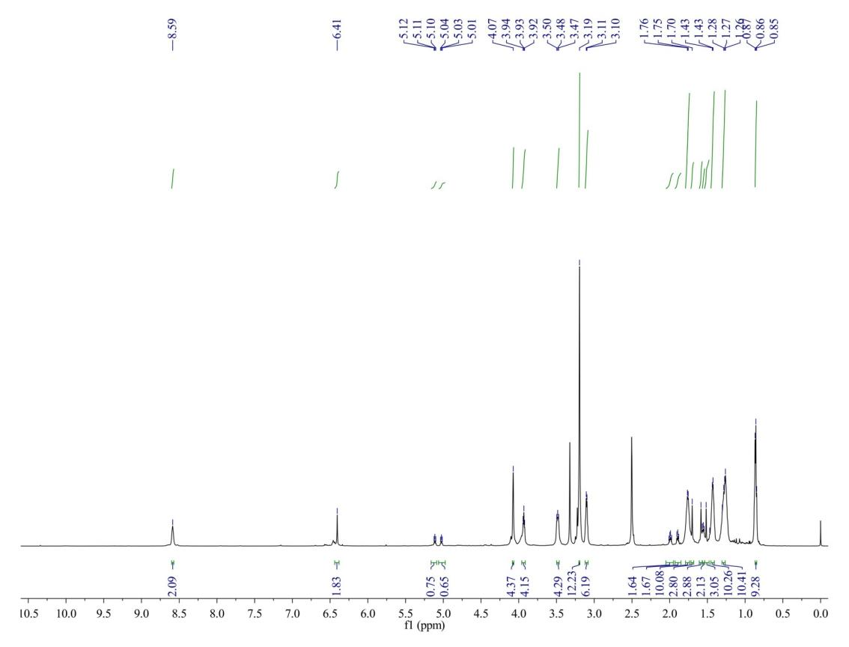
Fig S52. ¹H NMR spectrum of 5r
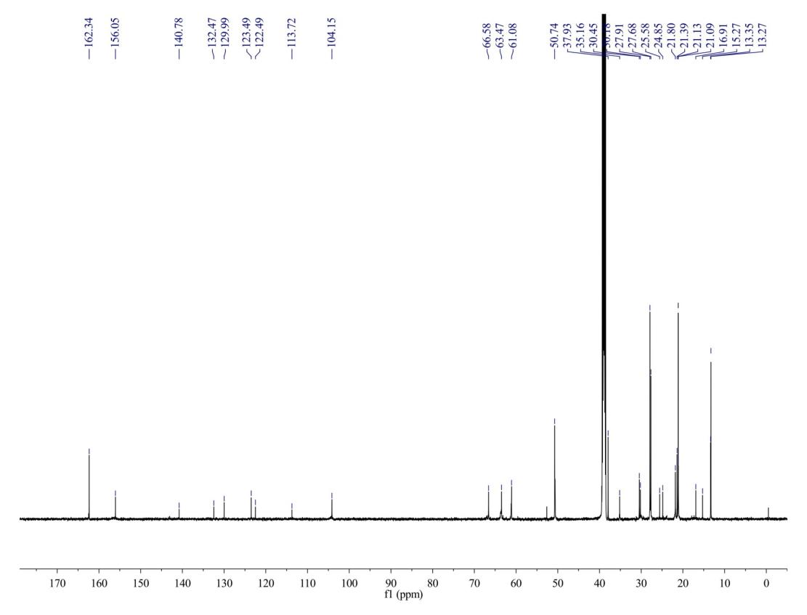
Fig S53. ¹³C NMR spectrum of 5r
Fig S54. HRMS spectrum of 5r

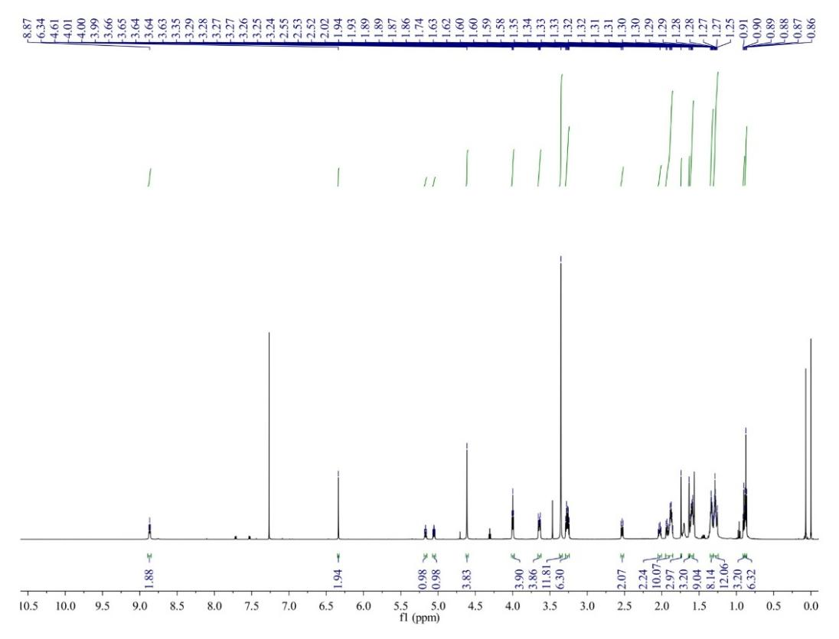
Fig S55. ¹H NMR spectrum of 5s
Fig S56. ¹³C NMR spectrum of 5s
Fig S57. HRMS spectrum of 5s
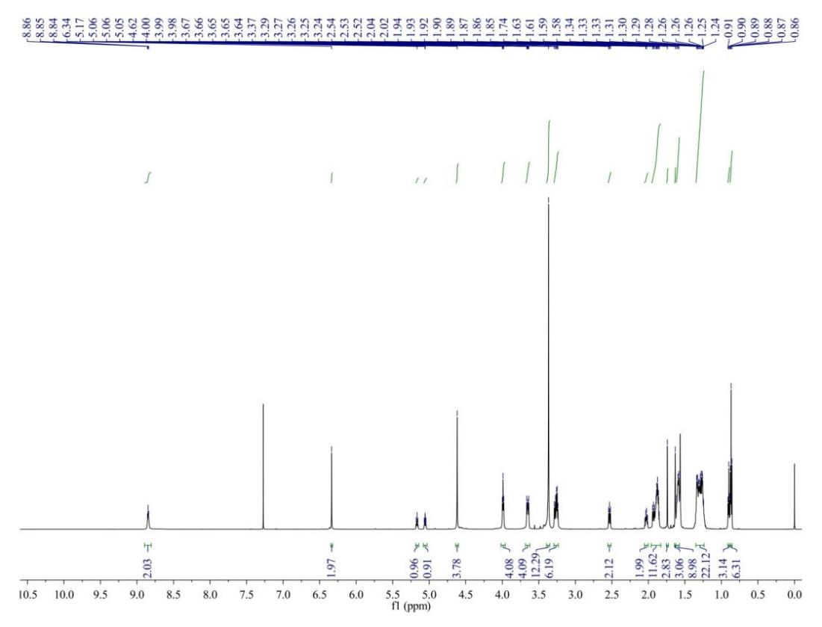
Fig S58. ¹H NMR spectrum of 5t
Fig S59. ¹³C NMR spectrum of 5t
Fig S60. HRMS spectrum of 5t

References
1. Ingolfsson HI, Melo MN, van Eerden FJ, et al. Lipid organization of the plasma membrane. J Am Chem Soc. 2014;136(41):14554-9. doi:10.1021/ja507832e
2. Pogozheva ID, Armstrong GA, Kong L, et al. Comparative molecular dynamics simulation studies of realistic eukaryotic, prokaryotic, and archaeal membranes. J Chem Inf Model. 2022;62(4):1036-1051. doi:10.1021/acs.jcim.1c01514
3. Wu EL, Engstrom O, Jo S, et al. Molecular dynamics and NMR spectroscopy studies of E. coli lipopolysaccharide structure and dynamics. Biophys J. 2013;105(6):1444-55. doi:10.1016/j.bpj.2013.08.002
4. Wu EL, Fleming PJ, Yeom MS, et al. E. coli outer membrane and interactions with OmpLA. Biophys J. 2014;106(11):2493-502. doi:10.1016/j.bpj.2014.04.024
5. Bernat P, Paraszkiewicz K, Siewiera P, Moryl M, Plaza G, Chojniak J. Lipid composition in a strain of Bacillus subtilis, a producer of iturin A lipopeptides that are active against uropathogenic bacteria. World J Microbiol Biotechnol. 2016;32(10):157. doi:10.1007/s11274-016-2126-0
6. Lim JB, Klauda JB. Lipid chain branching at the iso- and anteiso-positions in complex chlamydia membranes: A molecular dynamics study. Biochim Biophys Acta. 2011;1808(1):323-31. doi:10.1016/j.bbamem.2010.07.036

