Supplementary Information


Figure S1 Western blot was used to detect CD62 and CD42 in PM and PM@PLA-PEG/SIM samples.

Figure S2 Intuitive pictures of PM@PLA-PEG/SIM on 1 and 7 days.

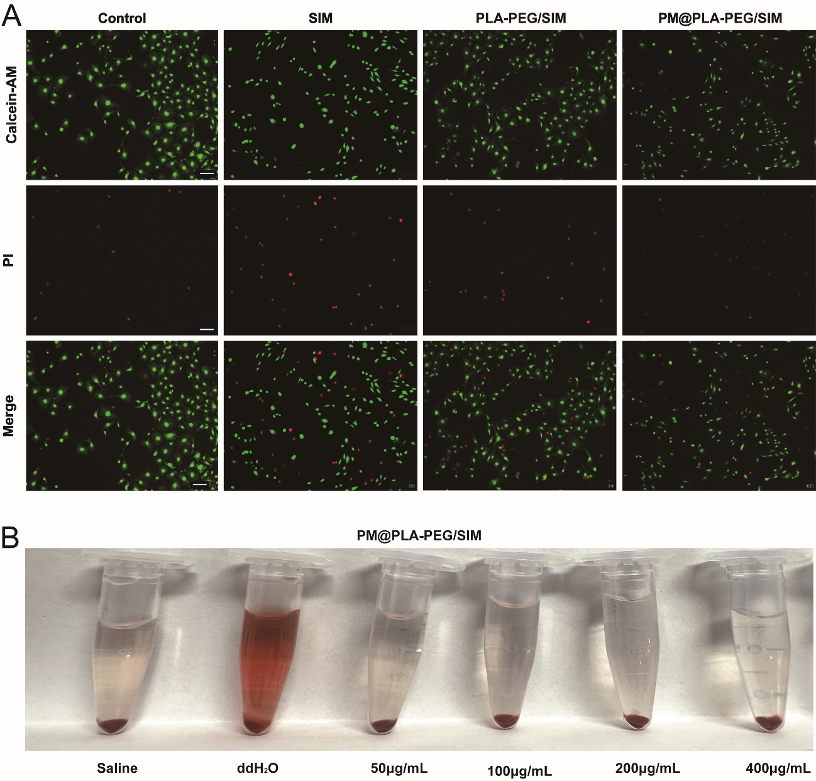
Figure S3 Biological compatibility of PM@PLA-PEG/SIM. (A) Calcein-AM/PI staining of HUVECs. SIM at 16 μg/mL. Scale bar, 100 μm. (B)Hemolysis visualisation of PM@PLA-PEG/SIM.
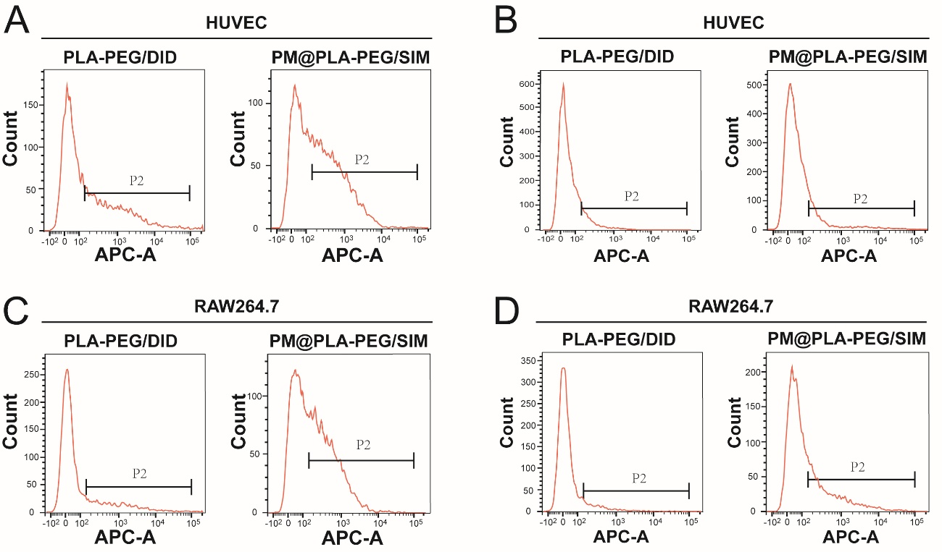
Figure S4 Uptake of PM@PLA-PEG/SIM by HUVECs and RAW264.7 cells. Uptake of PLA-PEG/DID and PM@PLA-PEG/DID by (A-B) HUVECs and (C-D) RAW264.7 cells without or with LPS activation, as determined by flow cytometry (P2, Positive cell).

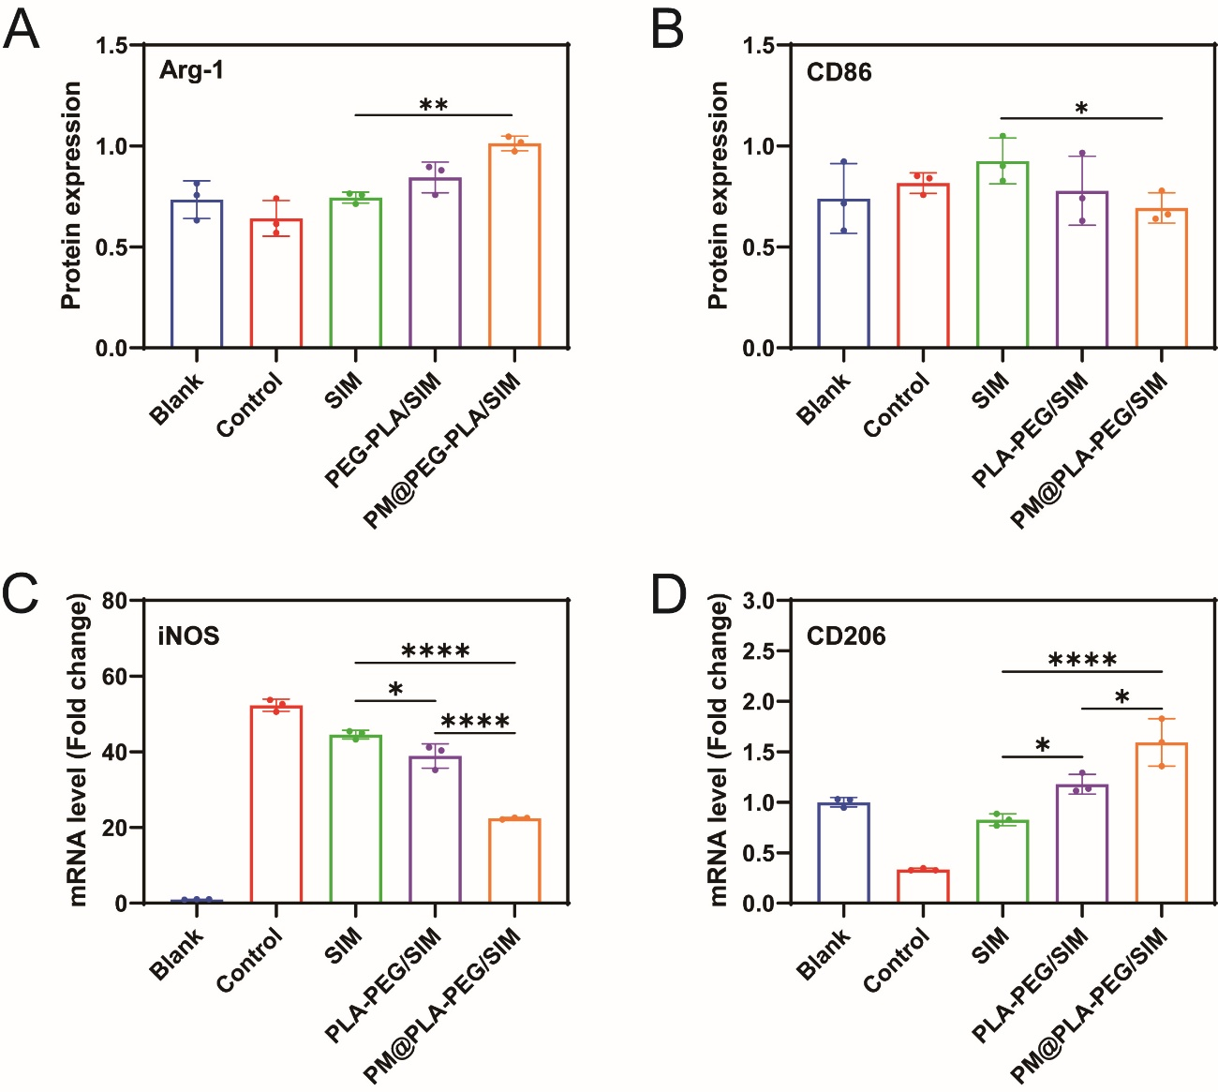
Figure S5 (A-B) Protein expression levels of CD86 and Arg-1. (C-D) Cells were treated with SIM, PLA-PEG/SIM, or PM@PLA-PEG/SIM following LPS stimulation. QRT-PCR analysis of inflammatory cytokine mRNA expression levels: iNOS and CD206. Data represent mean ± SD (n = 3, *P < 0.05, **P < 0.01, ****P < 0.0001).

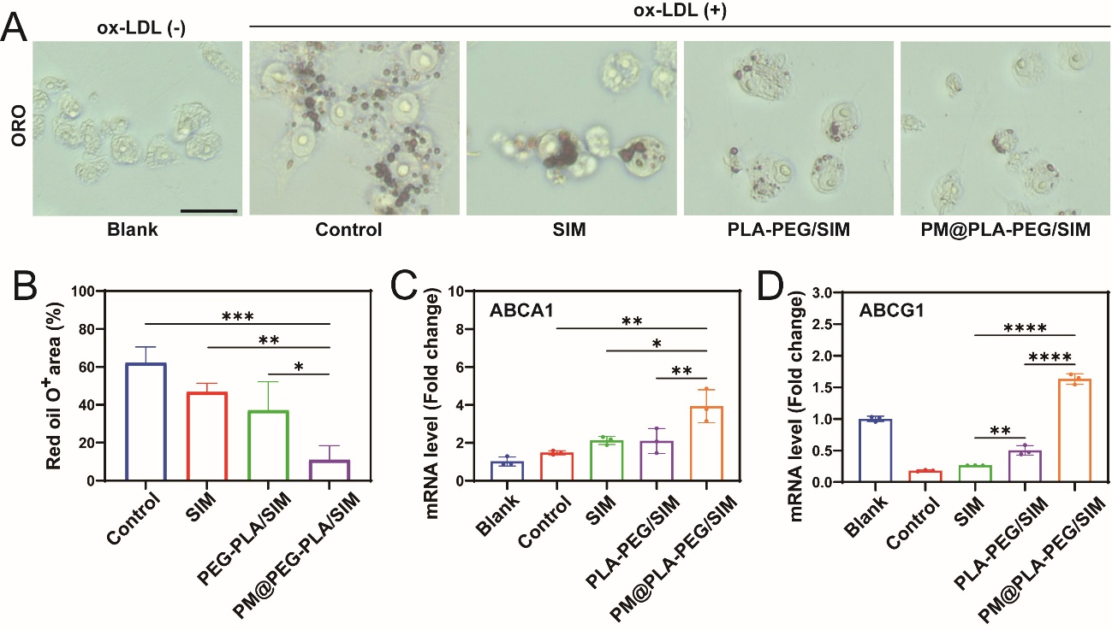
Figure S6 (A) Optical microscope images of representative ORO staining of ox-LDL-induced foam cells treated with different formulations. Scale bar, 50 μm. (B) Oil red o area quantification. (C-D) Cells were treated with SIM, PLA-PEG/SIM, or PM@PLA-PEG/SIM following OX-LDL stimulation. QRT-PCR analysis of cholesterol transport protein mRNA expression levels: ABCA1 and ABCG1. Data represent mean ± SD (n = 3, *P < 0.05, **P < 0.01, ***P < 0.001, ****P < 0.0001).
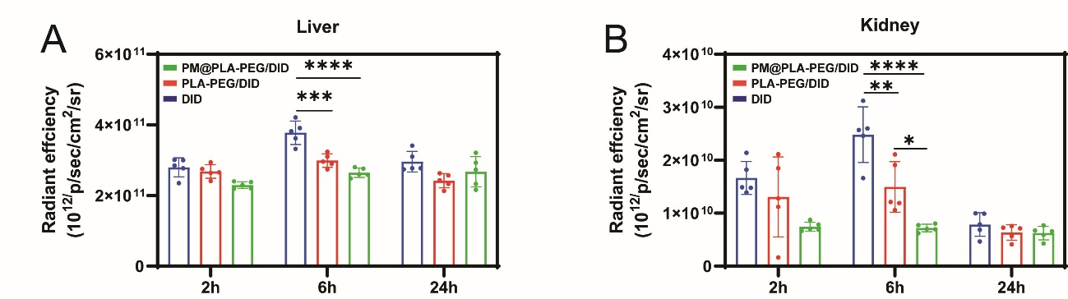

Figure S7 In vivo fluorescence statistics. (A-B) Quantitative liver and kidney Fluorescence intensity analysis in DID, PLA-PEG/DID, and PM@PLA-PEG/DID groups at different time points. Data were presented as mean ± SD (n = 5, *P < 0.05, **P < 0.01, ***P < 0.001, ****P < 0.0001).

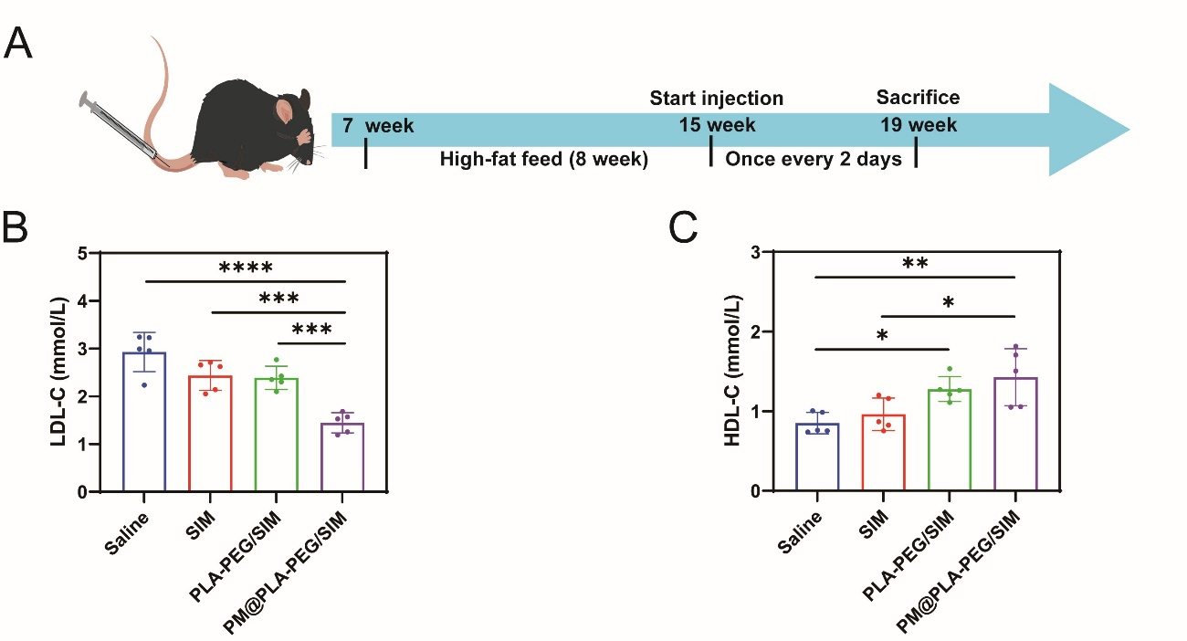

Figure S8 (A) Schematic diagram of mice fed and injected with the preparation in the tail vein. After different treatments, Serum (B)LDL-C and (C)HDL-C levels in ApoE^{-/-} mice. Data represent mean ± SD (n = 5, *P < 0.05, **P < 0.01, ***P < 0.001, ****P < 0.0001).

