Figure S1. Proportion of PSCI across different risk groups.
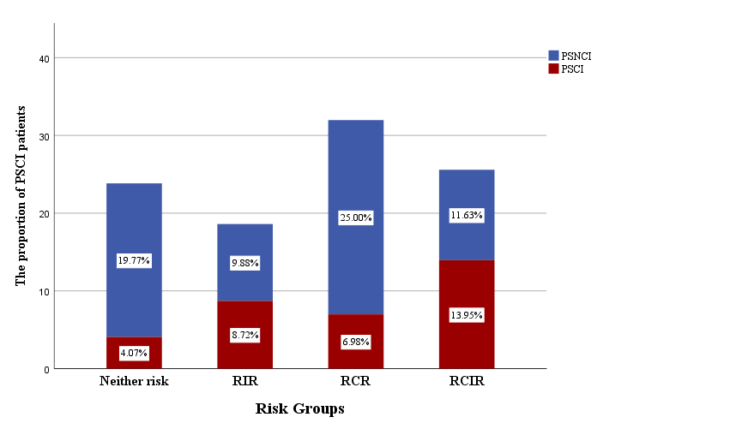
(PSCI, post-stroke cognitive impairment; PSNCI, post-stroke no cognitive impairment; RIR, residual inflammatory risk; RCR, residual cholesterol risk; RCIR, residual cholesterol and inflammatory risk.)

