Supplementary file

Supplementary table 1. CLEAR Derm checklist for image-based AI algorithm development in Dermatology.

Checklist | Description is Present/Absent
Data
1 Image types  2 Image artifacts (e.g., image quality, pen markings, anatomic site for photography)  3 Technical acquisition details  4 Preprocessing procedures  5 Synthetic images made public if used  6 Public images adequately referenced | 1. Relevant description of image type is provided in the section “Dataset and image preprocessing”.  2. Only images of the periorbital region were used in this study. No artifacts were included in the images.  3. Relevant description of image acquisition is provided in the section “Dataset and image preprocessing”.  4. Preprocessing included cropping the periorbital region, resizing to 128*128 pixels and normalized with a mean of 0.5 and a variance of 0.5.  5. synthetic images were not made public due to patient privacy concerns.  6. No public images were used in this study.
7 Patient-level metadata: geographic location of patients, sex and gender distribution, ethnicity and/or race, and how it was extracted  8 Skin tone information and procedure by which skin tone was assessed  9 Potential biases that may arise from use of patient information and metadata | 7. The age, gender, and ethnicity of patient are provided in the section “Dataset and image preprocessing”.  8. skin tone was not assessed in this study.  9. Potential biases include limited representation of male patients and patients from other ethnic backgrounds.
10 Dataset partitions  11 Sample sizes of training, validation, and test sets  12 External test set | 10. Details of dataset partitions for each dataset are provided in the “Model Training and Validation” section.  11. Details of sample sizes of training, validation, and test sets for each dataset are provided in the “Model Training and Validation” section.  12. No external test set was used in this study.
13 Multivendor images | 13. Multivendor images were not included in this study.
14 Class distribution and balance  15 Out of distribution images | 14. Details of class distribution and balance are provided in the “Model Training and Validation” and “Generated images” sections.  15. As the aim of this study was to develop and train a diffusion model specifically tailored to our dataset, no out of distribution images were included in this study.
Technique
16 Labeling method  17 References to common/accepted diagnostic labels  18 Histopathologic review for malignancies | 16. Details of the labeling method are provided in the “Dataset and image preprocessing” section.  17. Labeling in this study was conducted according to reference 17 & 18.  18. Not applicable.
19 Detailed description of algorithm development | 19. Detailed description of algorithm development are included in the “The Compositional zero-shot and few-shot Generation Model” and “Classification model” sections.
Technical Assessment
20 How to publicly evaluate algorithm | 20. The algorithm of this study are available from the corresponding author upon reasonable request.
21 Performance measures  22 Benchmarking, technical comparison, and novelty  23 Bias assessment | 21. The classification performance were measured in terms of classification accuracy, learning curve, and AUC.  22. The performance of the CNN trained on synthetic images using the compositional zero-shot and few-shot generation model was benchmarked against the CNNs trained on the original dataset and dataset containing images using traditional augmentation techniques.  23. Not applicable
Application
24 Use cases and target conditions (inside distribution)  25 Potential impacts on the healthcare team and patients | 24. In this study, we developed a diffusion model specifically tailored to our dataset to generate images with modifiable features and improved the outcomes of the classification neural network for grading lateral canthal lines. This newly developed algorithm (the compositional zero-shot and few-shot generation model) can be applied to dermatologic images other than lateral canthal lines and allow researcher to create synthetic images according to their needs.  25. This newly developed algorithm allows researchers to create a larger, more balanced dataset and improve neural network training outcomes.

Supplementary table 2. Hyperparameters of the generation model (compositional conditioning process).
self-attention head | learning_rate scheduler | train  epoch | embedding size | learning rate | weight_decay
4 | GradualWarmupScheduler | 1000 | 128 | 4e-5 | 1e-4

Supplementary table 3. Training parameters of the classification model.
optimizer type | learning rate | batch size | dropout | weight_decay | train_epoch
Adam | 1e-3 | 2048 | 0.5 | 1e-5 | 150

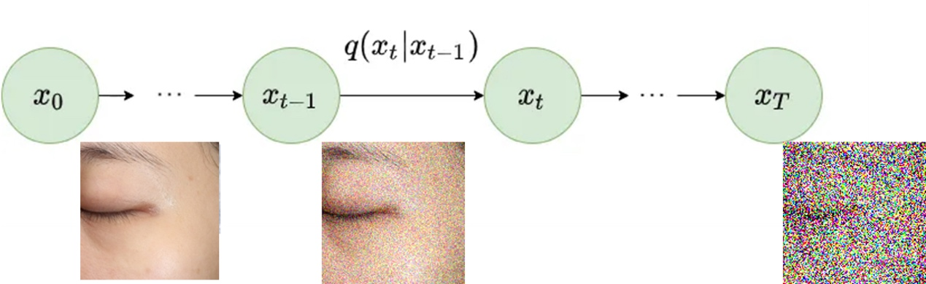
Supplementary figure 1. The forward diffusion process.
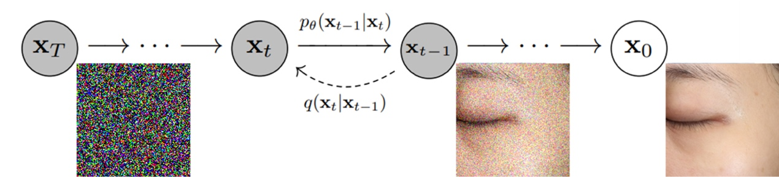
Supplementary figure 2. The inverse diffusion process.

The concept of compositional zero-shot and few-shot image generation is illustrated in the following figure (supplementary figure 3).
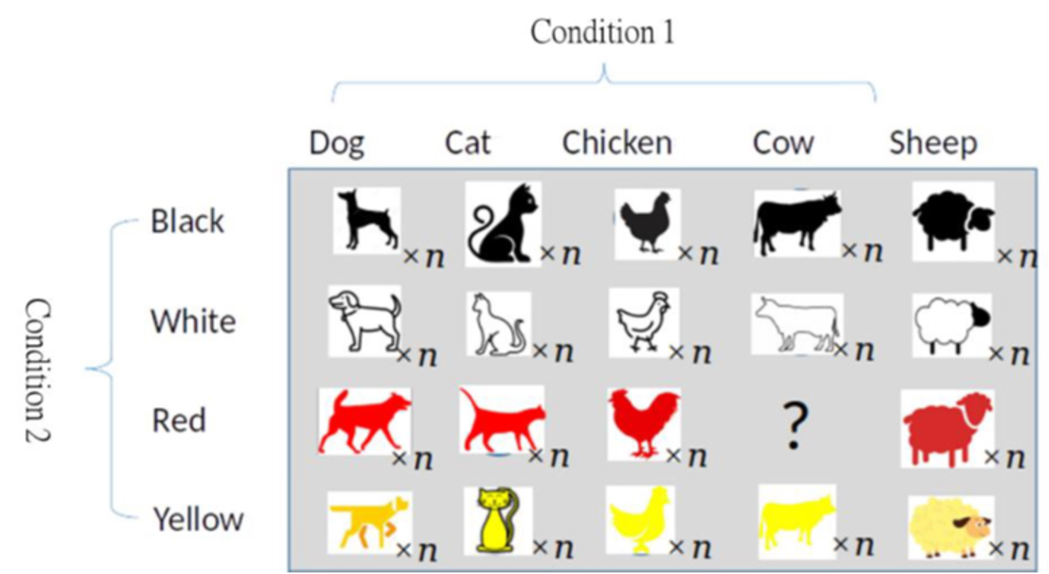
Supplementary figure 3. Conceptual diagram of compositional zero-shot and few-shot Image Generation for generating a new compositional concept - 'Red Cow' image.

Compositional zero-shot and few-shot image generation, from the perspective of knowledge generalization, involves “learning from a small number of old compositional concepts and using the learned concepts to reinforce the original small set of compositional concepts.” In the training dataset of the model, there are no images of 'Red Cow.' However, through compositional zero-shot and few-shot image generation techniques, it is possible to generate 'Red Cow' images based on the conditions 'Red' and 'Cow.' Additionally, other compositional conditions can be utilized, including an image containing the label 'Cow' and the condition 'Red,' to generate 'Red Cow' images. Applying this concept in our research is analogous to analyzing crow's feet wrinkle grades. In this context, condition 1 represents the wrinkle grade of the subject, and condition 2 represents the periorbital region containing complete lateral canthal lines, as shown in Figure 3.

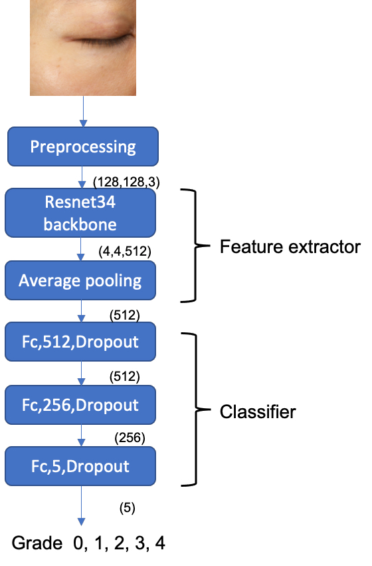
Supplementary figure 4. Architecture of the classification model.

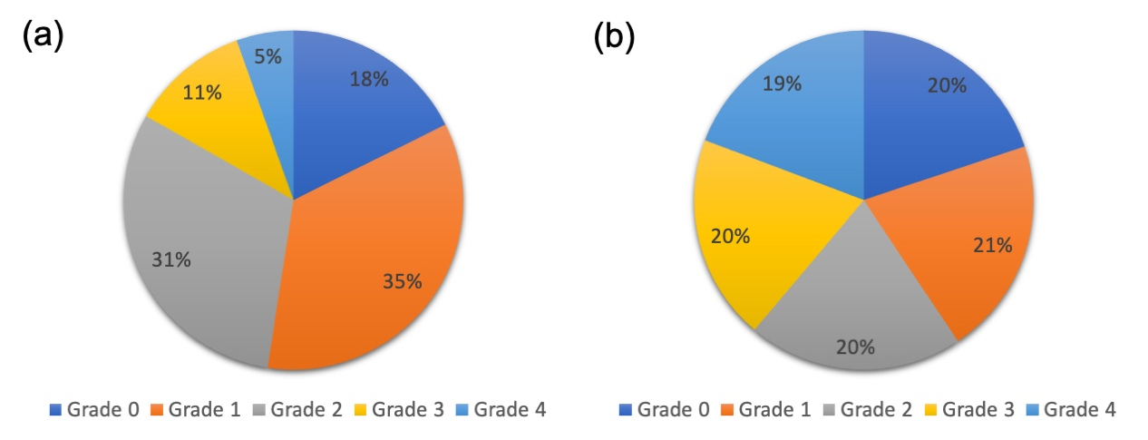
Supplementary figure 5. The original dataset consists of a higher proportion of grade 1 and grade 2 photographs and a much lower proportion of grade 4 photographs (a). The new dataset containing generated images is a more balanced dataset with lateral canthal line severity evenly distributed among the five grades (b).

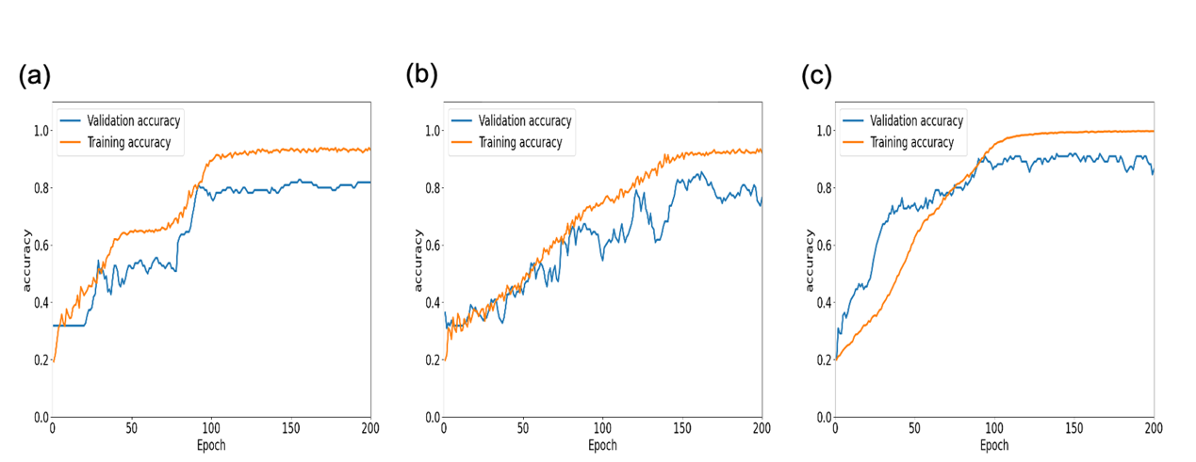
Supplementary figure 6. Learning curves of the original dataset (a), original dataset with traditional data augmentation (b), and dataset containing images from our generative model (c).

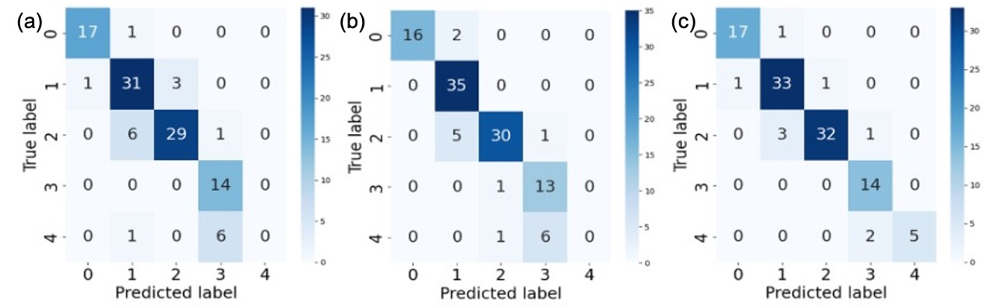
Supplementary figure 7. Confusion matrices for the original dataset (a), dataset with traditional data augmentation (b), and dataset augmented with traditional methods and generated images (c). True label indicates the severity of lateral canthal lines graded by human experts and predicted label indicates grading by the classification model.

