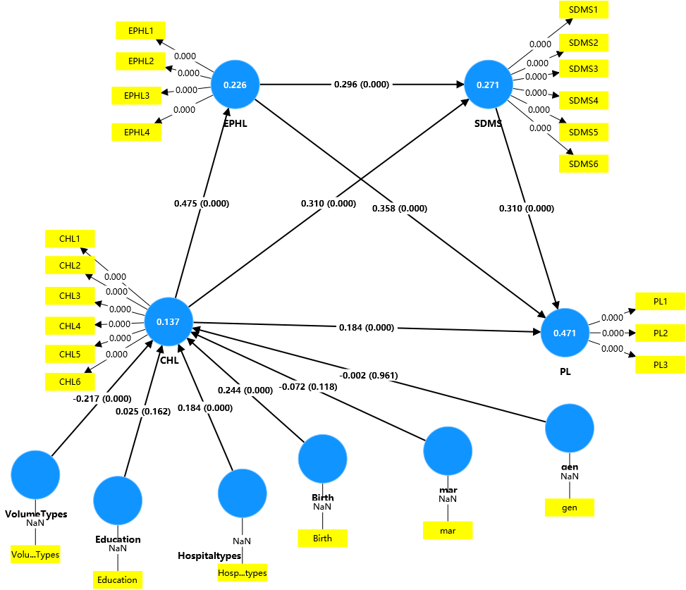
Appendix 1: Structural equation model results after controlling for demographic characteristics
Abbreviations: CHL: Communicative Health Literacy; EPHL: Enhancement of Perceived Health Literacy; DMIS: Decision-making Involvement Satisfaction; PL: Patient Loyalty; Gen: Gender; Mar: Marital status.

