Supplementary Table 1. Primer sequences for RT-qPCR.
Gene | Forward | Reverse
β-actin | CATGTACGTTGCTATCCAGGC | CTCCTTAATGTCACGCACGAT
PLK1 | ATTCCCAAGCACATCAACCC | GGAGACGGGCAGGGATATAG
CDC25C | TGTCAACCCAGAAACAGTGG | CTGGATGTGTCCTCCCAGAT
CCNB1 | AATAAGGCGAAGATCAACATGGC | TTTGTTACCAATGTCCCCAAGAG
CDK1 | AAACTACAGGTCAAGTGGTAGCC | TCCTGCATAAGCACATCCTGA

 | Healthy(n=17) | Sepsis(n=17)
Gender (male, %) | 8(47%) | 13(76%)
Ages (years) | 59.8±15.8 | 62.4±13.1
BMI (kg/m²) | 23.7±4.6 | 23.1±3.8
Neutrophils (10⁹/L) | 3.9±2.0 | 9.6±6.5**
Monocytes (10⁹/L) | 0.5±0.2 | 0.6±0.4**
Lymphocytes (10⁹/L) | 1.8±0.7 | 0.9±0.6
Platelets (10⁹/L) | 204.9±54.9 | 165.8±167.2
Hemoglobin (g/L) | 120.7±30.5 | 76.4±18.2**
CRP (mg/L) | 38.1±60.0 | 119.3±97.2**
Albumin(g/L) | 42.2±4.0 | 28.3±7.5**
PT(s) | 11.7±0.5 | 15.5±2.9**
APTT(s) | 26.8±1.9 | 37.4±11.1**
D-dimer(mg/L) | 1.3±1.9 | 7.3±5.1**
Fibrinogen(mg/dL) | 287.2±102.0 | 402.5±187.2*
IL-6(pg/ml),median(IQR) | 2.0(1.1-5.5) | 243.4(113-395)**
TB(umol/L) | 9.1±3.7 | 47.1±53.3*
MAP(mmHg) | 95.4±8.9 | 86.2±16.1*
Cr(umol/L) | 77.59±17.0 | 143.88±89.8**
Supplementary Table 2. Baseline of characteristics of healthy volunteers and sepsis patients enrolled in the group.
BMI：body mass index; CRP:C reactive protein; IQR:interquartile range; TB:total bilirubin; MAP:mean arterial pressure; Cr:creatinine
Data are expressed by percentage or mean±standard deviation [SD],median (interquartile range[IQR]), *P＜0.05 versus Healthy, **P＜0.01 versus Healthy.

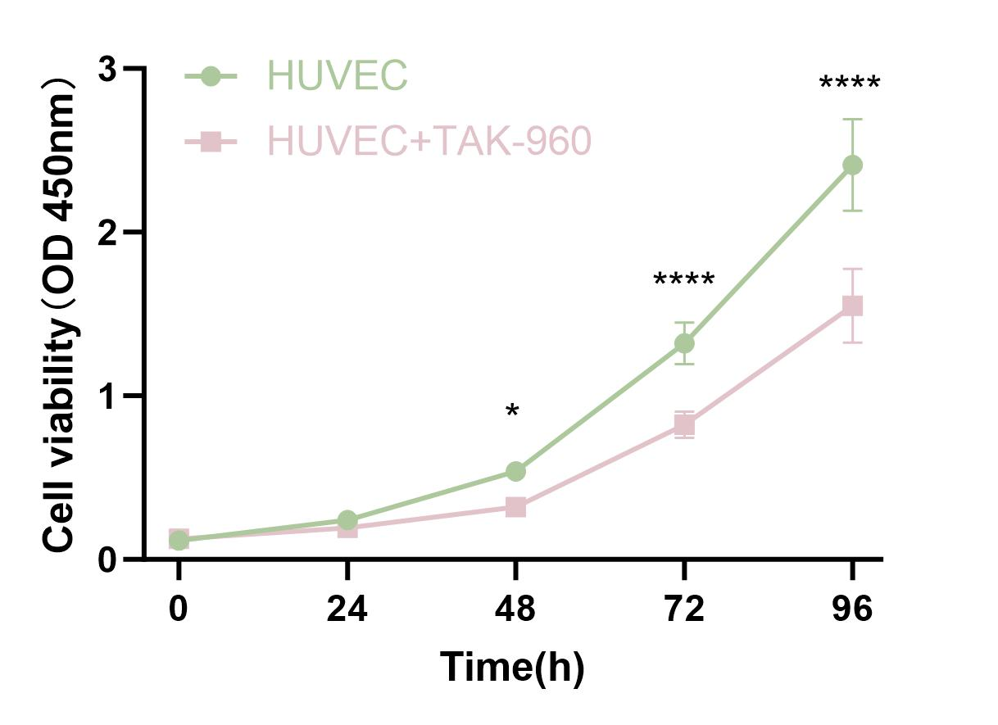
A

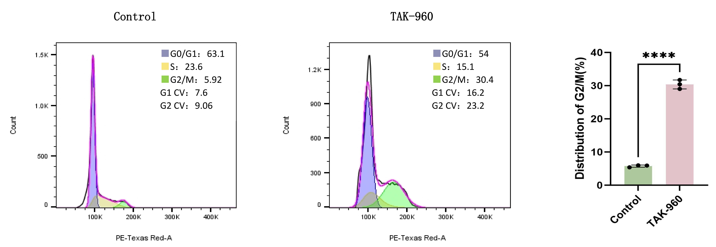
Supplementary Figure 1. The PLK1 inhibitor TAK-960(8nM) inhibits HUVEC activity and induces G2/M phase arrest. (A) CCK-8 cell viability assay of HUVECs (n=6). (B) Flow cytometric analysis of the cell cycle of HUVECs(n = 3).
B

