Supplemental materials
Phase II trial of an orelabrutinib-based combination therapy in newly diagnosed primary central nervous system lymphoma
Authors: Yajing Zhao, Xinguang Liu, Qiang He, Yafei Yu, Lei Xu, Caifeng Sun, Guoqiang Liu, Liang Wang, Ji Ma

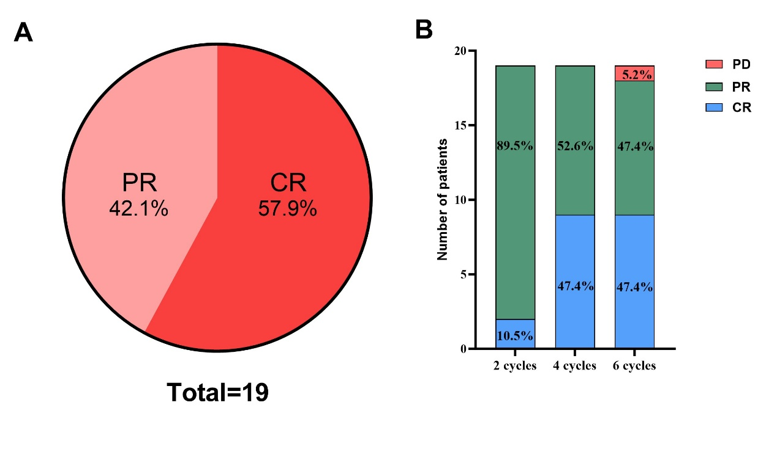
Figure S1. Outcomes after induction therapy in the evaluable population
(A) The best outcomes during the induction therapy. (B) Outcomes after 2, 4, and 6 cycles of induction therapy. PR, partial remission; CR, complete remission; PD, progressive disease.
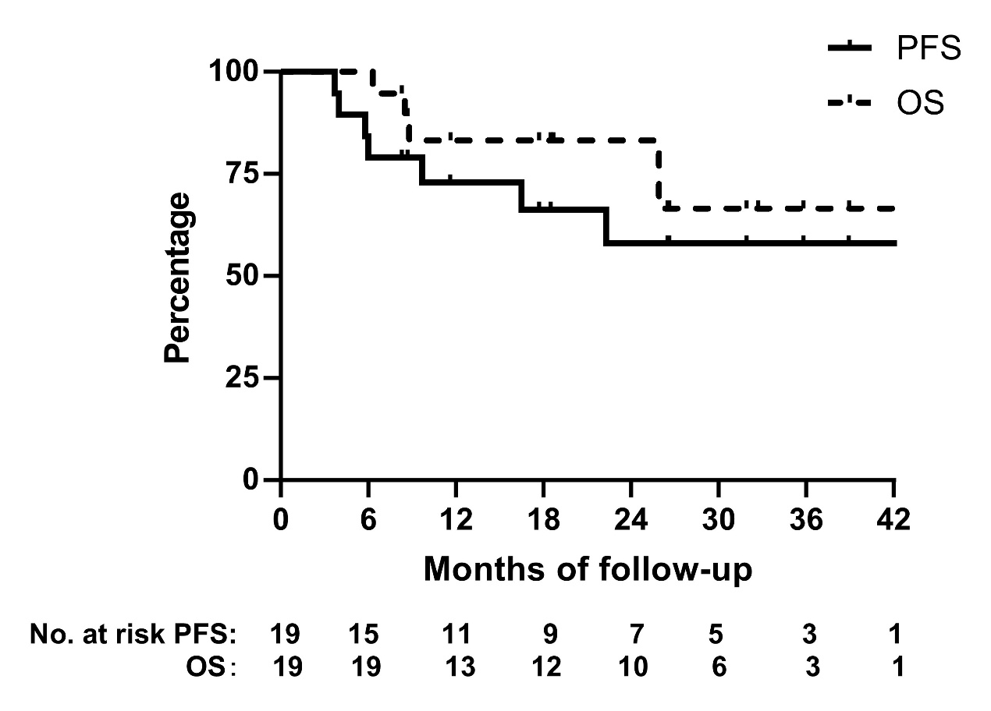
Figure S2. Kaplan–Meier survival curves in the evaluable population
The progression-free survival (PFS) and overall survival (OS) curves of the evaluable population.

