Supplementary Information
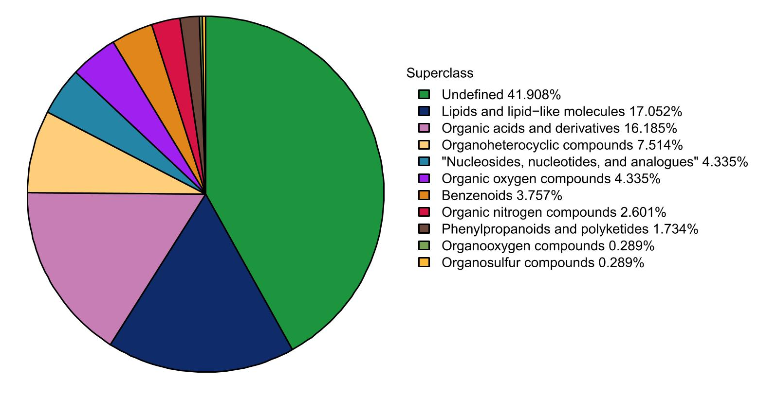
Supplementary Figure. 1 Statistics of chemical classification of metabolites

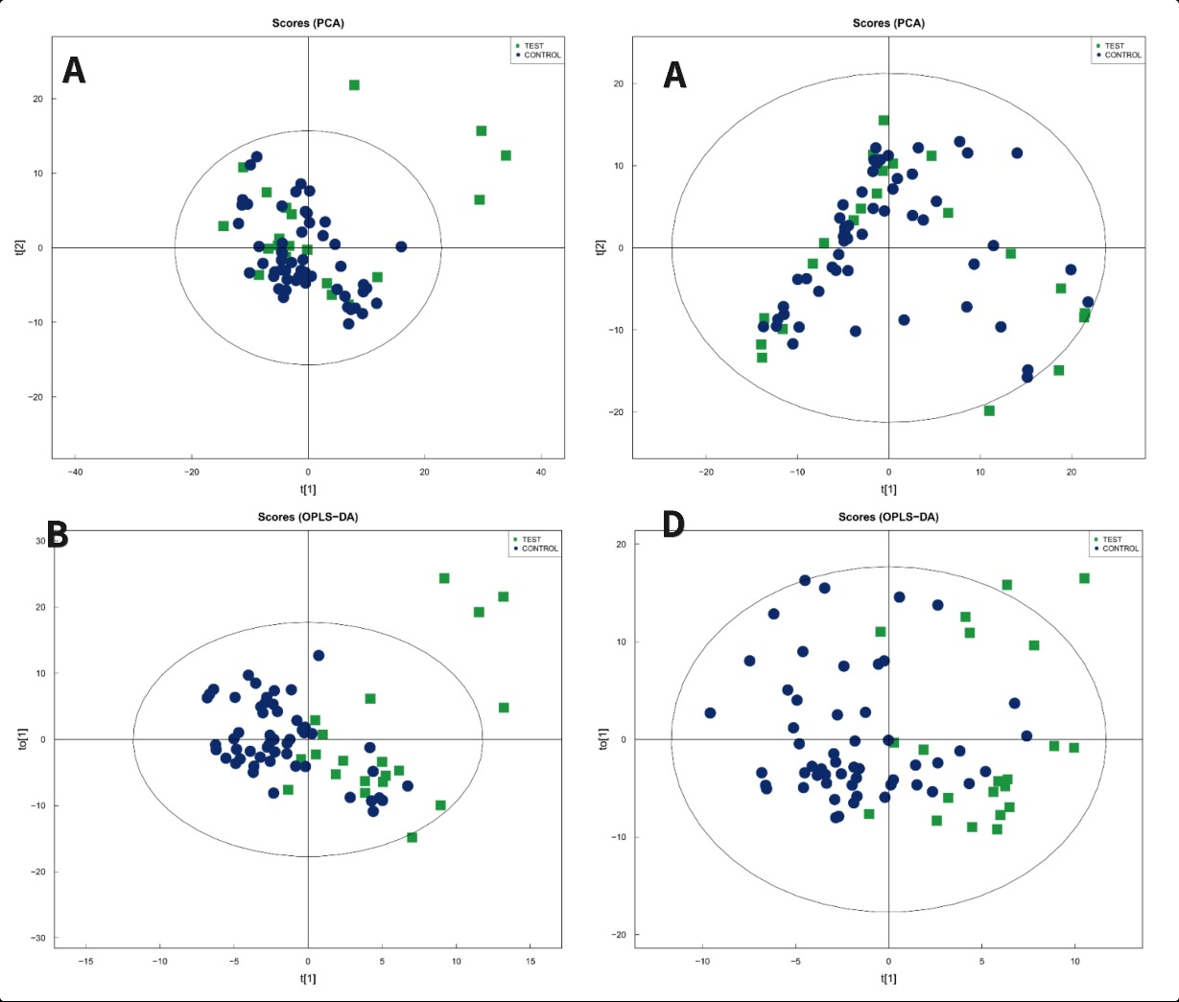
Supplementary Figure. 2 PCA and OPLS-DA plots. Note: Figure AB (A positive ion mode B negative ion mode) PCA maps of positive and negative differential metabolites; Figure CD (C positive ion mode D negative ion mode) OPLS-DA maps of positive and negative metabolites. The figure shows principal components 1,2, and 95% confidence intervals as ellipses. Similar-colored dots represent biological replicates in the same group and their distribution shows group variation.

Supplementary Table 1 General characteristics of the two groups
 | Acne with depression | Acne without depression | χ² | t | P
Age (years) | 22.75±2.75 | 23.75±1.25 |  | -1.6021 | 0.1135
BMI(kg/m2) | 20.78±1.84 | 19.9±1.57 |  | -1.463 | 0.144
Female: Male | 17:4 | 33:20 | 1.6201 |  | 0.2031
Residence  Urban: Rural | 12:9 | 26:27 | 0.1365 |  | 0.7118
Sleep quality  (good, fair, poor) | 4:12:5 | 18:30:5 | 3.4262 |  | 0.1803
Family history of acne Yes: No | 4:17 | 14:39 | 0.1336 |  | 0.7148
Drinking history Yes: No | 3:18 | 12:41 | 0.0555 |  | 0.8138
Smoking history Yes: No | 2:19 | 6:47 | 0.0243 |  | 0.7499

