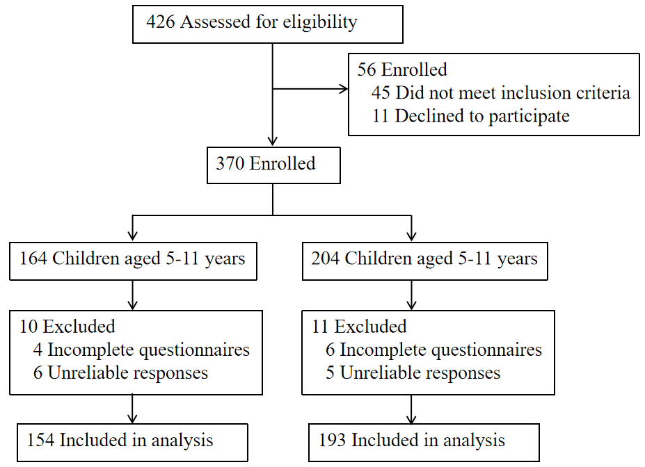
Figure S1. Participant flow (CONSORT diagram)

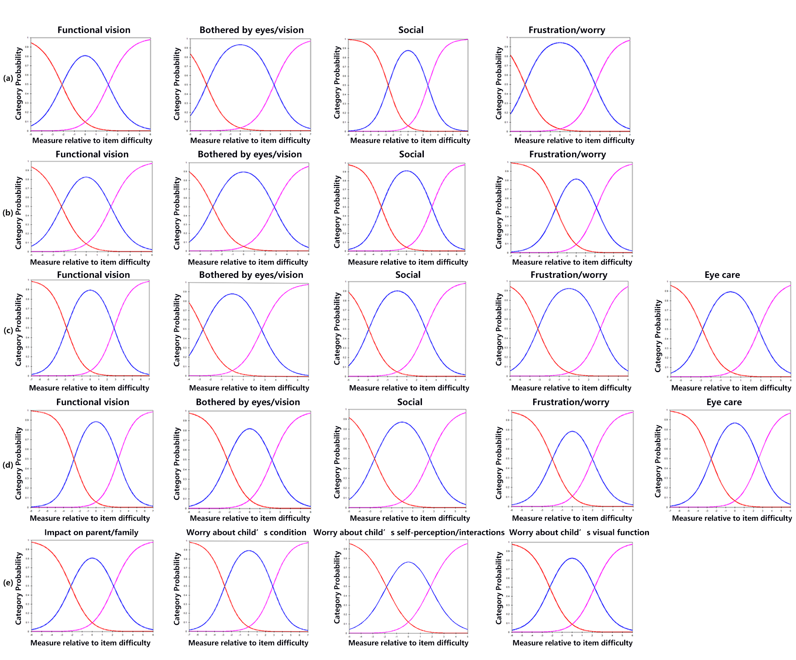
Figure S2. Category probability curves (CPC) illustrating the probability of each response category. The curve at the extreme left represents ““Never,” and the curve at the extreme right represents “All of the time.” (a) Child 5-11 Years; (b) Child 12-17 Years; (c) Proxy 5-11 Years; (d) Proxy 12-17 Years; (e) Parent. . These curves depict how respondents from each group are likely to choose among the available item-response categories as their underlying ability or level of the measured trait changes.
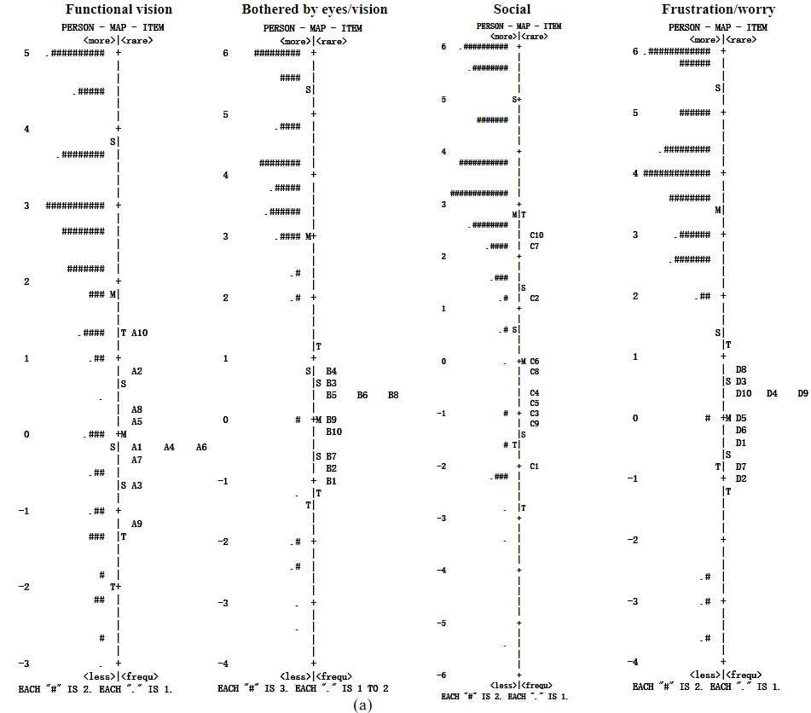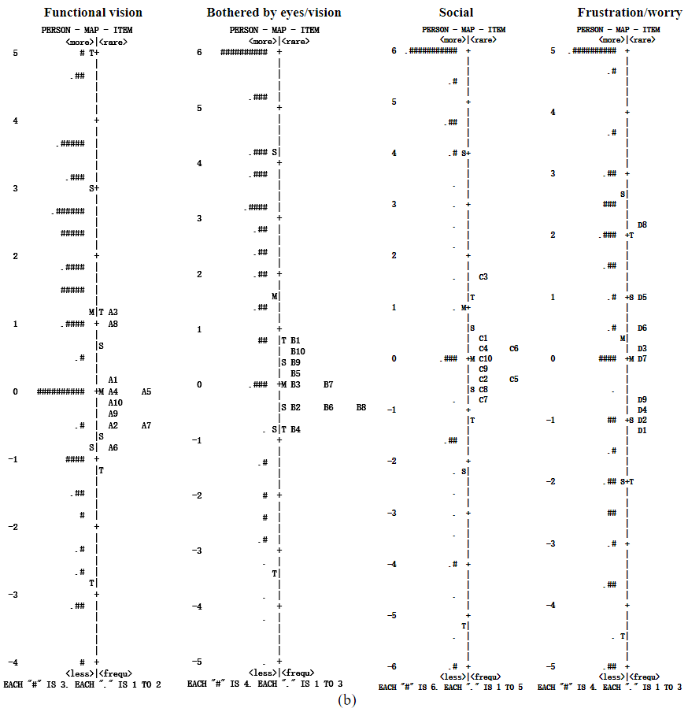
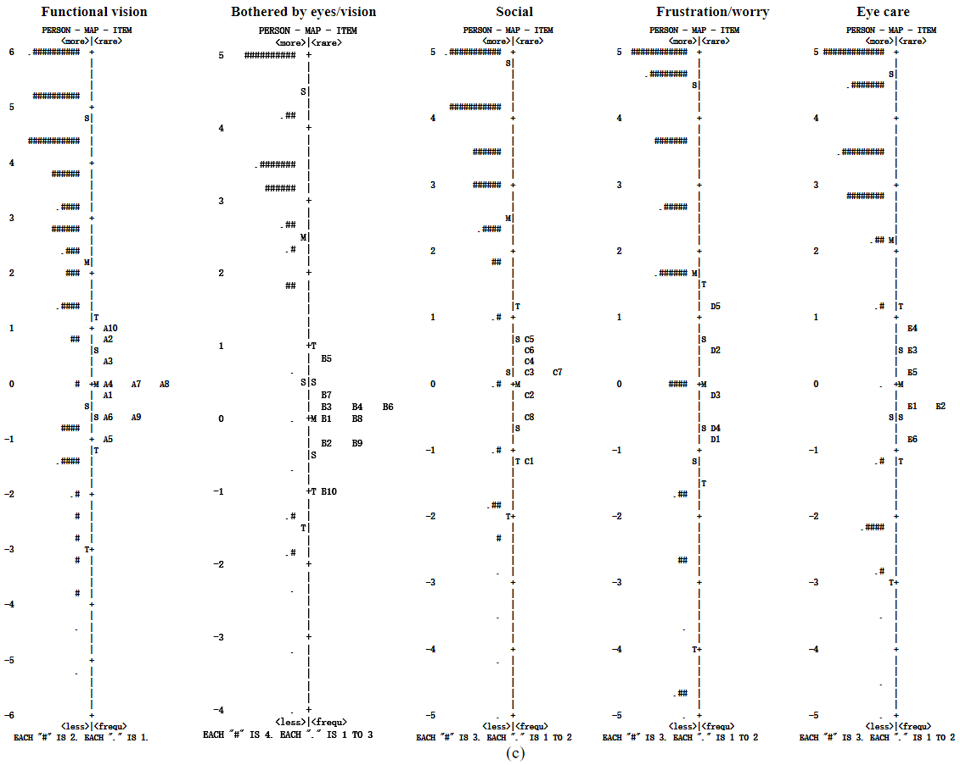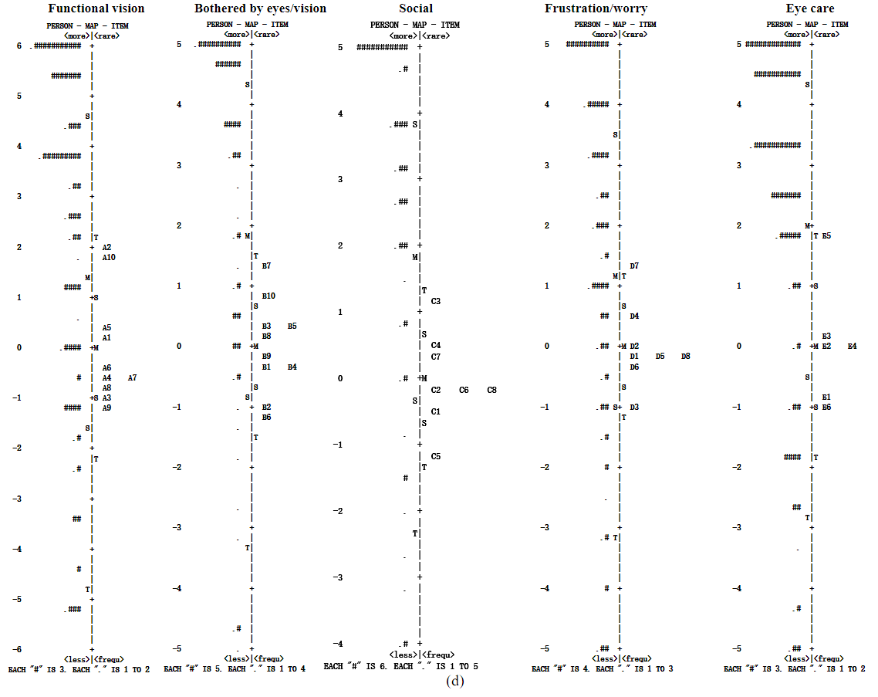
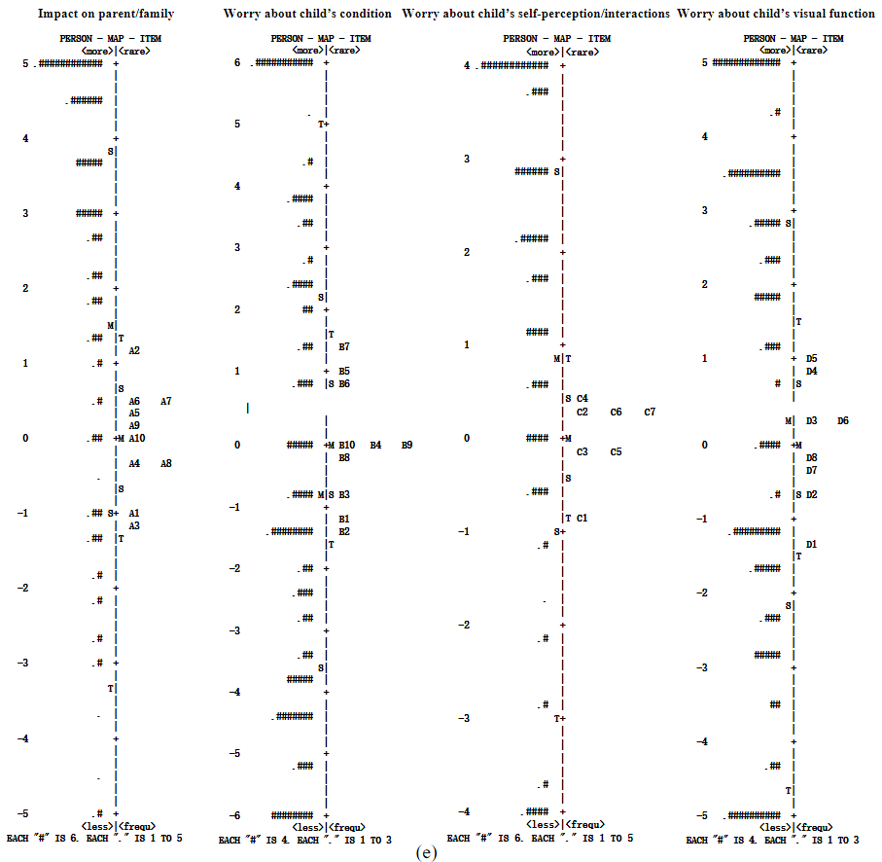
Figure S3. Person–item maps for the PedEyeQ-CN. The participants are located on the left of the dashed line, with more able participants located at the bottom of the map. Items are located on the right of the dashed line and more difficult items are located at the bottom of the map. (a) Child 5–11 Years; (b) Child 12–17 Years; (c) Proxy 5–11 Years; (d) Proxy 12–17 Years; (e) Parent. M, mean; S, 1 standard deviation (SD) from the mean; T, 2 SD from the mean.

Figure S4:The Pediatric Eye Questionnaire
The full English version of the Pediatric Eye Questionnaire (PedEyeQ) is freely available at: https://www.ajo.com/article/S0002-9394(19)30010-8/abstract.

Child 5–11 Year Pediatric Eye Questionnaires (PedEyeQ)
PedEyeQ -Functional vision: Child 5–11 years
1. Do your eyes make it hard to learn?
2. Do you have a hard time seeing?
3. Do you have to do things differently than other people because of your eyes?
4. Do your eyes make it hard to concentrate?
5. Do your eyes make it hard to do certain things?
6. Do you have trouble reading close-up?
7. Do you have to do certain things to help you see better?
8. Is it hard to see the board at school?
9. Do you run into things because of your eyes?
10. Do your eyes get tired easily?
PedEyeQ -Bothered by eyes / vision: Child 5–11 years
1. Does it bother you because your eyes make it hard to learn?
2. Does it bother you because your eyes make it hard to play sports?
3. Does it bother you because you have a hard time seeing?
4. Does it bother you that you can’t do certain things because of your eyes?
5. Does it bother you because your eyes make it hard to do certain things?
6. Does it bother you because it’s hard to see the board at school?
7. Does it bother you because it’s hard to see steps when you walk?
8. Does it bother you that bright light makes it hard to do things outside?
9. Is taking care of your eye condition hard for you?
10. Does it bother you because your eyes hurt?
PedEyeQ -Social: Child 5–11 years
1. Does it bother you that it’s hard to play/interact with others because of your eyes?
2. Does your eye condition cause problems in your family?
3. Are you shy because of your eyes?
4. Do other people get frustrated with you because of your eyes?
5. Do you get teased because of your eyes?
6. Do you worry about getting hurt because of your eyes?
7. Do you worry about your eyes getting worse?
8. Do you worry about what other people think about you because of your eyes?
9. Do you worry about getting teased because of your eyes?
10. Do you worry about your eyes?
PedEyeQ -Frustration / worry: Child 5–11 years
1. Are you bothered by the things you have to do to make your eyes better?
2. Do your eyes make you feel unsure of yourself?
3. Are you frustrated because your eyes aren’t getting better?
4. Does it bother you when other people say things or ask questions about your eyes?
5. Do you feel “different” because of your eyes?
6. Does it bother you that you get extra attention because of your eyes?
7. Do you feel left out because of your eyes?
8. Do you worry that your eyes will make it hard to do things when you’re older?
9. Do you worry about not being able to do things because of your eyes?
10. Do you worry about what you might have to do to make your eyes better?

Proxy 5–11 Year Pediatric Eye Questionnaires (PedEyeQ)
PedEyeQ -Functional vision: Proxy 5–11 years
1. Do your child’s eyes make it hard for them to play sports?
2. Does your child have a hard time seeing?
3. Are there certain things your child can’t do because of their eyes?
4. Does your child need help with certain things because of their eyes?
5. Does your child have to do things differently than other people because of their eyes?
6. Do your child’s eyes make it hard for them to concentrate?
7. Do your child’s eyes make it hard to do certain things?
8. Is it hard for your child to see the board at school?
9. Does your child run into things because of their eyes?
10. Do your child’s eyes get tired easily?
PedEyeQ -Bothered by eyes / vision: Proxy 5–11 years
1. Does it bother your child because they have to do things differently than other people because of their eyes?
2. Does it bother your child because their eyes make it hard to play sports?
3. Does it bother your child because they have a hard time seeing?
4. Does it bother your child to need special help at school because of their eyes?
5. Does it bother your child that they can’t do certain things because of their eyes?
6. Does it bother your child that they run into things because of their eyes?
7. Does it bother your child because their eyes get tired easily?
8. Does it bother your child because their eyes make it hard to do certain things?
9. Does it bother your child that it’s hard to play/interact with others because of their eyes?
10. Does your child feel left out because of their eyes?
PedEyeQ -Social: Proxy 5–11 years
1. Do your child’s eyes make them feel unsure of themself?
2. Does it bother your child when other people say things or ask questions about their eyes?
3. Does your child feel “different” because of their eyes?
4. Does it bother your child that they get extra attention because of their eyes?
5. Does it bother your child when people look/stare at them because of their eyes?
6. Does your child get teased because of their eyes?
7. Does your child worry about what other people think about them because of their eyes?
8. Does your child worry about getting teased because of their eyes?
PedEyeQ -Frustration / worry: Proxy 5–11 years
1. Is your child frustrated because their eyes aren’t getting better?
2. Does your child worry about their eyes getting worse?
3. Does your child worry that their eyes will make it hard to do things when they’re older?
4. Does your child worry about not being able to do things because of their eyes?
5. Does your child worry about their eyes?
PedEyeQ -Eyecare: Proxy 5–11 years
1. Does it bother your child to have to protect their eyes?
2. Does it bother your child to have to do certain things to help them see better?
3. Is your child bothered by the things they have to do to make their eyes better?
4. Does your child hate going to the eye doctor?
5. Is taking care of their eye condition hard for your child?
6. Does your child worry about what they might have to do to make their eyes better?

Child 12–17 Year Pediatric Eye Questionnaires (PedEyeQ)
PedEyeQ -Functional vision: Child 12–17 years
1. Do your eyes make it hard to learn?
2. Do your eyes make it hard to play sports?
3. Do you have a hard time seeing?
4. Do you need special help at school because of your eyes?
5. Do you need help with certain things because of your eyes?
6. Do you have to do things differently than other people because of your eyes?
7. Do your eyes make it hard to concentrate?
8. Is it hard to see the board at school?
9. Is it hard to see steps when you walk?
10. Do you run into things because of your eyes?
PedEyeQ -Bothered by eyes / vision: Child 12–17 years
1. Does it bother you that you need help with certain things because of your eyes?
2. Does it bother you to have to do things differently because of your eyes?
3. Does it bother you because your eyes make it hard to learn?
4. Does it bother you because your eyes make it hard to play sports?
5. Does it bother you because you have a hard time seeing?
6. Does it bother you to need special help at school because of your eyes?
7. Does it bother you because your eyes make it hard to concentrate?
8. Does it bother you because your eyes make it hard to do certain things?
9. Does it bother you because it’s hard to see the board at school?
10. Are you bothered by the things you have to do to make your eyes better?
PedEyeQ -Social: Child 12–17 years
1. Are you bothered by how your eyes look?
2. Do your eyes make you feel unsure of yourself?
3. Does it bother you when other people say things or ask questions about your eyes?
4. Do you feel “different” because of your eyes?
5. Does it bother you that you get extra attention because of your eyes?
6. Does it bother you when people look/stare at you because of your eyes?
7. Are you shy because of your eyes?
8. Do you get teased because of your eyes?
9. Do you worry about what other people think about you because of your eyes?
10. Do you worry about getting teased because of your eyes?
PedEyeQ -Frustration / worry: Child 12–17 years
1. Do you hate going to the eye doctor?
2. Is taking care of your eye condition hard for you?
3. Are you frustrated because your eyes aren’t getting better?
4. Do you worry about getting hurt because of your eyes?
5. Do you worry about your eyes getting worse?
Author Manuscript
6. Do you worry that your eyes will make it hard to do things when you’re older?
7. Do you worry about not being able to do things because of your eyes?
8. Do you worry about your eyes?
9. Do you worry about what you might have to do to make your eyes better?

Proxy 12–17 Pediatric Eye Questionnaires (PedEyeQ)
PedEyeQ -Functional vision: Proxy 12–17 years
1. Do your child’s eyes make it hard for them to play sports?
2. Does your child have a hard time seeing?
3. Does your child need special help at school because of their eyes?
4. Does your child have to do things differently than other people because of their eyes?
5. Do your child’s eyes make it hard for them to concentrate?
6. Do your child’s eyes make it hard to do certain things?
7. Is it hard for your child to play/interact with others because of their eyes?
8. Is it hard for your child to see steps when they walk?
9. Does your child run into things because of their eyes?
10. Do your child’s eyes get tired easily?
PedEyeQ -Bothered by eyes / vision: Proxy 12–17 years
1. Does it bother your child that they need help with certain things because of their eyes?
2. Does it bother your child because they have to do things differently than other people because of their eyes?
3. Does it bother your child because their eyes make it hard to learn?
4. Does it bother your child because their eyes make it hard to play sports?
5. Does it bother your child because they have a hard time seeing?
6. Does it bother your child that they run into things because of their eyes?
7. Does it bother your child because their eyes get tired easily?
8. Does it bother your child because their eyes make it hard to concentrate?
9. Does it bother your child because they have trouble reading close-up?
10. Does it bother your child because it’s hard to see the board at school?
PedEyeQ -Social: Proxy 12–17 years
1. Is your child bothered by how their eyes look?
2. Do your child’s eyes make them feel unsure of themself?
3. Does it bother your child when other people say things or ask questions about their eyes?
4. Does it bother your child when people look/stare at them because of their eyes?
5. Is it hard for your child to make friends because of their eyes?
6. Is your child shy because of their eyes?
7. Does your child worry about what other people think about them because of their eyes?
8. Does your child worry about getting teased because of their eyes?
PedEyeQ -Frustration / worry: Proxy 12–17 years
1. Does your child get upset because of their eyes?
2. Is your child frustrated because their eyes aren’t getting better?
3. Does your child worry about getting hurt because of their eyes?
4. Does your child worry about their eyes getting worse?
5. Does your child worry that their eyes will make it hard to do things when they’re older?
6. Does your child worry about not being able to do things because of their eyes?
7. Does your child worry about their eyes?
8. Does your child worry about what they might have to do to make their eyes better?
PedEyeQ -Eyecare: Proxy 12–17 years
1. Does your child hate going to the eye doctor?
2. Is taking care of their eye condition hard for your child?
3. Does it bother your child because their eyes hurt?
4. Does it bother your child that they get extra attention because of their eyes?
5. Does your child’s eye condition cause problems in your family?
6. Do other people get frustrated with your child because of their eyes?

Parent Pediatric Eye Questionnaires (PedEyeQ)
PedEyeQ -Impact on parent and family: Parent
1. Do you feel different from other parents because of your child’s eye condition?
2. Does taking care of your child’s eye condition cause stress on your family?
3. Is it difficult to ensure that your child receives the help they need because of their eye condition?
4. Is it hard because you need to be more involved in your child’s schooling because of their eye condition?
5. Does it bother you to have to change how you do things because of your child’s eye condition?
6. Does it bother you that you can’t do certain things because of your child’s eye condition?
7. Is it hard because it takes extra time to do things because of your child’s eye condition?
8. Is it hard work having to explain your child’s eye condition to others?
9. Is it hard because you have to attend frequent eye exams for your child?
10. Is it hard because your child needs more supervision because of their eye condition?
PedEyeQ -Worry about child’s eye condition: Parent
1. Does it bother you that your child has an eye condition?
2. Does it bother you that your child doesn’t see well out of one or both eyes?
3. Does it bother you that your child’s eye condition causes physical discomfort?
4. Do you worry about your child getting upset because of their eye(s)?
5. Do you worry about your child’s eye condition getting worse?
6. Do you worry about your child’s future because of their eye condition?
7. Do you worry about protecting your child’s eye(s)?
8. Do you worry about your child’s safety because of their eye condition?
9. Do you worry about the treatment(s) your child may need for their eye condition?
10. Do you worry that you don’t fully understand your child’s eye condition?
PedEyeQ -Worry about self-perception and interactions: Parent
1. Are you bothered by your child’s appearance because of their eye condition?
2. Does it bother you when others say things about your child’s eye condition?
3. Does it bother you when others look/stare at your child because of their eye condition?
4. Do you worry about your child being “different” because of their eye condition?
5. Do you worry about your child getting teased because of their eye condition?
6. Do you worry about your child’s eye condition affecting them socially?
7. Do you worry about your child’s self-esteem because of their eye condition?
PedEyeQ -Worry about functional vision: Parent
1. Does it bother you that your child can’t do certain things because of their eye condition?
2. Do you worry about your child being unable to do certain things because of their eye condition?
3. Do you worry about your child having a hard time reading because of their eye condition?
4. Do you worry about your child’s eye condition affecting their development?
5. Do you worry about your child’s eye condition affecting their learning?
6. Do you worry about your child’s depth perception?
7. Does it bother you when others aren’t patient with your child’s eye related needs?
8. Is it hard because your child’s eye condition affects their behavior?

Figure S5:The bilingual (English-Chinese) version of Pediatric Eye Questionnaire
The Chinese version of the Pediatric Eye Questionnaire (PedEyeQ-CN) constitutes the primary outcome of our translation and validation process. It has been included as an essential supplement to enable future researchers to directly evaluate the adapted instrument and to support its practical application in Chinese-speaking clinical environments. (Should the Editors deem this material unsuitable due to language requirements, we will promptly remove it in accordance with your guidance.) The Chinese version for children aged 5–11 years (PedEyeQ-CN) can also be accessed at: https://www.nature.com/articles/s41433-022-02157-5#Sec18.
5-11 岁中文版儿童眼相关生活质量问卷——儿童版
功能性视觉
1. Do your eyes make it hard to learn?
1. 你是否因为眼睛的问题而感到“学习困难”？
2. Do you have a hard time seeing?
2. 你是否感觉“看东西费劲”？
3. Do you have to do things differently than other people because of your eyes?
3. 你是否因为眼睛的问题而“需要用和别人不同的方式来做事情”？
4. Do your eyes make it hard to concentrate?
4. 你是否因为眼睛的问题而“很难集中注意力”？
5. Do your eyes make it hard to do certain things?
5. 你是否因为眼睛的问题而“做有些事情的时候存在困难”？
6. Do you have trouble reading close-up?
6. 你是否在“近距离阅读”时感到困难？
7. Do you have to do certain things to help you see better?
7. 你是否会用特别的方式来让自己看得更清楚？
8. Is it hard to see the board at school?
8. 你在学校上课时看黑板困难吗？
9. Do you run into things because of your eyes?
9. 你是否因为眼睛的问题而撞上东西？
10. Do your eyes get tired easily?
10. 你是否容易感到眼睛疲劳？
被眼睛/视觉所困扰
1. Does it bother you because your eyes make it hard to learn?
1. 你是否因为“眼睛的问题导致学习困难”而感到烦恼？
2. Does it bother you because your eyes make it hard to play sports?
2. 你是否因为“眼睛的问题导致运动困难”而感到烦恼？
3. Does it bother you because you have a hard time seeing?
3. 你是否因为“看东西困难”而感到烦恼？
4. Does it bother you that you can’t do certain things because of your eyes?
4. 你是否因为“眼睛的问题导致不能做某些事情”而感到烦恼？
5. Does it bother you because your eyes make it hard to do certain things?
5. 你是否因为“眼睛的问题导致做某些事情时比较费劲”而感到烦恼？
6. Does it bother you because it’s hard to see the board at school?
6. 你是否因为“在学校上课时看不清黑板”而感到烦恼？
7. Does it bother you because it’s hard to see steps when you walk?
7. 你是否因为“走路时看台阶困难”而感到烦恼？
8. Does it bother you that bright light makes it hard to do things outside?
8. 你是否因为“在户外时光线太亮影响日常生活”而感到烦恼？
9. Is taking care of your eye condition hard for you?
9. 你是否因为“日常需要注意眼睛问题”而感到烦恼？
10. Does it bother you because your eyes hurt?
10. 你是否因为眼睛疼痛而感到烦恼？
社交
1. Does it bother you that it’s hard to play/interact with others because of your eyes?
1. 因为眼睛的问题影响你和别人玩耍/交流，这是否让你感到烦恼？
2. Does your eye condition cause problems in your family?
2. 你眼睛的问题是否在你的家庭中引起了问题？
3. Are you shy because of your eyes?
3. 你是否因为眼睛的问题而感到害羞？
4. Do other people get frustrated with you because of your eyes?
4. 别人是否会因为你眼睛的问题而对你感到失望？
5. Do you get teased because of your eyes?
5. 你是否因为眼睛的问题而被嘲笑？
6. Do you worry about getting hurt because of your eyes?
6. 你是否担心“因为眼睛的问题而导致自己受伤”？
7. Do you worry about your eyes getting worse?
7. 你是否担心“你的眼睛会变得越来越差”？
8. Do you worry about what other people think about you because of your eyes?
8. 你是否因为你的眼睛而担心别人对你的看法？
9. Do you worry about getting teased because of your eyes?
9. 你是否因为你的眼睛而担心被别人嘲笑？
10. Do you worry about your eyes?
10. 你担心你眼睛的情况吗？
沮丧/担忧
1. Are you bothered by the things you have to do to make your eyes better?
1. 你是否因为“必须做一些事来让眼睛变好”而感到烦恼？
2. Do your eyes make you feel unsure of yourself?
2. 你是否因为眼睛的问题而对自己不自信？
3. Are you frustrated because your eyes aren’t getting better?
3. 你是否因为眼睛没有变好而感到失望？
4. Does it bother you when other people say things or ask questions about your eyes?
4. 当别人谈论或询问您的眼睛时，你是否感到烦恼？
5. Do you feel “different” because of your eyes?
5. 你是否因为你的眼睛而感到“自己和其他人不一样”？
6. Does it bother you that you get extra attention because of your eyes?
6. 当因为你的眼睛而受到额外的关注时，你是否感到烦恼？
7. Do you feel left out because of your eyes?
7. 你是否因为眼睛的问题而感到被忽视？
8. Do you worry that your eyes will make it hard to do things when you’re older?
8. 你是否担心“长大后因为眼睛的问题会让你做有些事情很困难”？
9. Do you worry about not being able to do things because of your eyes?
9. 你是否担心“因为眼睛的问题而不能做某些事情”？
10. Do you worry about what you might have to do to make your eyes better?
10. 你是否因为“需要做一些事情来改善眼睛的情况”而感到担心？

5-11 岁中文版儿童眼相关生活质量问卷——父母代理版
功能性视觉
1. Do your child’s eyes make it hard for them to play sports?
1. 您的孩子是否因为眼睛的问题而感到运动困难？
2. Does your child have a hard time seeing?
2. 您的孩子是否看东西困难？
3. Are there certain things your child can’t do because of their eyes?
3. 您的孩子是否因为他（她）的眼睛而不能做某些事情？
4. Does your child need help with certain things because of their eyes?
4. 您的孩子是否因为他（她）的眼睛而在做某些事情的时候需要帮助？
5. Does your child have to do things differently than other people because of their eyes?
5. 您的孩子是否因他（她）的眼睛而需要用和别人不同的方式来做事情？
6. Do your child’s eyes make it hard for them to concentrate?
6. 您的孩子是否因为眼睛的问题而很难集中注意力？
7. Do your child’s eyes make it hard to do certain things?
7. 您的孩子是否因为眼睛的问题而导致他（她）做某些事情很困难？
8. Is it hard for your child to see the board at school?
8. 您的孩子在学校时看黑板是否困难？
9. Does your child run into things because of their eyes?
9. 您的孩子是否因为他（她）的眼睛而撞上东西？
10. Do your child’s eyes get tired easily?
10. 您孩子是否容易感到眼睛疲劳？
被眼睛/视觉所困扰
1. Does it bother your child because they have to do things differently than other people because of their eyes?
1. 您的孩子是否“因为他（她）的眼睛，导致需要用和别人不同的方式来做事情”感到困扰？
2. Does it bother your child because their eyes make it hard to play sports?
2. 您的孩子是否“因为他（她）的眼睛，导致运动困难”而感到困扰？
3. Does it bother your child because they have a hard time seeing?
3. 您的孩子是否因为“看东西困难”而感到困扰？
4. Does it bother your child to need special help at school because of their eyes?
4. 您的孩子是否因为“在学校时由于他（她）的眼睛，导致需要特殊帮助”而感到困扰？
5. Does it bother your child that they can’t do certain things because of their eyes?
5. 您的孩子是否“因为他（她）的眼睛，导致不能做某些事情”而感到困扰？
6. Does it bother your child that they run into things because of their eyes?
6. 您的孩子是否“因为他（她）的眼睛，导致撞上东西”而感到困扰？
7. Does it bother your child because their eyes get tired easily?
7. 您的孩子是否“因为他（她）容易感到眼睛疲劳”而感到困扰？
8. Does it bother your child because their eyes make it hard to do certain things?
8. 您的孩子是否“因为他（她）的眼睛，导致做某些事情困难”而感到困扰？
9. Does it bother your child that it’s hard to play/interact with others because of their eyes?
9. 您的孩子是否“因为他（她）的眼睛，导致他（她）很难和别人玩耍或互动”而感到困扰？
10. Does your child feel left out because of their eyes?
10. 您的孩子是否因为他（她）的眼睛而感到被排斥？
社交
1. Do your child’s eyes make them feel unsure of themself?
1. 您孩子的眼睛是否让他（她）对自己感到不自信？
2. Does it bother your child when other people say things or ask questions about their eyes?
2. 您的孩子是否“因为别人谈论或询问他（她）的眼睛”而感到困扰？
3. Does your child feel “different” because of their eyes?
3. 您的孩子是否因为他（她）的眼睛而感到“与众不同”？
4. Does it bother your child that they get extra attention because of their eyes?
4. 您的孩子是否“因为他（她）的眼睛，导致获得额外的关注”而感到困扰？
5. Does it bother your child when people look/stare at them because of their eyes?
5. 您的孩子是否“因为他（她）的眼睛，导致被别人盯着看”而感到困扰？
6. Does your child get teased because of their eyes?
6. 您的孩子是否因为他（她）的眼睛而被嘲笑？
7. Does your child worry about what other people think about them because of their eyes?
7. 您的孩子是否因为他（她）的眼睛而“担心别人对自己的看法”？
8. Does your child worry about getting teased because of their eyes?
8. 您的孩子是否因为他（她）的眼睛而“担心别人嘲笑自己”？
沮丧/担忧
1. Is your child frustrated because their eyes aren’t getting better?
1. 您的孩子是否“因为他（她）的眼睛没有变好”而感到沮丧？
2. Does your child worry about their eyes getting worse?
2. 您的孩子是否担心他（她）的眼睛会变得越来越差？
3. Does your child worry that their eyes will make it hard to do things when they’re older?
3. 您的孩子是否担心“长大后他（她）的眼睛会让自己很难做某些事情”？
4. Does your child worry about not being able to do things because of their eyes?
4. 您的孩子是否因为他（她）的眼睛而“担心自己不能做某些事情”？
5. Does your child worry about their eyes?
5. 您的孩子是否担心他（她）的眼睛？
眼部护理
1. Does it bother your child to have to protect their eyes?
1. 您的孩子是否因为“需要保护自己的眼睛”而感到困扰？
2. Does it bother your child to have to do certain things to help them see better?
2. 您的孩子是否因为“需要做某些事情来让自己看得更清楚”而感到困扰？
3. Is your child bothered by the things they have to do to make their eyes better?
3. 您的孩子是否因为“需要做某些事情来让自己的眼睛变好”而感到困扰？
4. Does your child hate going to the eye doctor?
4. 您的孩子是否讨厌去看眼科医生？
5. Is taking care of their eye condition hard for your child?
5. 对于您的孩子来说，保护他（她）的眼睛状态是否困难？
6. Does your child worry about what they might have to do to make their eyes better?
6. 您的孩子是否担心“需要采取一些措施才能让眼睛变好”？

12-17岁中文版儿童眼相关生活质量问卷——儿童版
功能性视觉
1. Do your eyes make it hard to learn?
1. 你是否因为眼睛的问题而感到“学习困难”？
2. Do your eyes make it hard to play sports?
2. 你是否因为眼睛的问题而导致“运动困难”？
3. Do you have a hard time seeing?
3. 你是否感觉“看东西费劲”？
4. Do you need special help at school because of your eyes?
4. 你是否因为眼睛的问题而“在学校需要特殊帮助”？
5. Do you need help with certain things because of your eyes?
5. 你是否因为眼睛的问题而“做某些事情的时候存在困难”？
6. Do you have to do things differently than other people because of your eyes?
6. 你是否因为眼睛的问题而“需要用和别人不同的方式来做事情”？
7. Do your eyes make it hard to concentrate?
7. 你是否因为眼睛的问题而“难以集中注意力”？
8. Is it hard to see the board at school?
8. 你在学校上课时看黑板困难吗？
9. Is it hard to see steps when you walk?
9. 你走路时看台阶有困难吗?
10. Do you run into things because of your eyes?
10. 你会因为眼睛的问题而撞到东西吗？
被眼睛/视觉所困扰
1. Does it bother you that you need help with certain things because of your eyes?
1. 你是否因为“眼睛的问题导致做某些事情困难”而感到烦恼?
2. Does it bother you to have to do things differently because of your eyes?
2. 你是否因为“眼睛的问题导致需要用和别人不同的方式来做事情”而感到烦恼？
3. Does it bother you because your eyes make it hard to learn?
3. 你是否因为“眼睛的问题导致学习困难”而感到烦恼？
4. Does it bother you because your eyes make it hard to play sports?
4. 你是否因为“眼睛的问题导致运动困难”而感到烦恼？
5. Does it bother you because you have a hard time seeing?
5. 你是否因为“看东西困难”而感到烦恼？
6. Does it bother you to need special help at school because of your eyes?
6. 你是否因为“眼睛的问题导致在学校时需要特殊帮助”而感到烦恼？
7. Does it bother you because your eyes make it hard to concentrate?
7. 你是否因为“眼睛的问题导致难以集中注意力”而感到烦恼？
8. Does it bother you because your eyes make it hard to do certain things?
8. 你是否因为“眼睛的问题导致做某些事情时比较费劲”而感到烦恼？
9. Does it bother you because it’s hard to see the board at school?
9. 你是否因为“在学校上课时看不清黑板”而感到烦恼？
10. Are you bothered by the things you have to do to make your eyes better?
10.你是否因为“必须做一些事让眼睛变好”而感到烦恼？
社交
1. Are you bothered by how your eyes look?
1. 你是否因为眼睛的样子而感到烦恼？
2. Do your eyes make you feel unsure of yourself?
2. 你是否因为眼睛的问题而对自己不自信？
3. Does it bother you when other people say things or ask questions about your eyes?
3. 当别人谈论或询问您的眼睛时，你是否感到烦恼？
4. Do you feel “different” because of your eyes?
4. 你是否因为你的眼睛而感到“自己和其他人不一样”？
5. Does it bother you that you get extra attention because of your eyes?
5. 你是否因为你的眼睛受到过多的关注而感到烦恼？
6. Does it bother you when people look/stare at you because of your eyes?
6. 你是否因为眼睛的问题在别人盯着你看时而感到烦恼?
7. Are you shy because of your eyes?
7. 你是否因为你的眼睛而感到害羞?
8. Do you get teased because of your eyes?
8. 你是否因为眼睛的问题而被嘲笑？
9. Do you worry about what other people think about you because of your eyes?
9. 你是否因为你的眼睛而担心别人对你的看法？
10. Do you worry about getting teased because of your eyes?
10.你是否因为你的眼睛而担心被别人嘲笑？
沮丧/忧虑
1. Do you hate going to the eye doctor?
1. 你是否讨厌去看眼科医生？
2. Is taking care of your eye condition hard for you?
2. 护理你的眼病对你来说有困难吗？
3. Are you frustrated because your eyes aren’t getting better?
3. 你是否因为眼睛没有变好而感到失望？
4. Do you worry about getting hurt because of your eyes?
4. 你是否担心“因为眼睛的问题而导致自己受伤”？
5. Do you worry about your eyes getting worse?
5. 你是否担心眼睛变得越来越差?
6. Do you worry that your eyes will make it hard to do things when you’re older?
6. 你是否担心“长大后因为眼睛的问题会让你做有些事情很困难”？
7. Do you worry about not being able to do things because of your eyes?
7. 你是否担心“因为眼睛的问题而不能做某些事情”？
8. Do you worry about your eyes?
8. 你是否担心自己的眼病?
9. Do you worry about what you might have to do to make your eyes better?
9. 你是否因为“需要做一些事情来改善眼睛的情况”而感到担心？

12-17岁中文版儿童眼相关生活质量问卷——父母代理版
功能性视觉
1. Do your child’s eyes make it hard for them to play sports?
1. 您的孩子是否因为眼睛的问题而感到运动困难？
2. Does your child have a hard time seeing?
2. 您的孩子是否看东西困难？
3. Does your child need special help at school because of their eyes?
3. 您的孩子是否因为因为眼睛的问题在学校时需要特殊帮助？
4. Does your child have to do things differently than other people because of their eyes?
4. 您的孩子是否因为眼睛的问题而需要用和别人不同的方式来做事情？
5. Do your child’s eyes make it hard for them to concentrate?
5. 您的孩子是否因为眼睛的问题而很难集中注意力？
6. Do your child’s eyes make it hard to do certain things?
6. 您的孩子是否因为眼睛的问题而导致他（她）做某些事情很困难？
7. Is it hard for your child to play/interact with others because of their eyes?
7. 您的孩子是否因为眼睛的问题而很难和别人玩耍或交流？
8. Is it hard for your child to see steps when they walk?
8. 您的孩子走路时看台阶有困难吗?
9. Does your child run into things because of their eyes?
9. 您的孩子是否因为眼睛的问题而撞上东西？
10. Do your child’s eyes get tired easily?
10.您孩子是否容易感到眼睛疲劳？
被眼睛/视觉所困扰
1. Does it bother your child that they need help with certain things because of their eyes?
1. 因为眼睛的问题导致你的孩子在某些事情上需要帮助，对此他（她）是否感到烦恼?
2. Does it bother your child because they have to do things differently than other people because of their eyes?
2 您的孩子是否“因为眼睛的问题，导致需要用和别人不同的方式来做事情”感到困扰？
3. Does it bother your child because their eyes make it hard to learn?
3. 您的孩子是否因为“学习困难”而感到困扰？
4. Does it bother your child because their eyes make it hard to play sports?
4. 您的孩子是否“因为眼睛的问题，导致运动困难”而感到困扰？
5. Does it bother your child because they have a hard time seeing?
5. 您的孩子是否因为“看东西困难”而感到困扰？
6. Does it bother your child that they run into things because of their eyes?
6. 您的孩子是否“因为眼睛的问题，导致撞上东西”而感到困扰？
7. Does it bother your child because their eyes get tired easily?
7. 您的孩子是否“因为眼睛的问题容易感到眼睛疲劳”而感到困扰？
8. Does it bother your child because their eyes make it hard to concentrate?
8. 您的孩子是否“因为眼睛的问题导致难以集中注意力“而感到困扰？
9. Does it bother your child because they have trouble reading close-up?
9. 您的孩子是否“因为近距离阅读有困难“而感到困扰？
10. Does it bother your child because it’s hard to see the board at school?
10.您的孩子是否“因为在学校看不清楚黑板上的字“而感到困扰？
社交
1. Is your child bothered by how their eyes look?
1. 您孩子是否因为自己眼睛的样子而感到困扰？
2. Do your child’s eyes make them feel unsure of themself?
2. 您孩子的眼睛是否让他（她）对自己感到不自信？
3. Does it bother your child when other people say things or ask questions about their eyes?
3. 您的孩子是否“因为别人谈论或询问他（她）的眼睛”而感到困扰？
4. Does it bother your child when people look/stare at them because of their eyes?
4. 您的孩子是否“因为眼睛问题，在被别人盯着看时”感到困扰？
5. Is it hard for your child to make friends because of their eyes?
5. 您的孩子是否“因为眼睛问题导致交朋友有困难”?
6. Is your child shy because of their eyes?
6. 您的孩子是否因为眼睛的问题而感到害羞?
7. Does your child worry about what other people think about them because of their eyes?
7. 您的孩子是否“因为眼睛问题而担心别人对自己的看法”？
8. Does your child worry about getting teased because of their eyes?
8. 您的孩子是否“因为眼睛问题而担心别人嘲笑自己”？
沮丧/担忧
1. Does your child get upset because of their eyes?
1. 您的孩子是否“因为他（她）的眼睛没有变好”而感到沮丧？
2. Is your child frustrated because their eyes aren’t getting better?
2. 您的孩子是否“因为他（她）的眼睛不能变好”而感到沮丧？
3. Does your child worry about getting hurt because of their eyes?
3. 您的孩子是否担心“因为眼睛的问题而导致自己受伤”？
4. Does your child worry about their eyes getting worse?
4. 您的孩子是否担心他（她）的眼睛会变得越来越差？
5. Does your child worry that their eyes will make it hard to do things when they’re older?
5. 您的孩子是否担心“长大后他（她）的眼睛会让自己很难做某些事情”？
6. Does your child worry about not being able to do things because of their eyes?
6. 您的孩子是否因为他（她）的眼睛而“担心自己不能做某些事情”？
7. Does your child worry about their eyes?
7. 您的孩子是否担心他（她）的眼睛？
8. Does your child worry about what they might have to do to make their eyes better?
8. 您的孩子是否担心“需要采取一些措施才能让眼睛变好”？
眼部护理
1. Does your child hate going to the eye doctor?
1. 您的孩子是否讨厌去看眼科医生？
2. Is taking care of their eye condition hard for your child?
2. 需要护理自己的眼病，这对您的孩子来说困难吗？
3. Does it bother your child because their eyes hurt?
3. 您的孩子是否因为眼痛而感到烦恼?
4. Does it bother your child that they get extra attention because of their eyes?
4. 您的孩子是否“因为眼睛的问题受到过多的关注”而感到烦恼?
5. Does your child’s eye condition cause problems in your family?
5. 您孩子的眼病是否给您家庭带来了一些问题?
6. Do other people get frustrated with your child because of their eyes?
6. 别人是否会因为您孩子眼睛的问题而对他（她）感到失望吗?

中文版儿童眼相关生活质量问卷——家长版
对家长及家庭的影响
1. Do you feel different from other parents because of your child’s eye condition?
1. 您是否因为您孩子的眼睛状况而感到“和别的家长不一样”？
2. Does taking care of your child’s eye condition cause stress on your family?
2. 照顾孩子的眼睛是否给您的家庭造成压力？
3. Is it difficult to ensure that your child receives the help they need because of their eye condition?
3. 确保您孩子的眼睛能够获得所需的帮助是否困难？
4. Is it hard because you need to be more involved in your child’s schooling because of their eye condition?
4. 因为孩子的眼睛状况，您需要更多地参与他（她）的教育，这是否让您感到困难？
5. Does it bother you to have to change how you do things because of your child’s eye condition?
5. 因为孩子的眼睛状况，不得不改变您做事的方式，这是否让您感到困扰？
6. Does it bother you that you can’t do certain things because of your child’s eye condition?
6. 因为孩子的眼睛状况，使您不能做某些事情，这是否让您感到困扰？
7. Is it hard because it takes extra time to do things because of your child’s eye condition?
7. 因为孩子的眼睛状况，您需要花费额外的时间去做事情，这是否让您感到困难？
8. Is it hard work having to explain your child’s eye condition to others?
8. 向他人解释孩子的眼睛状况是否让您感到困难？
9. Is it hard because you have to attend frequent eye exams for your child?
9. 您是否因为需要频繁地带您的孩子参加眼部检查而感到困难？
10. Is it hard because your child needs more supervision because of their eye condition?
10. 因为孩子的眼睛状况，需要您花费更多的时间监督他（她），这是否让您感到困难？
担心孩子的眼部情况
1. Does it bother you that your child has an eye condition?
1. 您是否因为孩子的眼睛状况而感到困扰？
2. Does it bother you that your child doesn’t see well out of one or both eyes?
2. 您是否因为孩子单眼或双眼视力不好而感到困扰？
3. Does it bother you that your child’s eye condition causes physical discomfort?
3. 您是否因为孩子的眼睛状况引起身体不适而感到困扰？
4. Do you worry about your child getting upset because of their eye(s)?
4. 您是否担心“您的孩子由于眼睛而感到沮丧”？
5. Do you worry about your child’s eye condition getting worse?
5. 您是否担心“孩子的眼睛状况变差”？
6. Do you worry about your child’s future because of their eye condition?
6. 您是否因为孩子的眼睛状况而担心他（她）的未来？
7. Do you worry about protecting your child’s eye(s)?
7. 您是否为保护孩子的眼睛而担心？
8. Do you worry about your child’s safety because of their eye condition?
8. 您是否因为孩子的眼睛状况而担心他（她）的安全？
9. Do you worry about the treatment(s) your child may need for their eye condition?
9. 您是否因为孩子的眼睛状况而担心他（她）的治疗？
10. Do you worry that you don’t fully understand your child’s eye condition?
10. 您是否因为不能充分了解孩子的眼睛状况而担心？
担心孩子的自我感知及互动
1. Are you bothered by your child’s appearance because of their eye condition?
1. 您是否因为孩子的眼睛状况而“对孩子的外表”感到困扰？
2. Does it bother you when others say things about your child’s eye condition?
2. 您是否因为别人提及您孩子的眼睛状况而感到困扰？
3. Does it bother you when others look/stare at your child because of their eye condition?
3. 您是否“因为您孩子的眼睛状况，导致别人盯着他（她）看”而感到困扰？
4. Do you worry about your child being “different” because of their eye condition?
4. 您是否因为孩子的眼睛状况而担心他（她）“与众不同”？
5. Do you worry about your child getting teased because of their eye condition?
5. 您是否因为孩子的眼睛状况而担心他（她）被嘲笑？
6. Do you worry about your child’s eye condition affecting them socially?
6. 您是否担心孩子的眼睛状况影响他（她）社交？
7. Do you worry about your child’s self-esteem because of their eye condition?
7. 您是否因为孩子的眼睛状况而担心他（她）的自尊？
担心孩子的功能性视觉
1. Does it bother you that your child can’t do certain things because of their eye condition?
1. 因为孩子的眼睛状况，导致他（她）不能做某些事情，您是否对此感到困扰？
2. Do you worry about your child being unable to do certain things because of their eye condition?
2. 因为孩子的眼睛状况，导致他（她）无法做某些事情，您是否对此感到困扰？
3. Do you worry about your child having a hard time reading because of their eye condition?
3. 您是否担心“孩子由于眼部状况，导致他（她）阅读困难”？
4. Do you worry about your child’s eye condition affecting their development?
4. 您是否担心“孩子由于眼睛状况而影响他（她）的成长”？
5. Do you worry about your child’s eye condition affecting their learning?
5. 您是否担心“孩子由于眼睛状况而影响他（她）的学习”？
6. Do you worry about your child’s depth perception?
6. 您是否担心“孩子对物体远近距离的感知”？
7. Does it bother you when others aren’t patient with your child’s eye related needs?
7. 您是否因为“其他人对您孩子眼睛的相关需求不耐烦”而感到困扰？
8. Is it hard because your child’s eye condition affects their behavior?
8. 您是否担心“孩子由于眼睛状况而影响他（她）的行为”？

