CoFe₂O₄-Based Multifunctional Nanozymes Remodel Tumor Redox Balance for Enhanced Osteosarcoma Treatment

Yang Yang^{1,2,#}, Hongmei Gu^{3,#}, Shuhen Qin^{4,#}, Jiajia Liu², Jianhua Xue², Yong Hu⁴, Qiang Xue^{3,*}, Xianchen Liu^{3,*}

¹Department of Emergency Medicine, Affiliated Hospital of Nantong University, Nantong City, Jiangsu Province,226001, China.
²Department of Chemistry, School of Science, China Pharmaceutical University.
Nanjing City, Jiangsu Province, 226001, China.
³Department of Radiation Oncology, Affiliated Hospital of Nantong University, Nantong City, Jiangsu Province,226001, China.
⁴College of Engineering and Applied Sciences, Nanjing University, Nanjing 210023, China

*Corresponding authors.
E-mail addresses: Xianchen Liu (xianchenliunt@sina.com), Qiang Xue (ntxueqiang@163.com).

#These authors contributed equally to the work

Figure S1. The size changes of CF@P stored in PBS 7.4 buffer for different periods of time.

Figure S2. Infrared spectra of PEG and CF@P.

Figure S3. Core level XPS spectrum of O1s in CF@P.

Figure S4. Ultraviolet absorption spectra of CF@P nanozymes at different concentrations.

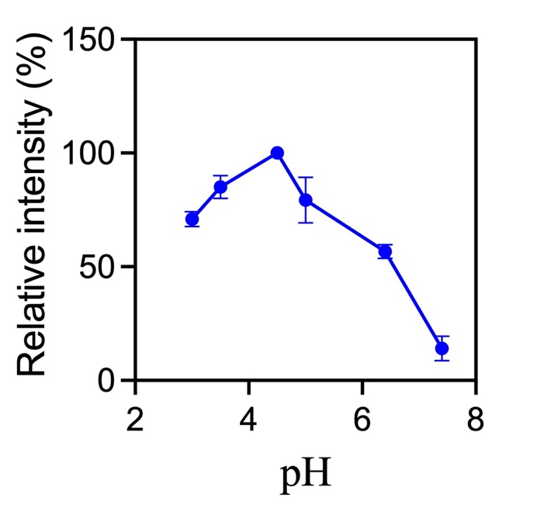
Figure S5. Effect of pH on the POD-like activity. Reaction conditions: 25℃, 100 μg mL⁻¹ material, 0.25 mg mL⁻¹ TMB.

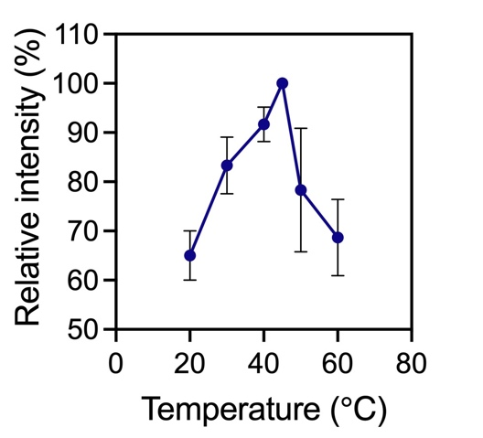
Figure S6. Effect of temperature on the POD-like activity. Reaction conditions: pH 4.5, 100 μg mL⁻¹ material, 0.25 mg mL⁻¹ TMB.

Figure S7. UV–vis absorption spectra of 1, 10-phenanthroline solution treated with CF@P and glutathione under different reaction times, (pH 4.5 buffer).

Figure S8. Intracellular GSH level of U2OS cells after different treatments, CF@P: 0.1 mg/ml; NIR: 1.32 W/cm², 1064 nm,10min. ***p < 0.001

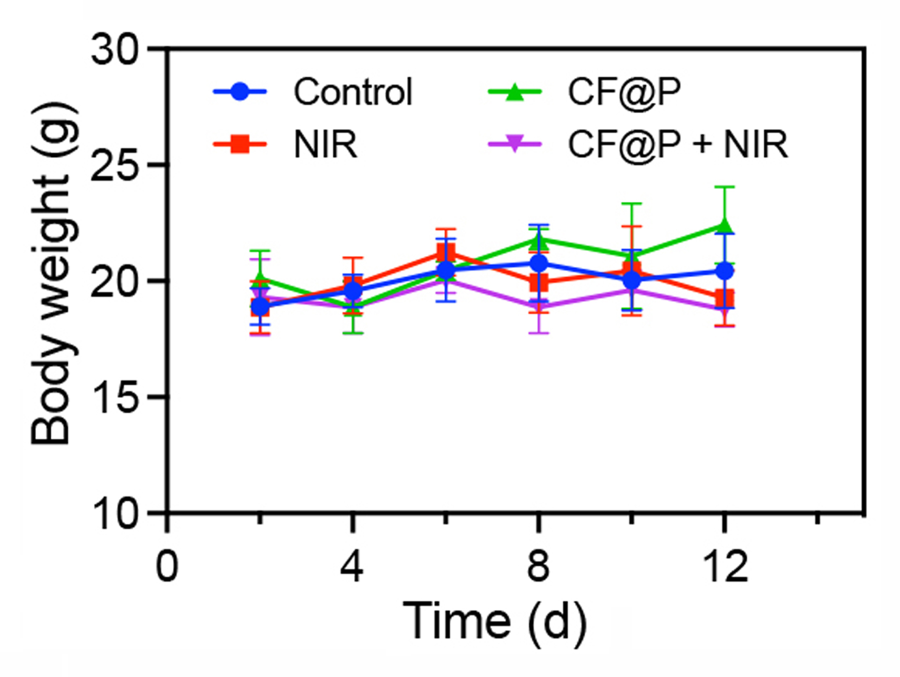
Figure S9. Body weights of the mice in various treatment groups.

