APPENDICES

Appendix 1:
Literature Search: Summary of Papers

Study | Population | Intervention  [Evaluation] | Comparison | Outcome
Mazotti et al. 2011 | Single-centre, US study. 45 supervisors of 3rd year students who supervised both longitudinal (one year) and regular block placements (of unspecified duration), multi-specialty, across two year group cohorts. | 29 Likert scale questions (5-point scale). Scale: 1-strongly disagree; 5-strongly agree | Responses merged into three overarching questions (validity of evaluation process; Quality of clinical skills evaluation; Willingness to provide feedback), and results statistically compared between longitudinal and block rotations | Assessors perceived longitudinal placements were better for:  Validity of evaluation process  Effect size = 0.63 (p<0.001)  Quality of clinical skills evaluation  Effect size = 1.11 (p<0.001)  Willingness to provide feedback  Effect size = 0.94 (p<0.001)
DaRosa et al. 2000 | Single-centre, US study. 31 supervisors of 3rd year students, 10-week surgical placement, across five year group cohorts. | 25 Likert scale questions (5-point scale). Scale: 1-strongly disagree; 5-strongly agree. | Mean responses calculated for each item, and presented as descriptive statistics. | Assessors held relatively positive perceptions about the quality and content of the evaluation system.  Assessors perceived they:  - rated fairly (mean 3.9/5.0)  - observed adequate clinical skills (mean 4.0/5.0)  - provided remedial attention where needed (mean 3.9/5.0).  However, assessors perceived they struggled to rate poor levels of performance and may not have been rating consistently with other raters.  Assessors perceived they:  - did not water down negative evaluations (mean 2.7/5.0)  - candidly commented on poor performance (mean 2.3/5.0)  - used similar criteria to other raters (mean 2.8/5.0).
PICO format used for comparison of studies (54).
Appendix 2:
Sign-off grading

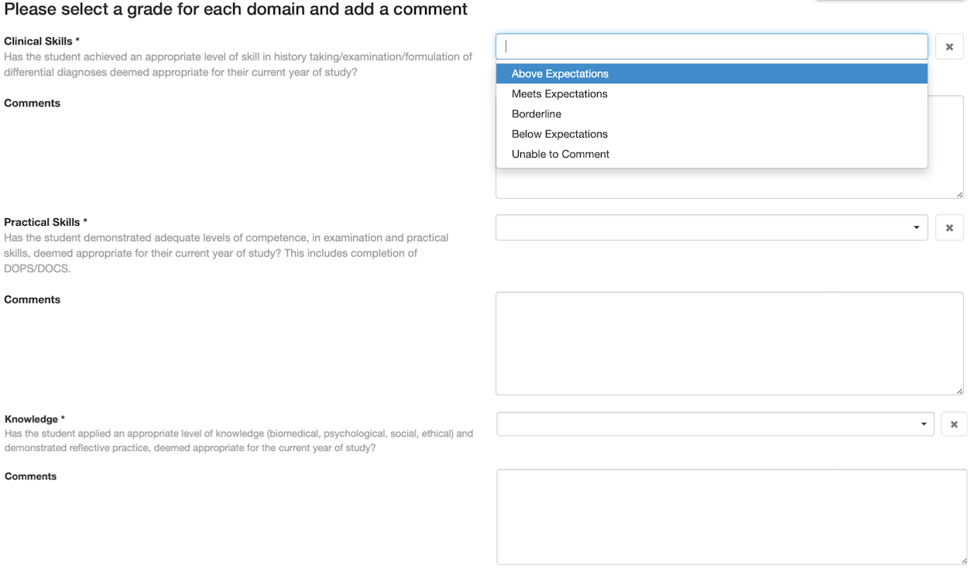

Appendix 3:
Supervisor feedback survey
The following questionnaire is intended to help us improve the sign-off process for medical students on clinical placements.
Answers are anonymous and there is no time limit. There will be 10 questions and it will take around 5-10 minutes of your time. Your feedback is much appreciated.
For questions 1-4 please indicate your response to each statement by selecting a tick-box.
For questions 6-10 please answer in the spaces provided.

Start of Block: Default Question Block

Background
Please indicate your specialty
- GP
- Medicine
- Surgery

Q1
I feel that I have adequate supervision time to assess students' knowledge on their clinical placement
 | Strongly Disagree | Disagree | Somewhat Disagree | Neither Agree nor Disagree | Somewhat Agree | Agree | Strongly Agree

Q2
I feel that I have adequate supervision time to assess students' skills on their clinical placement
 | Strongly Disagree | Disagree | Somewhat Disagree | Neither Agree nor Disagree | Somewhat Agree | Agree | Strongly Agree

Q3
I believe that my assessment of students' knowledge reflects their likely performance in end-of-year examinations
 | Strongly Disagree | Disagree | Somewhat Disagree | Neither Agree nor Disagree | Somewhat Agree | Agree | Strongly Agree

Q4
I believe that my assessment of students' skills reflects their likely performance in end-of-year examinations
 | Strongly Disagree | Disagree | Somewhat Disagree | Neither Agree nor Disagree | Somewhat Agree | Agree | Strongly Agree

Q5
Please indicate how many contact hours you have on average with students you supervise before you perform the end-of-placement sign-off


Page Break

Q6
Please list what sources of information you utilise when making a sign-off decision

Q7
Please comment on what you feel are the main advantages of a single clinical supervisor sign-off model for students on clinical placement

Q8
Please comment on what you feel are the main disadvantages of a single clinical supervisor sign-off model for students on clinical placement

Page Break

Q9
Please describe how the current sign-off process could be improved

Q10a
Please indicate if you would make any changes to the end-of-placement sign-off process
- Yes
- No

Q10b
Please explain your answer to question 10a above

End of Block: Default Question Block

We thank you for your time spent taking this survey.

Your response has been recorded.

Appendix 4:
Template Coding

Assessment form issues
Assessor training
Contact time
Conflicting learning requirements
Feasibility
Feedback
Informal sign-off considerations
Longitudinal assessment
Multi-source feedback
Other supervisory figures
Oversight of learner
Placement duration
Role of supervisor
Staff absences
Student curriculum

Appendix 5:

NVIVO Thematic analysis:

Themes | Sub-Themes | Codes
POSITIVES OF SINGLE SUPERVISOR MODEL
Accountability | Robust competency rating | Accountability to one person allows oversight
Accountability | Robust competency rating | Adequate scrutiny through named assessor
Accountability | Robust competency rating | Assigned assessor rather than student selected assessor
Accountability | Robust competency rating | Multiple assessors might presume another colleague has oversight
Accountability | Institutional requirements | Expected standards should be known to assessor
Accountability | Institutional requirements | Communication enhanced with a named contact for queries
Accountability | Institutional requirements | Training in sign-off form and curriculum for assessor
Accountability | Institutional requirements | Student attendance promoted at sessions with named assessor
Continuity | Continuity of assessment | Direct contact with student enhanced
Continuity | Continuity of assessment | Identification of gaps in student knowledge
Continuity | Continuity of assessment | Longitudinal assessment provides a better view of the learner
Continuity | Continuity of learning | Assessor can guide learning needs
Continuity | Continuity of learning | Heightened awareness of student strengths/weaknesses
Continuity | Continuity of learning | Individualised feedback from known assessor
Feasibility | Feasibility for assessor | Logistical ease
Feasibility | Feasibility for assessor | No requirement to review information from multiple raters
Feasibility | Feasibility for assessor | Time efficient sign-off process
Feasibility | Feasibility for assessor | Simple sign-off process for assessor (one meeting, one form)
Feasibility | Feasibility for student | Achievable sign-off process for student (one meeting, one form)
Feasibility | Feasibility for student | One sign-off minimalises potential student stress
NEGATIVES OF SINGLE SUPERVISOR MODEL
Effect on learning | Group structure of student placement | One student in learning group may dominate
Effect on learning | Group structure of student placement | Groups of students on each placement reduces individual contact time
Effect on learning | Negative effect on student learning from others in informal supervisory roles | Modern working practices share inpatient care between consultants
Effect on learning |  | Reduced student motivation to engage with teachers who are not the named supervisor
Effect on learning |  | Student expectation that clinical time without their supervisor present is not efficient to achieve goals
Effect on learning | Sign-off focused students | Attendance of learners drops once sign-off form completed
Effect on learning | Sign-off focused students | Students are sign-off focused
Effect on learning | Supervisor style variance | Conflict between role of teacher and assessor
 | Supervisor style variance | Formal feedback limited to one voice
 | Supervisor style variance | Supervision style may not suit student learning style
Inflexibility | Availability | Clashing university and hospital agendas/learning activities
Inflexibility | Availability | In person sign-off causes timetabling difficulties
Inflexibility | Availability | Lack of information available from others in supervisory roles at time of sign-off
Inflexibility | Availability | No interim progress meeting
Inflexibility | Availability | Staff leave or emergency cover
Inflexibility | Availability | Staff or student sickness
Inflexibility | Organisational constraints | Changes to curriculum or to assessment forms
Inflexibility | Organisational constraints | Frequent supervisor changes
Inflexibility | Organisational constraints | No time provision for supervision in supervisor’s job plans
Inflexibility | Organisational constraints | Service provision commitments take precedent
Inflexibility | Organisational constraints | Unpaid supervisor role
Limited contact time | Observation bias | Altered motivation of students in presence of assessor
Limited contact time | Observation bias | Direct oversight of learner relatively brief
Limited contact time | Observation bias | Limited feedback possibilities
Limited contact time | Observation bias | Short rotations provide a snapshot viewpoint of competency
Limited contact time | Observation bias | Student attendance needs to be adequate for accurate assessment
Limited contact time | Observation bias | Variation in case presentation or informal teaching difficulty
Limited contact time | Supervisor absence | Absence of supervisor affects entire process (leave/sickness)
Limited contact time | Supervisor absence | Fragmented period of observation from named supervisor
Limited contact time | Supervisor absence | Lack of backup option if the single supervisor is off
Limited contact time | Supervisor absence | Supervisor’s rota may not align with the best educational opportunities for students
Psychometric concerns | Reliability concerns | Assessor bias
Psychometric concerns | Reliability concerns | Differing assessor perceptions of acceptable standards
Psychometric concerns | Reliability concerns | No triangulation with other assessors
Psychometric concerns | Reliability concerns | Rating variation between different assessors
Psychometric concerns | Reliability concerns | Snapshot assessments
Psychometric concerns | Reliability concerns | Supervisors may not be equally engaged in the process
Psychometric concerns | Reliability concerns | Variation in assessor marking stringency
Psychometric concerns | Validity concerns | Lack of workplace-based assessment requirements
Psychometric concerns | Validity concerns | No formal quantitative progress assessment of knowledge or skills
Psychometric concerns | Validity concerns | Rating often based on surrogate markers (attendance/punctuality)
Psychometric concerns | Validity concerns | Reluctance to fail
Psychometric concerns | Validity concerns | Willingness to engage/enthusiasm easier to rate than knowledge/skills
Sign-off form shortcomings | Generic sign-off form | Attendance log on form would be useful
Sign-off form shortcomings | Generic sign-off form | Lack of specific tasks to complete (e.g. workplace-based assessment)
Sign-off form shortcomings | Generic sign-off form | Overlapping skills domains
Sign-off form shortcomings | Generic sign-off form | Ratings based on overall impressions
Sign-off form shortcomings | Generic sign-off form | Ratings from previous placements not visible to supervisors
Sign-off form shortcomings | Generic sign-off form | Tick box approach
Sign-off form shortcomings | Lack of student input on form | Lack of student activity logbook on form
Sign-off form shortcomings | Lack of student input on form | Self-reflection/self-rating not included on form
Sign-off form shortcomings | Not all domains assessed on the sign-off form are necessarily observed | Clinical skills performance is often not observed
Sign-off form shortcomings |  | Skills tutor a better placed rater for skills
Sign-off form shortcomings |  | Lack of multi-source feedback mechanism
Sign-off form shortcomings | Process issues | In person sign-off can reduce depth of feedback due to time pressure
Sign-off form shortcomings | Process issues | Junior doctors spend more time with students than supervisor
Sign-off form shortcomings | Process issues | No option for remote sign-off
Sign-off form shortcomings | Process issues | Sign-off may reflect performance in the workplace, rather than in exams
Sign-off form shortcomings | Process issues | Teaching fellow well placed to rate students but not included on form

