Local M1 macrophage reprogramming with gluconic acid-coated selenium nanoparticles
Zi-Xian Liao ¹
Da-Liang Ou ²
Chia-Lang Hsu ^{2,3}
Lin-Ni Lu ¹
Cheng-Han Wen ⁴
Lin Lu ⁴
Chun-Lun Chiu ⁴
Pan-Chyr Yang ⁵
S.-Ja Tseng ^{6,7}

¹Institute of Medical Science and Technology, National Sun Yat-sen University, Kaohsiung, Taiwan; ²Graduate Institute of Oncology, National Taiwan University College of Medicine, Taipei, Taiwan; ³Department of Medical Research, National Taiwan University Hospital, Taipei, Taiwan; ⁴Department of Research and Development, True Diamond Health Co., Ltd., Taoyuan, Taiwan; ⁵Department of Internal Medicine, National Taiwan University College of Medicine, Taipei, Taiwan; ⁶Department of Pharmacology, College of Medicine, National Cheng Kung University, Tainan, Taiwan; ⁷NCKU Center of Applied Nanomedicine, Tainan, Taiwan

Correspondence: Pan-Chyr Yang, Department of Internal Medicine, National Taiwan University College of Medicine, Taipei, Taiwan. Email: pcyang@ntu.edu.tw; S.-Ja Tseng, Department of Pharmacology, College of Medicine, National Cheng Kung University, Tainan, Taiwan. Email: z11302016@ncku.edu.tw

Figure S1. Zeta potential analysis of GA-SeNPs.

Figure S2. Fourier transform-infrared (FT-IR) spectrum of GA-SeNPs. The black arrow in the FT-IR spectrum identifies the peak associated with a particular functional group.

A

B

Figure S3. Characterization of GA-SeNPs. (A) X-ray diffraction (XRD) pattern of GA-SeNPs. (B) Transmission electron micrographs (TEM) of GA-SeNPs. The GA-SeNPs were studied at three particle size increments: 30-70 nm, 80-120 nm, and 180-220 nm. Scale bar: 1000 nm.
Figure S4. Sample to sample comparison. Heatmap clustering analysis visualized composition of M1-like macrophages, M2-like macrophages, or M2-like macrophages treated with GA-SeNPs similarities using Euclidean distance and transcripts per million (TPM) values to group samples by gene expression. Darker colors indicated higher similarity.

Figure S5. Differential Gene Expression Across Samples. Heatmap clustering analysis visualized differential gene expression across experimental conditions. Genes with similar expression patterns may share functions or regulatory pathways. The standardized expression values were converted to Z-scores, with red indicating high expression and blue low expression. The heatmap highlighted the top 100 genes with the highest variance, revealing key expression differences.

(a)
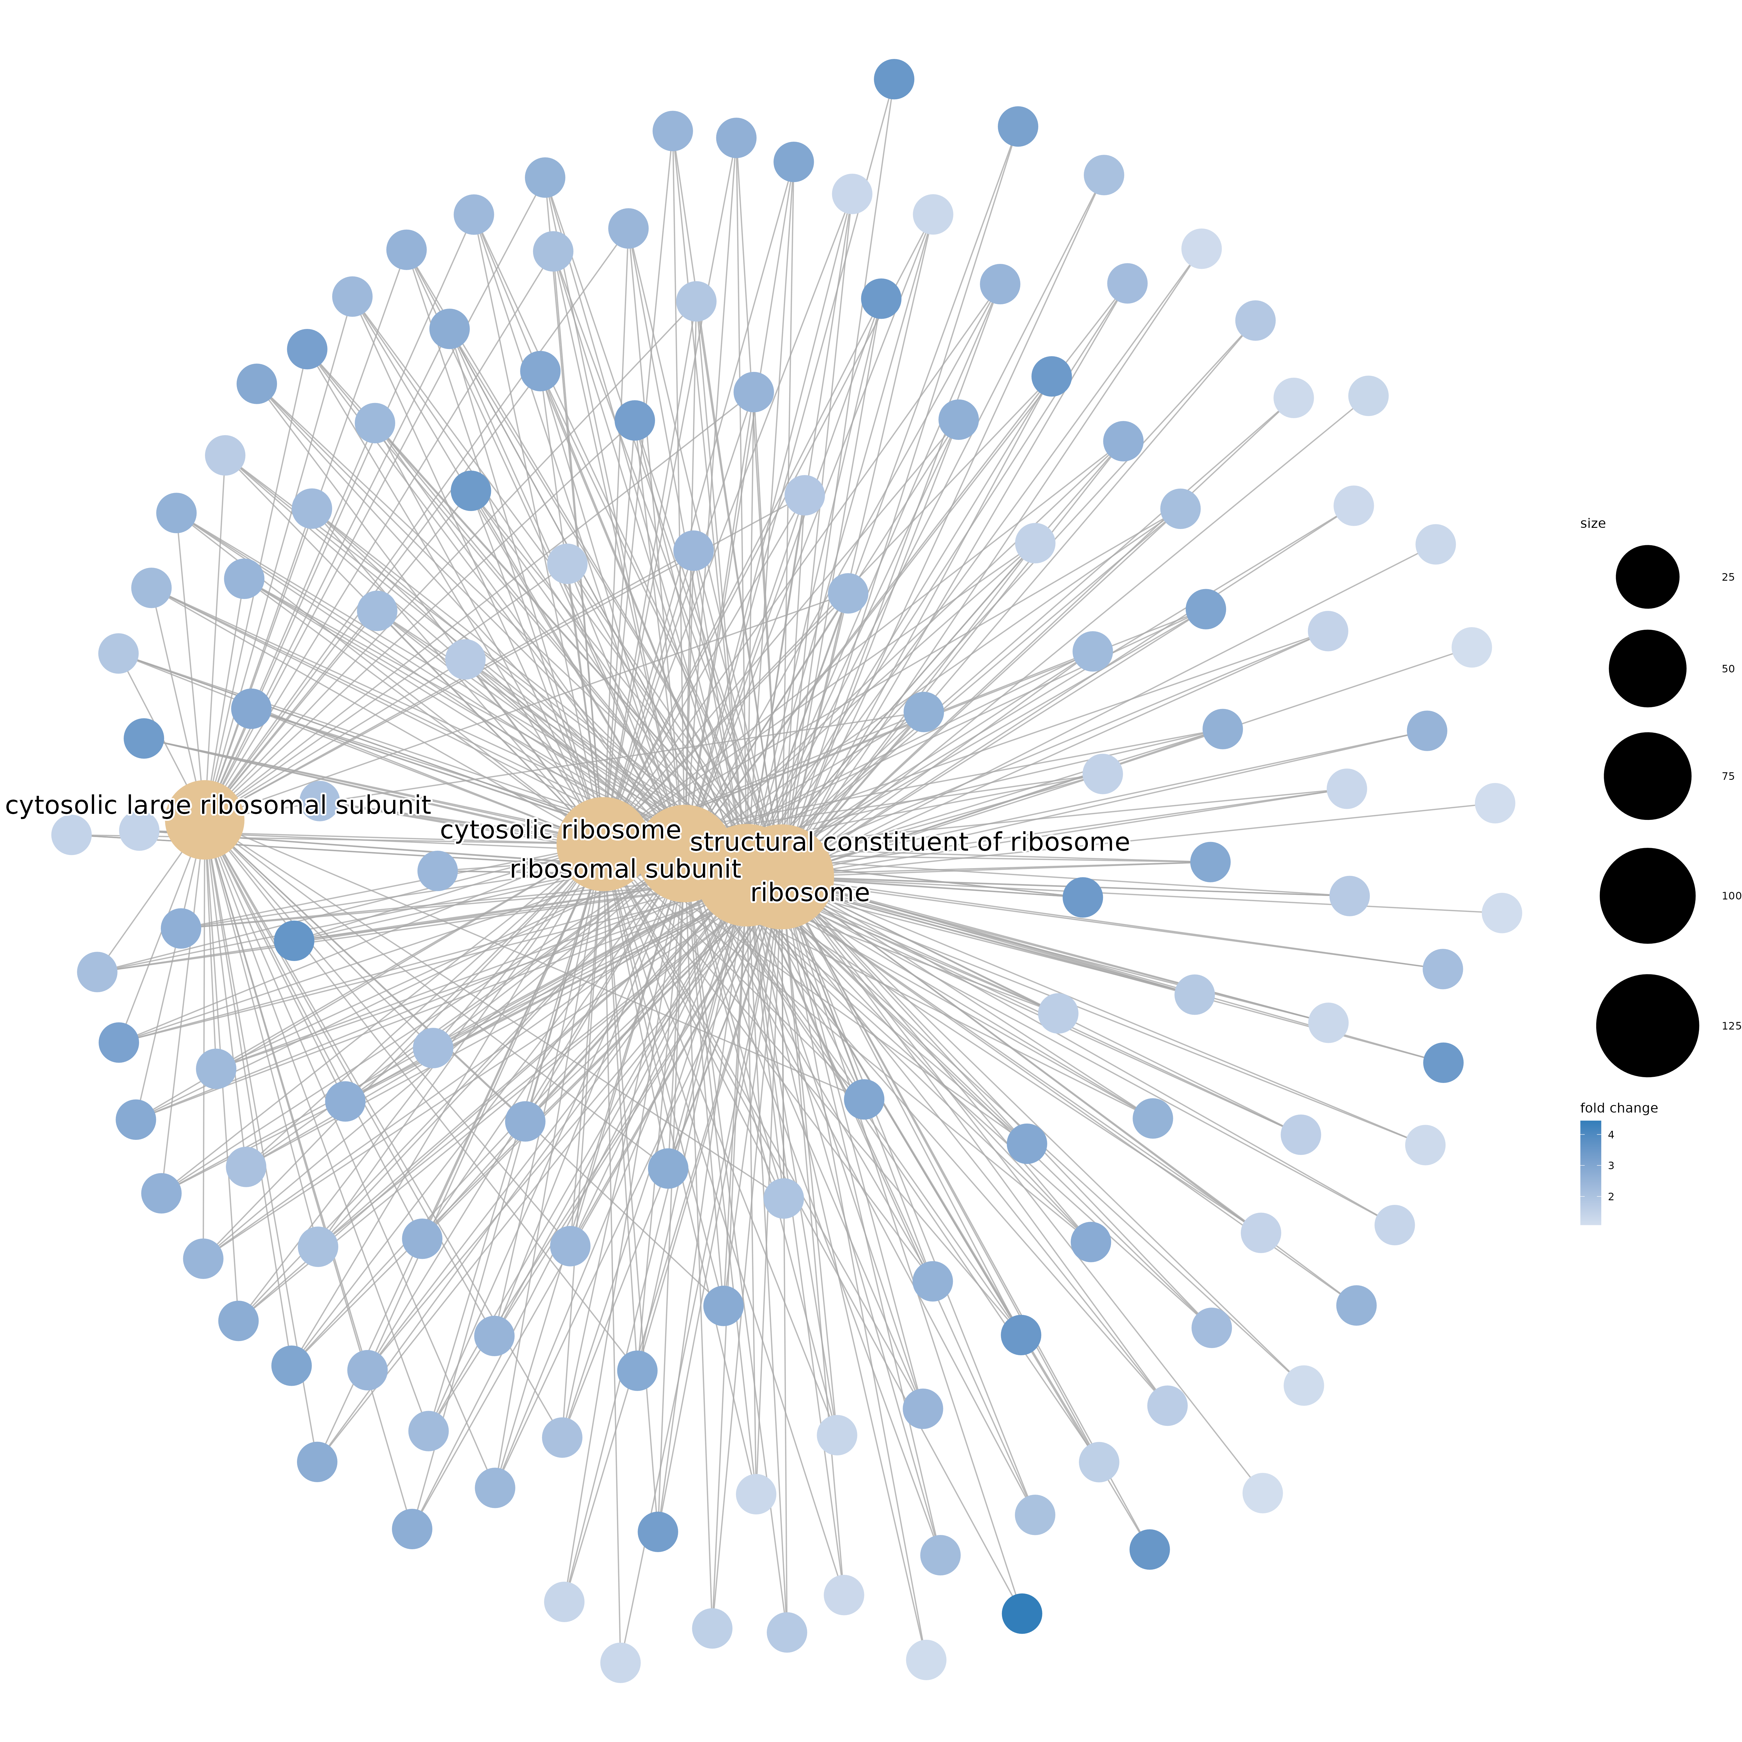
(b)
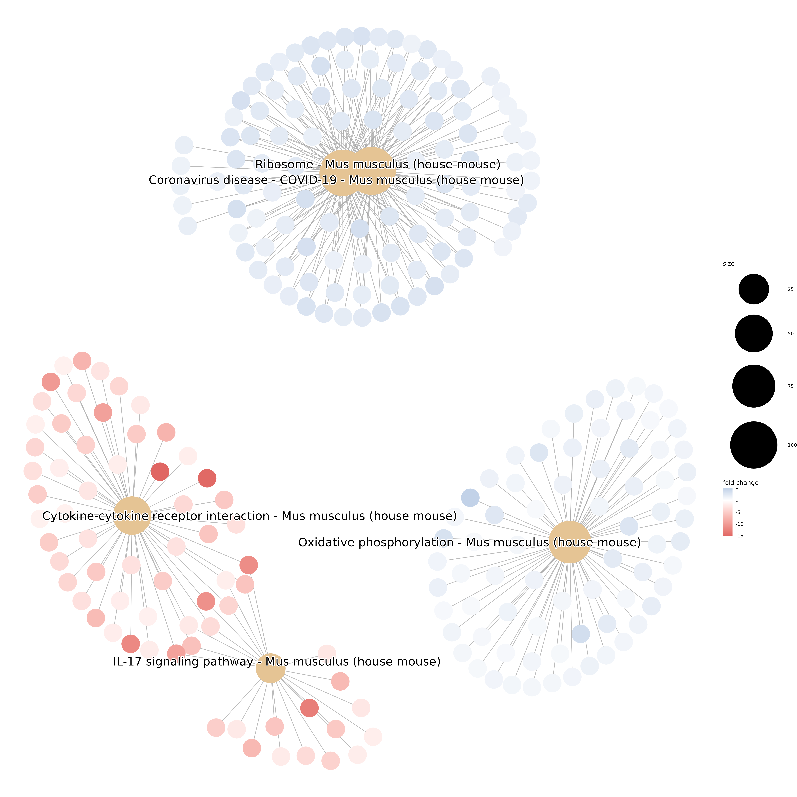
Figure S6. The cnetplot of gene set enrichment analysis. GO (a) and KEGG (b) of M1-like vs M2-like macrophages.
(a)
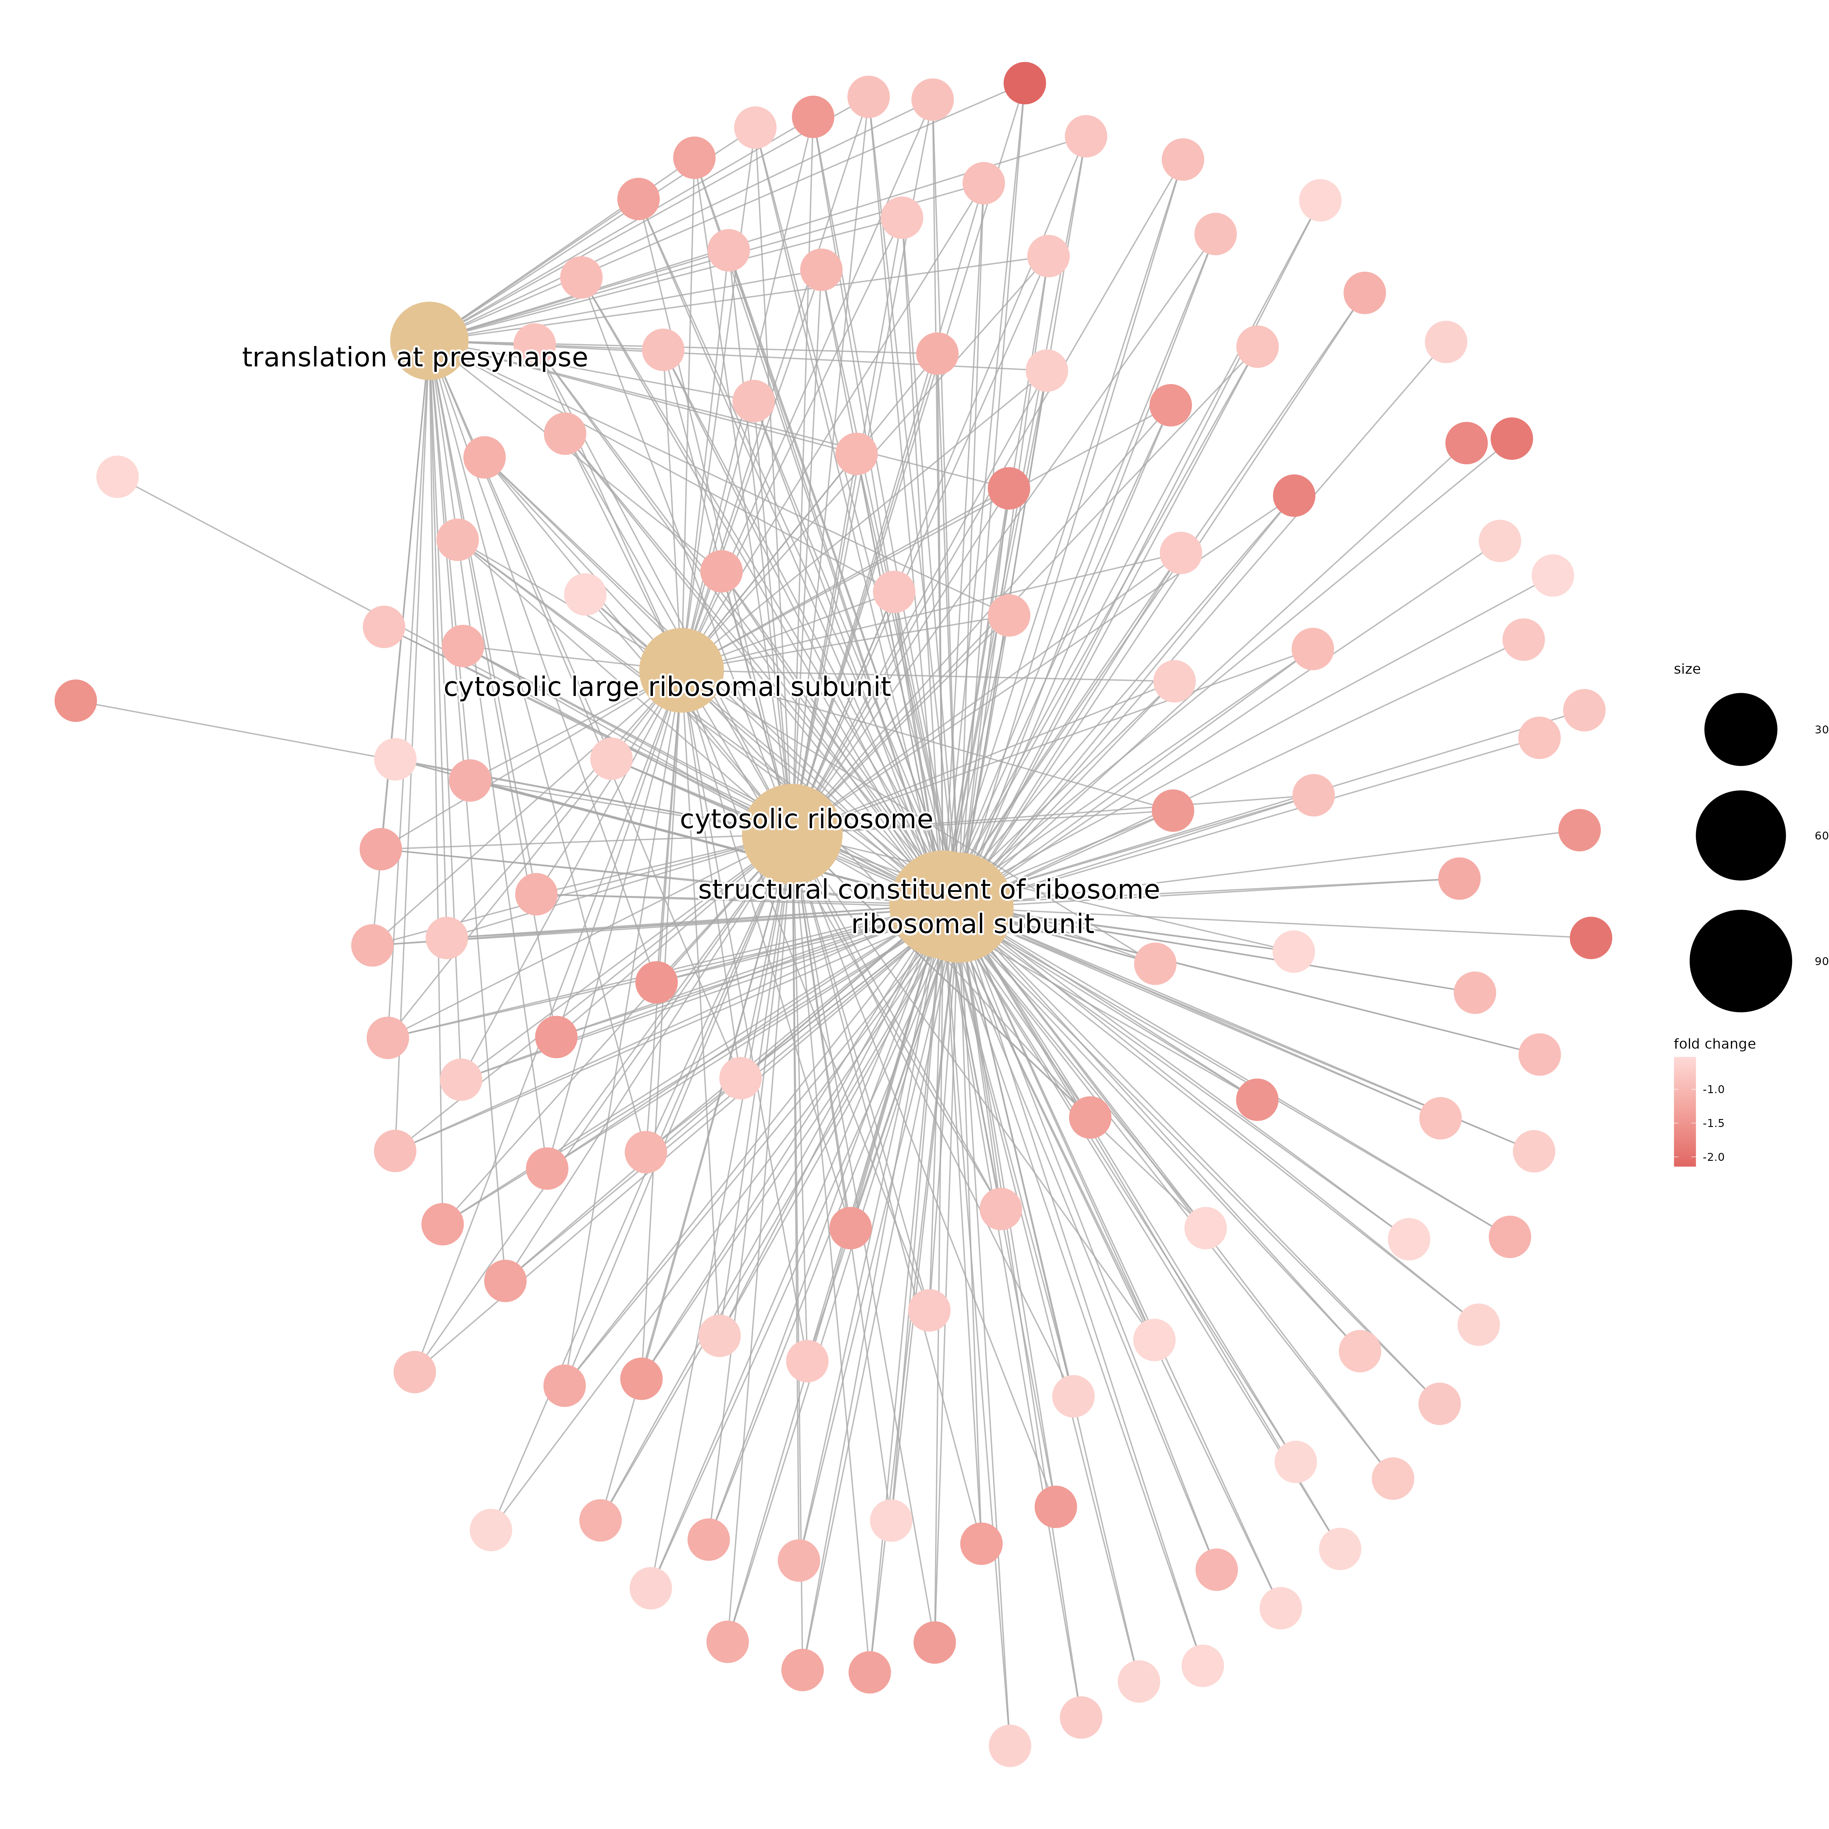
(b)
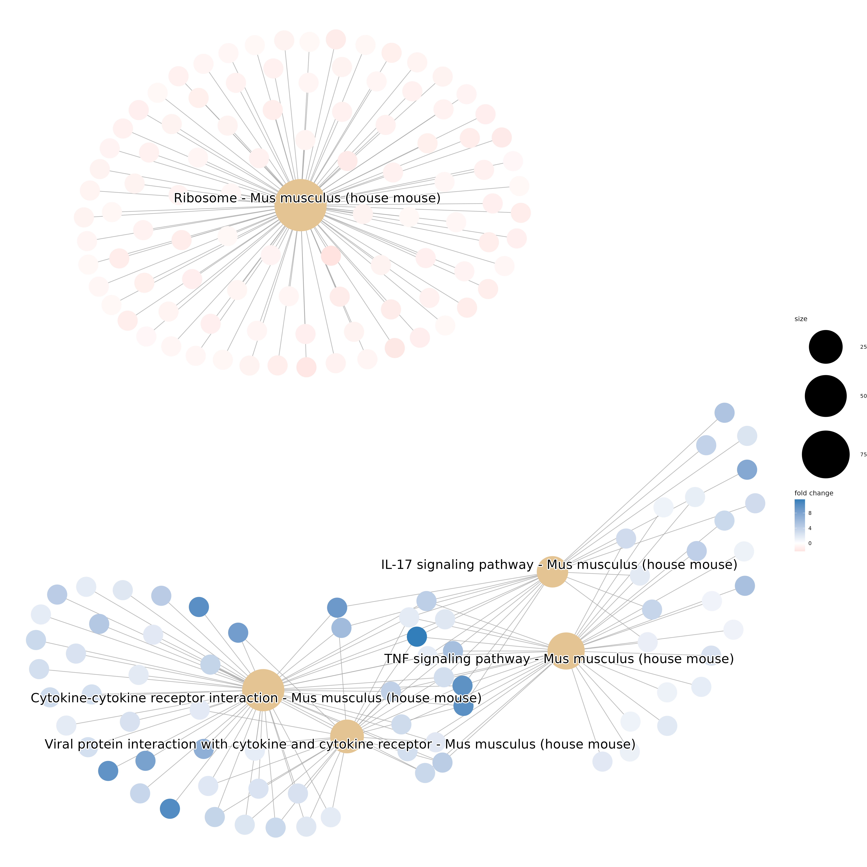
Figure S7. The cnetplot of gene set enrichment analysis. GO (a) and KEGG (b) of GA-SeNPs + M2-like vs M2-like macrophages.

Figure S8. Representative images showing ROS production induced by GA-SeNPs of varying diameters in B16-F10 cells at pH 7.4. Scale bars = 200 µm. The GA-SeNPs exhibited three particle size ranges: 30 to 70 nm (I), 80 to 120 nm (II), and 180 to 220 nm (III).

Figure S9. Representative images of TUNEL assay showing apoptotic cells induced by GA-SeNPs of varying diameters in B16-F10 cells at pH 7.4. Scale bars = 200 µm. The GA-SeNPs were studied at three particle size increments: 30-70 nm (I), 80-120 nm (II), and 180-220 nm (III).

Figure S10. H&E-stained sections of major organs (heart, liver, kidney, spleen, and lung) from mice following various treatments. Scale bars: 200 μm.

Figure S11. Measurement of tumor-infiltrating immune cells in xenograft tumors, including B cells (CD19⁺ staining), CD4⁺ T cells (CD4⁺ staining), and CD8⁺ T cells (CD8⁺ staining).

