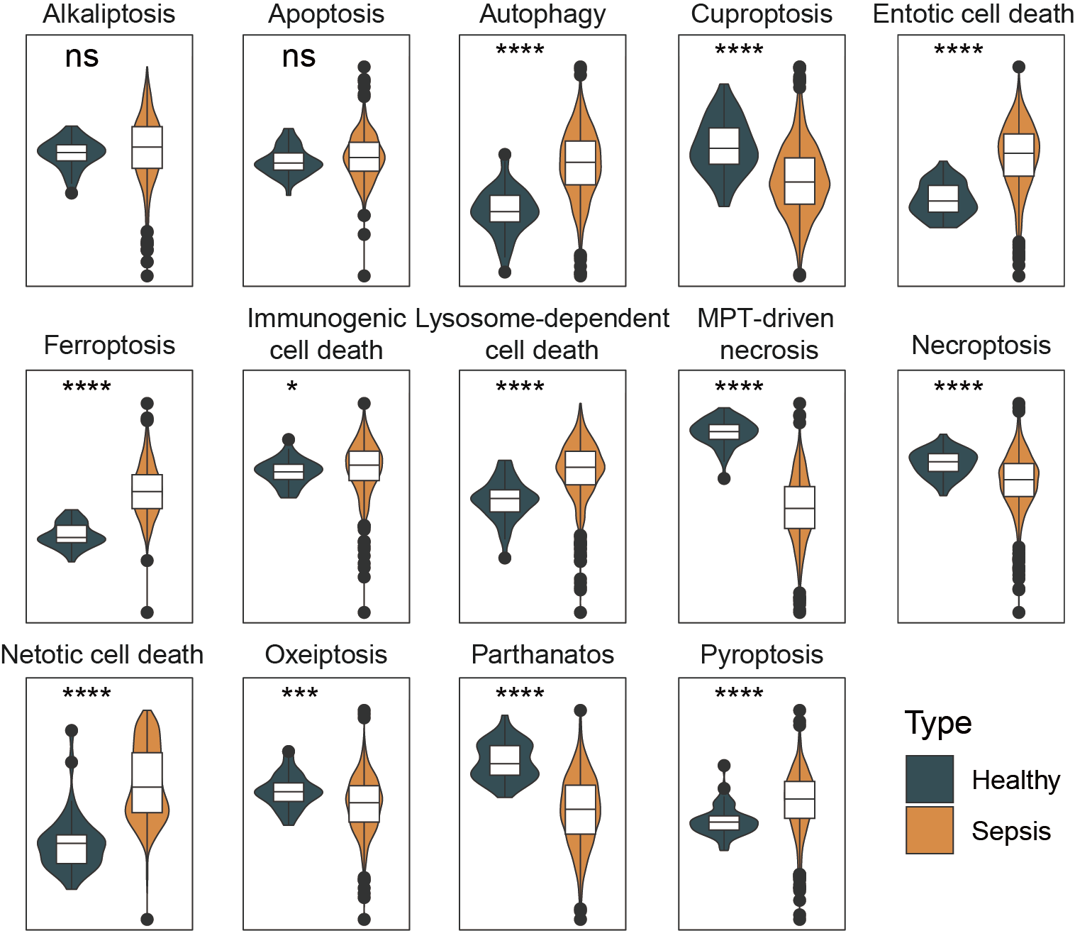
Fig.S1 The scores of 14 programmed cell death (PCD) patterns in healthy and sepsis groups. ns not significant, * p < 0.05, *** p < 0.001, **** p < 0.0001.

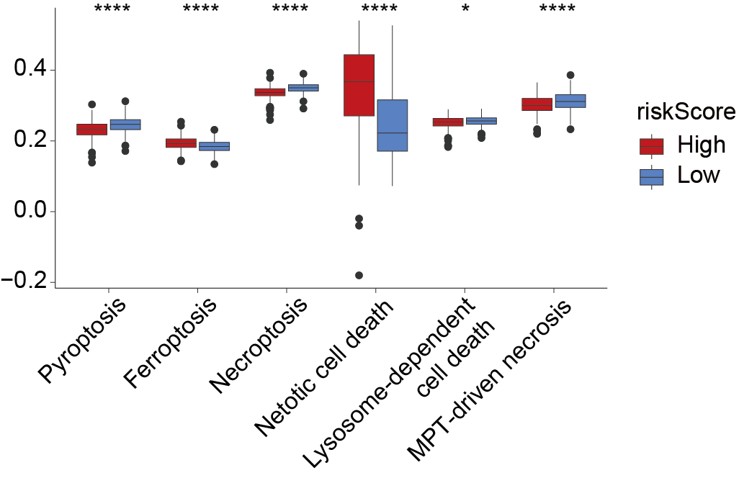
Fig.S2 The risk scores of 6 PCD patterns in high- and low-risk groups. * p < 0.05, **** p < 0.0001.
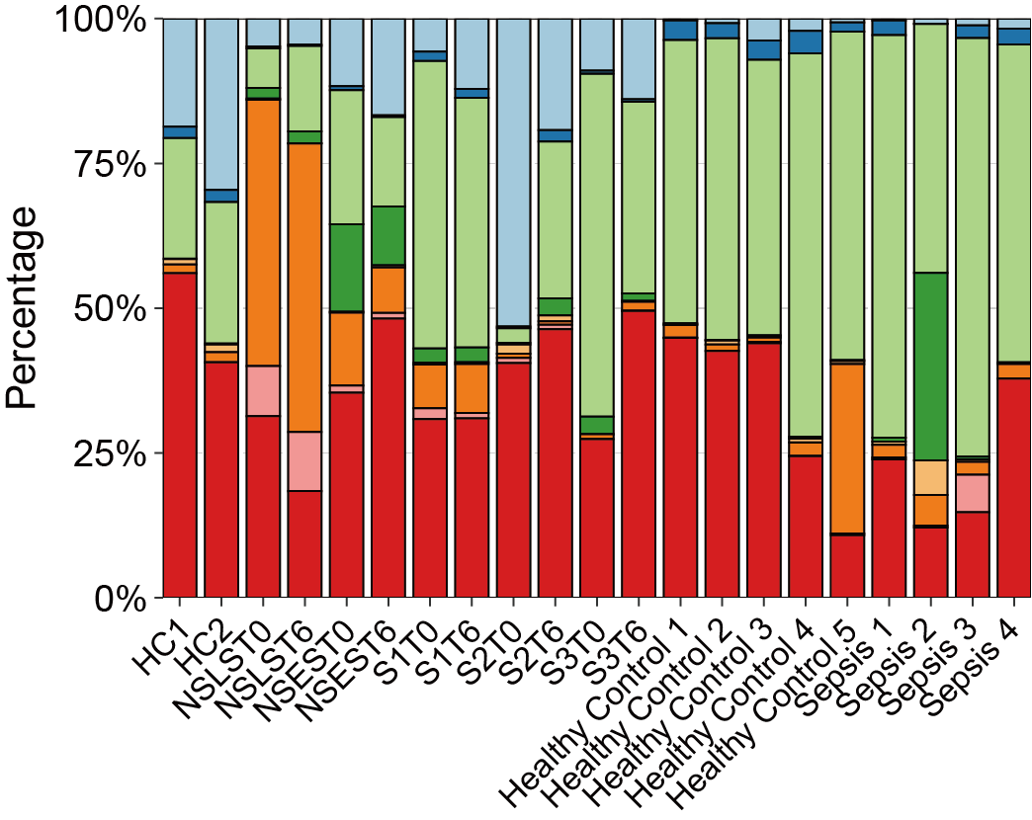
Fig.S3 The cellular percentage of the main cell types among different samples

