Supplementary Materials

Supplementary Materials and Methods

Synthesis of MHSD monomers
The CA monomers, (5-methyl-2-styryl-1,3-dioxan-5-yl)methyl methacrylate (CAMA), was synthesized using a two-step procedure. Firstly, 1,1,1-tris(hydroxymethyl)ethane (1.9 g, 16 mmol) and CA (1.06 g, 8 mmol) were dissolved in anhydrous THF, to which 16 g 5 Å molecular sieves and a catalytic amount of p-toluenesulfonic acid were added to the mixture. The reaction was carried out overnight at room temperature. Subsequently, 2 mL of triethylamine was added to terminate the reaction. The molecular sieves were removed and puriﬁed by silica gel chromatography using 2:1 hexanes/ethyl acetate to obtain white solid.

Synthesis of MMSD monomers
Secondly, the MHSD monomer (0.50 g, 2.1 mmol) and anhydrous triethylamine (0.42 g, 4.2 mmol) were dissolved in anhydrous CH₂Cl₂ and cooled to 0 °C. Methacryloyl chloride (0.44 g, 4.2 mmol) was then added dropwise. The reaction was carried out at room temperature for 24 h. The solvent was subsequently removed by rotary evaporation, and puriﬁed by silica gel chromatography using 4:1 hexanes/ethyl acetate to obtain MMSD monomers.

Preparation of PEG-PMMSD
Briefly, a mixture of CNM-containing monomer (134.7 mg, 0.45 mmol), macro-RAFT chain-transfer agent (48 mg, 0.023 mmol), and AIBN (0.14 mg, 0.99 μmol) dissolved into 1,4-dioxane (3 mL) was transferred into the polymerization tube (5 mL). Subsequently, the tube was degassed by three freeze−pump− thaw cycles before being sealed under vacuum. The mixture was polymerized for 24 h in an oil bath that was preheated at 80 °C. Thereafter, the tube was dipped into liquid nitrogen followed by exposing the reaction to air. The resultant mixture was diluted by CH2Cl2 (2 mL). The product was collected by precipitation and centrifugation into diethyl ether three times. Next, the obtained polymer was dried out in an oven overnight under vacuum to get a product.

Supplementary Figures
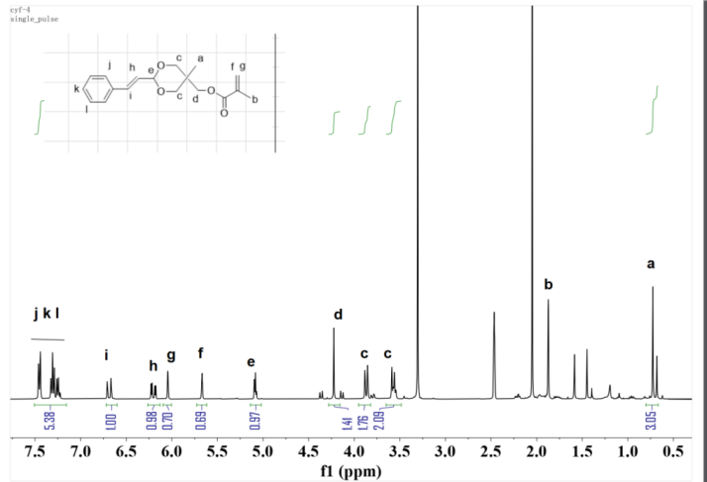
Figure S1. The H-NMR spectra of MMSD. The “a-l” designated proton ('H') in H-NMR spectrum.
Figure S2. The H-NMR spectra of PEG-PMMSD. The “a-i” designated proton ('H') in H-NMR spectrum.

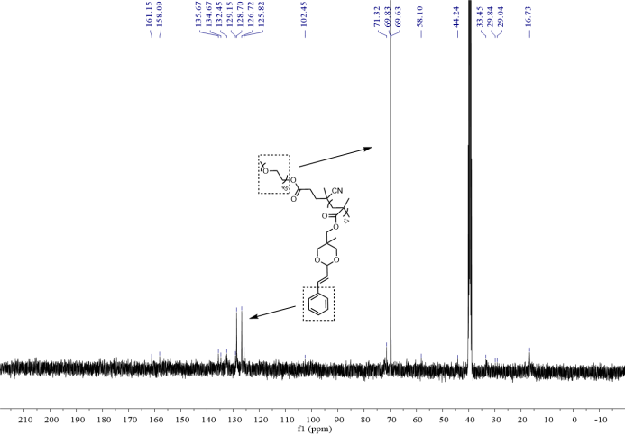
Figure S3. The C-NMR spectra of PEG-PMMSD.
Figure S4. The morphology of PPM nanomicelles in different pH environments was observed by transmission electron microscopy (TEM). Bar = 400 nm.
Figure S5. The size bar values for the microscopy image subfigure A (Figure 3).
Figure S6. Uptake of PPM by LLC and BEAS-2B cells was examined using confocal microscopy at pH 7.4 and pH 6.5, and the fluorescence intensity of PPM uptake was quantified. Data are presented as mean ± SD. Two-way ANOVA was used for intergroup comparisons, followed by appropriate post-hoc tests (Sidak's multiple comparisons test), *p < 0.05.
Figure S7. 2.5D fluorescence visualization of PPM uptake by co-cultured LLC and BEAS-2B cells under pH 7.4 (A) and pH 6.5 (B) conditions. The uptake of PPM by LLC/BEAS-2B cells within the co-culture system was assessed via confocal microscopy under pH 7.4 (C) and pH 6.5 (D) conditions. The yellow arrow indicates LLC cells, and the white arrow indicates BEAS-2B cells. Bar = 100 μm.
Figure S8. Successful establishment of LLC-LUC lung cancer xenograft model. (A) IVIS-based quantification of bioluminescence in LLC-LUC tumors (in vivo imaging system, IVIS). (B) Gross appearance of tumor (arrows/dashed circles denote tumor foci). (C) Histopathological demarcation between lung (L) and tumor (T) tissues (H&E; dashed line: border).
Figure S9. (A) Quantitative analysis of Ki-67-positive cells (absolute counts), n = 5. (B) TUNEL staining (AOD expressed as % of control, defined as 100%). n = 5. Data are presented as mean ± SD. One-way ANOVA was used for intergroup comparisons, followed by appropriate post-hoc tests (Tukey's HSD), *p < 0.05, **p < 0.01,***p < 0.0001, ****p < 0.0001.
Figure S10. Distinct tissue H&E staining patterns were observed in each experimental animal group, scale bar = 50 μm.

Supplementary Table

Table S1: Loading capacity and encapsulation efficiency of the drug-loaded nanomicelles.
SN38:PMMSD | EE(%) | DL(%)
1:3 | 88.89±6.96 | 13.3±4.61
1:5 | 88.72±5.11 | 19.57±2.17
1:8 | 82.93±13.84 | 8.19±2.93
1:10 | 88.91±7.92 | 8.55±1.76

