Supporting Information
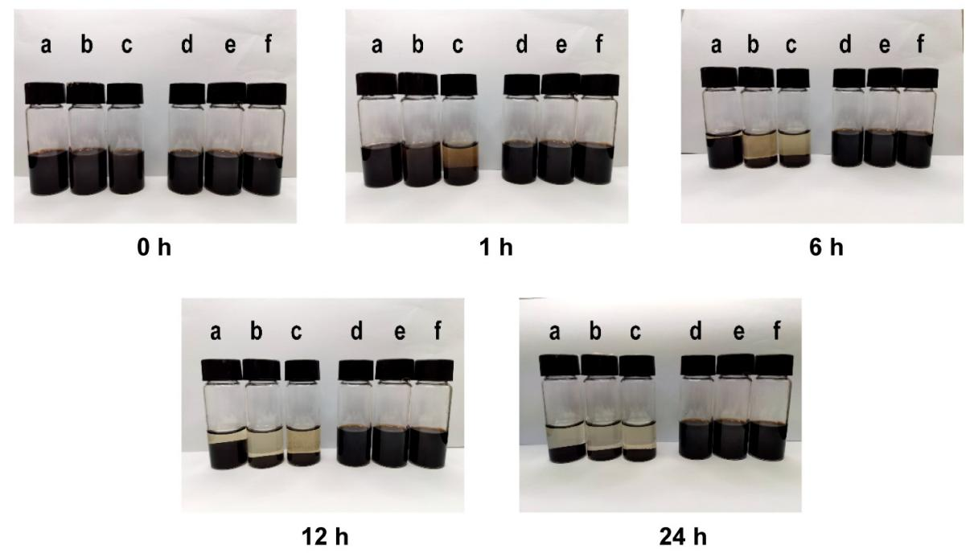
Figure S1. Dispersion stability of PDA and PEG-PDA NPs of different sizes in PBS at different time points. a. 50–100 nm PDA b. 100–150 nm PDA c. 150–200 nm PDA d. 50–100 nm PEG-PDA e. 100–150 nm PEG-PDA f. 150–200 nm PEG-PDA
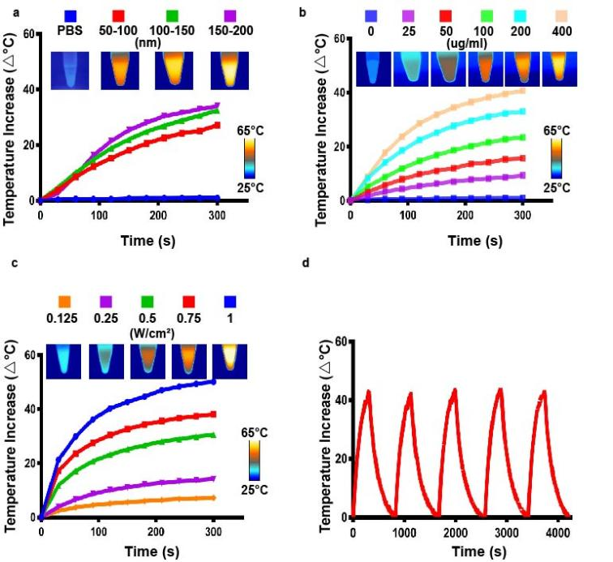
Figure S2. In vitro photothermal characterization of PPIG NPs. a. Temperature changes in solutions of the PPIG NPs of different sizes (400 μg/mL) in PBS under 808-nm laser irradiation (1 W/cm²) for 5 min. Inset: thermal images of PPIG NPs of different sizes (400 μg/mL) after constant 808-nm laser irradiation for 5 min. b. Temperature changes of varying concentrations of 150-200nm NPs (0, 25, 50, 100, 200, 400 μg/mL) in PBS under 808-nm laser irradiation (1 W/cm²) for 5 min. Inset: thermal images of 150-200nm PPIG NPs at indicated concentrations after constant 808-nm laser irradiation for 5 min. c. Temperature changes of 150-200nm PPIG NPs (400 μg/mL) under 808-nm laser irradiation at various power densities (0.125, 0.25, 0.5, 0.75, 1 W/cm²). Inset: thermal images of 150-200nm PPIG NPs (400 μg/mL) after constant 808-nm laser irradiation at indicated power densities for 5 min. d. Temperature elevation in the solution of 150-200nm PPIG NPs (400 μg/mL) in PBS over five cycles of NIR laser irradiation (808 nm, 1 W/cm²).
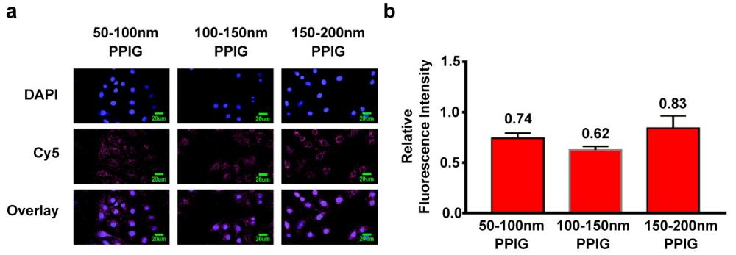
Figure S3. In vitro cellular uptake of PPIG NPs. a. Fluorescence imaging of SVEC4-10 cells incubated with the different-sized PPIG NPs (100 μg/mL) for 12 h. Images were acquired at the cy5.5 channel (670 nm) and DAPI channel (358 nm). Scale bar: 10 μm. b. Mean fluorescence intensity of SVEC4-10 cells incubated with different sizes of PPIG (100 μg/mL) for 12 h.
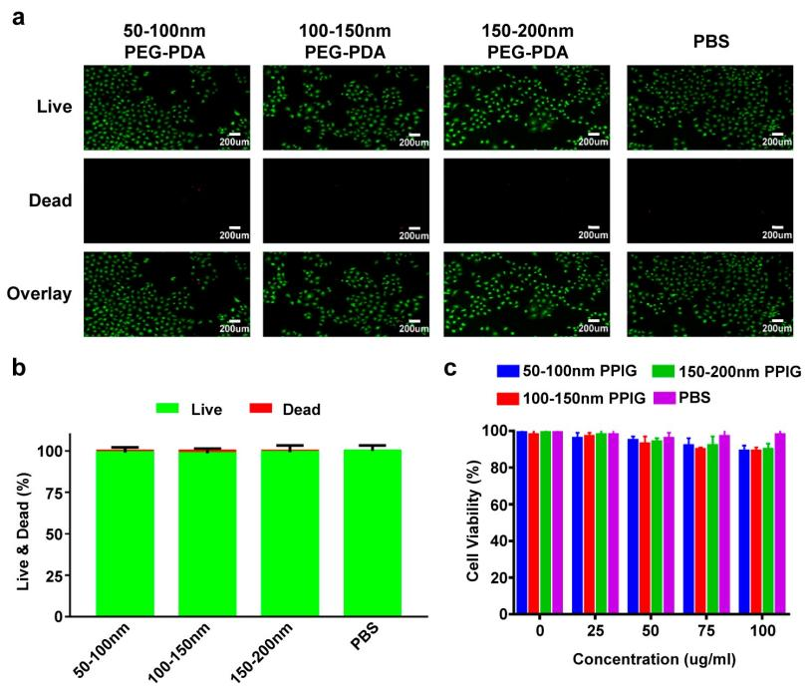
Figure S4. In vitro biosafety of PPIG NPs. a. Fluorescence imaging of SVEC4-10 cells incubated with the different-sized PPIG NPs (100 μg/mL) for 24 h. Green and red fluorescence in cells stained with calcein AM and PI indicate live and dead cells, respectively. Scale bar: 100 μm. b. Live-to-dead SVEC4-10 cell ratio after incubation with different-sized PPIG (100 μg/mL) for 24 h. c. Viabilities of SVEC4-10 cells incubated with different-sized PPIG NPs at various concentrations (0, 25, 50, 75, 100 μg/mL).
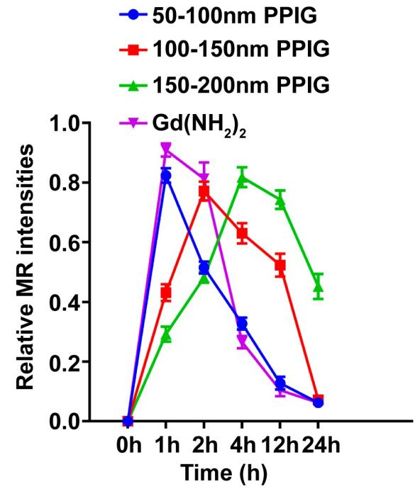
Figure S5. Average relative T1-weighted MRI signal intensities of the LN over 24 h after the injection of PPIG NPs of different sizes. (general linear model repeated measures) (n = 3).
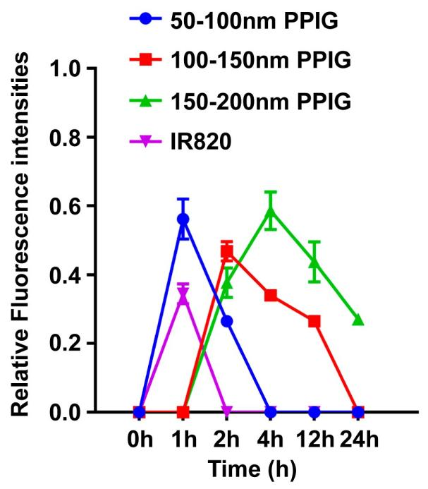
Figure S6. Average relative normalized fluorescence intensity of the LNs over 24 h after injection of PPIG NPs of different sizes and IR820 dye. (general linear model repeated measures) (n = 3).
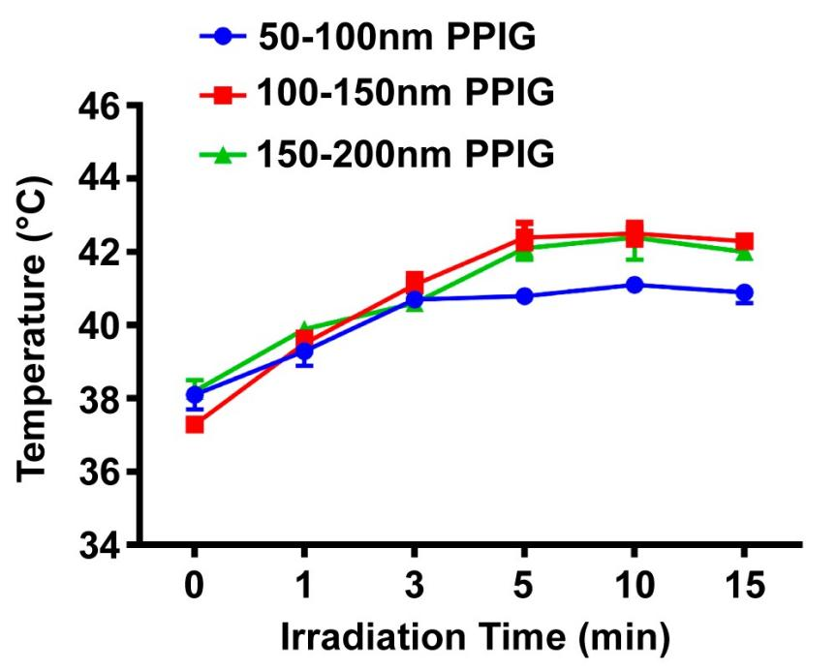
Figure S7. Temperature of LNs in living mice treated with PPIG NPs of different sizes under 808 nm laser irradiation.
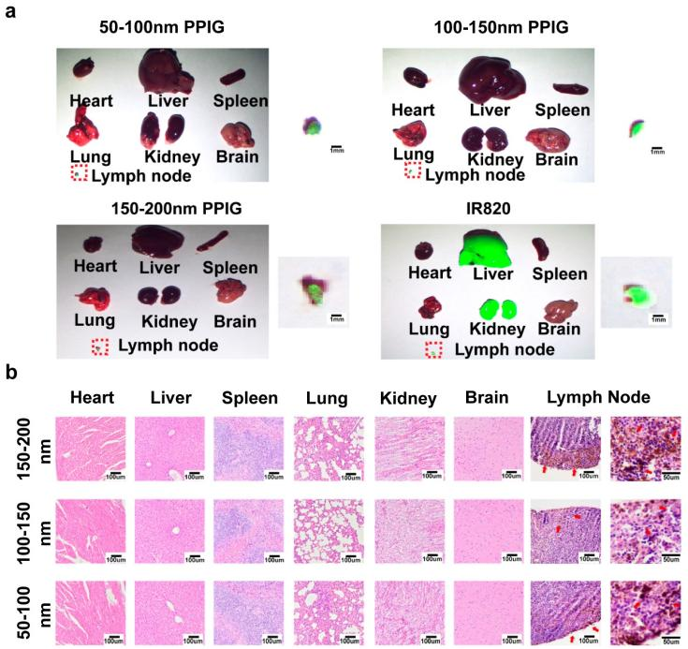
Figure S8. In vivo biodistribution and biosafety of PPIG NPs of different sizes in mice. a. In-vivo NIR fluorescence images of major organs and LNs after footpad injection of the different-sized of PPIG NPs. b. Histological examination of the major organs and LNs after footpad injection of the different-sized PPIG NPs. Red arrows indicate PPIG NPs in LNs.

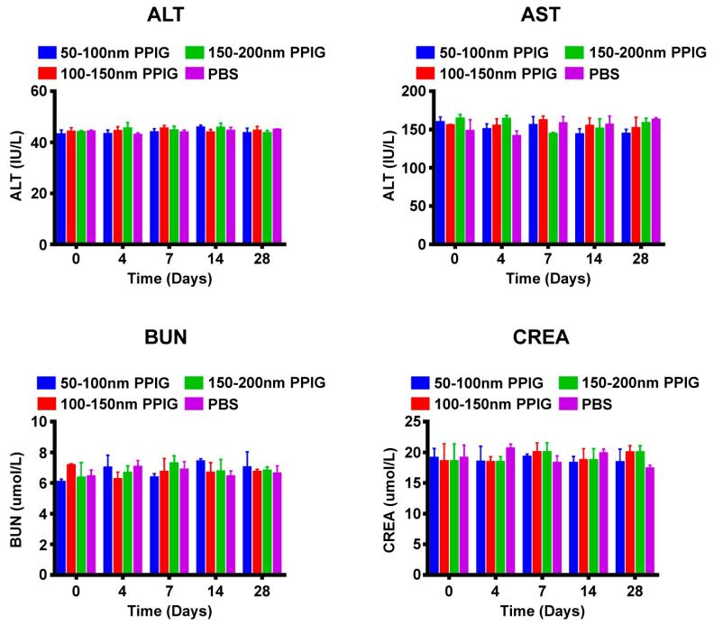
Figure S9. Changes in blood biochemistry indices (ALT, AST, BUN, and CREA) after footpad injection of PPIG NPs of different sizes in Balb/c.
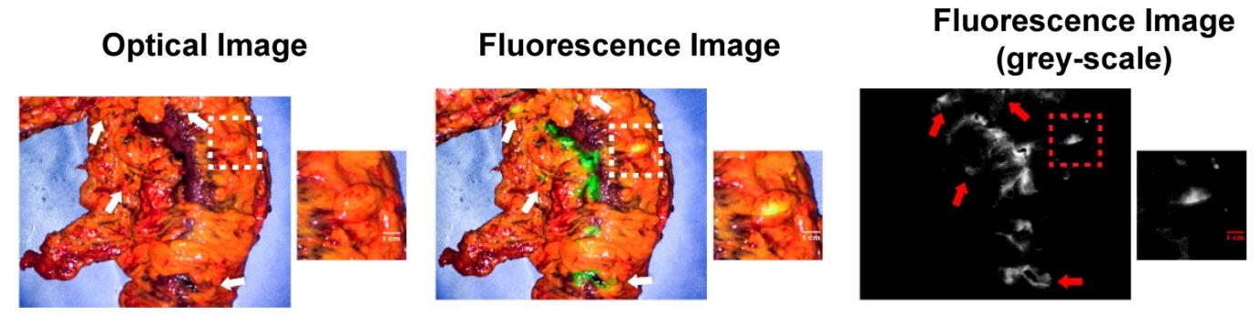
Figure S10. Optical/NIR fluorescence LN imaging in human specimens. Optical/NIR fluorescence LN images were acquired 60 min after subserosal injection of 50–100 nm PPIG NPs in the descending colon. Boxes and arrows indicate the LNs.
Figure S11. Representative D2-40 staining images of lymphatic vessel. Scale bar: 100 μm

