Supplemental Material 1
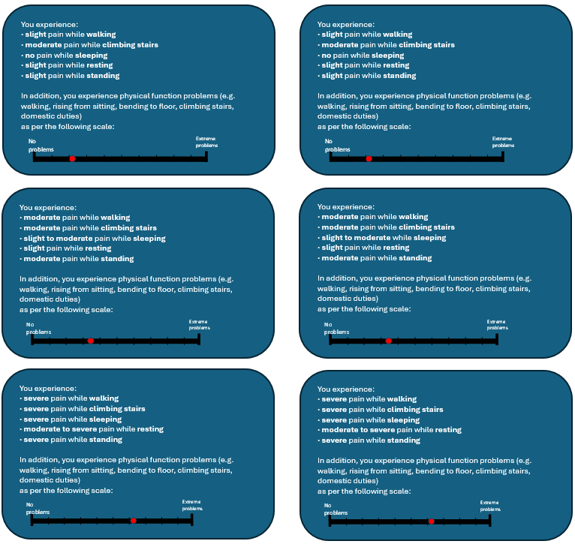
Figure S1. Add-on vignettes including a physical function component
SL1
SV1
MD1
SL2
MD2
SV2
MSL1
MSV1
MMD1
MSL2
MMD2
MSV2

SL1 slight 1, SL2 slight 2, MD1 moderate 1, MD2 moderate 2, SV1 severe 1, SV2 severe 2

Table S1. EQ-5D-5L dimension responses
EQ-5D level/dimension | Mobility  % (N) | Self-care  % (N) | Usual activities  % (N) | Pain/  discomfort  % (N) | Anxiety/  depression  % (N)
No problems | 4% (8) | 47.5% (94) | 9.6% (19) | 0.5% (1) | 37.9% (75)
Slight problems | 31.8% (63) | 25.3% (50) | 32.8% (65) | 30.8% (61) | 27.3% (54)
Moderate problems | 39.9% (79) | 22.7% (45) | 42.9% (85) | 41.9% (83) | 25.3% (50)
Severe problems | 24.2% (48) | 4.5% (9) | 12.1% (24) | 20.7% (41) | 6.1% (12)
Unable/Extreme problems | 0% (0) | 0% (0) | 2.5% (5) | 6.1% (12) | 3.5% (7)
 | Mean | SD | 25th percentile | Median | 75th percentile
EQ VAS | 56.04 | 19.77 | 40 | 60 | 70
UK EQ-5D-5L index values | 0.472 | 0.266 | 0.278 | 0.549 | 0.679
SD standard deviation, VAS visual analogue scale, UK United Kingdom

Table S2. Mean utility values for pain-based and pain+physical-based vignettes and the differences between the two sets of utilities
Health states | N  (pain only) | Mean  (pain only) | N  (pain+physical) | Mean  (pain+physical) | Difference  (pain+physical) - (pain only)
SL1 | 198 | 0.983 | 102 | 0.965 | -0.018
SL2 | 198 | 0.896 | 96 | 0.869 | -0.027
MD1 | 198 | 0.797 | 102 | 0.798 | 0.001
MD2 | 198 | 0.710 | 96 | 0.627 | -0.083
SV1 | 198 | 0.458 | 102 | 0.457 | -0.001
SV2 | 198 | 0.305 | 96 | 0.283 | -0.022
Differences between health states
SL2-SL1 |  | -0.087 |  | -0.096
MD1-SL2 |  | -0.099 |  | -0.071
MD2-MD1 |  | -0.087 |  | -0.171
SV1-MD2 |  | -0.252 |  | -0.170
SV2-SV1 |  | -0.153 |  | -0.174
SL1 slight 1, SL2 slight 2, MD1 moderate 1, MD2 moderate 2, SV1 severe 1, SV2 severe 2
Note: pain+physical-based vignettes were grouped into 2 groups (SL1/MD1/SV1 and SL2/MD2/SV2) and randomly assigned to half/half of the participants

Table S3. Differences mean vs mean censored utility values for pain-based and pain+physical-based vignettes

 | Pain-based health states |  |  | Pain+physical-based health states
Health States | Mean | Censored mean | Difference | Mean | Censored mean | Difference
Health States | Mean | Censored mean | (mean - censored mean) | Mean | Censored mean | (mean - censored mean)
SL1 | 0.983 | 0.983 | 0 | 0.965 | 0.965 | 0
SL2 | 0.896 | 0.896 | 0 | 0.869 | 0.869 | 0
MD1 | 0.797 | 0.797 | 0 | 0.798 | 0.797 | -0.001
MD2 | 0.71 | 0.708 | -0.002 | 0.627 | 0.624 | -0.003
SV1 | 0.458 | 0.44 | -0.018 | 0.457 | 0.44 | -0.017
SV2 | 0.305 | 0.247 | -0.058 | 0.283 | 0.221 | -0.062
Differences between health states SL1 as reference
SL2-SL1 | -0.087 | -0.087 |  | -0.096 | -0.096
MD1-SL2 | -0.099 | -0.099 |  | -0.071 | -0.072
MD2-MD1 | -0.087 | -0.089 |  | -0.171 | -0.173
SV1-MD2 | -0.252 | -0.268 |  | -0.17 | -0.184
SV2-SV1 | -0.153 | -0.193 |  | -0.174 | -0.219

SL1 slight 1, SL2 slight 2, MD1 moderate 1, MD2 moderate 2, SV1 severe 1, SV2 severe 2

