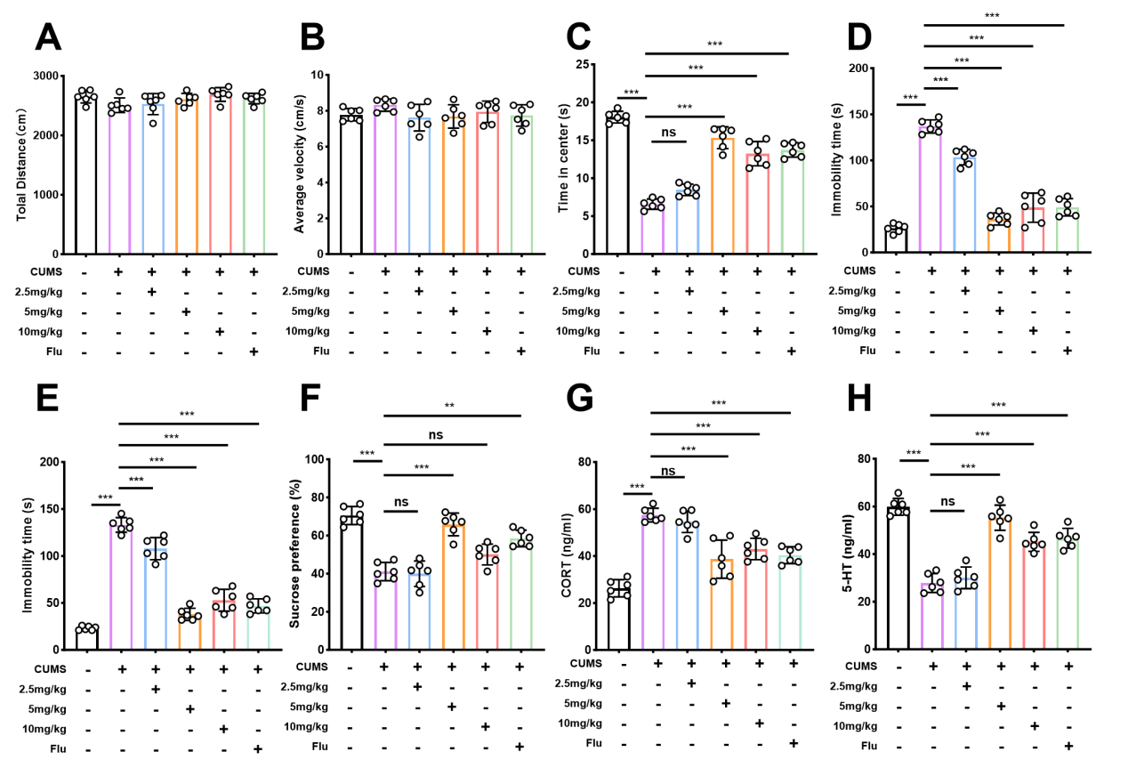
Figure S1. The antidepressant effects of GLX-NPs at different doses in the CUMS-induced depressive mice model. (A) Total distance traveled in the OFT (n = 6). (B) Average velocity in the OFT (n = 6). (C) Time spent in the center zone during the OFT (n = 6). (D)Immobility time in the FST (n = 6). (E) Immobility time in the TST (n = 6). (F) Sucrose consumption in the SPT (n = 6). (G) Serum CORT levels (n = 6). (H) Serum 5-HT levels. Values are presented as the mean ± SD. ns = not significant, **p<0.01, ***p<0.001.

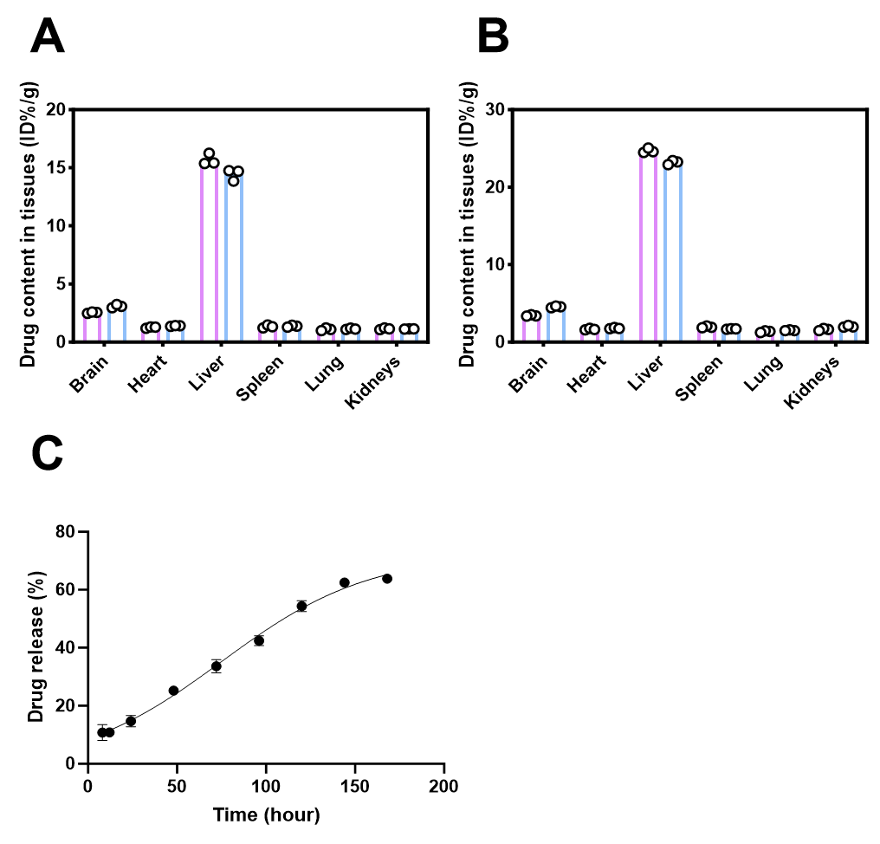
Figure S2. Synthesis and characterization of GLX-NPs. (A) Biodistribution of GLX and GLX-NPs in various tissues at 6 hours post-administration (n = 3). (A) Biodistribution of GLX and GLX-NPs in various tissues at 12 hours post-administration (n = 3). (C) In vitro release curve of GLX-NPs (n = 3).

Figure S3. Evaluation of CORT-induced stress model and GLX-NPs effects on cell viability via CCK-8 assay. (A-B) Cells were exposed to different concentrations of CORT, and an appropriate concentration was selected by CCK-8 assay to establish the ptosis model (n=3). (C) Effects of different concentrations of GLX-NPs on cell viability assessed by CCK-8 assay (n=3).

Figure S4. Assessment of intracellular lipid peroxidation and antioxidant biomarkers. (A-B) Measurement of intracellular LPO and relative fluorescence intensity (n=3). Scale bar = 50 μm. (C-E) Levels of GSH, SOD and MDA in HT22 cells from different groups (n=3). Data are presented as mean ± SD. ***p < 0.001.

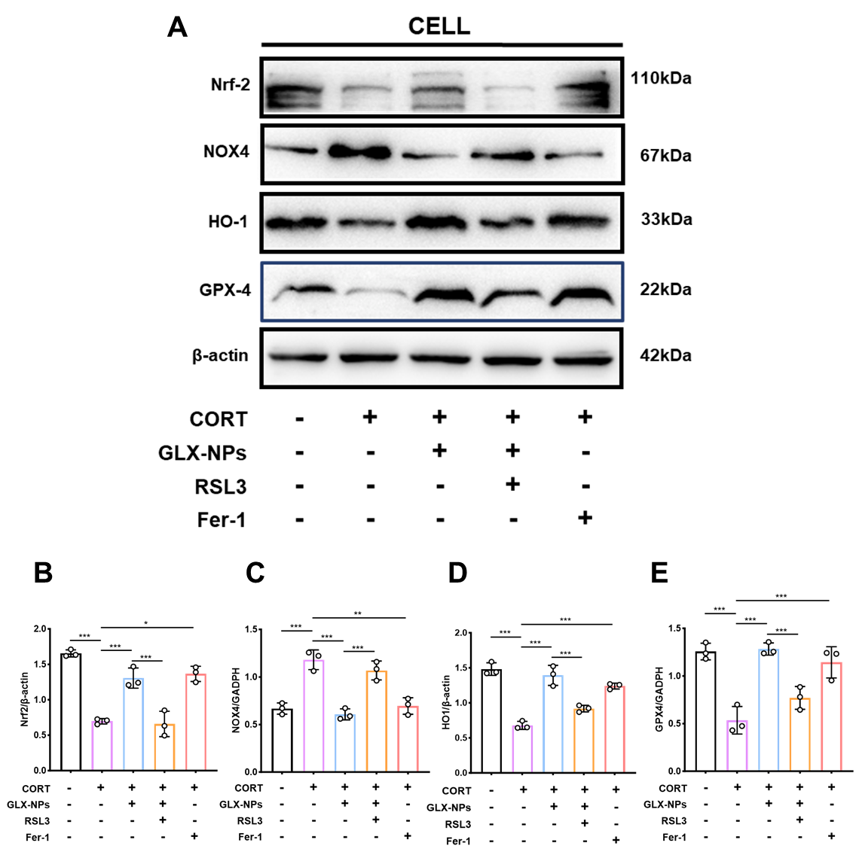
Figure S5. Protein expression analysis of NOX4, NRF2, HO-1, and GPX4 in HT22 cells. (A-E) Representative immunoblotting and quantitative analysis of NOX4, Nrf2, HO-1, and GPX4 of HT22 cells from different groups (n=3). Data are presented as mean ± SD. *p < 0.05, **p < 0.01, ***p < 0.001.

Figure S6. qPCR analysis in hippocampus and HT22 cells. (A-D) qPCR analysis of NOX4, NRF2, HO-1, and GPX4 expression levels in hippocampal tissue of mice from different groups (n=4). (E-H) qPCR analysis of NOX4, NRF2, HO-1, and GPX4 expression in HT22 cells from different groups (n=4). Data are presented as mean ± SD. ***p < 0.001.

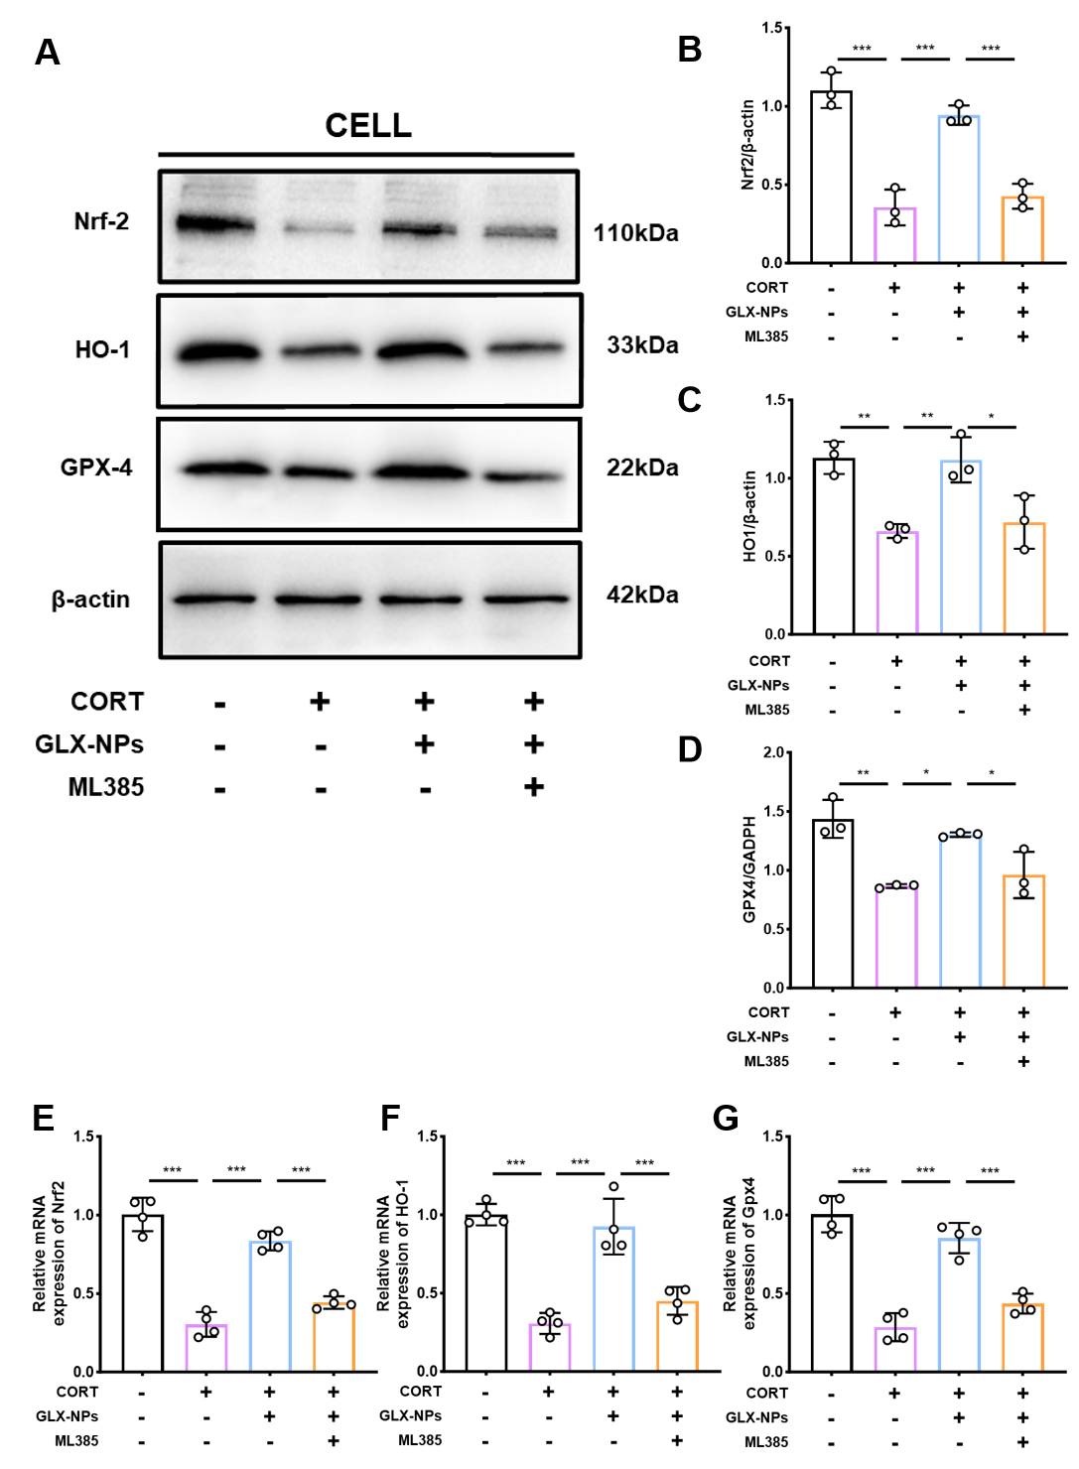
Figure S7. Protein and mRNA expression analysis of NRF2, HO-1, and GPX4 in HT22 cells. (A-D) Representative immunoblotting and quantitative analysis of Nrf2, HO-1, and GPX4 in HT22 cells from different groups (n=3). (E-G) qPCR analysis of Nrf2, HO-1, and GPX4 expression in HT22 cells from different groups (n=4). Data are presented as mean ± SD. *p < 0.05, **p < 0.01, ***p < 0.001.

Table. S1 Investigation of the mPEG-PCL to GLX ratio for DL and EE in preliminary experiments.

Table. S2 The antibodies used in the immunofluorescence experiments in this study
Antibody | Source/Identifier | Dilution ratio
anti-NADPH oxidase 4 (NOX4) | ABclonal, A22149 | 1:100
anti-Glutathione Peroxidase 4 (GPX4) | Abcam, ab125066 | 1:100
anti- NRF2 | Proteintech,16396-1-AP | 1:100
anti- HO-1/HMOX1 | Proteintech, 10701-1-AP | 1:100
anti-NeuN | Abcam, ab104224 | 1:50
Goat anti-Mouse IgG | Proteintech, SA00003-1 | 1:100
Goat anti-Mouse IgG | Proteintech, SA00009-1 | 1:100

Table. S3 The antibodies used in the Western blot experiments in this study
Antibody | Source/Identifier | Dilution ratio
anti-NADPH oxidase 4 (NOX4) | ABclonal, A22149 | 1:1000
anti- NRF2 | Proteintech,16396-1-AP | 1:1000
anti- HO-1/HMOX1 | Proteintech, 10701-1-AP | 1:2000
anti-Glutathione Peroxidase 4 (GPX4) | Abcam, ab125066 | 1:1000
anti-GAPDH | Proteintech, 60004-1-Ig | 1:10,000
anti-β-Actin | Beyotime, AF0003 | 1:1000
Goat anti-Mouse IgG | Beyotime, A0216 | 1:1000
Goat anti-Rabbit IgG | Beyotime, A0208 | 1:1000

Table. S4 Primer sequences
Gene | Forward Primer (5’—3’) | Reverse Primer (5’—3’)
Nox4 | CAGATGTTGGGGCTAGGATTG | GAGTGTTCGGCACATGGGTA
Nrf2 | AAAATCATTAACCTCCCTGTTGAT | CGGCGACTTTATTCTTACCTCTC
Ho-1 | CAAGCCGAGAATGCTGAGTTCATG | GCAAGGGATGATTTCCTGCCAG
Gpx4 | GCCTGGATAAGTACAGGGGTT | CATGCAGATCGACTAGCTGAG
β-actin | TTCAACACCCCAGCCATG | CCTCGTAGATGGGCACAGT

