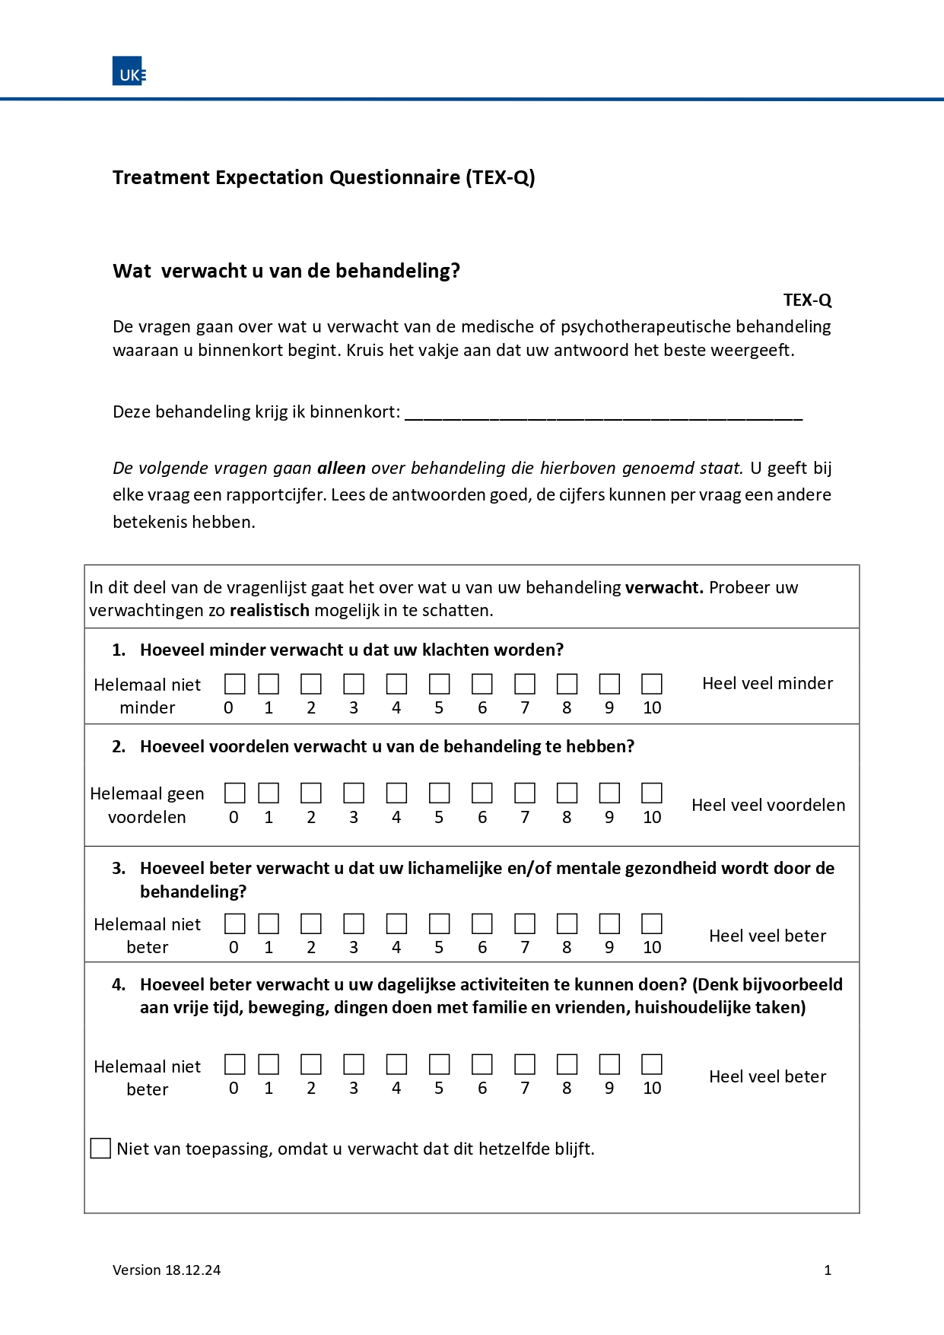
Additional Figure S1: Dutch TEX-Q
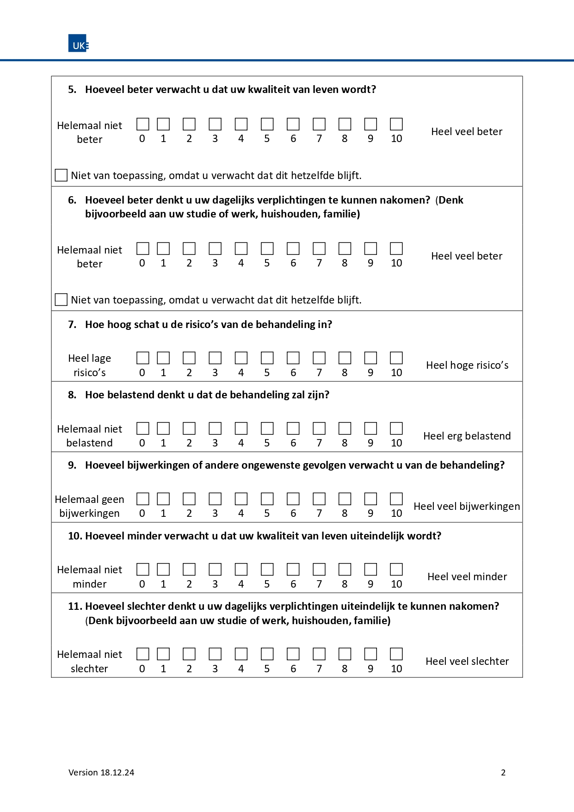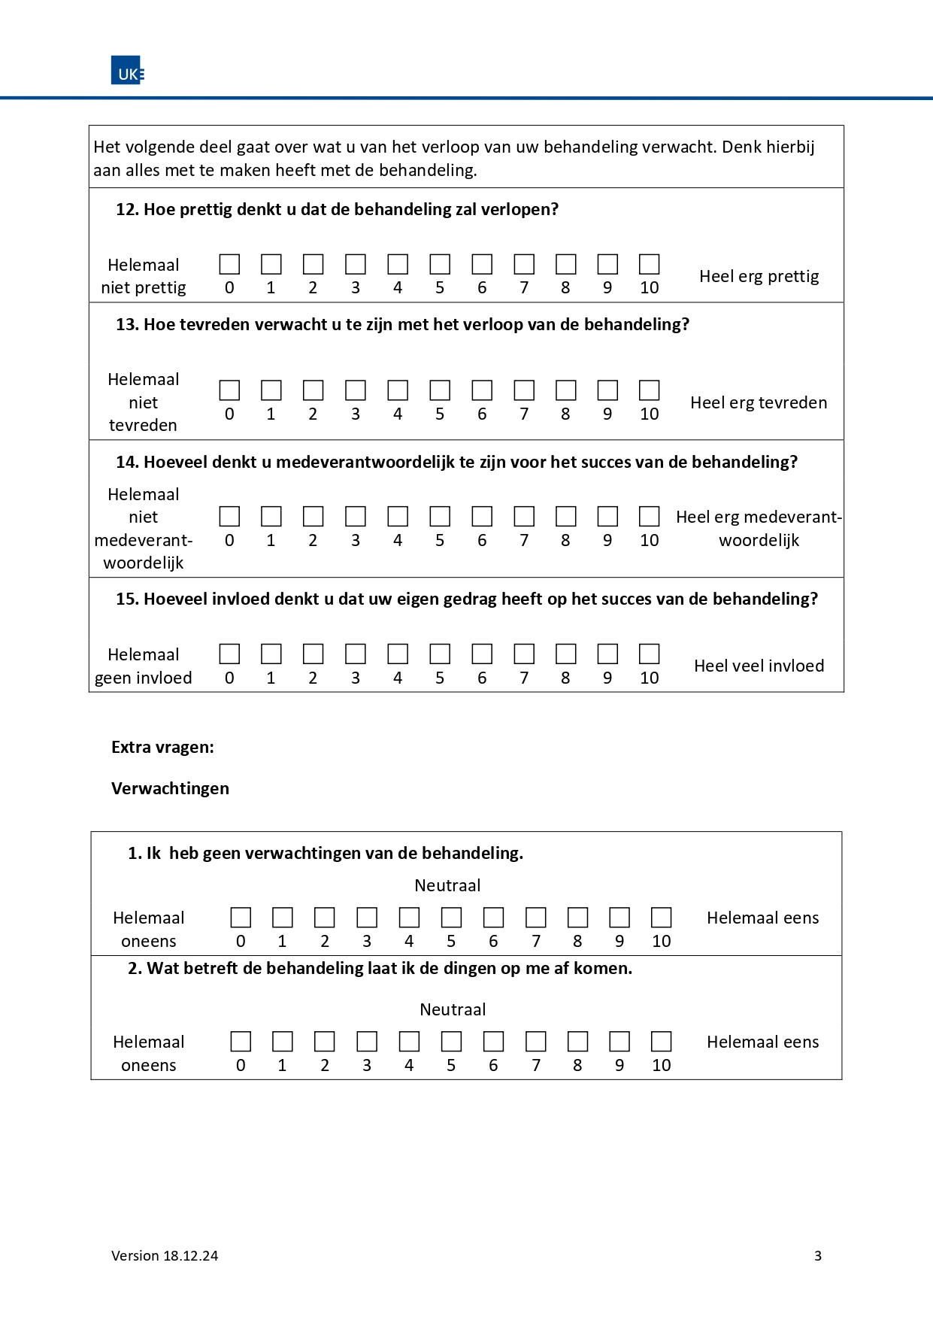
Additional Table S1:
Test-retest reliability of the Dutch TEX-Q (n=25)
 | Total  (M±SD or n (%)) | First test  (M±SD) | Retest  (M±SD) | ICC | P value
Demographics
Age in years, M±SD | 52.0±13.7
Education, N (%)  Primary Education  Secondary Education  Tertiary Education  Bachelor’s Degree  Masters/ Doctoral Degree | 0 (0)  5 (20)  11 (44)  5 (20)  4 (16)
Treatment  Medical treatment  Hysteroscopic surgery  Laparoscopic surgery  Other surgery | 3 (12)  11 (44)  7 (28)  4 (16)
Scales
TEX-Q, M±SD |  | 6.3±0.84 | 6.5±0.91 | 0.72 | 0.000
Treatment benefit |  | 7.8±1.4 | 7.9±1.3 | 0.72 | 0.000
Positive impact |  | 5.4±2.4 | 5.7±2.7 | 0.57 | 0.001
Adverse events |  | 4.6±1.8 | 4.7±1.6 | 0.68 | 0.000
Negative impact |  | 1.1±1.6 | 0.9±1.2 | 0.50 | 0.006
Process |  | 5.6±1.5 | 5.9±1.7 | 0.50 | 0.005
Behavioural control |  | 4.8±3.1 | 5.2±2.8 | 0.83 | 0.000
M: mean. SD: standard deviation. ICC: intraclass coefficient.

Additional data file S1:
All versions of TEX-Q
Link to all versions of the TEX-Q: OSF | The Treatment Expectation Questionnaire (TEX-Q) : https://osf.io/dr3gc/

