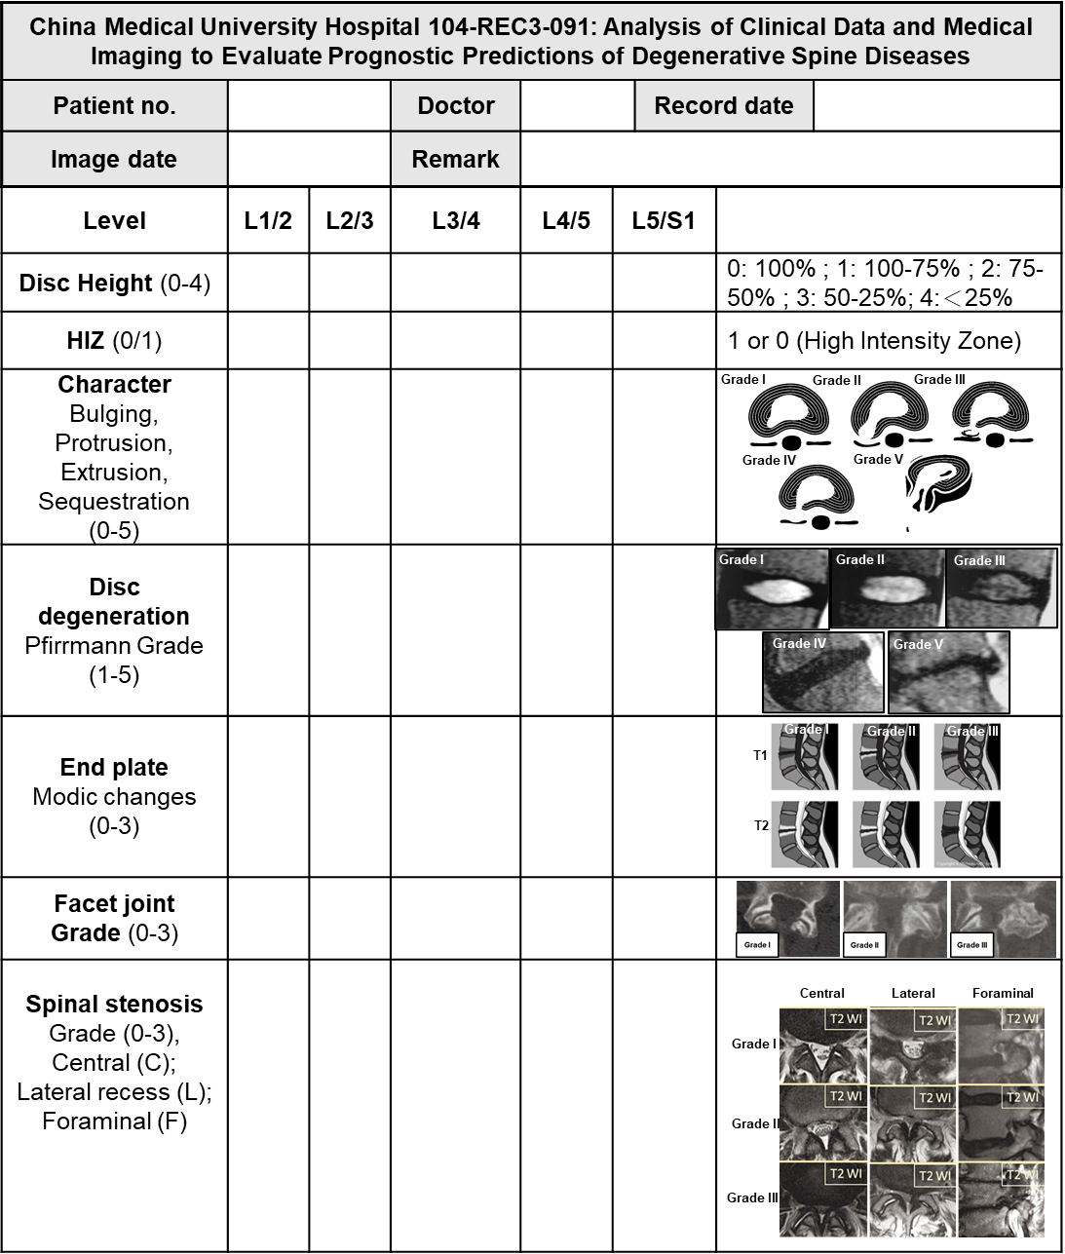
Figure S1. Preoperative imaging assessment form.

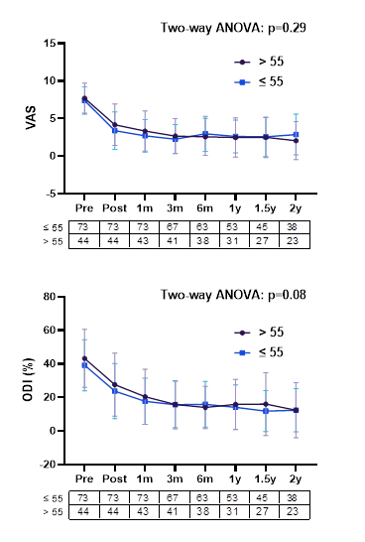

Figure S2. The impact of age on the prognosis of IDB. The figure analyzes the effect of VAS and ODI over time after surgery, using 55 years as the cutoff point. The number of participants in each period is listed below the chart.

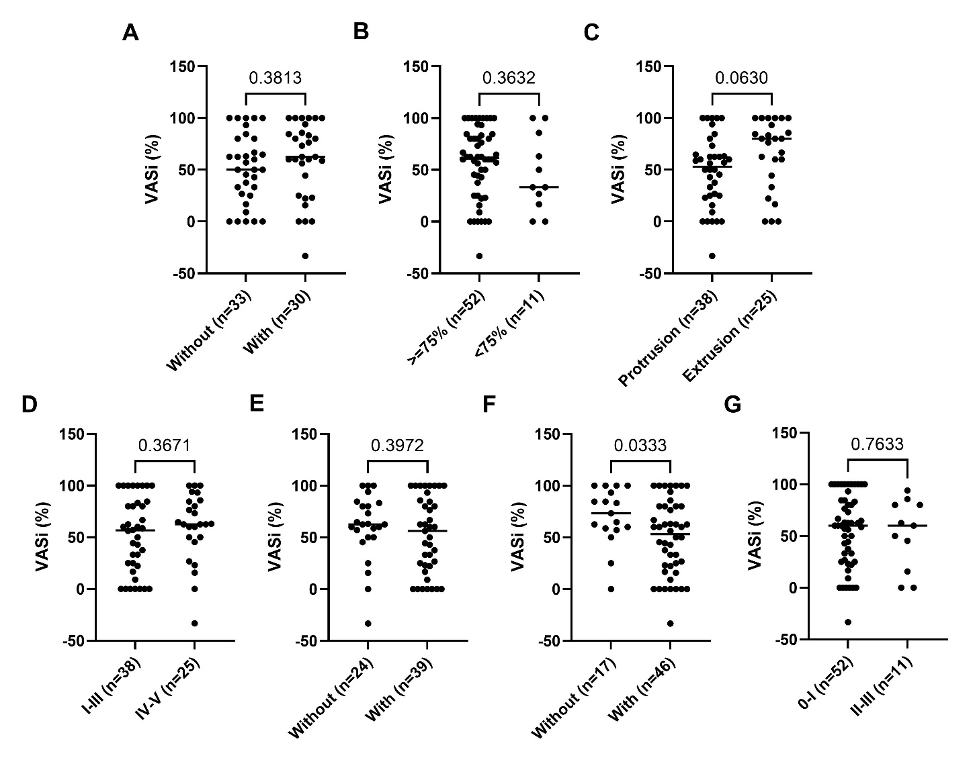
Figure S3. Univariate analysis of preoperative imaging data distribution. Evaluated parameters included HIZ (A), disc height (B), disc character (C), Pfirrmann grade (D), endplate Modic changes (E), facet joint (F), and stenosis grade (G), assessed according to the tabular criteria shown in Figure 1. Statistical comparisons were performed using unpaired t-tests.

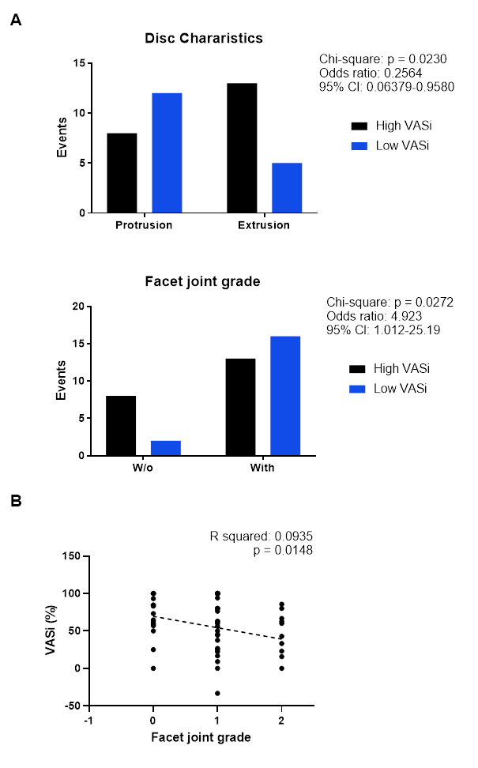
Figure S4. Analysis of the impact of disc character and facet joint on post-operative VAS improvement. (A) Chi-square analysis, with extreme data obtained using Mean ± 0.7 SD. (B) Linear regression analysis of the relationship between facet joint grade and 6-month VAS improvement for all patients.

