Comparative Effectiveness of Pharmacological, Non-pharmacological, and Combined Strategies for Pain Relief During Colonoscopy: A Bayesian Network Meta-analysis of Randomized Trials

Supplementary Materials

Table 1s Search strategy
Patients：  Colonoscopy  Colonoscopic Surgery | Comparison：  Placebo  Blank control  Air insufflation
Interventions：  Anisodamine hydrobromide  6-hydroxyhyoscyamine  Midazolam  Fentanyl  Propofol  Ketorolac trometamol  Meperidine  L-menthol  Peppermint oil  Simethicone  Lidocaine  Water exchange  Water aided  Carbon dioxide  Nitrous oxide  Transcutaneous electrical acupoint stimulation  Transcutaneous electric nerve stimulation  Abdominal compression  Abdominal corset  Acupuncture  Virtual reality  Audiovisual distraction  Visual distraction  Smartphone  hot pack | Outcomes：  Pain score  Visual analog scale  Numerical rating scale  Anxiety  Patient satisfaction  Pain measurement  Sedative drug dosage
Study：
Randomized controlled trial
Controlled clinical trial
Time：
2004/11/7 – 2024/11/7

Table 2s WOS search formula
 | Search Query | Database | Results
1 | (((((SO=(randomized controlled trial)) OR SO=(controlled clinical trial)) OR TS=(random*)) OR TS=(placebo)) OR TS=(trial)) OR TS=(group) and Preprint Citation Index (Exclude – Database) | All Databases | 18375836
2 | (((TS=(colonoscopy)) OR TS=(colonoscop*)) OR TS=(colonoscopic surgical procedure)) OR TS=(colonoscopic surgery) and Preprint Citation Index (Exclude – Database) | All Databases | 91301
3 | ((((((((((((((((((((((((((((((((((((((((((TS=(water exchange)) OR TS=(water aided)) OR TS=(water assisted)) OR TS=(water infusion)) OR TS=(carbon dioxide)) OR TS=(CO2)) OR TS=(anisodamine hydrobromide)) OR TS=(raceanisodamine)) OR TS=(6-hydroxyhyoscyamine)) OR TS=(lidocaine)) OR TS=(transcutaneous electric nerve stimulation)) OR TS=(stiumlation)) OR TS=(TEAS)) OR TS=(TENS)) OR TS=(transcutaneous electrical acupoint stimulation)) OR TS=(Electric*)) OR TS=(nitrous oxide)) OR TS=(midazolam)) OR TS=(fentan*)) OR TS=(propofol)) OR TS=(ketorolac trometamol)) OR TS=(meperidine)) OR TS=(L-Menthol)) OR TS=(Colpermin)) OR TS=(peppermint oil)) OR TS=(alverine citrate)) OR TS=(simethicone)) OR TS=(patient controlled analgesia)) OR TS=(patient controlled)) OR TS=(PCA)) OR TS=(abdominal compression)) OR TS=(abdominal massage)) OR TS=(Acupuncture)) OR TS=(Electroacupuncture)) OR TS=(virtual reality)) OR TS=(VR)) OR TS=(music)) OR TS=(audiovisual distraction)) OR TS=(visual distraction)) OR TS=(smartphone)) OR TS=(hot pack)) OR TS=(progressive muscle relaxation)) OR TS=(abdominal corset) and Preprint Citation Index (Exclude – Database) | All Databases | 20139297
4 | (((((TS=(visual analog scale)) OR TS=(Time)) OR TS=(anxiety)) OR TS=(patient satisfaction)) OR TS=(pain management)) OR TS=(pain measurement) and Preprint Citation Index (Exclude – Database) | All Databases | 29916318
5 | DOP=(2004-11-07/2024-11-07) and Preprint Citation Index (Exclude – Database) | All Databases | 118366802
6 | #5 AND #4 AND #3 AND #2 AND #1 and Preprint Citation Index (Exclude – Database) | All Databases | 3507

Table 3s EMBASE search formula
No. | Query | Results
#6 | #1 AND #2 AND #3 AND #4 AND #5 | 1273
#5 | [2004-2024]/py | 28521893
#4 | 'randomized controlled trial':it OR 'controlled clinical trial'/de OR 'randomized controlled trial'/de OR randomized:ti,ab OR placebo:ti,ab OR randomly:ti,ab OR trial:ti,ab OR group:ti,ab | 6525229
#3 | 'visual analog scale'/de OR 'visual analogue scale' OR time OR anxiety OR 'patient satisfaction'/de OR 'patient satisfaction' OR 'pain management'/de OR 'pain management' OR 'pain measurement'/de OR 'pain measurement' | 7533428
#2 | 'water exchange':ti,ab OR 'water aided':ti,ab OR 'water assisted':ti,ab OR 'water infusion':ti,ab OR 'carbon dioxide'/exp OR 'carbon dioxide':ti,ab OR 'anisodamine hydrobromide':ti,ab OR raceanisodamine:ti,ab OR '6-hydroxyhyoscyamine':ti,ab OR lidocaine:ti,ab OR 'transcutaneous electric nerve stimulation'/exp OR 'transcutaneous electric nerve stimulation':ti,ab OR 'electricity'/de OR electric*:ti,ab OR stimulation:ti,ab OR 'transcutaneous electrical acupoint stimulation':ti,ab OR teas:ti,ab OR tens:ti,ab OR 'nitrous oxide':ti,ab OR midazolam:ti,ab OR fentan*:ti,ab OR propofol:ti,ab OR 'ketorolac trometamol':ti,ab OR meperidine:ti,ab OR 'l-menthol':ti,ab OR colpermin:ti,ab OR 'peppermint oil':ti,ab OR 'alverine citrate':ti,ab OR simethicone:ti,ab OR 'patient controlled analgesia':ti,ab OR pca:ti,ab OR 'abdominal compression':ti,ab OR 'abdominal massage':ti,ab OR 'acupuncture'/de OR acupuncture:ti,ab OR electroacupuncture:ti,ab OR 'virtual reality'/de OR 'virtual reality':ti,ab OR vr:ti,ab OR music:ti,ab OR 'audiovisual distraction':ti,ab OR 'visual distraction':ti,ab OR smartphone:ti,ab OR 'hot pack':ti,ab OR 'progressive muscle relaxation':ti,ab OR 'abdominal corset':ti,ab | 1731533
#1 | 'colonoscopy'/exp OR 'colonoscop*':ti,ab OR 'colonoscopic surgical procedure':ti,ab OR 'colonoscopic surgery':ti,ab | 123628

Table 4s PUBMED search formula
 | Query | Results
10 | ((((#1) AND (#2)) AND (#7)) AND (#8)) AND (#9) | 518
9 | ("2004/11/07"[Date - Create] : "2024/11/07"[Date - Create]) | 22,386,994
8 | (((((((((Visual Analogue Scale[MeSH Major Topic]) OR (Visual Analogue Scale[Text Word])) OR (Time[Text Word])) OR (anxiety[Text Word])) OR (Patient Satisfaction[Text Word])) OR (Patient Satisfaction[MeSH Major Topic])) OR (Pain Management[MeSH Major Topic])) OR (Pain Management[Text Word])) OR (Pain Measurement[Text Word])) OR (Pain Measurement[MeSH Major Topic]) | 5,661,183
7 | (((#3) OR (#4)) OR (#5)) OR (#6) | 504,759
6 | ((((((((((((((Abdominal compression[Title/Abstract]) OR (Abdominal massage[Title/Abstract])) OR (Acupuncture[Title/Abstract])) OR (Electroacupuncture[Title/Abstract])) OR (Acupuncture[MeSH Major Topic])) OR (Virtual Reality[MeSH Major Topic])) OR (Virtual Reality[Title/Abstract])) OR (VR[Title/Abstract])) OR (music[Title/Abstract])) OR (audiovisual distraction[Title/Abstract])) OR (Visual distraction[Title/Abstract])) OR (smartphone[Title/Abstract])) OR (Hot Pack[Title/Abstract])) OR (Progressive Muscle Relaxation[Title/Abstract])) OR (Abdominal Corset[Title/Abstract]) | 117,434
5 | (((((((((((((Nitrous oxide[Title/Abstract]) OR (midazolam[Title/Abstract])) OR (fentan*[Title/Abstract])) OR (propofol[Title/Abstract])) OR (ketorolac trometamol[Title/Abstract])) OR (meperidine[Title/Abstract])) OR (L-Menthol[Title/Abstract])) OR (Colpermin[Title/Abstract])) OR (peppermint oil[Title/Abstract])) OR (alverine citrate[Title/Abstract])) OR (simethicone[Title/Abstract])) OR (patient-controlled analgesia[Title/Abstract])) OR (Analgesia, Patient-Controlled[MeSH Major Topic])) OR (PCA[Title/Abstract]) | 144,973
4 | (((((Transcutaneous Electric Nerve Stimulation[MeSH Major Topic]) OR (Transcutaneous Electric Nerve Stimulation[Title/Abstract])) OR (Electric stiumlation[Title/Abstract])) OR (Transcutaneous electrical acupoint stimulation[Title/Abstract])) OR (TEAS[Title/Abstract])) OR (TENS[Title/Abstract]) | 32,556
3 | (((((((((water exchange[Title/Abstract]) OR (water aided[Title/Abstract])) OR (water assisted[Title/Abstract])) OR (water infusion[Title/Abstract])) OR (Carbon dioxide[Title/Abstract])) OR (CO2[Title/Abstract])) OR (anisodamine hydrobromide[Title/Abstract])) OR (raceanisodamine[Title/Abstract])) OR (6-hydroxyhyoscyamine[Title/Abstract])) OR (lidocaine[Title/Abstract]) | 222,996
2 | (((Colonoscopy[MeSH Major Topic]) OR (Colonoscop*[Title/Abstract])) OR (Colonoscopic Surgical Procedure[Title/Abstract])) OR (Colonoscopic Surgery[Title/Abstract]) | 45,048
1 | ((((((randomized controlled trial[Publication Type]) OR (controlled clinical trial[Publication Type])) OR (randomized[Title/Abstract])) OR (placebo[Title/Abstract])) OR (randomly[Title/Abstract])) OR (trial[Title/Abstract])) OR (groups[Title/Abstract]) | 4,050,834

Table 5s Comprehensive table of each study
First Author, Year | Population | Group | Sample Size | Intervention | Dosage/Parameters | Pain Score Mean (SD)
Ni Yufei, 2008¹ | Adults | 1 | 40 | Electroacupuncture | Acupoints: GB34, ST36, ST37, SP6 | 2.25（0.9）
Ni Yufei, 2008¹ | Adults | 2 | 40 | Blank Control | - | 2.51（0.81）
James, 2008² | Adults | 1 | 46 | CO₂, Diazepam, Pethidine | 0.1 mg/kg; 0.5 mg/kg | 2.34（0.42）
James, 2008² | Adults | 2 | 50 | Diazepam, Pethidine | 0.1 mg/kg; 0.5 mg/kg | 4.16（0.4）
Leung, 2009³ | - | 1 | 28 | Water perfusion, Fentanyl, Midazolam | Intermittent infusion of water using peristaltic pump; 25 mg; 1 mg | 1.3（1.8）
Leung, 2009³ | - | 2 | 28 | Fentanyl, Midazolam | 25mg; 1mg | 4.1（3.4）
Hayee, 2009⁴ | Adults | 1 | 149 | Meperidine, Midazolam | 50mg; 0.05mg/kg | 1.5（0.16）
Hayee, 2009⁴ | Adults | 2 | 138 | Fentanyl, Midazolam | 25-100 mg; 0.05mg/kg | 1.7（0.19）
Hsieh, 2009⁵ | Adults | 1 | 100 | Meperidine, Propofol | 25mg; 1mg/kg | 0.97（1.48）
Hsieh, 2009⁵ | Adults | 2 | 100 | Propofol | 1mg/kg | 1.38（1.76）
Felix, 2010⁶ | - | 1 | 42 | Water Infusion | If there is residual feces, add water and suction until visibility is restored. | 3.6（2.1）
Felix, 2010⁶ | - | 2 | 40 | Blank Control | - | 5.5（3）
Radaelli, 2010⁷ | Adults aged 18-80 | 1 | 116 | Water Infusion | The peristaltic flushing pump intermittently injects 37° warm water, and the flow rate is set to 210 mL/min | 2.8（2.4）
Radaelli, 2010⁷ | Adults aged 18-80 | 2 | 114 | Blank Control | - | 3.55（3）
Geyer, 2011⁸ | - | 1 | 110 | CO2, Propofol | Basic flow rate 0.5 L/min, increased to 3 L/min if necessary; 10-20 mg | 1.2（1.9）
Geyer, 2011⁸ | - | 2 | 109 | Propofol | 10-20mg | 1.2（1.8）
Amer-Cuenca, 2011⁹ | Adults | 1 | 30 | Electrical stimulation | 7*13cm electrodes on both sides of L1-S3, frequency: 80-100HZ, intensity value is the patient's maximum tolerance | 2.46（5.73）
Amer-Cuenca, 2011⁹ | Adults | 2 | 30 | Placebo electrical stimulation | No current | 5.73（2.79）
Amer-Cuenca, 2011⁹ | Adults | 3 | 30 | Blank Control | - | 4.91（3.16）
POHL, 2011¹⁰ | Adults | 1 | 58 | Water Infusion | Warm water infusion to dilate the colon and shut off the air supply | 2.5（1.7）
POHL, 2011¹⁰ | Adults | 2 | 58 | Blank Control | Air | 4.3（2.3）
Hsieh, 2011¹¹ | - | 1 | 90 | Water infusion, Meperidine, Scopolamine | 25 mg and 20mg before surgery | 2.5（2.5）
Hsieh, 2011¹¹ | - | 2 | 89 | Meperidine, Scopolamine | 25 mg and 20mg before surgery | 3.4（2.8）
Toros, 2012¹² | - | 1 | 106 | Abdominal compression | Abdominal compression | 3.89（2.66）
Toros, 2012¹² | - | 2 | 110 | Blank Control | - | 5.74（2.77）
Chen, 2012¹³ | Adults aged 65 and above | 1 | 23 | CO2 | - | 4.05（1.67）
Chen, 2012¹³ | Adults aged 65 and above | 2 | 24 | Blank Control | Air | 7.02（13.7）
Chen, 2012¹³ | Adults aged 65 and above | 3 | 26 | CO2, Dezocine, Diazepam | 5 mg and 2.5 mg injected into the gluteus maximus | 3.07（1.02）
Chen, 2012¹³ | Adults aged 65 and above | 4 | 25 | Dezocine, Diazepam | 5 mg and 2.5 mg injected into the gluteus maximus | 5.04（0.87）
Bayupurnama, 2012¹⁴ | Adults | 1 | 53 | Water Infusion | Water immersion and water exchange, turn off the air pump | 4.1（2.6）
Bayupurnama, 2012¹⁴ | Adults | 2 | 57 | Blank Control | - | 6.4（2.4）
Szura, 2015¹⁵ | Adults aged 50-65 | 1 | 100 | CO2 | - | 2.4（1.3）
Szura, 2015¹⁵ | Adults aged 50-65 | 2 | 100 | Blank Control | Air | 2.44（1.2）
Umezawa, 2015¹⁶ | Adults aged 20-80 | 1 | 28 | Visual distraction | Wearable display to watch silent movies | 3.03（2.39）
Umezawa, 2015¹⁶ | Adults aged 20-80 | 2 | 29 | Blank Control | Wear the display without playing any content | 5.15（2.47）
Chen, 2015¹⁷ | Adults aged 18-65 | 1 | 114 | Electrical stimulation, Dentanyl, Propofol | Jiaji points on both sides, 30 minutes, 2-100HZ sparse and dense waves, current intensity until muscle twitching; intravenous injection of 0.05 μg/kg; as needed | 2.35（0.75）
Chen, 2015¹⁷ | Adults aged 18-65 | 2 | 115 | Placebo electrical stimulation, Fentanyl, Propofol | Same as above but without current output; 0.05 μg/kg IV; as needed | 3.35（2.25）
Jiang, 2015¹⁸ | Adults | 1 | 60 | Visual distraction | Silent playback of DVDs of interest | 4.89 (2.8)
Jiang, 2015¹⁸ | Adults | 2 | 60 | Visual and auditory distraction | DVD with audio playback that you are interested in | 4.51 (2.26)
Jiang, 2015¹⁸ | Adults | 3 | 60 | Blank Control | - | 5.16 (2.9)
Schroeder, 2016¹⁹ | Adults | 1 | 126 | Propofol | As needed, not exceeding 60 mg | 0.2（0.9）
Schroeder, 2016¹⁹ | Adults | 2 | 136 | Fentanyl, Midazolam | 2mg；50μg | 2.4（3.1）
Silva, 2016²⁰ | - | 1 | 66 | Music, Meperidine, Midazolam | Patient-selected music; 5 mg divided into equal parts, increased as needed; 0.5 mg divided into equal parts, increased as needed | 3（1.52）
Silva, 2016²⁰ | - | 2 | 67 | Visual distraction, Meperidine, Midazolam | Patient choice of film; 5 mg divided into equal parts, increased as needed; 0.5 mg divided into equal parts, increased as needed | 4（3.03）
Silva, 2016²⁰ | - | 3 | 67 | Meperidine, Midazolam | 5 mg divided into equal parts, increase as needed; 0.5 mg divided into equal parts, increase as needed | 5.35（3.79）
Ko, 2016²¹ | - | 1 | 40 | Music, Fentanyl, Midazolam | Wear MP3 and listen to 15 light music; the smallest standard dose | 3.24（2.72）
Ko, 2016²¹ | - | 2 | 40 | Fentanyl, Midazolam | Minimum standard dose | 3.37（3.07）
Cao, 2017²² | Adults aged 65-75 | 1 | 20 | Water infusion | The water pump injects 36°C warm water instead of air to expand the intestinal tube | 3.1（1.4）
Cao, 2017²² | Adults aged 65-75 | 2 | 20 | Blank Control | Air | 4.9（1.7）
Azevedo, 2018²³ | Adults aged 18-90 | 1 | 70 | Water infusion | Water exchange to remove occlusion and air bubbles | 3.39（2.32）
Azevedo, 2018²³ | Adults aged 18-90 | 2 | 71 | Blank Control | Air | 4.94（2.1）
Adigun, 2019²⁴ | Adults | 1 | 31 | Pentazocine, Midazolam | 2.5 mg; 15 mg | 4.8（1.9）
Adigun, 2019²⁴ | Adults | 2 | 31 | Fentanyl, Propofol | 0.5 mg/kg; 0.5ug/kg | 3.19（1.9）
Pontone, 2020²⁵ | Adults | 1 | 40 | Fentanyl, Midazolam | 50 μg; 0.07mg/kg | 3.95（2.77）
Pontone, 2020²⁵ | Adults | 2 | 40 | Meperidine, Midazolam | 50 mg; 0.07mg/kg | 1.87（2.23）
Veldhuijzen, 2020²⁶ | - | 1 | 10 | Visual distraction, Alfentanil, Midazolam | VR plays Caribbean movies, but no sound; injection on demand | 3.27（3.44）
Veldhuijzen, 2020²⁶ | - | 2 | 9 | Alfentanil, Midazolam | Injection on demand | 2.63（2.62）
Hsieh, 2020²⁷ | Adults aged 40-80 | 1 | 75 | Water infusion | Turn off the air pump and inject warm tap water to suck out the air. | 2.1（2.6）
Hsieh, 2020²⁷ | Adults aged 40-80 | 2 | 75 | Blank Control | Air | 4（2.9）
Joan, 2021²⁸ | Adults | 1 | 19 | Electrical stimulation | A 2.5*2.5cm electrode is placed on Zusanli, with a frequency of 4HZ and an intensity of painless muscle twitching. | 4.6（4.6）
Joan, 2021²⁸ | Adults | 2 | 18 | Placebo electrical stimulation | Wear but don't activate | 6（2.58）
Cakir, 2021²⁹ | Adults | 1 | 30 | VR | - | 2.76（1.25）
Cakir, 2021²⁹ | Adults | 2 | 30 | Blank Control | Air | 3.76（2.11）
Han, 2021³⁰ | Patients aged 16-60 years | 1 | 180 | Visual distraction | Playing with mobile phone | 2.18（2.8）
Han, 2021³⁰ | Patients aged 16-60 years | 2 | 180 | Blank Control | Air | 3.55（3.07）
Brix, 2022³¹ | Adults undergoing first-time screening | 1 | 169 | Music, Fentanyl, Midazolam | Instruments and natural sounds; 0.25mcg; 3mg | 4.7（4.49）
Brix, 2022³¹ | Adults undergoing first-time screening | 2 | 168 | Fentanyl, Midazolam | 0.25mcg; 3mg | 4（2.99）
Liu, 2022³² | - | 1 | 58 | VR | Short film featuring tropical islands and forests, accompanied by soothing music, 30 minutes | 5（1.52）
Liu, 2022³² | - | 2 | 59 | Blank Control | Wearing VR and headset without any video or sound | 7（1.52）
Sun, 2022³³ | - | 1 | 112 | Music | 15 popular piano songs with soft melodies, moderate rhythms and no lyrics | 1.37（1.78）
Sun, 2022³³ | - | 2 | 104 | Blank Control | Air | 2.06（2.04）
Tani, 2022³⁴ | Adults aged 18-80 | 1 | 42 | Music | Binaural Beats | 5.19（2.68）
Tani, 2022³⁴ | Adults aged 18-80 | 2 | 48 | Blank Control | Air | 6.65（2.5）
He, 2022³⁵ | Adults aged 18-79 | 1 | 91 | Acupuncture, Propofol | Wrist-ankle acupuncture: 0.5 mg/kg | 1.38（0.49）
He, 2022³⁵ | Adults aged 18-79 | 2 | 90 | Propofol | 0.5mg/kg | 2.31（0.47）
Cakir, 2023³⁶ | Adults | 1 | 30 | Music | Wear it for the first ten minutes, classical Turkish music | 2.76（1.5）
Cakir, 2023³⁶ | Adults | 2 | 30 | Abdominal compression | Press ball | 4.36（1.56）
Cakir, 2023³⁶ | Adults | 3 | 30 | VR | Watch licensed VR app 'A Walk on the Beach' with sound | 3.2（1.06）
Cakir, 2023³⁶ | Adults | 4 | 30 | Blank Control | Air | 4.1（1.95）
Huang, 2024³⁷ | Adults aged 18-75 | 1 | 60 | Electrical stimulation | 2.5cm diameter electrode on ankle, 2HZ, current to maximum tolerance | 3.82（2.66）
Huang, 2024³⁷ | Adults aged 18-75 | 2 | 60 | Placebo electrical stimulation | Minimum current | 5.32（1.44）
Shamali, 2024³⁸ | - | 1 | 23 | VR, Fentanyl, Midazolam | Patients choose according to their needs | 2.26（2.8）
Shamali, 2024³⁸ | - | 2 | 24 | Fentanyl, Midazolam | Injection on demand | 3.96（2.8）
Hirani, 2024³⁹ | Adults | 1 | 55 | Music, Nalbuphine, Midazolam | Unique recordings of nature (such as the rhythmic sounds of birds, ocean waves, forests, rainfall, etc.), combined with soft instruments; 0.1-0.2mg/kg; maximum 5mg | 2.92（1.5）
Hirani, 2024³⁹ | Adults | 2 | 55 | Nalbuphine, Midazolam | 0.1-0.2 mg/kg; maximum 5 mg | 3.15（1.3）
Veisman, 2024⁴⁰ | Adults | 1 | 30 | VR | Relaxation video clips | 4.36（0.78）
Veisman, 2024⁴⁰ | Adults | 2 | 30 | Blank Control | Air | 2.64（0.78）

Table 6s Specific categories of all interventions
1 | Blank Control
2 | Placebo
3 | Propofol
4 | Water perfusion/CO2 insufflation | Water perfusion
4 | Water perfusion/CO2 insufflation | CO₂ insufflation
5 | Distraction | Virtual reality
5 | Distraction | Music
5 | Distraction | Visual distraction
6 | External physical intervention | Electrical stimulation
6 | External physical intervention | Abdominal compression
7 | Distraction + Analgesia + Sedation | Visual distraction + Fentanyl + Midazolam
7 | Distraction + Analgesia + Sedation | Music + Fentanyl + Midazolam
7 | Distraction + Analgesia + Sedation | Virtual reality + Fentanyl + Midazolam
7 | Distraction + Analgesia + Sedation | Music + Nalbuphine + Midazolam
7 | Distraction + Analgesia + Sedation | Music + Pethidine + Midazolam
7 | Distraction + Analgesia + Sedation | Virtual reality + Pethidine + Midazolam
8 | CO2/Water insufflation + Analgesia + Sedation | CO₂ + Diazepam + Pethidine
8 | CO2/Water insufflation + Analgesia + Sedation | Water perfusion + Fentanyl + Midazolam
8 | CO2/Water insufflation + Analgesia + Sedation | Water perfusion + Pethidine
8 | CO2/Water insufflation + Analgesia + Sedation | CO₂ + Dezocine + Diazepam
9 | Pethidine + Sedation | Pethidine
9 | Pethidine + Sedation | Pethidine + Midazolam
9 | Pethidine + Sedation | Pethidine + Propofol
10 | Fentanyl + Sedation | Fentanyl + Midazolam
10 | Fentanyl + Sedation | Fentanyl + Propofol
11 | Physical intervention + Analgesia + Sedation | Electrical stimulation + Fentanyl + Propofol
11 | Physical intervention + Analgesia + Sedation | Acupuncture + Propofol
12 | Agonist-antagonist opioids + Sedation | Dezocine + Diazepam
12 | Agonist-antagonist opioids + Sedation | Diazepam + Meperidine
12 | Agonist-antagonist opioids + Sedation | Nalbuphine + Midazolam
12 | Agonist-antagonist opioids + Sedation | Pentazocine + Midazolam

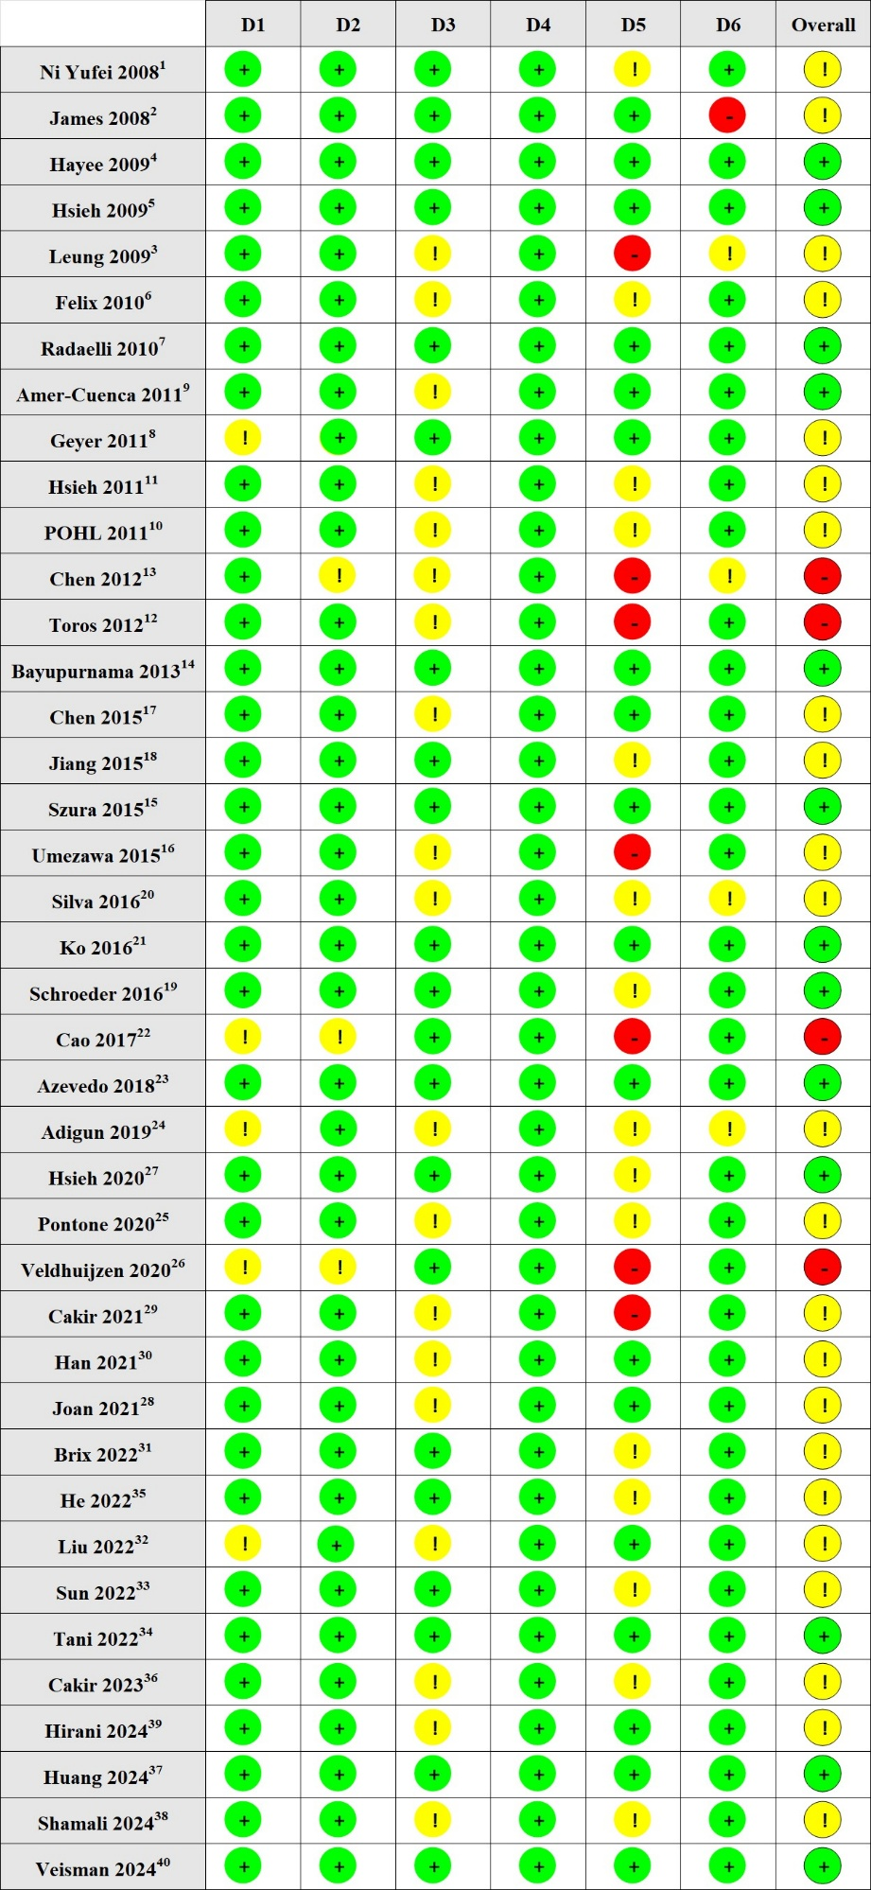
Figure 1s Risk of Bias 2 assessment for each item and included study network meta-analysis.
Fig 2s The inconsistency test chart of all intervention measures. 1, Blank control; 2, Placebo; 3, Propofol; 4, Water perfusion/CO2 insufflation; 5, Distraction; 6, External physical intervention;7, Distraction + Analgesia + Sedation; 8, CO2/Water insufflation + Analgesia + Sedation; 9, Pethidine + Sedation; 10, Physical intervention + Analgesia + Sedation; 11, Fentanyl + Sedation; 12, Agonist-antagonist opioids + Sedation.

Fig 3s The inconsistency test chart of non-pharmaceutical intervention measures. 1, Blank Control; 2, Placebo; 3, Water perfusion; 4, CO2 insufflation; 5, VR; 6, Music; 7, Visual distraction; 8, Abdominal compression; 9, Electrical stimulation.

Fig 4s Inconsistency test chart of drugs and combined intervention measures. 1, Placebo; 2, Propofol; 3, Propofol + Non-pharmacological Interventions; 4, Nalbuphine/Dezocine/Pentazocine + Diazepam/Midazolam; 5, Nalbuphine/Dezocine/Pentazocine + Benzodiazepines + Non-pharmacological Interventions; 6, Pethidine + Benzodiazepines/Propofol; 7, Pethidine + Benzodiazepines + Non-pharmacological Interventions;8, Fentanyl + Midazolam/Propofol; 9, Fentanyl + Midazolam + Non-pharmacological Interventions.

Fig 5s A mixed comparative forest plot of all intervention measures

Fig 6s Mixed comparative forest plots of non-pharmaceutical intervention measures

Fig 7s A mixed comparative forest plot of drugs and mixed intervention measures

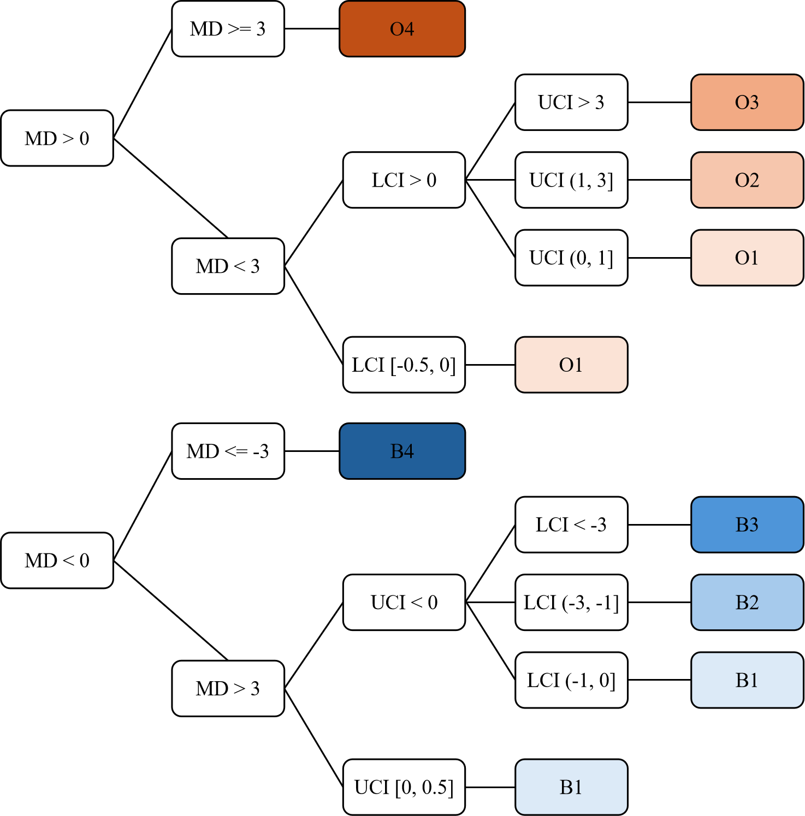
Fig. 8s Color filling calculation formula; (MD stands for mean difference; UCI stands for upper limit of confidence interval; LCI stands for lower limit of confidence interval)

Reference
1. Ni YF, Lian QQ, Jiang PW, et al. Application of acupuncture analgesia in colonoscopy. Zhongguo Zhen Jiu 2008;27(10):766-8.
2. Wong JC, Yau KK, Cheung HY, et al. Towards painless colonoscopy: a randomized controlled trial on carbon dioxide-insufflating colonoscopy. ANZ J Surg 2008;78(10):871-4. doi: 10.1111/j.1445-2197.2008.04683.x
3. Leung JW, Mann SK, Siao-Salera R, et al. A randomized, controlled comparison of warm water infusion in lieu of air insufflation versus air insufflation for aiding colonoscopy insertion in sedated patients undergoing colorectal cancer screening and surveillance. Gastrointest Endosc 2009;70(3):505-10. doi: 10.1016/j.gie.2008.12.253 [published Online First: 20090624]
4. Hayee BH, Dunn J, Loganayagam A, et al. Midazolam with meperidine or fentanyl for colonoscopy: results of a randomized trial. Gastrointestinal Endoscopy 2009;69(3):681-87. doi: 10.1016/j.gie.2008.09.033
5. Hsieh Y-H, Chou A-L, Lai Y-Y, et al. Propofol Alone Versus Propofol in Combination With Meperidine for Sedation During Colonoscopy. Journal of Clinical Gastroenterology 2009;43(8):753-57. doi: 10.1097/MCG.0b013e3181862a8c
6. Leung FW, Jackson G, Okamoto KE, et al. A Proof-of-Concept RCT of Water vs. Air Method in Scheduled, Unsedated Colonoscopy in United States Veterans - Final Report Demonstrating Significantly Improved Outcomes in Unsedated Colonoscopy by the Water Method. Gastroenterology 2010;138(5):S56-S57.
7. Radaelli F, Paggi S, Amato A, et al. Warm water infusion versus air insufflation for unsedated colonoscopy: a randomized, controlled trial. Gastrointest Endosc 2010;72(4):701-9. doi: 10.1016/j.gie.2010.06.025
8. Geyer M, Guller U, Beglinger C. Carbon dioxide insufflation in routine colonoscopy is safe and more comfortable: results of a randomized controlled double-blinded trial. Diagn Ther Endosc 2011;2011:378906. doi: 10.1155/2011/378906 [published Online First: 20110615]
9. Amer-Cuenca JJ, Goicoechea C, Girona-López A, et al. Pain relief by applying transcutaneous electrical nerve stimulation (TENS) during unsedated colonoscopy: a randomized double-blind placebo-controlled trial. Eur J Pain 2011;15(1):29-35. doi: 10.1016/j.ejpain.2010.05.006 [published Online First: 20100609]
10. Pohl J, Messer I, Behrens A, et al. Water infusion for cecal intubation increases patient tolerance, but does not improve intubation of unsedated colonoscopies. Clin Gastroenterol Hepatol 2011;9(12):1039-43.e1. doi: 10.1016/j.cgh.2011.06.031 [published Online First: 20110713]
11. Hsieh Y-H, Lin H-J, Tseng K-C. Limited water infusion decreases pain during minimally sedated colonoscopy. World Journal of Gastroenterology 2011;17(17):2236-40. doi: 10.3748/wjg.v17.i17.2236
12. Toros AB, Ersoz F, Ozcan O. Does a fitted abdominal corset makes colonoscopy more tolerable? Dig Endosc 2012;24(3):164-7. doi: 10.1111/j.1443-1661.2011.01207.x [published Online First: 20111027]
13. Chen Y, Du B, Yang C, et al. Insufflation of carbon dioxide at colonoscopy elevates degree of comfort in elderly patients: a randomized controlled trial. Chinese Journal of Gastroenterology 2012;17(5):288-92. doi: 10.3969/j.issn.1008-7125.2012.05.008
14. Bayupurnama P, Ratnasari N, Indrarti F, et al. The Water-Aided Method in Routine Unsedated Colonoscopy: A Randomized Controlled Trial (RCT) in Diagnostic Cases in Indonesian Patients Presidential Poster. American Journal of Gastroenterology 2012;107:S733-S34. doi: 10.14309/00000434-201210001-01802
15. Szura M, Pach R, Matyja A, et al. Carbon dioxide insufflation during screening unsedated colonoscopy: a randomised clinical trial. Eur J Cancer Prev 2015;24(1):37-43. doi: 10.1097/cej.0000000000000047
16. Umezawa S, Higurashi T, Uchiyama S, et al. Visual distraction alone for the improvement of colonoscopy-related pain and satisfaction. World J Gastroenterol 2015;21(15):4707-14. doi: 10.3748/wjg.v21.i15.4707
17. Chen Y, Wu W, Yao Y, et al. Transcutaneous electric acupoint stimulation at Jiaji points reduce abdominal pain after colonoscopy: a randomized controlled trial. International Journal of Clinical and Experimental Medicine 2015;8(4):5972-77.
18. Jiang X, Li X, Zhou Hui L. Effects of Visual and Audiovisual Distraction on Pain and Anxiety Among Patients Undergoing Colonoscopy. Gastroenterology Nursing 2015;38(1):55-61. doi: 10.1097/sga.0000000000000089
19. Schroeder C, Kaoutzanis C, Tocco-Bradley R, et al. Patients Prefer Propofol to Midazolam Plus Fentanyl for Sedation for Colonoscopy: Results of a Single-Center Randomized Equivalence Trial. Dis Colon Rectum 2016;59(1):62-69. doi: 10.1097/dcr.0000000000000512
20. De Silva AP, Niriella MA, Nandamuni Y, et al. Effect of audio and visual distraction on patients undergoing colonoscopy: a randomized controlled study. Endoscopy international open 2016;4(11):E1211-E14.
21. Ko SY. The Effectiveness of Music Interventions on Anxiety Level, Pain Level and Satisfaction for Chinese Adult Patients Undergoing Colonoscopy2016.
22. Cao Y, Wang P. Impact of water infusion colonoscopy on abdominal pain and inflammatory response in elderly patients. Chinese Journal of Gastroenterology 2017;22(1):40-42. doi: 10.3969/j.issn.1008-7125.2017.01.009
23. Azevedo R, Leitão C, Pinto J, et al. Can Water Exchange Improve Patient Tolerance in Unsedated Colonoscopy A Prospective Comparative Study. GE Port J Gastroenterol 2018;25(4):166-74. doi: 10.1159/000484093 [published Online First: 20171116]
24. Adigun TA, Akere A, Ayandipo OO, et al. A comparison of propofol - fentanyl with midazolam - pentazocine combination for sedation and analgesia during colonoscopy in Ibadan Nigeria. Journal of Clinical Sciences 2019;16(1):1-6. doi: 10.4103/jcls.jcls_38_18
25. Pontone S, Palma R, Donato G, et al. Efficacy of Sedation by Midazolam in Association With Meperidine or Fentanyl and Role of Patient Distress During Elective Colonoscopy. Gastroenterol Nurs 2020;43(3):258-63. doi: 10.1097/sga.0000000000000456
26. Veldhuijzen G, Klaassen NJM, Van Wezel RJA, et al. Virtual reality distraction for patients to relieve pain and discomfort during colonoscopy. Endosc Int Open 2020;8(7):E959-e66. doi: 10.1055/a-1178-9289 [published Online First: 20200630]
27. Hsieh Y-H, Tseng C-W, Koo M, et al. Feasibility of sedation on demand in Taiwan using water exchange and air insufflation: A randomized controlled trial. Journal of Gastroenterology and Hepatology 2020;35(2):256-62. doi: 10.1111/jgh.14839
28. Joan Gan CY, Chan KK, Tan JH, et al. Smartphone-controlled patch electro-acupuncture versus conventional pain relief during colonoscopy: a randomized controlled trial. ANZ J Surg 2021;91(6):E375-e81. doi: 10.1111/ans.16870 [published Online First: 20210419]
29. Cakir SK, Evirgen S. The Effect of Virtual Reality on Pain and Anxiety During Colonoscopy: A Randomized Controlled Trial. Turkish Journal of Gastroenterology 2021;32(5):451-57. doi: 10.5152/tjg.2021.191081
30. Han C, Xu T, Sheng L, et al. Improving the discomfort and satisfaction of colonoscopy by distraction with smartphones A prospective randomized controlled study. Medicine 2021;100(9) doi: 10.1097/md.0000000000023799
31. Brix LD, Pedersen ASB. Effect of music intervention in colonoscopy-naïve adults: a randomised controlled trial. Br J Nurs 2022;31(10):526-32. doi: 10.12968/bjon.2022.31.10.526
32. Liu Q, Zang Y, Zang W, et al. Implementation of virtual reality technology to decrease patients' pain and nervousness during colonoscopies: a prospective randomised controlled single-blinded trial. Clinical Medicine 2022;22(3):237-40. doi: 10.7861/clinmed.2022-0001
33. Sun D-J, You Y-X, He X-J, et al. Effects of light music played by piano intervention on satisfaction, anxiety, and pain in patients undergoing colonoscopy: A randomized controlled trial. Medicine 2022;101(52) doi: 10.1097/md.0000000000032339
34. Tani A, Tartarisco G, Vagheggini G, et al. Binaural beats reduce feeling of pain and discomfort during colonoscopy procedure in not-sedated patients: A randomized control trial
Complementary Therapies in Clinical Practice 2022;48 doi: 10.1016/j.ctcp.2022.101605
35. He T, Liu C, Lu Z-X, et al. Effect of wrist-ankle acupuncture on propofol dosage during painless colonoscopy: A randomized controlled prospective study. World Journal of Clinical Cases 2022;10(12):3764-72. doi: 10.12998/wjcc.v10.i12.3764
36. Cakir SK, Evirgen S. Three Distraction Methods for Pain Reduction During Colonoscopy: A Randomized Controlled Trial Evaluating the Effects on Pain and Anxiety. J Perianesth Nurs 2023;38(5):e1-e7. doi: 10.1016/j.jopan.2023.02.007 [published Online First: 20230810]
37. Huang X, Wang H, Shi L, et al. Effect of transcutaneous electrical nerve stimulation based on wrist-ankle acupuncture theory for pain relief during colonoscopy without anesthesia: a randomized controlled trial. Endoscopy 2024 doi: 10.1055/a-2373-0513 [published Online First: 20240916]
38. Shamali M, Vilmann P, Johansen NR, et al. Virtual reality intervention to improve quality of care during colonoscopy: a hybrid type 1 randomized controlled trial. Gastrointest Endosc 2024 doi: 10.1016/j.gie.2024.05.023 [published Online First: 20240606]
39. Hirani AAA, Ismail FW, Abdulaziz F, et al. The Effects of Music Therapy on Patients Undergoing Colonoscopy in a Tertiary Care Hospital at Karachi, Pakistan: A Comparative Study. J Pain Palliat Care Pharmacother 2024:1-11. doi: 10.1080/15360288.2024.2357551 [published Online First: 20240603]
40. Veisman I, Duchan MT, Lahat A, et al. Unsedated colonoscopy utilizing virtual reality distraction: a pilot-controlled study. Surgical Endoscopy and Other Interventional Techniques 2024;38(9):5060-67. doi: 10.1007/s00464-024-10999-1

